NOTICE OF ORDER

Wildlife and Countryside Act – 1981 – Section 53
CORNWALL COUNCIL
(Addition of Footpaths at Babis Lane & Town Quay in the Parish of Saltash) Modification Order 2017

Notice is hereby given that the above referenced Order has been submitted to the Secretary of State for Environment, Food and Rural Affairs for determination. Following an earlier inquiry, the Inspector appointed to determine the Order issued a letter in which he proposed to make modifications to the Order as drafted. Following advertisement of those proposals objections/representations have been received.

The start date for the above Order is 21 January 2025.

Consideration of the Order will take the form of a public local inquiry. It is being held so that the Inspector can hear evidence in respect of the modified part of the Order and new evidence in respect of the unmodified part of the Order. The Inspector would like to invite relevant parties to provide comments on, and evidence in relation to, the accuracy of maps and plans including the Order Plan, as submitted in evidence in respect of this Definitive Map Modification Order. The Inspector would further invite comments and the submission of any new evidence from relevant parties, in respect of the location of the claimed point of access onto the foreshore adjacent to Saltash Sailing Club and the properties at ‘Rivermist’ and ‘The Jetty’.

The Inquiry will be held at New County Hall, Treyew Road, Truro, Cornwall, TR1 3AY on Tuesday 3 June 2025 at 10.00am.

The appointed Inspector will also open the Inquiry as a virtual event on Tuesday 3 June 2025 at 10.00am.

Anyone wishing to attend the inquiry virtually must register that interest with the Council as soon as possible prior to the Inquiry, but no later than midday on Friday 30th May 2025, either by email or telephone, details of which are set out in this notice. To take part using video, participants will need to have access to Microsoft Teams (via an app or web browser). The link https://support.microsoft.com/en-us/office/welcome-to-microsoft-teams-b98d533f-118e-4bae-bf44-3df2470c2b12 gives further information on how to use this. Alternatively, you can take part by telephone. Registered participants will receive individual joining instructions, providing details of any requirements, guidance and support, whether joining by Teams or telephone.

The effect of the Order, if confirmed without modifications, will be to modify the definitive map and statement for the area by:
(i) Adding a length of Public Footpath in the Parish of Saltash commencing at Unclassified Road U6164 Babis Lane 30 metres north-west of ’31 Coombe Road’ at Ordnance Survey Grid Reference (OSGR) SX 4278/5848 shown as point ‘A’ on the attached Order map then continuing in a generally southerly then south-easterly direction for a distance of 39 metres terminating at the foreshore 19 metres south-south-west of ‘31 Coombe Road’ at OSGR SX 4280/5845 shown as point ‘B’ on the attached map.
(ii) Adding a length of Public Footpath in the Parish of Saltash commencing at the foreshore 18 metres south-east of ’The Jetty’ at Ordnance Survey Grid Reference (OSGR) SX 4318/5852 shown as point ‘C’ on the attached Order map then running in a generally north-easterly direction for a distance of 149 metres to a junction with another footpath to be added by this Order approximately 27 metres north-east of ’Waterside Bungalow’ at OSGR SX 4327/5864 shown as point ‘D’ on the attached Order map then running in a north-westerly direction for a distance of 8 metres terminating at the Footway 28 metres north-north-east of ‘Waterside Bungalow’ at OSGR SX 4326/5864 shown as point ‘E’ on the attached map.
(iii) Adding a length of Public Footpath in the Parish of Saltash commencing at another footpath to be added by this Order 27 metres north-east of ’Waterside Bungalow’ at OSGR SX 4327/5864 shown as point ‘D’ on the attached Order map then running in a generally easterly direction for a distance of 19 metres terminating at the entrance to Saltash Sailing Club 42 metres north-east of ‘Waterside Bungalow’ at OSGR SX 4329/5863 shown as point ‘F’ on the attached Order map.

The effect of the proposed modifications would be to modify the Order by providing for the following:
- In Part I of the Schedule to the Order delete all the text after “for a distance of 39 metres” and insert:

“to the foreshore approximately 19 metres south-south-west of ’31 Coombe Road’ at OSGR SX 4280/5845 shown as point ‘B’ on the attached Order map then continuing in a generally east-north-east direction along the foreshore to a point approximately 18 metres south-east of ‘The Jetty’ at OSGR SX 4318/5852 shown as point ‘C’ on the attached Order map then running in a generally north-easterly direction for a distance of 149 metres to a junction with another footpath to be added by this Order approximately 27 metres north-east of ‘Waterside Bungalow’ at OSGR SX 4327/5864 shown as point ‘D’ on the attached Order map then running in a north-westerly direction for a distance of 8 metres terminating at the Footway approximately 28 metres north-north-east of ‘Waterside Bungalow’ at OSGR SX 4326/5864 shown as point ‘E’ on the attached Order map.

A length of Public Footpath in the Parish of Saltash commencing at another footpath to be added by this Order approximately 27 metres north-east of ‘Waterside Bungalow’ at OSGR SX 4327/5864 shown as point ’D’ on the attached Order map then running in a generally easterly direction for a distance of 19 metres terminating at the entrance to Saltash Sailing Club approximately 42 metres north-east of ‘Waterside Bungalow’ at OSGR SX 4329/5863 shown as point ‘F’ on the attached Order map.

The width of the lengths of Public Footpath described vary between 2 (two) metres and 5 (five) metres.
- In Part II of the Schedule to the Order delete the text “FP from Babis Lane to foreshore” and insert:

“FP from Babis Lane along the foreshore”.
- In the Schedule to the Order add:
- “PART III

Modification of Definitive Statement

Limitations: The public’s right to use the footpath along the foreshore may be limited by the temporary placing of boats and other materials on it by landowners associated with the mooring and laying up of boats, but not such as to form an obstruction to the whole width of the footpath or to prevent the passage of pedestrians. The public’s right to use the footpath along the foreshore may also be limited by the effects of the tide.”
- On the Order map add a length of footpath between points B-C.

Any queries relating to this Order should be referred to Helen Sparks by email: helen.sparks@planninginspectorate.gov.uk quoting reference number ROW/3295824M1 on all correspondence. Alternatively, queries may be sent in writing to The Planning Inspectorate, Rights of Way Section, Room 3/A Eagle Wing, Temple Quay House, 2 The Square, Temple Quay, Bristol, BS1 6PN. Telephone: 0303 444 5646.

Any person wishing to view the statements of case and other
documents relating to this Order may do so by appointment at
Cornwall Council, New County Hall, Truro, Cornwall, TR1 3AY.
The web site where the documents can be accessed is:
Submissions to the Secretary of State - Definitive Map Modification Orders - Cornwall Council. If there are any queries, please contact Miss Hannah Rodger, Countryside Access Team on Telephone Number 01872 322222 or E-mail: Hannah.Rodger@cornwall.gov.uk

Timetable for sending in statements of case and proofs of evidence

Within 8 weeks of the start date [by 18 March 2025]

The Order Making Authority, the applicant and everyone who has made an objection or representation following the proposed modifications and anyone who wishes to give evidence at the Inquiry must ensure their statement of case is received by the Secretary of State. As soon as possible after receiving it the Secretary of State will send a full copy to the Authority. Copies (excluding copies of any supporting documents - these will be available to view at the Authority’s offices) will also be sent to everyone who has made an objection or representation following the modifications, the applicant and anyone else who has previously written to us in respect of the Order.

4 weeks before the date of the inquiry [by 6 May 2025]

The Authority, everyone who has made an objection or representation following the proposed modifications, the applicant (if applicable) and anyone who wishes to give evidence at the Inquiry must ensure their proof of evidence (together with any summary) is received the Secretary of State. As soon as possible after receiving them, the Secretary of State will send copies of:

- the Authority’s proof of evidence to everyone who has made an objection or representation following the proposed modifications, the applicant, anyone who has submitted a statement of case and anyone else who has previously written to us in respect of the Order;

- the applicant’s proof of evidence to the Authority, everyone who has made an objection or representation following the proposed modifications, anyone who has submitted a statement of case and anyone else who has previously written to us in respect of the Order; and

- all other proofs of evidence to the Authority, the applicant and anyone else who has either submitted a statement of case or who has previously written to us in respect of the Order .

All parties must keep to the timetable set out above and ensure that statements of case and proofs of evidence are received by the Secretary of State on time. Late documents will be returned.

We cannot accept any inflammatory, discriminatory or abusive comments. Any documents containing such comments will be returned.

Notice of order for inquiry mods

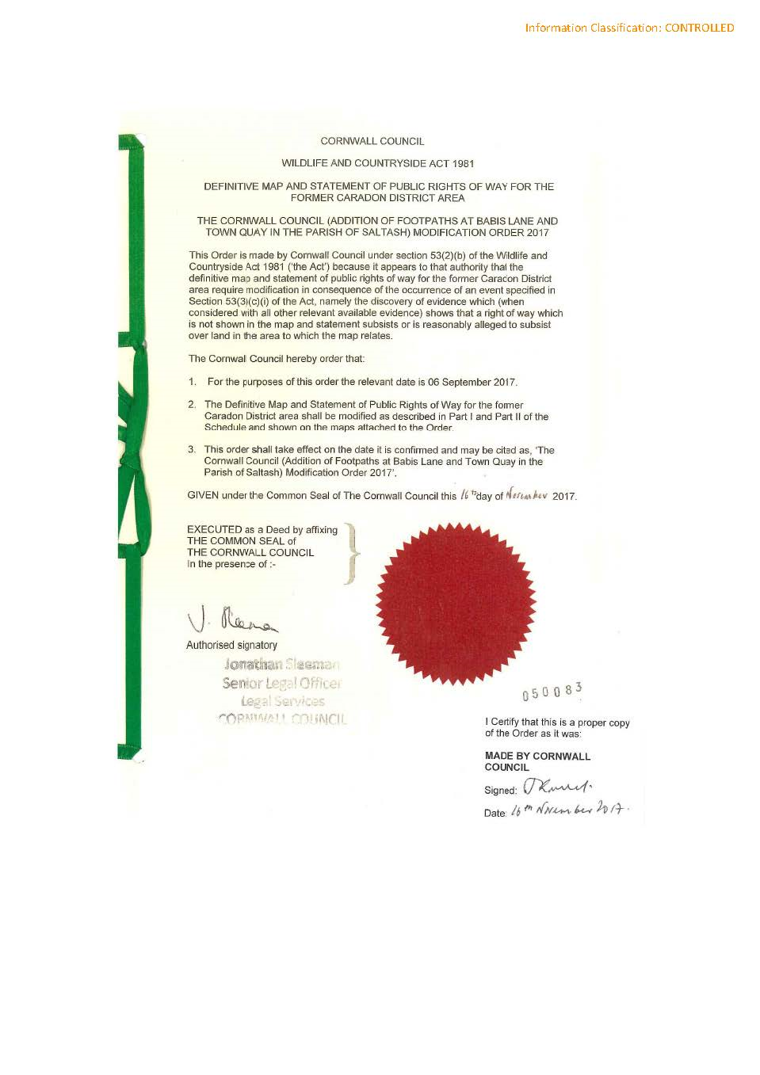

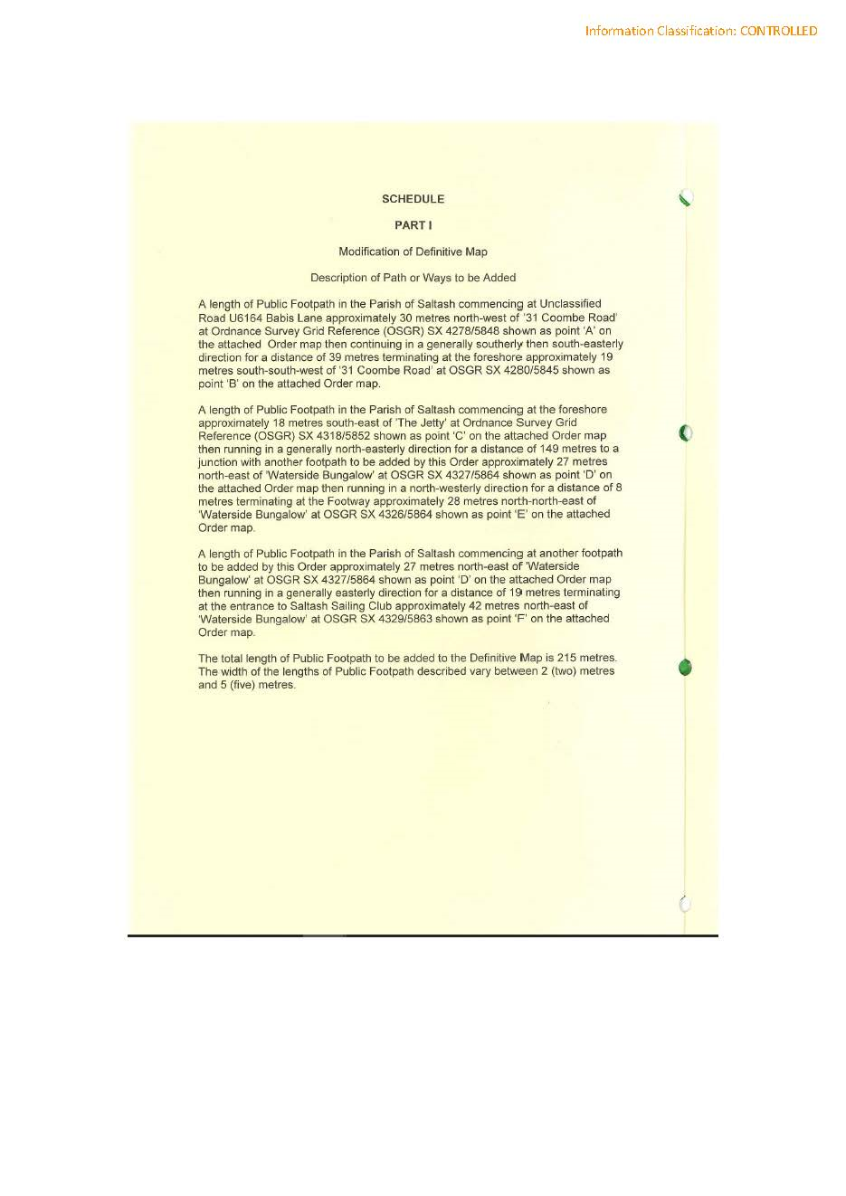

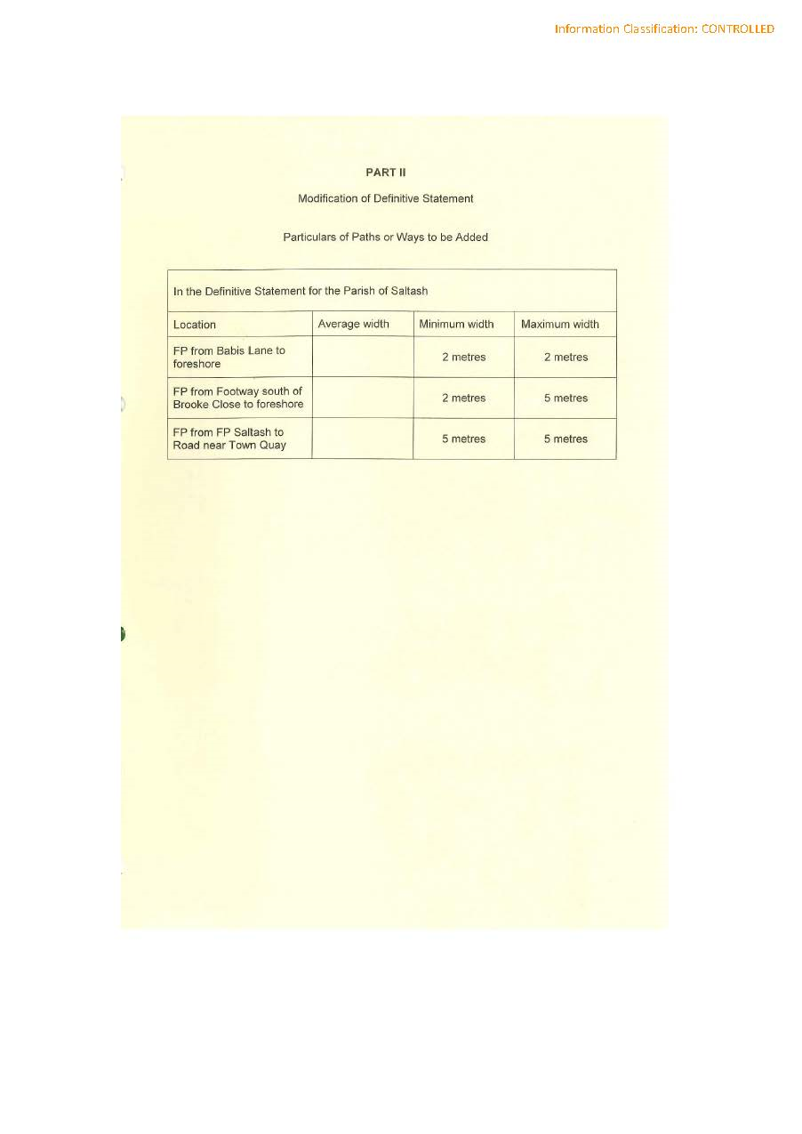

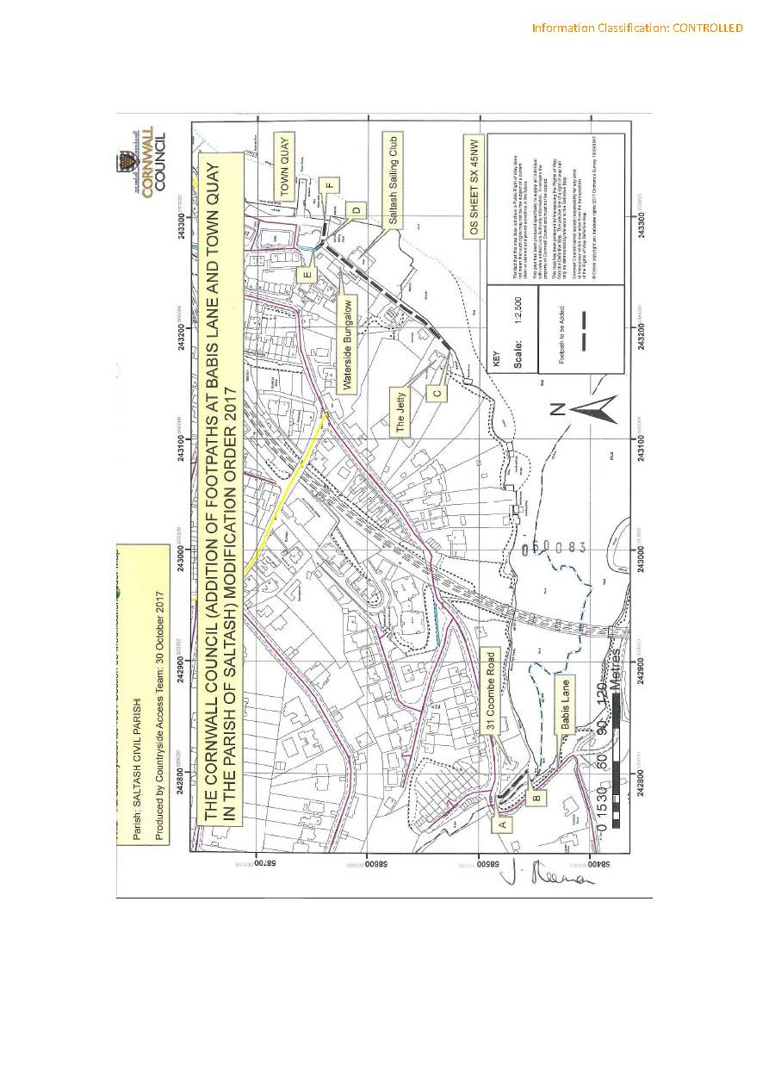

If you wish to make a legal submission, this should be submitted at the same time as your statement of case. Otherwise legal submissions will have to be submitted in writing on the day of the inquiry.

