
Date | Our Reference  URN
Nominated person/Responsible individual
Provider name

Dear Nominated person/Responsible individual

Notice of inspection

This letter is to confirm that Ofsted will be carrying out an inspection undertaken under the social care common inspection framework (SCCIF) of your voluntary adoption agency, beginning on inspection start date and ending on inspection end date.
The name of the inspector is lead inspector and he/she will contact you to discuss the inspection.
Please can you provide as soon as possible (by no later than 4pm today) the information listed below. An online portal has been established to receive this information securely. Details for uploading the information to the portal are in the attached guidance note.

Please upload the following information to the portal:

- a completed Annex A
- details of meetings that will occur during the inspection, including panel meetings, which the inspector may be able to attend. The inspector will confirm as soon as possible whether they wish to do so
- the three most recent sets of adoption panel minutes.
Case tracking and sampling
Please contact the inspector as soon as possible if there are any problems with providing the required information.

The inspector will select cases to track and sample from the completed Annex A. The inspector will confirm as soon as possible which cases they intend to track. This will allow you to begin arranging for the inspector to speak to relevant service users and relevant professionals (by visit or by telephone). The inspector will discuss the selection with you to ensure that visits or calls are appropriate.
Case files (either electronic or paper-based) will usually be discussed with the allocated worker (unless on leave), using their knowledge of the case, file structure and recording systems. In the absence of the allocated worker, please arrange for a suitable colleague to assist.
The records that the inspector will generally need to see are those you keep for adopters and of the children and young people placed with them, this includes any assessment reports. The inspector may also wish to see supervision notes, team meeting notes, staff recruitment files, panel member records and additional panel meeting minutes. Please provide the case details requested.
The inspector will sample other cases during the inspection and will need time to incorporate this into their inspection programme.
Meetings and discussions
During the inspection, it is likely that the inspector would wish to speak to:
- the manager
- the registered provider
- the chair or vice-chair of the adoption panel
- a small group of adopters, prospective adopters or a preparation course that is already running during the course of the inspection
- a group of children and young people if one is already running during the course of the inspection; please do not arrange a meeting with a group of children and young people who do not already know each other
- the agency decision-maker.
If there are existing appropriate groups or meetings running, please do use these. Please also ensure there are at least 30 minutes between meetings. Meetings with groups should be on-site wherever possible and may last up to an hour, although they may be shorter. Discussions with individuals may be held by telephone.
Data
The inspector already has the data you submitted in the annual quality assurance and data reports and from completed questionnaires. You do not have to re-submit these.
If you wish to provide any updated, brief, relevant statistical data or information, it must be submitted through the portal as explained above. You may provide this in a format you already use, as long as this provides only succinct and relevant information. Additional information or data, other than updates to what you have previously provided, should only be supplied during the inspection at the request or with the agreement of the inspector.
This material must be explicitly relevant to the inspection framework and associated evaluation schedule and enhance or clarify information about the quality of service provided. Statistical data submitted before the inspection must be correct at the time of submission. Amendments or changes to data submitted during the inspection may not be accepted.
The adoption Annex A form is available at:
www.gov.uk/government/publications/voluntary-adoption-agencies-inspection-documents

Please let the inspector know at the start of the inspection if there are any sensitivities they need to be aware of. This includes any adaptations to the inspection process due to a protected characteristic, or any reasonable adjustments due to a disability, to ensure that staff and children can take part in the inspection.
Raising concerns
The great majority of our work is carried out smoothly and without incident. However, if concerns do arise during the inspection, please raise these with the inspector as soon as possible, in order to resolve them before the inspection is completed. Any concerns raised, and actions taken, will be recorded in the evidence.
If there are any concerns that it is not possible to resolve with the inspector during the inspection, the inspector will provide you with a telephone number that you or another senior leader may use to contact a senior Ofsted leader.
In addition to being able to raise concerns or seek clarification at any stage during the inspection, you can contact Ofsted after the end of the inspection, if necessary, until the complaint window closes.
For detailed information and guidance on SCCIF inspections, please see: www.gov.uk/guidance/social-care-common-inspection-framework-sccif-voluntary-adoption-agencies

Privacy notice
During the inspection of your adoption agency, the inspectors will collect information about carers and the children or young people placed with them by talking to individuals or groups and by looking at the records referred to above. No names will be recorded but some of the information may make it possible to identify a particular individual. Ofsted uses this information to prepare its report and for the purposes set out in its privacy policy. We will not publish any information that identifies an individual in the report.
More information is available in Ofsted’s privacy policy: www.gov.uk/government/publications/ofsted-privacy-notices/social-care-ofsted-privacy-notice#registered-childrens-care-services
The contact details for Ofsted’s data protection officer are as follows.
Email:
informationrequest@ofsted.gov.uk
Post:
Information Management Team
Ofsted
2 Rivergate
Temple Quay
Bristol
BS1 6EH

Thank you for your assistance.

Yours sincerely
>Name<

Inspection Support Team

How to share information with Ofsted
Ofsted has arranged access to SharePoint online that will allow the voluntary adoption agency to share inspection information with Ofsted securely. Please follow the steps below.

Accessing the site
- Identify up to three nominees (named individuals) from the agency who will provide the information to Ofsted.
- Send the email addresses of these nominees to <Insert IST social care email address for the region>
- These individuals will then receive an invitation email from Ofsted which will look similar to the example below.
- Click the external sharing site link from the invitation email. (If you have difficulties accessing the site, contact the Ofsted member of staff who is copied in to the email invite. If you don’t appear to have received the invitation email in your normal inbox please check your junk or spam folder.)

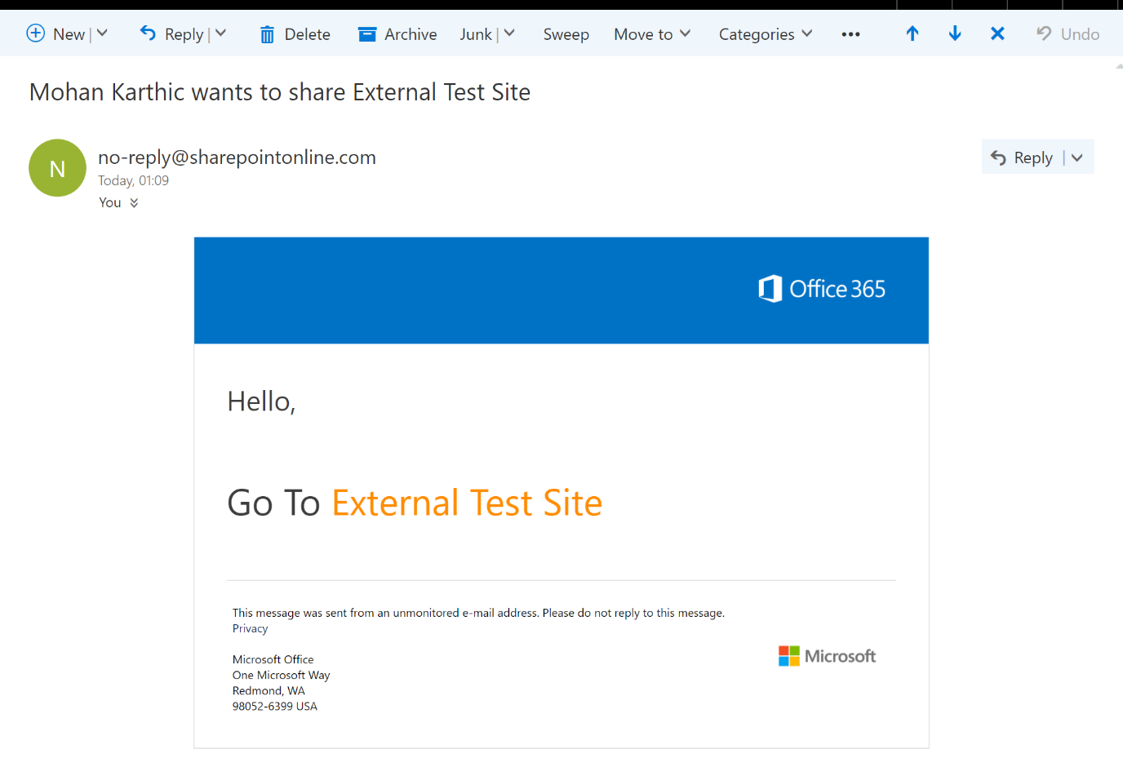

- Once the link is clicked you will be redirected to a new page where two options are available:

- Microsoft Account
- Organisational Account

If your system has a Microsoft Office 365 subscription, click “Organisational Account” or Client Microsoft Account.

If your work email account is not a Microsoft Account, you will get an option to register your email account with Microsoft.

- You will then be given the option of staying signed in (see below). Click no if you don’t want to remain signed in and yes if you wish to continue to load up files.

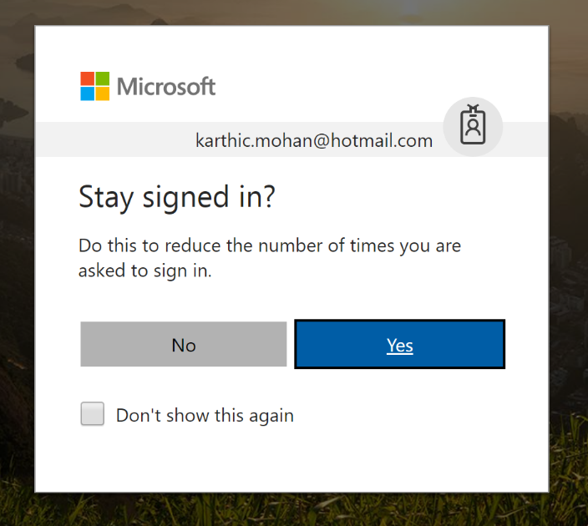

- Once you have signed in successfully you should be able to see a folder relating to the inspection of the agency, as below. This is where you should upload the documents/information.

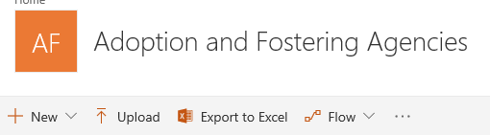
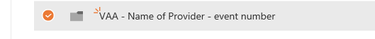

Uploading documents to the SharePoint site
- Click on the folder to open it.

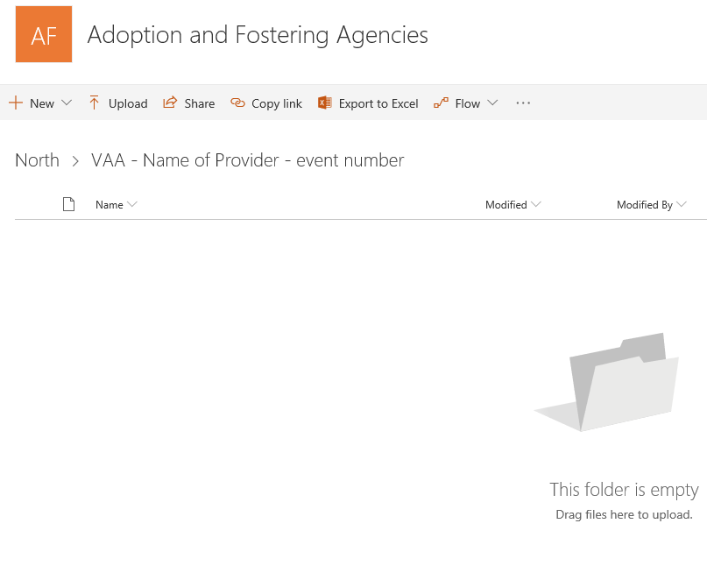

- Click ‘upload’ and select the document that you wish to add to the folder.

- The file should now be visible in the SharePoint site and can now be viewed by the Ofsted inspection team as part of the inspection. Please do not upload any information that you do not wish to be viewed by the Ofsted inspection team.

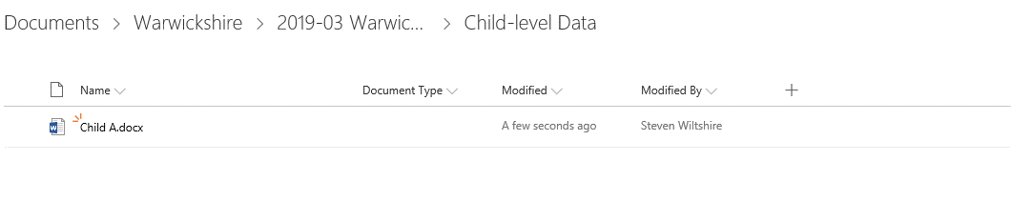
- Please refer to the inspection framework for full details on the content and timescales for submissions: www.gov.uk/government/publications/social-care-common-inspection-framework-sccif-voluntary-adoption-agencies
- At the end of the onsite inspection your access to this folder will be removed by Ofsted.

- For queries about using SharePoint for this inspection contact: <Insert IST social care email address for the region>; <Insert work phone number of ISA>

Access to SharePoint online for the inspection
Your nominees will be able to access this collaboration site only for the duration of your inspection. Access to the site is password protected and only available to the nominees you identify, the Ofsted inspector and the inspection support team at Ofsted.
Do not share passwords and avoid accessing this site from public wifi ‘hotspots’. Make sure you are aware and take action against common cyber threats. Information in SharePoint is encrypted by the system, this means individual documents do not need to be password protected.
Inspection information saved on SharePoint should only be shared on SharePoint. It must not be downloaded and forwarded on by insecure email.
SharePoint has been risk assessed by Ofsted against the Government’s Cloud Security Principles to handle sensitive personal data.

