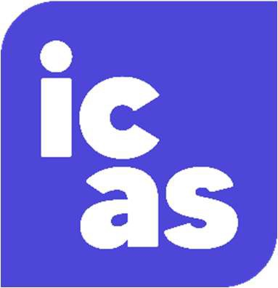

Type of Order: Regulatory Penalty

Date of Order: October 2024

Committee name: ICAS Authorisation Committee

Details of IP: Penny McCoull Summary of complaint:
This penalty has been applied in respect of the following four issues:

- A failure to take appropriate steps to verify the information provided by a claims management company before submitting claims to the Redundancy Payments Office.

- In two appointments, there was insufficient evidence of (a) appropriate action to recover books and records from directors, (b) a proper investigation Covid-related loans, and (c) a reasonable level of work and consideration on the files (contrary to the principles in SIP 2).
- Pre-appointment fees were drawn in four CVLs without the necessary approval from creditors, in breach of Rule 6.7 of the Insolvency (England and Wales) Rules 2016.

- Unsatisfactory delays in the payment of a dividend to creditors in one case, with a lack of progress reports.

Issues 1, 2, and 3 occurred while Mrs McCoull was employed by McLaren Insolvency Practitioners Limited, whilst issue 4 arose through work in her own practice, ASM Recovery.

Summary of sanctions:

The ICAS Authorisation Committee has applied a regulatory penalty of £3,500 to Ms McCoull.

The Committee noted the starting points in the CSG and was satisfied that a regulatory penalty was appropriate in the circumstances, with a single penalty applied to cover the four issues. In calculating the level of penalty, the Committee consulted the Sanctions Guidance and did not identify any aggravating factors to take into consideration. In mitigation, the Committee considered the steps which Mrs McCoull has taken to try and resolve the issues (including repayment of fees), the absence of evidence to suggest a loss of monies to the insolvency estates and/or any third parties, and the fact that she would no longer be working for McLaren Insolvency Practitioners.

