

|  |
| --- |
| **Application Decision** |
| Site Visit conducted on 10 December 2024 |
| **by Rory Cridland LLB (Hons) PG Dip, Solicitor** |
| **an Inspector appointed by the Secretary of State for Environment, Food and Rural Affairs** |
| **Decision date: 20 December 2024** |

|  |
| --- |
| **Application Ref: COM/3346085**  **Elstree Common**  Register Unit No: CL299  Commons Registration Authority: Hertfordshire County Council |
| * The application, dated 13 June 2024, is made under Section 38 of the Commons Act 2006 for consent to construct works on common land. * The application is made by Sellar Media Logistics LLP. * The works comprise the construction of a new access way joining Rowley Lane (including a minor bridge), the widening and reconstruction of an existing access way, the placing of underground utilities, landscaping and other minor works. |
|  |

Decision

1. Consent for the construction of a new access way joining Rowley Lane (including a minor bridge), the widening and reconstruction of an existing access way, the placing of underground utilities, landscaping and other minor works on parts of Elstree Common (Register Unit CL299) is granted in accordance with the application dated 13 June 2024 and accompanying plan subject to the following conditions:
   * + 1. The works shall begin no later than 5 years from the date of this decision.
       2. No later than 2 years following the commencement of the restricted works, an application under section 15(8) of the Commons Act 2006 for the dedication of the land identified as ‘Enhancement land’ in plan 22261-UMC-ZZZZ-SIDR-A-0102 P.04 submitted with the application shall be made to the Commons Registration Authority in the form of a Deed of Dedication on Form 44.
2. For the purposes of identification only, the location of the relevant works and the replacement land are shown on the attached plans.

**Main issues**

1. Section 38 of the Commons Act 2006 (“the 2006 Act”) provides that a person may apply for consent to carry out restricted works on land registered as common land.
2. In determining such an application, s.39 of the 2006 Act requires me to have regard to the following:
3. the interests of those occupying or having rights over the land (and in particular, persons exercising rights of common over it);
4. the interests of the neighbourhood;
5. the public interest; and
6. any other matter considered to be relevant.
7. Section 39(2) of the 2006 Act provides that the ‘public interest’ includes the public interest in:
8. nature conservation;
9. the conservation of the landscape;
10. the protection of public rights of access to any area of land; and
11. the protection of archaeological remains and features of historic interest.
12. I have also had regard to Defra’s Common Land Consents Policy (November 2015) (“the Consents Policy”).

**Reasons**

***The interests of those occupying or having rights over the land***

1. The application land consists of a small section of highway verge forming part of Elstree Common (Register unit CL299). No rights of common are registered over the common. The common is owned by Hertfordshire County Council which has made no objection regarding the effect of the proposed works on its interests.
2. An application for outline Planning (Reference: 23/0478/OUT) is currently being considered by Hertsmere Borough Council (HBC) for the flexible use (B3/B8) including ancillary office floorspace, associated parking, loading docks, servicing, landscaping and substation. The proposed works would help facilitate the implementation of that proposal, and while I note that consent has not yet been granted, the applicant has indicated that HBC’s planning committee has resolved to grant permission upon completion of a section 106 obligation.
3. Only the applicant has the right to use the existing vehicular access way across the common. Members of the public have the right to access the common on foot and this would continue to be the case after the proposed works have been carried out.
4. Overall, I consider the proposed works will have no adverse effect on the interests of those occupying or having rights over the land.

***The Interests of the Neighbourhood***

1. The application proposes to carry out works on a small section of the common located on Rowley Lane alongside the existing highway. While this part of the common adds verdancy to the surroundings, it would appear to most casual observers as an unremarkable section of highway verge. In view of its size and location alongside a busy road, it offers few opportunities for public recreation other than as a cycleway/footway.
2. The Consents Policy makes clear that works should only be permitted on common land if they maintain or improve the condition of the common or where they confer some wider public benefit and are either temporary in duration or have no significant or lasting impact.
3. The proposed works would have the effect of converting a relatively small part of the common into paved roadways and there would be little impact on the way in which those living and working nearby would use or access the land.
4. Furthermore, the applicant has proposed to dedicate an area of land as a village green if the application is approved. While the effect of the proposed works on the interests of the neighbourhood would in any event be small, the establishment of the village green would ensure that any residual effect on the interests of the neighbourhood would be suitably mitigated. I am therefore content that the proposed works would not adversely affect the interests of the neighbourhood.

**The Public Interest**

*Nature conservation*

1. Natural England have commented that the works will affect the habitats present in this part of the common but that it would, in part, be compensated for within the overall landscape strategy associated with the wider development. I have no reason to conclude otherwise.
2. Furthermore, I note that the area affected by the proposed works is relatively small and their direct effect on natural habitats is likely to be limited.
3. In my view, while the proposed works will have limited adverse effect on nature conservation, this will be mitigated by the provision of new planting, open space and the dedication of the proposed replacement land.

*Conservation of the landscape*

1. The part of the common subject to the proposed works is small and currently of limited landscape value. In view of the neighbouring developments, the landscape impact of the proposed works is unlikely to be noticeable. In fact, the landscaping works proposed may improve the appearance of the area.
2. In my view the proposed works will not have an adverse effect on the landscape of the common

*Public access*

1. The Common is subject to public rights of access under section 193 of the Law of Property Act 1925. The proposed works would result in the widening of the existing access and the creation of a new access both of which would result in disruption to walkers but not impede public access. Furthermore, I am satisfied that any impact on public access would be mitigated by the provision of the proposed replacement land.
2. Overall, I am satisfied that the proposed works would not significantly adversely affect public rights of access over the common.

**Other matters**

1. There is no requirement in section 38 of the 2006 Act for an applicant to provide replacement land. Such arrangements are instead dealt with under section 16 of the 2006 Act (Deregistration and Exchange). However, the Consents Policy indicates that applications for infrastructure projects on common land are more likely to be successful under section 16(1), so that an exchange of land is proposed and can be considered on its merits. Furthermore, it makes clear that an application for consent to such works under section 38(1) will rarely be granted unless there are convincing reasons why an application under section 16(1) cannot or ought not to be pursued.
2. In the present case, I accept that it is reasonably necessary to utilise the common to create access to the development site from Rowley Lane. Furthermore, I accept that it may not be possible for the applicant to seek the deregistration and exchange of land under section 16 if the 2006 Act. However, these are circumstances that could arise with some frequency and are not sufficient in themselves to override the safeguards set out in the Consents Policy.
3. Nevertheless, in order to mitigate the resultant harm, the applicant has indicated a willingness to dedicate an area of land as a town and village green. This course of action is supported by both Natural England and the Open Spaces Society and I accept that it would provide suitable mitigation for the limited harm identified above.
4. In order to secure such mitigation, the applicant has suggested the imposition of a condition requiring the dedication of this land prior to the commencement of any of the restricted works. I accept that, subject to some minor amendments to the wording, this would provide an adequate means of securing the offered replacement land.

**Overall conclusion**

1. I have found above that the proposed works would not adversely impact on the interests of those occupying or having rights over the land. Likewise, I have found that they would not adversely impact on the interests of the neighbourhood or on the public interest in conservation of the landscape. While there would be some limited adverse effect on the public interest in nature conservation and some minor disruption to public access, I am satisfied that these would be suitably mitigated by the registration of the replacement land as a town and village green.
2. Accordingly, for the reasons set out above, and having had regard to all other matters raised, I conclude that consent should be granted subject to a condition requiring the applicant to make an application under section 15(8) of the 2006 Act to dedicate the replacement land as town or village green. I also consider a condition requiring the restricted works to commence within a period of 5 years from the date of this decision is necessary in order to provide certainty.

Rory Cridland

Inspector

**Plan 1 - Restricted Works**

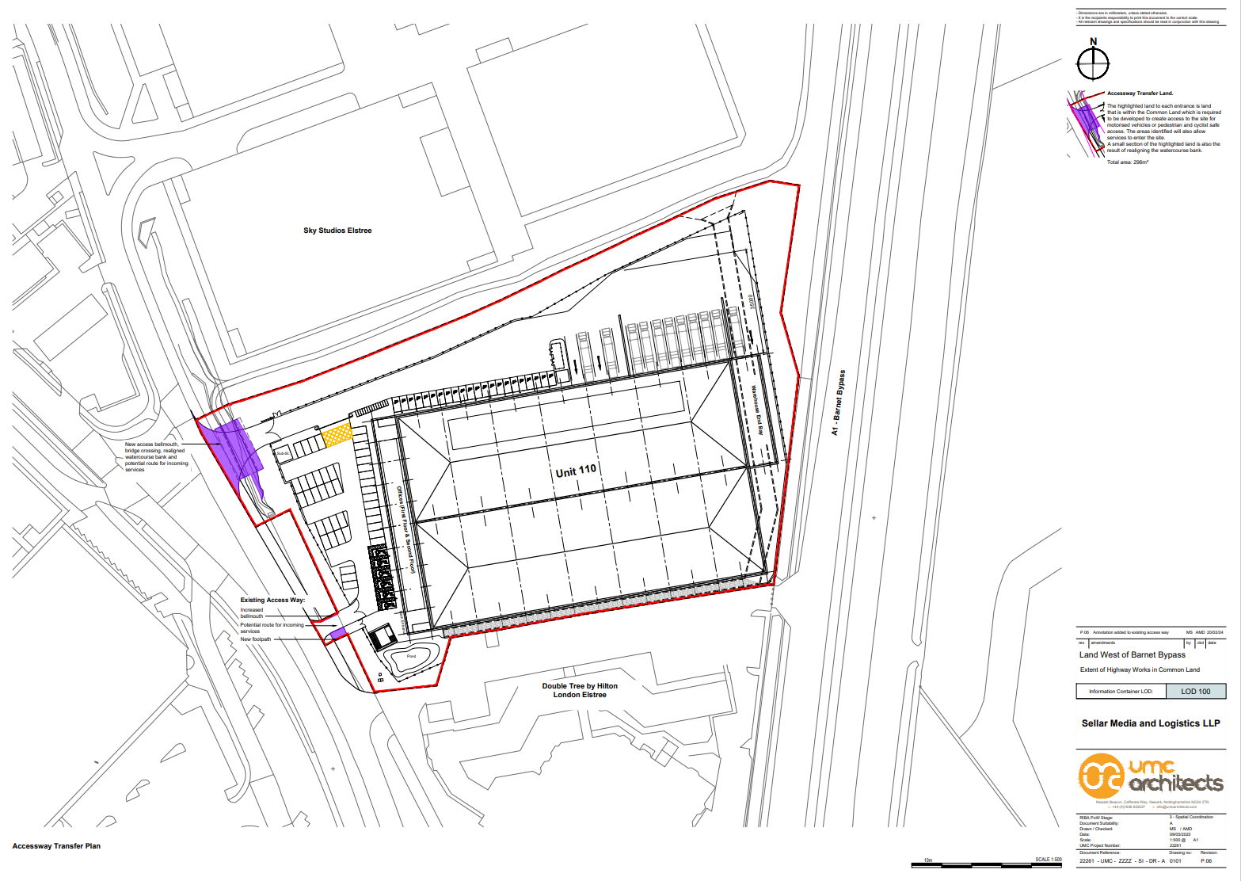

**Plan 2 – Replacement Land**

