

DCO1 guide

Completing the DCO Fastrack claim form

# Introduction

This guide is intended for individuals claiming back the private costs of their defence in the magistrates’ court.

If you have had your case dismissed or have been acquitted by the magistrate’s court, use this form where the total claim is for £2000 or less. The £2000 limit includes your counsel (barrister) fees but does not include disbursements (such as your solicitor’s travel expenses, and expert fees) or VAT.

All claims should be emailed to [dcofastrak@justice.gov.uk](mailto:dcofastrak@justice.gov.uk) with the required documentation attached.

You must download the most up to date version of the DCO Fastrak (DCO1) claim form from the gov.uk website:

<https://www.gov.uk/government/publications/dco-magistrates-court-fastrak-claims-form-dco1>

Once downloaded, it is recommended that you rename the file as follows:

**Your name** followed by the **case number** (this can be found on correspondence from the court)

Please do not remove lines of information on the claim form.

If work claimed has not been entered in date order, this can be rectified once the claim is received. This ensures that any values entered do not affect anything in the background of the forms.

Your claim and papers must be submitted via email, and include as separate attachments the following documents:

1. DCO1 claim form
2. Defendant’s Costs Order (DCO) - you must send both pages of the order provided by the court
3. Client care letter or evidence of private retainer (this will be the letter from the solicitor when they first took the case, setting out the agreement with you)
4. Invoices or receipts for any disbursements over £20 (for solicitor’s expenses only for example their travel costs and/or expert’s fees)

Your personal expenses can only be claimed directly from the court, not from the Criminal Cases Unit (CCU).

If the total attachments exceed 10MB, please send via separate emails, entering ‘1 of 2’ and so on in the subject heading.

Documents submitted electronically will not be returned.

# Claim details

## Step 1 – Details about you and your case

Enter the details of the instructed solicitor, including the address on the court order, the name of the solicitor who dealt with the case, and their contact information**.**

Enter your name and address, the court where your case was heard, and the case number.

As the claim will be paid directly to your bank account, there is no need to include the solicitors VAT number or DX address. We will request your bank details separately – see page 11.

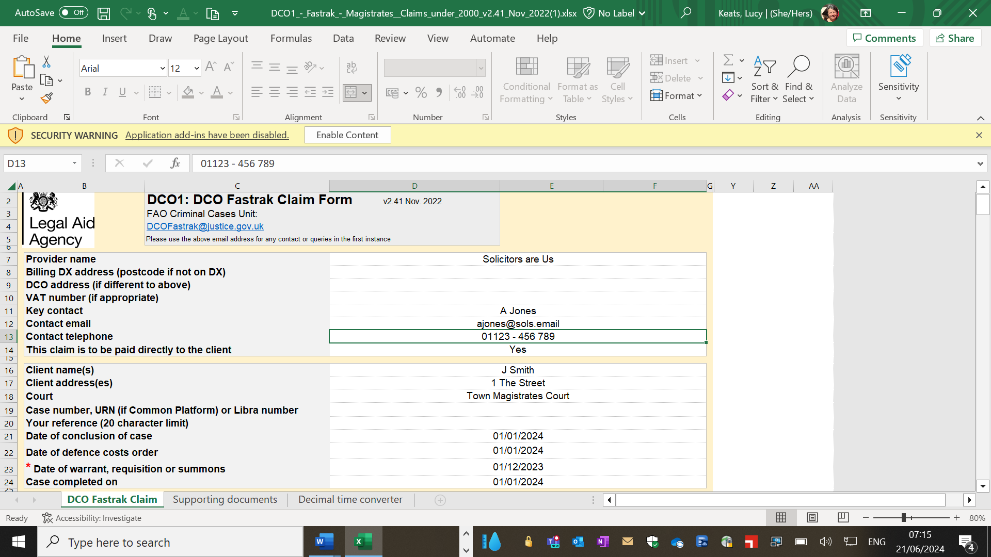

Enter the date of the summons and the date your case came to an end. If the matter was discontinued by the prosecution enter the date you received notification.

Enter the date of the court order (DCO) awarding your costs.

## Step 2 – Your declaration and the amount paid to your solicitor

Read the declaration and if in agreement you must ‘sign’ the declaration by selecting yes from the drop-down.

Unsigned claims will be rejected and returned.

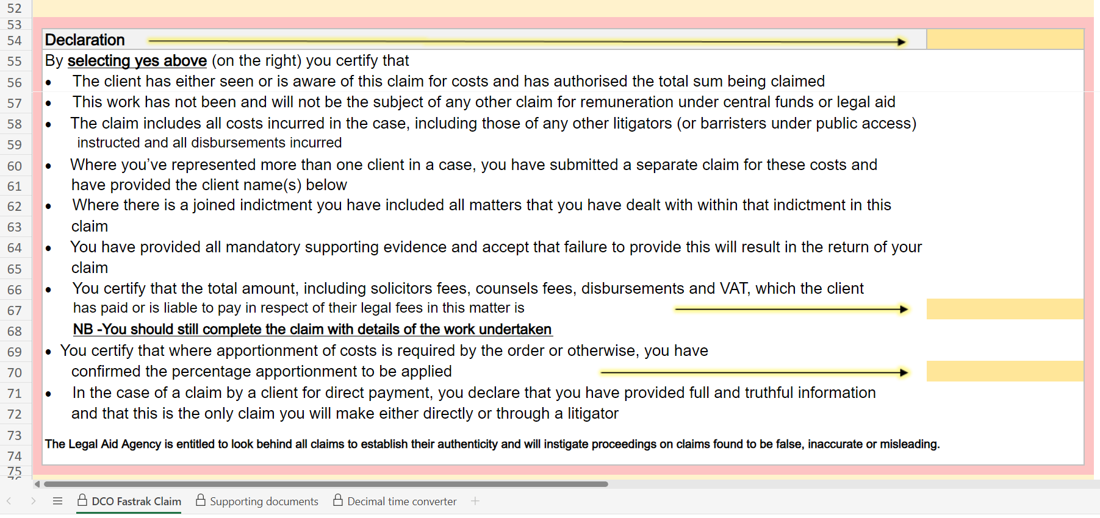

Enter the total costs, including VAT, paid to your solicitor.

This includes counsel’s fees and/or expert’s fees.

## Step 3 – Percentage of costs to be claimed

If you were convicted or pleaded guilty to any part of the charges, the Criminal Cases Unit cannot pay any claim unless the court has indicated the percentage of assessed costs to be allowed.

Enter the percentage shown on the Defendant’s Cost Order.



If a percentage has not been set by the court, your claim cannot be assessed but will be put on hold to enable you to obtain an amended order from the court.

## Step 4 – Fee earners

Enter the full names of the solicitors (fee earners) who dealt with your case.

The ‘grade’ of fee earner is dependent upon their experience. We will complete this section for you.

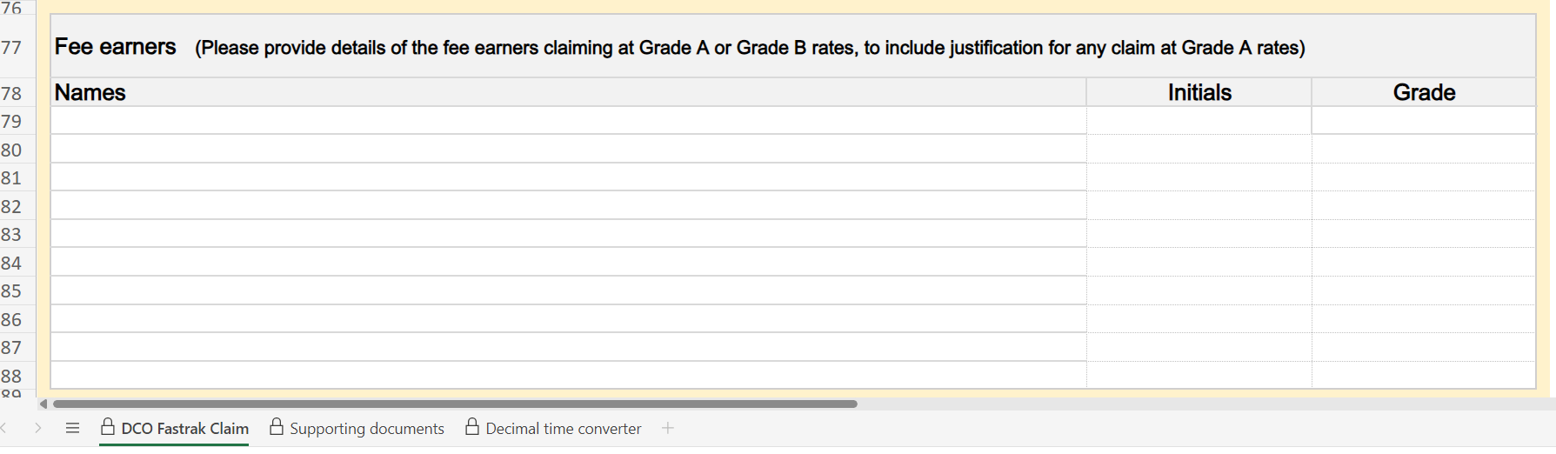

## Step 5 – Work carried out

Details of the work carried out can be obtained from the solicitors who worked on the case or details may have been provided on their invoices or bills.

Enter the description of the work carried out by your solicitors using the drop-down box.

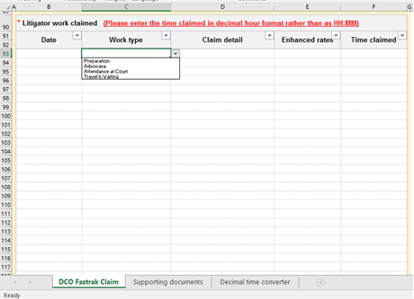

Then enter the Date of the work, Claim detail, and Time claimed.

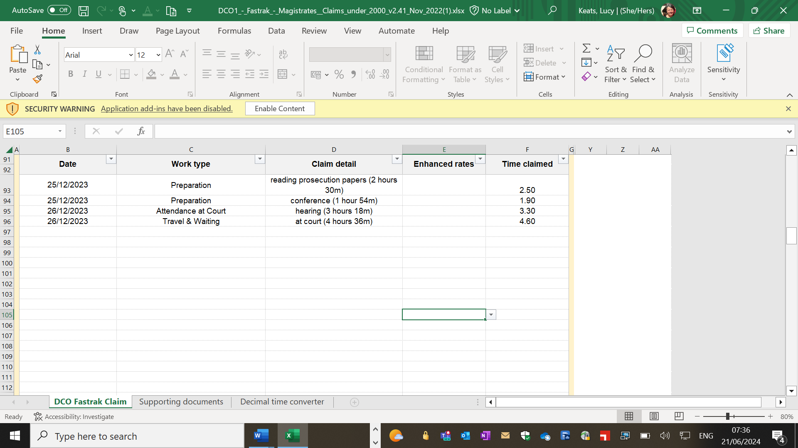

You must enter time in a decimal format.

For example, 1 hour 15 minutes = 1.25

A decimal time converter can be found at the final tab of the claim form.

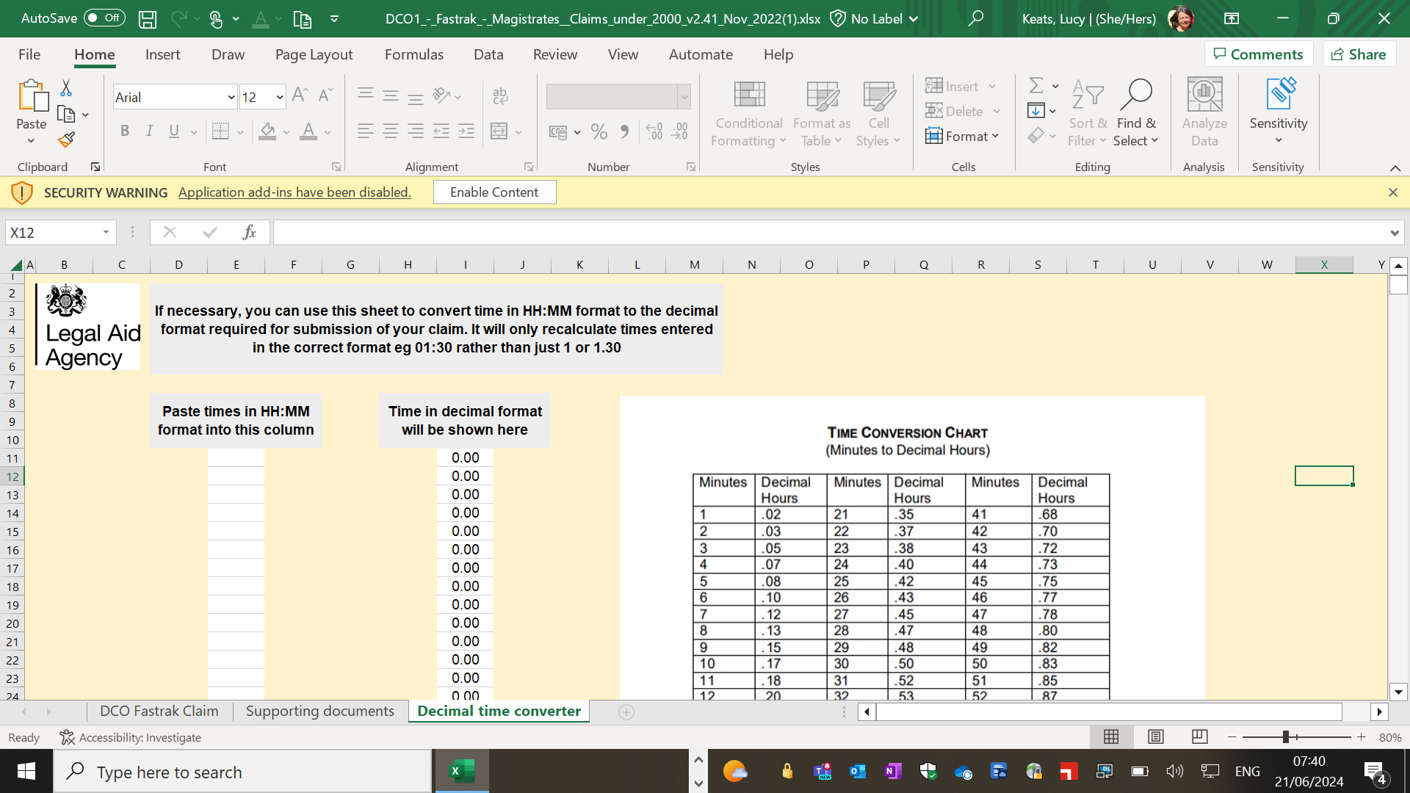

## Step 6 - Routine correspondence:

Enter the number of routine items. These should be specified on the invoice or bill received from your solicitor.

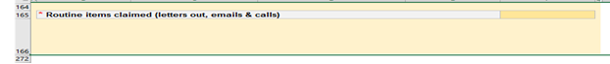

A routine item is a short email or letter sent or telephone call made or received.

Examples include notifications of hearing dates or conferences, requests for papers from the prosecution and short telephone calls, usually under 6 minutes. Routine letters and emails received are not paid separately.

## Step 7 - Disbursements (Solicitor Expenses):

Enter your solicitor’s travel expenses, and expert fees.

If you are claiming an expense that is over £20 you mustprovide a copy of the receipt.

Details of the expenses claimed should be itemised on the invoice or bill provided to you by your solicitor.

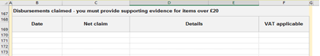

Disbursements include the travel costs of your solicitors and the costs of any expert instructed in your case. Photocopying, printing, and other similar expenses are regarded as an overhead of the solicitor and are not recoverable.

## Step 8 - Advocate fees

If you have instructed an advocate (also known as a barrister or “counsel”) who is not an employee of the solicitors’ firm, you must claim their fees separately.

You must include a copy of their fee note or invoice and, if possible, their work log.

Unless a King’s Counsel (KC) was instructed, all advocates are described as “junior”.

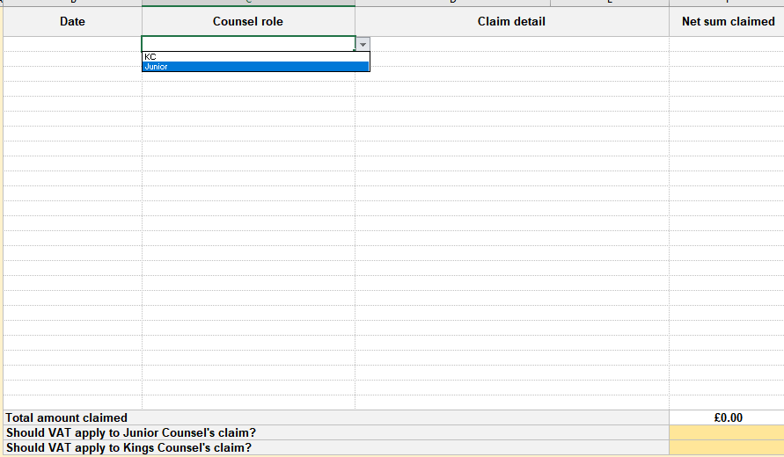

## Step 9 - Enhanced rates

Your costs will be assessed using an hourly rate. This rate can be uplifted by up to 100% in **exceptional** circumstances. Those circumstances are:

* that the work was done with exceptional skill, competence, or expertise
* that the work was completed with exceptional dispatch
* 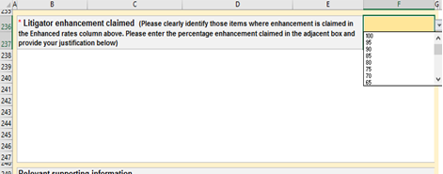that the case involved exceptional circumstances or complexity

You should set out the reasons why an uplift is appropriate in your case. These can be added to the claim form or provided in a separate letter or within your email.

Your solicitor should be able to advise you and provide information to support your claim.

## Step 10 - Supporting information

You should provide details of your case to support your claim. This should include details of the offence and any other information you wish to be taken into account. If there is insufficient space on the claim form, this can be provided as a separate document.

These can be obtained from your solicitors.

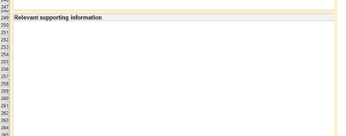

To enable us to assess your claim we may request additional information or documentation, including your solicitor’s attendance notes and correspondence file.

## Step 11 - Claim summary (total amount claimed)

The ‘summary of claim’ will not populate until you have entered all of the claim details. Once this is done, the total amount claimed should update with the correct figures.

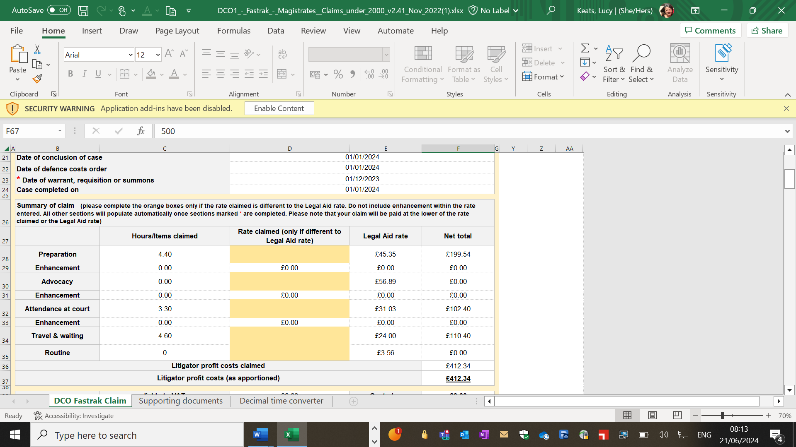



If your claim form does not populate correctly, check that you have:

* Entered the date of the costs order (DCO)
* Entered the date of the summons
* Confirmed whether VAT applies to the advocate fees and disbursements
* Entered a date, work type and time for all work claimed

# Submitting the form

**Email your claim and accompanying documents to:** dcofastrak@justice.gov.uk

If you are submitting the claim and documents in more than one email, please label them in the subject heading, for example DCO claim John Smith email 1 of 2.

Once your claim has been received it will be allocated a unique reference number which should be quoted whenever you contact us – for example M2501234.

We aim to assess all claims within 20 days of receipt. If you have not received notification after 20 days, please contact us at: dcofastrak@justice.gov.uk

Once your claim has been assessed you will receive a notification that payment has been authorised. Unless your costs have been allowed in full, a copy of your assessed claim will be sent to the email address you have provided.

To ensure you receive payment as quickly as possible you will be requested to provide your bank details for a BACS payment.

This request will be sent to you via a separate email once your claim has been received.

You will need to provide the name of your bank, sort code, account name and account number.

If you prefer you can be paid by cheque.

# If you are dissatisfied with the costs allowed

Please note that the hourly rate for work by your solicitor and the maximum fees payable to your barrister are restricted by the regulations. This may mean that you receive back less than you have paid.

Details of the rates and fees payable can be found on GOV.UK:

https://www.gov.uk/guidance/claim-back-costs-from-cases-in-the-criminal-courts

There is no provision within the regulations for an assessment of costs incurred in the magistrates’ court to be appealed.

However, the CCU will carry out an informal review of the assessment on request.

A request for review should be sent to dcofastrak@justice.gov.uk quoting the unique reference number.

A request for review may be made using your original claim form or via email alone.

You must set out on which items a review is requested, include any information you wish the case manager to consider and attach any relevant attendance notes or copies of correspondence.

## Requesting a review using DCO1:

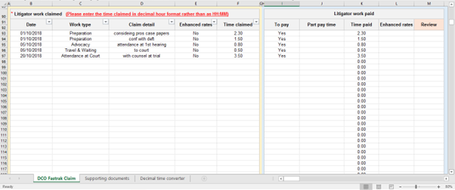Using the drop-down list, indicate in column ‘M’ which items you wish to be reviewed.

You must provide detailed reasons for each item you wish to be reviewed in your accompanying letter or email.

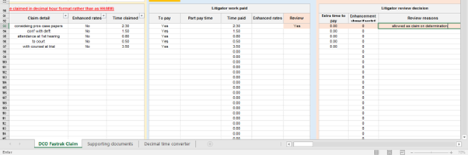Once reviewed, a copy of your claim form will be returned detailing any additional amount to be paid. Further clarification setting out the reasons behind any decision will be sent either via letter or email or, if an additional payment is made via the payment notification.

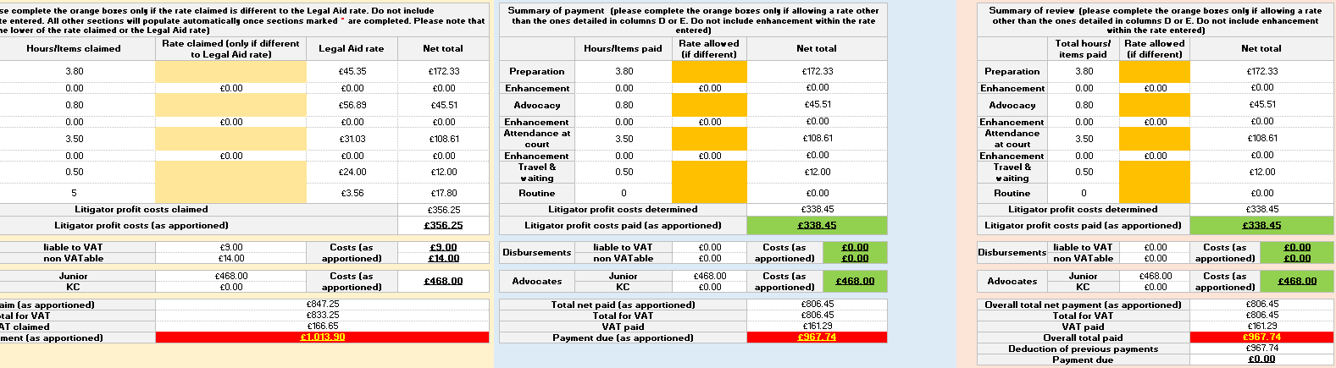If you remain dissatisfied with the assessment following review you can apply for Judicial review. Guidance on this process can be found at:

<https://www.justice.gov.uk/courts/rcj-rollsbuilding/administrative-court/applying-for-judicial-review>

A video providing a step-by-step guide on completing your claim form can be accessed by following this link:

[How to complete the DCO Fastrak claim form – Legal Aid Learning](https://legalaidlearning.justice.gov.uk/how-to-complete-the-dco-fastrak-claim-form/)

If you require further assistance, please contact us via [dcofastrak@justice.gov.uk](mailto:dcofastrak@justice.gov.uk) and someone will contact you to assist.

If you would like legal advice, a list of useful resources can be found below:

[www.lawsociety.org.uk](http://www.lawsociety.org.uk)

[www.sra.org.uk](http://www.sra.org.uk)

<http://www.communitylegaladvice.org.uk>

[www.citizensadvice.org.uk/law-and-courts](http://www.citizensadvice.org.uk/law-and-courts)

### Ownership

|  |  |  |
| --- | --- | --- |
| Role | Job/role title | Current post holder |
| Policy owner | Head of Criminal Cases Unit | Kath Burdett |
| Policy lead |  |  |
| Approval body |  |  |

|  |  |
| --- | --- |
| Current version | Version 1 |
| Last review date |  |
| Next review date |  |

### Version history

|  |  |  |
| --- | --- | --- |
| Version | Date | Reason |
| 1 | November 2024 | New guidance |