

|  |
| --- |
| **Application Decision** |
| Site Visit conducted on 22 October 2024 |
| **by Rory Cridland, LLB (Hons) PG Dip, Solicitor** |
| **an Inspector appointed by the Secretary of State for Environment, Food and Rural Affairs** |
| **Decision date: 26 November 2024** |

|  |
| --- |
| **Application Ref: COM/3327735R Lyneham Green**  Register Unit No: CL47  Commons Registration Authority: Wiltshire Council |
| * The application, dated 10 August 2023, is made under Section 38 of the Commons Act 2006 for consent to construct works on common land. * The application is made by Gladman Developments Limited. * The works comprise construction of part of the bellmouth of a new access road, construction of footway, installation of services (pipes, cables, ducts) and temporary fencing as part of a proposed new residential development. * This decision supersedes that issued on 11 April 2024. That decision on the application was quashed by order of the High Court. |

# Decision

1. Consent for the construction of part of the bellmouth of a new access road, construction of footway, installation of services (pipes, cables, ducts) and temporary fencing on parts of Lyneham Green (Register Unit CL47) is granted in accordance with the application dated 10 August 2023 and accompanying plan subject to the following condition:

*Prior to the commencement of the restricted works, an application under section 15(8) of the Commons Act 2006 for the dedication of the land shown in pink on the Replacement Land Plan 2 (2019-003-505) shall be made to the commons* *Registration Authority on the form of a Deed of Dedication in Form 44.*

1. For the purposes of identification only, the location of the relevant works and the replacement land are shown on the attached plans.

# Background and main issues

1. Notwithstanding its name, Lyneham Green is an area of registered common land forming part of Register Unit CL47. It comprises mostly linear parcels of land on both sides of the roads at the junction of Chippenham Road, Calne Road and the Green in the village of Lyneham.
2. The application itself relates to a small section of the common located on Chippenham Road alongside the existing highway. While it adds to the verdant setting of this section of highway, it would appear to most casual observers as an unremarkable section of highway verge. Although it makes a positive contribution to the surrounding

<https://www.gov.uk/planning-inspectorate>

area is limited and, in view of its size and location alongside a busy road, it offers few opportunities for public recreation. Its main use is likely to be to provide pedestrians safe refuge from oncoming traffic.

1. Outline planning permission (reference APP/Y3940/W/20/3253204) was granted on 22 November 2021 for the erection of up to 200 dwellings, up to 2600m2 of business uses and up to 600m2 of community uses. Access was approved as part of the permission and shows a vehicular access point and footway onto Chippenham Road, part of which includes the application land.
2. The works proposed involve the construction of approximately 85m2 of the bellmouth and tarmac surfacing, kerbing and tactile paving of about 40m2 of footway. These works would be permanent and have a lasting impact on this part of the common. In addition, around 3-5m of pipes and cables are proposed to be laid to allow for the passage of sewage, water, electricity, and gas. A trench of approximately 35m in length is proposed to provide a connection and route for telecommunications cabling. The land will be reinstated to its original condition after these works. Temporary safety fencing of approximately 196m in length is also proposed to prevent access during the construction period and is intended to remain in place for around 16 weeks. Section 38 of the Commons Act 2006 (the 2006 Act) prohibits such works on common land except with the consent of the Secretary of State.
3. A previous application (reference COM/3309337) was refused on the grounds that there was not an adequate mechanism that would secure the status or appropriate timing of the offered Town and Village Green (TVG) as replacement land. I have had regard to this decision in my determination of the application.
4. A second application was submitted (COM/3327735) and a decision issued dated 11 April 2024. That decision was subsequently quashed by the High Court and the

matter referred back to the Planning Inspectorate for redetermination. In summary, the grounds on which the decision was quashed were that the Inspector did not provide legally adequate reasons for concluding that the dedication of the offered replacement land could not be secured by means of a condition.

1. The applicant has invited me to adopt the findings of the previous Inspector on the substantive issues for consideration under sections 38 and 39 of the 2006 Act. In summary, these are that the proposed works would not impact on the interests of those who occupy or have rights over the land and would not adversely impact on the public interest in archaeology or features of historic interest.
2. The Inspector also found the proposed works would have an adverse visual impact on the neighbourhood, would result in a loss of public access (which would adversely impact on both the neighbourhood and the wider public), would negatively impact on the public interest in nature conservation and would have a limited but negative impact on the public interest in the conservation of the landscape.
3. I agree with those conclusions, and I am generally content to adopt the findings of the previous Inspector on the substantive issues.
4. Consequently, I consider the main issues are:
   1. Whether it is necessary for the applicant to provide replacement land; and, if so,
   2. Whether there is an adequate mechanism in place to secure the offered replacement land.

# Reasons

1. There is no requirement in section 38 of the 2006 Act for an applicant to provide replacement land. Such arrangements are instead dealt with under section 16 of the 2006 Act (Deregistration and Exchange). However, Defra’s Common Land Consent’s Policy (“the Consent’s Policy”) indicates that applications for infrastructure projects on common land are more likely to be successful under section 16(1), so that an exchange of land is proposed and can be considered on its merits. Furthermore, it makes clear that an application for consent to such works under section 38(1) will rarely be granted unless there are convincing reasons why an application under section 16(1) cannot or ought not to be pursued.
2. In addition, it refers to Paragraph 5.9 of the Consents Policy which advises that the construction of a vehicular way across common land may be consistent with the continuing use of the land as common, even where the way is entirely for private benefit. While it recognises that such works may have an impact on the enjoyment of the common it also makes clear that in some circumstances a paved vehicular way may be the only practical means of achieving access to the land.
3. Further guidance can be found in the Planning Inspectorate’s Common Land Guidance Sheet 1a (Guidance Sheet 1a) which distinguishes between works which are for the management, improvement or protection (or to the negligible detriment) of the common or are otherwise consistent with the traditional uses of the common (e.g. grazing, public recreation), for which a Section 38 application may be needed; and works that are not consistent with the traditional use of the common, or for its management, improvement or protection, for which a deregistration and exchange application under Section 16 of the 2006 Act (with its requirement to provide replacement land) may be more appropriate.
4. In the present case, it is common ground that it is reasonably necessary to utilise the common to create access to the development site from Chippenham Road. Furthermore, I accept that it may not be possible for the applicant to seek the deregistration and exchange of land under section 16 if the 2006 Act. However, I agree with the previous Inspector that these are circumstances that could arise with some frequency and are not sufficient in themselves to override the safeguards set out in the Consent’s Policy.
5. A number of the works proposed (e.g. those to facilitate statutory undertaker’s apparatus and the security fencing) would be temporary, the area of common affected by them marginal and the land would be reinstated to its original condition shortly after their completion. None of these works would materially affect either the condition or the use of the common as a whole and I accept that these would have little impact.
6. However, the same cannot be said of the proposed surfacing works. These would be permanent and would irrevocably alter the character of this piece of common land. It would change from verdant highway verge to an urbanised access, eroding the positive contribution it makes to its surroundings. While I acknowledge the land is neither used for grazing nor capable of providing or facilitating any meaningful form of public recreation, the proposed permanent works would nevertheless have a lasting impact.
7. I accept that a number of public benefits would arise from enabling the development to proceed, including the provision of market and affordable housing, support for local businesses and services and increased employment. However, I am also mindful that the Consents Policy is clear that the Government’s aim is to safeguard commons for current and future generations to use and enjoy. Furthermore, it indicates that the consent process under section 38 aims to ensure the stock of common land and greens is not diminished and that works take place on common land only where they maintain or improve the condition of the common or where they confer some wider public benefit *and* are either temporary in duration or have no significant or lasting impact.
8. In the present case, while I recognise the benefits of enabling the development to proceed would confer a wider public benefit, the proposed works would be detrimental to both the condition and character of this part of the common and would have a significant and lasting impact. As such, it would be at odds with the Consent’s Policy.
9. However, in order to mitigate the resultant harm, the applicant has indicated a willingness to dedicate an area of land as a town and village green. This course of action is supported by both OSS and NE and I accept that it would provide suitable mitigation for the harm identified above.
10. In order to secure such mitigation, the applicant has suggested the imposition of a condition requiring the dedication of this land prior to the commencement of any of the restricted works. I accept that, subject to some minor amendments to the wording, this would provide an adequate means of securing the offered replacement land.

# Overall conclusion

1. Accordingly, for the reasons set out above, and having had regard to all other matters raised, I conclude that consent should be granted subject to a condition requiring the applicant to make an application under section 15(8) of the 2006 Act to dedicate the replacement land as town or village green.

*Rory Cridland*

INSPECTOR

Plan 1 - Restricted Works

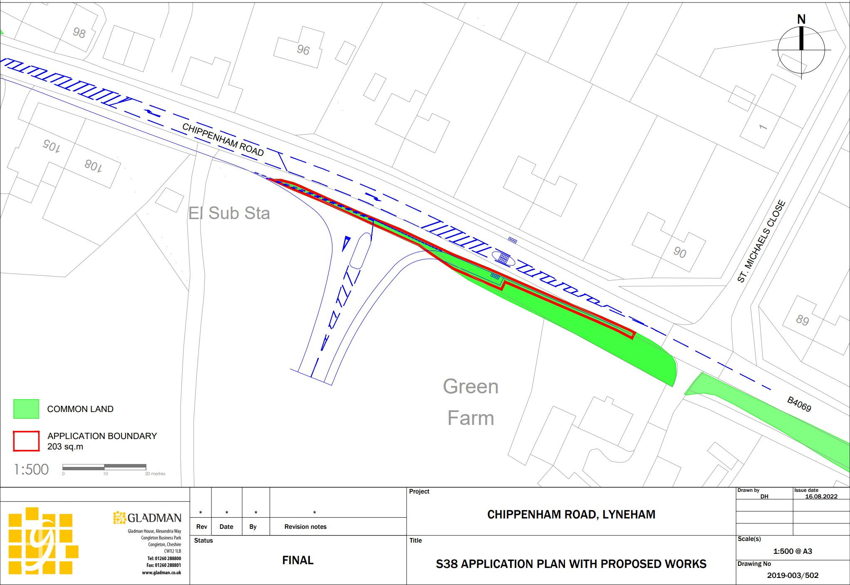

Plan 2 – Replacement Land

