


London Accommodation Pathfinder
Final evaluation report
CLIENT: CAMDEN BOROUGH COUNCIL
EVALUATORS: MIDDLESEX UNIVERSITY – CENTRE FOR ABUSE AND TRAUMA STUDIES

PROFESSORS ANTHONY GOODMAN and ELENA MARTELLOZZO
DEPT CRIMINOLOGY and SOCIOLOGY
MIDDLESEX UNIVERSITY

Disclaimer: This report serves as the final report for the London Accommodation Pathfinder (LAP) programme. It is important to note that the evaluation is an ongoing process, and the information presented here is subject to further analysis and exploration. Therefore, this report should be considered as a snapshot of the current progress and is not a completed evaluation due to the status of the LAP project. This report is a final update of the status of the LAP Project which includes an evaluation of all the data received.

GLOSSARY

EAP - Evaluation Advisory Panel
KPIs - Key Performance Indicators
LAP - London Accommodation Pathfinder
LARP - London Accommodation and Resettlement Partnership
SDM - LAP Strategic Development Manager
YJB - Youth Justice Board

PROJECT INFORMATION
PROJECT ACRONYM: LAP
PROJECT NAME: LONDON ACCOMMODATION PATHFINDER PROJECT
PROJECT FUNDER: YOUTH JUSTICE BOARD
PROJECT DURATION: 1 YEAR
CLIENT: CAMDEN BOROUGH COUNCIL
PROJECT COORDINATORS: PROFESSOR ANTHONY GOODMAN and PROF ELENA MARTELLOZZO
PROJECT EVALUATORS: CENTRE FOR ABUSE AND TRAUMA STUDIES

Contents
GLOSSARY 3
PROJECT INFORMATION 3
The Evaluation Team 6
Executive Summary 6
Target Project Level Outcomes: 6
Stages of evaluation completion 7
Phase One: In-Depth Interviews – LARP Board Members 8
Phase Two: Mixed Methods Survey 8
Phase Three: Child Surveys and Planners 9
Summary of Findings 9
Recommendations for LAP Board 10
The London Accommodation Pathfinder programme 11
Purpose 11
Aims 11
Evidence of Need 12
Children 14
The Evaluation 17
Purpose and Scope 17
Research Questions 17
Approach 18
Originally Proposed Methodology 18
Revised Methodology 19
A ‘Pilot’ Evaluation 19
Ethics 20
Qualitative Analysis of LARP Board interviews 21
Summary of Findings: 21
Pre-Delivery Survey of Sub-Regional with Steering/Operations Group 22
Summary of Survey Findings 22
Quantitative Analysis of Child Key Performance Indicator data 23
Child Survey Data 23
Attitudes Towards the LAP 23
Prosocial 23
Safety 24
Child Key Performance Indicator Data 24
The number of children having received the LAP service is increasing 24
Figure 9. Number of Children Having Received the LAP Service, September 2023-February 2024 24
Behaviour 24
Engagement 25
The majority of children engage in more than 80% of direct support sessions 25
Figure 10. Percentage of Children Participating in Over 80% of Direct Support Sessions at the LAP Service, September 2023-February 2024 25
Percentage of children achieving accreditations in education is falling, whilst the percentage who feel confident engaging with education is increasing 26
Figure 11. Percentage of Children Achieving Educational Accreditations and Reporting Confidence in Engaging with Education at the LAP Service, September 2023-February 2024. 26
Safety ratings and health ratings are improving against initial benchmarks, the majority of children attend over 85% of health appointments 27
Figure 12. Percentage of children whose safety ratings and heatlh ratings improved and attended over 85% of health appointments at the LAP service, September 2023-February 2024. 27
Transitioning 27
Summary 28
Evaluation of Children’s Planners 28
Quality of the Data Received 28
Methodology of Data Analysis 28
Results 29
Discussion 32
Concluding Comments 33
Research Questions 34
Recommendations 34
Future Evaluations 35
Standardised Tests 35
Parents 35
Staffing 36
Therapeutic Environment 36
References 37
APPENDICES 39
APPENDIX 1: Referral Participants and Roles 39
APPENDIX 2: Evaluation Infographic 40
APPENDIX 3: LARP Structure 42
APPENDIX 4: LARP Board Interview Questions Stage 1 43
APPENDIX 5: The LAP Steering Groups Questionnaire 44

The Evaluation Team
The evaluation team consists of criminologists (one professor, one associate professor, and one senior researcher) and psychologists (one research fellow, and two researchers). The structure of the evaluation team is as follows:
EVALUATION TEAM
Professor Anthony Goodman
Co-PI
Dr Ruth Spence
Senior Researcher
Sue Mulcahy
Researcher
Sabrina Holness Project Manager
Paula Bradbury
Senior Researcher
Professor Elena Martellozzo Co-PI

Executive Summary
The London Accommodation Pathfinder (LAP) is a program designed to support and divert ethnic minorities (excluding White minorities) boys aged 16-17 years away from youth custody and assist them in shifting towards a pro-social identity. Governance is provided by the London Accommodation and Resettlement Pathfinders Board, with Sub-regional Steering Groups responsible for the project's operation and a single specialist service provider responsible for managing the delivery of the programme to the children across all supported accommodations. Each supported accommodation houses up to five boys with a target maximum of 20 child placements at any time.

Target Project Level Outcomes:
- Reducing the number of first-time entrants to custody
- Reduction in over-representation of [ ethnic minorities (excluding White minorities) children in custody
- Reduced offending rates for children in receipt of a Pathfinder offer
- Reduced risk of harm to self and others and the protection of the public and victims
- Improved life chances for children
- The pathfinder outcomes above are delivered more successfully than the existing alternatives
- To demonstrate value for money
- Communication to ensure that lessons are learnt and appropriately disseminated at policy, regional and practice level
- To maximise occupancy of bed spaces of the [local authority].
The six-month programme has two overlapping stages: The first is personal support for the child, which is complemented by individualised structural support in the second stage. Entry to the LAP is by court order following referrals from the Youth Justice Service with a joint agency agreement.
This report provides a finalised progress update of the LAP through a Magenta Book-directed evaluation that is focused on five research questions:
- Have the objectives of the LAP been met?
- To what extent has there been an impact on the outcomes for children?
- What aspects of the LAP programme have been most effective?
- What aspects of the LAP programme have been least effective?
- What improvements could be made to the programme?
The report notes that the implementation of the LAP has been negatively impacted by significant delays in the supported accommodations becoming operational, resulting in the arrival of the first children a year behind schedule. The success of the evaluation was inevitably linked to the availability of child data. Ultimately, these delays in the delivery of the programme precluded the completion of all phases of the originally agreed evaluation methodology. It also meant that it was impossible to answer all the research questions.
When it was commissioned, the LAP implementation schedule indicated that at least 20 boys, and likely closer to thirty, would complete LAP placements during the 12-month evaluation period. However, none of the first few children to enter the LAP had completed the programme by the cut-off date for data collection.

Accordingly, this is a report based on a modified evaluation, the design of which was negotiated with the LAP, and completed up until the point at which the agreed final data collection point was reached.

Stages of evaluation completion

STAGES OF THE EVALUATION
PHASE ONE: In-depth Interviews – LARP Board | COMPLETED
PHASE TWO: Survey – Sub-regional Steering Groups | PARTIALLY COMPLETED
PHASE THREE: Child surveys, KPIs and Journal analysis | INCOMPLETE

A fourth phase, Staff surveys, was not conducted due to staffing issues and a consequential lack of data.
The first two phases were informed by the four quadrants of the LAP Evaluation Infographic provided to the Evaluation Team by the LAP.

Phase One: In-Depth Interviews – LARP Board Members
Conducted with five members of the LARP Board, these interviews explored general perspectives on the LAP with regard to the four quadrants:
- The set-up of the LAP;
- Sub-Regional Framework;
- Outcomes for Children;
- Cost Benefits and Research.
The findings indicate that the LARP Board viewed the LAP as a pivotal step towards supporting and diverting ethnic minorities (excluding White minorities) boys away from detention, thereby supporting their development of a pro-social identity.
Challenges around the programme's set-up and barriers to its success were recognised. Firstly, securing the buy-in of pan-London boroughs proved to be more difficult than anticipated, creating difficulties in establishing joint commissioning, a unique characteristic of the LAP and upon which its business model is based. Another early obstacle was identifying and adapting habitable properties, which caused considerable unforeseen delays. Coupled with the turnover of personnel at all levels due to the passage of time, this challenged the maintenance of effective communication between the prerequisite partnerships across and within participating boroughs. The Board’s future concerns for the LAP lay in the potential unforeseen costs once the children are in the supported accommodation and its financial dependence on the ongoing commitment of a break-even number of boroughs to sustain its business model. Currently, two boroughs are actively participating in the LAP, half the number originally intended.

Phase Two: Mixed Methods Survey
The second phase of the evaluation involved a mixed methods survey distributed to all members of the two Sub-regional Steering Groups, with 20 people providing responses. These expressed optimism about the suitability of the process for referring children for participation in the LAP, but also recognition that endorsement decisions may be influenced by factors beyond a child’s suitability, such as demand for places and inter-child compatibility. The majority (75%) of respondents reported challenges in their Steering Group role, almost all of which related to the delay in the provision of accommodation and maintenance of effective communication during periods of inactivity due to the delays in securing and adapting suitable accommodation.
All the respondents were confident that the LAP would be able to identify the children’s pro-offending narrative, with 95% being confident that whilst developing the support plan, the LAP would be able to identify the children’s strengths and goals, personal pro-social identity, and route plan for developing a pro-social identity. Additionally, participants were significantly confident that the children could be encouraged to engage with the staff's educational and leisurely activities proactively. Furthermore, 80% believed that the LAP would develop a pro-social identity by being in the supported accommodations and engaging in the activities.

Phase Three: Child Surveys and Planners
The third phase of the evaluation was developed as an adaptation of the original proposal to capture the views, experiences and feelings of the children residing in the two LAP-supported accommodations via their completed LAP planners. Using a mixed methods approach, the data was limited in scope, partly due to the delays in the readiness of the properties and the consequential absence of participating children. The evaluation could not examine the required 6-month duration of any LAP child’s residency on the programme. At the endpoint of the data collection period, only 8 children were in the properties, the surveys had not been administered to all children as agreed, no journals were complete, and journals had not been completed in the manner intended, indicating a clear conflict of understanding around their purpose. Making it impossible to evaluate whether there were any signs of a pro-social shift. Without any children completing the programme, there were no exit surveys to analyse. Only aggregate Key Performance Indicator (KPI) data was provided to the evaluation team in time. Therefore, relationships between outcomes and factors relating to children’s engagement with LAP support provisions could not be assessed. Consequently, the ability to determine, from this phase, whether the LAP programme has demonstrated any positive impact on the children’s development of a pro-social identity is tentative at best.

Summary of Findings
In conclusion, this report provides valuable insight into the LAP project’s progress to date, despite the fact that conclusive measurement of the extent to which the programme is achieving its aims is not possible, not least in respect of child-level outcomes.
SUMMARY OF FINDINGS
PHASE ONE: In-depth Interviews – LARP Board | - Viewed as a pivotal step in supporting and diverting ethnic minorities (excluding White minorities) boys away from detention, with the opportunity to develop a pro-social identity.  - The difficulty in securing buy-in of pan-London boroughs created commissioning challenges  - Securing habitable properties with permission to develop caused a significant time delay  - High turnover of staff impacted effective communication between partnerships  - Concerns were raised regarding unseen financial costs not predicted in the business model  - Only 2 out of the 4 boroughs participated at this point
PHASE TWO: Survey – Sub-regional Steering Groups | - Optimism in the referral process; however, concerns were raised that endorsement decisions may be influenced by space availability and inter-child compatibility  - The delay in the provision of accommodation and maintenance of effective communication during periods of inactivity has been challenging  - High level of confidence that the support provisions would identify the needs of the children  - High level of confidence in the ability of the programme to deliver support that would result in pro-social change
PHASE THREE: Child surveys, KPIs and Journal analysis | - No children had been in the house long enough for a complete evaluation of their experiences to determine whether any positive change had been made through their planners or a survey  - There was a lack of consistency and clear communication on how the planners would be completed.
RECOMMENDATIONS FOR FUTURE EVALUATION | - Incorporating standardised tests into evaluations can provide repeated quantitative measures of various characteristics related to pro-social identity, thus informing the future streamlining of the referral process  - Engagement with parents or guardians to identify their perspectives of the programme and any change in the children’s behaviour  - Future consideration should be given to the local demographic and its potential impact on the service provider's ability to recruit appropriately qualified and experienced staff.  - Other aspects to measure in evaluations include the therapeutic environment of the LAP houses and scenario mapping.

Nonetheless, the report highlights the strengths and weaknesses of the project, including the challenges faced by stakeholders during the implementation phase, particularly difficulties in securing suitable properties. The report also underscores the optimism of the LARP Board and Sub-regional Steering Groups about the suitability of the child referral process and the LAP’s ability to identify the child’s pro-offending narrative and to support them in shifting towards their pro-social identity. Also reported are the early reactions of children following their arrival on the LAP. This report will serve as an important benchmark for future evaluation able to engage with the children throughout their placements and with established frontline child support staff. Overall, the LAP remains a significant step towards supporting and diverting children away from custody in the London region.

Recommendations for LAP Board
To ensure long-term sustainability of the LAP:

- Long-term funding needs to be secured
- Cross-borough engagement needs to be optimised and stakeholder challenges addressed to ensure continued participation
- Information sharing across multi-agency partnerships needs to be improved
- Child-centric evaluation and collaboration with parents should be prioritised.

Future evaluations of the LAP should adopt a tri-focal approach reflecting the 3 stages of the child’s involvement with the program: Referral process and court decisions, programme suitability and cost-effectiveness, and post-participation outcomes, particularly recidivism.

The London Accommodation Pathfinder programme

Purpose
The London Accommodation Pathfinder (LAP) programme is designed to provide a therapeutic alternative to youth custody for boys in London. Four London regions are participating in the project, each with 1 property providing supported accommodation for up to five boys aged 16-17. A single, jointly commissioned, specialist service provider is responsible for delivery of the six-month support programme for up to 20 children at any given time across the four regions. The project is sponsored by the Ministry of Justice, funded by the Youth Justice Board and endorsed by the London Association of Directors of Children’s Services, with the London Borough of Camden acting as the lead local authority. It is governed by the board of the London Accommodation and Resettlement Pathfinders (LARP) which is supported by multi-agency Regional Steering/Operations Groups and with a full-time Strategic Development Manager (SDM) providing day-to-day oversight.

Aims
There is a hierarchy of aims for the LAP expressed by the various stakeholder organisations. The Youth Justice Board (YJB) (2019), includes the LAP as part of its vision for the future in its business plan:
‘A youth justice system that sees children as children, treats them fairly and helps them to build on their strengths so they can make a constructive contribution to society. This will prevent offending and create safer communities with fewer victims.'
The YJB describes the combined aim of the LAP and its sister project, the London Resettlement Pathfinder, as “Influencing policy and decision makers to choose an evidence-based Child First approach, prioritise prevention and diversion and invest in support for children to prevent offending and make communities safer.” The Child First approach means placing the needs of a child first in a developmentally focused way; taking a constructive approach, including highly supportive relationships; and, collaborating with children wherever possible (Wainwright & Nee, 2014); and, in the context of youth justice, diversion away from criminogenic stigma (Case & Browning, 2021). Child First principles are not restricted to the justice sector; rather, they are applicable to every intervention and with all children. Consequentially, enactment of Child First principles is dependent upon effective collaboration across all services that are concerned with children including health, education, social care, youth justice and allied service providers. The YJB also sets out the following LAP-specific aims:
“Deliver a psychologically informed alternative to custody which will reduce the number of children in custody from London”
And; “Provide supported housing for up to five males in 1 location. The children will benefit from integrated multi-disciplinary support services, within a setting that is safe.”
The LARP (2021) describes the aim of the LAP being ‘to develop alternative accommodation within the community for children who would otherwise be remanded or sentenced to custody’ (2021).
The project level outcomes for the LAP are defined its Service Provider Specification as follows:
- Reducing the number of first-time entrants to custody
- Reduction in over-representation of ethnic minorities (excluding White minorities) children in custody
- Reduced offending rates for children in receipt of a Pathfinder offer
- Reduced risk of harm to self and others and the protection of the public and victims
- Improved life chances for children
- The pathfinder outcomes above are delivered more successfully than the existing alternatives
- To demonstrate value for money
- Communication to ensure that lessons are learnt and appropriately disseminated at policy, regional and practice level
- To maximise occupancy of bed spaces of the [local authority].
As well as greater specificity these project outcomes introduce an economic focus. Whilst optimisation of bed space occupancy may be relatively straightforward to evaluate, demonstrating value for money will be considerably more complex and will be possible only once the LAP is fully operational and its impact on outcomes for children following completion of the programme can be measured.

Evidence of Need
The detention of any child in youth custody, regardless of whether they ultimately receive a custodial sentence is a cause for concern because of its negative effects on their mental health and not uncommon negative behavioural outcomes. These resultant effects are due to the failure of custodial provisions to address the underlying criminogenic needs of the child that stem from environmental influences (Lambie & Randell, 2013) and, adverse childhood experiences (Centre for Youth & Criminal Justice, 2018). Furthermore, the longer the child’s immersion in the custody environment, the further they are diverted away from pro-social behaviours (Lambie & Randell, 2013).

In 2017, the UK government commissioned David Lammy MP to conduct an independent review of the Criminal Justice System (at large) with a particular focus on the treatment of and outcomes for Black, Asian and Minority Ethnic (BAME) (a terminology specific to the Lammy Review) people (hereafter referred to as ethnic minorities (excluding White minorities) within this report). The Lammy Report, based on the period 2006 to 2016, underscores that its biggest concern is ethnic disparity within the youth justice system and, more particularly:

- The proportion of ethnic minorities (excluding White minorities) child first time entrants rose from 11% to 19%
- The proportion of ethnic minorities (excluding White minorities) children reoffending also rose from 11% to 19%
- There was a rise from 25% to 41% in the proportion of ethnic minorities (excluding White minorities) youth prisoners, despite this group representing only 14% of the youth population nationally.

The subsequent White Paper ‘A Smarter Approach to Sentencing’ recognised that ‘any time spent in custody can be highly disruptive to a child’s life, impacting their family connections and education’ and emphasised government plans to ensure that youth custody was used as a last resort by changing the legal tests for custodial remands (HM Government, 2020).

Recently published government figures evidence ongoing disproportionality nationally with Black children representing 33%, Asian 12%, and Mixed 16% (total 61%) of all youth in custody on remand (see Figure 1 below). In many cases (96%) subsequent sentencing decisions are made in a magistrates’ court and the remaining 4% in the Crown Court. Strikingly, upon sentencing only a little over a third of the children (37%) on remand (at some stage during court proceedings) receive a custodial sentence. Additionally, half of all children in custody in the youth secure estate more generally are in the ethnic minorities (excluding White minorities) (26% Black, 15% Mixed and 10% Asian) (see Figure 2 below). These figures indicate that rates of disproportionality across all ethnic minorities (excluding White minorities) sub-groups are higher for children in custody on remand than for children in custody as a whole. And boys aged 15-17 represent 97% of children in youth custody. However, the overall number of children in custody decreased from nearly 11,000 in 2017 to just over 5,000 by 2023 (Youth Justice Board, 2024) following a government target to reduce the number of children entering the youth justice system by 20% (HM Government, 2008).

Nonetheless, in London there is an 87% representation of ethnic minorities (excluding White minorities) children in youth custody (Howard League for Penal Reform, 2020) which is significantly higher than the 61% national average (Youth Justice Board, 2024).
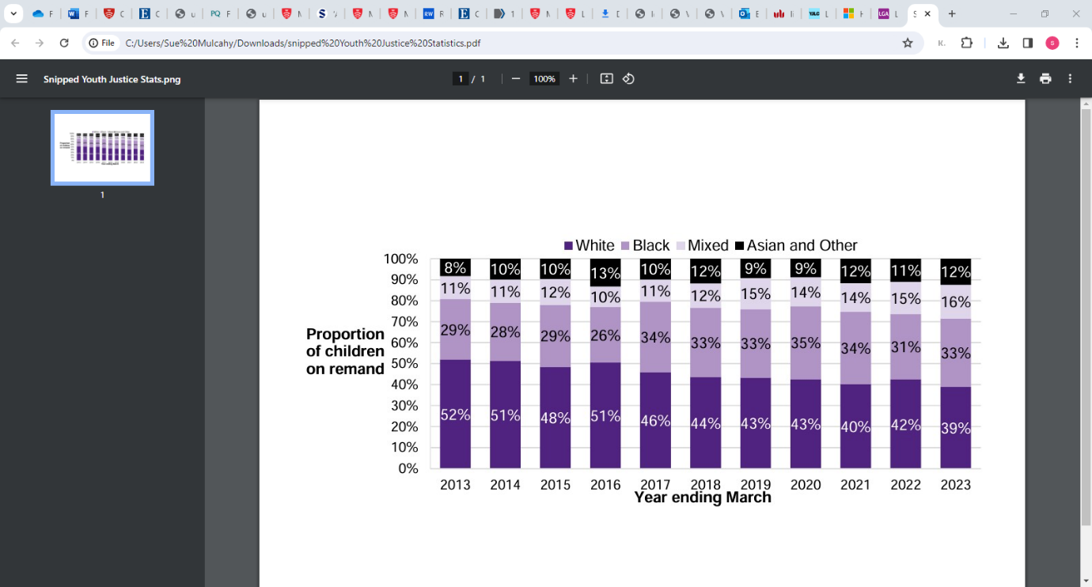
Figure 1: Proportion of children in youth custody on remand by ethnicity, youth secure estate in England and Wales, years ending March 2013 to 2023 (Youth Justice Board, 2024)

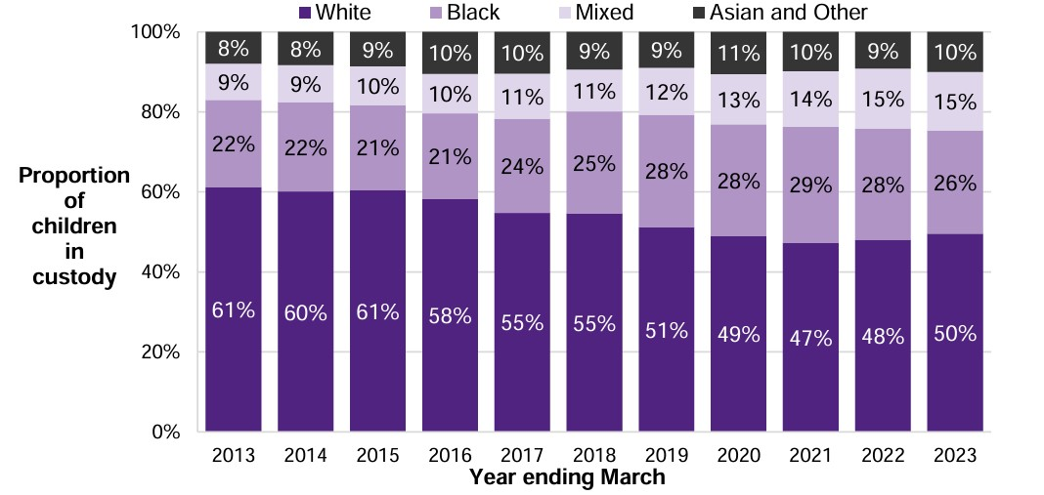
Figure 2: Proportion of children in custody by ethnicity (10–17-year-olds), youth secure estate in England and Wales, average for year ending March 2013 to 2023 (Youth Justice Board, 2024)

Four key points regarding race are highlighted in The Alliance for Youth Justice’s (2023) Evidence Review of Young People in Transition [to adulthood] in the Criminal Justice System (2023): Firstly, perceptions of culpability and vulnerability and, in turn, provision of support services, are impacted by Adultification [treating ethnic minorities (excluding White minorities) children as if they were adults]; secondly, lack of trust and confidence in the justice system impacting negatively on children’s engagement; thirdly, a lack of cultural competence within services resulting in provisions offered that may not be suitable for the specific needs of ethnic minorities (excluding White minorities) children; and, fourthly, provision of ethnically-tailored provisions, such as from community sector organisations, can help mitigate these problems. The Alliance stresses that “there is a long way to go to improve outcomes and there remain significant gaps in understanding how different groups of children facing layers of marginalisation and disadvantage experience the transition [to being seen as an adult] and the response that is required.” (Alliance for Youth Justice, 2024, P4).

Although the Lammy Report emphasises that it found no single explanation for the disproportionate ethnic minorities (excluding White minorities) representation of children involved in the criminal justice system, it recognises that there is evidence of unequal treatment of ethnic minorities (excluding White minorities) defendants, children and adults, in Crown Courts. Research findings suggest that unequal treatment occurs across the youth justice system more generally; for example, Moore and Padavic (2012) found that structural race discrimination and unconscious racial bias occur at all stages of decision-making in the youth justice system, including within risk assessment tools. In addition, 15–17-year-old ethnic minorities (excluding White minorities) boys in London are more likely than any other children nationally to be detained in youth custody (Youth Justice Board, 2024). This increases their risk of them suffering consequential negative effects on their health, disruption to their education, reduced employment prospects (Bateman, 2012), loss of friendships and separation from families (HM Government, 2020).

Children
There are four routes for children, set out below, onto the LAP each of which is accessed by court order:

- Child is currently remanded in custody but suitable for LAP
- Child faces a custodial sentence but is suitable for LAP
- Child’s first appearance in Court and is suitable for LAP to prevent custodial remand
- Child is suitable as part of resettlement package/licence condition for release.

(Entry via routes 3 and 4 was not made available at the first phase launch of the LAP).
(LAP Operations Manual, 2022)
It follows that success of the project is dependent upon the willingness of the courts to make the prerequisite orders for children’s participation on the programme. Such orders are made following recommendations to the court from the youth justice service with prior joint agency endorsement at sub-regional level. It is a requirement for entry onto the LAP that the child and parent/carer both agree to the child being remanded into the care of the local authority. Whilst on the LAP the child is subject to a curfew with electronic monitoring. The process of referral of the child for placement on the LAP is relatively complex and involves the child and their parent/carer, the youth justice service, the local authority, the LAP service provider and the SDM (LAP Operations Manual, 2022). A depiction of this process is in Appendix 1. Continuation of the child’s LAP placement is dependent upon continuous assessment and satisfactory levels of public safety and safeguarding (LAP Operations Manual, 2022).

Children joining the LAP are likely to be characterised variously by: History of or current involvement in gangs; complex needs; history or risk of exploitation such as county lines; involvement with social care; possession of weapons; extensive history of offending; and being victim or witness of serious violence (LAP Operations Manual, 2022).

The LAP Service Provider Specification (undated) describes the vision for the programme as follows:

‘Our vision through the delivery of this pathfinder is that is that we avoid custody where possible for children aged 16 and 17 (and those who turn 18 whilst in this placement). By doing so we will be able to avoid future extensive contact with the criminal justice system and reduce reoffending rates for children, some of whom are disproportionally represented in the criminal justice system’

It also specifies detailed outcomes for children:

- Reduce the likelihood of offending, the risk of harm and the child’s vulnerability
- The child enjoys good physical, emotional, mental and sexual health; has a healthy lifestyle, and has access to information about health issues that allows them to make informed choices.
- The child is physically safe, stable, and emotionally secure. They are protected from ill-treatment, neglect, violence and sexual exploitation; they are free from bullying and discrimination; and are protected from social exclusion through involvement in crime, anti-social behaviour, and other risk-taking activities.
- The child attends and fully engages in education, training or employment and receives encouragement and recognition for their achievements.
- The child positively participates in restorative practices and receives encouragement and recognition for their achievements.
- The child is actively involved in making decisions about their future and develops their self-confidence.
- The child will develop and increase their sense of identity; they understand the effects of racism and discrimination and are able to enhance their coping mechanisms.
- The child positively engages with their family and services, where possible the child should have access to family therapeutic interventions to improve their trusted relationships and be supported to move back to their family, or otherwise into supported accommodation or permanent independent living, making smooth and successful transition.
- The child is equipped with independent life skills they require to support them, making a smooth and successful transition.
- Children’s ability to make positive choices is measured by a strength-based outcome tool which can measure distance travelled through targeted interventions.
- That the child lives in a psychologically informed environment (staffing support, physical environment, and access to specialist services).

The LAP describes how it aims to provide an alternative to Youth Detention Accommodation and support the children shift from a pro-offending to pro-social identity’ (Youth Justice Resource Hub, 2023). As can be seen in Figure 3.

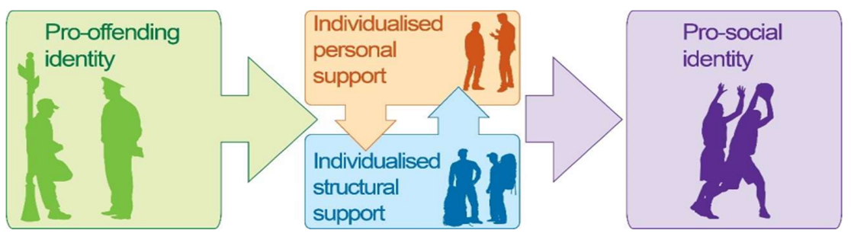

Figure 3. Diagram from the LAP Operations Manual 2022

The commissioned LAP service provider (currently St Christoper’s Fellowship) manages the provision of two overlapping individualised ‘stages’ support each child’s shift from their particular pro-offending identity towards their personally aspired pro-social identity.

The supported accommodations are managed by the LAP service provider with delivery of the different elements of the programme variously by St Christopher’s itself and collaborating third party specialist services and community organisations. The personal support stage directs and underpins the structural support delivered in the overlapping second stage. Pivotal in the first stage is supporting the child’s self-identification of their historical pro-offending narrative, their strengths and goals, prospective pro-social identity and a plan for shifting towards their individual target identity. This stage forms the foundation upon which the child is also supported to develop an individualised programme of wrap around support, such as health support, fitness, life skills, leisure etc. in the second stage of the programme.

On completion of the programme, the child leaves the LAP supported accommodation via one of 3 exit routes:

- A custodial sentence following a remand into local authority accommodation
- A community order and return to family
- A community order and a Local Authority Placement.

The regional steering groups are required to identify the likely exit route for the child within five days of the point of placement on the LAP.

The Evaluation

Purpose and Scope
The LARP Board called for an independent impact evaluation following the guidelines set out in the Magenta Book (HM Treasury, 2020) – Central Government Guidance on Evaluation (Guidance) - for the purposes of learning and accountability. This Guidance describes impact evaluation as a test of changes that have occurred, including their scale, and an assessment of the extent to which these are attributable to the intervention.
This evaluation was commissioned in September 2022, in anticipation of the children’s arrival on the LAP in October 2022. The guidance explains how evaluations conducted during implementation typically focus on the efficacy of an intervention’s design, implementation and emerging outcomes. Whether delivery is as intended, whether the intervention is operating as intended and to what extent for different groups are all potential foci; similarly, early indications of possible effect size, operation in practice, unintended consequences and opportunities for enhancement are also of potential interest at this stage.

More conclusive issues, not typically examined at the implementation stage, include overall success, effect size and cost, contribution of intervention to final outcome and whether this matched predictions and unintended impacts are considered not at this stage but, rather, after implementation. Nonetheless, reflecting the six-month duration of LAP placements, originally it was anticipated that this evaluation would also obtain evidence of some early indications of more conclusive design and implementation considerations.
The evaluation commission did not include evaluation of court decisions on recommendations for LAP placements (or LAP engagement with courts more generally), LAP engagement with parents or outcomes for children following transition from the LAP.

Research Questions
Accordingly, the following research questions for the evaluation were agreed on commissioning:
- Have the objectives of the LAP been met?
- To what extent has there been an impact on the outcomes for children?
- What aspect of the LAP programme has been most effective?
- What aspect of the LAP programme has been least effective?
- What improvements could be made to the programme?
(Evaluation team bid presentation to LARP, 2022)

Approach
Following the Guidance, the ‘Theory of Change’ is at the heart of this evaluation; that is, how the LAP is intended to work. This is that the provision of therapeutic supported accommodation as an alternative to detention will motivate 16- and 17-year-old boys to shift towards pro-social from pro-offending identities; thereby building desistence and improving their life outcomes.

The children’s motivation to change, intrinsic and extrinsic, is highlighted by the LAP as key to its success (LAP Service Provider Specification, undated). This view is supported by previous work indicating that children’s motivation is key for their successful rehabilitation (e.g. Hagell, Hazel & Shaw, 2015), which is predictable based on the broader literature on motivation; for example, the Integrative Theory of Training Motivation (ITTM). Motivation is a direct factor in the change in motivation and attitude alongside the acquisition of knowledge and skills, leading, ultimately, to a change in behaviour. The two proximal predictors of motivation to learn are valence and self-efficacy, and a key distal factor is environmental climate (Colquitt, LePine & Noe, 2000). Valence is the learner’s perception of the desirability of the intended outcomes of the intervention (Mathieu & Martineu, 1992); in this case, the child’s sense of potential benefit from developing a pro-social identity.

Self-efficacy refers to the learner’s confidence in their ability to achieve a specific goal—in this case, the child’s belief in their capacity to develop a pro-social identity. Furthermore, climate refers to the learner’s perception of the dominant attitudes and behaviours within their social environment. (Tracey, Tannenbaum and Kavanagh, 1995) and the perceived favourability of adopting target behaviour (Ford, Quinnones, Sego & Sorra, 1992); for the LAP child, the attitudes of the people around them towards pro-social behaviour and the child’s perception of the benefits of adopting a more pro-social identity in their future lives, respectively. The model also explains how post-training self-efficacy as a direct predictor is, alongside other non-intervention-related factors, for applying learning beyond the training environment. Usefully, the model also explains non-training related factors predictive of the application of learning outside the formal training environment, for example, in decision-making. These factors include locus of control, conscientiousness, anxiety and climate, all of which are highly pertinent to the LAP support programme and to the children’s out-of-house behaviour whilst in the LAP, which will inform their learning whilst on the programme.

Originally Proposed Methodology
As per the stipulations from the board, the evaluation used the Magenta Handbook to develop a mixed methods approach, thereby providing both the rigour of quantitative analysis and the richness of qualitative analysis (Creswell, 2014). The objective was to explore of the perspectives of those involved in the implementation and delivery of the LAP, as well as the perspectives and experiences of the children. The original design consisted of 3 phases:
PHASE ONE (Qualitative):
Desistence model-based
Interviews with
key stakeholders
PHASE TWO (Quantitative):
Analysis based on Child KPIs
PHASE THREE (Qualitative):
'Photographic diary' interviews with children
Figure 5. Evaluation team presentation to LARP, 2022

Revised Methodology
The original completion date for the evaluation was the end of the financial year 2022/23, with child-level data collection due to take place from October 2022 to January 2023 (Evaluation team presentation to LARP, 2022). Unanticipated difficulties in the procurement of suitable properties and planning difficulties across participating host local authorities led to a decision by the LARP to reduce the supported accommodation provision to two properties across two subregions (comprising of twelve local authorities). As well as the reduction in scale, these difficulties resulted in protracted delays to the commencement of delivery. This required a reflexive response to the methodological design.
Procurement of suitable properties continues to be problematic. Suitable real estate is yet to be identified in the West and South Regions. The lead borough does not anticipate the third and fourth supported accommodations being launched before April 2025. It is noteworthy that the service provider attributes difficulties in recruiting suitable staff in the North-West Region to the relative affluence of the local area and anticipates increased staffing costs. It is further acknowledged that staffing LAP-supported accommodation is more challenging than staffing normal children’s homes, not least due to the level of skill and experience required to support the boys.

A ‘Pilot’ Evaluation
The revised design retained a robust mixed methods approach and continued to involve collecting and analysing both quantitative and quantitative data. However, the scope was slightly extended to include light touch process evaluation elements, and some alternative data collection tools were used. Notably, replacing photographic diary-based child interviews with child surveys and analysis of the child LAP Planner allowed for quantitative and qualitative measurement of changes in the children’s views and experiences. This provided the additional benefit of reducing the number of unfamiliar people that the children are asked to meet as they navigate likely stressful early days on the LAP, thereby militating against the risk of jeopardising their early progress. Furthermore, as part of the revised methodology, the evaluation team introduced further methods of data collection using the LAP Evaluation Infographic as a framework:

- Interviews with the LARP Board;
- Surveys with the sub-regional groups
- A survey with operational support staff

The LARP Board interview schedule and Sub-regional Steering/Operations Group survey are designed to measure satisfaction and confidence in the project design and implementation. The staff survey is designed to capture first-hand experiences of programme delivery within the supported accommodations. By conducting these interviews and surveys, the evaluation team was able to gain a deeper understanding of how the LAP is perceived at governing, sub-regional and operational levels and to identify any areas requiring improvement. The surveys are important components of the evaluation designed to capture valuable insights into the programme's perceived effectiveness, enabling data-driven recommendations for future development. The figure of six months was determined as it reflected the length of stay anticipated for each child in the programme and would also provide a significant period of time ‘in role’ for the LAP staff to have a clear understanding of what the strengths and weaknesses are in the LAP.

The four phases are represented below:

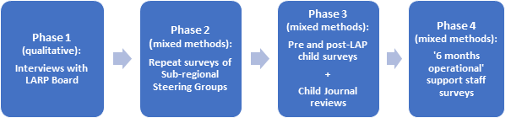

Figure 6. Phase 2. The sub-regional Steering Group survey was not repeated as planned due to significant staff turnover precluding comparison of responses from the same people over time.

Ethics
All data collection tools were designed by the evaluation team, approved by the LAP and the Ethics Committee at Middlesex University, and conform to the ethical standards of the British Psychological Society, the Health and Care Professions Council, and, similarly, to the guidance of the British Sociological Association.
The LAP Information Infographic (Appendix 1) informed phases 1 and 2 of the evaluation. It illustrates the four main foci of the LARP Board and the lead authority during the early stages of the project.

Qualitative Analysis of LARP Board interviews

The interim report discussed this data collection phase in greater depth. Therefore, this coverage of the qualitative interviews with the LARP board members will be discussed in a summary of the key findings.
The interviews were designed to explore the general perspectives on the LAP held at the governing body (LARP)level regarding the four quadrants of the evaluation infographic: The setup of the LAP, Sub-Regional Framework, Outcomes for Children, and Cost Benefits and Research. The evaluation team interviewed five members of the Board.

Summary of Findings:
The following table outlines the primary findings from this interview phase of the evaluation per quadrant.
EVALUATION QUADRANT | FINDINGS
SET-UP OF THE LAP | - To develop an alternative to custody and increase pro-social outcomes especially for black boys  - Identifying programme access thresholds  - Trauma informed support in wrap-around care  - Strength in the high level of professional practice experience  - Strength in its proactive objectives towards a pro-social change  - Strength in the ‘Home’ emphasis and socialisation of the accommodation  - Weakness in the processes of identifying suitable accommodation and the processes surrounding this – this could have been identified earlier and properties sought with usage approvals in place.  - Voices of children were included in the set-up and provision design  - Voices of parents/guardians were not included  - Significant time loss meant that there was a high staff turnover with poor communication and updates
SUB-REGIONAL FRAMEWORK | - Steering group established out of a framework that already existed as a London sub-regional services structure – strong breadth of experience and shared drive  - Two sub-regions were chosen as the only locations with secured properties
OUTCOMES FOR CHILDREN | - LAP provides a positive opportunity for pro-social change  - The programme provides children with essential access to key therapeutic support  - Concerns were raised around the level of vulnerability and anxiety the children would arrive with.  - Concerns regarding communication between partnerships  - Concerns regarding potential cost increases once the children are in the houses  - The trauma-informed approaches were not clear to all members  - The risk monitoring process is not clear to all members  - The health monitoring process is not clear to all members
COST BENEFITS AND RESEARCH | - The programme was viewed as a lower cost than having a child in custody  - There is a long-term cost to those children not selected to participate in the programme  - The greatest cost was the delays caused by the housing  - The COVID-19 pandemic slowed down the progress of the LAP Project  - Sustainable, subject to certain caveats: long-term sponsorship, centralised management, long-term commitment, and collaboration to continue.  - Any serious incident could destabilise the programme  - Long term it will require some form of cross-borough investment to provide sustainability
Figure 7. Evaluation Quadrant – Findings

Pre-Delivery Survey of Sub-Regional with Steering/Operations Group

A survey of the two Sub-regional steering groups members was used to explore their pre-delivery views on: the LAP as an alternative to custody; its prospects for success in delivery of the personal support stage; and prospects for successful engagement of children in the structural support stage. The survey (see Appendix 3) contained a series of sixteen questions, each consisting of a set of options to choose from and a space for explanatory narrative responses. It was intended that the initial survey would be used as the basis for comparing the steering groups’ intuitive pre-delivery views on the LAP with their later delivery-informed views. Due to delays in delivery of the LAP, and high turnover levels of steering group membership, a more limited mixed-methods analyses has been conducted to explore the steering groups’ intuitive views on the LAP based on their responses to the Pre-delivery survey. Out of a possible 30, 20 (66%), individuals answered the survey (see Graph 1 for a breakdown of participants). Of those answering, 50% reported they would have no direct involvement with the children, 40% stated they would and 5% were not sure.
For a more in-depth discussion of the survey findings, see the interim report.

Summary of Survey Findings
SUMMARY
1. | Respondents were optimistic about the suitability of the referral process. However, there is also a recognition that endorsement decisions may be determined by factors beyond a child’s personal suitability, for example demand for places and child compatibility.
2. | Whilst respondents were optimistic about the proportion of applications to the courts being granted but less confident than they were about the prospects of endorsement at the LAP Multi Agency referral meeting stage.
3. | The majority (75%) of respondents reported challenges in their Steering Group role all of which related to the delay in provision of accommodation.
4. | All the respondents were confident that the LAP would be able to identify the children’s pro-offending narrative. With 95% being confident that whilst developing the support plan the LAP would be able to identify the children’s strengths and goals, personal pro-social identity and route plan for developing a pro-social identity.
5. | Participants were significantly confident that the children could be encouraged to proactively engage with the educational and leisurely activities being run by the staff. In addition to this, 80% believed that the LAP would develop a pro-social identity by being in the houses and engaging it the activities.
Figure 8. Summary of Findings
Due to the small amount of data available throughout all quantitative analyses are purely descriptive and findings should not be interpreted as statistically significant.

Quantitative Analysis of Child Key Performance Indicator data

This phase of the evaluation focused on both a qualitative and quantitative examination of both the children’s planners and KPI data. This phase of the evaluation remained incomplete. So far only 1 child has declined to accept an offer of a LAP placement.

Child Survey Data
There were eight surveys completed in all. The survey items were answered on a scale from 0 to 100, with a score of 100 being total disagreement and 0 being total agreement. Categories were also created with scores between 0-40 being ‘agree’, 41-59 being ‘ambivalent’ and 60-100 being ‘disagree’.

Attitudes Towards the LAP
The children seemed reasonably ambivalent about the LAP, for example 37.5% of them were excited to be part of the LAP, whereas 37.5% were ambivalent and 25.0% were not excited (average score = 49.63). Similarly, only 50.0% thought the LAP was better than prison (average score = 48.12). Half (50.0%) the children disagreed that the LAP was a good idea for other children (average score = 60.75). Strikingly, only 1 child agreed the staff support would be good for them (average score = 85.63), and the majority disagreed that the support with education (50.0%, average score = 76.00), health (88.75%, average score = 92.86) or leisure activities (87.5%, average score = 86.63) would be good for them. Similarly, 100% of the children disagreed that living in a safe environment would be good for them (average score = 92.13). These negative attitudes point towards the children having low self-efficacy on entry to the LAP. According to motivation theory this could be expected to impact negatively on their initial motivation to engage with the programme.

Prosocial
The children however, appeared to want to change; 62.5% (average score = 42.25) wanted to stop getting in trouble with police, and the same (62.5%; average score = 41.50) wanted to stop getting into risky situations with other people in their life. This desire to change and avoid getting into trouble suggests that the children’s motivation is positively aligned with the child outcomes for the LAP on entry to the programme and is encouraging as valence is the second biggest predictor (after self-efficacy) of motivation and, in turn, outcomes including attitude change and behaviour changes.

Safety
Only half (50.0%) agreed that they felt safe in their life (average score = 46.63), and half (50.0%) reported wanting to have less to worry about (average score = 48.12). As might be expected, these two answers were highly correlated (r = .91), suggesting feelings of safety and worrying may be linked.

Child Key Performance Indicator Data
Although there was a lack of children in the LAP, Figure 9 shows that recruitment is starting to accelerate and is suggestive that issues with lack of awareness and finding suitable children are reducing. Most of the children came from Youth Detention Accommodation, only 1 child has so far left the service and that was to move back to their family home.

The number of children having received the LAP service is increasing

Figure 9. Number of Children Having Received the LAP Service, September 2023-February 2024

Description of figure 9: The number of children that have received the LAP service has increased since October 2023. In February 2024 there were five children in the Barnet house and 4 in the Newham house
Source: NC Provider monthly return from Camden LAP

Behaviour
Only 1child has been reported missing over the six-month period and there have been no LADO notifications. However, although there were no serious incidents until December, there is an increasing trend with two in January 2024 and four in February all in the Barnet house. This coincided with the arrival of the latest child and may be suggestive of problems with the resident mix. Across both sites only 1 child secured or sustained formal ETE provision and only 1 child has engaged in community reparations, and this occurred in January 2024 but ceased in February 2024. This may reflect that the wider networks needed for this type of work to commence are not wholly in place yet or a reluctance on the part of the children.

Engagement
Despite the survey responses suggesting none of the children could appreciate the benefits of staff support, it appears that in general most children are showing high levels of engagement with the direct support sessions (see Figure 10). The fluctuations in engagement may demonstrate the ongoing adjustment for staff and children as new children enter the houses or staff leave.

The majority of children engage in more than 80% of direct support sessions

Figure 10. Percentage of Children Participating in Over 80% of Direct Support Sessions at the LAP Service, September 2023-February 2024
Description of Figure 10: The majority of children engage in more than 80% of their direct support sessions. Except for October where it decreased to 50%.
Source: NC Provider monthly return from Camden LAP

Despite the lack of formal ETE provision, the percentage of children who feel supported and confident in engagement with education is reasonable and after an initial decrease, looks to be increasing over time (see Figure 11). If post-surveys were available, it would be interesting to investigate if this is reflected in more positive attitudes towards education support. The children are also achieving accreditations every month, which may be adding to their confidence. Accreditations include practical cookery skills, maths problem solving and English reading for information.

Percentage of children achieving accreditations in education is falling, whilst the percentage who feel confident engaging with education is increasing

Figure 11. Percentage of Children Achieving Educational Accreditations and Reporting Confidence in Engaging with Education at the LAP Service, September 2023-February 2024.

Description of Figure 11: Between October 2023 and February 2024 there is an upward trend in the percentage of children feeling confident engaging with education. The percentage of children gaining accreditations decreased between October 2023 and January 2024.
Source: NC Provider monthly return from Camden LAP

Reassuringly, although the survey suggested most children did not think support with health would be good for them, there was an upward trend for the percentage of children whose health ratings and safety ratings improved against the initial benchmark (see Figure 12). The children also demonstrated good compliance with attending health appointments.

Safety ratings and health ratings are improving against initial benchmarks, the majority of children attend over 85% of health appointments

Figure 12. Percentage of children whose safety ratings and health ratings improved and attended over 85% of health appointments at the LAP service, September 2023-February 2024.

Description of Figure 12: the percentage of health ratings and safety ratings that are improving against the initial benchmark are increasing over time. The percentage of children attending over 85% of their health appointments remains high.
Source: NC Provider monthly return from Camden LAP

Transitioning
In Newham, planning for service transition had begun for 1 child.This started during the second month of their stay, whilst planning for their living arrangement transition began in their third month. In Barnet, there was a gap of two months before transition planning for services and living arrangements began for the first child. By December 2023, two of the five residents had begun transition planning and by February 2024 this was up to 3 residents. This suggests that transition planning may not start within five days of placement as specified in the Service Provision Specification.

Summary
Generally, the KPI data suggests that the LAP is beneficial to the residents’ confidence and indicators suggest increased motivation for engagement over time. This is positive, given the negativity displayed by the children when answering the survey at the beginning of their time in the houses. However, any conclusions are made with caution. The small number of children and time frame involved means that longer-term trends cannot be discerned, and each child has an outsized effect on the overall trend witnessed. Although it is difficult to know whether these behaviours are linked to an underlying shift in identity without any kind of formal or more nuanced measurement, the overall engagement with staff, accreditations and lack of serious incidents is positive.

Evaluation of Children’s Planners

The purpose of this phase of the evaluation was to review the Children’s Planners over a six-month period to determine, through the voices of the children, indications of there being a development towards a pro-social identity. As has already been discussed, there were significant delays to delivery of the LAP programme which had a subsequent impact on the number of children in the supported accommodation during the evaluation data collection phase. At the point of analysis, there were five children in JONAH House, and three children in OSIRIS House. The children were required to complete these planners every month with a key worker. These monthly returns were to be redacted and shared with the evaluation team.

Quality of the Data Received
Of the 8 planners received only two were complete. Some only had the first two pages completed, and several had multiple sections missing throughout. There were also some concerns regarding the similarity of the journals completed. Whereby several had the same responses for the same questions. At the point of analysis, only 1planner was received per child for all bar 1 who had a second completed planner submitted. The second planner was not included in this evaluation. Therefore, this report reflects this fact and is not an analysis over a six-month period.

Methodology of Data Analysis
The redacted planners were uploaded onto a thematic analysis platform called Dedoose. The coding took a semi-structured approach, with the headings within the journals serving as the primary codes and the individual questions as the secondary codes. Tertiary codes were applied as they were presented. Aside from the primary codes based on the subheadings in the planners, codes were developed organically as researchers engaged deeply with the data, identifying patterns, ideas, and concepts that emerge naturally through repeated reading and interpretation. This process is inductive and data-driven, meaning that the researcher allows themes to emerge from the data rather than starting with a predefined set of codes. However, it is essential to note that the volume of information provided was limited. Whilst the journals provided the opportunity for open answers, the majority only included single-word responses. Meaning that there was limited opportunity for interpretation at any great depth. The research team reviewed all codes independently to ensure internal consistency.

Results
The results will be discussed in the order in which the planners are organised. As stated, the level of richness in the responses varied significantly, and there were indicators of quite a disparity in literacy level. Cases of higher literacy levels provided more complex and detailed responses, whereas those on the lower literacy level, which is all but 1, responded with singular-word answers.

Thinking About Me
In this section, children were asked to discuss their identity and visions for the future.
How do I see myself and my place in the world?
For this question many children viewed themselves as being a ‘normal human’ or ‘just a person’. One child provided a more candid response stating that they were ‘Just a young person trying to figure the world out’. Whereas another more confidently viewed themselves as being ‘A young man with great potential’. The sense of normalcy from the majority was indicative of the differential association between themselves, their peers and their environment.
What aspects of my life are important to my identity?
For this section the most commonly reported answer centred around friends and family. A couple of the children reported various material items as being important to their identity, such as clothes and food. Two children referred to their culture or religious beliefs.
What are my strengths, interests, or things that I am good at?
The most commonly reported answer for this question was sport. Some appear to be training at a high level and indicate this as an intended career path. In addition to this the same child also reported to have a developed interest in music. The children also commonly reported individual characteristics they viewed as strengths, which included their calm demeanour and listening abilities. There were also a number of basic living references relating to sleeping, eating and having sex.
How do I see myself and my place in the world?
For this question, the majority of children reported aspirations for a career. All but one desired for a career in construction. The 1 child who reported differently desired for a career in either music, rugby or acting.
How can I achieve my vision for the future and what help might I need?
Children’s responses fell into 3key areas; Individual characteristic accountability, personal development and circumstantial factors. Three of the 8 children recognised that they needed to change aspects of their behaviour (by staying out of trouble and becoming more disciplined) to achieve their goals for the future, others noted that they would need to attend a course (most commonly in construction) and two recognised that they would need to successfully complete the LAP. Two children recognised that they would need the support and positive influence of those around them in their home environment.

Hobbies and Interests
In this section of the planners the children were asked to report on their current hobbies and interests, whether they required any support in developing or continuing these interests, and finally to report on any key people who will support them.
Current hobbies and interested
For this section the children most commonly referred to their physical interests relating to sport, and creative interests of music and acting. Two of the children reported having an interest in cooking. Two referred to their only interest being hanging out with friends and ‘going out’.
Support needed to continue or develop their hobbies and interests
For this section, children made either passive or active responses. Passive in that they viewed no 1 as being needed for support, or to be left to do it alone, or that they did not view themselves as being capable of development. Those that took an active approach to the question reported the desire to be supported in gaining access to further course or programmes centred around their interests. Which included access courses to construction or music, or resources that could facilitate their development, such as equipment. Children also reported needing the support of the LAP staff.
Key supporting individuals
When asked what individuals could be key to developing these hobbies and interests, the children most commonly reported their key workers at the LAP, and secondly, their youth justice worker. Family and friends were also mentioned.

Family and Relationships
In this section the children were asked to add the key people in their lives into a diagram, putting the persons closest to them at the top, and the ones least close at the bottom. The children were asked to reflect firstly on current relationships and then on future relationships that they desire.
Current relationships
The person or persons most commonly at the top of the diagram were either friends or family. Youth justice workers and social workers were most commonly at the bottom. Only 1 child mentioned a sports coach who was featured second from highest.
Future relationships
Unfortunately, only half of the submissions had this page completed. For those that did, the most common responses at the top of the diagram were friends and family. At the bottom of the diagram was again, most commonly, youth justice workers and social workers.

Targets at the LAP
In this section of the planner the children were asked to consider what they would like to achieve whilst participating in the LAP, what actions they would need to take in order to achieve these targets, and finally who could support them in achieving these targets.
Target achievements
The most commonly discussed achievement target discussed by the children was to gain qualifications. These were qualifications that would enable them to gain access to a desired occupation, primarily construction. The second most discussed targets were, by equal measure, related to making plans for the future and developing life skills. The children again voiced an interest in cooking and being able to take care of themselves better. This included learning to wash clothes.
Actions to achieve targets
The children acknowledged that there were several actions that they could take to achieve their targets. Actions on their own or through the support of others. Whilst the children recognised that it was important to avoid certain locations and other children who have a negative influence over their behaviour which could serve as a barrier to achieving their targets, they set themselves achievable goals within the LAP. These most commonly included a recognition that their behaviour dictated their ability to be successful, so too did their willingness to accept support from others and the need to participate in courses.
Support to achieve targets
The majority of children viewed the LAP staff as being vital to their ability to achieve their targets. In addition to the LAP staff, the children also considered the support of the youth justice service as important. Some acknowledged that they themselves were the support they needed to succeed over that of others.

Health
The children were asked to set themselves health targets which fell into four groups; sexual, physical and emotional, substance misuse and health support. Under sexual health, the majority of children referred to their goal of using contraception. For physical and emotional health, the children acknowledged, in the majority, that they needed to become fitter and eat more healthily. For substance misuse, most children expressed a desire to quit smoking. No other substances were discussed. Finally, for health support, most children viewed the LAP staff as being important factors in the improvement and achievement of their health targets. As well as their participation in gym activities.

My Achievements
The children were asked to note their achievements to the date at which the planners were completed during their participation in the LAP. This section was not completed by all the children but of those that did there were 3 key areas identified; Improved behaviour, personal development and self-care.
The children acknowledged that their behaviour had improved and so too had their level of communication. They felt that they had increased their knowledge and fitness throughout their stay, with the majority commenting that they had increased their knowledge around their own self-care which again related to their ability to cook for themselves.

Safety Planner
For this section the children noted specific geographical areas that were unique to the areas they call home and locations in which they spend time with their friends. Whilst no two responses were the same it was evident that the children clearly understood where they were safe and unsafe. The children were asked to comment on what ‘I’ or ‘others’ can do to increase safety. Several of the children commented that they wanted to ‘not be made to go’ to unsafe places by others.

Transition
This final phase of the LAP Planners required the children to consider where they plane to reside after their stay at the LAP, what they want to do, and who is going to support them through their transition phase.
Where will you live after the LAP?
The majority of the children who responded to this question reported that they did not know where they would be living after the LAP.
What will you do after the LAP?
The majority of children stated that they wanted to acquire a job, closely followed by the desire to avoid ‘getting into trouble’. The children also commented that they wanted to continue with maintaining their fitness and hobby interests.
Who will support you after the LAP?
For this question there were only four responses. All of which were different, and included; Family, Social Worker, Sports Coach and LAP Support Staff.

Discussion

The thematic content analysis provided initial insights into the primary experiences and attitudes of children participating in the LAP program. While these insights are valuable, they are constrained by certain limitations observed in the completion of planners. There were several limitation that had a direct impact on this phase of the evaluation;

Limitations:
- Incomplete submissions: Only two out of 8 planners were fully completed. Some submissions consisted of only two completed pages, while others had multiple missing sections.
- Replica responses: Some children from the same 'House' provided identical answers to the same questions, arranged in the same sequence. This suggests potential assistance from a key worker or collaboration with another LAP child during planner completion. Instances were noted where children evidently copied example answers provided.
- Staff training: Inconsistencies were observed in the guidance provided to staff regarding planner completion with children. This variance likely contributed to differences in the extent of completion and sections left incomplete.
Despite these challenges, the analysis reveals several noteworthy points indicating a positive impact of the LAP on children, even at this early stage.

Areas of Positive Impact
- The children perceived the LAP as a chance for personal growth and transformation. This was evident in their recognition of necessary behavioural changes to avoid trouble, their aspirations for self-improvement, and their acknowledgement of newly acquired skills during their time in the program.
- The children expressed pride in developing life skills that enabled them to become more self-sufficient. Common examples included cooking, physical fitness, and learning to do their own laundry.
- There was a notable level of trust placed in their key workers as agents of change. This was particularly evident in responses related to support, where the children viewed their key workers as primary figures capable of guiding them towards a positive, pro-social identity.
During the analysis, several additional points emerged that merit attention regarding the development of the LAP program and its impact on the children.

Areas of LAP development
- A concerning level of uncertainty was expressed by the children regarding their post-program living arrangements. The evaluation team is keen to understand how such concerns are being addressed or mitigated.
- Responses revealed a noticeable gap in literacy, cognitive abilities, and social/emotional awareness between children with varying levels of educational attainment. The evaluation team is interested in determining whether the educational components of the LAP are standardised or tailored to each child's learning level.
- The children expressed a strong interest in accessing courses that would enhance their employment opportunities, particularly in construction, as well as in music and sports. Therefore, the evaluation team seeks to understand to what extent such opportunities can be provided.
It would be valuable to ascertain whether the children's confidence in sports was nurtured through support provisions developed either before or after their enrolment in the program.

Concluding Comments
Despite the challenges faced during this pilot evaluation, some participants viewed the LAP positively, recognising it as a promising alternative to custody for children. However, its success hinges on effective management of supported accommodations and long-term financial commitment. It is imperative that stakeholders are adequately informed and engaged in the LAP’s development and that measures ensuring the safety and well-being of the children are regularly reviewed. Furthermore, it is recommended that the voices of parents whose children engage with the LAP be included.

As the LAP delivery progresses and undergoes evaluation, addressing challenges identified by respondents, particularly regarding endorsement and participation, is crucial. It is essential to ensure that the needs and perspectives of both children and staff are considered. Nevertheless, the results indicate a widespread belief in the LAP's potential to impact the lives of vulnerable children positively.

Responses to questions concerning trauma and risk responses suggest a need for more frequent information sharing among multiagency partnerships. Staff turnover over the last 3 years has hindered consistent communication, indicating a need for improved dissemination strategies.

Moving forward from this initial evaluation stage to the setup of the LAP, it is imperative that focus is shifted towards a principal focus on the experiences of and outcomes for the children. The second phase of evaluation needs to focus on incorporating the children's voices through monthly completion of planners, thematically analysed by the team. Data reports completed by the children's YJS practitioners will provide valuable insights.

Research Questions
The very limited availability of data means that the Evaluation Team can respond only tentatively to any of the research questions and not at all to others.
1. Have the objectives of the LAP been met?
It is not possible to systematically address this question due to lack of data. Nonetheless, two of the planned supported accommodations are now fully operational with each at or approaching full occupancy and the stakeholders are optimistic that children on LAP placements will be encouraged to shift towards a pro-social identity. Furthermore, for every child residing in a LAP supported accommodation that is 1 less than would otherwise be in youth custody. To that extent the LAP succeeds simply by operating.
2. To what extent has there been an impact on the outcomes for children?
It has not been possible to address this question due to lack of data. However, early indications are that the first children entering the LAP are engaging with its support provisions.
3. What aspects of the LAP programme have been most effective?
It is too early in the delivery stage of the LAP to respond to this question.
4. What aspects of the LAP programme have been least effective?
It is too early in the delivery stage of the LAP to respond to this question.
5. What improvements could be made to the programme?
Answers to the first four research questions are required to provide a properly informed response to this question. Nonetheless the Evaluation Team makes some more general recommendations which are set out below.

Recommendations

Based on the findings and observations from the pilot evaluation of the LAP program, these are the team’s recommendations for further improvement:

- Enhance Stakeholder Engagement: Establish mechanisms for regular and transparent communication with stakeholders to ensure they are adequately informed and engaged in the LAP's development. This includes involving parents of children participating in the program to gather their insights and feedback.

- Secure Long-Term Financial Commitment: Develop strategies to secure long-term financial commitment for the LAP program to ensure its sustainability and continuity, thereby safeguarding its potential to positively impact vulnerable children.

- Address Challenges in Endorsement and Participation: Address challenges identified by respondents regarding endorsement and participation in the LAP program. This could involve targeted interventions to encourage greater buy-in from stakeholders and enhance participation rates.

- Improve Information Sharing Among Multiagency Partnerships: Enhance communication and information-sharing practices among multiagency partnerships involved in the LAP program. This could involve implementing more robust dissemination strategies to overcome barriers caused by staff turnover and ensure consistent sharing of vital information.

- Prioritize Child-Centric Evaluation: Shift focus to prioritize the experiences and voices of the children participating in the LAP program. This includes conducting thorough evaluations that incorporate the perspectives of children through monthly completion of planners and analysis of data reports provided by YJS practitioners. This child-centric approach will provide valuable insights for ongoing program development and improvement.

Future Evaluations
Future evaluations of the LAP should adopt a tri-focal approach, reflecting the 3 key stages of the program's operation:

- Firstly, evaluations should scrutinise the referral process, aiming to pinpoint which children are most likely to benefit from the program.

- Secondly, assessments should focus on the delivery of the program itself, providing insights into the ongoing development of its constituent support provisions, both individually and collectively.

- Thirdly, evaluations should closely examine the post-participation outcomes for children, particularly with regard to the program's impact on re-offending rates and its cost-effectiveness.

Standardised Tests
Incorporating standardised tests into evaluations can provide repeated quantitative measures of various characteristics related to pro-social identity, thus informing the future streamlining of the referral process. Such tests could gauge factors like gang affiliation, moral identity, and civic identity. Administering these tests at different stages of a child's progression through the program would; firstly, aid in identification of children most likely to benefit from the LAP; secondly, inform future development of the program itself; and, thirdly, would help identify support requirements of individual children in transition from the LAP.

Parents
Furthermore, evaluations should consider parental views on and experiences of the LAP as their children progress through the program.

Staffing
In selecting future properties for supported accommodation, consideration should be given to the local demographic and its potential impact on the service provider's ability to recruit appropriately qualified and experienced staff.

Therapeutic Environment
Other aspects to measure in evaluations include the therapeutic environment of the LAP houses and scenario mapping.

These factors collectively contribute to a comprehensive assessment of the LAP's effectiveness and areas for potential improvement.

References

Alliance for Youth Justice. (April 2023). Evidence Review. Young people in transition in the criminal justice system. London: AYJ.

Alliance for Youth Justice. (February 2024). Bridging gaps and changing tracks. London: AYJ.

Antolak-Saper, N. (2020). The adultification of the youth justice system: The Victorian experience. Law in Context, 37(1), 99-113.

Bandura, A. (1977). Self-efficacy: toward a unifying theory of behavioural change. Psychological review, 84(2), 191.

Barn, R., Feilzer, M., & Hardwick, N. (2018). Black and minority ethnic boys and custody in England and Wales: Understanding subjective experiences through an analysis of official data. Social Sciences, 7(11), 226.

Bateman, T., Brodie, I., Day, A.M., Pitts, J., & Osidipe, T. (2022). 'Race', disproportionality and diversion from the youth justice system: a review of the literature. Nuffield Foundation.

Bateman, T., & Hazel, N. (2018). Promoting shifts in personal narratives and providing structures of support: transitions of incarcerated children in England and Wales. In Incarcerated Youth Transitioning Back To Community: International Perspectives (pp. 167-185). Singapore: Springer.

Case, S., & Browning, A. (2021). Child first justice: the research evidence-base [full report].

Colquitt, J. A., LePine, J. A., & Noe, R. A. (2000). Toward an integrative theory of training motivation: a meta-analytic path analysis of 20 years of research. Journal of applied psychology, 85(5), 678.

Creswell, J. W. (2014). A concise introduction to mixed methods research. SAGE publications.

Department for Education. (2022). The Case for Change. The Independent Review of Children’s Social Care. London: Department for Education.

Ford, J. K., Quiñones, M. A., Sego, D. J., & Sorra, J. S. (1992). Factors affecting the opportunity to perform trained tasks on the job. Personnel psychology, 45(3), 511-527.

Haines, K., & Case, S. (2015). Positive youth justice. Children first, offenders second. Bristol: Policy press.

HM Government. (2008). Youth crime action plan. [ARCHIVED CONTENT] (nationalarchives.gov.uk).

Hornsey, M. J. (2008). Social identity theory and self-categorization theory: A historical review. Social and Personality Psychology Compass, 2(1), 204-222.

Kirkwood, S. (2023). ‘A wee kick up the arse’: Mentoring, motivation and desistance from crime. Criminology & Criminal Justice, 23(2), 183-199.

Lambie, I., & Randell, I. (2013). The impact of incarceration on juvenile offenders. Clinical psychology review, 33(3), 448-459.

Lep, Ž., & Zupančič, M. (2023a). Civic identity in emerging adulthood: Validation of the civic identity status scale. European Journal of Psychological Assessment: Official Organ of the European Association of Psychological Assessment, 39(2), 114-123.

Luyckx, K., Vansteenkiste, M., Goossens, L., & Duriez, B. (2009). Basic need satisfaction and identity formation: Bridging self-determination theory and process-oriented identity research. Journal of Counseling Psychology, 56(2), 276-288.

MacAlister, J. (2022). The independent review of children’s social care. The independent review of children's social care.

Mathieu, J. E., & Martineau, J. W. (2014). Individual and situational influences in training motivation. In Improving training effectiveness in work organizations (pp. 205-234). Psychology Press.

Moore, LD., & Padavic, I. (2011). Risk assessment tools and racial/ethnic disparities in the juvenile justice system. Sociology Compass, 5(10), 850-858.

O’Brien, K., Daffern, M., Chu, C. M., & Thomas, S. D. M. (2013). Youth gang affiliation, violence, and criminal activities: A review of motivational, risk, and protective factors. Aggression and Violent Behavior, 18(4), 417-425.

Soiferman, L. K. (2010). Compare and Contrast Inductive and Deductive Research Approaches. Online Submission.

Stets, J.E., & Burke, P.J. (2000). Identity Theory and Social Identity Theory. Social psychology quarterly, 63(3), 224-237.

Terry, D. J., Hogg, M. A., & White, K. M. (1999). The theory of planned behaviour: Self-identity, social identity and group norms. British Journal of Social Psychology, 38(3), 225-244.

Treasury, H. M. S. (2020). The magenta book: guidance for evaluation. HM Treasury.

Van Laar, C., Derks, B., Ellemers, N., & Bleeker, D. (2010). Valuing social identity: Consequences for motivation and performance in low-status groups. Journal of Social Issues, 66(3), 602-617.

Wainwright, L., & Nee, C. (2014). The good lives model - new directions for preventative practice with children? Psychology, Crime & Law, 20(2), 166-182.

Whitehouse, H., & Fitzgerald, R. (2020). Fusion and reform: The potential for identity fusion to reduce recidivism and improve reintegration. Anthropology in Action (London, England: 1994), 27(1), 1.

Wright, S., Hazel, N., Liddle, M., Renshaw, J., & Gray, P. (2012). Evaluation of North West Resettlement Consortium for Young People.

Youth Justice Research Hub. (2022). A Guide to Child First. Retrieved from https://yjresourcehub.uk/images/YJB/Child_First_Overview_and_Guide_April_2022_YJB.pdf.

APPENDICES

APPENDIX 1: Referral Participants and Roles

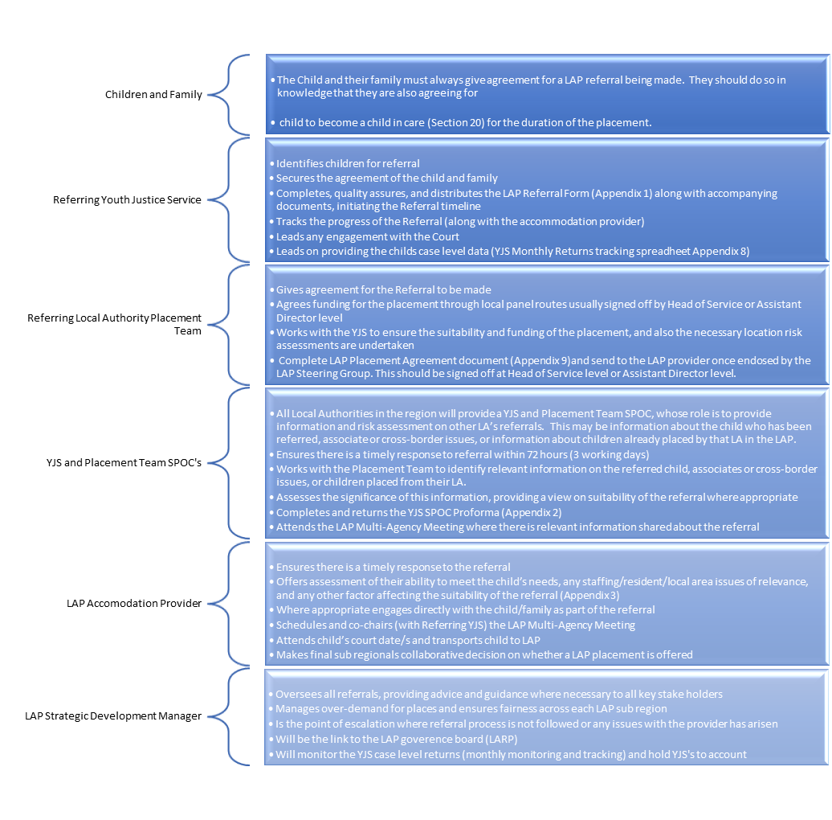

APPENDIX 2: Evaluation Infographic

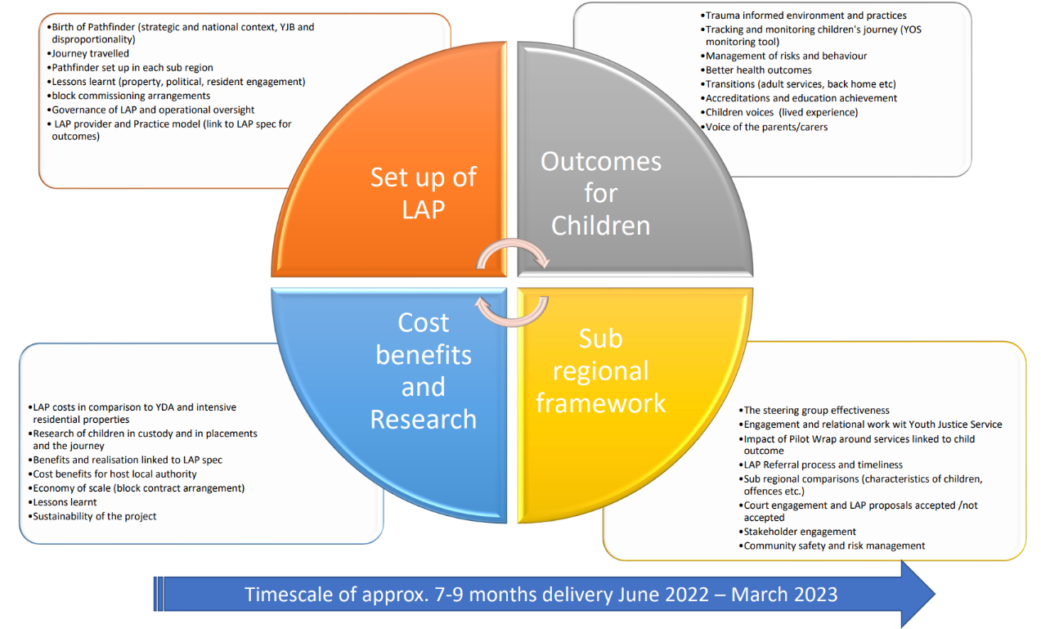

APPENDIX 3: LARP Structure
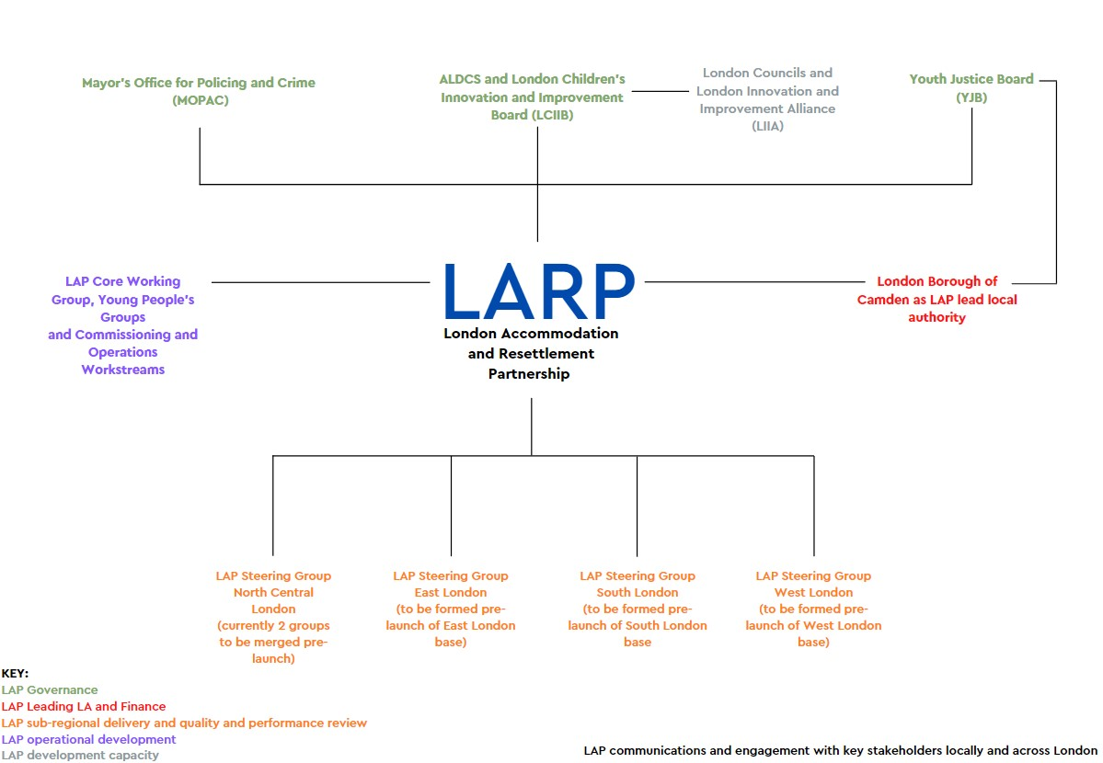

APPENDIX 4: LARP Board Interview Questions Stage 1

SET UP OF THE LAP
- Can you take us through the journey of the LAP development?
- What were the greatest challenges in the design process? How did you overcome these challenges?
- How is the intervention expected to work and what is the evidence that supports this thinking?
- What do you perceive to be the strengths in the design/set-up of the intervention? Why?
- What do you perceive to be the weaknesses of the design/set-up of the intervention? Why?
- Have the children been involved in the development of the lap. If so, how?
- What was their feedback?
- Did you make any amendments based off this?
- Did you involve the parents/carers of those children engaged in the LAP, if so, how?
- What was their feedback?
- Did you make any amendments based of this?
- If you had the opportunity to repeat this process what would you do differently, if anything?

OUTCOMES FOR THE CHILDREN
- Why is this programme a positive alternative for the children?
- What do you envisage as being the primary outcomes goals for the children engaging with the programme?
- What are the main challenges for successful outcome of this intervention? Why?
- How did you develop a trauma informed environment and practice approach to tracking the children’s journey?
- How did you determine the most effective way of monitoring risk behaviours within the LAP housing?
- How did you determine the most effective way of monitoring better health outcomes within the LAP?

COST BENEFITS AND RESEARCH
- What would render the LAP cost effective in comparison to the Youth Detention Accommodation and the alternative intensive residential properties?
- What has been the greatest, unforeseen, cost to the set-up of the LAP so far?
- Is this model, as it has been designed, sustainable?

SUB-REGIONAL FRAMEWORK
- We understand that there are a lot of stakeholders and groups involved in this programme, how were these groups identified and brought together? Has this proven to be effective? Why?
- What are the most important facets of a steering group in effectively contribute to the setup of the LAP?
- Can you explain why these two specific subregions were chosen?
- How were the locations of the housing chosen and what obstacles did you face in their set-up within these regions?
- Do you believe that the wrap around support needed for this LAP to be successful is in place? Why? And how have you ensured this?

APPENDIX 5: The LAP Steering Groups Questionnaire

No. | Question | Question Type | Expansion Box?
Q1 | What is your role in the development of the Supported Accommodation? | Text Box | NO
Q2 | What organisation or borough are your representing? | Text Box | NO
Q3 | How long have you been employed in your current role? | Text Box | NO
Q4 | Do you anticipate having any direct involvement with the children participating in the Supported Accommodation? | Text Box | NO
Q5 | How does the design of the Supported Accommodation compare to other (child focused) programmes that you have worked on? | Very Alike - Very Diff | YES
Q6 | What proportion of referrals to the Supported Accommodation do you anticipate being endorsed (as opposed to rejected) at the Joint Agency Meeting stage of the child selection process? | Volume options | YES
Q7 | What proportion of Supported Accommodation placement applications do you think will be granted by the court? | Volume options | YES
Q8 | How confident are you in the ability of the Supported Accommodation to identify… | Matrix
Q8 | A child's pro-offending narrative in the development of a support plan | Highly Likely - Highly Unlikely | YES
Q8 | A child's strengths and goals in the development of a support plan | Highly Likely - Highly Unlikely | YES
Q8 | A child's route plan for developing a pro-social identity as a part of their support plan | Highly Likely - Highly Unlikely | YES
Q8 | A child's personal pro-social identity as a part of their support plan | Highly Likely - Highly Unlikely | YES
Q9 | Based on your experience of similar children, how likely is it that… | Matrix
Q9 | The children will be motivated to participate in the education opportunities provided by the Supported Accommodation? | Highly Likely - Highly Unlikely | YES
Q9 | The children could be persuaded to participate in education opportunities provided by the Supported Accommodation? | Highly Likely - Highly Unlikely | YES
Q9 | The children will be self-motivated to participate in structured leisure activities (Boxing/fitness etc) provided by the Supported Accommodation? | Highly Likely - Highly Unlikely | YES
Q9 | The children could be persuaded to participate in structured leisure activities (boxing/fitness etc) provided by the Supported Accommodation? | Highly Likely - Highly Unlikely | YES
Q9 | The Supported Accommodation will improve the children's wellbeing and mental health. | Highly Likely - Highly Unlikely | YES
Q9 | The children will shift towards a pro-social identity as a result of the Supported Accommodation. | Highly Likely - Highly Unlikely | YES
Q9 | The children will be motivated to continue their journey to a pro-social identity at the point they complete the Supported Accommodation. | Highly Likely - Highly Unlikely | YES
Q10 | What do you consider the likely most helpful support provision for the children in their shift to a pro-social identity? | Text Box | NO
Q11 | What do you think is the greatest challenge facing In-House staff providing support to the children in their individual shifts to their personal pro-social identities? | Text Box | NO
Q12 | What do you consider to be the weakest element of the Supported Accommodation for supporting children's shift to a pro-social identity? | Text Box | NO
Q13 | What do you anticipate as being the greatest In-House risk to the children's shifts to a pro-social identity? | Text Box | NO
Q14 | What do you anticipate as being the greatest Out-of-House risk for the children's progression to a pro-social identity? | Text Box | NO
Q15 | What do you consider to be the greatest challenge for the children in adapting to the Supported Accommodation? | Text Box | NO

