NOTICE OF ORDER

Highways Act 1980 – Sections 119 & 118
& Wildlife and Countryside Act 1981 – Section 53

WILTSHIRE COUNCIL
The Wiltshire Council Westbury 29 (Part) and Dilton Marsh 20 (Part) Diversion and Definitive Map and Statement Modification Order 2021

&

The Wiltshire Council Westbury 28 (Part) and Dilton Marsh 19 (Part) Extinguishment and Definitive Map and Statement Modification Order 2021

Notice is hereby given that the above referenced Orders have been
submitted to the Secretary of State for Environment, Food and Rural
Affairs for determination. An Inspector will be appointed by the
Secretary of State to determine the Orders.

The start date for the above Orders is 20 November 2024.

Consideration of the Orders will take the form of a hearing.

The Hearing will be held at Wiltshire Council, County Hall, Bythesea Road, Trowbridge, Wiltshire, BA14 8JN on Wednesday 9 April 2025 at 10.00am.

The appointed Inspector will also open the Hearing as a virtual event on Wednesday 9 April 2025 at 10.00am.

Anyone wishing to attend the Hearing virtually must register that interest with the Order Making Authority as soon as possible prior to the Hearing, by telephone, details of which are set out in this notice. To take part using video, participants will need to have access to Microsoft Teams (via an app or web browser). The link https://support.microsoft.com/en-us/office/welcome-to-microsoft-teams-b98d533f-118e-4bae-bf44-3df2470c2b12 gives further information on how to use this. Alternatively, you can take part by telephone. Registered participants will receive individual joining instructions, providing details of any requirements, guidance and support, whether joining by Teams or telephone.

The effect of the first Order, if confirmed without modifications, will be to divert Footpaths Westbury 29 (part) and Dilton Marsh 20 (part) situated at Dilton Vale Farm, Old Dilton Road, Old Dilton, Westbury in the parishes of Westbury and Dilton Marsh and thereupon the Westbury Urban Council Area Definitive Map and Statement dated 1953 and the Warminster and Westbury Rural District Council Area Definitive Map and Statement dated 1953 shall be modified accordingly: Footpath Westbury 29 leading from OSGR ST 8607-4929 in a north north westerly direction for approximately 52 metres to OSGR ST 8605-4934. And leading from OSGR ST 8603-4932 in a north easterly direction for approximately 34 metres to OSGR ST 8605- 4934 then heading in a broadly north north westerly direction for approximately 99 metres to OSGR ST 8601-4942, to a new route at OSGR ST 8603-4932, leading in an east south easterly direction for approximately 51 metres to OSGR ST 8607- 4929, then heading in a north north easterly direction for approximately 140 metres to OSGR ST 8614- 4941, then heading in a broadly westerly direction for approximately 92 metres to OSGR ST 8605-4944. Having a width of 3 metres. Footpath Dilton Marsh 20 leading from OSGR ST 8601-4942 in a north westerly direction for approximately 90 metres to OSGR ST 8596-4949, to a new route at OSGR ST 8605-4944, leading in a broadly west north westerly direction for approximately 105 metres to OSGR ST 8596-4949. Having a width of 3 metres.

The effect of the second Order, if confirmed without modifications, will be to extinguish the entire width of that length of footpath, over land at Dilton Vale Farm, Old Dilton Road, Old Dilton, Westbury. If confirmed the order will also have the effect of modifying the Westbury Urban Council Area Definitive Map and Statement dated 1953 and the Warminster and Westbury Rural District Council Area Definitive Map and Statement dated 1953 shall be modified accordingly: Footpath Westbury 28 leading from OSGR ST 8604-4938 in a broadly northerly direction for approximately 48 metres to OSGR ST 8605-4943. Footpath Dilton Marsh 19 leading from OSGR ST 8605-4943 in a broadly northerly direction for approximately 13 metres to OSGR ST 8605-4944.

Any queries relating to these Orders should be referred to Helen Sparks by email: helen.sparks@planninginspectorate.gov.uk
quoting reference numbers ROW/3301931 & ROW/3301934 on all correspondence. Alternatively, queries may be sent in writing to The Planning Inspectorate, Rights of Way Section, Room 3/A Eagle Wing, Temple Quay House, 2 The Square, Temple Quay, Bristol, BS1 6PN. Telephone: 0303 444 5646.

Any person wishing to view the statements of case and other documents relating to these Orders may do so by appointment at Wiltshire Council, County Hall, Bythesea Road, Trowbridge, Wiltshire, BA14 8JN from 0900 to 1700 Monday to Friday. To book An appointment to view the documents please contact definitivemap@wiltshire.gov.uk or Tel: 01225 756178. The paperwork is also available on the Rights of Way pages on Wiltshire Council website at P/2020/010 - Rights Of Way - Wiltshire Council. For queries, please contact Ali Roberts, Definitive Map Officer by email: ali.roberts@wiltshire.gov.uk or Telephone: 01225 756178.

Timetable for sending in statements of case

Within 8 weeks of the start date [by 15 January 2025]

The Order Making Authority must ensure their statement of case is received by the Secretary of State. As soon as possible after the deadline, the Secretary of State will send a copy (excluding copies of any supporting documents, although these will be available to view at the Authority’s offices) to everyone who has made an objection or representation, the applicant and any other person who has written to us in respect of the Orders.

Within 12 weeks of the start date [by 12 February 2025]

Everyone who has made an objection or representation and anyone who wishes to give evidence at the Hearing must ensure their statement of case is received by the Secretary of State. As soon as possible after the deadline, the Secretary of State will send full copies to the Authority. Copies will also be sent to the applicant, every person who has made an objection or representation and any other person who has written to us in respect of the Orders (excluding copies of any supporting documents - these will be available to view at the Authority’s offices).

Within the same period the applicant (if applicable) must ensure their statement of case is received by the Secretary of State. As soon as possible after the deadline, the Secretary of State will send a full copy to the Authority. Copies will also be sent to everyone who has made an objection or representation and any other person who has written to us in respect of the Orders (excluding copies of any supporting documents - these will be available to view at the Authority’s offices).

All parties must keep to the timetable set out above and ensure that statements of case are received by the Secretary of State on time. Late documents will be returned.

We cannot accept any inflammatory, discriminatory or abusive comments. Any documents containing such comments will be returned.

Notice of order for hearing

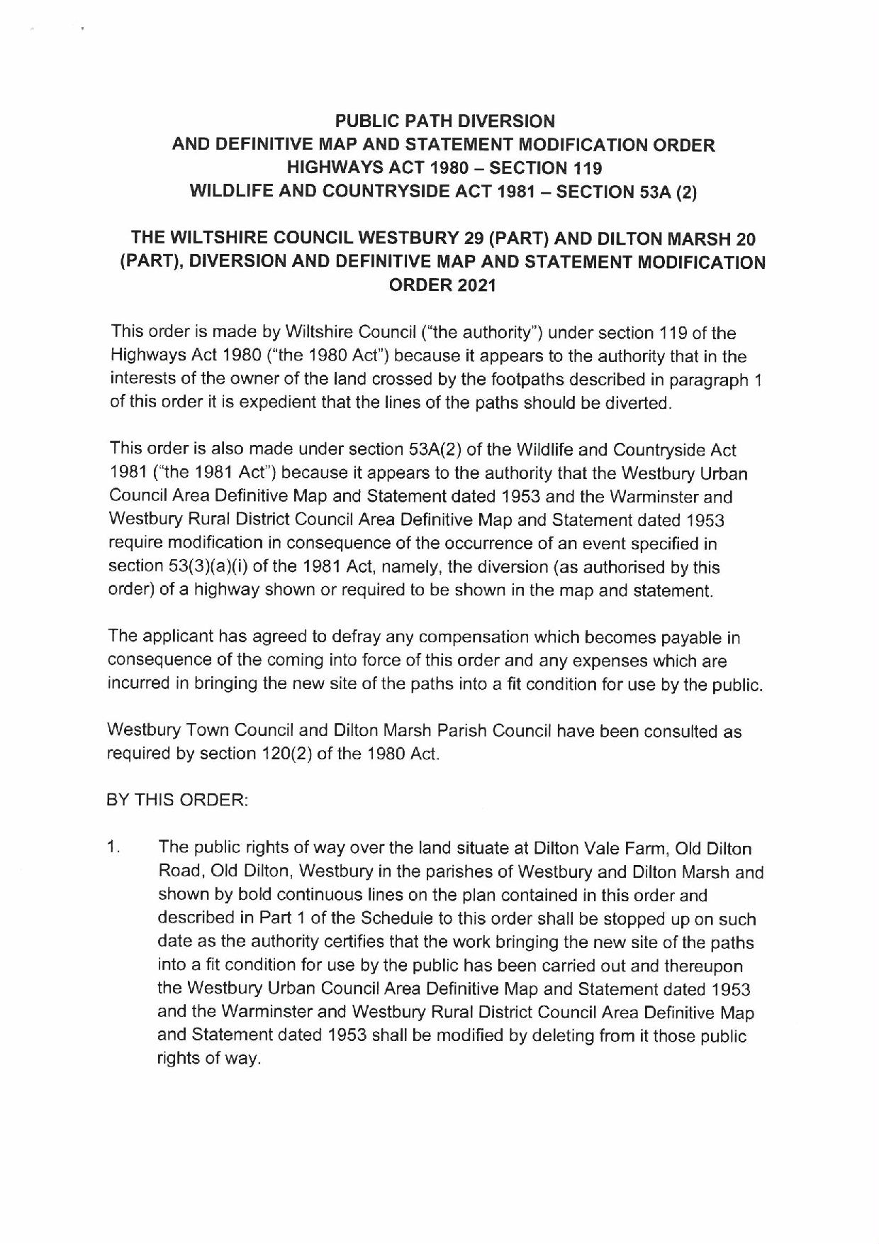

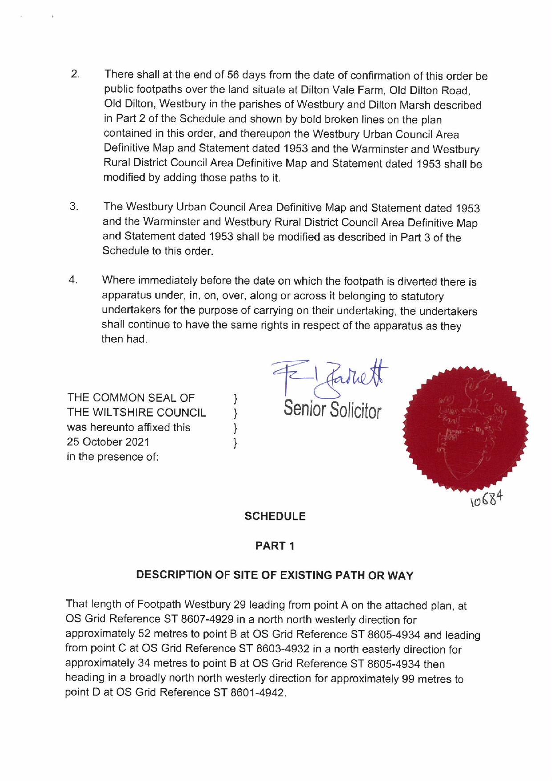

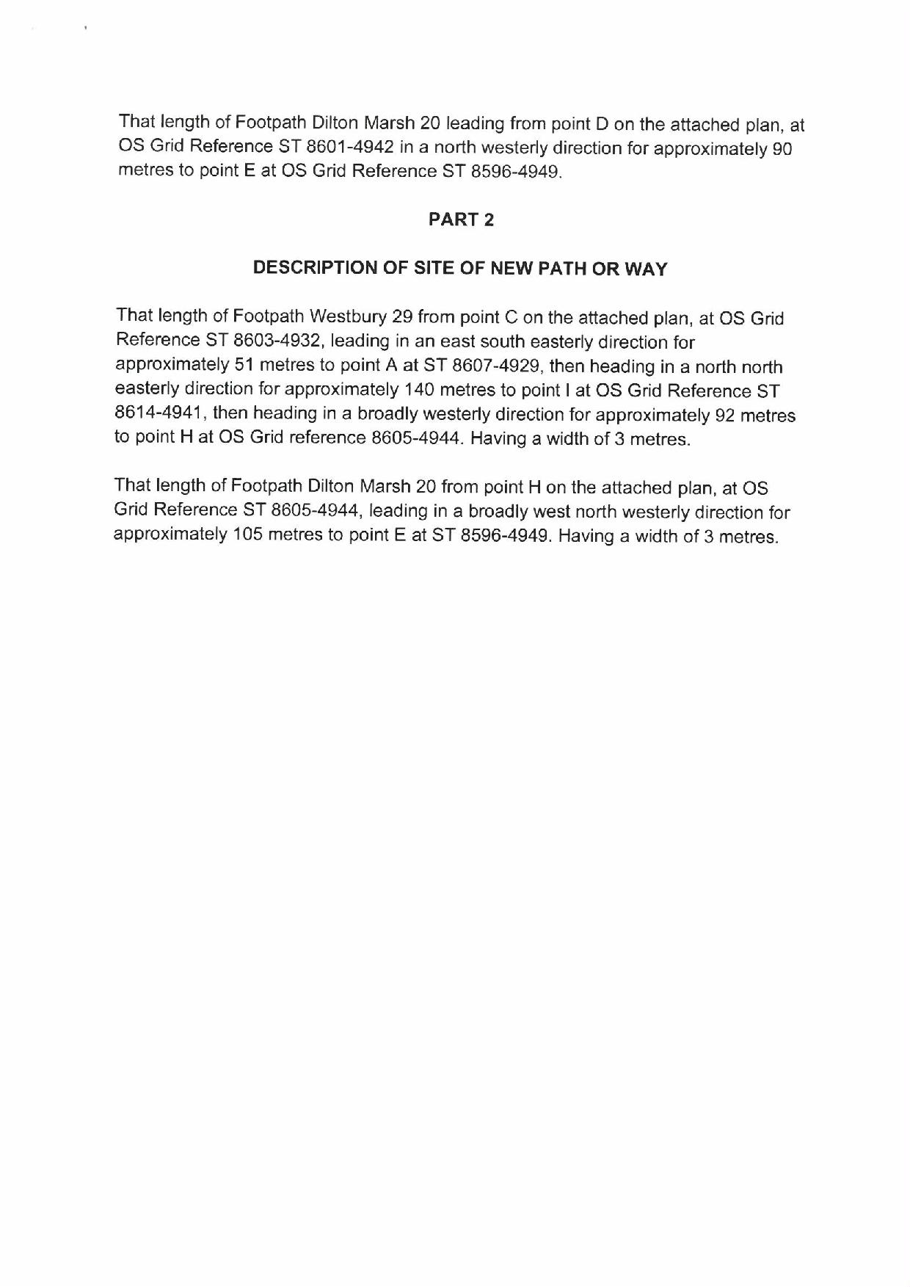

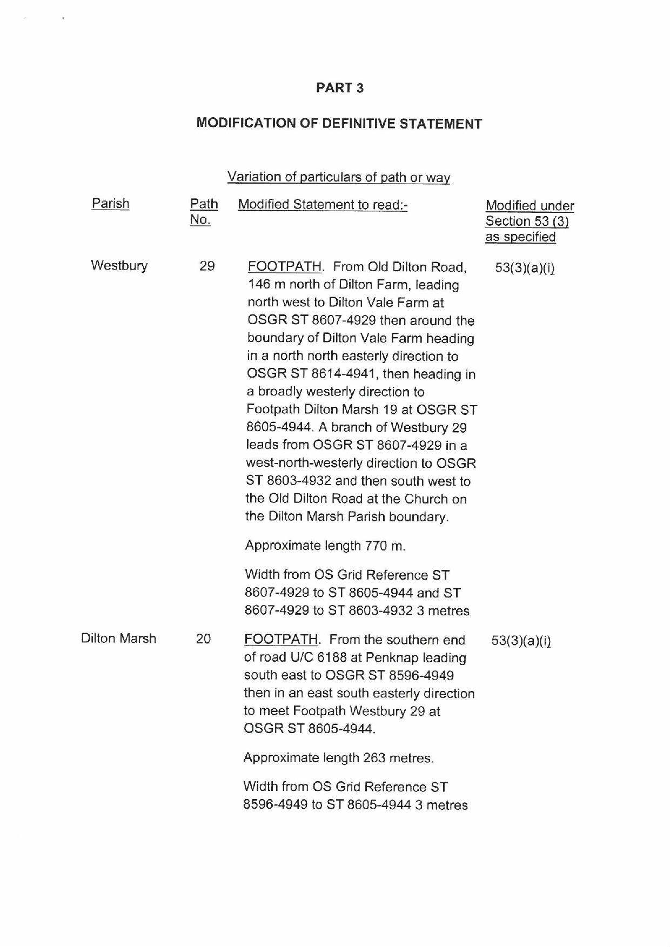

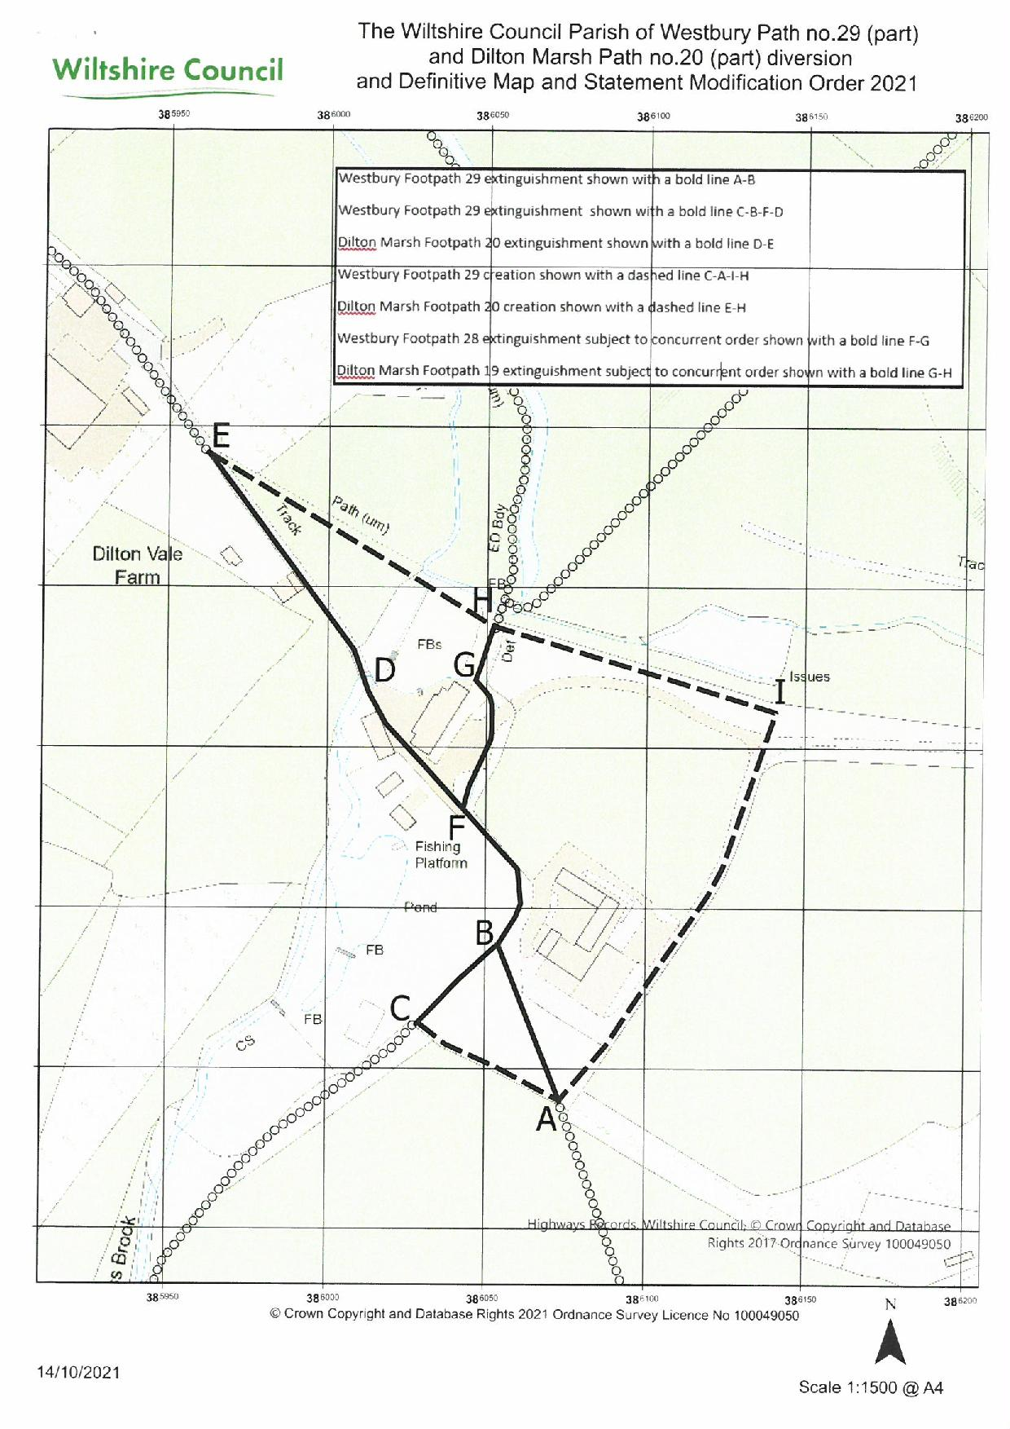

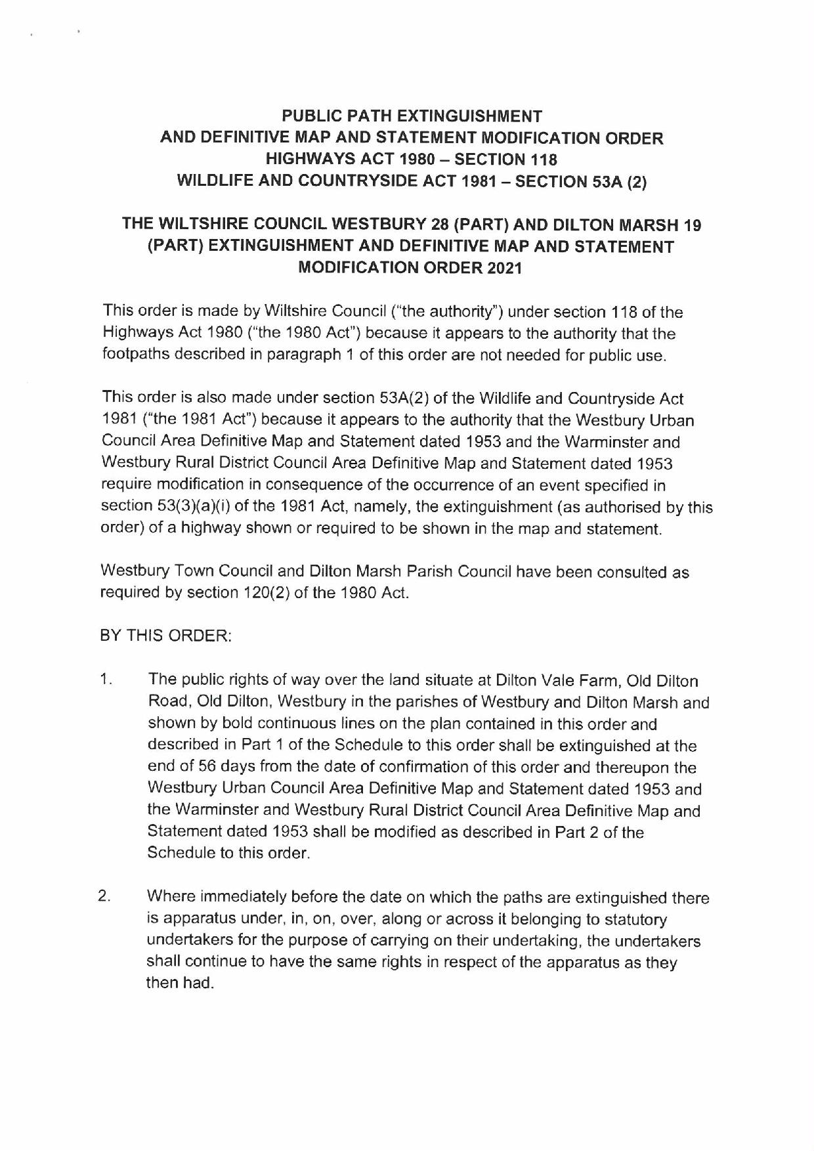

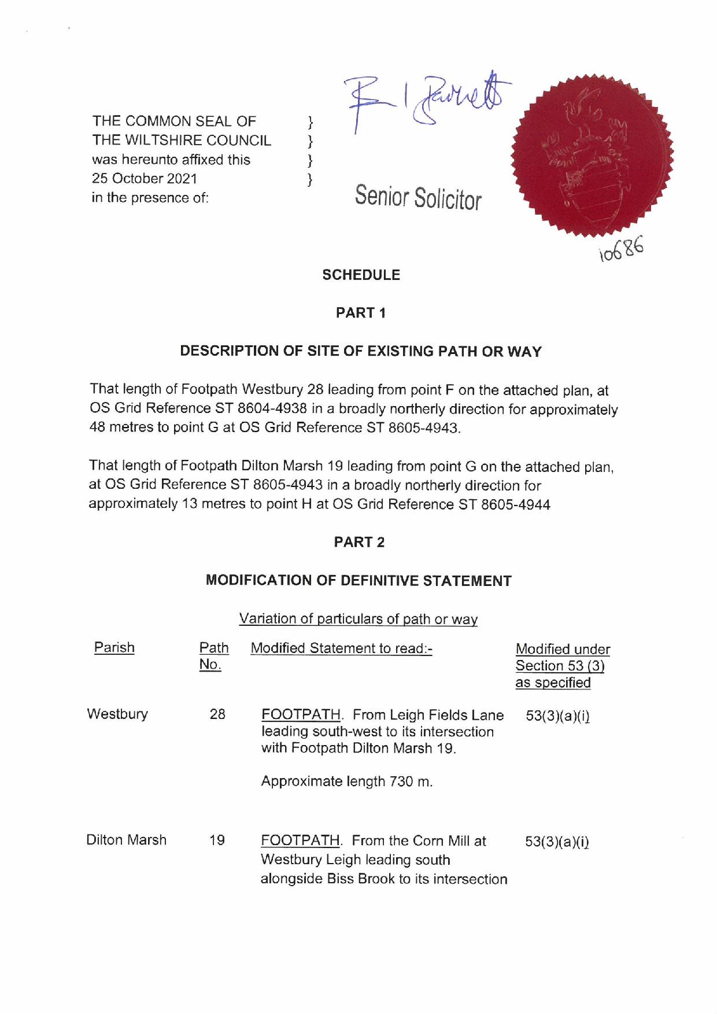

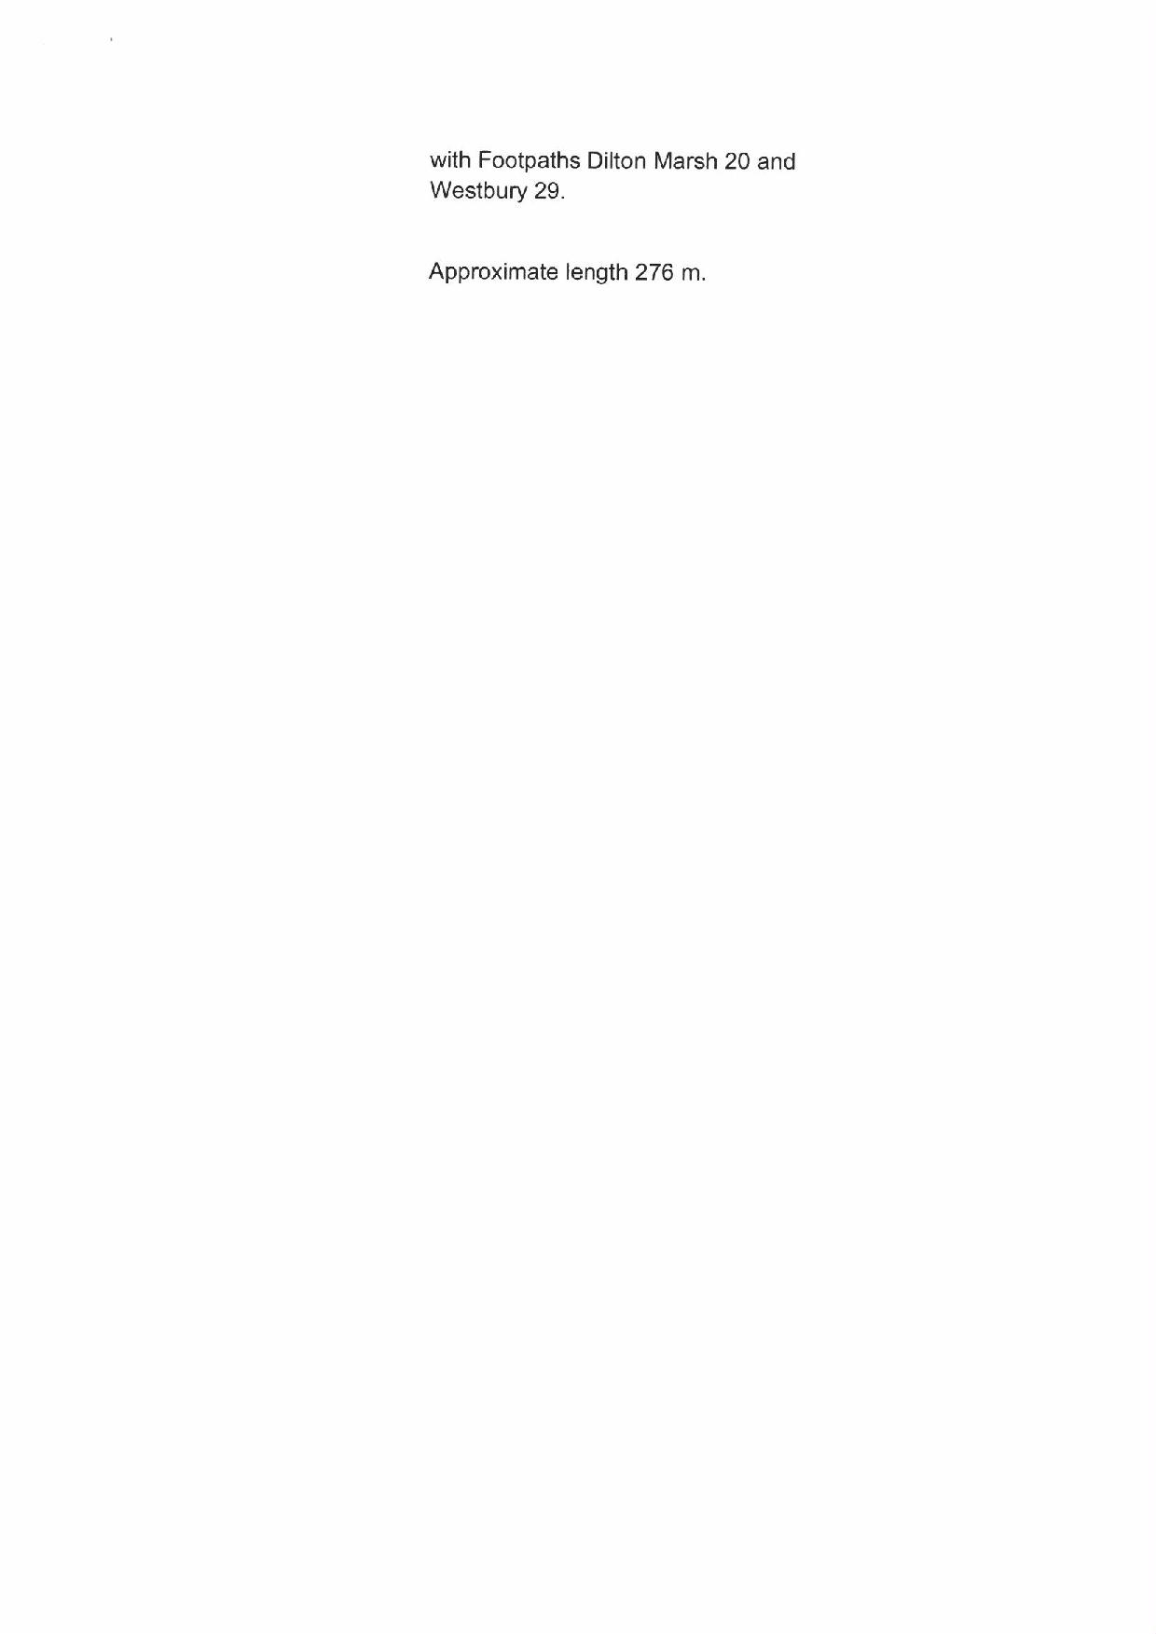

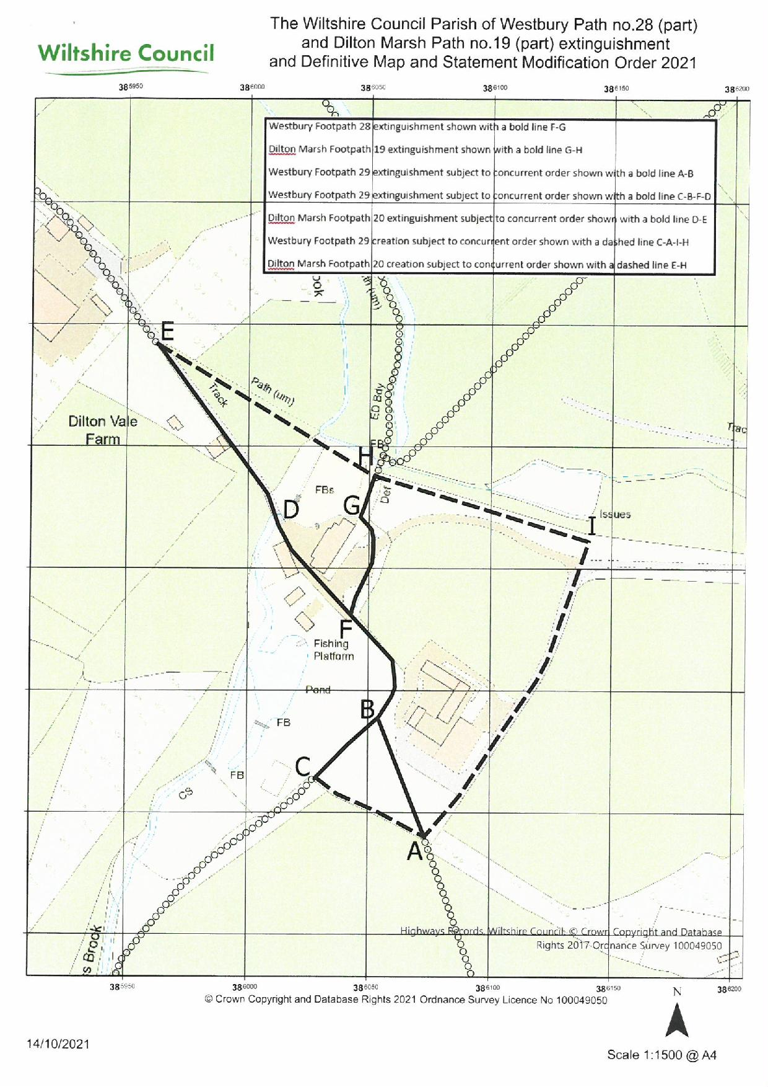

If you wish to make a legal submission, this should be submitted at the same time as your statement of case. Otherwise legal submissions will have to be submitted in writing on the day of the hearing.

