NOTICE OF ORDER

Wildlife and Countryside Act 1981 – Section 53
WILTSHIRE COUNCIL
The Wiltshire Council Trowbridge Path No.8 Definitive Map and Statement Order 2021

Notice is hereby given that the above referenced Order has been submitted to the Secretary of State for Environment, Food and Rural Affairs for determination. Following an earlier exchange of written representations, the Inspector appointed to determine the Order issued a letter in which he proposed to make modifications to the Order as drafted. Following advertisement of those proposals objections/representations have been received.

The start date for the above Order is 16 October 2024.

Consideration of the Order will take the form of a hearing. It is being held so that the Inspector can hear evidence in respect of the modified part of the Order and new evidence in respect of the unmodified part of the Order.

The Hearing will be held at West Wilts Meeting Room, Wiltshire Council, County Hall, Bythesea Road, Trowbridge, Wiltshire, BA14 8JN on Tuesday 4 February 2025 at 10.00am.

The appointed Inspector will also open the Hearing as a virtual event on Tuesday 4 February 2025 at 10.00am.

Anyone wishing to attend the Hearing virtually must register that interest with the Order Making Authority by 4pm on Monday 3 February 2025, by telephone or by e-mail, details of which are set out in this notice.

To take part using video, participants will need to have access to Microsoft Teams (via an app or web browser). The link https://support.microsoft.com/en-us/office/welcome-to-microsoft-teams-b98d533f-118e-4bae-bf44-3df2470c2b12 gives further information on how to use this. Alternatively, you can take part by telephone. Registered participants will receive individual joining instructions, providing details of any requirements, guidance and support, whether joining by Teams or telephone.

The effect of the Order, if confirmed without modifications will be to modify the definitive map and statement for the area by upgrading to a bridleway the public right of way,(Path no.8 Trowbridge, Church Lane), leading from its junction with Frome Road at OS Grid Reference ST 8427-5629, in a generally north-westerly direction for approximately 294 metres to its junction with Path no.9 Trowbridge at OS Grid Reference ST 8407-5648, and varying the particulars relating to Path no. 8 Trowbridge by providing a recorded width varying between 4 metres and 13 metres, as shown on the Order Map.

The effect of the proposed modifications would be to provide for the following:
- Delete ‘in green’ from the first line of the description in Part I of the Order Schedule.
- Delete ‘in green’ from the fifth line of the description in Part I of the Order Schedule.
- Delete the sixth and seventh lines from the description in Part I of the Order Schedule.
- Replace ‘4m’ in the seventh line of the description in Part II of the Order Schedule with ‘7m’.
- Add at the end of the description in Part II of the Order Schedule:

‘Limitations

The Wiltshire Council may permit posts or bollards to be erected between points X and Y on the Order Map to prevent use by mechanically propelled vehicles’.
- Include the remainder of Church Lane within the Order Map and add points X and Y at the appropriate points.
- Modify the key to the Order Map to reflect the extent of the route.

Any queries relating to this Order should be referred to Helen Sparks by email: helen.sparks@planninginspectorate.gov.uk
quoting reference number ROW/3295476M1 on all correspondence. Alternatively, queries may be sent in writing to The Planning Inspectorate, Rights of Way Section, Room 3/A Eagle Wing, Temple Quay House, 2 The Square, Temple Quay, Bristol, BS1 6PN. Telephone: 0303 444 5646.

Any person wishing to view the statements of case and other documents relating to this Order may do so by appointment from 9am – 5pm Monday to Friday at the offices of: Rights of Way and Countryside, Wiltshire Council, County Hall, Bythesea Road, Trowbridge, Wiltshire, BA14 8JN. To make an appointment to view please E-mail: definitivemap@wiltshire.gov.uk or Telephone: 01225 713345.

Documents will also be placed on the Wiltshire Council website and may be viewed using the following link: https://apps.wiltshire.gov.uk/RightsOfWay/Map/Index/D2018006

For any queries, please contact Janice Green, Senior Definitive Map
Officer – E-mail: janice.green@wiltshire.gov.uk or Telephone:
01225 713345.

Timetable for sending in statements of case

Within 8 weeks of the start date [by 11 December 2024]

The Order Making Authority, the applicant and everyone who has made an objection or representation following the proposed modifications and anyone who wishes to give evidence at the Hearing must ensure their statement of case is received by the Secretary of State. As soon as possible after receiving it the Secretary of State will send a full copy to the Authority. Copies (excluding copies of any supporting documents - these will be available to view at the Authority’s offices) will also be sent to everyone who has made an objection or representation following the proposed modifications, the applicant and anyone else who has previously written to us in respect of the Order.

All parties must keep to the timetable set out above and ensure that statements of case are received by the Secretary of State on time. Late documents will be returned.

We cannot accept any inflammatory, discriminatory or abusive comments. Any documents containing such comments will be returned.

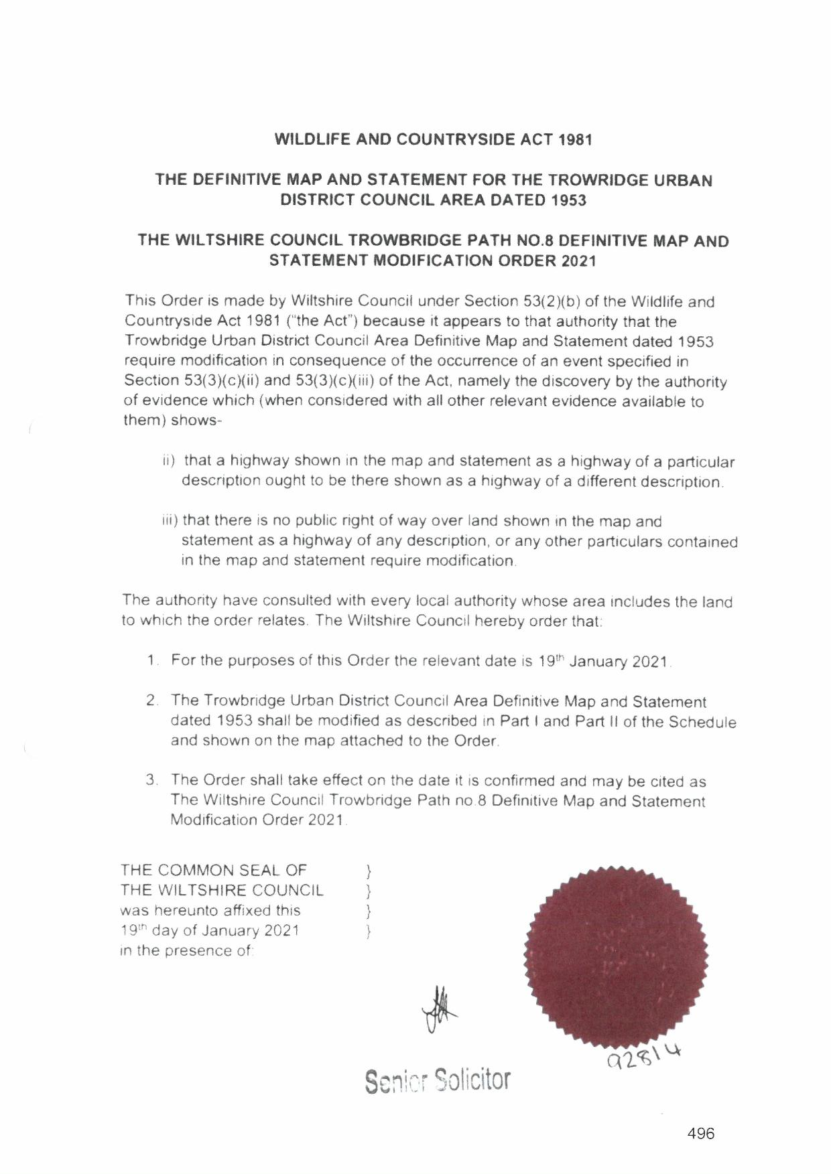

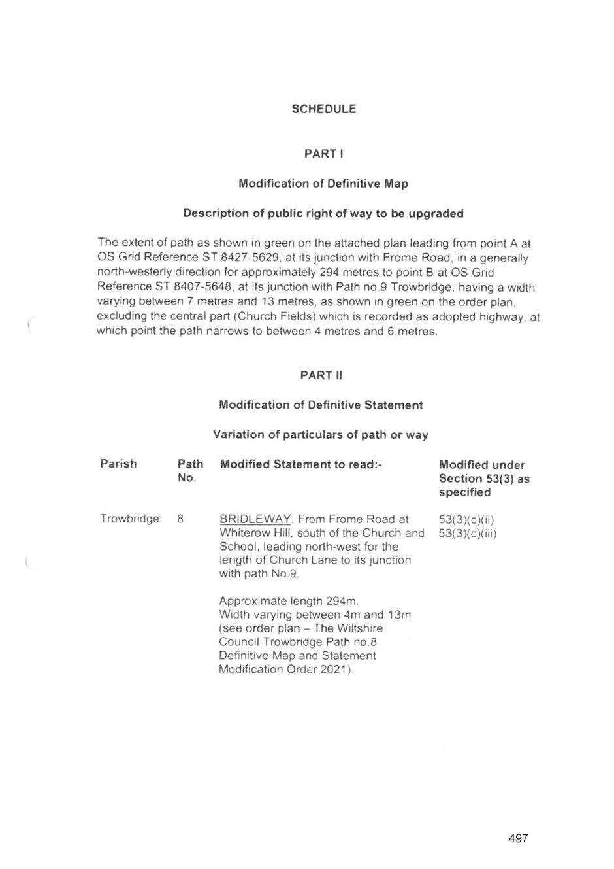

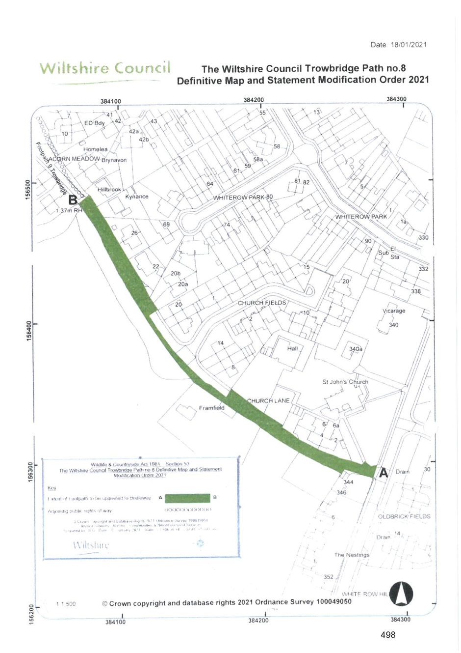

If you wish to make a legal submission, this should be submitted at the same time as your statement of case. Otherwise legal submissions will have to be submitted in writing on the day of the hearing.

