NOTICE OF ORDER
Wildlife and Countryside Act 1981 - Section 53
Lincolnshire County Council
Addition of Public Footpath Number 1182 & 1183 Chapel St Leonards
Definitive Map Modification Order 2021
Notice is hereby given that the above referenced Order has been submitted to the Secretary of State for Environment, Food and Rural Affairs for determination. An Inspector will be appointed by the Secretary of State to determine the Order.
The start date for the above Order is [03 October 2024]
Consideration of the Order will take the form of a public local inquiry.
The Inquiry will be held at Chapel St. Leonards Village Hall, 28 Sea Road, Chapel St Leonards, Lincs, PE24 5SA on 25 February 2024 at 10.00am.
The effect of the Order, if confirmed without modifications, will be to modify the definitive map and statement for the area by adding Public Footpath No.1182 in the parish of Chapel St Leonards running from St Leonards Drive at Ordnance Survey Grid Reference ("OSGR") TF 5602 7303 in a generally south-easterly direction for approximately 47 metres to OSGR 5607 7301 on Roman Bank. The Public Footpath has a width of 1.0 metre and a total length of 47 metres as shown on Order drawing 2020/007/DMMO 404 between points E-C. And also adding Public Footpath No.1183 in the parish of Chapel St Leonards running in a generally south westerly direction from the promenade at OSGR TF 5617 7311 over sand dunes then continuing over Roman Bank to meet with Public Footpath No 37 at OSGR TF 5607 7297. The Public Footpath has the following widths as shown on Order drawing 2020/007/DMMO 404 between points A-B-C-D: At point A the Public Footpath has a width of 2 metres where it meets the promenade. At point B where it meets Roman Bank the Public Footpath has a width of 1.3 metres. Between points B-C– D on Roman Bank the Public Footpath has width of 3 metres. At point D the Public Footpath has a width of 4 metres where it meets Public Footpath No 37. The total length of the path is approximately 181 metres as shown on Order drawing 2020/007/DMMO 404 between points A-B-CD.
Any queries relating to this Order should be referred to Ian Aston by email: ian.aston@planninginspectorate.gov.uk quoting reference numbers ROW/3317245 on all correspondence. Alternatively, queries may be sent in writing to The Planning Inspectorate, Rights of Way Section, Room 3/A Eagle Wing, Temple Quay House, 2 The Square, Temple Quay, Bristol, BS1 6PN. Telephone: 0303 444 5670.
Any person wishing to view the statements of case and other documents relating to this Order may do so by appointment at Main Reception, Lincolnshire County Council, County Offices, Newland, Lincoln, LN1 1YL. Contact: Andrew Pickwell, Senior Definitive Map Officer, telephone 01522 782070 or e-mail countryiside_access@lincolnshire.gov.uk
Timetable for sending in statements of case and proofs of evidence

Within 8 weeks of the start date by [28 November 2024]
The Order Making Authority must ensure their statement of case is received by the Secretary of State. As soon as possible after the deadline, the Secretary of State will send a copy (excluding copies of any supporting documents - these will be available to view at the Authority’s offices) to everyone who has made an objection or representation and the applicant and any other person who has written to us in respect of the Order.

Within 14 weeks of the start date [9 January 2025]
Everyone who has made an objection or representation and anyone who wishes to give evidence at the Inquiry must ensure their statement of caseis received by the Secretary of State. As soon as possible after the deadline, the Secretary of State will send full copies to the Authority. Copies will also be sent to the applicant, every person who has made an objection or representation and any other person who has written to us in respect of the Order (excluding copies of any supporting documents - these will be available to view at the Authority’s offices).
Within the same period the applicant (if applicable) must ensure their statement of case is received by the Secretary of State. As soon as possible after the deadline, the Secretary of State will send a full copy to the Authority. Copies will also be sent to everyone who has made an objection or representation and any other person who has written to us in respect of the Order (excluding copies of any supporting documents - these will be available to view at the Authority’s offices).

weeks before the date of the inquiry [28 January 2025]
The Authority, everyone who has made an objection or representation, the applicant (if applicable) and anyone who wishes to give evidence at the Inquiry must ensure their proof of evidence (together with any summary) is received by the Secretary of State. As soon as possible after the deadline, the Secretary of State will send copies of:
- the Authority’s proof of evidence to everyone who has made an objection or representation, the applicant and anyone who has submitted a statement of case (including copies of any supporting documents – although none should be submitted with a proof of evidence);
- the applicant’s proof of evidence to the Authority, everyone who has made an objection or representation and anyone else who has submitted a statement of case (including copies of any supporting documents – although none should be submitted with a proof of evidence); and
- all other proofs of evidence to the Authority, the applicant, everyone who has made an objection or representation and anyone else who has submitted a statement of case (including copies of any supporting documents – although none should not be submitted with a proof of evidence).
All parties must keep to the timetable set out above and ensure that statements of case and proofs of evidence are received by the Secretary of State on time. Late documents will be returned.
We cannot accept any inflammatory, discriminatory or abusive comments. Any documents containing such comments will be returned.
Notice of order for inquiry
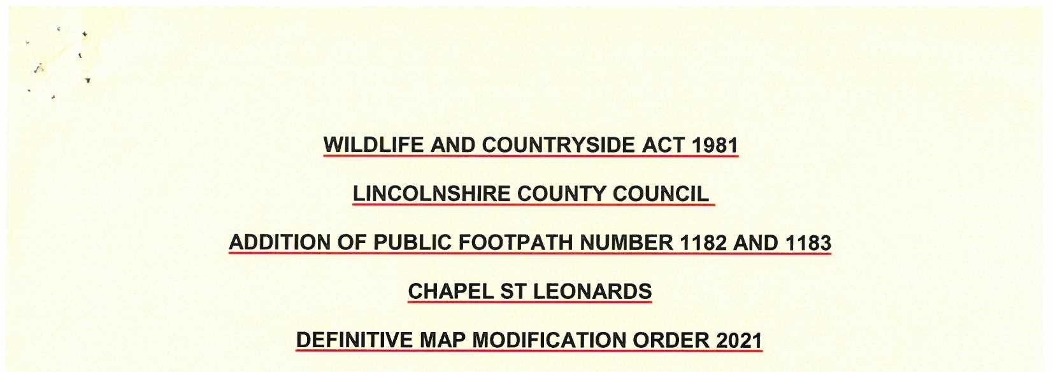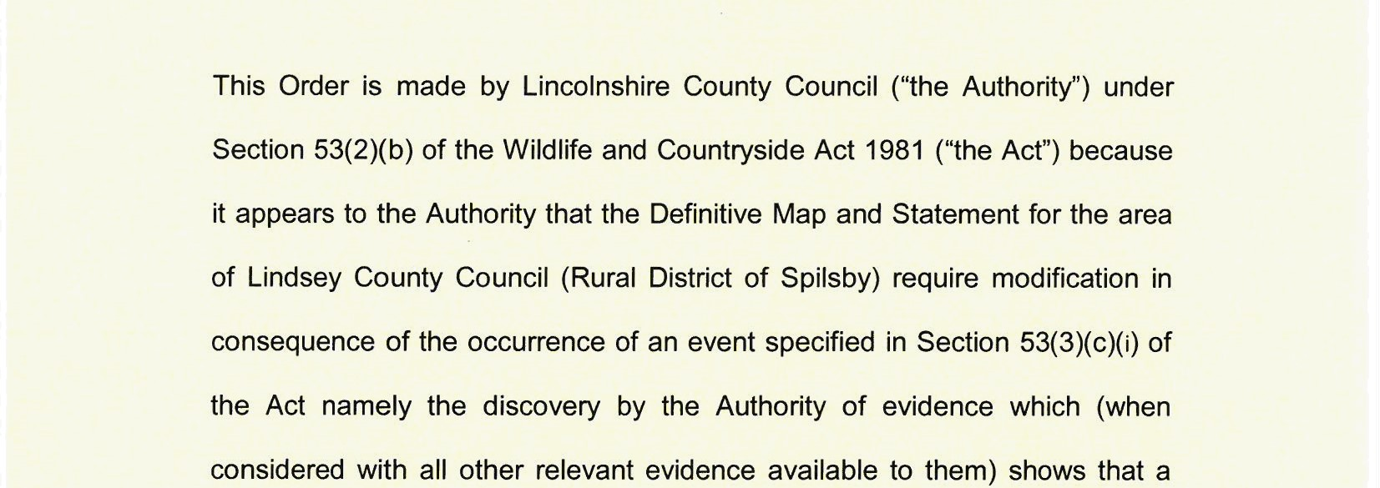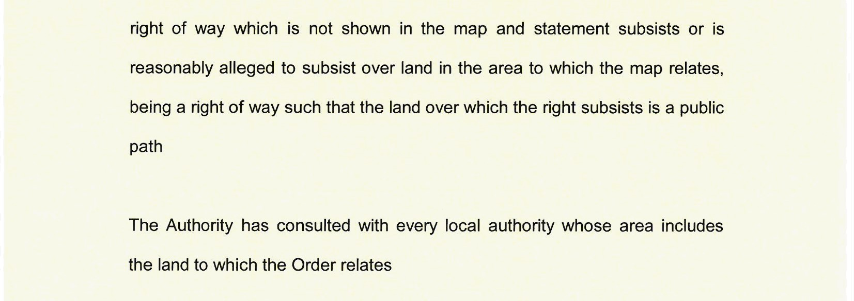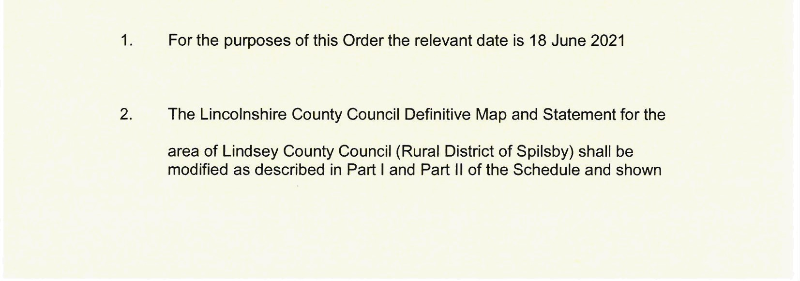
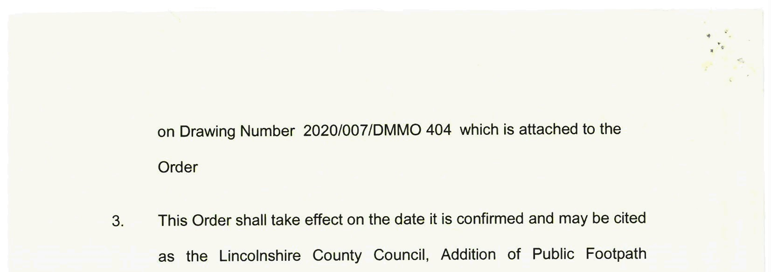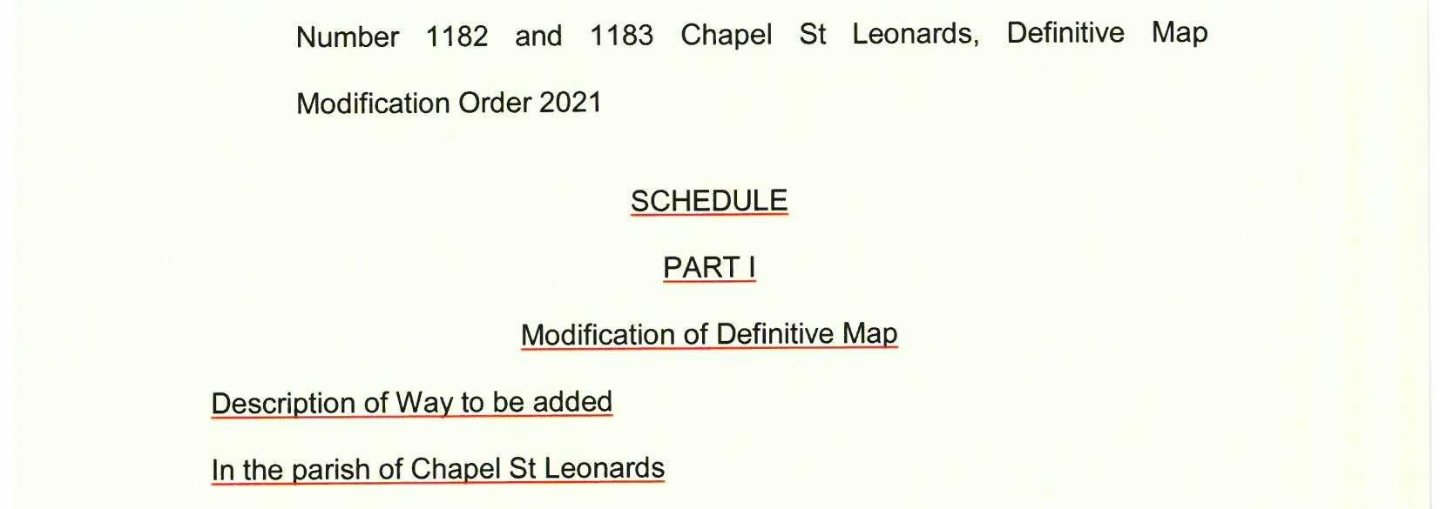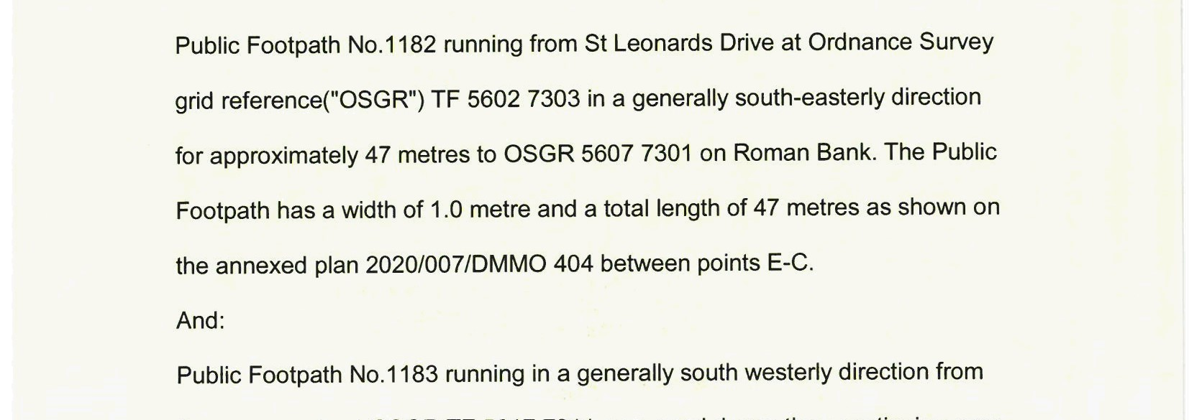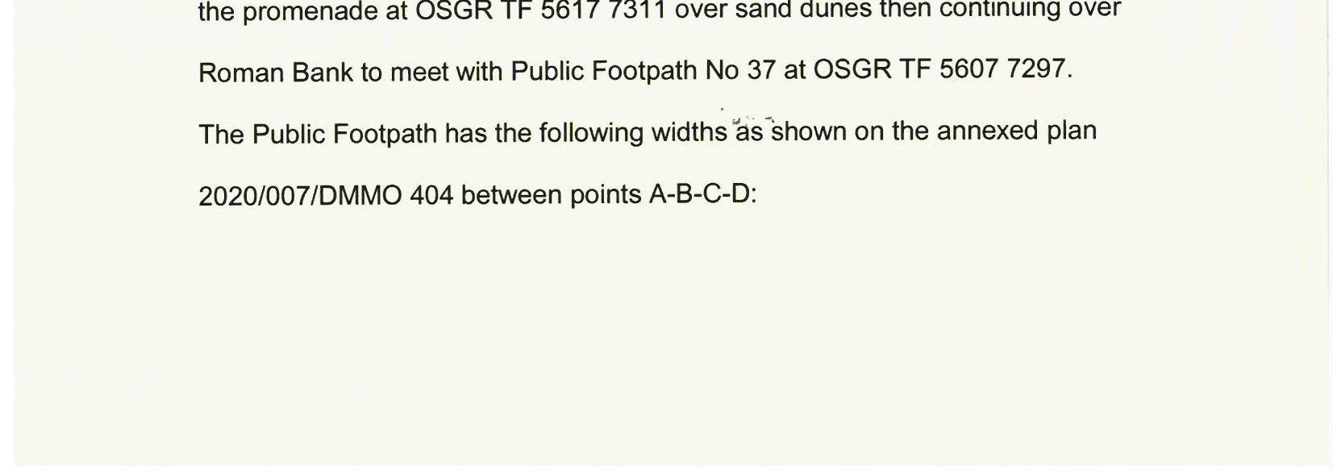
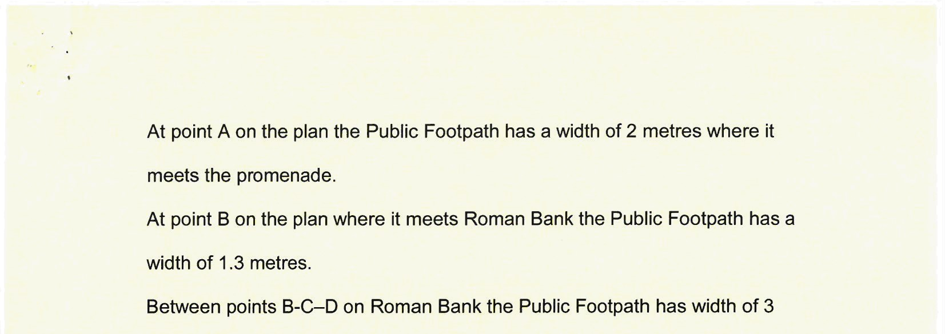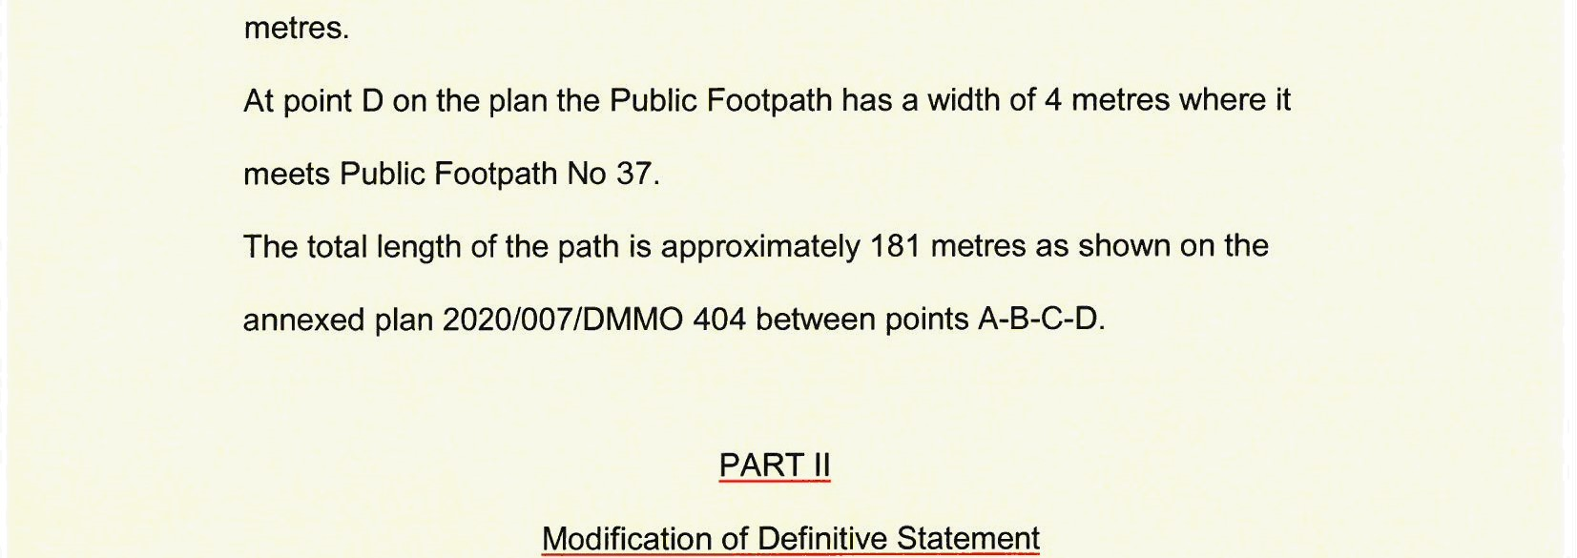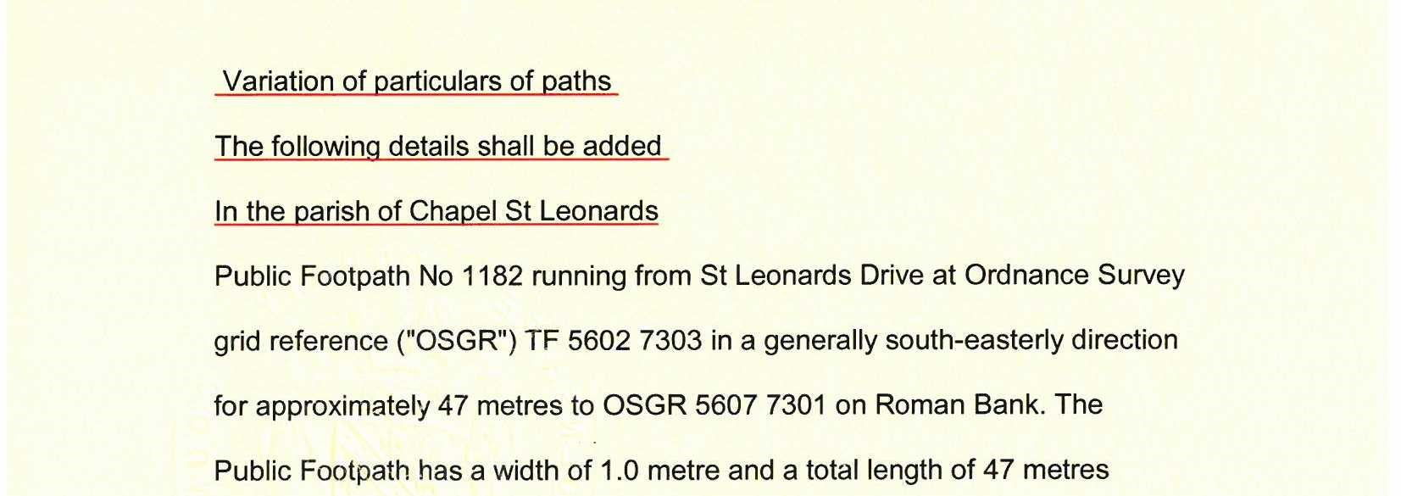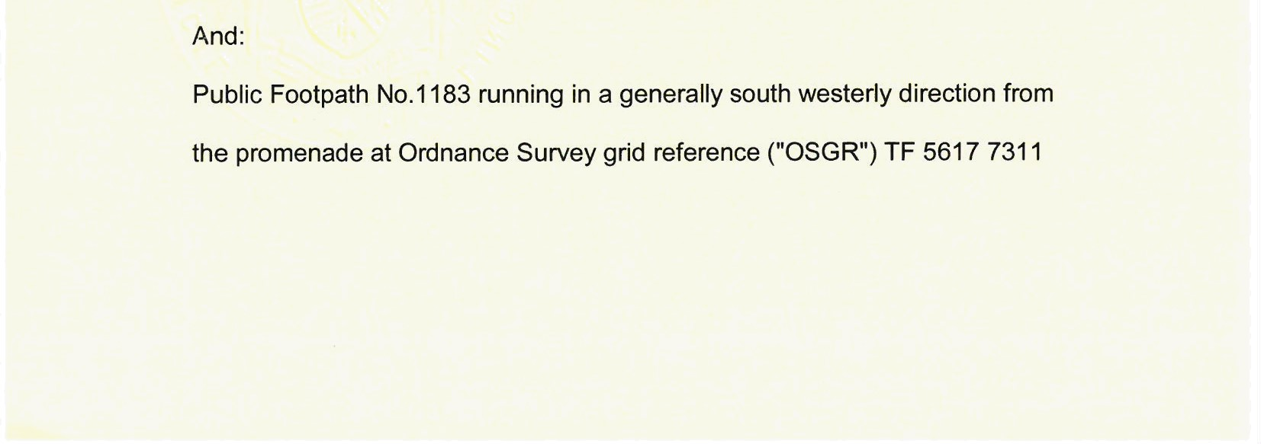
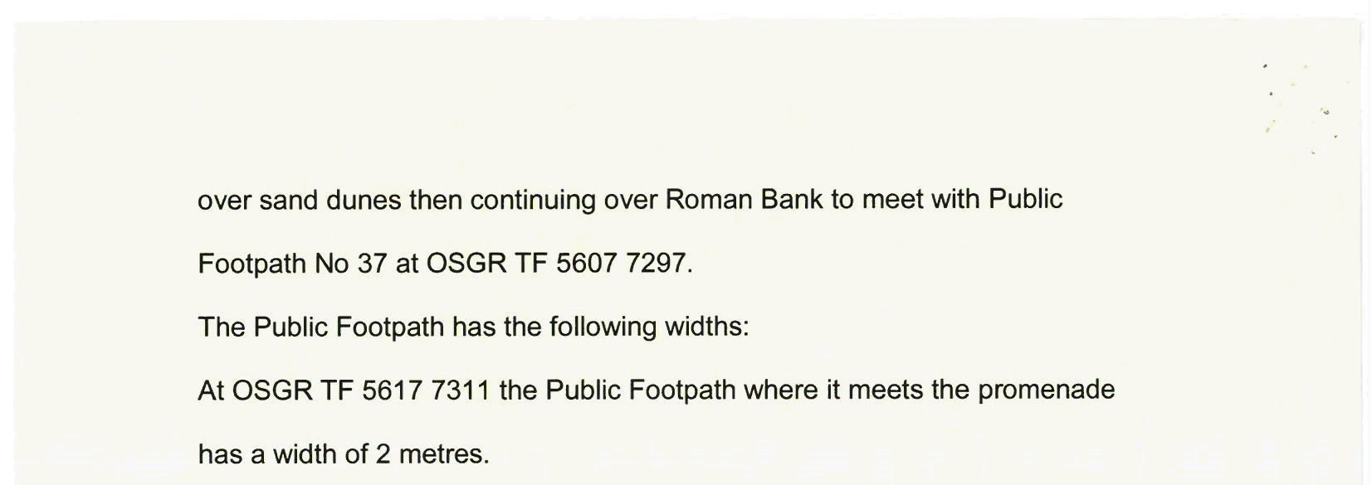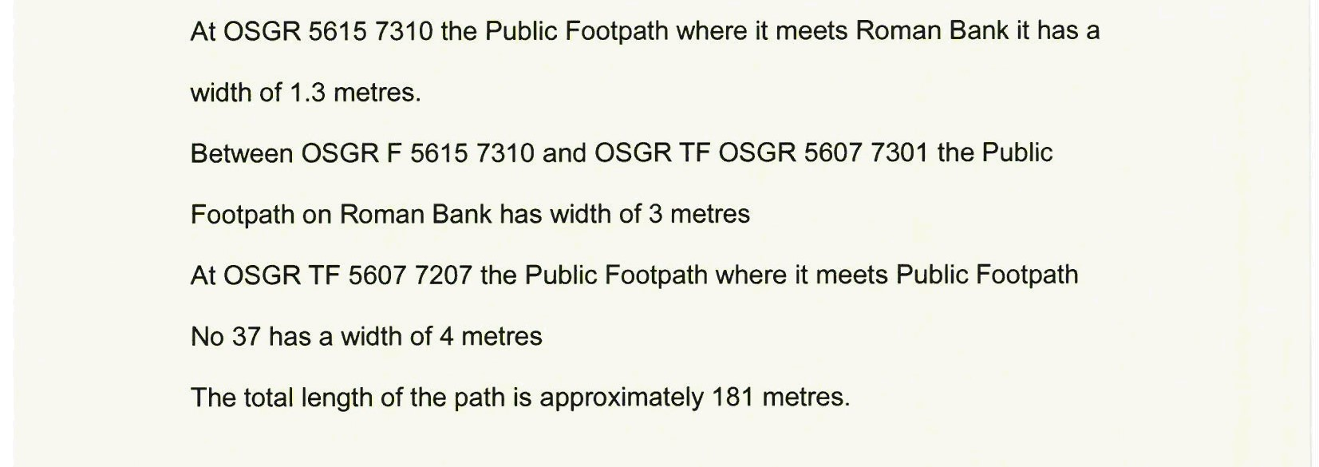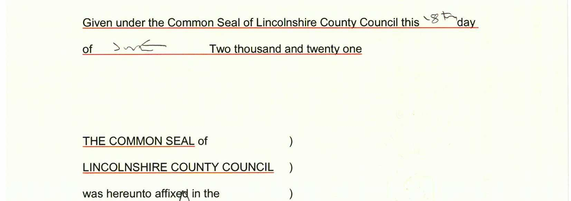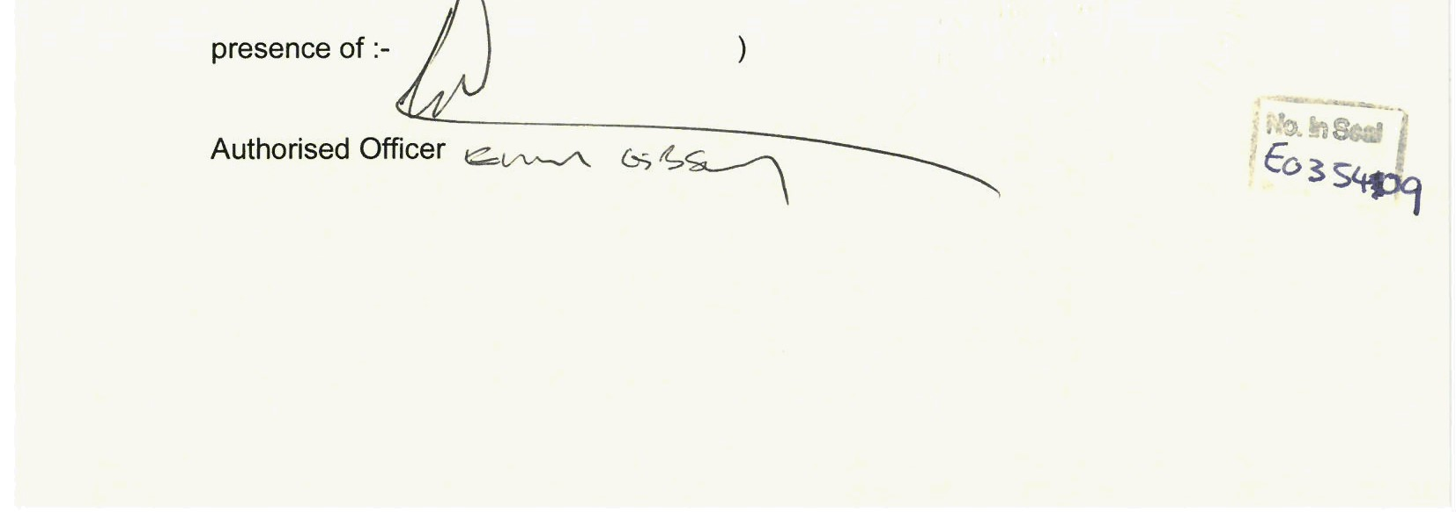
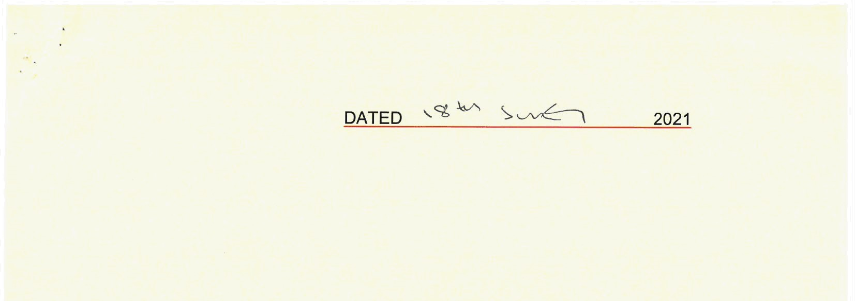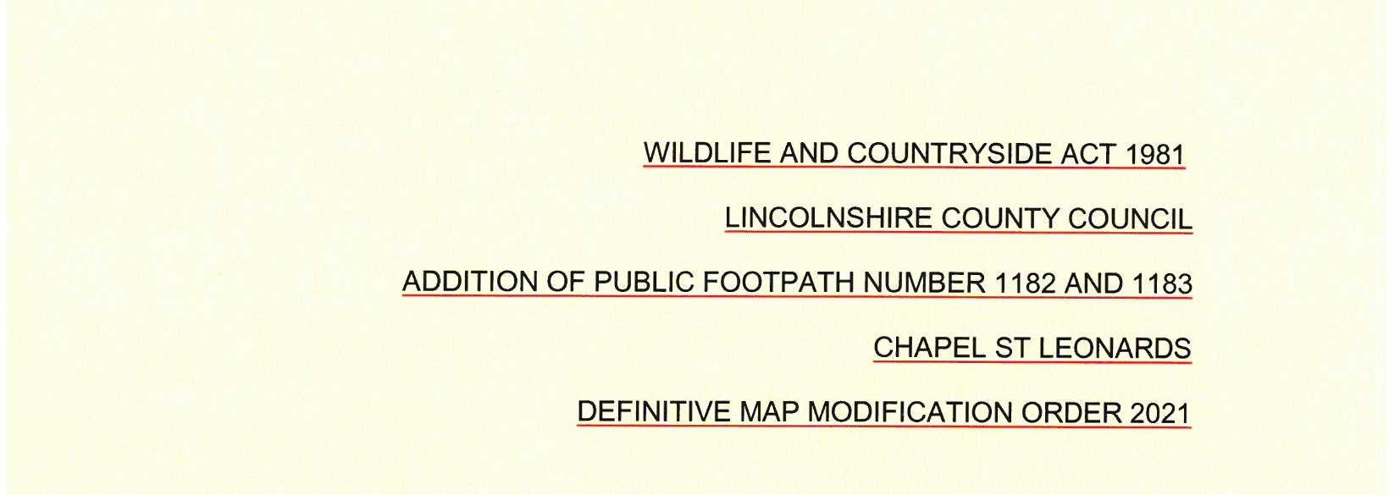
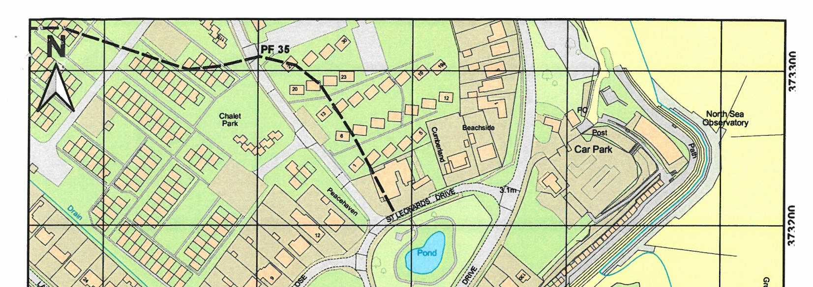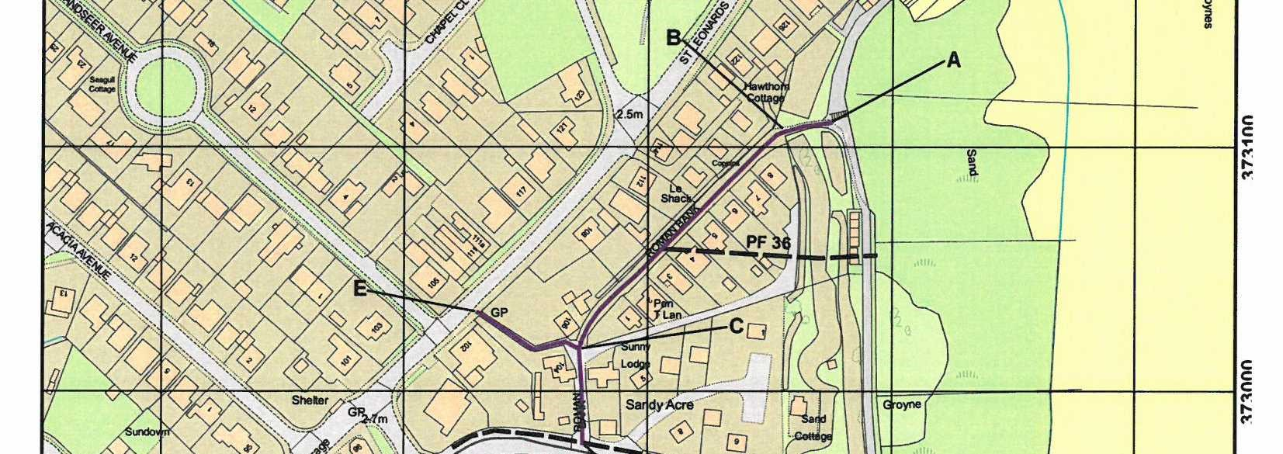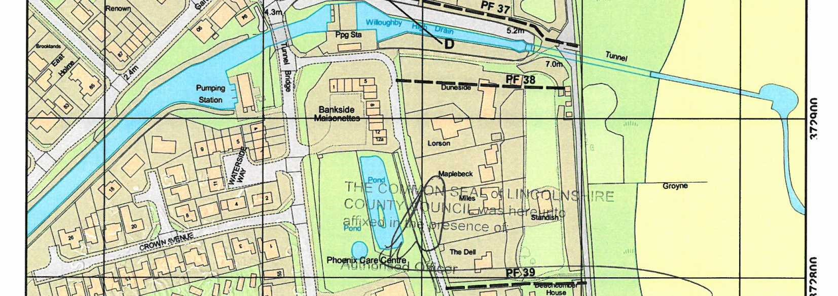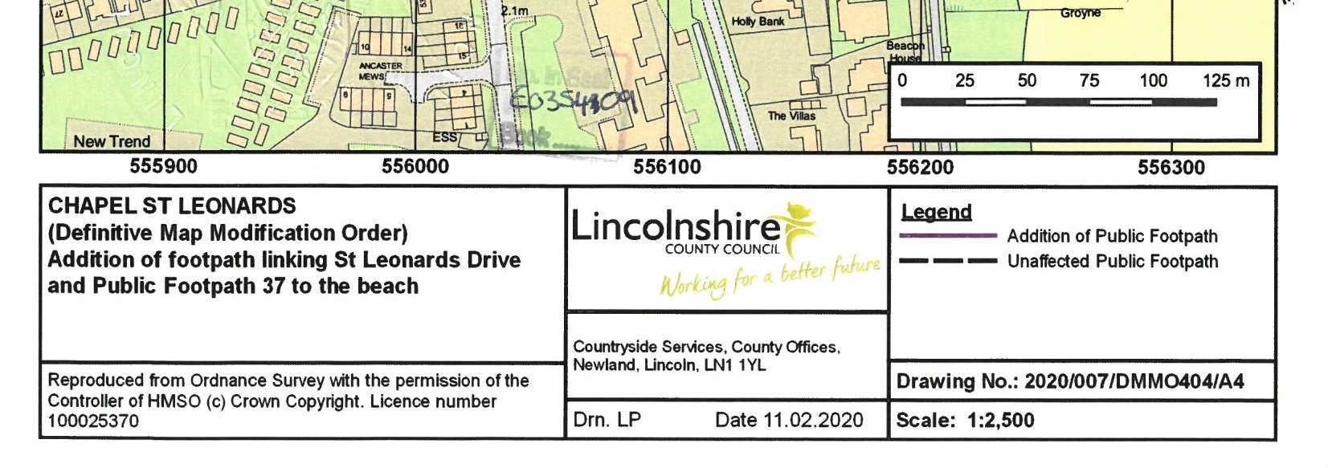

If you wish to make a legal submission, this should be submitted at the same time as your statement of case. Otherwise legal submissions will have to be submitted in writing on the day of the inquiry.

