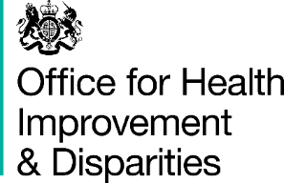

**National Dental Epidemiology Programme**

**Oral health survey of adults aged 65 years and older living in care homes, 2024 to 2025.**

**Agreement to participate**

1. I confirm I have read the survey information sheet, I have had the opportunity to consider the information, ask questions and have had these answered satisfactorily.

2. I understand my participation is voluntary and that I am free to withdraw at any time without giving any reason, without my medical care or legal rights being affected.

3. I understand this agreement form and any identifiable information will be treated in strict confidence by the survey team.

|  |  |
| --- | --- |
|  | **Please tick which applies** |
| I agree to take part in a questionnaire as part of this survey. |  |
| I DO NOT agree to take part in a questionnaire as part of this survey. |  |
| I agree to take part in a dental examination of my teeth and dentures (where applicable) as part of this survey. |  |
| I DO NOT agree to take part in a dental examination of my teeth and dentures (where applicable) as part of this survey. |  |

Resident’s name ___________________________________________________________

Resident’s date of birth ______________________________________________________

Resident’s signature ________________________________________________________

Name of person collecting agreement to participate_________________________________

Signature of person collecting agreement to participate_______________________________

Date of signatures ___________________________________________________________

|  |  |  |  |  |  |  |  |  |
| --- | --- | --- | --- | --- | --- | --- | --- | --- |
|  |  |  |  |  |  |  |  |  |

Care home postcode