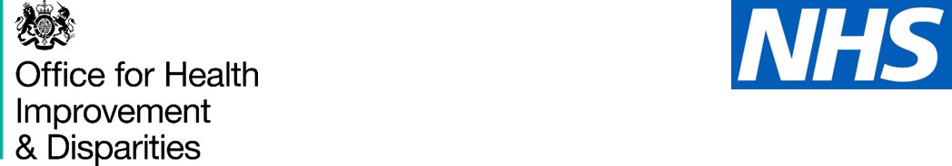

### Information for prospective participants

### National Dental Epidemiology Programme: Oral health survey of adults aged 65 years and older living in care homes, 2024 to 2025

1. Your care home is taking part in a dental survey looking at the mouth health of people over the aged of 65 years living in in care homes. Before you decide if you would like to take part, it is important that you know why the survey is being done and what it involves. Please read the information below and ask as many questions as you like before deciding. This leaflet explains why we are doing the survey and outlines the benefits and risks of taking part. The dental team will be visiting the home and will be happy to talk to you about the study and answer any questions in person, over the phone or by email.

### Why is there a dental survey?

* Having a clean healthy mouth helps you to speak, eat and smile. Not brushing teeth, gums and dentures daily can lead to discomfort, pain and affect general health
* Every year we collect information on the health of peoples’ teeth. This is called a dental survey. The information helps to plan NHS dental services in your area.
* This year the survey is collecting information about the health of the teeth of participant care home residents.
* As a care home resident, you are being asked to agree to taking part in the dental survey.

### Do I have to take part? What if I change my mind?

* You are free to decide whether to take part in this survey or not. If you choose not to, this will not affect the care you receive from your dentist
* If you do decide to take part, you should keep this information sheet and you will be asked to sign an agreement to participate form
* If you agree to participate, you are free to withdraw at any time without giving a reason

### What does the survey involve?

* If you agree, a dental team will ask you some short questions about your mouth health and dental visits.
* 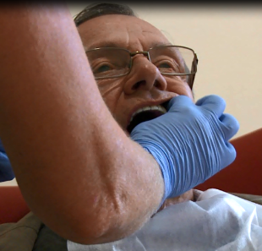The dental team will then have a quick look at your teeth at your care home. This only takes a few minutes.
* New gloves and clean mirrors will be used for each resident. No treatment will be provided.
* This does not replace your regular dental appointments. You should continue to see your regular dentist.

### What information is collected?

* Your details are provided by the care home to the dental team. These details include your name and date of birth and the care home postcode.
* If you agree to taking part, the dental team will ask you, your sex, ethnicity and postcode.
* These details will be linked to your dental check.
* We use this to see if there are changes in care home residents' dental health in different groups and different places where they live to understand patterns in dental health.
* The information will then be sent safely to the Office for Health Improvement and Disparities.

### What if the dental team finds a problem?

* This is not like a full dental check-up. If we find something that needs a closer look, we will let you know afterwards.

### Is the information confidential?

* Yes, the information you give us will be treated as strictly confidential as directed by the Code of Practice adopted by the NHS. No identifying information like names or addresses will be recorded on the survey forms – just a number – so it will be anonymous on the paper sheets and when it is entered into the computer.
* No information will be published that identifies you.

### What will the Office for Health Improvement and Disparities do with the information?

* The Office for Health Improvement and Disparities works to improve health for everybody. The Department of Health and Social Care is the data controller for your information.
* The details of the participants who take part will be studied. A report will be written. Your dental information may be linked to other health information about you.

Your information is kept securely:

* in files in our offices
* on our computers

Under the General Data Protection Regulation, the lawful bases we rely on for using your care home resident’s information are:

* we have a legal obligation
* we need it to perform a public task

The information may be shared by the Office for Health Improvement and Disparities with other organisations, such as universities. Names and dates of birth will be removed so that no participant can be identified.

We keep your details for 3 years then we will destroy it securely.

You can read about the Office for Health Improvement and Disparities at: www.gov.uk/government/organisations/office-for-health-improvement-and-disparities

### Your rights

* You can ask us to see the information we hold about you.
* You can ask us to make changes to information we hold about you.
* You can ask us to delete information about yourself.
* You can ask for copies of the information we hold about you.
* You can ask us to stop processing information about you.

### Who has reviewed the study?

* The National Research Ethics Service has reviewed the survey and deemed it health surveillance, not requiring research ethics committee approval.

### What if I have a question?

If you have a question about the dental survey, you can contact:

INSERT LOCAL CONTACT DETAILS HERE

You can also contact:

The Office for Health Improvement and Disparities at: dentalphintelligence@dhsc.gov.uk or by writing to:

Dental Public Health  
Office for Health Improvement and Disparities  
Department of Health and Social Care

39 Victoria Street  
London SW1H 0EU

If you have a question about how your information is being used for the dental survey, you can contact: data_protection@dhsc.gov.uk or by writing to:

Data Protection Officer  
1st Floor North  
39 Victoria Street  
London SW1H 0EU

Or the Information Commissioner’s Office by calling 0303 123 1113 or by live chat at https://ico.org.uk/make-a-complaint