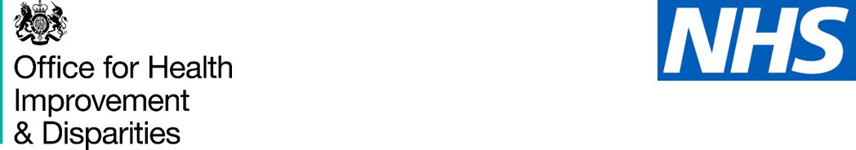

#### ****National Dental Epidemiology Programme, oral health survey of adults aged over 65 living in care homes****

Dear care home manager

I am writing to you to ask if you would be willing to help with a national survey of adult dental health. We would like to include a sample of the residents at the care home you manage. The survey itself would consist of a questionnaire about dental health and dental treatment services and an easy check of the participant resident’s teeth, both of which we can do in their home.

This is part of a national survey and will help to give your local NHS information to help them provide services to suit the needs of the older population. Local authorities are required by law to assess the health needs of the population and this survey is a way of doing this.

We are asking for care home managers' support by working in partnership with dental teams to deliver the survey. This will involve completing the attached document, distributing invitations to residents who meet the criteria to be included and then collecting the response slips of those who wish to take part. The dental team will support you in this work. The criteria to be eligible to participate is adults aged 65 years and older with capacity to agree to take part and who are not on end of life, respite or palliative care.

You are free to choose whether to take part or not and the future treatment of residents will not be affected in any way by your or their choice.

I do hope you will feel able to help with this and improve the planning of dental services for older people. Someone from the local fieldwork team will contact you in a few days to see if you have any further questions and find out if you are happy to help.

Yours faithfully

Survey clinician