# Ravensthorpe Station Closure ConsultationGraphic Cover Image - GreenPhoto Cover Image - Navy BlueGraphic Cover Image - YellowGraphic Cover Image - OrangeGraphic Cover Image - BluePhoto Cover Image - Blue

September 2024

Department for Transport

Great Minster House

33 Horseferry Road

London

SW1P 4DR

Logo - Open Government License

© Crown copyright 2024

This publication is licensed under the terms of the Open Government Licence v3.0 except where otherwise stated. To view this licence, visit [www.nationalarchives.gov.uk/doc/opengovernment-licence/version/3/](http://www.nationalarchives.gov.uk/doc/opengovernment-licence/version/3/) or contact,   
The National Archives at [www.nationalarchives.gov.uk/contact-us](http://www.nationalarchives.gov.uk/contact-us).

Where we have identified any third party copyright information you will need to obtain permission from the copyright holders concerned.

This publication is also available on our website at [www.gov.uk/government/organisations/department-for-transport](http://www.gov.uk/government/organisations/department-for-transport)

Any enquiries regarding this publication should be sent to us at [www.gov.uk/government/organisations/department-for-transport](http://www.gov.uk/government/organisations/department-for-transport)

Contents

Contents 3

Foreword 4

Executive summary 5

How to respond 7

Freedom of Information 7

Confidentiality and data protection 8

Sharing personal data 8

Further information 9

Personal questions 9

Consultation questions 9

Closure of Ravensthorpe Station 10

Purpose of the Consultation 11

Background 11

Summary of Appraisal 16

What will happen next 19

Annex A: Formal Appraisal 20

Introduction and Context 20

Transpennine Route Upgrade Context 21

Option Selection Process of the Operational Layout 23

Economic Case 29

Appraisal Results 31

Annex B: List of those consulted 34

## Foreword

Network Rail, as part of the Transpennine Route Upgrade, have developed plans for a new Ravensthorpe station to the west of the current site of Ravensthorpe station. The new station will function as a better gateway for the local community and support social and economic regeneration through development of a more efficient railway connecting homes, workplaces and key destinations across the North. The new station will provide step free-access to services and will allow longer trains with more seats to call at the station. The relocation of the station to the west of Thornhill Junction also affords train operators the opportunity to provide services from Ravensthorpe towards Wakefield Kirkgate and beyond. The station will serve an increased local passenger demand resulting from the planned development of the Dewsbury Riverside site led by Kirklees Council which would bring up to 4000 new homes to the area. Passenger train services that currently stop at Ravensthorpe station will be timetabled to stop at the new Ravensthorpe station.

Network Rail, as network operator, proposes closure of the existing Ravensthorpe station no earlier than September 28th 2025 to facilitate the Transpennine Route Upgrade works. This proposal is made in accordance with the Railways Act 2005 and Railways Closures Guidance.

In order to provide the capacity and journey time improvements required by the wider Transpennine Route Upgrade, a grade separated flyover junction is proposed in the Ravensthorpe area. The grade separated junction at this point necessitates the re-location of Ravensthorpe station approximately 200m to the west of the existing station. The new station is planned to open during Summer 2028. Retaining the existing station was discounted earlier in the development of the Transpennine Route Upgrade, as it would require the grade separated flyover junction to be built elsewhere with increased costs to build and maintain, a bigger environmental impact and lower benefits to passengers.

By closing the existing station, Network Rail will be able to focus rail industry resources on delivering the Transpennine Route Upgrade in the most efficient manner, enabling improved passenger experiences and supporting the regeneration of the surrounding area.

Between the closure and reopening, Network Rail propose to fund a rail replacement bus operation.

We are carrying out this consultation to get views from interested parties on the closure of the existing station and its replacement by a new one.

## Executive summary

Introduction

The existing Ravensthorpe station is located on the North Transpennine Route between Mirfield and Dewsbury stations. It is located to the south of Ravensthorpe village and just north-east of Thornhill Junction, where a line branches to Wakefield Kirkgate. The station, which is managed by Northern, is currently served by an hourly stopping service between Hull and Manchester Piccadilly, operated by TransPennine Express and an occasional stopping service between Leeds and Wigan Wallgate, operated by Northern.

Network Rail as part of the Transpennine Route Upgrade have developed plans to upgrade the North Transpennine Route which serves Ravensthorpe station. The Transpennine Route Upgrade delivers faster journeys, increased capacity, reliability and punctuality and supports the government’s decarbonisation strategy through electrification of the route.

Due to the remodelling of Thornhill Junction, which lies immediately west of the existing Ravensthorpe station, Network Rail are unable to retain the station in its current location. The new station will be approximately 200m west of the existing station and will be accessed from Calder Road as the existing station is.

The existing station is approximately 110m from Calder Road, on a narrow road that slopes towards the station. There is no parking at the station. The station has two platforms. Platform 1 serves trains towards Leeds and Platform 2 serves trains towards Manchester. Platform 2 is only accessible by a footbridge from Platform 1.

The new station will be approximately 200m from Calder Road and level with the road. There will be an integrated Rail Replacement bus stop and parking spaces for blue badge holders. The station will have step-free access with a footbridge and lifts provided. The station will have a single island platform with two 150m long faces; Platform 1 and 2.

The new station will be near to the proposed new Dewsbury Riverside development, which plans to deliver up to 4000 new homes in Ravensthorpe over the next decade. The new station, with improved accessibility and connectivity, will support the increased passenger demand from this major regeneration Scheme.

In order to maximise these benefits and enable efficient delivery of the Transpennine Route Upgrade, the existing Ravensthorpe station will need to be closed by no earlier than September 28th 2025. This will allow Network Rail to construct a grade separated flyover junction on the footprint of the existing station. The grade separated junction allows the North Transpennine fast-lines to flyover the slow lines, where the Spen Valley line to Wakefield Kirkgate diverges from the North Transpennine Route. This removes a bottleneck from the existing railway and increases the number of trains that can run through this section of the railway. It is a key intervention to enable the Transpennine Route Upgrade to deliver wider benefits for the whole region.

## How to respond

The consultation period began on 26th September 2024 and will run until 5th January 2025. Please ensure that your response reaches us before the closing date. If you would like further copies of this consultation document, it can be found at [consultation - Policy papers and consultations - GOV.UK (www.gov.uk)](https://www.gov.uk/search/policy-papers-and-consultations?parent=department-for-transport&keywords=consultation&organisations%5B%5D=department-for-transport&order=relevance) or you can contact Andrew Johnson at the address or email below if you need alternative formats (Braille, audio CD, etc.).

Please send consultation responses to:

Ravensthorpe Consultation

Department for Transport

Great Minster House

33 Horseferry Road

London SW1 4DR

Or by email to:

[Ravensthorpe.Consultation@dft.gov.uk](mailto:Ravensthorpe.Consultation@dft.gov.uk)

When responding, please state whether you are responding as an individual or representing the views of an organisation. If responding on behalf of a larger organisation, please make it clear who the organisation represents and, where applicable, how the views of members were assembled.

A list of those consulted is attached at Annex B. If you have any suggestions of others who may wish to be involved in this process please contact us.

### Freedom of Information

Information provided in response to this consultation, including personal information, may be subject to publication or disclosure in accordance with the Freedom of Information Act 2000 (FOIA) or the Environmental Information Regulations 2004. If you want information that you provide to be treated as confidential, please be aware that, under the FOIA, there is a statutory Code of Practice with which public authorities must comply and which deals, amongst other things, with obligations of confidence.

In view of this it would be helpful if you could explain to us why you regard the information you have provided as confidential. If we receive a request for disclosure of the information, we will take full account of your explanation, but we cannot give an assurance that confidentiality can be maintained in all circumstances. An automatic confidentiality disclaimer generated by your IT system will not, of itself, be regarded as binding on the Department.

The Department will process your personal data in accordance with the Data Protection Act (DPA) and in the majority of circumstances this will mean that your personal data will not be disclosed to third parties.

### Confidentiality and data protection

The Department for Transport (DfT) is carrying out this consultation on Network Rail's proposal to close Ravensthorpe railway station. View our [DfT online form and survey privacy notice](https://www.gov.uk/government/publications/dft-online-form-and-survey-privacy-notice/dft-online-form-and-survey-privacy-notice) for more information on how your personal data is processed in relation to this consultation.

In addition for all:

* individuals we are asking if you use Ravensthorpe station, to understand your relationship with the topic and, if so, the method or methods of transport to that station, for transport insight
* organisations we are asking for the name of the organisation for identification

The Department for Transport (DfT) is carrying out this consultation to gather evidence on the Network Rail proposal to close Ravensthorpe station. The consultation is being carried out in the public interest to inform the Secretary of State’s opinion that the closure should be allowed. DfT is the data controller for your personal information.

When responding to this consultation you may share personal data with us such as postal, email or IP addresses. Any such data will only be stored for the duration of the consultation exercise and deleted following the publication of the DfT’s response to the consultation. Until that point, your information will be stored securely.

### Sharing personal data

DfT may also share your consultation response with Network Rail or other parties involved in the Ravensthorpe project, to inform discussion which will feed into our consideration and decision-making. However, no personal data (such as names and contact details) will be shared with these third parties.

### Further information

DfT’s privacy policy has more information about your rights in relation to your personal data, how to complain and how to contact the Data Protection Officer. You can view it at <https://www.gov.uk/government/organisations/department-fortransport/about/personal-information-charter>.

To receive this information by telephone or post, contact us on 0300 330 3000 or write to Data Protection Officer, Department for Transport, Ashdown House, Sedlescombe Road North, St Leonards-on-Sea, TN37 7GA.

### Personal questions

#### Individual questions

If you use Ravensthorpe station explain the transport methods you use to get to the station?  
  
[Now go to 'Consultation questions']

#### Organisation questions

What is the name of your organisation?

### Consultation questions

What, if any, are your views on closure of the existing Ravensthorpe station?

What, if any, are your views on the replacement by a new Ravensthorpe station?

Any other comments?

## Closure of Ravensthorpe Station

## Purpose of the Consultation

Network Rail, as network operator have carried out an assessment in accordance with the Department for Transport's (DfT) Railways Closures Guidance of whether retaining the existing Ravensthorpe station as part of the national rail network represents value for money. It concluded that retaining the existing station is neither an appropriate nor responsible use of resources given the investment in opening a new Ravensthorpe station and other infrastructure enhancements in that area.

Under section 29(7)(a) of the Railways Act 2005 the Secretary of State, as the relevant national authority, is required to carry out a consultation concerning a network operator's proposal to discontinue use of a particular station if, having received the network operator's assessment, the Secretary of State has formed an opinion that the closure should be allowed.

A copy of the Railways Closures Guidance may be found at:

<https://www.gov.uk/government/uploads/system/uploads/attachment_data/file/266296/railwaysclosuresguidance.pdf>

Interested parties are therefore invited to comment on the Network Rail proposal.

### Background

Ravensthorpe station was opened in 1890 and is located on the North Transpennine Route between Mirfield and Dewsbury stations. It is located to the south of Ravensthorpe village and just north-east of Thornhill Junction, where a line branches to Wakefield Kirkgate. The existing station is not accessible.

Figure 1 – The existing Ravensthorpe Station is in the left of centre in the picture

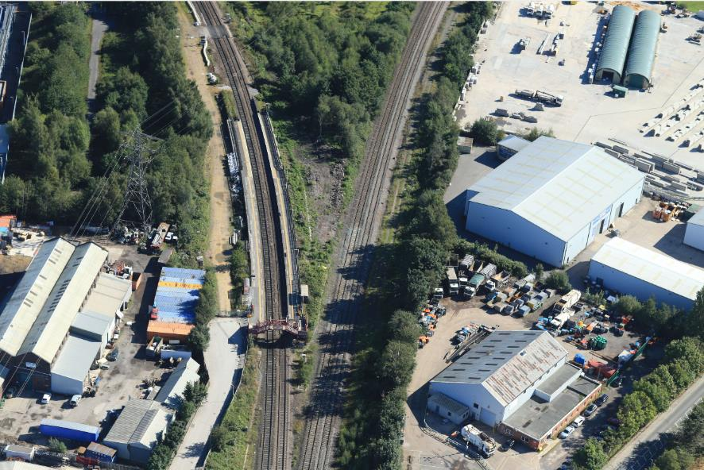

Network Rail as part of the Transpennine Route Upgrade, have developed plans to build a new station approximately 200m west of the existing station site. The new station will provide the following benefits:

* Step-free access from street level and across the station.
* 150m platforms to enable longer trains, offering more seats to call at the station.
* Blue Badge parking provision.
* Creating the opportunity to extend the platforms by a further 50m in future, to support growth.
* A dedicated Rail Replacement bus stop outside the station entrance with waiting shelters.
* The ability for trains travelling to and from Wakefield Kirkgate to serve Ravensthorpe.

The new station is planned to open as part of the Transpennine Route Upgrade during Summer 2028. This is an integrated programme of works that will provide faster journeys and more capacity for local and regional services on the North Transpennine route, as well as improvements at most stations between Manchester and York.

Figure 2 - Proposed Ravensthorpe Station Visualisation from the North-west

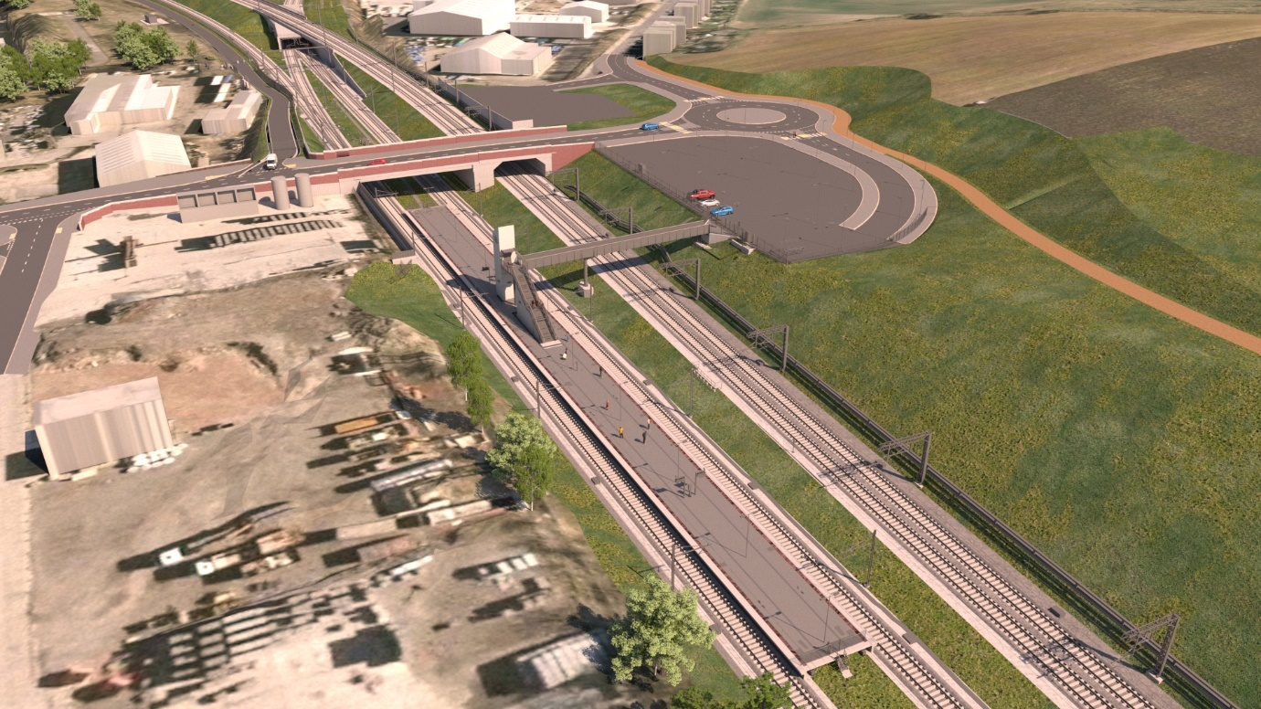

Figure 3 – Proposed Ravensthorpe Station Visualisation from the South-west

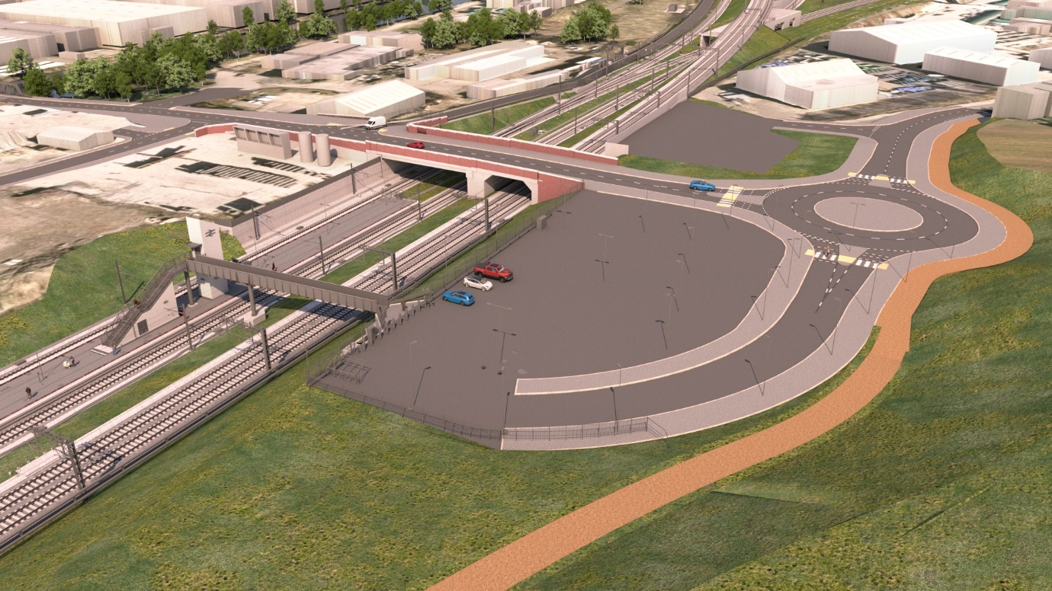

The programme of works, including the new station proposal was endorsed by rail industry stakeholders under Network Change which is the procedure by which changes can be made to the network. The funding package for the delivery of the new station was secured in December 2023. Planning permission for the new station was secured through the government’s approval of the Transport and Works Act Order (TWAO) in June 2022. Part of the programme of works is the closure of the existing Ravensthorpe station, no earlier than September 28th 2025. Retaining the existing station is not possible with the delivery of the new grade separated junction in Ravensthorpe.

Figure 4 – Proposed Grade Separation at Ravensthorpe Visualisation

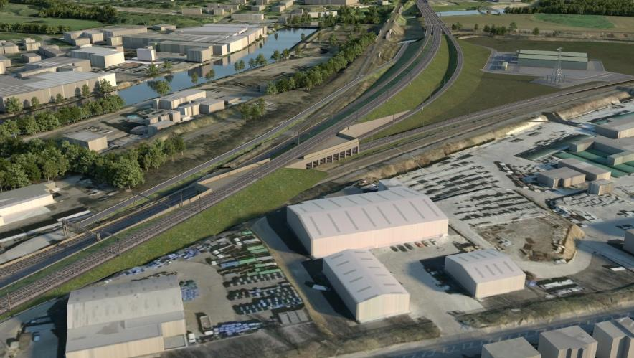

Transpennine Route Upgrade context

The Transpennine Route Upgrade (TRU) is a major multi-billion-pound programme of railway improvements between Manchester and York, via Leeds and Huddersfield.  TRU, which forms part of the portfolio of work on Rail Infrastructure in the north of England, is a once-in-a-generation railway upgrade which will deliver more frequent, faster, greener trains running on a better, cleaner, more convenient and crucially more reliable railway.  The programme will see the North Transpennine Main Line upgraded with digital signalling, capacity for extra services including freight, and improved punctuality. TRU will better connect passengers to towns and cities across the north more quickly – reducing journey times between Manchester and Leeds to between 42-44 minutes and 63-70 minutes between Manchester and York once complete.

The section of the TRU between Huddersfield and Ravensthorpe (known as Project W3) is key to delivering the benefits of the wider programme. It is the section where most performance issues are encountered, and where capacity constraints would significantly limit the wider benefits for the whole region of the TRU if not addressed. The key elements of Project W3 Scheme include the installation of a four-track railway across most of the route between Huddersfield and Ravensthorpe, the provision of railway grade separation works at Ravensthorpe, works to the stations at Huddersfield, Deighton, Mirfield and Ravensthorpe, and the electrification of the full length of this section of the North Transpennine Route.

One objective of the W3 Scheme is a requirement to remove conflicting train movements where the Wakefield Kirkgate lines join the North Transpennine Route at Ravensthorpe. These conflicts need to be removed by means of grade separation to create the opportunity for increasing the frequency of train services and to optimise the number of train paths available through the junction between the two lines at Ravensthorpe. If not addressed as part of the Scheme, these conflicts would continue to have a severe adverse impact on the capacity of both the North Transpennine Route and the Wakefield Kirkgate lines and would serve to negate the benefits derived from the upgrading works elsewhere on this section of the route.

During design development, two options were considered in detail for the location of the grade separated junction, either at Heaton Lodge or Ravensthorpe. The grade separated junction is where the mainline (North Transpennine Route) and the diverging line (Wakefield Kirkgate) are separated vertically to allow fast trains to overtake. At Ravensthorpe, the grade separated junction will be a flyover which removes the conflict between traffic using the fast and slow lines. Removing this conflict keeps trains moving, instead of waiting for another service to pass the junction. This contributes to a reduction in journey times and increasing capacity on the railway. The decision for the grade separation location was based on many factors, which included: impact to neighbours, landowners and businesses close to the railway; capital and operational costs; construction risk; operational performance, constructability, safety and environmental impact. The study concluded that grade separation at Ravensthorpe provided the best overall business case. The grade separated junction at this point necessitates the re-location of Ravensthorpe station.

Between the closure and reopening of Ravensthorpe station, Network Rail propose to fund a rail replacement bus operation – subject to ongoing demand. Due to the considerable construction work happening in the area of the existing station, the rail replacement bus would operate from Huddersfield Road (A644) in Ravensthorpe. This service would operate between Ravensthorpe and Mirfield, and Ravensthorpe and Dewsbury once an hour as per the current rail service. Visible signage at well located decision points will help passengers find these alternative transport routes.

Ravensthorpe is also currently served by frequent local bus services between Leeds, Dewsbury, Mirfield and Huddersfield providing up to four services per hour on Mondays to Saturdays and two per hour on Sundays. While journey times are longer than by the train, the impact of this will be mitigated by the higher frequency of the bus services and the number and location of bus stops in Ravensthorpe which will give greater choice to passengers compared to the station which is located to the south of the village.

## Summary of Appraisal

The relocation of Ravensthorpe Railway Station is part of the delivery of TRU sub-scheme W3 which includes all the works happening between Huddersfield – Ravensthorpe and is intrinsically linked to the wider programme enhancing the North Transpennine Route. The scope of the appraisal does not seek to re-evaluate the wider value-for-money of TRU in the absence of the wider W3 scheme or in the absence of the sub-section of works identified to provide grade separation. Rather, the formal appraisal considers the relative merits of the two of the basic operational layouts that were taken forward for Governance for Railway Investment Projects (GRIP) 3 design development for W3.

Summary of Operational Layout 1 – Station closure and rebuild results in realisation of full TRU benefits

* The do-something option is taken as the sub-project W3 (Huddersfield to Ravensthorpe) Operational Layout 1 for which the government granted a TWAO in June 2022. In this layout the fast lines are positioned to the south side of the four-track corridor between Ravensthorpe and Huddersfield. It requires TRU to build a new grade separated junction at Ravensthorpe to pass the new fast lines over the existing Wakefield Kirkgate lines where they diverge at Thornhill LNW Junction. Grade separation at this point necessitates the relocation of Ravensthorpe railway station.

Summary of operational layout 5 – Station retained, and capacity remains constrained

* The Base Case considers the merits of the other operational layout, which was also developed for consideration, this was Operational Layout 5. In this layout, the fast lines were positioned on the north side of the four-track corridor through Ravensthorpe and Mirfield geographies. At Heaton Lodge the fast lines are taken over the Calder Valley lines by a new grade separated junction. The fast lines then run along the south of the four-track corridor into Huddersfield railway station just like Operational Layout 1. Without a grade separated Junction at Thornhill LNW Junction, it is assumed the existing Ravensthorpe railway station would be retained under this option. If this were the case, TRU would not realise its benefits in full.

As a result of the appraisal of these two options, Operational Layout 1 provides lower capital and whole life costs than Operational Layout 5 and provides significant operational benefits as a result of reducing more conflicts. Within this context Operational Layout 1 offers “very high” (and financially positive) value-for-money relative to proceeding with Operational Layout 5, offering greater benefits and being delivered at a lower cost.

Figure 5 Operational Layout 1 (preferred)

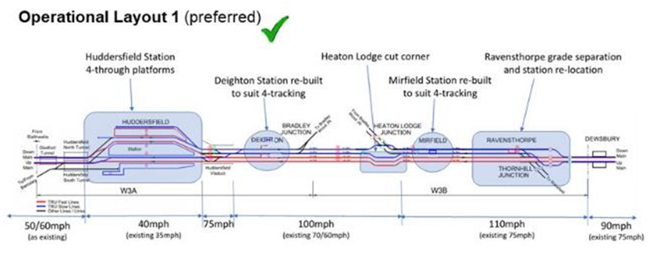

Figure 6 Operational Layout 1 (deferred)

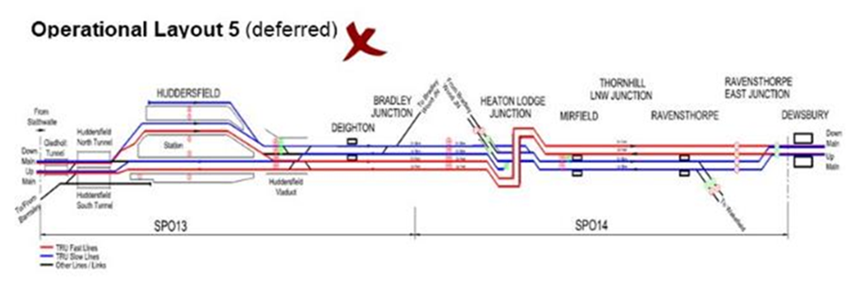

The Railways Closures Guidance 2006 requires a benefit:cost ratio analysis to be undertaken and sets out five key criteria which need to be addressed by the appraisal. The conclusions are summarised below, with further detail in Annex A:

Economy  
Operational Layout 1 with the grade separated junction at Ravensthorpe provides lower capital and whole life costs than Operational Layout 5 with the grade separated junction at Heaton Lodge and provides significant operational benefits as a result of reducing more conflicts. Within this context Operational Layout 1 would offer Very High (and Financially Positive) value-for-money relative to proceeding with Operational Layout 5 offering greater benefits and being delivered at a lower cost.

Environmental  
The primary difference between options is that Operational Layout 5 presents the most significant detrimental impact on the visual environment through the introduction of viaducts at the Heaton Lodge end. Structures at Ravensthorpe are less visually intrusive given their location and surrounding land uses.

Safety  
The key differentiators between operational layouts are in favour of Operational Layout 1. Operational Layout 1 offers improved operational safety of the railway through removing more conflicting movements. In addition, maintenance risks associated to the construction of the grade separated flyover within Operational Layout 5 were unsupportive.

Accessibility  
Both options were evaluated as supportive of objectives to make travel more accessible and supporting Britain's economic development. Specifically with relation to rail passengers at Ravensthorpe station the revised location maintains the walking distance between the station, and the village centre and nearest bus stops whilst improving the prominence of the station. The island platform will be accessed via a footbridge with stairs and a lift down to platform level, platform 2 is currently accessed via a stepped footbridge from platform 1.

Integration  
Both options support the wider development of the Transpennine Route Upgrade integrated strongly to government strategic objectives. The relocation of Ravensthorpe station supports local land use development unlocking additional benefits through moving the station closer to the proposed Dewsbury Riverside housing development (4000 homes).

Conclusion  
During design development, two options were considered for the location of the grade separated junction, either at Heaton Lodge as shown in Operational Layout 5 or Ravensthorpe as shown in Operational Layout 1. Ravensthorpe passed the BCR test, offered lower whole life costs, gained wider railway operational benefits and had a lesser environmental impact. The preferred solution for the Scheme is therefore to implement a grade separated junction at Ravensthorpe necessitating the relocation of Ravensthorpe station.

## What will happen next

Following the consultation period, we will review the responses to the closure proposal and undertake such further analysis as might be necessary. We will produce a summary of the outcome of the consultation and publish this on the DfT website.

The outcome of the closure consultation will be shared with Network Rail. Should the outcome of the consultation process agree with Network Rail's assessment, the Office of Rail and Road will then be required to ratify the proposal before the closure can go ahead.

If you have questions about this consultation please contact: Andrew Johnson, Department for Transport, Great Minster House, 33 Horseferry Road, London SW1P 4DR Telephone 0300 330 3000 Website [www.dft.gov.uk](http://www.dft.gov.uk)

1. Formal Appraisal

### Introduction and Context

The formal appraisal carried out by Network Rail considers the relative merits of the two basic operational layouts that were taken forward for GRIP 3 design development for W3.

* The Do-Something is taken as the Project W3 (Huddersfield to Ravensthorpe) layout Operational Layout 1 for which the [government granted a TWAO](https://www.gov.uk/government/publications/huddersfield-to-westtown-dewsbury-improvements-transport-and-works-act-order) in June 2022. In this layout the fast lines are positioned to the south side of the 4-track corridor between Ravensthorpe and Huddersfield. It requires a new grade separation at Ravensthorpe to pass the new fast lines either over or under the existing Wakefield Kirkgate lines where they diverge at Thornhill LNW Junction. Grade separation at this point necessitates the relocation of Ravensthorpe station. (Operational Layout 1 was progressed with two sub-options, known as layout 1A (flyover) and 1B (dive-under) with Option 1A ultimately becoming the preferred option).
* The Base Case, against which this is assessed, considers the merits of Operational Layout 5 also developed to GRIP3. In this layout the fast lines are positioned on the north side of the 4-track corridor through the Ravensthorpe and Mirfield areas. At Heaton Lodge the fast lines are taken either over or under the MVN2 Calder Valley lines by a new grade separation. The fast lines then run along the south of the 4-track corridor into Huddersfield station as per Operational Layout 1. Without grade separation at Thornhill LNW Junction the existing Ravensthorpe station would be retained under this option as developed to GRIP3.

Subsequently the appraisal is the same as that made for the Single Programme Option (SPO) selection for the overall operational layout as developed for Project W3 (Huddersfield to Ravensthorpe). This project has now developed completed Single Option Development (GRIP4/ ES4 - conventionally a Full Business Case decision). The following section outlines the single option process within the context of the Transpennine Route Upgrade.

### Transpennine Route Upgrade Context

Huddersfield to Westtown Option Selection Process

As documented within the Statement of Case for the Network Rail (Huddersfield to Westtown (Dewsbury) Improvements Order application within the context of the Transpennine Route Upgrade all Single Programme Options were subject to the same appraisal criterial summarised in Table 1 and Figure 7 below.

Table 1 – Option Selection Process

|  |  |
| --- | --- |
| Process Stage | Description |
| Initial Option Identification | Identification of the full range of viable options for the SPO to create a “Sift Long List” of options. This range of options was to include (where applicable) “do nothing” and “do minimum” options. |
| Initial Option Sift (Sift Long List) | A long list Sift meeting was arranged with a panel of attendees formed from a consistent set of senior programme managers and engineers across the Alliance and Network Rail. A standard range of Sift criteria were used to develop a “Sift Short List” of options which were to be further developed. |
| Initial Option Development | Design development of the sift short list options to a consistent level of detail including for example, general arrangement drawings, costs, safety assessments, likely operation outputs and foreseeable environmental impacts. |
| Expert Panel Appraisal (Sift Short List) | The developed short list options were assessed by a panel of industry experts drawing staff not only from the Alliance and Network Rail, but also from the wider railway industry. Each option was assessed against a standard set of appraisal criteria that had been developed by Network Rail and agreed with the DfT. |
| Initial GRIP 3 OSR | The output from the Expert Panel meeting(s) was either a preferred option or a range of preferred options, which were to be developed in further detail to support the production of the Initial GRIP3 Option Selection Report (OSR). |

Figure 7 – Transpennine Route Upgrade “Sift Short List” Option Appraisal Criteria

|  |  |
| --- | --- |
| Option Appraisal Criteria (i) | |
| Criteria | Criteria Definition |
| Performance | |
| Journey Time | Contribution to the system outputs for journey time |
| Train Capacity | Provision for specified capacity |
| Train Length | Provision for specified capacity |
| Train Performance | Reliability of infrastructure |
| Number of incidents/response time |
| Resilience (ability to recover) |
| Capacity for further growth |
| Operational Safety | Layout risk assessment, residual hazards CSM review |
| Operability | Support vision of future railway state |
| Maintainability | Supports vision for future railway state |
| Engineering | Compliance to engineering and operational specifications |
| Sustainability and environmental | |
| Landscape/Townscape, Visual | National Park: Areas of outstanding natural beauty |
| Visual impact: landscape/townscape impact |
| Ecology, biodiversity | International (designated, proposed and compensatory) – SAC, SPA and Ramsar |
| National – National Nature Reserve, SSSI, Ancient Woodland and ‘Veteran Trees’, limestone pavement orders |
| Local – Local Nature reserve, Tree Preservation Orders, Sites of Importance for Nature Conservation (SINCs) |
| Cultural Heritage | International – UNESCO World Heritage Site |
| National – Grade I and II listed buildings; Grade I and II registered parks and gardens; Scheduled Monuments |
| Local – Conservation Areas |
| National Trust Property |
| Air Quality | Air Quality Management Areas |
| Noise and Vibration | Sensitivity of potential receptor |
| Soils and Geology | Geological SSSI; regionally important geological and geomorphological sites (RIGS) |
| Best and most versatile land |
| Water Environment | Flood risk areas; water quality (ground water source protection zones/major aquifers) |
| Carbon Footprint | Rail carbon tool |
| Resilience | Route weather resilience &climate change adaptation (WRCCA) Plan high and medium priority impact areas |
| Local wellbeing | Network Rail social performance themes |
| TranSingle Program Asset Management Option | Transport impacts on the local community through the transport of materials, waste and employees |
| Impacts on connectivity for local community |
| Resource Management | Waste, material use and reuse, water use |
| Land use/Amenity | Allotments; village greens, common land |
| National Cycle Network, long distance walking trails |
| Public open space (park) and Public Rights of Way |
| Recreational waterways |
| Other sensitive receptors (community & education facilities, residential etc) |
| Assets of Community Value (ACV) |

|  |  |
| --- | --- |
| Option Appraisal Criteria (ii) | |
| Criteria | Criteria Definition |
| Stakeholders | |
| Network RAM | Level of support from Route Asset Management for option |
| Stakeholders External to NR | Stakeholders impacted by works by type and influence; considering previous relationship with Network Rail; potential conflict with stakeholders; impact on community/business |
| Deliverability | |
| Availability of sufficient land | For example some land uses might prevent development – hazardous facilities, important community facilities (hospitals); contaminated land; crown land |
| Timescale | Not Available |
| Technical Complexity | Add commentary on Accessibility/DIA in this section |
| Consent Risk | TWAO etc |
| Implementation Risks | Not Available |
| Safety | Not Available |
| Constructability | Consider staging viability, ease of access, possession requirements, impact on O&M during construction, construction and environment and safety in construction |
| Cost | |
| CAPEX CBR | <£2m/sec = Highly Supportive  <£2m/sec but <£4m(incl.)/sec = Supportive  >£4m/sec but <£6m/sec = Unsupportive  >£6m/sec = Highly Unsupportive |
| WLC CBR | Lowest WLC CBR = Supportive  Above lowest WLC CBR = Unsupportive |

Following GRIP3 Phase 1, it was clear, given the complexity of the programme and individual SPOs, that there were still several underdeveloped options, which could question the preferred option choice. There was also the potential for significant change resulting from development of asset level detail, which might also lead to different option or sub-option choices. This process is illustrated in Ravensthorpe Station Closure Figure 8 below.

Figure 8 – Single Programme Options (SPO) Development Process

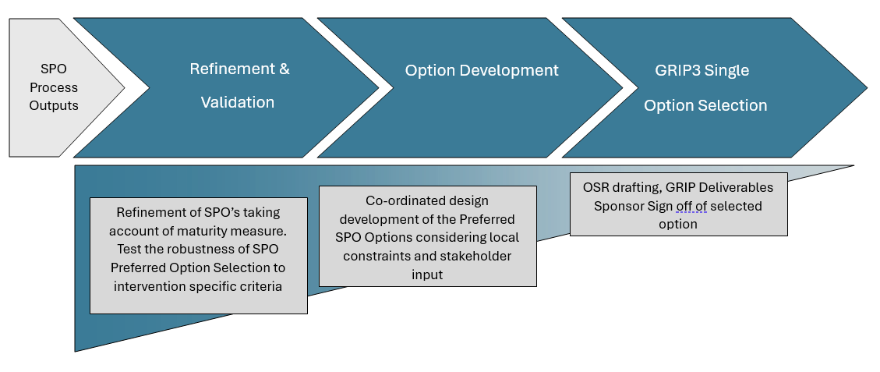

Further commentary on the above process is as follows:

* Validation panel meetings held after the option refinement phase. The validation panels were made up of similar attendees to the earlier “expert panel” meetings with representatives from across the Transpennine Route Upgrade programme and Network Rail operational maintenance teams. The intention of these meetings was to “validate” the original option selection taking account of any further design development or new options considered as well as making recommendations for any further work. If further work was required to decide, the validation panel meeting would be re-held until a single option could be selected.
* The option development phase was then normally restricted to development of a single option. However, in some instances several sub-options were taken forward for development. The first rounds of stakeholder consultation were held within this period with the first public consultation held in September 2019.
* This carefully staged development and testing of options meant that the GRIP 3 Option Selection Report could be gradually built up on a solid evidence base with validation panel meeting minutes, technical reports and presentation materials developed throughout. The emphasis was always placed on ensuring that critical decisions were based on a thorough evaluation of all valid options and recording of decision making in a consistent manner.

### Option Selection Process of the Operational Layout

This section summarises how the process outlined in the section above was followed for the single option selection of the overall operational layout.

Following on from the recommendations made at GRIP 2, the development of the end-to-end operational layout centred around 4-tracking, and the separation of the slow (local passenger & freight) and fast (express) services, to meet the performance aspirations of the Transpennine Route Upgrade remit. However, during the early option identification phase, reduced options were considered, primarily between Huddersfield and Bradley Junction where 3- track sections were also proposed.

The development of 4-track options along this corridor depends on the end-to-end operational layout with respect to fast and slow line positions, their effects on grade separations (to eliminate conflicts), line speed and junction performance. During option identification, five basic operational layouts were considered (although there are many potential sub-variants).

Following the Initial Sift process, two of the basic operational layouts were taken forward for GRIP 3 design development. These are as identified for the Do-Minimum and Do-Something relating to the closure, and relocation of, Ravensthorpe station.

* Operational Layout 1 – Fast lines are positioned to the south side of the 4-track corridor between Ravensthorpe and Huddersfield. It requires a new grade separation at Ravensthorpe to pass the new fast lines either over or under the existing Wakefield Kirkgate lines where they diverge at Thornhill LNW Junction. This necessitates the relocation of Ravensthorpe station.
* Operational Layout 5 – This end-to-end layout was preferred at GRIP 2. In this layout the fast lines are positioned on the north side of the 4- track corridor through the Ravensthorpe and Mirfield areas. At Heaton Lodge the fast lines are taken either over or under the MVN2 Calder Valley lines by a new grade separation. The fast lines then run along the south of the 4-track corridor into Huddersfield station as per Operational Layout 1. Without grade separation at Thornhill LNW Junction the existing Ravensthorpe station would be retained under this option.

Both operational layouts were developed during the initial GRIP Stage 3 phase for the “Expert Panel” review. This was held to select the interim GRIP Stage 3 preferred option to take forward to the DfT report and business case submitted in December 2017. Following the Expert Panel review, Operational Layout 1 was preferred, and Operational Layout 5 was deferred.

Although Operational Layout 1 was presented as the preferred option for the Interim GRIP3 submission in December 2017, both options 1 and 5 were progressed through the second stage option validation process to enable a more comprehensive evaluation of each layout. This evaluation included substantial engineering refinement of both layouts, re-estimation of costs and further stakeholder feedback. Following this second stage option validation process, Operational Layout 1 was still preferred and no further development was undertaken on Operational Layout 5. It was concluded at Validation Panel 3 that options considering a grade separation at Heaton Lodge should be paused for the following primary reasons:

* Consents: Numerous residential properties in very close proximity to the proposed grade-separation in an environmentally sensitive area. Residents would likely challenge the Scheme at enquiry.
* Constructability: Large scale civils works (bridges & earthworks) to construct in a very difficult area to access with associated disruption to local community and railway. In addition, a large-scale civil engineering scheme was still required at Ravensthorpe.
* Costs: Capital and Whole Life costs for Layout 5 were greater than Layout 1, with reduced operational resilience due to a remaining junction conflict at Ravensthorpe.

below summarises the multi-criteria appraisal between Operational Layout 1 and Operational Layout 5 as part of the above process.

Figure 9 – Transpennine Route Upgrade “Sift Short List” Option Appraisal Criteria

|  |  |  |  |  |  |
| --- | --- | --- | --- | --- | --- |
| Criteria | | Operational Layout1A | | Operational Layout 5 | |
| Notes - including key issues, impacts or contribution to objectives | 1 | Notes - including key issues, impacts or contribution to objectives | 5 |
| Economy / Performance | Journey Time | Operational Layout1A may deliver a journey time benefit of up to 74 seconds when compared to existing journey times. | + | Operational Layout 5A may deliver a journey time benefit of up to 71 seconds when compared to existing journey times. | + |
| Train Capacity | This option provides the same functionality as Operational Layout 5A but provides an added benefit that the Up Slow line can also use the grade separation and therefore removes a number of conflicting moves at Ravensthorpe. This option is likely to deliver the indicative train service specification (ITSS v0.4) robustly. | + | Train Service Capacity: Operational Layout 5A is likely to deliver the indicative train service specification (ITSS v0.4) robustly.  The ITSS is a hypothetical timetable to help inform the design and development of the infrastructure, to help ensure the design provides sufficient capacity. | + |
| Train Performance | Performance Risk (impact on PPM): Operational Layout 1A shows performance benefit compared to Operational Layout 5A. This design includes just one potential timetable and regulating conflict for trains running in opposite directions between the Down Slow and Up Slow lines to the west of Ravensthorpe. Performance risk has been scored as supportive. | + | Operational Layout 5A introduces two potential timetable and regulating conflicts for trains running in opposite directions, between the Down Slow and Up Fast lines to the east of Ravensthorpe and between the Down Slow and Up Slow lines to the west of Ravensthorpe. Performance risk has been scored as neutral on the basis of these potential conflicts. | 0 |
| Operational Safety | Generally supportive except for neutral view at Mirfield because staging is more difficult than Layout 5 options. | + | Significant 900m viaduct constructed on Flood plain. Major visual impact and similar outputs can be achieved utilising less resources. At grade junctions at Ravensthorpe introduces additional conflicting moves and retention of existing Calder Viaduct structures to carry lines is not preferred. | 0 |
| Maintainability | Improvement towards future railway state | + | Unsupportive due to access for maintenance. | - |
| Sustainability and Environment | Noise and Vibration | Generally neutral across options. A number of noise important areas are located in proximity to the Scheme along the A62 and A644 | 0 |  | 0 |
| Air Quality | General neutrality across options. Kirklees Air Quality Management Area (AQMA) is located along sections of the A62 Leeds Road, at the A62 near Heaton Lodge. A second AQMA encompasses properties along two sections of the A62 Leeds Road, in the vicinity of the junctions with the A6107 Bradley Road, and with the A644.  An Air Quality Management Area is put in place in any area the local authority finds air quality objectives are unlikely to be met. The Local Authority must then put a plan in place to improve air quality in this area. | 0 |  | 0 |
| Carbon Footprint | Embodied carbon costs have not been assessed through toolkit | 0 | Embodied carbon costs have not been assessed through toolkit | 0 |
| Landscape and Townscape |  | - | All options have some LVIA effects however 5A presents the most significant of these due to viaducts at Heaton Lodge end. Structures at Ravensthorpe are less visually intrusive given location and surrounding land uses however the flyover is likely to have greater visual impacts than the dive under option. Current receptors are limited however consideration should also be given to the new housing development proposed to the south of Ravensthorpe | -- |
| Ecology - Biodiversity | Generally Neutral across options | 0 |  | 0 |
| Soils and Geology | General neutrality across options. Various landfills are located in proximity of the route. The area at Ravensthorpe will impact directly on the landfill located here and therefore potential contamination/waste issues are anticipated | 0 |  | 0 |
| Water Environment | General neutrality across options. Route passes through sever flood zones and will need careful management. | 0 |  | 0 |
| Cultural Heritage | Issues re impacts on setting and sympathetic design of new structures across Calder will need to be considered in 1A and 1B | 0 | Listed bridges affected by all 3 options however 5A requires works to viaducts which have greater impact. | - |
| Local wellbeing | General neutrality across options. Proposals are likely to support at least one of NR Social Performance themes e.g. making travel accessible and supporting Britain's economic development. Proposals may negatively impact on some of NR Social Performance Themes such as 'being a caring neighbour' due to significant noise during construction. In the long term the proposal is likely to support some of the NR Social Performance Themes e.g. making travel accessible and supporting Britain's economic development. | 0 |  | 0 |
| Resource Management | General neutrality across options. Material generation through all 3 options will also be significant but more so in 1B | 0 |  | - |
| Land use / Amenity | No direct impact | 0 |  | 0 |
| Deliverability | Availability of sufficient land | Additional land would be required to deliver options. CPO of properties may be required to facilitate line speed increases at Heaton Lodge. Land would be required for grade separated junction at Ravensthorpe | - |  | - |
| Timescale | Given TWAO requirement and uncertainty over access strategy. Marginal preference for 1A but should not be seen as a significant comparator. | -- | Given TWAO requirement and uncertainty over access strategy. | -- |
| Technical Complexity | Likely to be preferred option, with relatively simple form of 'box' construction with in-line heavy wingwalls. If ground demonstrably poor then likely that access and operation of piling rigs will require a degree of temporary track re-alignment. | 0 | Inadequate detail to review with any level of authority, however the degree of interface with addition structures is greater than for Operational Layout 1B and thus this is likely to be less preferred | - |
| Implementation Risks | Structures built generally above ground; access reasonable. Embryonic construction details only available, methodologies likely to be relatively simple with robust details. | 0 | Inadequate detail to review with any level of authority, however the degree of interface with addition structures is greater than for Operational Layout 1B and thus this is likely to be less preferred | - |
| Safety | Significant risk with the construction of the flyover. Potential risks associated with temporary works, Earthworks and embankment works. Construction risks with large retaining structures and importing large quantities of back fill materials. Significant risk with proximity of HV overhead cables and unknown ground conditions. Working in or about a water course (Training Walls) also has significant risks when constructing the tie in viaduct. | - | While this would be an "off line " build with exception to the tie ins, the Significant risks and overall construction complexity and subsequent Maintenance risks associated to the construction of the grade separation fly over is unsupportive.  Potential risks associated with temporary works, Earthworks and embankment works. Construction risks with large retaining structures and importing large quantities of construction materials. Significant impact on lineside neighbours with land take and close proximity alignment to existing properties. Increased maintenance risk on such a large structure. | -- |
| Constructability | Subject to additional detail, it is envisaged that with local track slews and RoR construction of the flyover solution is practicable and preferable to Operational Layout 1B | + | The wholesale slew of slow lines to south is likely to produce additional works scope. Compared to the 1A Operational Layout so this would be less preferred. | - |
| Public Finances | CAPEX CBR | SPO 14 provides capacity and some JTI benefit therefore criteria definition not strictly adhered to. Decision not made purely on JTI. Cheapest range of costs with more opportunity. | + | Highest cost therefore unsupportive. | - |
| WLC CBR | Mandate is to go with the cheapest whole life cost option  [Preferred Option CAPEX AFC cost £730m for Operational Layout 1A with whole life costs of £1,159m] | + | Cost difference is substantial, unsupportive based on mandate  [Option CAPEX AFC cost £766m for Operational Layout 5 with whole life costs of £1,233m} | - |
| Expert Panel Decision. Operational Layout 1A preferred with 110mph cutting the corner option at Heaton Lodge and grade separated flyover at Ravensthorpe. This option provides significant operational benefits, reducing more conflicts than other options presented. It was favoured across the expert panel example being from a CDM perspective and when considering external stakeholders (less roadworks / closures are required). All works regarding Operational Layout 5 to be suspended - this option is more visually intrusive and does not reduce as many operational conflicts as Operational Layout 1. | | | | | |

The completion of the optioneering process concluded that an end to end option which provided a single grade separated junction with four tracking between Huddersfield and Ravensthorpe (Operational Layout 1) should be progressed to GRIP Stage 4 and the associated TWAO public consultation. [The government granted a Transport and Works Act Order (TWAO)](https://www.gov.uk/government/publications/huddersfield-to-westtown-dewsbury-improvements-transport-and-works-act-order) for the Huddersfield to Ravensthorpe project in June 2022. This project has now developed completed Single Option Development (GRIP4/ ES4 - conventionally a Full Business Case decision).

## Economic Case

Introduction

Following the Railway Closures Guidance 2006 a test is applied using the same benefit: cost ratio (BCR) methodology as is used in assessing investment proposals and is discussed in detail in this guidance. In brief, the test ensures that a closure cannot be pursued in Scotland, England or Wales if the BCR of retaining the service, station or network is 1.5 or over.

Appraisal methodology and sources

The socio-economic appraisal in this document takes account of the Department for Transport’s (DfT) transport analysis guidance or WebTAG, available at [Transport analysis guidance - GOV.UK (www.gov.uk)](https://www.gov.uk/guidance/transport-analysis-guidance-tag)

The economic appraisal has been undertaken using the Department for Transport’s standard approach to the economic appraisal of transport infrastructure investment as set out in TAG, with a focus on the guidance for appraisal of rail schemes provided in TAG Unit A5.3. The table below summarises the core appraisal assumptions and parameters made consistently with the latest economic case for the Transpennine Route Upgrade.

Table 2 – Core Appraisal Assumptions

|  |  |
| --- | --- |
| Parameter | Core Option |
| Opening year | 2032/33 |
| Appraisal period | 60 years |
| Demand growth | 2018/19-2030/31 =20.3% (CAGR = 1.55%)  2018/19-2041/42 =28.0% (CAGR = 1.08%) |
| Revenue Growth | 2018/19-2030/31 =30.9% (CAGR = 2.27%)  2018/19-2041/42 =55.7% (CAGR = 1.95%) |
| Final forecast year | 2041/42 (demand extrapolated with national population growth thereafter) |
| Price base | 2010 |
| Discount rate | 3.5% for 30 years from the current year, 3% for years 31 onwards |
| TAG Release | May 2022 |
| Rail Demand Driver Generator | May 2022 (No behavioural impact of COVID) |

Costs and Benefits

The costs and benefits comprise the following elements addressed in turn:

Costs

Scheme costs are within the appraisal are based on estimates for each option taken at equivalent stages of development as presented within the Validation Panel 3 on 13th June 2018.

Table 3 – Ravensthorpe Station and NTPR Demand

|  |  |  |
| --- | --- | --- |
|  | Operational Layout 5  (Baseline) | Operational Layout 1a  (Do -Something) |
| Capex | 766 | 726 |
| LCC (100 yr.) | 465 | 432 |
| Total Whole Life Cost | 1,233 | 1,159 |

* Source: Validation Panel 3 Presentation for SPO 13 & 14 151667-TSA-00-000-BRF-W-MN-000012.pdf

For the purposes of the assessment it has been assumed that all costs are:

* In 2016 Q3 prices
* Are priced at GRIP3 in advance of QSRA based risk allowance

For the purposes of appraisal whole life costs are assumed to be evenly distributed in real terms over the 100 year assessment – with the impact appraised over a 60-year period in-line with the rest of the economic appraisal.

Benefits

Not all impacts considered within the assessment criteria presented to the validation panel are capable of being expressed in the quantifiable value for money case. The monetised benefits appraisal considers the following aspects of the assessment.

Table 4 – Ravensthorpe Station and NTPR Demand

|  |  |  |
| --- | --- | --- |
|  | Operational Layout 5  (Baseline) | Operational Layout 1a  (Do -Something) |
| Journey Time Savings | Deliver a journey time benefit of up to 71 seconds when compared to existing journey times. | Deliver a journey time benefit of up to 74 seconds when compared to existing journey times. |
| Performance Benefits | Operational Layout 5A introduces two potential timetable and regulating conflicts for trains running in opposite directions, between the Down Slow and Up Fast lines to the east of Ravensthorpe and between the Down Slow and Up Slow lines to the west of Ravensthorpe. Performance risk has been scored as neutral on the basis of these potential conflicts. | Provides an added benefit that the Up Slow line can also use the grade separation and therefore removes a number of conflicting moves at Ravensthorpe. This design includes just one potential timetable and regulating conflict for trains running in opposite directions between the Down Slow and Up Slow lines to the west of Ravensthorpe. |
| Note: The assessment above did not extent to providing a modelled performance benefit of the reduced number of conflicts under Operational Layout 1a. As modelled with the December 2018 baseline timetable average minutes lateness across the four fast services was approximately 3 minutes 30 seconds whilst the Transpennine Route Upgrade had the objective of decreasing average minutes lateness (AML) by 50%. For the purposes of the appraisal an additional 10 second AML saving has been attributed to Operational Layout 1a applied downstream from Ravensthorpe in each direction. This is then sensitivity tested to show the impact of an increased impact to 20 seconds and of a - conservative assumption - that there would be no net performance benefit over Operational Layout 5. | |

### Appraisal Results

The value of these costs and benefits discussed above are shown in Table 5 below. The preferred option, to provide grade separation at Ravensthorpe, generates benefits to wider society and ‘pays for itself’ as both capital costs and whole life costs are lower than the scheme option retaining Ravensthorpe station whilst the option also provides greater journey time and performance related savings. The Net Present Value (NPV) is of the Operational Layout 1a over Operational Layout 5 is £117.5m delivering "Very High (and Financially Positive)” value for money. The total scale of NPV scheme benefits are sensitive to assumptions relating to AML savings although the results of the value-for-money assessment are not sensitive in terms of the categorisation and conclusions due to the lower whole life costs of the preferred option.

Conversely the BCR of retaining the existing Ravensthorpe station – through the provision of grade separation at Heaton Lodge – would generate net disbenefits to society and would be delivered at a net cost relative to grade separation at Ravensthorpe. In brief this passes the test that the BCR of retaining the existing station is not 1.5 or over.

Table 5 – Ravensthorpe Station Appraisal: incremental costs and benefits compared to Do Minimum option, £ millions present value, 2010 prices

|  |  |  |  |
| --- | --- | --- | --- |
|  | Core Upgrade | Sensitivity Tests | |
| 20 second AML Saving | 0 Second AML Saving |
| GJT Benefits | 2.6 | 2.6 | 2.6 |
| Crowding Benefits | 0.0 | 0.0 | 0.0 |
| Performance Benefits | 40.8 | 81.7 | 0.0 |
| Non-Traded Carbon Benefits | 0.0 | 0.0 | 0.0 |
| Local Air Quality | 0.0 | 0.0 | 0.0 |
| Congestion | 0.0 | 0.0 | 0.0 |
| Other MEC | 0.0 | 0.0 | 0.0 |
| Indirect Taxation | -4.1 | -8.0 | -0.3 |
| GJT During Construction | 0.0 | 0.0 | 0.0 |
| Freight | 0.0 | 0.0 | 0.0 |
| PVB | 39.3 | 76.3 | 2.3 |
| Revenue | -30.8 | -59.3 | -2.3 |
| TOC Operating Costs | 0.0 | 0.0 | 0.0 |
| Highway Infrastructure | 0.0 | 0.0 | 0.0 |
| TOC Support Costs | 0.0 | 0.0 | 0.0 |
| Capital Costs | -41.7 | -41.7 | -41.7 |
| Capital Maintenance Costs | -5.8 | -5.8 | -5.8 |
| PVC | -78.3 | -106.8 | -49.8 |
| NPV | 117.5 | 183.0 | 52.1 |
| BCR | Very High (and Financially Positive) | Very High (and Financially Positive) | Very High (and Financially Positive) |

As noted above not all impacts considered within the assessment criteria presented to the validation panel are capable of being expressed in the quantifiable value for money (vfm) assessment. Non-monetised impacts included within the multicriteria assessment provided additional support to the decision to pause consideration of grade separation at Heaton Lodge, these included:

* Consents: Numerous residential properties in very close proximity to the proposed grade-separation in an environmentally sensitive area. Residents would likely challenge the Scheme at enquiry.
* Constructability: Large scale civils works (bridges & earthworks) to construct in a very difficult area to access with associated disruption to local community and railway. In addition, a large-scale civil engineering scheme was still required at Ravensthorpe.
* Environmental: The impact on the visual environment would be greatest through the introduction of viaducts at the Heaton Lodge end. Structures at Ravensthorpe are less visually intrusive given location and surrounding land uses.
* Safety: The key differentiators between operational layouts are in favour of Operational Layout 1. Operational Layout 1 offers improved operational safety of the railway through removing more conflicting movements. In addition maintenance risks associated to the construction of the grade separation flyover within Operational Layout 5 were unsupportive.
* Ravensthorpe station: Under grade separation at Ravensthorpe the revised station location maintains the walking distance between the station, and the village centre and nearest bus stops whilst improving the prominence of the station. Meanwhile the location unlocks additional benefits through moving the station closer to the proposed Dewsbury Riverside housing development (4000 homes) and relocating the station west of Thornhill Junction allows the platforms to also serve the diverging Wakefield Kirkgate lines (subject to demand and TOC timetabling). The Scheme proposes to provide one island platform with two faces to serve the stopping services on the slow lines. This approach unites the two current separate platforms which are linked by an inaccessible footbridge providing a more intuitive station environment. The island platform will be accessed via a footbridge with stairs and a lift down to platform level. Additional facilities will be provided at the station including two new sheltered seating areas for waiting, improved train information and improved CCTV systems and coverage.

1. List of those consulted

British Transport Police

Carers Count Kirklees

DB Cargo Ltd

Dementia Community Group, Thornhill Lees

Direct Rail Services Limited

Disabled Persons Transport Advisory Committee

Freightliner Ltd

GB Railfreight Ltd

Halifax & District Rail Action Group

Huddersfield Harambee Association

Hull City Council

Iqbal Mohamed (MP) Dewsbury and Batley

Kirklees Council

Leeds Council

LGBTQ+ Youth Service Huddersfield

LNER

MHA Communities, Kirklees

Network Rail

Northern

Northern Accessibility User Group

Office of Rail and Road

Rail Delivery Group

Rail Freight Group

Railfuture

Real Employment, Kirklees

TransPennine Trains

TransPennine Trains Accessibility User Group

Transport Focus

Transport for All

Transport for Greater Manchester

Transport for the North

West Coast Railways

West Yorkshire Combined Authority