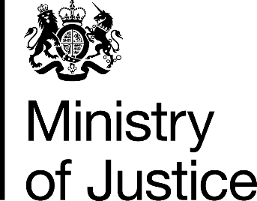

# OPEN MEETING

# FAMILY PROCEDURE RULE COMMITTEE

Application to attend an open meeting of the Family Procedure Rule Committee

## Monday 4 November 2024

11:00 – 14:00

Via MS Teams

Name:

Address:

Organisation:

Nature of Interest in the Committee:

Telephone Number:

E-mail Address:

Question(s) for the Family Procedure Rule Committee (see notes):

Closing date for applications is 18 October 2024.

Please return this form via e-mail to: [fprcsecretariat@justice.gov.uk](mailto:fprcsecretariat@justice.gov.uk)

**Notes:**

* If invited, you will be attending to observe a meeting of the Family Procedure Rule Committee (‘the Committee’). Please note that you will have the opportunity to put invited questions to the Committee in the Q&A section but will not be able participate in the normal business of the Committee discussed on the day. [*The Q&A section of the meeting is where you will have the opportunity to put your submitted question (time permitting) to the Committee and we will contact you before the day to confirm whether your question is amongst those which will be responded to*].
* Invitees will be selected to try to ensure a diverse and representative audience.