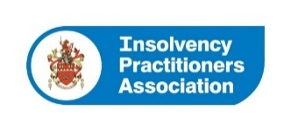
Type of Order: DISCIPLINARY CONSENT ORDER

Date of Order: 25 June 2024

Committee name: REGULATION AND CONDUCT COMMITTEE (the Committee)

Details of IP: Laura Stewart, formerly of Arkle Insolvency, an IPA Member and Licensed Insolvency Practitioner

Summary of complaint: This Order has been made in relation to a complaint that whilst employed by, and/or involved with Arkle Insolvency (August 2021 to 11 May 2022), Laura Stewart in her role as Supervisor of no less than 70 Individual Voluntary Arrangement’s, breached Statement of Insolvency Practice (‘SIP’) 11 when she failed to hold estate money in account(s) where the funds are readily identifiable to each estate.

Accordingly, Ms Stewart was found liable to disciplinary action under the IPA’s Articles of Association.

Summary of sanctions: The Common Sanctions Guidance (‘CSG’) provides for a severe reprimand and a fine of £5,000 as a starting point for a failure to comply with the principles of a SIP.

The Committee decided that a prima facie case of misconduct was made out on the facts. Whilst Ms Stewart considered that she had segregated estate funds from those of the firm, she had not kept estate funds in separate estate accounts as required by SIP11.

The Committee agreed that the conduct with reference to the CSG was ‘serious’ because protecting estate funds was a fundamental part of an Insolvency Practitioner’s role. In mitigation, a low number of cases were affected and there was no loss to any party.

The Committee ordered that Ms Stewart be severely reprimanded and fined £4,000.

