
National Shipbuilding Office
Shipbuilding Enterprise for Growth
Member Biographies
SEG Biographies

Surname  (inc post nominals) | Forename | SEG Role | Organisation / Company
Kenny (OBE) | Sarah | Industry SEG Co-Chair and Design Representative | BMT
Paterson | Rod | Government SEG Co-Chair | National Shipbuilding Office
Barton | Richard | Engineering Supply Chain Representative | Rolls-Royce
Bratt | Adrian | Leisure Sector Representative | Princess Yachts
Chant | Tom | Equipment, Systems & Supply Chain Representative | Society of Maritime Industries
Collins | Fran | Ship Owner / Operator Representative | Red Funnel
Conway | Chris | Finance Representative | Citibank
Keegan | Sarah Louise | Academia / R&D / Innovation Representative | MarRI UK
Lister (Sir/KCB OBE FREng) | Sir Simon | Naval Shipyards Representative | BAE Systems – Naval Ships
Percy (Dr/OBE) | Iain | Green Innovation Representative | CEO, Artemis Technologies
Powell (OBE) | Richard | Test & Evaluation / Integration Representative | QinetiQ
Sheerin | Paul | Skills Representative | Scottish Engineering
Shirling-Rooke (MBE) | Chris | Maritime Enterprise | Maritime UK
Srimoolanathan | Balaji | Industry Cross Sector | Aerospace Growth Partnership
Stewart | Rob | Offshore Renewables Vessels Representative | Aluminium Marine Consultants
Ring | David | Independent Advisor | Independent
Waddell | Ian | Employees Representative | Confederation of Shipbuilding and Engineering Unions
Wood | Charlotte | SME Representative | Mainstay Marine

Sarah Kenny OBE

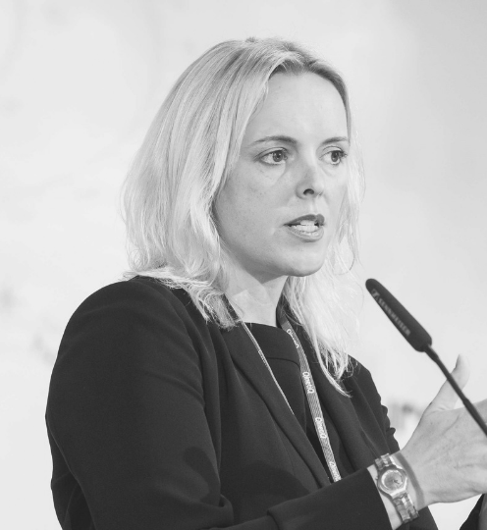 | Job title & Organisation  Chief Executive, BMT
SEG Role

Industry Co-Chair and Design Representative

Bio

Sarah Kenny is the Chief Executive of BMT. A marine environmental scientist by background, she has worked in marine and maritime science and technology businesses throughout her career. Sarah is Chair of Maritime UK, a board member of Maritime London, and a Trustee Director of the National Oceanography Centre.

Sarah is also a member of the UK Defence Innovation External Advisory Panel member, an Honorary Captain of the Royal Navy and an Honorary Member of the Royal Corps of Naval Constructors.

Sarah was awarded an OBE in the 2019 Queen’s Birthday Honours list for her services to the Maritime Industry and Diversity. In the same year, Sarah was also awarded an honorary doctorate from Portsmouth University.

Rod Paterson

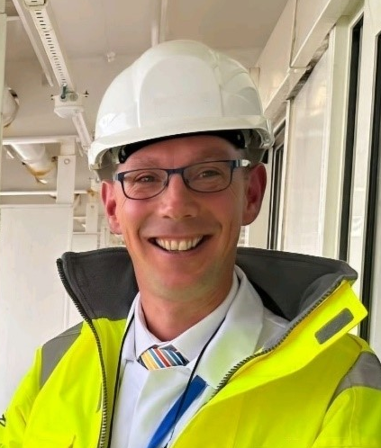 | Job title & Organisation  CEO National Shipbuilding Office (NSO)
SEG Role

Government Co-Chair

Bio

In May 2024, Rod Paterson was delighted to be appointed as the Chief Executive Officer of the National Shipbuilding Office (NSO).

Prior to that he was the NSO’s Deputy Director since its creation working across Government and the entire shipbuilding enterprise to drive delivery of the refreshed National Shipbuilding Strategy.

From 2015 to 2021 Rod held various Deputy Director roles in the Department for Transport’s (DfT) Maritime Directorate. Rod first joined the Civil Service in 1999 and has held wide ranging roles including leading EU negotiations on aviation security issues, working for HS2 Ltd and leading the Department for Transport’s Business Planning process. Rod has also had spells in private office and on secondment at the Marine Accident Investigation Branch.

Richard Barton

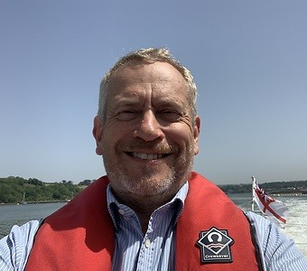 | Job title & Organisation  UK Defence Solutions Centre  Asst Director Strategy & Policy
SEG Role

Heavy Engineering Representative
Bio

In 2024 Richard took up a 2-year secondment opportunity from Rolls-Royce with the UK Defence Solutions Centre, where he is accountable for its strategy implementation, increasing its network of partners and ensuring alignment with government. Prior to this he held leadership roles in Rolls-Royce’s Defence, Marine and Civil businesses in Programme Management, Customer Services and Engineering. Most recently in Business Development of naval marine and sustainable power opportunities.

During his career he has had the opportunity to lead major transformation programmes, including those spanning the Rolls-Royce portfolio. He also spent two rewarding years overseas in Indianapolis to successfully deliver a challenging new marine gas turbine programme.

Richard is passionate about the development of the Marine industry in the UK and is a Council Member on the Society of Maritime Industries’ Maritime, Defence and Security Group, and a member of the Global Underwater Hub’s South’s Advisory Group. Outside work he is a Trustee of the Somerset Sight charity and a Director of the Rolls-Royce Heritage Trust. He is married with 2 boys and lives with his family in Somerset.

Adrian Bratt

 | Job title & Organisation  Executive Director, Princess Yachts Ltd
SEG Role

Leisure Sector Representative
Bio
Adrian is a chartered governance professional and a commercial solicitor. He joined Princess Yachts in 2017 having acted for the organisation over the previous decade whilst in a national private practice law firm. He now heads up the People, Legal and External Affairs functions.

Adrian previously served as a Warfare Officer in the Royal Navy and then retrained as a lawyer following 10 years' operational service in the Gulf, Caribbean, Australasia and the Mediterranean, as well as a stint as the skipper of a patrol boat. Adrian graduated in Biochemistry from Cardiff University and subsequently obtained Post-Graduate Diplomas in Law and Legal Practice, he is also a graduate and fellow of the Chartered Governance Institute and a member of the Trading Standards Institute.

Adrian recently chaired the SW Regional Council for the CBI, and was a Non- Executive Director of the British Marine Federation. He currently sits on the Plymouth and South Devon Freeport Board along with a number of other public-private partnership organisations. Adrian is an Honorary Colonel of 165 Port and Maritime Regiment.

Tom Chant

 | Job title & Organisation  Chief Executive Officer, Society of Maritime Industries (SMI)
SEG Role

SMI (Equipment, Systems & Supply Chain) Representative
Bio

Tom was appointed Chief Executive of the SMI in August 2020. He has a long association with the marine industry having been an active sailor and student of boatbuilding in Southampton. His career has encompassed a wide range of market sectors and he has gathered experience of business development, marketing and distribution in an international business environment.

A nine year period at the trade body for the leisure and superyacht sector was committed to developing the members’ export business. This included running UK pavilions at overseas shows, management of inward and outward missions including Meet-the-Buyer events, plus the creation of market reports and representation on government committees.

Recent career experience included distributor management for a marine equipment company before he joined SMI in February 2017 as the Business Development Director and Secretary to the Commercial Marine Group and Marine Science & Technology Group.

Fran Collins

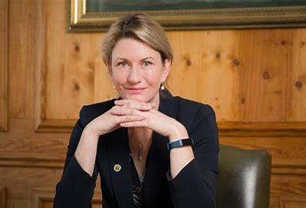 | Job title & Organisation  CEO Red Funnel
SEG Role

Ship Owner/Operator Representative
Bio

Fran Collins is a Chartered Director and Master Mariner. She is the CEO of Red Funnel, a position she has held since June 2018 and brings over 30 years of experience in the merchant navy.​ Having undertaken a dual cadetship, she qualified with both Deck and Engineer licenses and worked mainly on oil & gas, and cable vessels. ​ In 2002, she joined Condor Ferries, subsequently being promoted to Master.

In 2008, Fran transitioned to shore-based management and business leadership, undertaking a range of executive roles and furthering her career in general business management with a strong commercial and operational focus. ​

Alongside her role at Red Funnel, Fran supports Saga Cruises as a Non-Executive Director and is actively involved in several industry bodies at regional and national level.

Fran received the Merchant Navy Medal for Meritorious Service in 2019 and was sworn into the Elder Brethren of the Court of Trinity House in 2023. ​

Chris Conway

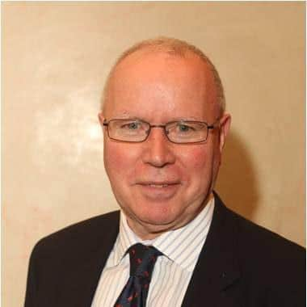 | Job title & Organisation  Global Head of Shipping, Citibank
SEG Role

Finance Representative

Bio

Christopher Conway is the Global Head of Shipping – Export Agency Finance at Citibank. He has held this role since August 2015. Prior to this Chris was Global Head of Risk for Shipping and Offshore Logistics in addition to being Head of Risk for Global Industrials (GIG) in EMEA.

Prior to joining Citi, he spent 5 years as a lender in the Shipping Industry covering Greece and Scandinavia. While at Citi, he has held a number of coverage roles in both shipping and industrial sectors driving complex structured transactions from an early stage in his career of which the privatisation financing for the UK ports and ferry business was an early example.

From 1986 to 1996, he was part of Citi’s global workout team based in New York in a restructuring role for both general corporates and real estate. His return to Europe included a 5 year spell in Poland as Head of Risk for the Corporate Bank. Chris returned to New York for a 2 year stint helping build a mid-cap business, before returning to the UK to take up a pan-European risk role. Throughout his career he has stayed close to the shipping industry which now is his sole focus.

Sarah Louise Keegan

 | Job title & Organisation  Director, Maritime Research & Innovation (MarRI-UK)
SEG Role

Academia Representative
Bio

Sarah was appointed Director of MarRI-UK in May 2023, following a two-year tenure as Assistant Director. Prior to this, she spent a decade in various roles, leading large-scale strategic programmes that unified industry, academia, and government to boost innovation and economic growth across the engineering sector, including aerospace, defence, manufacturing, and maritime.

Sarah has also been deeply involved in regional initiatives, collaborating with the UK and Regional Government, local authorities, and councils to secure funding and deliver region-specific objectives. Notably, she led a £96M programme which saw the creation of the National Manufacturing Institute Scotland (NMIS), an industry-led international centre of manufacturing expertise, transforming skills, productivity, and innovation, attracting further investment.

Her primary interest lies in working with industry to understand their immediate and future needs, aligning these with government objectives, and leveraging emerging academic developments to enhance the sector’s global competitiveness.

Sir Simon Lister KCB OBE FREng

Job title & Organisation

Managing Director, BAE Systems Maritime – Naval Ships

SEG Role

Naval Shipyards Representative
Bio

Simon Lister became Naval Ships Managing Director on 1 January 2021. He joined BAE Systems as Managing Director of the Aircraft Carrier Alliance in 2017, before being appointed Chief Operating Officer (COO) of BAE Systems Maritime and Land in April 2020 and since joining the Company he has been a member of the Maritime & Land UK Board.

Prior to joining BAE Systems, Simon enjoyed a successful and interesting career as a nuclear submariner and marine engineer in the Royal Navy, concluding as a Vice Admiral, Member of the Navy Board, Chief of Materiel (Fleet), and Chief Naval Engineer.

Simon is married to Anita and they have three grown up children. Free time is spent propping up a property in Malvern, Worcestershire, sailing around the UK coast, skiing, theatre, and tinkering with old cars that have exceeded their economic life and using them for long distance exploration.

Dr Iain Percy OBE

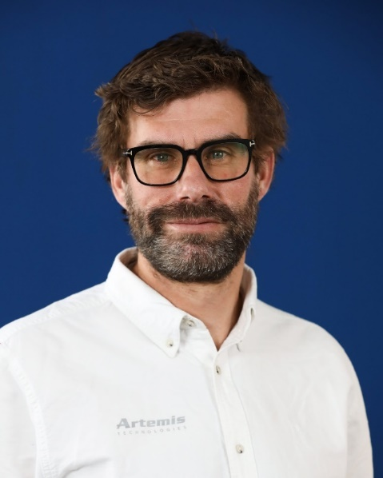 | Job title & Organisation  Chief Executive Officer, Artemis Technologies
SEG Role

Green Innovation Representative

Bio

Iain is a four time Olympian, three time Olympic medallist and double Olympic champion. He is also a veteran of four America’s Cup challenges beginning in 2005 as a helmsman for the +39 Challenge, before joining Great Britain’s America’s Cup challenge, Team Origin.

After retiring from Olympic competition in 2012, he joined Artemis Racing as a tactician, and was appointed Team Manager in October 2013. Iain then went on to lead the team’s successful 35th America’s Cup campaign in Bermuda, reaching the Louis Vuitton Challenger Series final in 2017.

Passionate about protecting the oceans, the economics graduate founded Artemis Technologies in 2017, with a mission to see how America’s Cup technology could play a part in the decarbonization of the maritime industry.

He has overseen the company’s transition from a sailing services provider to an applied technologies company focusing on green innovations for marine transportation.

Richard Powell OBE

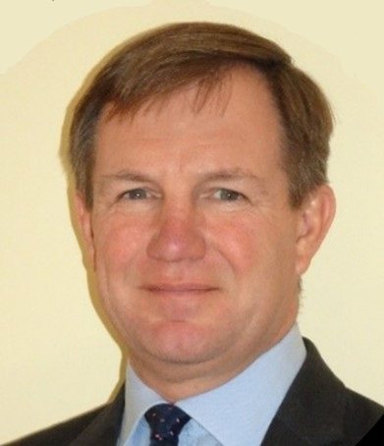 | Job title & Organisation  Director of Strategic Engagement, QinetiQ
SEG Role

Test & Evaluate / Integrate
Bio
Building on a 37 year career in the Royal Navy as a Destroyer Captain, aviator and diplomat, Richard Powell is QinetiQ’s Director of Strategic Engagement for the maritime sector. In this role, he is responsible for relationship management with defence and industry in the maritime domain across the global QinetiQ group, in order to inform QinetiQ’s strategy development. More broadly, he is the Chairman of the Maritime Defence and Security Group Council and Board member within the Society of Maritime Industries.

In this role, he was invited to give evidence to the House of Commons Defence Committee and Scottish Affairs Committee as part of their enquiries into the National Shipbuilding Strategy. He is also a member of the Shipbuilding Enterprise for Growth advising the government on shipbuilding and is also Vice Chairman of the National Shipbuilding Office’s project examining Centres of Excellence in the maritime domain as part of the refresh of the National Shipbuilding Strategy.

Finally, he is the UK Maritime lead for the AUKUS Pillar 2 Advanced Capabilities Industry Forum, working with UK, US and Australian government officials and Trade Associations, to represent UK maritime interests in the develop of the Tri-National submarine and advanced technologies programmes.

David Ring

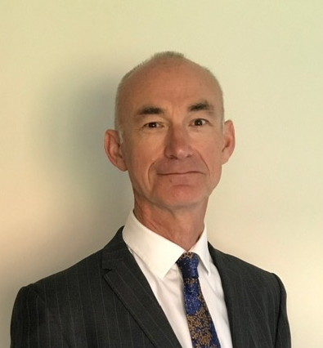 | Job title & Organisation  Unaffiliated
SEG Role

Independent Advisor
Bio

David chairs the Project Delivery Board for the Type 26 and Type 31 Shipbuilding Programmes. Prior to this he has worked as a Non-Executive Chair of Engineering businesses and performed various senior executive roles in the marine, aerospace and automotive sectors.

Paul Sheerin

Job title & Organisation

Chief Executive Scottish Engineering

SEG Role

Skills
Bio
Paul Sheerin has been Chief Executive of Scottish Engineering since 2018 having previously been involved through member companies Polaroid and B&W Diamond Power Specialty Ltd. Paul studied Electrical and Electronic Engineering at The University of Glasgow and joined Nuclear Electric in 1990 as part of the Sizewell ‘B’ project team.

After a period of working in the USA, he returned to Scotland and joined Polaroid at its Dumbarton base in 1996 and became Managing Director in 2005, then VP Global Operations of Polaroid’s sunglass business until 2017.

Paul has been a volunteer and supporter of Young Enterprise Scotland, and enjoys opportunities to promote Enterprise, Engineering and Manufacturing opportunities for all.

Chris Shirling-Rooke MBE

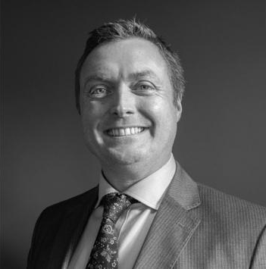 | Job title & Organisation  CEO Maritime UK
SEG Role

Maritime UK
Bio
Chris became Chief Executive of Maritime UK in Summer 2023, the umbrella body for the £116 Billion UK maritime sector, which brings together the shipping, ports, professional services, engineering and leisure marine industries.

He has continued to lead the establishment of Maritime UK’s cluster support programme for coastal communities, a partnership between the Department for Transport and Maritime UK supporting regional maritime clusters, fostering collaboration and driving growth across the United Kingdom.

Previously Chris was Chief Executive of Mersey Maritime, the sector champion for the maritime industry in the North West of England, and was awarded an MBE for his services to Maritime in 2020. He remains a keen advocate for an inclusive workforce both as a member of WISTA (Women's International Shipping and Trading Association) as well as Chair of the Maritime UK Mental Health Network. Chris is also Chair of the Nautilus Welfare Fund Committee.

Balaji Srimoolanathan

 | Job title & Organisation  Programme Director of the Aerospace Growth Partnership and Director for the Aerospace and Space sectors at ADS
SEG Role

Independent cross sector input
Bio

Balaji is the Programme Director of the Aerospace Growth Partnership (AGP), a strategic partnership between the UK Government, industry, and other key stakeholders, established to secure the future of the UK aerospace industry in the face of an ever changing, and increasingly competitive global landscape.

Balaji is also the Director for the Aerospace and Space sectors at ADS, delivering member services, events and policy development and oversees the operations of the AGP. He also oversees the operations of ADS Toulouse and manages the programme managers in secondment to the AGP from industry.

Previously, Balaji was Strategy Manager for the Aerospace Technology Institute, where he led the ATI’s market and supply chain capabilities and contributed to the development of the ATI’s first technology strategy.

Prior to this, Balaji has worked in various senior consulting roles with IHS Janes and Frost & Sullivan during which he advised clients which included Fortune 500 companies, global aerospace and defence majors, and governments and has also held engineering roles in Cyient, a leading global engineering, manufacturing, and digital technology solutions company and in the Engineering department of Air India.

Balaji is an Aerospace engineer and a Master of Business Administration in Aviation Management from the Royal Melbourne Institute of Technology.

Rob Stewart

 | Job title & Organisation  Commercial Director, Aluminium Marine Consultants Ltd
SEG Role

Offshore Renewables Vessels Representative
Bio

Rob has been the Commercial Director of AMC Ltd for over ten years, overseeing the company’s expansion as the leading supplier of Crew Transfer Vessels, Tugs, Fire Fighting and Autonomous Survey boats. AMC employs 50 permanent staff and 30 subcontractors, operating from two shipyards on the Isle of Wight.
Rob is proactive in the design and manufacture of zero carbon vessels, having several ongoing projects. He is a strong advocate of advancing modular battery systems and offshore charging of wind farm vessels which have been adopted by overseas operators. Rob works worldwide with associate companies in Japan, USA, and the Middle East.
Rob is a Director of The Society of Maritime Industries and sits on the Commercial Integration Committee for AUKUS. He is on two Government Committees; the Dept for Transport Zero Implementation Board and the UK Gov Clean Maritime Council.

Ian Waddell

 | Job title & Organisation  General Secretary, Confederation of Shipbuilding and Engineering Unions
SEG Role

Employees Representative

Bio

Ian was elected as General Secretary in October 2017 after a 20 year career as a full-time officer with Unite and its predecessor unions. He has been a member of the Aerospace Growth Partnership (AGP) Board and the Chemistry Growth Partnership. He was a member of the Board of Semta, the former Sector Skills Council until its re-launch as Enginuity.

Ian is Chair of the IndustriAll Europe trade union federation’s Aerospace Committee and has been leading the campaign to reduce the hourly working week and deliver strategic investment in the industry.

The CSEU is a federation of the Unite, GMB, Community and Prospect trade unions, covering the engineering, shipbuilding & ship repair, aerospace, defence and steel industries.

Charlotte Wood

 | Job title & Organisation  Commercial Manager, Mainstay Marine Solutions Ltd
SEG Role

SME Representative
Bio

Charlotte serves as the Commercial Manager at Mainstay Marine Solutions, a leading marine engineering firm in Pembroke Dock, South West Wales. With over nine years of dedicated service, she is a key member of the senior management team, overseeing all commercial activities across the company’s diverse portfolio, including commercial workboat building and marine engineering.
Charlotte’s influential contributions have been pivotal in the company’s strategic expansion into new market sectors such as marine renewable energy, defence, offshore wind support craft, and autonomous craft.
Her advocacy for the blue economy, promotion of British manufacturing, skills development, and enhancement of local supply chains has led to her active engagement with various government entities. Additionally, she serves as a Board member of the Pembrokeshire Coastal Forum, the overseeing body of Marine Energy Wales.

