MEMORANDUM FOR THE MINISTRY OF DEFENCE
MAIN ESTIMATE 2024-25

Overview
This Memorandum covers the Main Estimate (ME) for the Ministry of Defence (MOD) and should be read in conjunction with the Central Government Main Supply Estimates 2024-25. The Department’s spending plans for 2024-25 are based on the Spending Review in 2020/21 and the 2023 Spring Budget Statement.
The Department’s Expenditure Limit (DEL) (Resource and Capital) for 2024-25 is £56.4Bn (including net budget cover transfers to Other Government Departments (OGDs) in 2024-25, but excluding ring fenced (depreciation and impairments) expenditure). This figure is also inclusive of initial funding provided by HM Treasury’s (HMT) Reserve for the net additional costs of Military Operations and Peacekeeping including Support to Ukraine.
There are no contingencies funded in this Estimate, and contingent liabilities are reported in a separate table in the Main Supply Estimate.
There is a separate Estimate Memorandum for the Armed Forces Pensions and Compensation Schemes vote.
Section 2 and 4 contains explanations for each new request for resources.
Please note, the figures in the tables within this memorandum have been rounded to one decimal place. In some cases, this has caused a minor discrepancy between the figures in the tables and the totals shown due to the rounding of the figures.

Objectives

The Estimates were prepared during a general election campaign and the priority outcomes were set in a previous Parliament as set out in the statement below.
Ministry of Defence’s Priority Outcomes that guide Defence Planning, as set out in the 2023 Defence Command Paper, are:
- Protect the UK, its Crown Dependencies, and its Overseas Territories, and contribute to the collective deterrence and defence of the Euro-Atlantic area: able to deter and, if necessary, defend against and defeat, attacks on the UK homeland (including our Overseas Territories) and our NATO Allies.
- Pursue a campaigning approach to counter the threats from state and non-state actors, wherever they manifest in the world, working in an integrated way with allies and partners to achieve focused and impactful results.
- Promote our national interests globally, building influential relationships, and maintaining engagement and access.
- Secure strategic advantage, achieve greater economic and industrial resilience, and contribute to national prosperity.

Spending controls
MOD’s spending is broken down into several different spending totals, for which Parliament’s approval is sought.
The spending totals which Parliament votes are:
- Resource Departmental Expenditure Limit (“Resource DEL”)- day to day running costs
- Capital Departmental Expenditure Limit (“Capital DEL”): - investment in new equipment and infrastructure
- Resource Annually Managed Expenditure (“Resource AME”): less predictable day to day spending: in MOD’s case, mainly provisions, depreciation and impairment and movements in financial instruments
- Capital Annually Managed Expenditure (“Capital AME”): in MOD’s case, nuclear provisions.
In addition, Parliament votes a net cash requirement, designed to cover the elements of the above budgets which require MOD to pay out cash in year.

Main areas of spending
The graphic below shows the main components of MOD’s proposed budget for the current year, included in the latest Main Estimate, and the proportions of funds spent on its main activities.
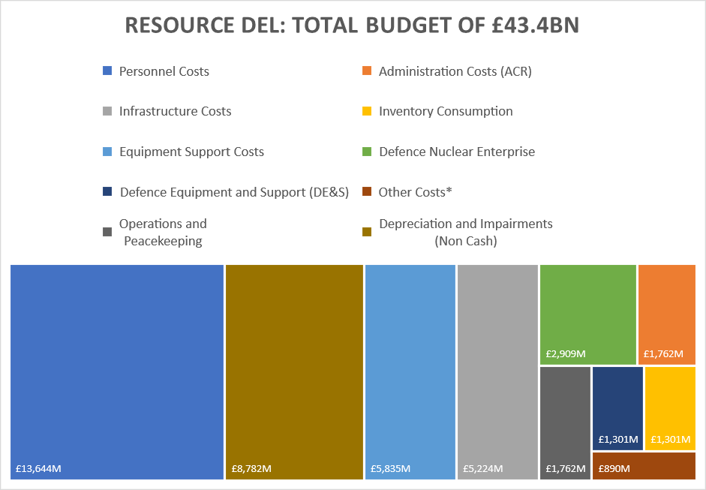
* Includes Other Costs and Services, Receipts and Other Income, Cash Release of Provisions, Research and Development Costs related to Provision of Defence Capability, DE&S (BTE) Costs, Arm's Length Bodies and War Pension Benefits Programme Costs.
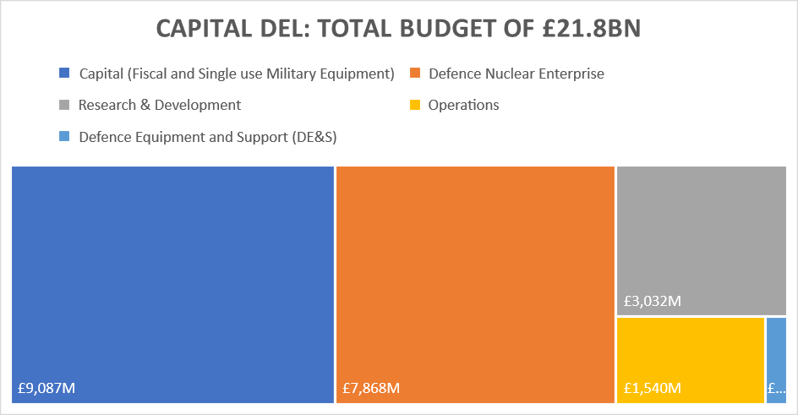
*Defence Equipment and Support (DE&S) = £277m

Comparison of spending totals sought
The table and graphic below show how the totals sought for the MOD compare with last year:
Table 1a: Main Estimate total sought for MOD compared with last year Note 1
Spending total - Main Estimate  2024-25 |  | Compared to  2023-24 SE |  | Compared to  2022-23 Outturn
 | £M | £M | % | £M | %
Resource DEL | 43,410 | (397) | -0.9% | 3,562 | 8.9%
Capital DEL | 21,754 | 2,557 | 13.3% | 1,450 | 7.1%
AME | 1,928 | - | - | 15,784 | -113.9%
Note 1: Total include spends for Operations and Peacekeeping.

Key drivers of spending changes since last year
The main causes of the changes in Resource DEL are:
- The 2023-24 Supplementary Estimates included a DEL switch from Capital to Resource;
- Change in spending for Resource for Operations, including increased Support to Ukraine;
- Increase in Military Superannuation Contribution Adjusted for Previous Experience (SCAPE); and,
- Budget cover transfers to/from other government departments due to transfer of responsibilities.
The main causes of the changes in Capital DEL are:
- The 2023-24 Supplementary Estimates included a DEL switch from Capital to Resource;
- Changes in Spending on Operations, including increased Support to Ukraine;
- Increased Capital spend on Nuclear;
- Additional funding as agreed at SR20/21; and,
- Budget cover transfers to/from other government departments due to transfer of responsibilities.
The initial Resource AME is set at £1.9Bn based on available information.

New policies and programme; ambit changes
The Department made no revisions to the ambit.

Spending trends
The charts below show overall spending trends for the last five years and plans presented in Estimates for 2023-24 and 2024-25.
Table 1b: Spending Trends - £Bn
 | 2018-19  Outturn | 2019-20  Outturn | 2020-21  Outturn | 2021-22  Outturn | 2022-23 Outturn | 2023-24 SE | 2024-25 ME
Resource DEL | 34.6 | 36.7 | 40.2 | 39.7 | 39.8 | 43.8 | 43.4
Capital DEL | 10.3 | 10.3 | 11.7 | 14.1 | 20.3 | 19.2 | 21.8
AME | (7.9) | (0.3) | 2.1 | 10.8 | (13.9) | 1.9 | 1.9

- Totals include spends for Operations and Peacekeeping.
- Resource AME, due to its nature, is volatile and reflects the changing Treasury Discount Rates on provision and fluctuations in financial instruments.

Administration costs and efficiency plans
The Department SR20 settlement set out the Administrative Cost Regime (ACR) budgets for the settlement period.
Table 2: Main Estimate total sought for Administration Costs
Spending total - Main Estimate  2024-25 |  | Compared to  2023-24 SE |  | Compared to  2022-23 Outturn
 | £M | £M | % | £M | %
Administration costs | 2,042 | 40* | 2.0% | 284 | 16.2%

*increase relates to military pension (SCAPE) increases

Funding: Spending Review and Budgets
The levels of DEL funding for MOD for 2024-25 are based on plans published in the Spending Review 2020,2021 and Spring Budget Statement 2023 for the Ministry of Defence. Details of funding changes from last year are set out in para 1.5.

Other funding announcements
There are no other spending announcements.

Spending detail

Explanations of changes in spending

Resource DEL
The table below shows how MOD’s spending plans for Resource DEL compare with last year.
Table 3: Main Estimate total sought for MOD compared with 2023-24 Supplementary Estimate
Resource DEL |  | 2024-25 ME | 2023-24 SE | Change from  SE
Subheads | Commodity Block | £M | £M | £M | %
A, B | Personnel Costs | 13,844.5 | 13,062.4 | 782.1 | 6.0%
C | Infrastructure Costs | 5,324.0 | 5,296.8 | 27.2 | 0.5%
D | Inventory Consumption | 1,301.0 | 1,440.2 | (139.2) | -9.7%
E | Equipment Support Costs | 5,835.5 | 6,635.5 | (800.0) | -12.1%
F,G,I,M,W,Y,Z | Other Costs and Services* | 1,891.1 | 2,582.1 | (690.9) | -26.8%
AC, AD | Defence Nuclear Enterprise Programme | 2,909.0 | 2,812.0 | 97.0 | 3.4%
N,O,X,AB | Administration Costs | 1,762.0 | 1,726.3 | 35.8 | 2.1%
P-U,AA | Operations and Peacekeeping (incl. CSSF) | 1,761.6 | 1,449.7 | 311.9 | 21.5%
H | Depreciation and Impairments Costs | 8,781.7 | 8,802.5 | (20.8) | -0.2%
 |  | 43,410.4 | 43,807.4 | (397.0) | -0.9%

* Includes Other Costs and Services, Receipts and Other Income, Cash Release of Provisions, Research and Development Costs related to Provision of Defence Capability, DE&S (BTE) Costs, Arm's Length Bodies and War Pension Benefits Programme Costs.

With this Main Estimate, the initial commodity block cost allocations reflect the latest information on the Department’s spending plans for 2024-25 as per the Spending Round 2020, 2021 and Spring Budget 2023. Changes will be made in the Supplementary Estimate to reflect the latest in-year forecast, along with subsequent funding adjustments. The main elements of these changes are:
- An initial Reserve for Operations and Peacekeeping, including Support to Ukraine of £1,902M to cover additional costs of operations; any further funding adjustments will be drawn down at Supplementary Estimates;
- Military SCAPE - £509M;
- Budget cover transfers to/from Other Government Departments (OGDs) totalling (£522M);
- Budget uplift for Defence Nuclear Enterprise and Resilience and Readiness of £715M; and
- Various re-allocations to Arm’s Length Bodies (Grant in Aid), with no overall impact on DEL, to reflect the initial Grant-in-Aid funding.

Capital DEL
The table below shows how spending plans for Capital DEL compare with last year Estimates.
Table 4: Main Estimate total sought for MOD compared with 2023-24 Supplementary Estimate
Capital DEL |  | 2024-25 ME | 2023-24 SE | Change from SE
Subheads | Commodity Block | £M | £M | £M | %
J | Single Use Military Equipment | 5,238.0 | 6,624.5 | (1,386.5) | -20.9%
K,W,Y,L | Other Capital (Fiscal) | 4,075.9 | 2,511.9 | 1,564.0 | 62.3%
M | Research and Development | 3,032.0 | 2,232.3 | 799.7 | 35.8%
AC | Defence Nuclear Enterprise Programme | 7,868.0 | 6,609.0 | 1,259.0 | 19.0%
V | Operations and Peacekeeping* | 1,540 | 1,219.0 | 321.0 | 26.3%
 |  | 21,753.9 | 19,196.7 | 2,557.2 | 13.3%

* Operations and Peacekeeping in Main Estimates only include the initial funding from HMT in RDEL any additional funding will be received in Supplementary Estimates (see note 4.4).

The changes in the Main Estimate reflect the current departmental plans. The main elements of these changes are:
- An initial Reserve claim for Operations and Peacekeeping, including Support to Ukraine £1,540M;
- Budget uplift for Defence Nuclear Enterprise and Resilience and Readiness - £2,250M;
- A budget uplift of £282M following the implementation of IFRS16; and
- Budget cover transfers to/from Other Government Departments (OGDs) totalling (£162M).

AME
The table below shows how spending plans for Resource AME compared with last year estimates. The initial requests take a realistic view based on previous patterns. These numbers will be updated at Supplementary Estimates following the release of HM Treasury Discount Rates.
Table 5: Main Estimate total sought for MOD compared with 2023-24 Supplementary Estimate
AME | 2024-25  ME | 2023-24  SE | Change from SE
 | £M | £M | £M | %
Total Resource AME | 1,928.1 | 1,928.1 | - | -

Ring fenced budgets
Within the Control Totals, the following elements are ring-fenced, i.e. savings in these budgets may not be used to fund pressures in other budgets.
Table 6: Main Estimate total Ring fenced budgets
Spending total - Main Estimate 2024-25 |  | 2023-24 SE | Change From Last Year
 | £M | £M | £M | %
Operations - RDEL and CDEL | 3,301.6 | 2,611.4 | 690.2 | 26%
Conflict, Stability and Security Fund | 42.6 | 57.3 | (14.7) | -26%
War Pension Benefits | 652.7 | 636.9 | 15.8 | 2%
Defence Nuclear Enterprise Programme RDEL and CDEL | 10,777.0 | 9,421.0 | 1,356.0 | 14%
Core Depreciation and Impairment Costs | 8,781.7 | 8,802.5 | (20.8) | 0%

Changes to contingent liabilities
Provisions for liabilities and charges are based on realistic and prudent estimates of the expenditure required to settle future legal or constructive obligations. The Department is required to identify contingent liabilities when agreeing contracts, seek HM Treasury approval and provide timely notification to Parliament of those more than £300k. This allows Parliament and HM Treasury to scrutinise the extent to which the taxpayer might be exposed to potentially significant liabilities in the future.
The MOD’s provisions cover legal claims, civilian early departure costs, environmental costs, restructuring and nuclear decommissioning and restoration costs. Details of the Department’s Contingent Liabilities are set out in a separate table in the Main Supply Estimate. We are currently assessing the impact on future contingent liabilities and will provide further detail on this in our 2023-24 Annual Report and Accounts.

Priorities and performance

How spending relates to objectives


The table below shows how expenditure against each subhead. The budgetary structure of the MOD does not show separately the exact costs or budgets for the four individual objectives as set out in section 1.1. This is because large parts of the Armed Services operate as fully integrated joint organisations in which elements from the Navy, Army and Air Force work closely together and share land, buildings and facilities and sometimes equipment. Detail of these areas of spending are provided below.
Total Defence Spending
£56.38bn3
Service Personnel
£11.46bn
Capital Expenditure
£12.12bn
Equipment Support
£5.844bn
Infrastructure
£5.22bn
Administration1
£1.76bn
Civilian Personnel £2.18bn
Inventory
£1.3bn
DE&S
£1.53bn
Costs of Operations and Peacekeeping
£3.3bn
Other Costs
£0.02bn2
War Pensions Benefits
£0.65bn
Arm’s Length Bodies
£0.22bn
1. Includes all administration costs relating to Other Costs and Services, Cash Release of Provisions and cost of Military and Civilian personnel who perform an administrative role.
2. Includes Other Costs and Services, Receipts and Other Income, Cash Release of Provisions and Research and Development resource and Costs related to Provision of Defence Capability.
3. Total Defence Spending represents Cash Resource DEL (non ring-fence RDEL) and Capital DEL for investment.
4 Defence Nuclear Enterprise (Admin, Resource and Capital)

Defence Nuclear Enterprise
£10.78bn4

Measures of performance against each priority
The MOD’s priority outcomes and strategic enablers for this parliament are set out in the MOD’s Outcome Delivery Plan (known as the Defence Plan), and agreed each year with HM Treasury and the Cabinet Office. The plan itself is classified; performance against that plan is reported every year in our Annual Report and Accounts. As stated at 1.1 Objectives, this Estimate has been prepared during a general election campaign and the priority outcomes were set in a previous Parliament.

Commentary on steps being taken to address performance issues
Spending designed specifically to address performance issues includes:
- The Department continues to progress interventions to address the recommendations put forward by NAO and PAC as they consider the annual Equipment Plan. In 2023 the department published an update on its progress in the annual equipment plan report, and we will continue to address the remaining elements. A copy of the Equipment Plan report can be found at: The Defence Equipment Plan 2023-GOV.UK(www.gov.uk)

Major projects
The 2023 Annual Report on the Government Major Projects Portfolio (GMPP) from the Infrastructure and Projects Authority (IPA) can be found here:
MOD Government Major Project Portfolio Data, 2023 - GOV.UK (www.gov.uk)
All MOD Capability Programmes are funded internally by the Department, via HM Treasury.

Other information

Summary of Resources sought in the Estimate
Part 1 of the Estimate sets out the new resource requirements for the year ending 31 March 2025. The resources requested are set out in Table 7 below.
Table 7: Summary of Expenditure and AME Request at 2024-25 Main Estimates
Resource Expenditure | £M
Resource DEL: Provision of Defence Capability | 41,648.7
Resource DEL: Operations and Peacekeeping & CSSF | 1,761.6
Resource DEL | 43,410.4
Resource AME Provision of Defence Capability | 1,928.1
Total Net Request for Resource at 2024-25 ME | 45,338.5
Capital Expenditure | £M
Capital DEL: Provision of Defence Capability | 21,213.9
Capital DEL: Operations and Peacekeeping | 1,540.0
Total Net Request for Capital at 2024-25 ME | 22,753.9

Budgetary Transfers to and from Other Government Departments
Table 8: Transfers to MOD from Other Government Departments
Exporting Department | Defence Output | £M | Purpose
Security and Intelligence Agencies | Provision of Defence Capability - RDEL | 35.900 | PES Transfer
Department for Education | Provision of Defence Capability - RDEL | 4.420 | PF-FE-HE scheme
Cabinet Office | Provision of Defence Capability - RDEL | 0.250 | Development of Veterans
Foreign, Commonwealth and Development Office | Provision of Defence Capability - RDEL | 14.655 | One HMG
Foreign, Commonwealth and Development Office | Provision of Defence Capability - RDEL | 42.619 | UKISF (CSSF)
Total |  | 97.844

Table 9: Transfers from MOD to Other Government Departments
Importing Department | Defence Output | £M | Purpose
Multiple OGD | Provision of Defence Capability - RDEL | -335.490 | NCSP (National Cyber Security Programme)
Department for Energy Security and Net Zero | Provision of Defence Capability - RDEL | -11.017 | HEX
Department for Energy Security and Net Zero | Provision of Defence Capability - CDEL | -5.000 | HALEU
Security and Intelligence Agencies | Provision of Defence Capability - RDEL | -7.000 | Gold 7
Cabinet Office | Provision of Defence Capability - RDEL | -0.652 | TOG SpAd (Admin)
Cabinet Office | Provision of Defence Capability - RDEL | -0.205 | Heads of Place (Admin)
Cabinet Office | Provision of Defence Capability - RDEL | -0.010 | Public Appointments Licence
Security and Intelligence Agencies | Provision of Defence Capability - CDEL | -1.500 | Support for IT Innovation (NSSIF)
Cabinet Office | Provision of Defence Capability - CDEL | -1.815 | Pj AutoFac (aka Spotlight)
Security and Intelligence Agencies | Provision of Defence Capability - RDEL | -173.920 | HQS
Security and Intelligence Agencies | Provision of Defence Capability - CDEL | -108.800 | HQS
Cabinet Office | Provision of Defence Capability - CDEL | -6.418 | ROSA Capital
Security and Intelligence Agencies | Provision of Defence Capability - RDEL | -13.491 | Joint Crypt Key Programme (JCKP)
Security and Intelligence Agencies | Provision of Defence Capability - CDEL | -34.297 | Joint Crypt Key Programme (JCKP)
Security and Intelligence Agencies | Provision of Defence Capability - CDEL | -2.296 | PJ- MARTYNR
Security and Intelligence Agencies | Provision of Defence Capability - RDEL | -10.051 | IATP CIO Budget Transfer to GCHQ
Department of Health and Social Care | Provision of Defence Capability - RDEL | -12.000 | WPS social means test to DHSC
Foreign, Commonwealth and Development Office | Provision of Defence Capability - RDEL | -20.000 | Integrated Activity Fund - Transfer out to FCDO
Cabinet Office | Provision of Defence Capability - RDEL | -26.500 | Crisis Response (JIO / NSS / COBR transfer to CO) (Admin)
Cabinet Office | Provision of Defence Capability - RDEL | -9.200 | Crisis Response (JIO / NSS / COBR transfer to CO) (Prog)
Department for Science, Innovation and Technology | Provision of Defence Capability - CDEL | -2.000 | Defence Innovation Loans
Total |  | (781.662)

Arm’s Length Bodies (ALBs)
Under Clear Line of Sight (CloS), Arm’s Length Bodies (ALBs) are part of Departmental DEL. Table 10 summarises the funding requested by MOD ALBs and is based on information received from the sponsoring Top-Level Budget (TLB).
Table 10: Bodies
Organisation | Resource DEL  £M | Capital DEL  £M
Armed Forces Covenant Fund Trustee Ltd | 10.856
Commonwealth War Graves Commission | 55.649
International Military Services Limited | 0.001
National Army Museum | 7.181
National Museum of the Royal Navy | 3.995
Royal Air Force Museum | 10.754
Royal Hospital, Chelsea | 13.918
Single Source Regulations Office | 6.436
Territorial, Auxiliary and Volunteer Reserve Associations established under s 110 of the Reserve Act | 109.728 | 2.500
Total | 218.518 | 2.500

Operations
The MOD’s total request for the initial net additional costs of military operations is set out in Table 11 below.
Table 11: Main Estimate total sought for MOD compared with last year
Operations and Peacekeeping |  | 2024-25 ME | 2023-24 SE | Change from Supplementary Estimate
Subheads | Commodity Block | £M | £M | £M | %
P-V | Operations - RDEL | 1,719.0 | 1,392.4 | 326.6 | 23.5%
 | Operations - Capital DEL | 1,540.0 | 1,219.0 | 321.0 | 26.3%
AA | Conflict, Stability and Security Fund | 42.6 | 57.3 | ( 14.7) | -25.7%
 |  | 3,301.6 | 2,668.7 | 632.9 | 19.2%

A total of £3,302m in resources for Operations, Peacekeeping and the MOD’s share of the Conflict, Stability and Security Fund (CSSF) is requested. The MOD presents the initial cost of operations at Main Estimates and requests any adjustments amount at Supplementary Estimates. A breakdown of the initial cost of operations is at Table 11. The details of key operations are:

Eastern Europe:
Funding is requested to cover the net additional costs of Defence’s contribution to the wider HMG response to increase threat levels in Eastern Europe.
Following on from the additional funding granted in 2022/23 and 2023/24, Treasury has given Defence a further £3bn to fund Ukraine. A further £280m of funding in 23/24, plus another £280m in 24/25, has also been given to Defence for munitions.

Wider Gulf:
Initial funding is requested to cover the initial net additional costs of UK forces deployed to the wider Gulf to sustain UK influence in the region, reassure our regional allies and support access and over flight for operations in Iraq and Syria.

Middle East:
Initial funding is requested to meet the initial net additional costs, including airstrikes and humanitarian aid.

Deployed Military Activity Pool (DMAP):
The DMAP is a joint HM Treasury and MOD initiative to make available resources to fund the initial and short-term costs of any unforeseen military activities, as authorised by the National Security Council. Initial funding is requested from the HM Treasury Special Reserve, which is matched by the same amount from the MOD’s Defence Capability resources.

Integrated Security Fund (ISF)
The ISF replaced the Conflict Stability and Security Fund (CSSF) as the Government’s mechanism for funding conflict prevention, stabilisation, security and peacekeeping activities, under the strategic direction of the NSC. An initial allocation of £43M is requested for the MOD’s contribution to this activity.

2024-25 Supplementary Estimates
It is anticipated that other adjustments will be required at the Supplementary Estimate (published early February 2025), including:
- Refinement and re-allocation of costs between commodity blocks;
- Civilian Personnel SCAPE adjustments;
- Additional resource and capital funding to cover any remaining adjustments in net additional costs of military operations; and
- Refinement of the AME requirements following release of HM Treasury’s Discount Rates.

Accounting Officer Approval
This memorandum has been prepared according to the requirements and guidance set out by the House of Commons Scrutiny Unit, available on the Scrutiny Unit website.
The information in this Estimates Memorandum has been approved by myself as the Accounting Officer at the Ministry of Defence.

David Williams
Permanent Secretary and Accounting Officer
Ministry of Defence
Annex A

- Annex A.1
- Definition of Terms:

Non Ring-Fenced DEL Resource Expenditure:
This includes current expenditure which covers, for example, pay, purchase of goods and services, net of receipts, within the resource budget. It excludes items such as depreciation and movement in provisions.

Ring-Fenced DEL Resource Expenditure:
- This control covers items such as depreciation and impairments.

Administration Cost Regime:
The current Administration Cost Regime, within DEL, cover departments’ current expenditure on civilian staff, and other services used in the administration of central government as agreed in our Spending Review Settlement.

Total Resource DEL:
- This is the sum of non ring-fenced expenditure and ring-fenced expenditure.

Annually Managed Expenditure (AME):
Annually Managed Expenditure (AME) includes Programmes that are demand-led, such as War Pensions, and exceptionally, volatile items that cannot be controlled by the Department. AME also includes Programmes that are so large that the Department could not be expected to absorb the effects of volatility within them, such as cash release of provisions.

Total Net Resource:
- This is the sum of Total Resource DEL and AME.

Capital Departmental Expenditure Limit (CDEL):
This is for new investment (SUME and Fiscal), including capital additions, disposals, and the capital repayment of loans.

Provision of Defence Capability:
Provision of Defence Capability provides for expenditure primarily to meet the Ministry of Defence’s operational support and logistics services costs and the costs of providing the equipment capability required by Defence policy.

Operations:
This provides primarily for the additional costs of operations. These are the net additional costs incurred: the costs that the Department would have incurred regardless of the operation taking place, such as wages and salaries, are recorded against provision of Defence Capability.

War Pensions Payments:
War Pensions and Allowances, etc. provides primarily for the payments of pensions and allowances for disablement or death arising out of war or service in the Armed Forces after 2 September 1939 and associated non-cash items.

Spending Review:
- Spending Review 2020 (Cp 330)

Total DEL:
This is the sum of Resource DEL and Capital DEL less the costs of depreciation. This is used as depreciation and is included as part of Resource DEL and, since Capital DEL includes capital spending, the inclusion of depreciation would lead to double counting.

Single Use Military Equipment (SUME):
National Accounts differentiates between single and dual use military equipment. Spending on single use military equipment is classified as current (resource) expenditure. Single use military assets are those that could not be used by civilian organisations to produce goods and services (i.e. weapons and equipment that supports and delivers such weapons). This distinction will disappear in the next Spending Review.

Voted and Non-Voted Expenditure:
- The introduction to the Supply Estimate now covers both Voted and Non-Voted items.
- Annex A.2
- List of Abbreviations used in the Estimate
ABC Annual Budget Cycle
ACR Administration Cost Regime
ALB Arms Length Body
AME Annually Managed Expenditure
ANSF Afghan National Security Force
BTE Bespoke Trading Entity
CDEL Capital Departmental Expenditure Limit
CLoS Clear Line of Sight
CRFCA Council for Reserve Forces and Cadets Association
CSR Comprehensive Spending Review
CWGC Commonwealth War Graves Commission
DCLG Department for Communities and Local Government
DHSC Department of Health and Social Care
DEL Departmental Expenditure Limits
DFID Department for International Development
DMAP Deployed Military Activity Pool
ERNIC Employer’s National Insurance Contribution
GCHQ Government Communication Headquarters
HMT His Majesty’s Treasury
LIBOR London Inter Bank Offered Rate
ME Main Estimate
MOD Ministry of Defence
MOG Machinery of Government
NATO North Atlantic Treaty Organisation
NDPB Non Departmental Public Body
OSCAR Online System for Central Accounting and Reporting
ONS Office of National Statistics
RDEL Resource Departmental Expenditure Limit
RHC Royal Hospital Chelsea
SCAPE Superannuation Contribution Adjusted for Previous Experience
SE Supplementary Estimates
SIA Single Intelligence Account
SR Spending Review
SUME Single Use Military Equipment
TLB Top Level Budget
UK United Kingdom
UOR Urgent Operational Requirement
- Annex A.3
- Current RDEL Commodity Structure

Commodity Block | Major Cost Categories
Service Personnel Costs | Military and other ranks pay and other allowances; SCAPE; Employer’s National Insurance Contributions (ERNIC)
Civilian Personnel Costs | Civilian pay and other allowances; pension contributions; Employer’s National Insurance Contributions (ERNIC)
Infrastructure Costs | Property management; service charges; IT & communications costs; utilities costs.
Inventory Consumption | Munitions; stores; fuel (marine & aviation); clothing; other materials consumed e.g. stationary, sundries, general stores etc.
Equipment Support Costs | Equipment support costs, including leases & hire charges for plant, machinery and transport.
Other Costs & Services | Travel & subsistence; professional services & fees; training.
Research and Development | Research and Development expenditure is incurred Supplementary for the future benefit of the Department. Such expenditure is primarily incurred on the development of new single use military equipment (SUME) and on the improvement of the effectiveness and capability of existing single use military equipment.
Receipts and Other Income | Receipts from various sources; costs recoveries; dividends; interest.
Cash Release of Provisions | Nuclear and non-nuclear provisions e.g. staff redundancies, legal costs, environmental, etc.
Arm’s Length Bodies | CRFCA; Royal Hospital Chelsea; National Army Museum; RAF Museum; National Museum of the Royal Navy; Commonwealth War Graves Commission. Single Source Regulation Office
Ring-Fenced Non-Cash: Depreciation/ Impairments | Depreciation and impairments on Non-current Assets (Property, SUME, dual purpose).

Spending Review 2020 - GOV.UK
Autumn Budget and Spending Review 2021: documents - GOV.UK (www.gov.uk)
Spring Budget Statement 2023 - GOV.UK
Cost of Support to Ukraine is also included in Core (£141m)
Spring Budget 2023 Announcement
Post preparation of HMT Estimate the liquidation of IMS Ltd has now been completed.

