NOTICE OF ORDER
Wildlife and Countryside Act 1981
Norfolk County Council
(South Acre - EH003) Modification Order 2021

Notice is hereby given that the above referenced Order has been submitted to the Secretary of State for Environment, Food and Rural Affairs for determination. An Inspector will be appointed by the Secretary of State to determine the Order.

The start date for the above Order is 17 September 2024

Consideration of the Order will take the form of exchanges of statements of case and comments on statements of case.

The effect of the Order, if confirmed without modifications, will be to modify the Definitive Map and Statement for the area by adding a Bridleway that starts from the west end of Sporle with Palgrave Bridleway No. 2 at grid reference TF 8199 1327 (point A on Order map) and proceeds in a west direction for approximately 165 metres to join the A1065 (Castle Acre Road) at grid reference TF 8182 1327 (point B on Order map). The width of the route extends between historic boundary features and varies between 3.5 and 4 metres as indicated on the Order map. Limitations and conditions: None.

Any queries relating to this Order should be referred to Paul Scrivener by email: Rightsofway2@planninginspectorate.gov.uk quoting reference number ROW/3320351 on all correspondence. Alternatively, queries may be sent in writing to The Planning Inspectorate, Rights of Way Section, Room 3/A Eagle Wing, Temple Quay House, 2 The Square, Temple Quay, Bristol, BS1 6PN. Telephone: 0303 444 «Telephone_Ext».

Any person wishing to view the statements of case and other documents relating to this Order may do so by appointment at Norfolk County Council, Community & Environmental Services, County Hall, Martineau Lane, Norwich, Norfolk NR1 2SG by emailing legalordersandregisters@norfolk.gov.uk Council contact: Kathryn Webb, Email: kathryn.webb@norfolk.gov.uk Telephone: 01603 22 88 82

Timetable for sending in statements of case and comments Within 2 weeks of the start date 1 October 2024
The Order Making Authority must ensure their statement of case is received by the
Secretary of State. As soon as possible after the deadline, the Secretary of State will send a copy (excluding copies of any supporting documents - these will be available to view at the Authority’s offices) to everyone who has made an objection or representation, the applicant and any other person who has written to us in respect of the Order.
Within 8 weeks of the start date 12 November 2024
Everyone who has made an objection or representation or any other written representation or any other person wishing to make representations in writing must ensure their statement of case is received by the Secretary of State. As soon as possible after the deadline, the Secretary of State will send full copies to the Authority.
Copies (excluding copies of any supporting documents - these will be available to view at the Authority’s offices) will also be sent to the applicant, every person who has made an objection or representation and any other person who has written to us in respect of the Order.

Within the same period the applicant (if applicable) must ensure their statement of case is received by the Secretary of State. As soon as possible after the deadline, Secretary of State will send a full copy to the Authority. Copies will also be sent to everyone who has made an objection or representation and any other person who has written to us in respect of the Order (excluding copies of any supporting documents - these will be available to view at the Authority’s offices).

Within 14 weeks of the start date 24 December 2024
Everyone who has made an objection or representation, the Authority, the applicant (if applicable) and anyone who has written to us in respect of the Order must ensure that their comments on any or every other statement of case is received by the Secretary of State. As soon as possible after the deadline, the Secretary of State will send copies of these comments to everyone else.
In fairness to the other parties everyone should keep to the timetable to ensure that statements of case and comments are received on time. Late documents will be returned.

We cannot accept any inflammatory, discriminatory or abusive comments. Any documents containing such comments will be returned.

Notice of order for w/r
WILDLIFE AND COUNTRYSIDE ACT 1981

NORFOLK COUNTY COUNCIL - DEFINITIVE MAP AND STATEMENT

NORFOLK COUNTY COUNCIL (SOUTH ACRE (EH003}}

MODIFICATION ORDER 2021

This Order is made by Norfolk County Council ("the Authority") under Section 53(2)(b) of the Wildlife and Countryside Act 1981 ("the Act") because it appears to the Authority that the Definitive Map and Statement of Public Rights of Way for the County of Norfolk ("the Definitive Map and Statement") require modification in consequence of events specified in Section 53(3) of the Act, namely:-

Section 53(3)(c)(i) - the discovery by the authority of evidence which (when considered with all other relevant evidence available to them) shows that a right of way which is not shown in the map and statement subsists or is reasonably alleged to subsist over land in the area to which the map relates, being a right of way such that the land over which the right subsists is a public path, a restricted byway or a byway open to all traffic,

The Authority have consulted with every local authority whose area includes the land to which the Order relates.
The Norfolk County Council hereby order that:-
- For the purposes of this Order the relevant date is 1st September 2021
- The Definitive Map and Statement of Public Rights of Way for the County of Norfolk shall be modified as described in Part I and Part II of the Schedule and shown on the map attached to the Order.
- This Order shall take effect on the date it is confirmed and may be cited as the Norfolk County Council (South Acre (EH003)) Modification Order 2021.

  - .5
GIVEN under the Common Seal of Norfolk County Council on this l.l-.. day of )'<Pk.MI-U Two Thousand and Twenty One

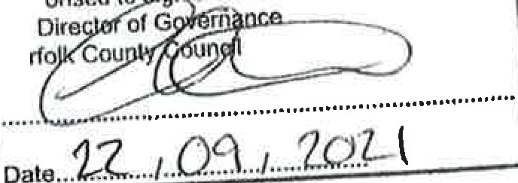
THECOMMONSEAL THE NORFOLK COUNTY COUNCIL
AUOl
the
No
a\tof
was hereunto affixed in the presence of:-

Director of Governance

)

    - .Co
SCHEDULE

PARTI

Modification of the Definitive Map

Description of path or way to be added

Bridleway Starts from the west end of Sporle with Palgrave Bridleway No. 2 at grid reference TF 8199 1327 (point A on annexed plan) and proceeds in a west direction for approximately 165 metres to join the A1065 (Castle Acre Road) at grid reference TF 8182 1327 (point Bon annexed plan).

PART II

Modification of Definitive Statement

Bridleway (Sporle with Plagrave BR2 to Castle Acre Road). Starts from the west end of Sporle with Palgrave Bridleway No. 2 at grid reference TF 8199 1327 and proceeds in a west direction for approximately 165 metres to join the A1065 (Castle Acre Road) at grid reference TF 8182 1327. The width of the route extends between historic boundary features and varies between 3.5 and 4 metres as indicated on the
) Order plan. Limitations and conditions: None

11
.:,ecuon :>.> or me vv11ame ana oumry"s- 1ae ACI-.:
Norfolk County Council (South Acre (EH003)) M fication Order 2021

Width of the route shown in metres
C
581900

Bridleway to be added (A-B) Unaffected Bridleway

Norfolk County Council County Hall
Martineau Lane
Norwich
NR1 2SG

582100

N
W+E
s

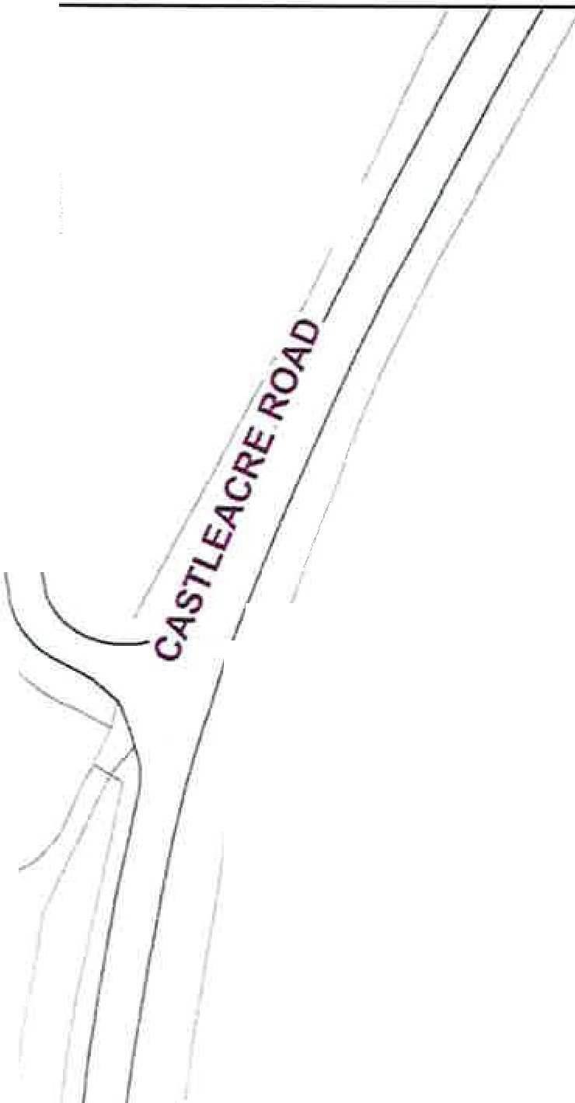
C
-----
0 Tef
I
I
C

0 ,,
0
-"
.-:
:,.)
3

0
. ,
f! "'

,,S(b(/J
"' /if ••h pa\grave 0
00
0

. ,
0
. ., ,$.$'
, o, ~'?
.,

B
?.I

5porle VII•

.,a
-
R2 o
A

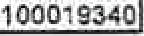

581900 582100 Scale 1:1,500
0
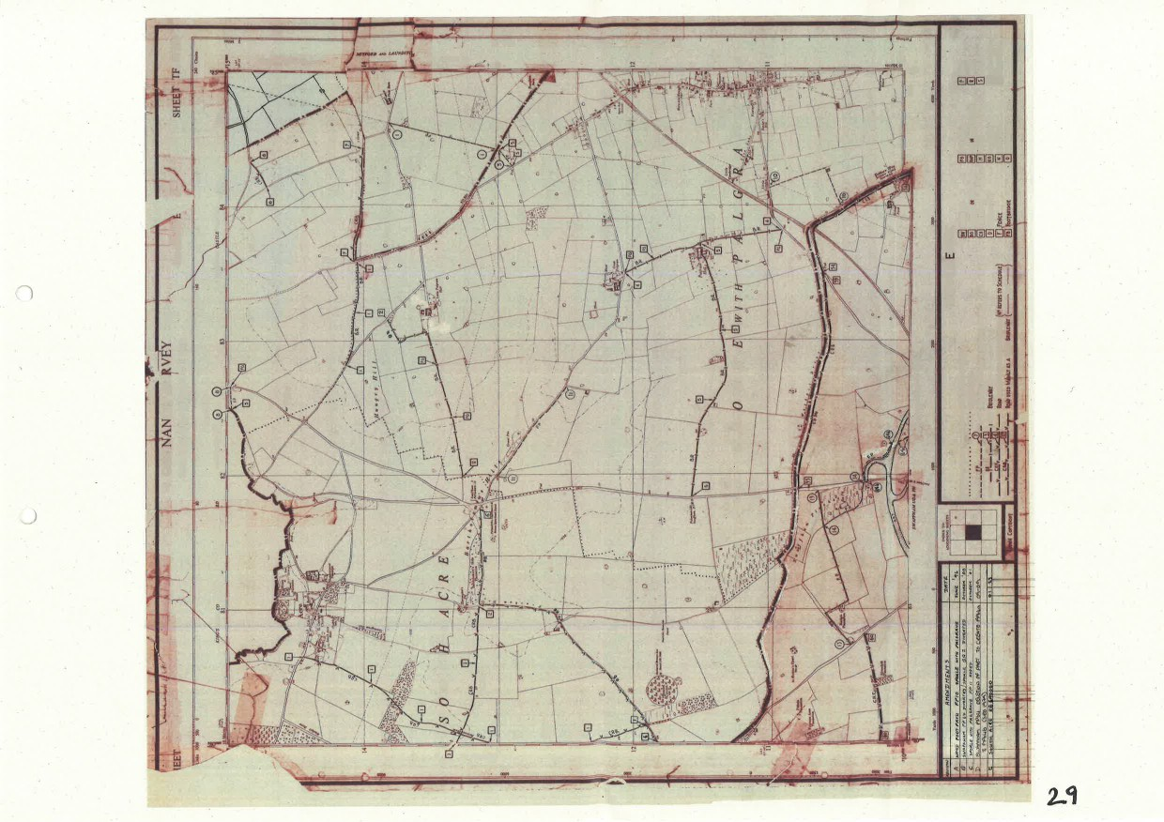




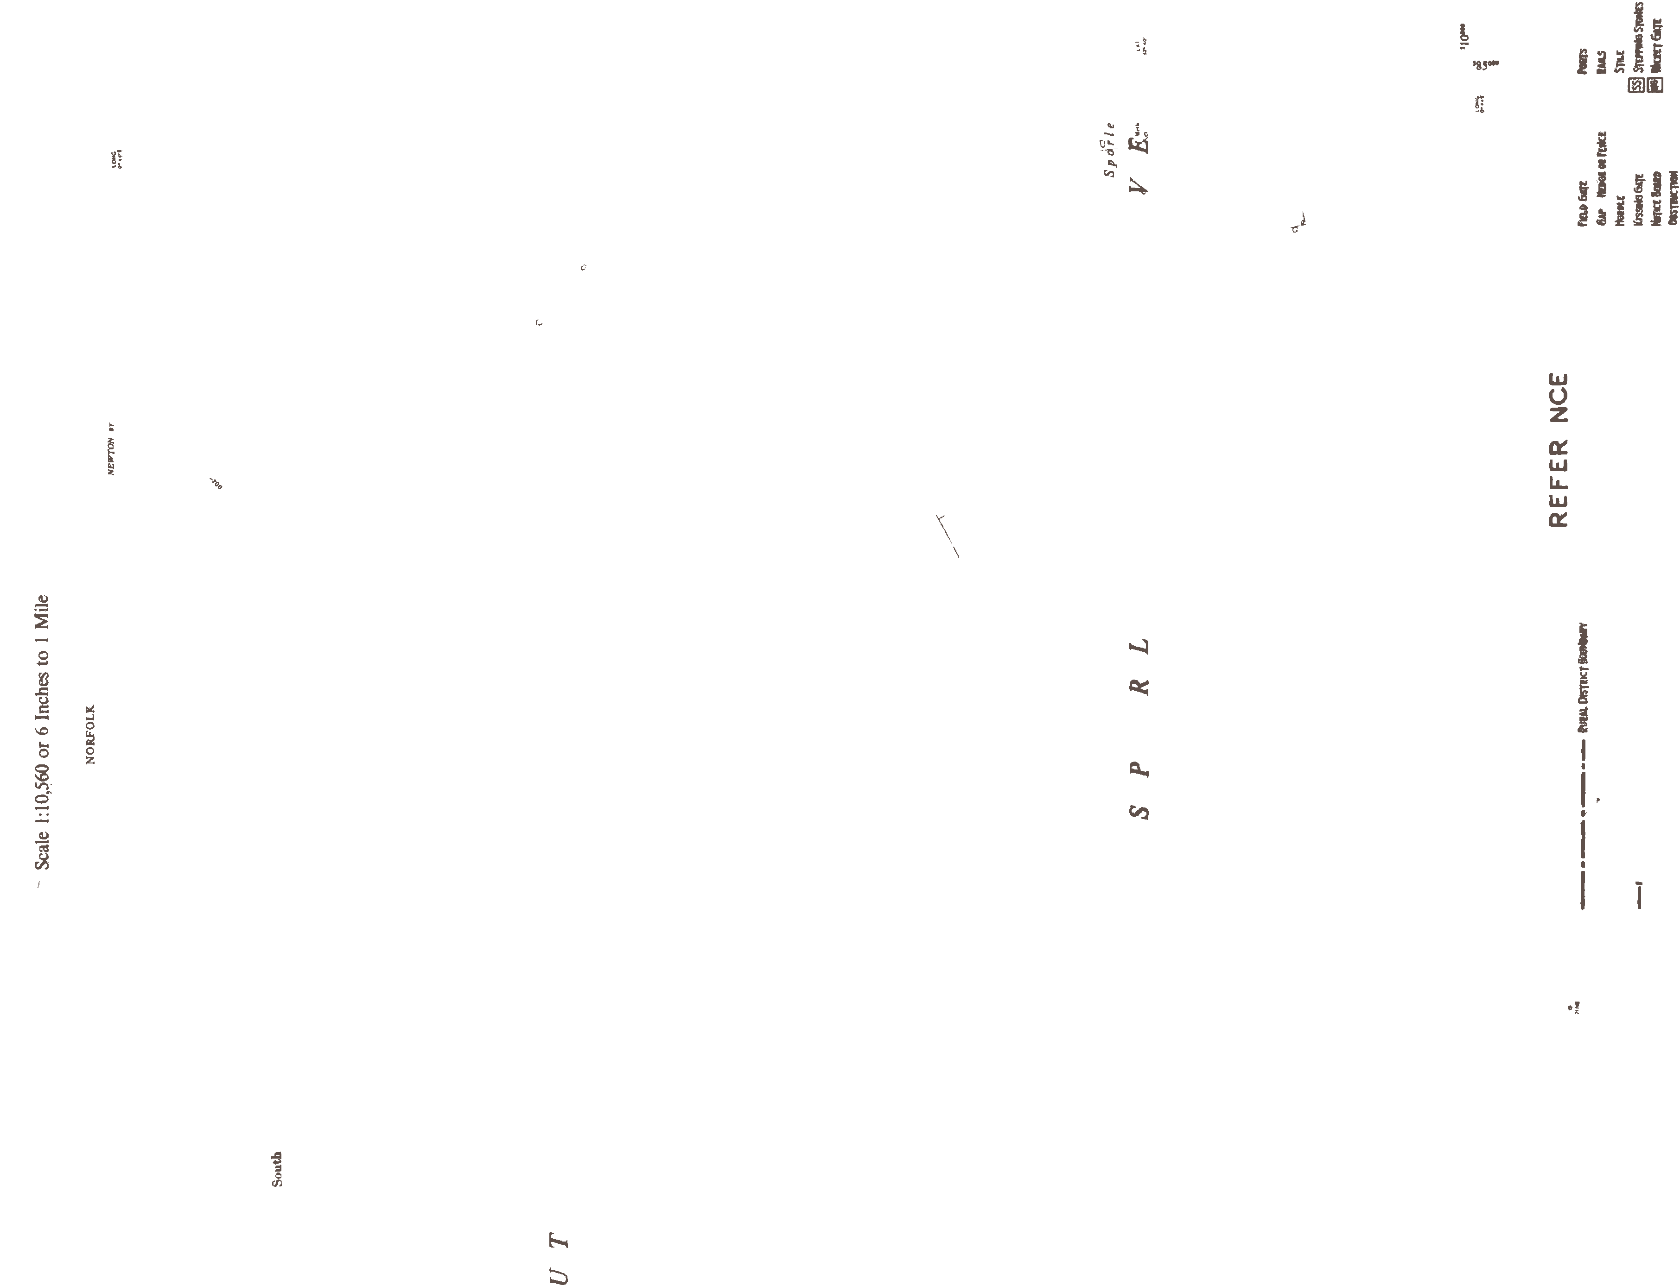
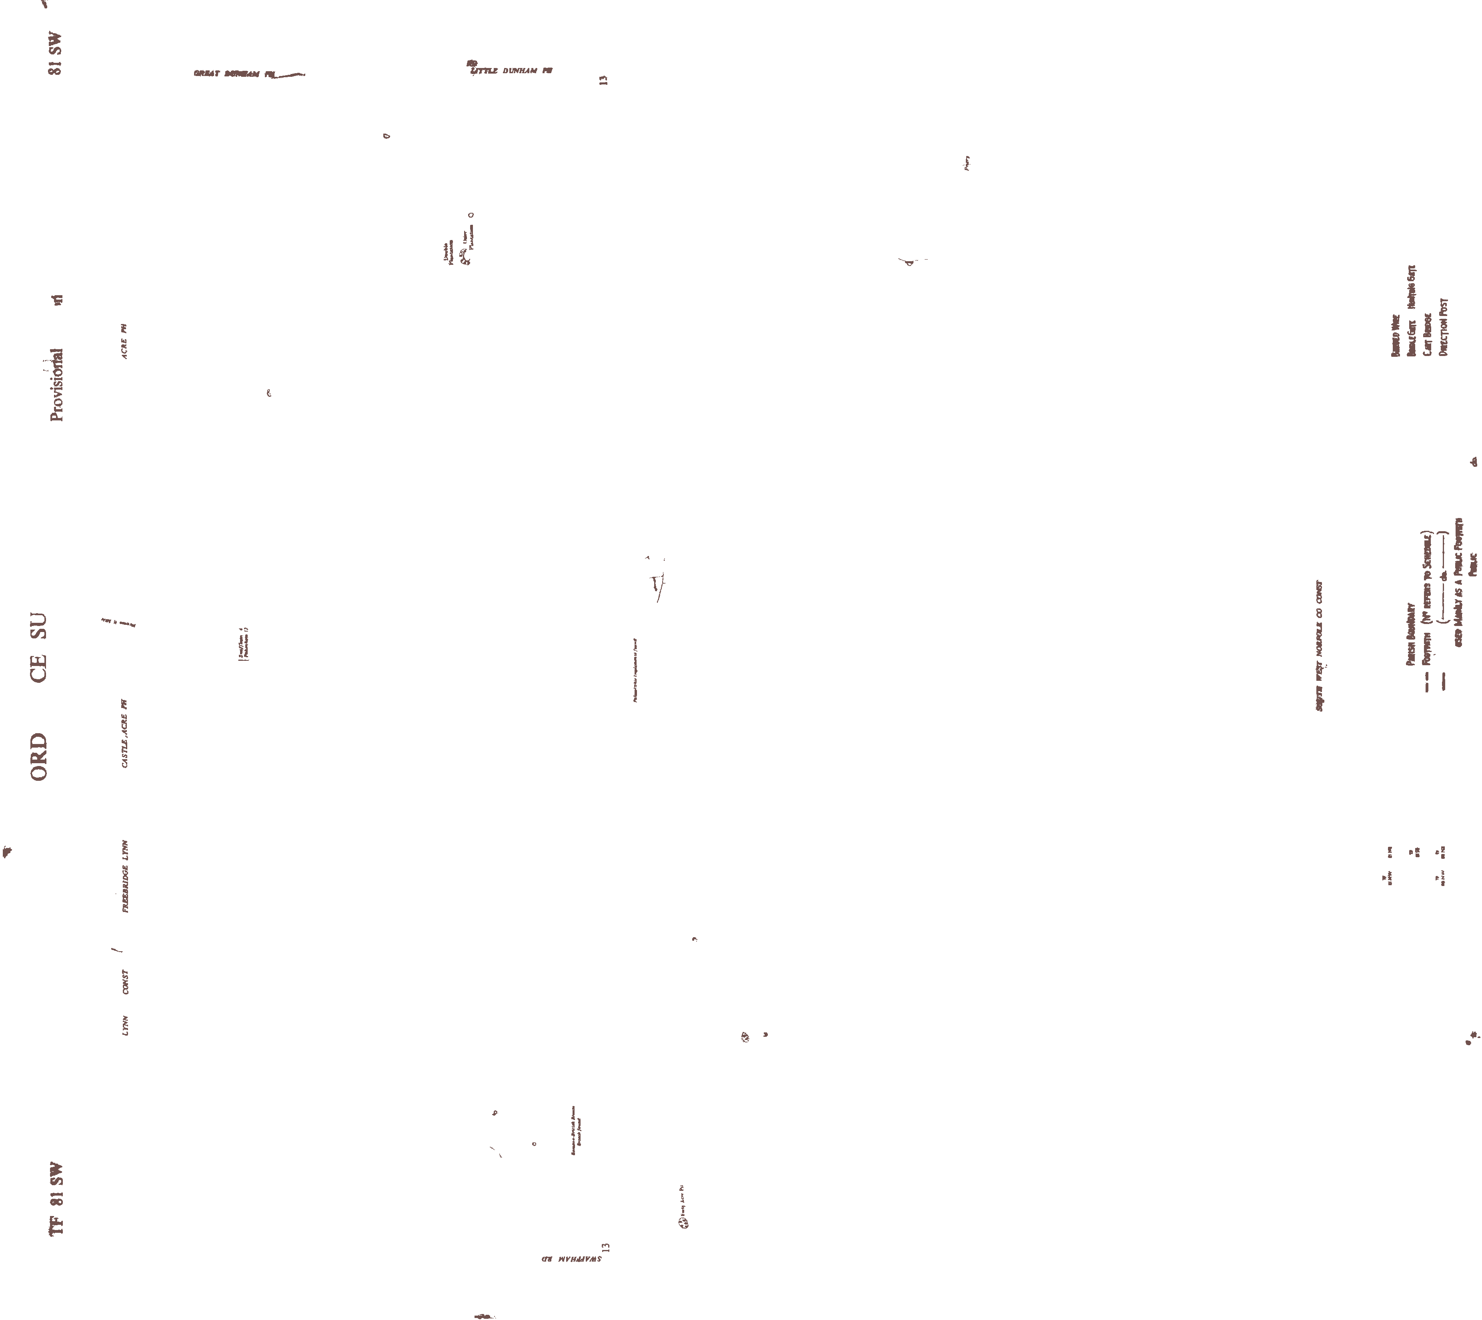


Parish of South Acre

Restricted Byway No. 1 (Petticoat Drove). Starts from fieldgate west of South Acre Hall Farm and runs south-westwards through Fingerhill Plantation crossing Restricted Byway No. 2 and continuing southwards to join Fincham Drive.

Restricted Byway No. 2 (Bartholomew's Hill Plantation to West Acre Road). Starts from Fincham Drove by south-west corner of Bartholomew's Hill Plantation and runs north-westwards crossing Petticoat Drove and Washpit Drove and running to the south of Three-Cocked-Hat Plantation and continuing to West Acre Road at parish boundary.

Restricted Byway No. 5 (Parish Boundary to Swaffham Road). Starts from the parish boundary and runs southwards along the eastern boundary of Three Cornered Whins to join the Swaffham Road.

Restricted Byway No. 6 (Big Wood Lane to River Road). Starts from a point on Big Wood Lane (U33064) at grid reference TF 8174 1315 and proceeds in a west direction for approximately 712 metres to the eastern end of South Acre Restricted Byway No. 2 at grid reference TF 8103 1315 where the route turns to run in a south direction for approximately 564 metres to grid reference TF 8097 1259. The route then turns to run in a south west direction for approximately 1597 metres to join River Road (U33086) at grid reference TF 7969 1165. The width of the route extends between historic boundary features and varies between 3 and 12 metres as indicated on the Ordnance Survey 1905 County Series second edition map. Limitations and conditions: None. January 2023

30
"---

Hungr_y_Hill
-\_,
\,.
, Wells's Green
-
-

----...._ ...

\
\ I

' "",'
Little Palg-r ,.I\ A 7\-4
I'
'
f
I

I
'ilJ I
i

ea
\
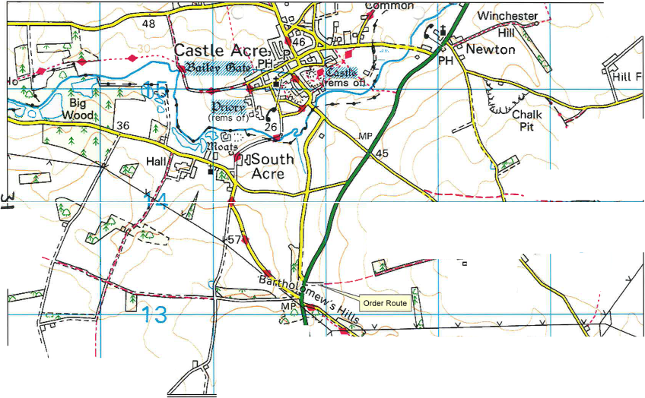
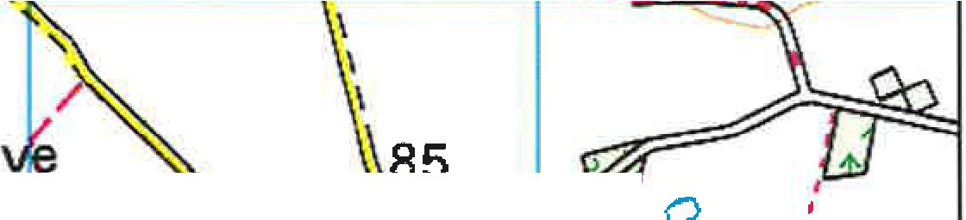
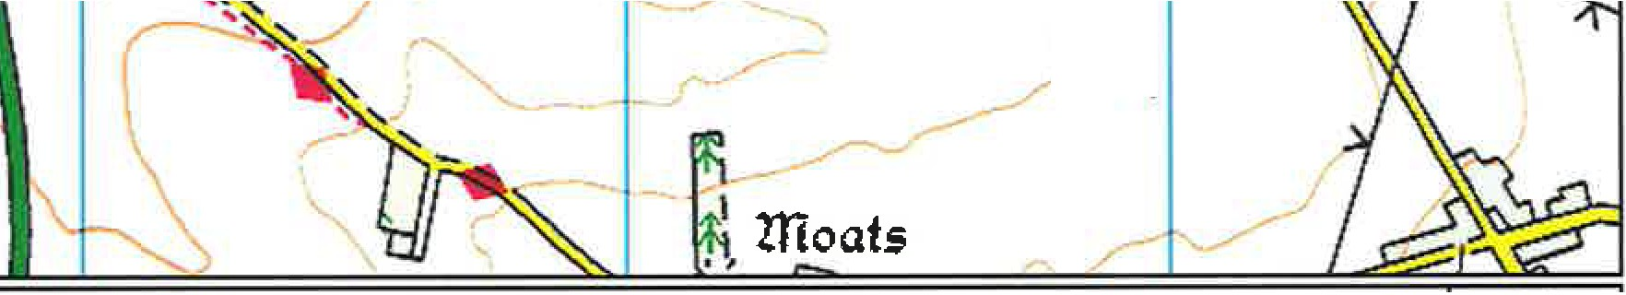
© Crown opyright)rJtt·d tabase rights, '
2011 o;nance StlJ-vey 1"00019340

;., Norfolk County Council  South Acre  582,004.1453 314,027.3999 | Location Plan  Scale:  1:20,000 | N  A

