NOTICE OF ORDER

Wildlife and Countryside Act 1981 Section 53
LEICESTERSHIRE COUNTY COUNCIL
Addition of Public Footpath B38a along Read’s Close, Slawston Definitive Map Modification Order 2018

Notice is hereby given that the above referenced Order has been submitted to the Secretary of State for Environment, Food and Rural Affairs for determination. Following an earlier exchange of written representations, the Inspector appointed to determine the Order issued a letter in which he proposed to make modifications to the Order as drafted. Following advertisement of those proposals one objection/representation has been received.

The start date for the above Order is 25 September 2024.

Consideration of the Order will take the form of a hearing. It is being held so that the Inspector can hear evidence in respect of the Inspector’s proposed modifications only.

The Hearing will be held at Framland Committee Room, County Hall, Glenfield, Leicester, Leicestershire, LE3 8RA on Wednesday 12 February 2025 at 10.00am.

The appointed Inspector will also open the Hearing as a virtual event on Wednesday 12 February 2025 at 10.00am.

Anyone wishing to attend the Hearing virtually must register that interest with the Order Making Authority as soon as possible prior to the Hearing, by telephone, details of which are set out in this notice. To take part using video, participants will need to have access to Microsoft Teams (via an app or web browser). The link https://support.microsoft.com/en-us/office/welcome-to-microsoft-teams-b98d533f-118e-4bae-bf44-3df2470c2b12 gives further information on how to use this. Alternatively, you can take part by telephone. Registered participants will receive individual joining instructions, providing details of any requirements, guidance and support, whether joining by Teams or telephone.

The effect of the Order, if confirmed without modifications will be to modify the Definitive Map and Statement for the area by adding public footpath (B38a) at Read’s Close, in the Parish of Slawston and the District of Harborough shown by a broken black line with short intervals on Plan No. M1038, which extends from point A on the plan situate at its junction with Main Street, Slawston in a generally northerly direction along Read’s Close for a distance of approximately 90 metres to point B on the plan situate at its junction with Public Footpath B38 and then continues in a generally easterly direction along Read’s Close for a further distance of approximately 90 metres, to point C on the plan and then continues in a generally southerly direction along Read’s Close for a further distance of approximately 80 metres returning to Main Street and joining it at point D on the plan.

The effect of the proposed modifications would be to provide for the
following:
- In the title delete ‘A’ from ‘AADDITION’.
- In the body of the Order, delete ‘public footpath’ and insert ‘restricted byway’.
- In Schedule 1 delete references to ‘public footpath’ and ‘footpath’ and insert ‘restricted byway’.
- On the key to the Order map delete ‘Public Footpath’ and insert ‘Restricted Byway’ and change notation of the Order route as appropriate.

Any queries relating to this Order should be referred to Helen Sparks by email: helen.sparks@planninginspectorate.gov.uk quoting reference number ROW/3243669M2 on all correspondence. Alternatively, queries may be sent in writing to The Planning Inspectorate, Rights of Way Section, Room 3/A Eagle Wing, Temple Quay House, 2 The Square, Temple Quay, Bristol, BS1 6PN. Telephone: 0303 444 5646.

Any person wishing to view the statements of case and other
documents relating to this Order may do so by appointment at the
offices of Leicestershire County Council, County Hall, Glenfield,
Leicester, Leicestershire, LE3 8RA and at the offices of Harborough
District Council, The Symington Building, Adam and Eve Street,
Market Harborough, Leicestershire, LE16 7AG. Please contact the
Highway Solicitor, Lisa Edwards at lisa.edwards@leics.gov.uk with
any queries about this case or Telephone on 0116 305 1496.

Timetable for sending in statements of case

Within 8 weeks of the start date [by 20 November 2024]

The Order Making Authority, the applicant and everyone who has made an objection or representation following the proposed modifications and anyone who wishes to give evidence at the Hearing must ensure their statement of case is received by the Secretary of State. As soon as possible after receiving it the Secretary of State will send a full copy to the Authority. Copies (excluding copies of any supporting documents - these will be available to view at the Authority’s offices) will also be sent to everyone who has made an objection or representation following the proposed modifications, the applicant and anyone else who has previously written to us in respect of the Order.

All parties must keep to the timetable set out above and ensure that statements of case are received by the Secretary of State on time. Late documents will be returned.
We cannot accept any inflammatory, discriminatory or abusive comments. Any documents containing such comments will be returned.

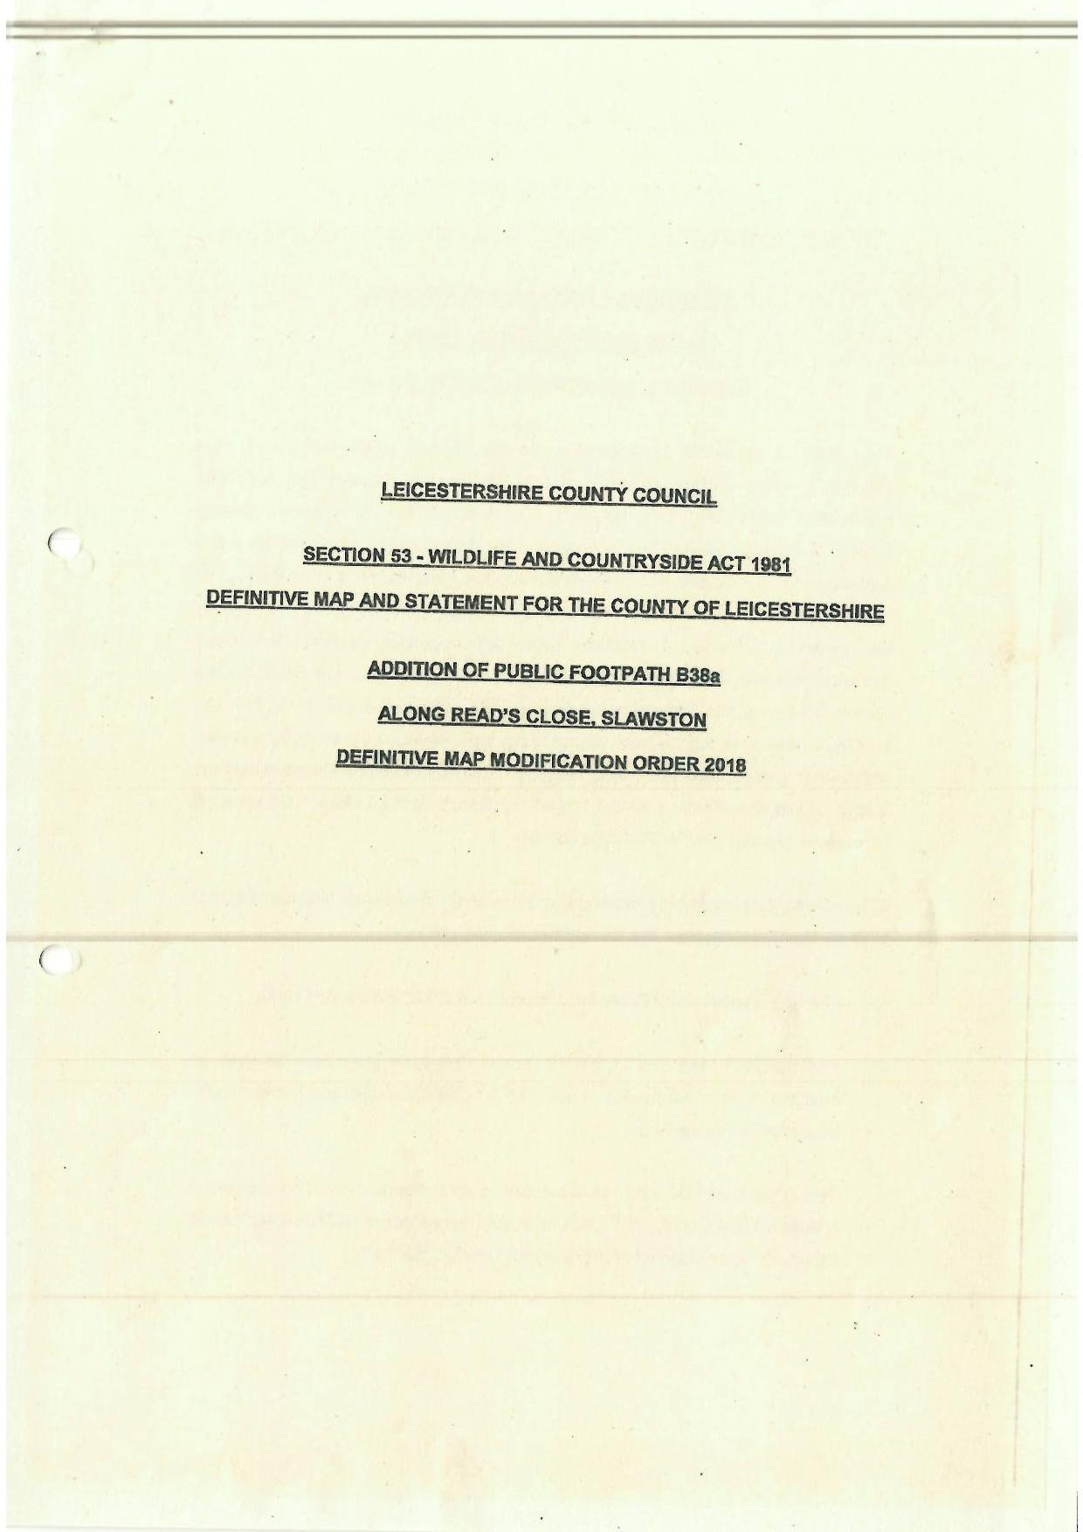

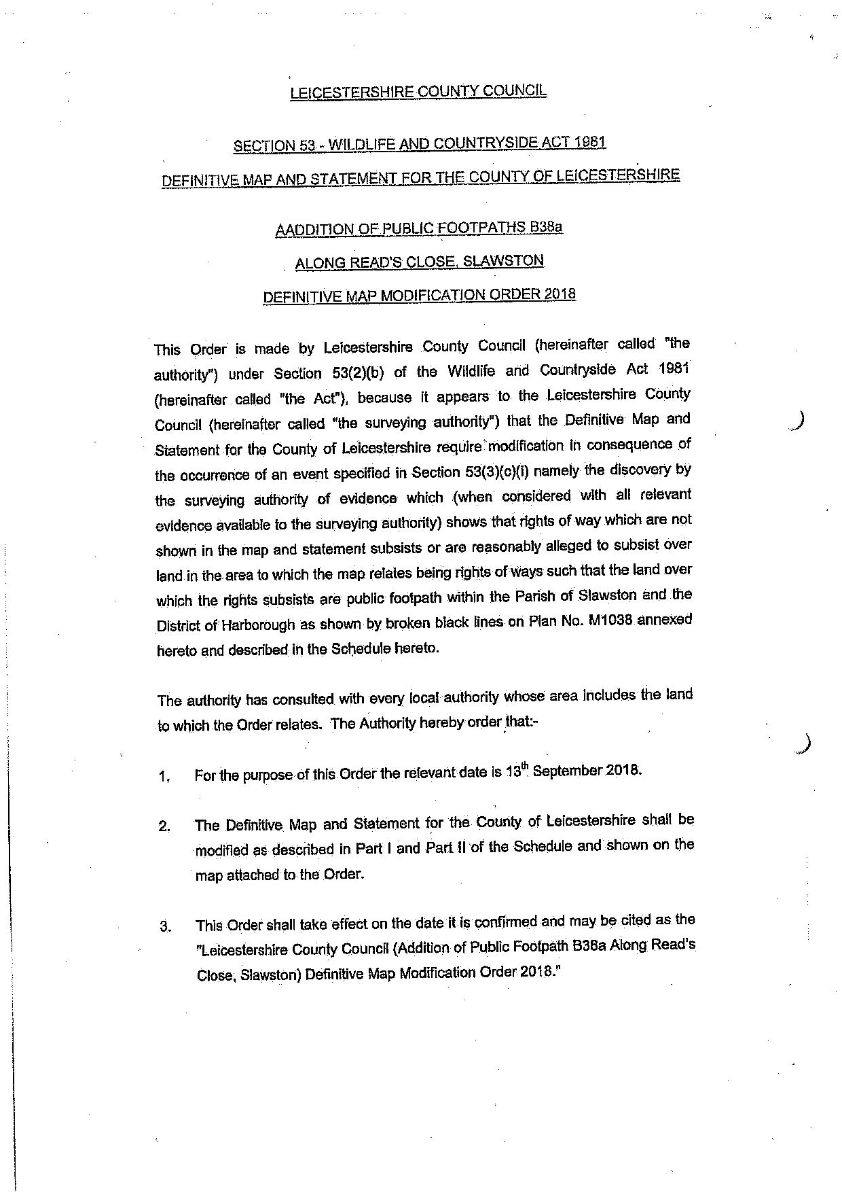

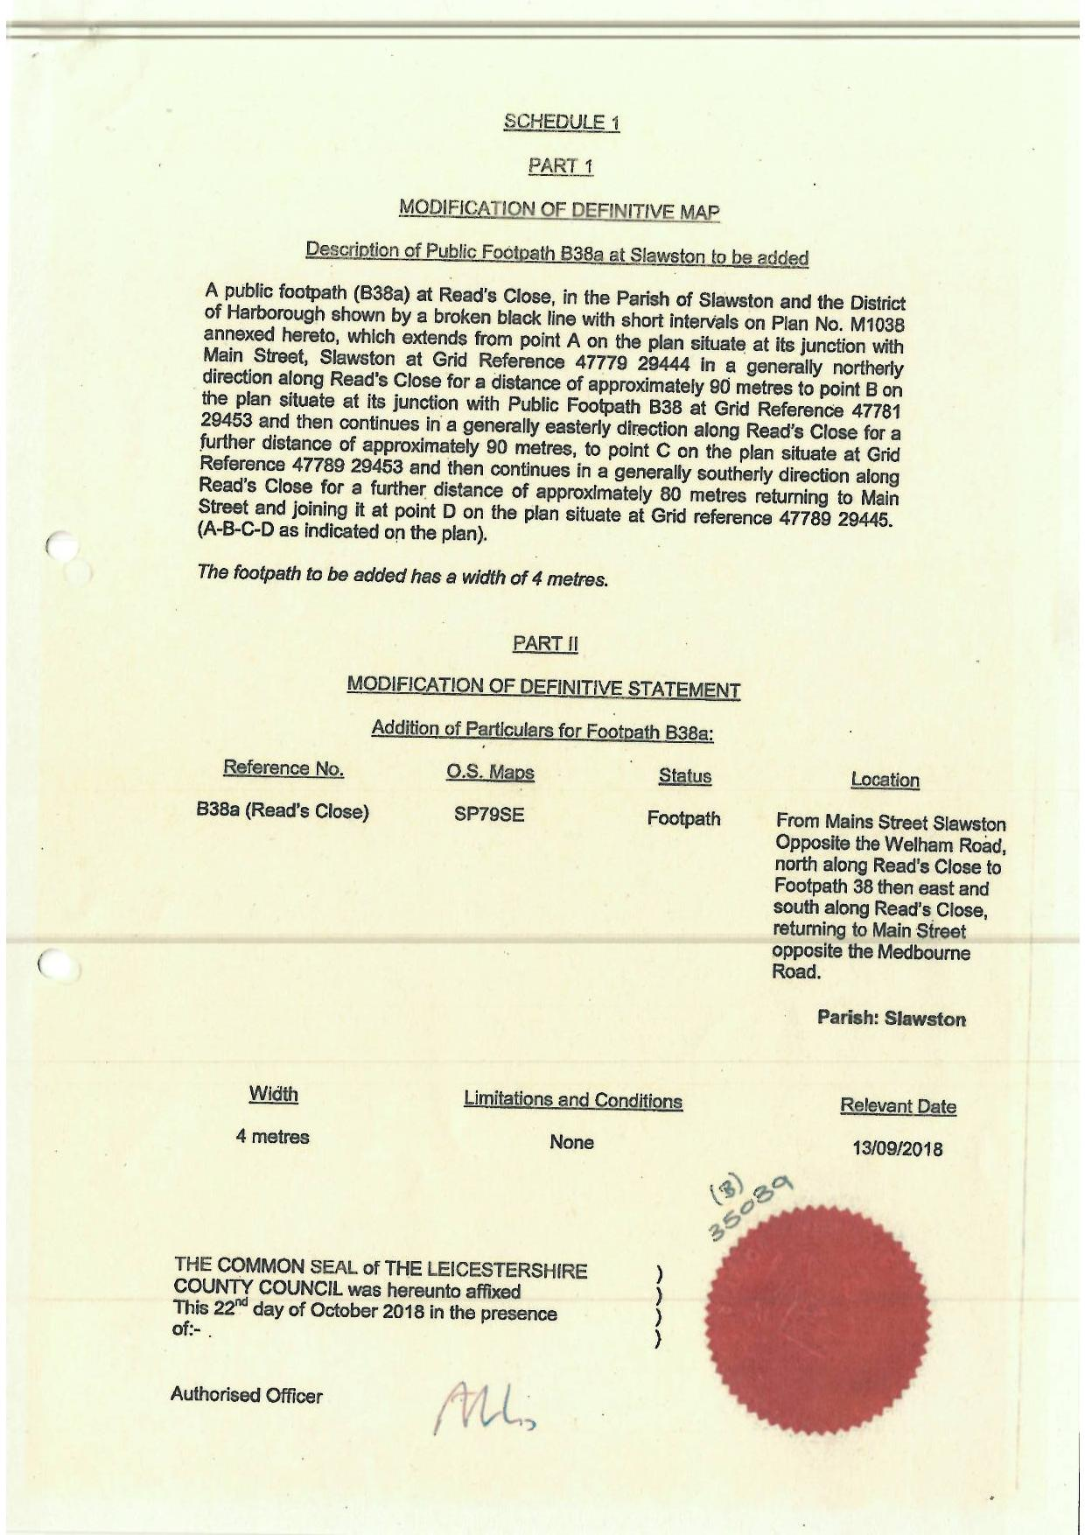

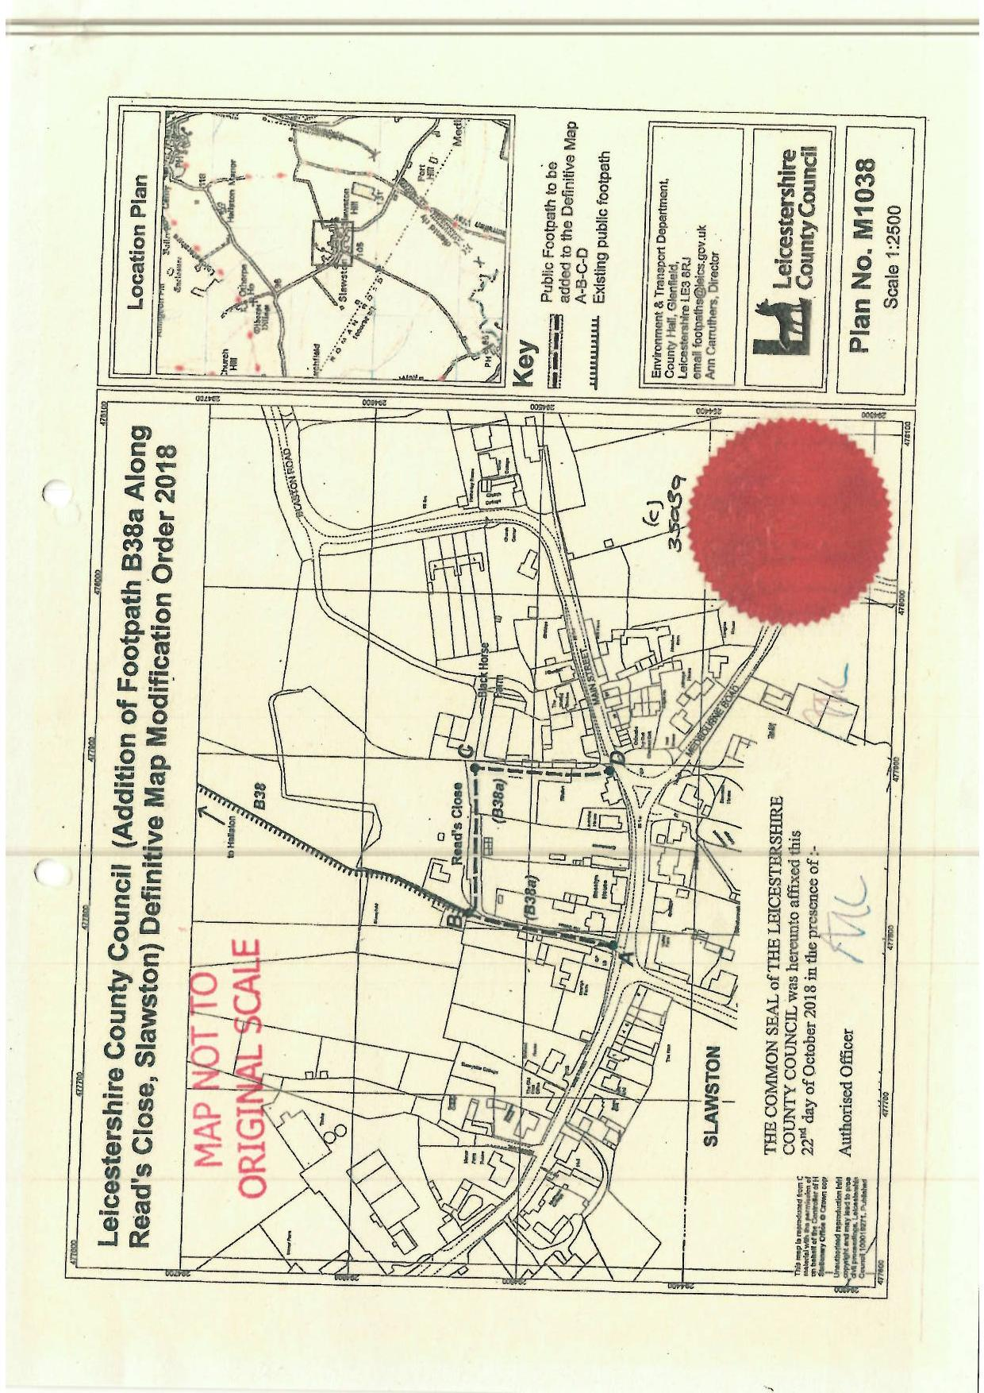

If you wish to make a legal submission, this should be submitted at the same time as your statement of case. Otherwise legal submissions will have to be submitted in writing on the day of the hearing.

