Contents

**1.** **How to resolve validation errors** 2

**2.** **Hard validations** 3

**3.** **Soft validations** 4

**4.** **How to resolve Validation 899N0130 - Admin  - All Mandatory questions must be answered** 5

5. How to resolve Validation 900V0061 - Reviewing Row and Column validations 6

6. How to resolve Validation 899I0012 8

7. How to resolve Validation 899I0011 11

9. Trial Balance Input Method 13

10. Restatement CI&E - Prior Year Comprehensive Income and Expenditure Statement - Restated 17

11. Restatement Analysis 18

# **How to resolve validation errors**

To address the entity's validation issues, it is necessary to undergo the validation process and rectify any errors associated with its DCT. These errors pertain to inaccuracies made by the entity in its DCT entries. To tackle the validation errors, the entity must engage in a bit of investigative work to understand the root causes of the errors. Begin by using the DCT mapping tool on the website to identify the specific cells affected by these errors.

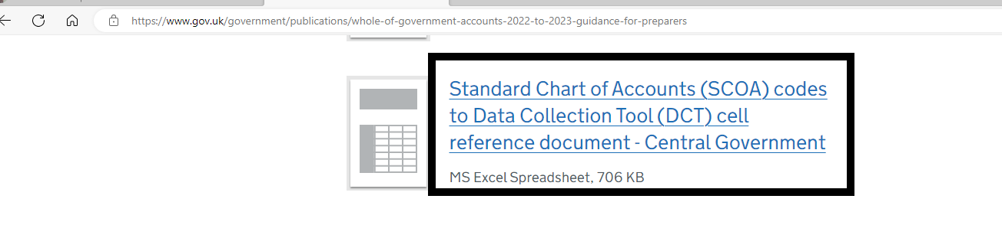

By generating a validation report, you will obtain validation codes that are triggering the errors. On the right side of the report, you'll find descriptions guiding you on how to address each validation issue. It is crucial to carefully review and act upon the comments in the status column corresponding to each validation code.

For comprehensive instructions on completing the DCT, including the investigation and resolution of validations, the written guidance contains all the relevant information. Additionally, there are screenshots provided to assist you in navigating through the process. You can access the written guidance at the following link:

<https://www.gov.uk/government/publications/whole-of-government-accounts-2023-to-2024-guidance-for-preparers>

# **Hard validations**

For hard validations, you need to investigate what is causing the error. Start by searching for the validation error codes on the DCT Mapping Tool and it will take you the relevant cells for that code and show you what you need to do.

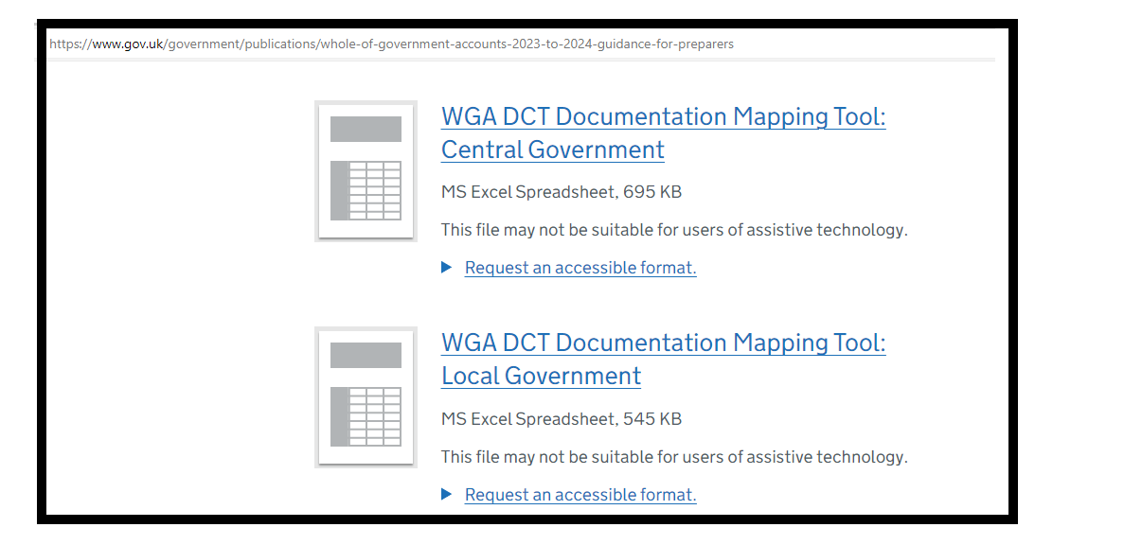

# **Soft validations**

For soft validations, you’ll need to provide an explanation in the relevant cells.

You need to provide an explanation in the relevant cells.

The validations do not disappear once you have commented. Once you validate the comments, the system will allow the DCT to progress.

# **How to resolve Validation 899N0130 - Admin  - All Mandatory questions must be answered**

To address **Validation 899N0130**, please follow the steps below.

The following is an illustrative example and does not represent actual data from your entity.

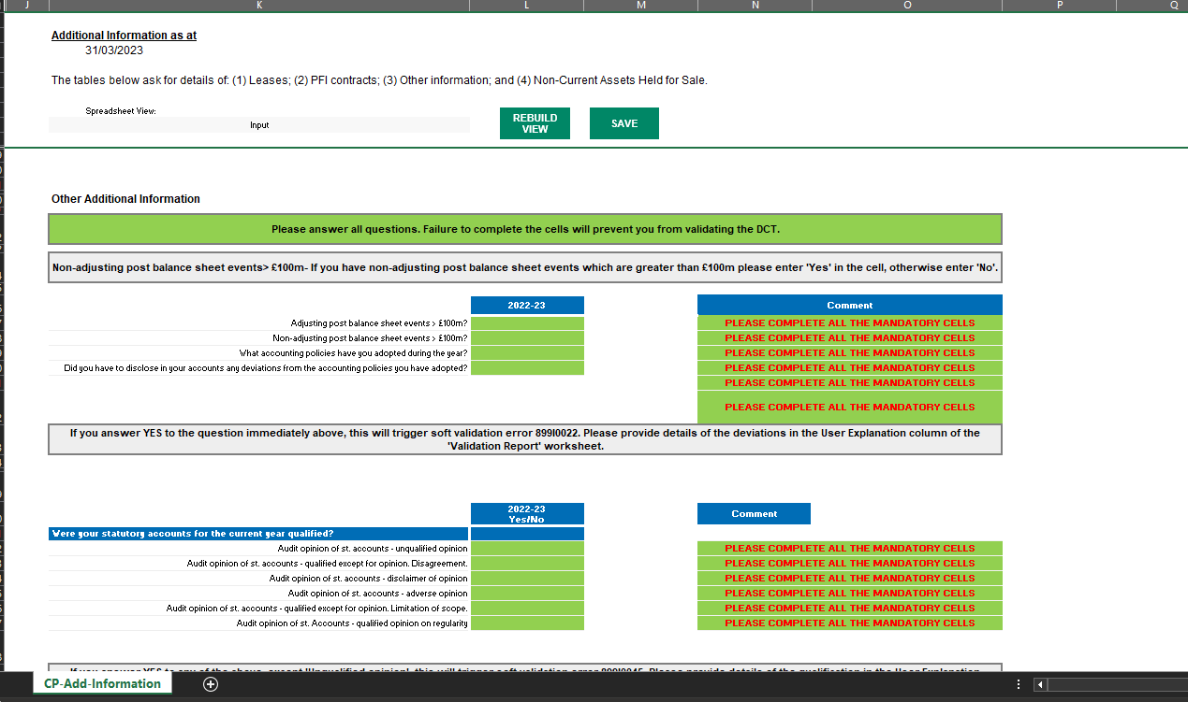

For additional assistance in pinpointing discrepancies in your figures concerning the validations, you may obtain the DCT **Cell Reference document** from our website.

# How to resolve Validation 900V0061 - Reviewing Row and Column validations

To address **Validation 900V0061**, please follow the steps below.

The following is an illustrative example and does not represent actual data from your entity.

So, the validation we’re looking at here is 900V0061

If you go on the LP validation tab, and filter for this validation you get the following:

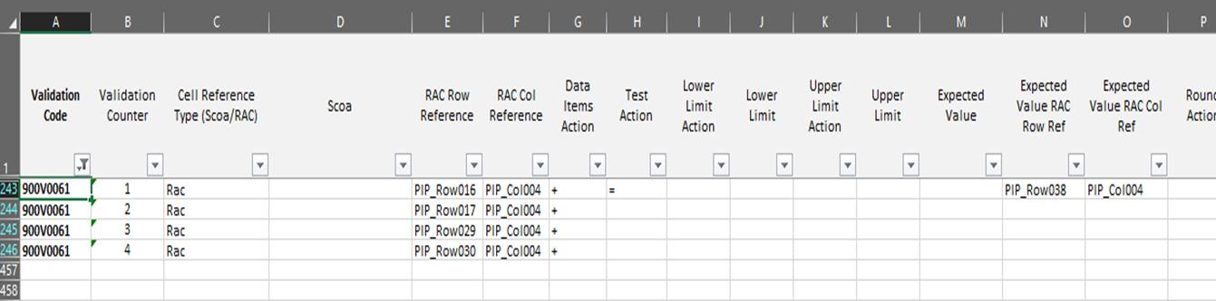

So instead of SCOA codes it shows Row and Column codes in columns E and F

You can easily find these references by using the search function in Excel, or if you navigate to the PPE and E tab you can see these orange-y peach bits around the edge.

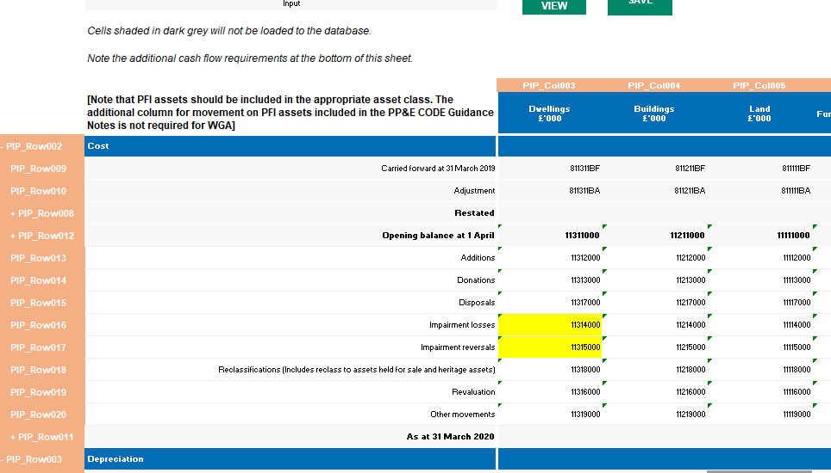

So, you can see here PIP_Row 16/PIP_Col004 is SCOA 11214000

The other bit worth remembering is how to read the validation list itself:

So, what is being compared is in column E&F, but what it is comparing it to is in columns N&O?

So, looking at our example:

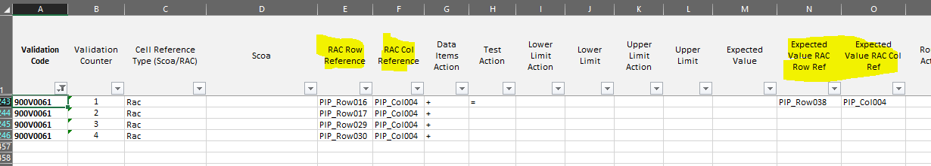

What the validation is asking you to do is compare rows 16+17+29+30 **to** Row 38

For additional assistance in pinpointing discrepancies in your figures concerning the validations, you may obtain the DCT **Cell Reference document** from our website.

# How to resolve Validation 899I0012

To address **Validation** 899I0012, please follow the steps below.

The following is an illustrative example and does not represent actual data from your entity.

The difference of -32090 shown on the validation report (Picture 1)  is made up of the difference between the Reserves and Pensions tab as highlighted below.

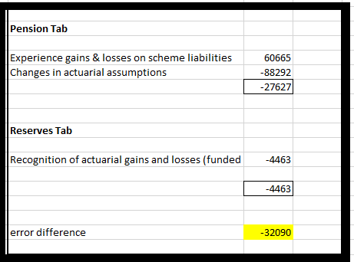

The yellow cells on the Reserves (Picture 2) tab must equal the yellow cells on the Pensions tab (Picture 3).

**Validation report**

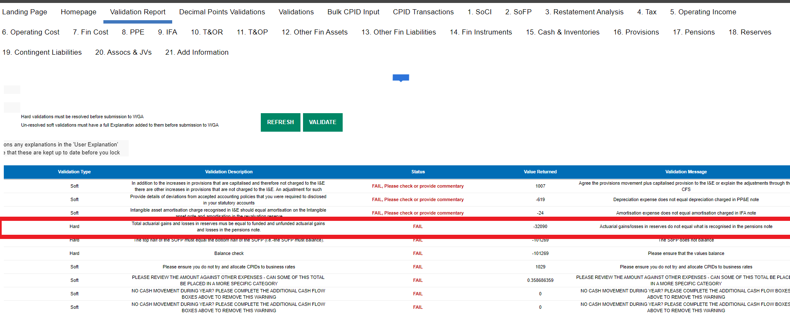

**Reserves tab**

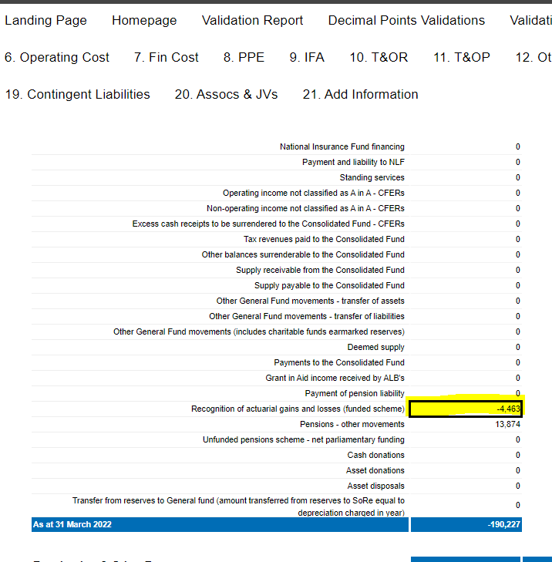

**Pensions tab**

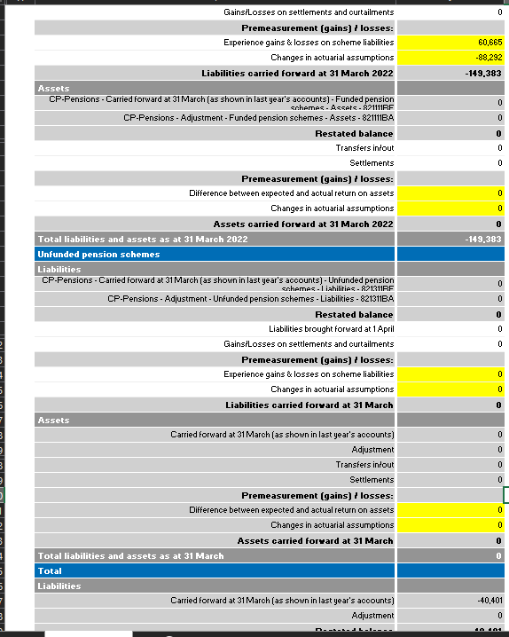

For additional assistance in pinpointing discrepancies in your figures concerning the validations, you may obtain the DCT **Cell Reference document** from our website.

# How to resolve Validation 899I0011

To address **Validation 899I0011**, ensure that the values in the two specified cells below are equal.

The following is an illustrative example and does not represent actual data from your entity.

Refer to the row labelled ‘**(Surplus) or Deficit on Provision of Services**’ located within the ‘Reserves’ tab:

|  |  |  |  |  |  |  |  |  |  |  |  |  |  |  |  |  |  |  |  |  |  |  |  |  |  |  |
| --- | --- | --- | --- | --- | --- | --- | --- | --- | --- | --- | --- | --- | --- | --- | --- | --- | --- | --- | --- | --- | --- | --- | --- | --- | --- | --- |
|  |  |  |  |  |  |  |  |  |  |  |  |  |  |  |  |  |  |  |  |  |  |  |  |  |  |  |
| |  | | --- | |  | |  |  |  |  |  |  |  |  |  |  |  |  |  |  |  |  |  |  |  |  |  |  |  |  |  |  |
|  |  |  |  |  |  |  |  |  |  |  |  |  |  |  |  |  |  |  |  |  |  |  |  |  |  |  |
|  |  |  |  |  |  |  |  |  |  |  |  |  |  |  |  |  |  |  |  |  |  |  |  |  |  |  |
|  |  |  |  |  |  |  |  |  |  |  |  |  |  |  |  |  |  |  |  |  |  |  |  |  |  |  |
|  |  |  |  |  |  |  |  |  |  |  |  |  |  |  |  |  |  |  |  |  |  |  |  |  |  |  |
|  |  |  |  |  |  |  |  |  |  |  |  |  |  |  |  |  |  |  |  |  |  |  |  |  |  |  |
|  |  |  |  |  |  |  |  |  |  |  |  |  |  |  |  |  |  |  |  |  |  |  |  |  |  |  |
|  |  |  |  |  |  |  |  |  |  |  |  |  |  |  |  |  |  |  |  |  |  |  |  |  |  |  |
|  |  |  |  |  |  |  |  |  |  |  |  |  |  |  |  |  |  |  |  |  |  |  |  |  |  |  |
|  |  |  |  |  |  |  |  |  |  |  |  |  |  |  |  |  |  |  |  |  |  |  |  |  |  |  |
|  |  |  |  |  |  |  |  |  |  |  |  |  |  |  |  |  |  |  |  |  |  |  |  |  |  |  |
|  |  |  |  |  |  |  |  |  |  |  |  |  |  |  |  |  |  |  |  |  |  |  |  |  |  |  |
|  |  |  |  |  |  |  |  |  |  |  |  |  |  |  |  |  |  |  |  |  |  |  |  |  |  |  |
|  |  |  |  |  |  |  |  |  |  |  |  |  |  |  |  |  |  |  |  |  |  |  |  |  |  |  |
|  |  |  |  |  |  |  |  |  |  |  |  |  |  |  |  |  |  |  |  |  |  |  |  |  |  |  |
|  |  |  |  |  |  |  |  |  |  |  |  |  |  |  |  |  |  |  |  |  |  |  |  |  |  |  |
|  |  |  |  |  |  |  |  |  |  |  |  |  |  |  |  |  |  |  |  |  |  |  |  |  |  |  |
|  |  |  |  |  |  |  |  |  |  |  |  |  |  |  |  |  |  |  |  |  |  |  |  |  |  |  |
|  |  |  |  |  |  |  |  |  |  |  |  |  |  |  |  |  |  |  |  |  |  |  |  |  |  |  |
|  |  |  |  |  |  |  |  |  |  |  |  |  |  |  |  |  |  |  |  |  |  |  |  |  |  |  |
|  |  |  |  |  |  |  |  |  |  |  |  |  |  |  |  |  |  |  |  |  |  |  |  |  |  |  |
|  |  |  |  |  |  |  |  |  |  |  |  |  |  |  |  |  |  |  |  |  |  |  |  |  |  |  |
|  |  |  |  |  |  |  |  |  |  |  |  |  |  |  |  |  |  |  |  |  |  |  |  |  |  |  |
|  |  |  |  |  |  |  |  |  |  |  |  |  |  |  |  |  |  |  |  |  |  |  |  |  |  |  |
|  |  |  |  |  |  |  |  |  |  |  |  |  |  |  |  |  |  |  |  |  |  |  |  |  |  |  |
|  |  |  |  |  |  |  |  |  |  |  |  |  |  |  |  |  |  |  |  |  |  |  |  |  |  |  |
|  |  |  |  |  |  |  |  |  |  |  |  |  |  |  |  |  |  |  |  |  |  |  |  |  |  |  |
|  |  |  |  |  |  |  |  |  |  |  |  |  |  |  |  |  |  |  |  |  |  |  |  |  |  |  |
|  |  |  |  |  |  |  |  |  |  |  |  |  |  |  |  |  |  |  |  |  |  |  |  |  |  |  |
|  |  |  |  |  |  |  |  |  |  |  |  |  |  |  |  |  |  |  |  |  |  |  |  |  |  |  |
|  |  |  |  |  |  |  |  |  |  |  |  |  |  |  |  |  |  |  |  |  |  |  |  |  |  |  |
|  |  |  |  |  |  |  |  |  |  |  |  |  |  |  |  |  |  |  |  |  |  |  |  |  |  |  |
|  |  |  |  |  |  |  |  |  |  |  |  |  |  |  |  |  |  |  |  |  |  |  |  |  |  |  |
|  |  |  |  |  |  |  |  |  |  |  |  |  |  |  |  |  |  |  |  |  |  |  |  |  |  |  |
|  |  |  |  |  |  |  |  |  |  |  |  |  |  |  |  |  |  |  |  |  |  |  |  |  |  |  |
|  |  |  |  |  |  |  |  |  |  |  |  |  |  |  |  |  |  |  |  |  |  |  |  |  |  |  |
|  |  |  |  |  |  |  |  |  |  |  |  |  |  |  |  |  |  |  |  |  |  |  |  |  |  |  |
|  |  |  |  |  |  |  |  |  |  |  |  |  |  |  |  |  |  |  |  |  |  |  |  |  |  |  |
|  |  |  |  |  |  |  |  |  |  |  |  |  |  |  |  |  |  |  |  |  |  |  |  |  |  |  |
|  |  |  |  |  |  |  |  |  |  |  |  |  |  |  |  |  |  |  |  |  |  |  |  |  |  |  |
|  |  |  |  |  |  |  |  |  |  |  |  |  |  |  |  |  |  |  |  |  |  |  |  |  |  |  |
|  |  |  |  |  |  |  |  |  |  |  |  |  |  |  |  |  |  |  |  |  |  |  |  |  |  |  |

Please refer to the ‘CI&E’ tab for this information:

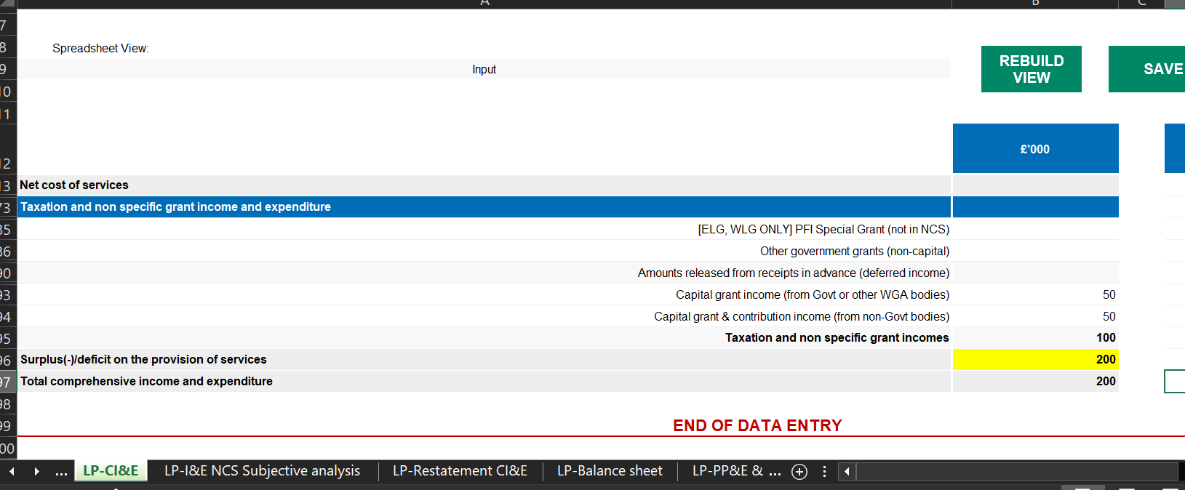

For additional assistance in pinpointing discrepancies in your figures concerning the validations, you may obtain the DCT **Cell Reference document** from our website.

It’s important to note that the quantity of validations is linked to the accounting elements, not to the system or process sequence. Therefore, it’s imperative to conduct a thorough review to confirm that the figures correspond with the overall total.

# Trial Balance Input Method

Please follow steps below

* + How to select the Entity for DCT Input
  + How to map your codes against OSCAR codes
  + Steps to Input your Trial Balance
  + How to review Trial Balance Posted Amounts
  + List of Available SCOAs

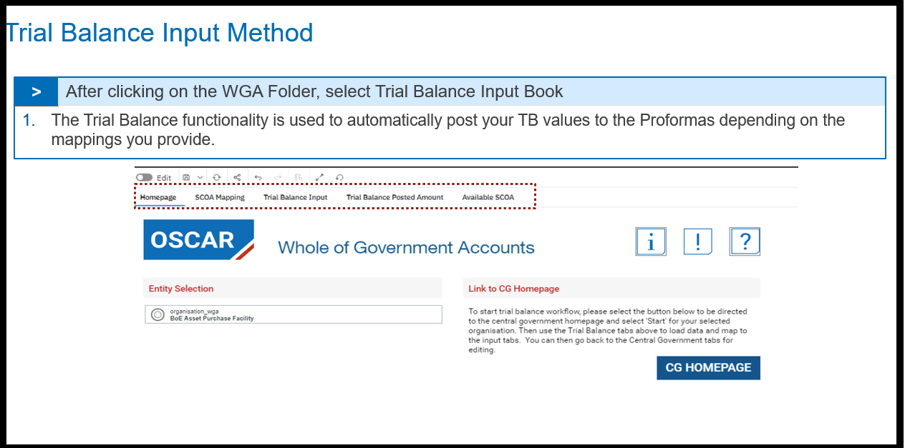

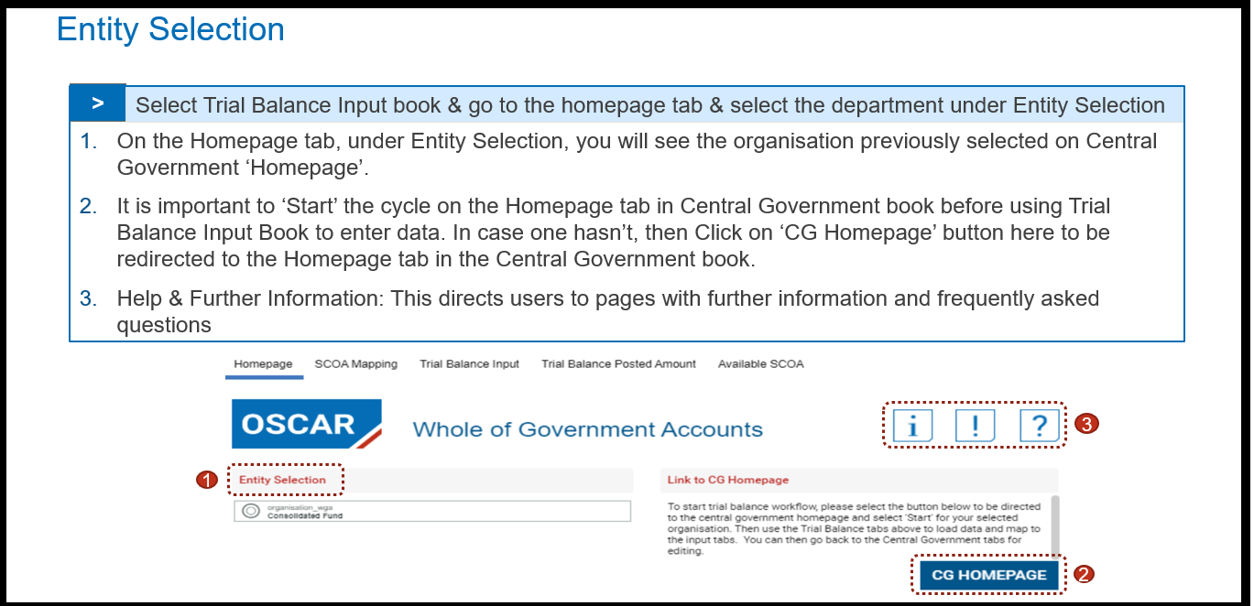

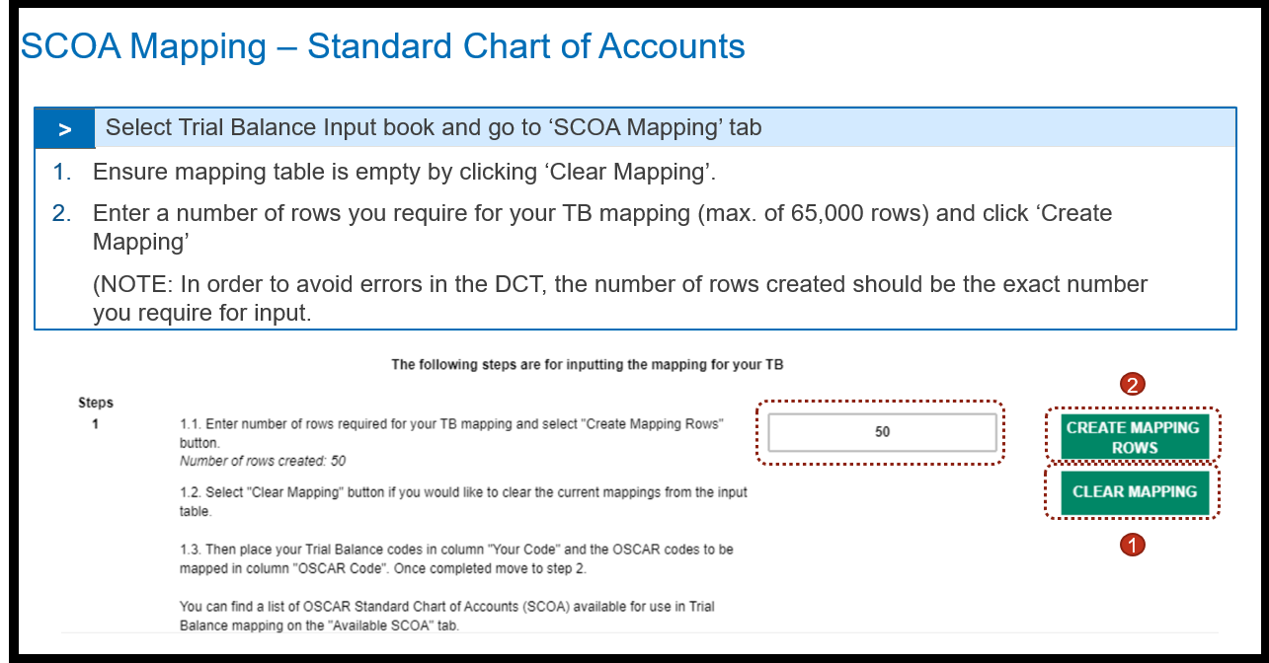

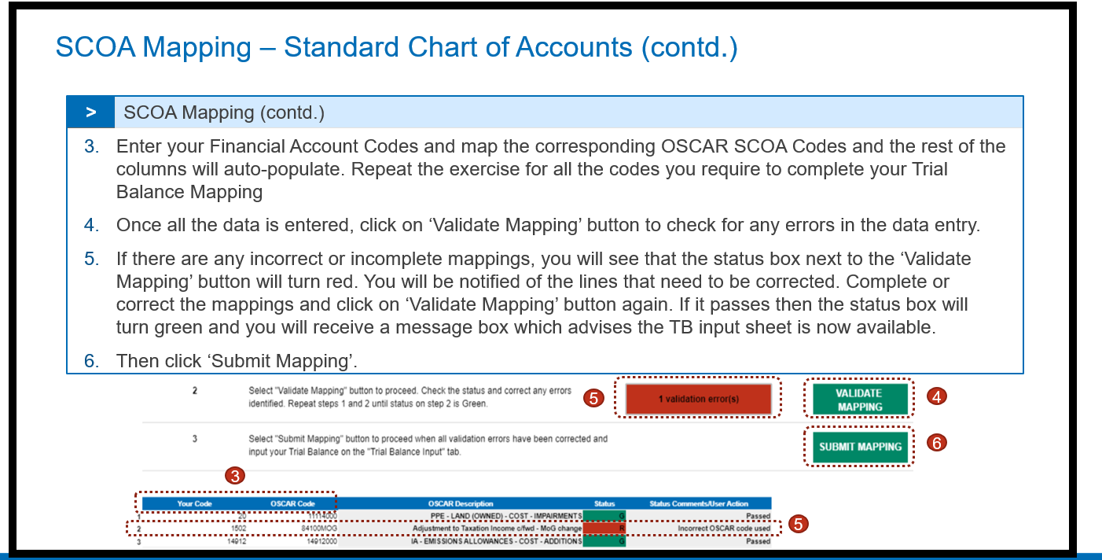

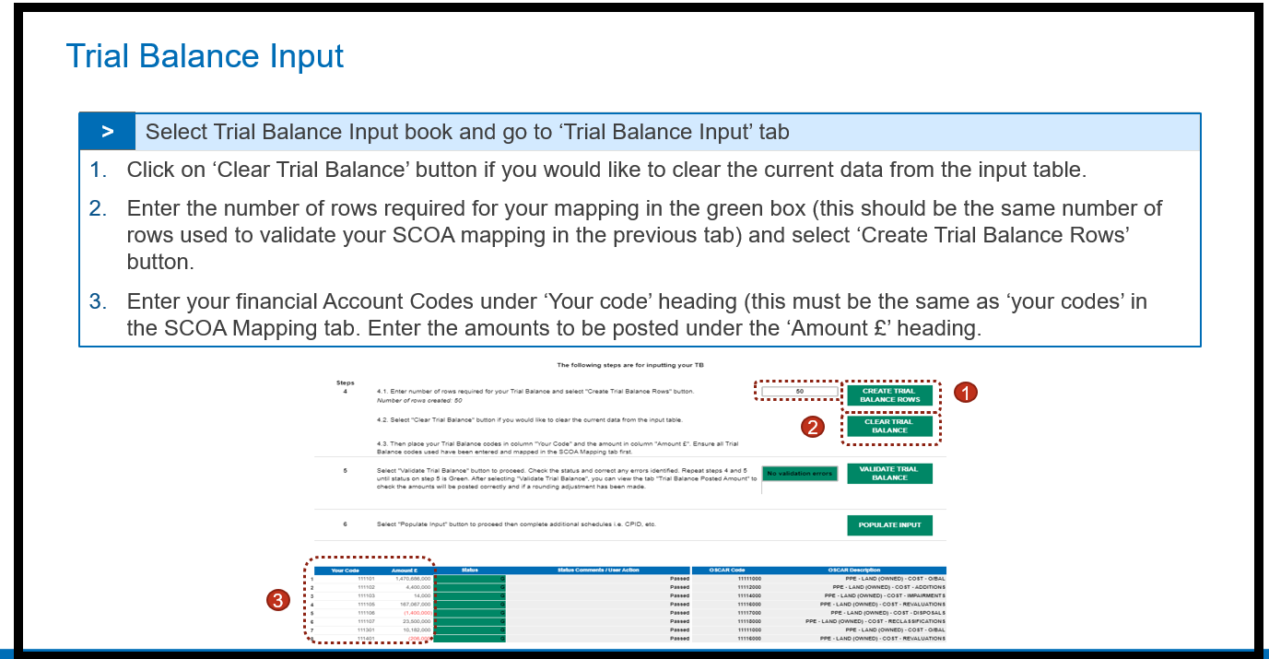

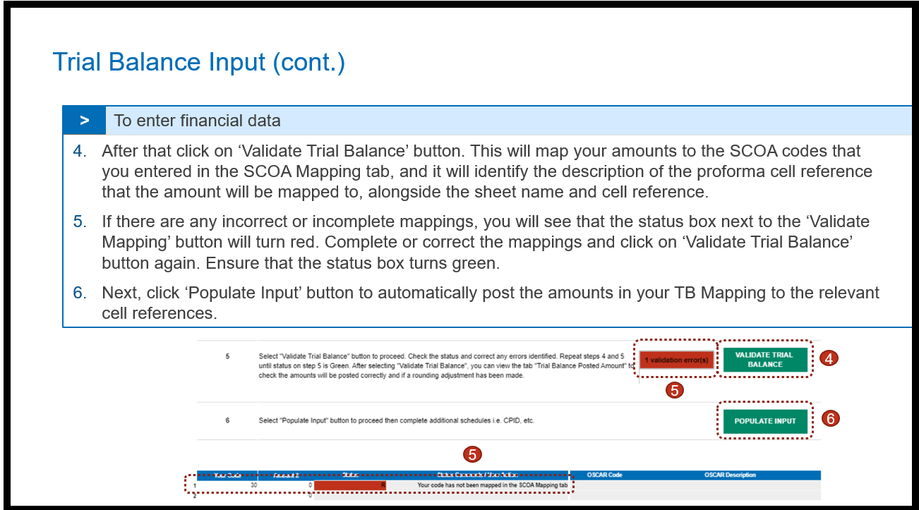

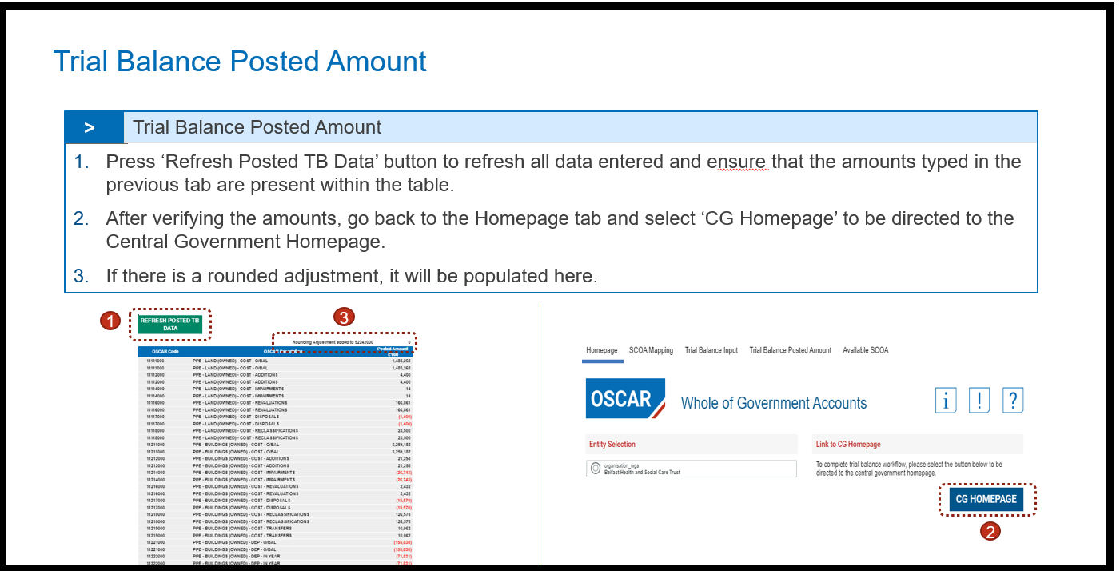

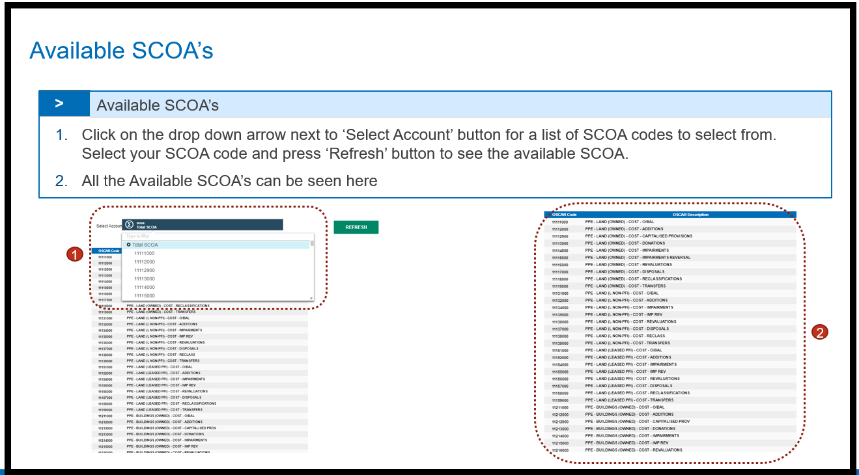

Q: Our account codes do not map easily to the SCOAs, so the TB method is not possible

A: You can map your entity’s codes to Oscar II via the audit report (TB tab). Entities only need to go through the mapping exercise once. You can reuse the mapping to Oscar II SCOAs for many years after, as WGA SCOA code are not changed annually.

# Restatement CI&E - Prior Year Comprehensive Income and Expenditure Statement - Restated

1. The restatements for prior year comprehensive income and expenditure that have been restated in the Restatement Analysis tab will be auto-populated in the Middle column on this tab, with the ability to enter adjustments in the first columns according to the income or expenditure type (such as staff costs, or grants and subsidies), and according to the reason for the adjustment (such as accounting policy changes, or changes to your authority’s structure).
2. There is a spreadsheet view option on this tab to select from the two data input methods: Input and Copy/Paste.

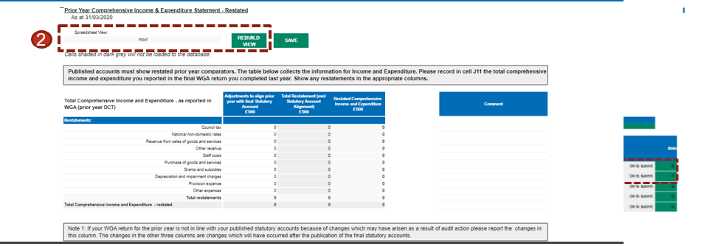

# Restatement Analysis

The Restatement tab is a new method and a singular tab for restatements which auto-populates the relevant proforma tabs.

Any entity who has made a prior period adjustment must complete this tab, detailing transactions at SCOA level, which affect their statements.

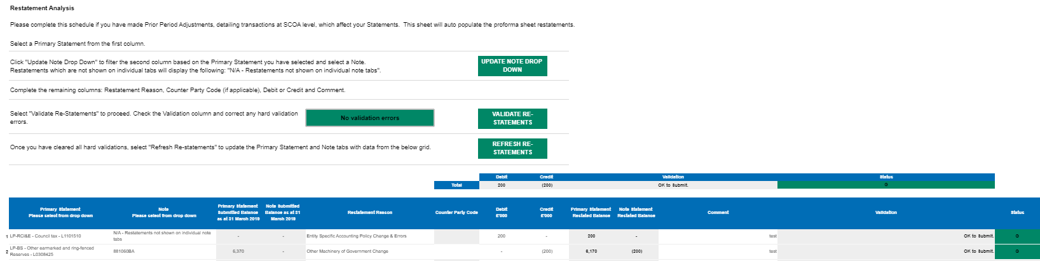

Please select the name of the affected tabs from the Primary Statement from the drop-down list. Click “Update Note Drop Down” to filter the Note column based on the primary statement you have selected and select a Note from the Note drop down list.

After that select the Restatement Reason from the drop down and also leave a comment or description, without which the restatement wont be validated. Enter Counter Party Code from the dropdown if required

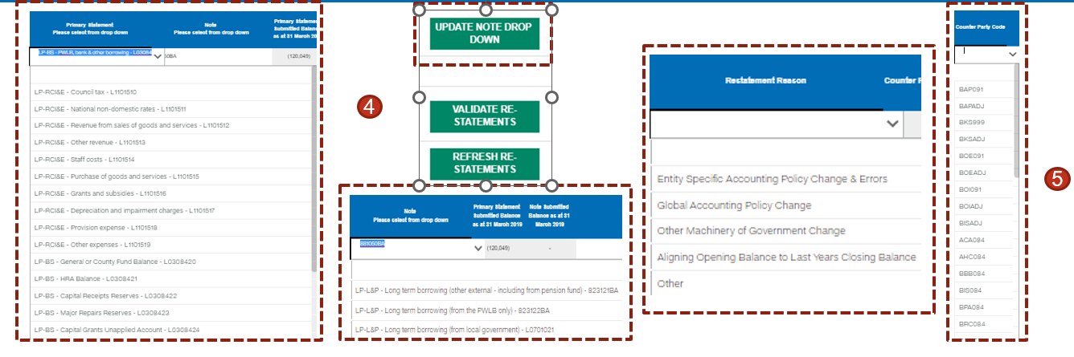

Then enter the debits and credits into the schedule.

Once the readjustments are entered, click on ‘Validate Re-Statement’ button and correct primarily the hard validation errors which will be highlighted in red. Soft Validations highlighted in yellow can be commented. Restatements highlighted in Green needs no resolution. Once these validations are resolved, select ‘Refresh Re-statements’ to update inputs with restatement data.

Note - Positive numbers to be entered as is and negative numbers should be entered with a minus (-) sign before them and users should ensure that the Schedule balances, i.e. debits and credits should net to zero.

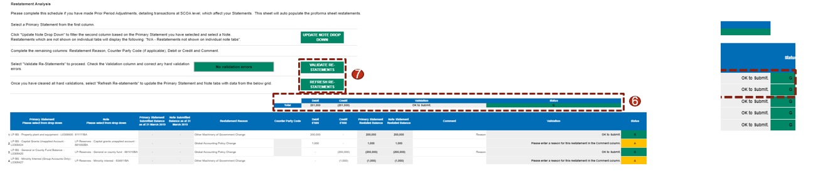

To change or delete a re-statement that has been validated, a reverse re-statement needs to be added. Note: Please do not amend or delete the re-statement, and instead add a reverse re-statement.

To add a reverse re-statement, select the Primary Statement and Note details similar to the re-statement that needs to be reversed and then reverse the debit or credit amounts. For e.g. in the below screenshot, Re-statement line 4 has been reversed in Restatement line 5 and the amount that was debited in Line 4 has been credited back in Line 5.

