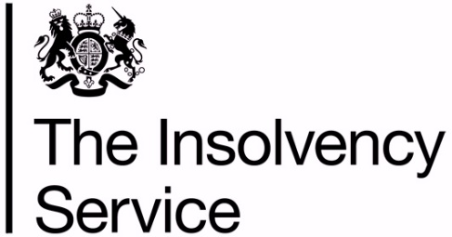

Customer Satisfaction Survey 2024
Executive Summary

Prepared for: The Insolvency Service
By: IFF Research

March 2024

© Crown Copyright 2024 - Published by the Insolvency Service

Disclaimer: The views in this report are the authors’ own and do not necessarily reflect those of the Insolvency Service.

1. Introduction

1.1 Background
The Insolvency Service commissions an annual survey of its customers to measure and track levels of satisfaction with the service that the Agency provides. The 2024 survey was conducted by IFF Research, an independent market research company.

This document summarises the key findings that emerged from the survey.

1.2 Research objectives
The key objective of the research is to track and measure customers’ views of the Insolvency Service’s performance and services, to help it gain a better understanding of its customers’ expectations and perceptions.

1.3 Methodology
IFF Research carried out a quantitative survey consisting of 736 interviews conducted using Computer Assisted Telephone Interviewing (CATI). Interviews lasted an average of 20 minutes and fieldwork took place between January and March 2024.

Mirroring the approach adopted in the 2022 and 2023 surveys, interviews were conducted with four key customer audiences. Table 1.1 provides a breakdown of the interviews achieved by each group.

Table 1.1 The profile of interviews achieved by each customer audience
Customer Audience | Achieved Interviews
DRO debtors | 200
RPS claimants | 200
Bankrupts  Creditors  Debtors | 200  (100)  (100)
Non-institutional creditors  Standard non-institutional creditors  Breathing space users | 136  (104)  (32)
Total | 736

Samples for all customer audiences were provided by the Insolvency Service. Those who participated in the survey must have had contact with the Insolvency Service on or after 1 January 2023 to be eligible to take part.

1.4 Calculating customer satisfaction.
As per the 2022 and 2023 surveys, the Insolvency Service uses a derived satisfaction score to measure overall customer satisfaction. This derived score is aligned to the three key areas of contact that the Agency has with its customers: contact, process, and quality. Views on the key customer measures in each of these areas are used to produce the derived satisfaction measure - see Figure 1.1 for details on the full calculation used.

Figure 1.1 Methodology for calculating the derived satisfaction measure
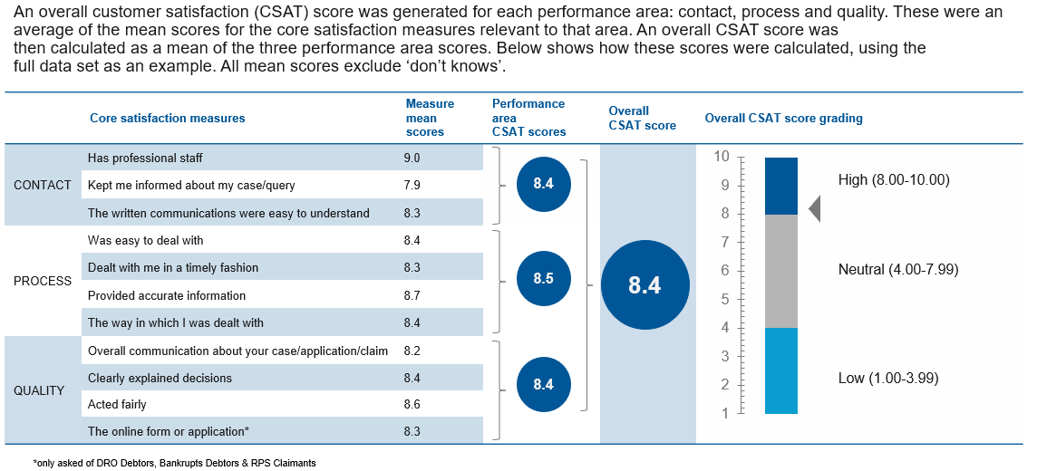

1.5 Report interpretation
Where possible, this document compares results from the 2024 survey with those from the 2023 survey. Arrows are used to highlight where changes between 2023 and 2024 are meaningful, directly comparable, and statistically significant. Green arrows indicate where there has been a significant increase, and red arrows indicate where there has been a significant decrease.

Most of the figures reported in this document exclude ‘don’t know’ responses. Where ‘don’t know’ responses have been excluded, results have been re-based on the remaining responses. This mirrors the approach to analysis taken in previous waves to ensure that results between waves are directly comparable.

2. Main findings

Summary
Overall derived satisfaction remained high in 2023/4 at 8.4 (84%). Whilst this is a slight increase on last year’s figure of 8.2 (82%), it is not a statistically significant improvement in satisfaction.
Satisfaction levels remained high amongst DRO debtors, debtor driven bankrupts, creditor petitioned bankrupts and non-institutional creditors.
RPS claimants posted the lowest satisfaction score amongst customer groups, however satisfaction has improved significantly this year (7.7) compared to last year (7.3), nearly back to levels reported in 2022 (7.9). Improvements in processing time and accuracy of information given to customers were key drivers for the improvement seen this year.
Communication continues to be a key area that the agency should focus improvements on specifically keeping people updated about their case / claim / query.

2.1 Derived satisfaction scores
The derived satisfaction score for all customers was high in 2024 (8.4). This is a slight increase (not a statistically significant increase) from the 2023 figure (8.2) and in line with the figure seen in 2022 (8.4).

As shown in Figure 2.1, three out of the five key customer groups surveyed also had a high derived customer satisfaction score, and two had scores that the Agency would classify as neutral (although both of these scores were at the upper end of the neutral category).

Figure 2.1 Derived satisfaction scores
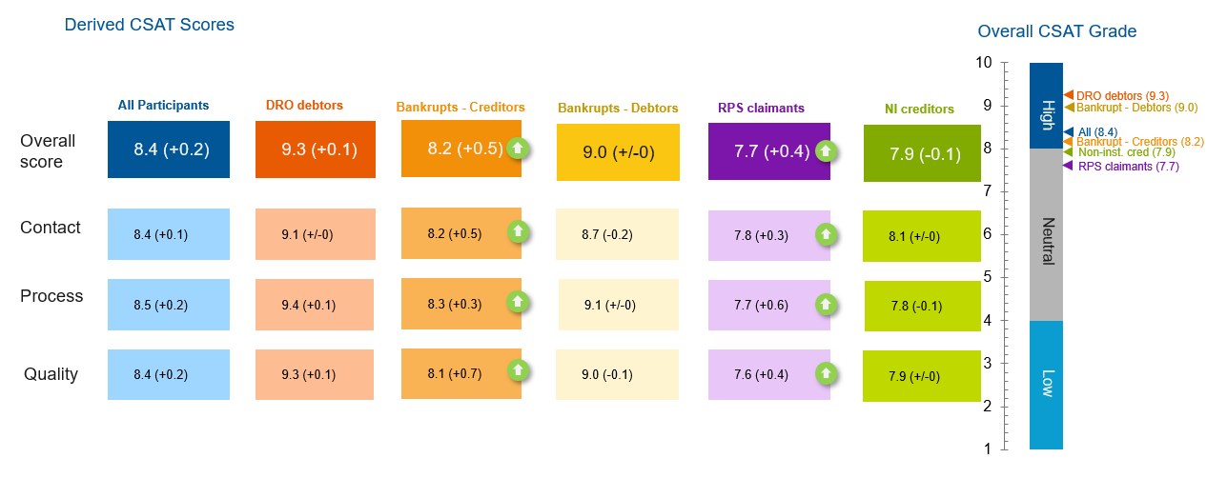
Base: All excluding ‘don’t knows’, 2024 - DRO debtors: 159-199; Creditor-Petitioned Bankrupts: 97-100; Debtor-Driven Bankrupts 95-100; RPS claimants: 168-198; Non-institutional creditors 122-135. The green arrow indicates where there has been a significant increase since 2023.

In line with the satisfaction measures already discussed, the highest derived satisfaction score was seen among DRO debtors (9.3), followed by Debtor-Driven Bankrupts (9.0), Creditor-Petitioned Bankrupts (8.2), non-institutional creditors (7.9), and RPS claimants (7.7).

Overall derived satisfaction scores increased significantly between 2023 and 2024 for Creditor-Petitioned Bankrupts (from 7.8 to 8.2 respectively) and RPS claimants (from 7.3 to 7.7 respectively); and this was driven by significant increases in the derived scores for contact, process and quality for both of each customer groups.

Within each customer group there was little significant variance in derived score across each of the three core areas of contact, process, and quality.

2.2 Performance on key satisfaction measures
During the survey, customers were asked a range of questions to explore whether they were satisfied with the Insolvency Service’s core satisfaction measures.

Figure 2.2 illustrates the proportion of customers who were satisfied with each measure (such as, they gave a score of 8-10 out of 10 for that measure).

Figure 2.2 Performance against core satisfaction measures
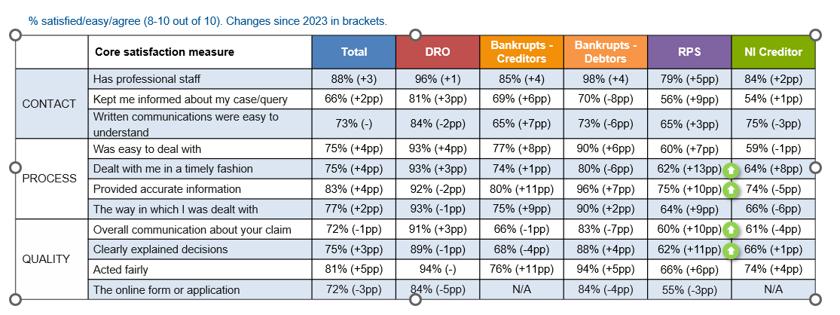
Base: All excluding ‘don’t knows’, 2024 - DRO debtors: 159-199; Creditor-Petitioned Bankrupts: 97-100; Debtor-Driven Bankrupts 95-100; RPS claimants: 168-198; Non-institutional creditors 122-135. The green arrow indicates where there has been a significant increase since 2023.

Mirroring the fact that overall satisfaction scores have remained consistent among these groups, there were no significant changes in satisfaction scores across the core satisfaction measures among DRO debtors, Creditor-Petitioned Bankrupts, Debtor-Driven Bankrupts and non-institutional creditors.

As Figure 2.2 shows, satisfaction has significantly increased for RPS claimants across a number of measures relating to process (for example, scores relating to timeliness and accuracy of information) and quality in terms of overall communication and clarity of explanations about decisions made. The significant increase of scores for these measures helps to explain the increase in the overall satisfaction score for RPS claimants between 2023 and 2024.

2.3 Ease of dealings with the Insolvency Service
Customers were asked how easy or difficult it was to deal with the Agency as part of the survey - results from this question are illustrated in Figure 2.3.

Figure 2.3 Ease of dealing with the Agency
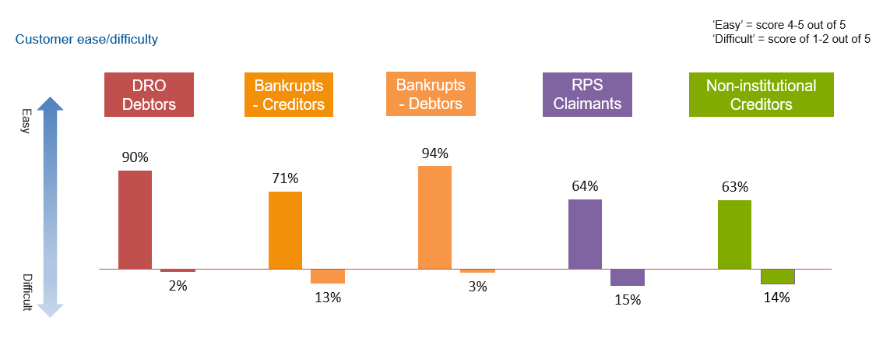
Base: All excluding ‘don’t knows’, 2024 - DRO debtors: 197; Creditor-Petitioned Bankrupts: 99; Debtor-Driven Bankrupts 98; RPS claimants: 198; Non-institutional creditors 118.

Debtor-Driven Bankrupts found it easiest to deal with the Agency in 2024 (94% of this customer group said it was easy, including 63% that rated it ‘very easy’), followed by DRO debtors (90% of whom said it was ‘easy’, including 74% that rated it ‘very easy’). These two findings correspond with the fact that DRO debtors and Debtor-Driven Bankrupts have the highest overall satisfaction levels.
A minority of participants in each customer group said they found it ‘difficult’ to deal with the Agency in 2024. RPS claimants found it the most difficult to deal with the Agency, with 15% saying they found it ‘difficult’ (7% said it was ‘very difficult’ and 8% said it was ‘difficult’). Again, this correlates with RPS claimants also having the lowest overall satisfaction levels.

2.4 Satisfaction with contact
Customers were also largely positive about their last experience of contacting the Agency. How customers felt the Agency performed against its seven contact measures are summarised in Figure 2.4.

Figure 2.4 Customer views on their last contact with the Agency
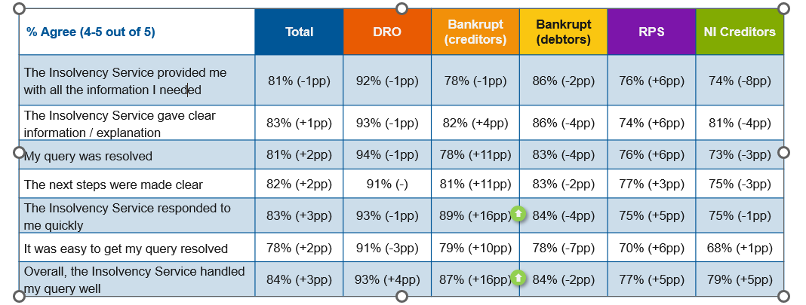
Base: All excluding ‘don’t knows’, 2024 - DRO debtors: 149-151; Bankrupt creditors: 89-91; Bankrupt debtor: 84-87; RPS Claimants: 153-156; Non-institutional Creditors 112-120. A green arrow indicates where there has been a significant increase since 2023.

Again, DRO debtors reported having the best experience of contacting the Agency (with over nine in ten agreeing with each of the satisfaction measures on contact).

The proportion of Creditor-Petitioned Bankrupts that agreed that the Agency responded to them quickly and the proportion that agreed that the Agency handled their query well overall both increased significantly in 2024.

2.5 Satisfaction with communication
As shown in Figure 2.5, satisfaction with core measures across communication was mixed among the different customer groups that participated in the survey in 2024.

Figure 2.5 Customer satisfaction with communication
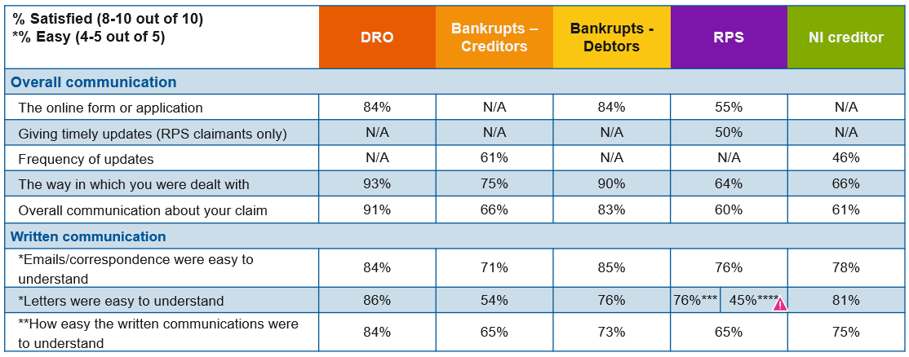
Base excl. DKs: DRO Debtors: 159-197; Bankrupt Creditor: 98-100, Bankrupt Debtor: 99-100; RPS claimants: 11-198; Non-institutional Creditors: 125-135. ***claim accepted, ****claim rejected. The pink warning sign indicates where base sizes are low which means results should be treated with caution.

Again, DRO debtors were the group most satisfied with their communication with the Agency. With at least 84% giving a positive score on each of the areas they were asked about regarding the Agency’s communication with them, which is consistent with findings from 2023.

A minority (46%) of non-institutional creditors were satisfied with the frequency of updates from the Agency, and a minority (45%) of RPS claimants whose claim was rejected agreed that the Agency’s letters were easy to understand. However, over half of participants were positive about each other aspect of the Agencies communication across all customer groups.

None of the scores for these questions for any customer group differed significantly from those posted as part of the 2023 survey.

2.6 Customer groups summaries

DRO debtors
DRO debtors remained the most satisfied of the Agency’s customer groups. Almost all (93%) were satisfied with their overall experience of dealing with the Agency in 2024, which is consistent with results from previous years.

Again, in line with previous years, DRO debtors posted the highest levels of agreement and satisfaction across many of the key satisfaction measures. Including those relating to satisfaction with their experience of Agency contact and communication.

Bankrupts
Most Bankrupts continue to be positive about their overall experience of dealing with the Agency. The overall derived satisfaction score among this group was 86%, which is a slight increase from 2023 (84%).

As in previous waves, Debtor-Driven Bankrupts posted consistently higher levels of satisfaction and agreement with key satisfaction, communication, and contact measures when compared to Creditor-Petitioned Bankrupts. Mirroring this, Debtor-Driven Bankrupts were significantly more satisfied with the Agency overall when compared with Creditor-Petitioned Bankrupts (9.0 vs. 8.2 respectively).

While the difference in scores between Debtor-Driven and Creditor-Petitioned Bankrupts is consistent with previous research, it should be noted that levels of satisfaction among Creditor-Petitioned Bankrupts have improved year-on-year since 2022.

Although the change in the overall derived satisfaction score between 2023 and 2024 was not statistically significant; the overall derived satisfaction score for Creditor-Petitioned Bankrupts increased significantly between 2023 and 2024 (from 7.8 to 8.2 respectively), as did scores relating to this customer groups’ contact with the Agency.

RPS claimants
There were significantly higher levels of satisfaction among RPS claimants in 2024 compared with 2023 (7.7 vs. 7.3 respectively). This increase in satisfaction can also be seen across many key satisfaction, communication and contact measures.

These results reverse those seen in 2023, when scores for a number of performance indicators decreased for this customer group.

Non-institutional Creditors
The proportion of non-institutional creditors who were satisfied with their experience of dealing with the agency in 2024 (7.9) was consistent with 2023 (8.0). Being kept updated about a claim and ease of resolving queries were areas to focus improvements on for this customer group.

Non-institutional creditors are a group which are difficult to reach, hence the lower number of completes with this group. However, the number of completes achieved in 2024 is far higher than that achieved in 2023 (86) and that achieved in 2022 (84).
In the survey participants were asked about a specific letter that was relevant to their user group, but ‘letters’ is used here as a summary. DRO debtors were asked about the ‘DRODEBNOT’ letter. Bankrupts were asked about the ‘NTB2’ letter. Successful RPS claimants were asked about the ‘payment advice letter’ and unsuccessful RPS claimants were asked about the refusal letter. Non-institutional creditors were asked about ‘any letters they received relating to your case’.

