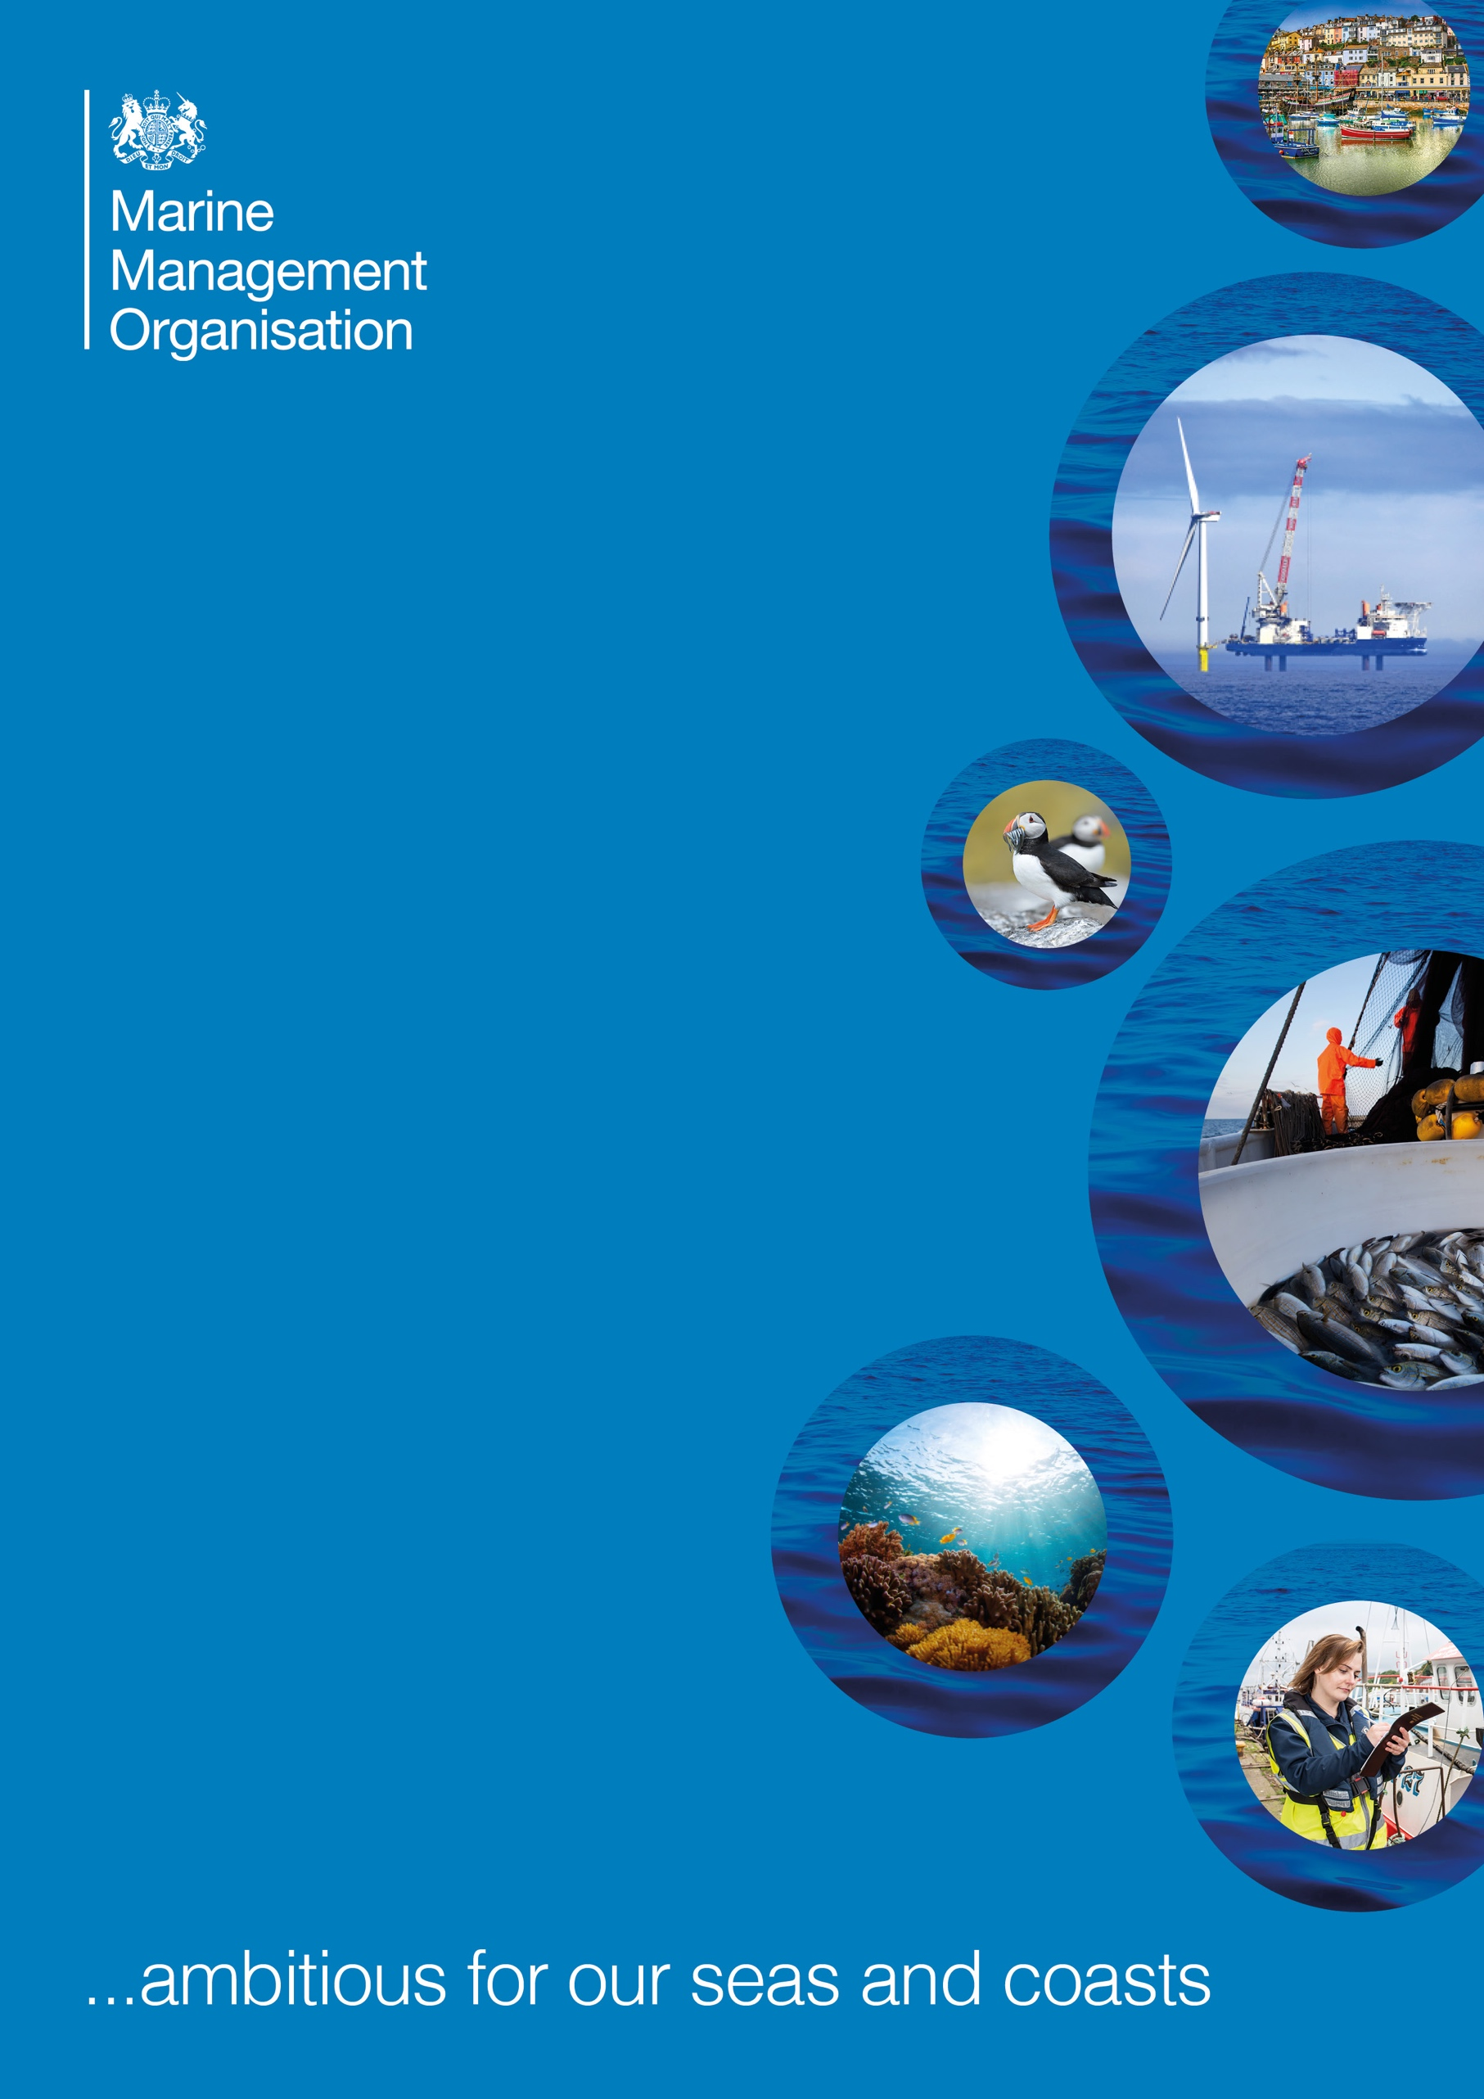

**Studland Bay   
Voluntary No Anchor Zone:   
2022 Review**

**June 2023**

**Contents**

Executive summary 3

1. Introduction 4

1.1 Structure of this document 5

2. MMO activities 5

2.1 Awareness raising and engagement 6

2.1.1 Phase 1 (December 2021 to May 2022) 6

2.1.2 Phase 2 (June to December 2022) 9

2.2 Activity monitoring 14

3. Stakeholder survey 15

3.1 Overview 15

3.2 Themes 17

3.2.1 Evidence 19

3.2.2 Historic and safe anchorage 22

3.2.3 Moorings 24

3.2.4 Marking the VNAZ boundary 28

3.2.5 Monitoring and management 30

3.2.6 Natural environment 33

3.2.7 Wellbeing 34

3.2.8 Communication and engagement 36

4. Conclusion 41

Annex 1 Results 43

Annex 2 Remote monitoring 69

Annex 3 Glossary of terms 71

References 72

# Executive summary

The Marine Management Organisation (MMO) is responsible for managing marine non-licensable activities to further the conservation objectives of marine conservation zones (MCZ).

Following a detailed and evidence-based assessment, and several rounds of stakeholder consultation, MMO concluded that management measures were required to ensure that anchoring over seagrass beds in Studland Bay MCZ did not undermine that MCZ’s conservation objectives. As a result, MMO introduced the Studland Bay voluntary no anchor zone (VNAZ) in December 2021.

This document sets out the findings of a review of the effectiveness of the VNAZ after the first year of it being in place. From this review, MMO have concluded that the voluntary measure will remain in place due to the positive progress being made. However, we note further actions are required to ensure that the voluntary approach is a success.

MMO is committed to working closely with partners, including the Studland Bay Marine Partnership (SBMP) to ensure the success of the voluntary approach. MMO thank stakeholders for the progress made in 2022 and the feedback you provided to the 2022 survey. This has been used to inform our plans for 2023; helping to ensure the protection of Studland Bay MCZ.

# Introduction

Studland Bay MCZ lies on the Dorset coast (Figure 1) in South West England. The site has four designated features: intertidal coarse sediment, long-snouted seahorse (*Hippocampus guttulatus*), subtidal sand and seagrass beds.

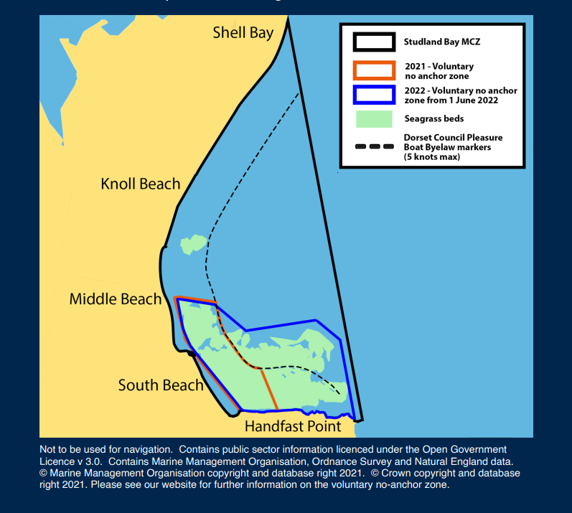

Map not to be used for navigation. Contains public sector information licensed under the Open Government Licence v3.0. Contains MMO, Ordnance Survey and Natural England data. © Marine Management Organisation copyright and database right 2021. © Crown copyright and database right 2021.

Figure 1 Map showing the Studland Bay MCZ and area of the VNAZ.

MMO is responsible for ensuring that marine non-licensable activities do not hinder the conservation objectives of MCZs.

In 2020, MMO drafted an assessment[1] on the impacts of marine non-licensable activities on the features of Studland Bay MCZ. This assessment concluded that management measures for anchoring were needed due to the impact on some designated features (long-snouted seahorse, subtidal sand and seagrass beds). As a result of the assessment, and following consultation with stakeholders, a phased voluntary approach for the management of anchoring was announced in September 2021[2].

Phase 1 of the VNAZ launched on 17 December 2021 covering the parts of the seagrass beds closest to Middle Beach and South Beach. Phase 2 commenced on 1 June 2022, extending protection for the majority of the seagrass habitat in the bay. The location of the VNAZ is displayed in Figure 1.

This document provides a review of the effectiveness of the VNAZ in relation to behaviour change, levels of awareness and MMO engagement methods in 2022. To do this we have reviewed MMO activities since the introduction of the VNAZ, results of available monitoring data, and collated valuable stakeholder feedback via an online survey. This will inform ongoing and future management of activities in Studland Bay MCZ, helping to ensure the success of the VNAZ and supporting the achievement of the site’s conservation objectives.

## Structure of this document

Section 2 outlines activities conducted by MMO since the introduction of the VNAZ in December 2021.

Section 3 provides an overview of responses and main themes resulting from the stakeholder survey. This section also provides our response to the main themes.

Section 4 provides a conclusion of the operation of the VNAZ in 2022 and next steps for 2023.

Annex 1 Results provides a more detailed breakdown of your responses for each question of the online survey, with information presented in tables and graphs.

Annex 2 Remote monitoring provides detailed graphs of our remote monitoring.

Annex 3 Glossary of terms provides a glossary of terms that you may find useful for reviewing this document.

# MMO activities

Following the call for evidence in October 2020 MMO carried out further stakeholder engagement in readiness of the VNAZ launch during 2020 and 2021. This report focuses on the work by MMO since the introduction in December 2021. Areas covered below will include awareness raising, engagement, communications, and monitoring.

An overview timeline of MMO work to date is provided in Figure 2.

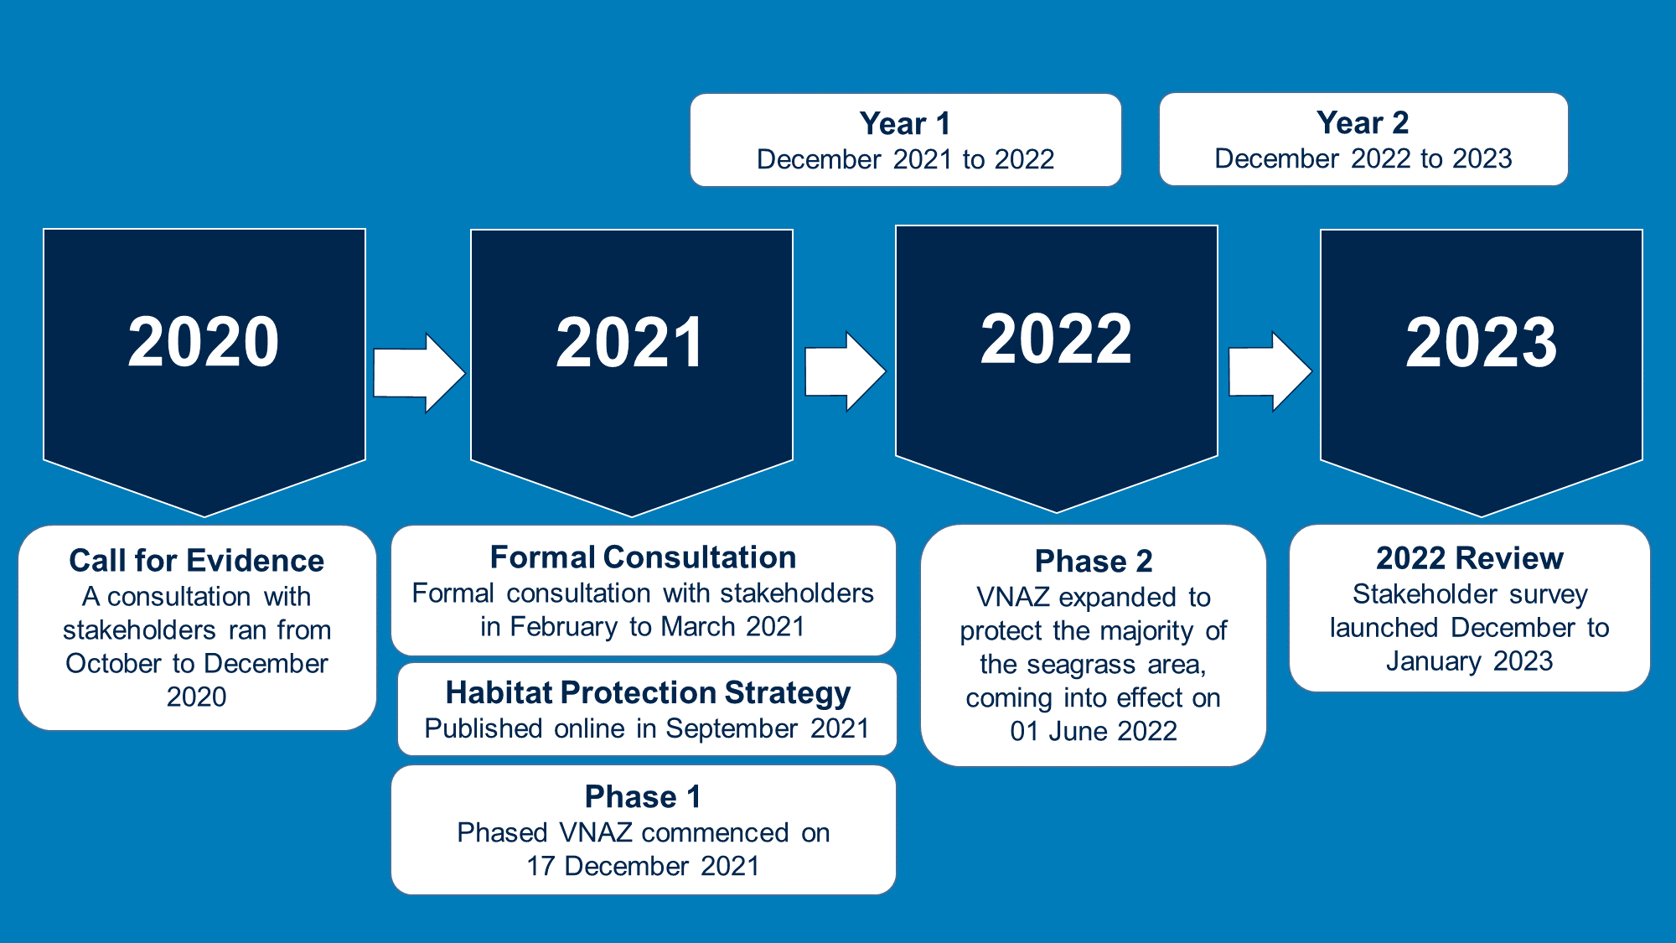

Figure 2 MMO timeline for Studland Bay VNAZ since 2020 with highlighted milestones.

## 2.1 Awareness raising and engagement

This section provides a summary of MMO’s awareness raising and engagement activities during the phased introduction of the VNAZ.

### 2.1.1 Phase 1 (December 2021 to May 2022)

**Online engagement**

In December 2021, MMO published a blog, leaflet, news story, social media posts and sent stakeholder emails to raise awareness about the launch of phase 1. We also used social media to raise awareness of on-water engagement being undertaken by MMO staff. Examples of social media posts can be seen below in Figure 3.

We updated GOV.UK[3] with frequently asked questions (FAQs), our assessment, consultation feedback and provided further details on the management approach. During phase 1 we communicated with stakeholders, answering queries about evidence, marker buoys and VNAZ coordinates. We provided an updated map of the VNAZ with a map projection preferred by boaters.

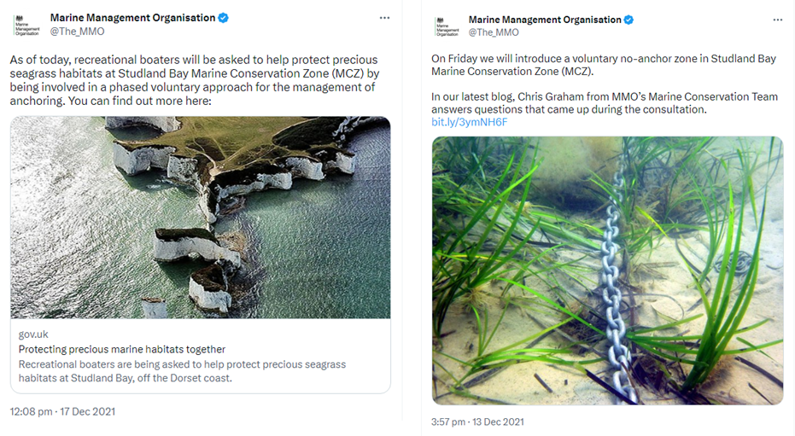

Figure 3 MMO social media posts on Twitter from December 2021 raising awareness of the launch of the Studland Bay VNAZ.

**Face-to-face engagement**

In April 2022 MMO hosted drop-ins and meetings for stakeholders with MMO staff. These events were held at the following locations: Poole Quay, Salterns Marina, Poole Yacht Club, Royal Motor Yacht Club and Parkstone Yacht Club. We also distributed materials such as leaflets and posters.

**On-water engagement and monitoring**

DuringApril and May 2022 MMO staff carried out on-water engagement campaigns on the Southern Inshore Fisheries and Conservation Authority (SIFCA) fisheries patrol vessel (Figure 4). On-water engagement typically took place over a 4-hour period. Please see Table 1 for a summary of the on-water engagement dates and the number of vessels engaged.

Monitoring of adherence to the VNAZ was conducted during on-water and shoreside visits by MMO staff. A total of 26 monitoring visits were conducted during phase 1 of the VNAZ.

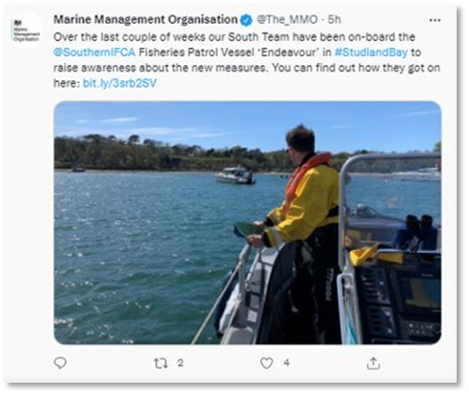

Figure 4 MMO social media on Twitter sharing information on our on-water engagement activities in Studland Bay in 2022.

Table 1 shows a summary of on-water engagement activities and the number of vessels engaged during visits. During on-water engagement, MMO staff distributed information leaflets, answered queries, and sought feedback. Examples of feedback received is below:

* vessels engaged were mostly aware of the VNAZ
* some expressed support of the measure and what it aims to achieve
* more and higher tonnage mooring area is required
* current ecomoorings were too far out and susceptible to wind/makes the use of tenders to come onshore more difficult or dangerous
* there is a need for clear demarcation of the area with marker buoys, to prevent uncertainty of the VNAZ boundary
* calls to delay the introduction of phase 2 of the VNAZ until more moorings were in place
* boating community felt victimised/targeted and not listened to, and
* questions and challenges of the evidential basis.

Table 1 Summary of the number of vessels engaged during on-water campaigns (phase 1).

|  |  |
| --- | --- |
| **Date** | **Total vessels engaged** |
| 15April 2022 | 23 |
| 18 April 2022 | 27 |
| 2 May 2022 | 22 |
| **Total boat count:** | **72** |

### 2.1.2 Phase 2 (June to December 2022)

**Local Notice to the Mariners (LNTM)**

In June 2022we arranged for a LNTM to be issued by Poole Harbour Commissioners and Yarmouth Harbour Commissioners.

**Digital Packs**

MMO sent out digital packs, (including VNAZ coordinates and map) and leaflets to Local Harbour Authorities and Marinas (including Portsmouth Queen’s Harbour Master, Weymouth, Poole Harbour, Cowes Harbour, Portland Harbour, Yarmouth Harbour, Portsmouth Harbour, Teignmouth Harbour, Exe Estuary/Exmouth, Southampton Harbour, Brixham/Torbay Harbour, Portland Marina Port, Lymington Harbour, Portland Marina boatfolk). These packs were also sent to 7 vessel charter businesses and 20 sailing training companies.

**Navigational applications and charts**

MMO contacted 16 chart providers. At the point of publication, 11 chart providers have confirmed that the VNAZ is visible on their electronic charts/navigational apps provided that users update their electronic charts (these include United Kingdom Hydrographic Office (UKHO) / Admiralty Chart, Open Sea Map, Savvy navvy, Imray, Chartworld, Navionics, Navily, Transas iSailor, iBoating, Visit my Harbour and Cruising Association Captain’s Mate/ Theca).

We further investigated setting up push notifications to alert people entering Studland Bay of the presence of the VNAZ, however due to the technical challenges this was not possible to implement at this stage.

**On-water engagement and monitoring**

Monitoring was conducted during both on-water and shoreside visits by MMO staff. A total of 21 monitoring visits were conducted from June to December 2022 of the VNAZ.

Table 2 shows a summary of on-water engagement activities and the number of vessels engaged during visits.

Table 2 Summary of the number of vessels engaged during on-water patrols during phase 2.

|  |  |
| --- | --- |
| **Date** | **Total vessels engaged** |
| 1 June 2022 | 27 |
| 3 June 2022 | 28 |
| 23 July 2022 | 22 |
| 7 August 2022 | 32 |
| 28 August 2022 | 21 |
| **Total boat count:** | **130** |

During on-water engagement, MMO staff distributed leaflets with

information about the VNAZ, answered queries and gathered feedback about the VNAZ (Figure 5). Information about the SBMP was also shared verbally. Overall, vessels engaged were positive about the VNAZ and were responsive in their discussions. Some boaters however had negative opinions about VNAZ, but still were willing to engage. There was a perception that the VNAZ was put in place specifically to protect seahorses, this was also accompanied by feedback that further awareness raising of the VNAZ and SBMP is needed.

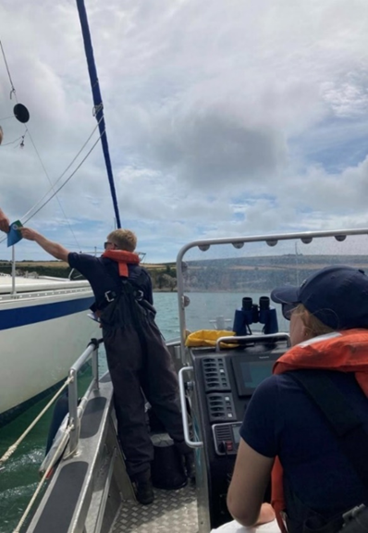

Figure 5 On-water engagement with MMO staff sharing information leaflets in July 2022 (Credit: MMO).

**Face-to-face engagement**

In August 2022 MMO hosted stakeholder drop-in events and meetings at Parkstone Bay Marina, Salterns Marina, Cobbs Quay Marina, Lilliput Sailing Club, Poole Quay Boat Haven/Poole Quay, Poole Harbour Commissioners, South Beach and Shell Bay. Through these events, we engaged with around 150 stakeholders.  
  
We distributed leaflets to Royal Motor Yacht Club, North Haven Yacht Club, East Dorset Sailing Club, Salterns Marina, Lilliput Sailing Club, Parkstone Yacht Club, Poole Yacht Club, Moore Yachts, Cobb’s Quay, Dorset Cruises, National Trust visitor centre, The Pig on the Beach Hotel, The Bankes Arms, Joe’s Café and members of the public. Other engagement materials included: LIFE Recreation Reducing and Mitigating Erosion and Disturbance Impacts affecting the Seabed (ReMEDIES) seagrass infographic[4], VNAZ A3 posters, and ‘Sally the seahorse maze game’ for children (Figure 6).

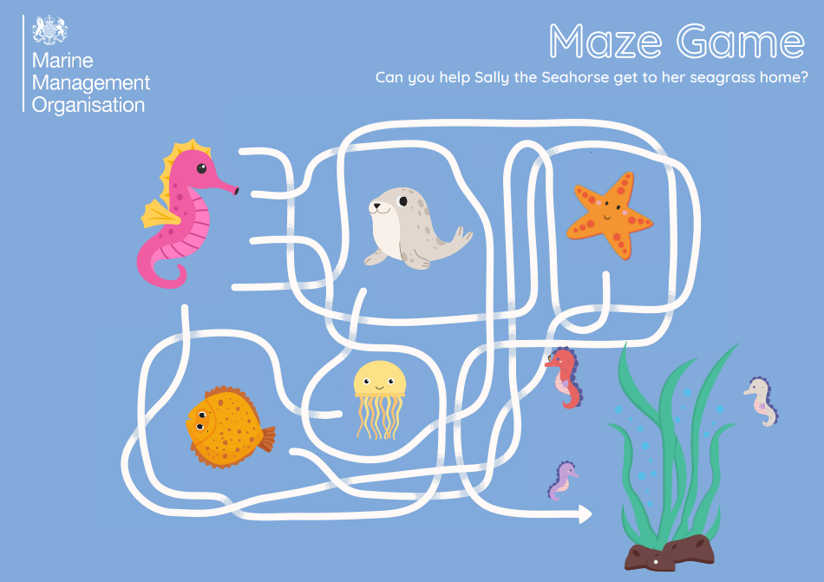

Figure 6 Maze Game for children that was distributed at public drop-in desks in August 2022.

**Online engagement**

MMO used online methods to continue to raise awareness of the VNAZ. We published an information sheet ‘Voluntary no anchor zone – coordinates’[5] on GOV.UK in response to feedback from stakeholders regarding difficulty locating the VNAZ on the water, and information on the coordinates for their chart plotters. We also sent emails in June 2022 to stakeholders to communicate the launch of phase 2 of the VNAZ, also publishing a news story and social media posts.

Ahead of the face-to-face engagement planned for August 2022, we sent emails to club and marina representatives in July 2022. We also published social media posts to raise awareness of Studland Bay visit, August drop-ins, on-water engagement, and monitoring activities (Figure 7).

During phase 2 we communicated with stakeholders on a number of topics including evidence, marker buoys, and VNAZ coordinates. We made updates to GOV.UK to reflect the changes in the VNAZ to phase 2 of the management approach.

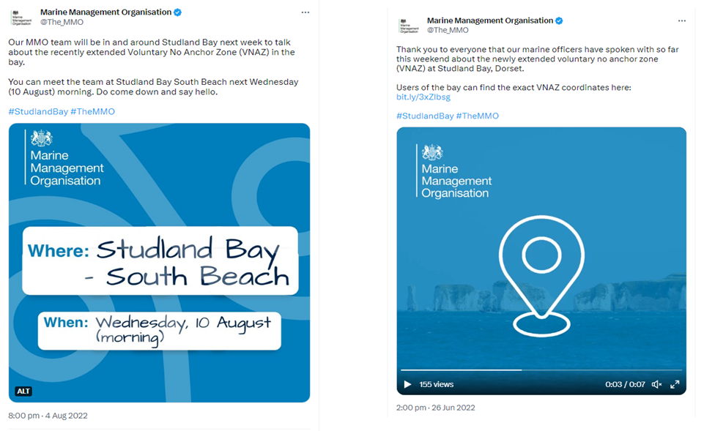

Figure 7 MMO social media posts on Twitter advertising public drop-in desks and the VNAZ co-ordinates information sheet developed in response to stakeholder feedback.

**Harbour Guides**

In December 2022 MMO secured adverts in the following harbour guides: Lymington Harbour Guide[6] (published in December 2022); Solent Handbook (published Easter Weekend 2023, Figure 8); Cowes Harbour Guide and Yarmouth Harbour Guide [7] (published March 2023).

Figure 8 MMO advert placed in Solent Handbook 2023-2024.

**Stakeholder survey**

In December 2022, MMO launched the 2022 VNAZ Review survey to collect stakeholder views and reflect on the first year of the VNAZ being in place. Please see section 3 below for the survey overview and results. We sent out emails to stakeholders throughout the survey period to invite them to take part in a survey. A news story and social media posts were also published on GOV.UK[8] to raise awareness of this review and launch of the online survey.

**Studland Bay Marine Partnership**

The Studland Bay Marine Partnership (SBMP) was formed in December 2021 as “a partnership brought together by the National Trust in a positive response to the MCZ management measures and is working towards proposals for the sustainable use of Studland Bay”.

In the summer of 2022, the SBMP conducted their own public consultation on their draft 10-year management strategy, moorings plan and future governance options for Studland Bay. MMO has worked with the SBMP to support public awareness raising and engagement around the VNAZ and wider MCZ. This has included collaboration on shared adverts in the Poole Harbour and Marina Guide for 2023, regular communication liaison meetings and attendance at steering group meetings when appropriate. MMO is a member of the SBMP Research and Monitoring and Communications and Engagement groups set up by the partnership.

The partnership is continuing the fundraise for the introduction of further ecomoorings, with a further 21 planned to be installed in Spring 2023.

## 2.2 Activity monitoring

To inform the 2022 anchoring activity baseline, and understand levels of adherence to the VNAZ, MMO staff undertook a total of 47 visits to Studland Bay MCZ between 31 December 2021 to 31 December 2022 (consisting of 8 on-water engagement visits and 39 shoreside visits).

To understand any unintended impacts of the VNAZ we have attended Dorset Council Water Safety Group meetings and engaged with the Poole Harbour Commissioners. This includes the monitoring of displacement of vessels to other locations or impacts to other recreational activities.

To complement on-the-ground monitoring, we trialled remote monitoring using Automatic Identification System (AIS). AIS is an automatic tracking system used to exchange navigational information between boats with marine traffic in the same area. AIS is used voluntarily by boat owners, and its main aim is to avoid collisions and control marine traffic. Whilst it is possible to infer from AIS whether a vessel is present, AIS is not required for all vessels and does not record whether or not a vessel is anchored and is therefore, alone, not an accurate measure of adherence with the VNAZ. However, AIS can be helpful in understanding the patterns of activity to aid the planning of site visits to support awareness raising and engagement, and on-site monitoring.

We received some concerns that using AIS data might encourage boaters to switch off their AIS, which may increase the risk to safety. AIS data has been used only to supplement our monitoring of levels of adherence to the VNAZ. As the VNAZ is a voluntary measure, AIS cannot be used to undertake any follow-up activities targeted at a particular boater.

Please see Figure A2.1 and Figure A2.2 for number of boats observed using AIS within the VNAZ for period January to June 2022 and July to December 2022. The number of boats is set alongside the relative maximum wind and temperatures, across the same date range, with bank holidays and weekends highlighted. The main period of visiting boats is between April and October, with peak activity occurring on warm weekends and bank holidays with lower wind conditions. There were around 25 weeks where we estimate that there were 10 or fewer vessels within the VNAZ. On the busiest week (week 32) we estimate that there were 245 vessels where, 177 may have been anchored, 62 likely moored and 6 other.

‘Other’ includes vessels that enter the VNAZ, that appear to be sailing or motoring around the bay for leisure or reasons other than simple transit, as well as those that appear to enter the bay but their intentions are unknown because of signal drop out. This does not include vessels that have transited (for example, maintained a fixed course, or speed without stopping).

# Stakeholder survey

This section covers the stakeholder survey undertaken at the end of 2022. Section 3.1 Overview provides a brief overview, with the focus being on the themes of the survey responses described in section 3.2 Themes.

## 3.1 Overview

To gather feedback from stakeholders directly impacted by the VNAZ MMO conducted an online survey from 9 December 2022 to 20 January 2023. The survey consisted of 29 questions, broken down into 6 sections (about you; about your boating activity; what you value most in Studland Bay; advance mooring systems/ecomoorings, your awareness of the VNAZ; your views on the VNAZ). The survey was shared with subscribers to our contact list for Studland Bay, as well as being circulated to our partners and via MMO and social media channels.

The objectives of the survey were to:

* understand awareness levels within the boating community
* seek feedback from stakeholders, recognising the value of the perspectives of those most directly impacted by the VNAZ
* identify awareness raising needs and suitable channels to engage with the boating community
* measure attitudes towards MMO
* understand experiences of using advanced mooring systems (AMS).

A brief overview of the results of the survey is provided below. Section 3.2 Themes provides analysis of the main themes compiled from feedback. The order of how responses are discussed may not follow the order asked in the survey. Annex 1 contains the detailed responses across the survey questions, including the number of respondents to each question, with data presented in the form of graphs and tables.

We received over 501 responses to the survey (where respondents had replied to at least 1 question – please see Annex 1 for further details). The majority (91%) of respondents were boat users (Figure A1.3), with the most common types of boat used being yachts/sailboats, followed by motorboats/power boats (Figure A1.5).

Questions 19 to 24 asked respondents to rate their level of agreement with statements (Figure 9). Responses for selection were ‘strongly agree’, ‘agree’, ‘neither agree nor disagree’, ‘disagree’ and ‘strongly disagree’. This provides a helpful overview of your feelings toward the VNAZ and reflect on the first year of it being in place.

**Figure 9 Summary of responses to question 19 to 24 asking respondents to rate how much they agreed with a range of statements. A legend for the selection chosen is provided below the graph. Results are expressed in percentage of respondents who selected each option.**

The majority of respondents were willing (48%), or somewhat willing (41%) to observe the VNAZ, with a lower proportion of respondents not willing to observe (11%) (Figure A1.13). Respondents to these questions provided further comments regarding their chosen response. These themes are discussed in more detail in section 3.2 Themes. Table 3 below provides a summary of themes raised for these statements.

Table 3 Summary of the main themes raised for selecting the relevant statement.

|  |  |  |
| --- | --- | --- |
| **Statement:** | **Total respondents:** | **Main theme of comments:** |
| Willing to observe | 48% | Respondents were willing to observe but noted there was a need for moorings and consideration of safety (observance being dependent on weather and sea conditions). Protecting seagrass, habitats, and/or the natural environment is important. Observance still depends on anchorage space outside of the VNAZ or how close to shore they were. |
| Somewhat willing to observe | 41% | Respondents noted that observance was dependent on the location or availability of moorings and need for safety considerations (for example, dependent on weather and sea conditions). There was the need for more evidence or monitoring and their observance could be dependent on anchorage space outside of the VNAZ or closeness to shore. |
| Not willing to observe | 11% | Respondents noted that there was a need for more evidence and/or monitoring. |

When asked if their anchoring habits changed since the VNAZ was introduced (for example, through a change in their location or behaviour), the majority of respondents (61%) noted that they have anchored in different locations and/or used ecomoorings (Figure A1.11). 10% noted that they always have anchored in different location or used moorings, with the remainder of respondents noting that they had not changed habits (20%), sometimes try to (7%) or had not visited the bay (2%).

## 3.2 Themes

This section discusses the main themes that came through from across survey sections and questions. Table 4 presents an overview of the themes that will be presented in this section. Certain specific responses to the free text survey questions are provided in order to help illustrate common topics or perspectives raised.

**Table 4 Overview of themes, description and location in this section.**

|  |  |
| --- | --- |
| **Section** | **Description** |
| 3.2.1 Evidence | More evidence is needed to show the impact of anchoring on seagrass and the impacts of the VNAZ in Studland Bay. |
| 3.2.2 Historic and safe anchorage | Studland Bay is an important and long used safe anchorage for boat users. The bay provides protection in poor weather conditions, as a refuge while on passage and access to onshore facilities. There are limited alternatives for safe and convenient anchorage in the area. |
| 3.2.3 Moorings | Additional moorings are needed to provide an alternative to anchoring. MMO should have installed moorings if trying to restrict anchoring. AMS have provided an alternative that is good and hassle-free experience but there are currently not enough of them. Contrary to this they are set too low in the water, difficult to pick up and need a greater tonnage limit. More guidance is needed about using the moorings. |
| 3.2.4 Marking the VNAZ boundary | The location of the VNAZ is not clear. It needs to be clearly marked both on electronic maps, charts and on the water to have any chance of success. Not all boat users have access to maps and charts. Simpler coordinates could help. |
| 3.2.5 Monitoring and management | Monitoring of boats and the local ecology is important. Measures of success and regular feedback reporting on progress over time are needed. The impacts should be visible by now and annual condition surveys should take place. The level of adherence should be shared. An increased presence of MMO, during peak times, on the water would be positive for engagement. The VNAZ should be made statutory, with fines provided to those ignoring the measure. |
| 3.2.6 Natural environment | The beauty, natural habitat and wildlife is greatly valued. The area is stunning, beach unspoilt and is like going back in time. The land is valued as well as the sea; with amazing sand dunes. The sea has species of value for nature conservation. |
| 3.2.7 Wellbeing | Studland Bay is valued for recreational activities, and for the benefits to wellbeing that it supports. The bay should be left free to be enjoyed. The view is now spoilt by a mass of plastic buoys. The VNAZ could be reduced to leave enough space for recreational users. It is important to balance the needs of wildlife and people. |
| 3.2.8 Communication and engagement | More awareness raising and face-to-face engagement from MMO is needed, especially for those visiting the area. The methods and tone of communication should change. MMO needs to understand the perspectives of boaters. Information on the VNAZ should be made more accessible online. |

### 3.2.1 Evidence

Responses to the survey highlighted a common theme of evidence. Some of you told us that you have a lack of trust in the evidence, or that more evidence and site-specific evidence or monitoring is required. When asked for any further feedback or comments, the need for more evidence or monitoring was one of the most common themes (21% of responses, Figure A1.25).

The evidence that MMO and Natural England have referenced in the decision document is not universally accepted and perceived by some to be ‘largely based on anecdotal/conventional wisdom and lack of hard data’. You told us you would like to see more monitoring of how anchoring is impacting seagrass in Studland Bay, with some citing the difference in impact between mooring and anchoring not being recognised. ‘Scouring effect of fixed chain moorings is beyond dispute, but the impact of anchoring in eelgrass, *Zostera marina*, is not clear.’ You want to see ‘higher quality evidence that seagrass density and size has actually decreased as a direct result of anchoring.’

“Produce some accessible, scientific and evidenced scientific documentation which proves that the zone is actually necessary and shows the environment impact of the environment zone.”

The survey had many responses questioning the application and validity of the evidence base underpinning the VNAZ. This issue was brought up by respondents across a number of survey questions and is the reason some people are not in favour of the measure. This was notable when comparing responses between the level of agreement with the statements for question(s) 19 and 20, where 54% either agreed or strongly agreed that seagrass is an important habitat requiring protection, but only 40% either agreed or strongly agreed that the VNAZ is necessary for protecting the seagrass beds (Figure A1.23).

Respondents said that ‘seagrass and anchoring have existed alongside each other for many years’ and commented that ‘seagrass beds have only increased in size despite increased numbers of boats in the bay’ over several decades. Some respondents wanted to see the impacts of anchoring on seagrass translated into meaningful, or more tangible measures, providing ‘accurate ways of assessing the damage and what it actually means in terms of impact on the environment’. This highlighted a view amongst some that anchoring has no negative impact on seagrass, with views shared that ‘anchoring has promoted seagrass’ through propagation and reproduction, causing its expansion. Further to this, some felt that information from the boating community had been ignored, citing historic aerial imagery of the seagrass expansion having not been considered as part of the evidence in assessing the site.

Some respondents told us that the evidence base is not robust enough to support the need for the VNAZ. There was a feeling that site specific data and evidence should have been gathered from Studland Bay prior to management being put in place. Some respondents stated that evidence of the anchoring impacts from other locations such as the Mediterranean or Australia, or based on other seagrass species, should not have been used in assessing the anchoring impact in Studland Bay. You told us that you would like to see ‘an evaluation of the impact the reduction in anchoring has had on the seagrass coverage’ from the VNAZ.

“Produce some accessible, scientific and evidenced scientific documentation which proves that the zone is actually necessary and shows the environment impact of the environment zone.”

Regarding seahorses, respondents shared feedback that seahorses have always been found in the bay, and there is a lack of trust in the data of seahorse prevalence. Some responses also highlighted scepticism that there were seahorses in Studland Bay.

**MMO Response**

MMO recognises that there are some gaps in the evidence around the impact of anchoring on seagrass and that some of the existing evidence is not accepted by all stakeholders. We will continue to work closely with partners and other stakeholders to address evidence gaps to the satisfaction of all parties, and ensure that evidence, including its limitations, is communicated clearly.

MMO has a duty under the Marine and Coastal Access Act 2009[9] to introduce appropriate management measures where marine non-licensable activity may be hindering the conservation objectives of an MCZ. Following a robust assessment process, and listening to stakeholder feedback, we introduced the VNAZ as a phased approach, and this review reflects on the first boating season (2022). We also know that anchoring is still taking place within the VNAZ, and while there is still anchoring in the seagrass beds, we will continue to see the impacts of anchoring there.

Many of you told us that the seagrass has been expanding in Studland Bay over recent decades despite its historic popularity as an anchorage. The aim of the VNAZ is to protect and conserve the seagrass beds in the MCZ. The extent of seagrass beds is an important factor in considering the condition of the seagrass beds, but not the sole indicator. Other relevant factors include the overall seagrass biomass (leaf length and shoot density). Our assessment[10] of the available evidence concluded that anchoring causes damage to the rhizome mats that form the structure of the seagrass beds and the resulting anchor scars can take many years to recover when they are damaged by a boat anchor. The action of many boat anchors over the boating season year after year has a cumulative impact and can cause anchor scars that fragment the seagrass bed. We have set out our current position on commonly occurring queries relating to aerial imagery and the view that anchoring benefits seagrass in section 3 of our Studland Bay FAQs[11].

We recognise the complexity of the coastal marine environment and the many influences that affect the health and resilience of its ecosystems. It is challenging to separate and study the different factors which could impact seagrass beds in isolation. Our assessment, based on the current best available evidence, is that we cannot rule out a significant risk of anchoring hindering the achievement of the site’s conservation objectives. We remain open to new evidence and updating our management approach accordingly.

Site-specific data about the health of the seagrass in Studland Bay is being gathered by a number of partners, including Natural England, Environment Agency and the SBMP.

MMO is a member of the SBMP Research and Monitoring Group, a collaboration of universities and other bodies (for example Environment Agency and Natural England) which seeks to improve the coordinated research and monitoring of the bay and communication of this to stakeholders. We will also work with Natural England and other partners to assess the ecological success of the VNAZ, and to better understand the impact of anchoring on seagrass beds. This data will help to help us to monitor the impact of the VNAZ.

We will continue to build on our work with our partners to improve the evidence base, in particular on condition of seagrass beds and evidencing impacts of anchoring on seagrass. We will continue to review evidence as the scientific body of evidence develops, to evaluate the risks to seagrass beds and how we best fulfil our statutory duties.

MMO are also a member of the SBMP Communications and Engagement Group. This group aims to improve the way that seagrass research is shared and communicated with the public.

We welcome any new data or evidence relevant to Studland Bay seagrass beds and anchoring. Any new data or evidence received will be quality assured before it is considered part of our evidence base. For further information on how we quality assure evidence, please see MMO quality assurance evidence process on GOV.UK[12].

### 3.2.2 Historic and safe anchorage

Safety, refuge and anchoragewere the most common responses given when we asked about what you value most in Studland Bay (combined 93% of responses to the question, Figure A1.2).You wanted us to know that ‘it is an essential area of refuge for sailors, particularly in extremis’. You told us that ‘Studland has been an anchorage from historic times offering crucial safe anchorage in westerly conditions’. You pointed out that ‘the seagrass is there because it is well sheltered which is also why it has been a safe anchorage for boats since time immemorial.’

Responses also highlighted the bay as an important ‘anchorage of refuge on passage’, providing ‘convenient and safe anchorage when transiting the channel coast’. You let us know that ‘it’s one of very few safe refuges from the prevailing south westerlies essential to safe passage making along the south coast or for waiting out often dangerous tidal gates’.

Some respondents expressed concern that the bay is ‘an essential passage anchorage for the safety of life’ and this is not fully understood and appreciated; ‘I do not believe that there is any understanding or appreciation of the importance of Studland Bay for boaters, especially sailing boatswhich can’t travel fast and are dependent on safe areas to anchor.’ You told us that ‘it would be good if MMO staff understood the safety concerns of boaters’, with one respondent stating ‘it must be voluntary so anchoring can be an option in extremis’.

“Don’t forget that Studland Bay has been an anchorage of refuge for many many years. The Needles Channel is not accessible to small boats particularly on ebb tides and strong westerly winds. Poole harbour is often not an option because the sea level makes the main anchorage areas inaccessible.”

To many respondents Studland Bay is an ‘essential safety stop over to facilitate catching two critical tidal gates in separate tidal windows. One gate off very hazardous Portland Bill and second through the Needles’. As well as being ‘a great passage anchorage along the south coast’ it is also ‘easy to access at any state of tide and at night’. You also told us that Studland Bay provides ‘shelter from prevailing wind’. You let us know that you consider Studland Bay to be an ‘ideal anchorage to shelter from West or Southwest wind’ and ‘a port/place of refuge in strong wind conditions.’

“Safe anchorage in prevailing U.K. weather. Protected from prevailing swell. Safe stop to a from Channel Islands and West Country especially with tide timings entering the Solent and potential danger in west winds from force 5.”

Respondents told us that Studland Bay is where you wait for the tide to enter Poole Harbour as the bay gives ‘shelter for leisure yachts unable to enter Poole on the ebb tide.’ You explained that Studland Bay is ‘convenient for a lunch stop and waiting for the tide into Poole Harbour’ and also provides ‘safe anchorage on way to/from Portland when Poole Harbour marinas are full.’ One respondent told us they value ‘the time saved by not having to enter Poole harbour when making a coastal passage.’

Respondents also told us that they find anchorage in the bay to be conveniently close to the beach, and value it being a ‘beautiful and safe anchorage, better than anything west of Chichester harbour, and east of the Exe’. It’s value as a place to stop and be able to anchor overnight or in order to go ashore also came up in responses; you told us you value ‘the security/shelter from prevailing winds, the ability to easily go to shore, knowing the boat will stay there safely at anchor’ and ‘the ability to have a peaceful sheltered anchorage to use as a daytime or overnight destination’. One respondent stated that they most value ‘being able to commence or finish a long cross-channel or along the coast sailing trip from here in the relative safety that the bay affords a yachtsman.’ You told us ‘we love the fact that you can get a nice sheltered anchorage close to the beach on the sand’*.*

When we asked in the survey about willingness to avoid anchoring in the VNAZ many respondents said that they are willing (48%) or somewhat willing (41%) to avoid anchoring but some noted that safety at sea and shelter would come first (Figure A1.13). One respondent shared their understanding of the ability to use the VNAZ when safety requires; ‘I understand that a vessel can anchor in the zone when press of weather or other conditions make this seamanlike.’ You told us that being able to avoid anchoring in the zone is ‘entirely weather dependent, for example wind strength and direction. While many of you let us know that you would aim to anchor outside ‘unless in emergency cases’ and that you ‘will not risk safety of crew’.

**MMO Response**

**Safety at sea is of upmost importance to MMO. Individuals should make their own decisions about their safety, and the safety of those around them, but MMO encourages boaters to take any necessary steps to preserve life, or to prevent an emergency situation from developing, including anchoring within the VNAZ if required.**

Please see below for further information on what to do in an emergency and guidance for safety at sea:

**In an emergency at the coast, call 999 and ask for the Coastguard.**

Royal Yachting Association (RYA) Safety at sea - [Safety | RYA](https://www.rya.org.uk/knowledge/safety)

Maritime and Coastguard Agency (MCA) - [Maritime and Coastguard Agency - GOV.UK (www.gov.uk)](https://www.gov.uk/government/organisations/maritime-and-coastguard-agency).

We acknowledge that asking boaters to change their habits and find alternatives is a significant request and that it may take time to adapt to. Planning your visit and journey in advance, and planning to anchor or moor elsewhere will help us to protect and conserve Studland Bay’s seagrass beds, while minimising safety risks.

We want to ensure the MCZ receives the necessary protection while minimising impacts on boaters visiting Studland Bay. We have been working with the SBMP and other partners to support the provision of additional moorings as an alternative to anchoring.

### 3.2.3 Moorings

**Alternatives to anchoring**

Throughout the survey and engagement with stakeholders, the importance of having an alternative to anchoring through available moorings has been highlighted as key to support the success of the VNAZ. Some respondents thought that MMO should have installed moorings if trying to restrict anchoring. When asked if you had any further feedback or comments to share, the need for more moorings and comments on the mooring’s location and availability were raised (11%, Figure A1.25).

The MMO Studland Bay MCZ Habitat Protection Strategy highlights the value of AMS, also known as ‘ecomoorings’, in providing this facility whilst reducing impacts to the seabed. Since the Habitat Protection Strategy was published, several ecomoorings have been installed in Studland Bay by boatfolk and The Seahorse Trust. Through the survey, we were keen to understand your experiences of using AMS.

**AMS (ecomoorings)**

When asked about AMS use, 66% of respondents said they had not yet used an AMS within Studland Bay (Figure A1.6). The majority of survey respondents who had used an AMS in Studland Bay said their experience of using AMS was positive, describing their experience as ‘good’, an ‘excellent facility’, ‘convenient’ and ‘works well’, but there are currently ‘not enough of them’ (Figure A1.7, Figure A1.8). Some noted that they had used moorings as an alternative to anchoring but some had not as they already anchored outside the VNAZ. AMS were also described as ‘hassle free’ and you ‘enjoyed the ease which with [you] were able to moor’. Some felt ‘the moorings are well placed with enough depth for most keelboats’ whilst others with smaller vessels and motorboats found they were ‘not sheltered enough and therefore too much swing’, causing ‘a lot of rocking’ and ‘too far offshore to facilitate a dinghy trip ashore.’

“A worry-free night's rest and was perfectly secure although the weather was not testing. The buoy was easy to pick up.”

“We arrived in Studland after a long and difficult sail from the West Country late at night. Very pleased to find a buoy available, otherwise we would have anchored. No problems in securing to the buoy. A fairly quiet night although the buoys are a long way out therefore prone to swell. We like to row ashore, but the distance was too great, so we stayed on board.”

“Excellent. Used twice, once engine problem, once crew sickness in bad weather whilst racing.”

Some respondents reported that the AMS are set ‘too low in the water’ and difficult to pick-up, particularly if they are alone on a vessel. We are aware that similar feedback was shared with both The Seahorse Trust and boatfolk around this, and subsequently, mooring pick-up lines were added to address this. Some respondents who had not used an AMS, felt they are placed ‘too far out from shore and unprotected from the westerly wind and swell’ and ‘generally thewater is too deep where they are located for recreational activities including younger children’. Many felt there are ‘not enough of them’ to meet demand and you often find they are already occupied meaning you are not able to use them. It was also suggested that additional rows of AMS would discourage anchoring as ‘yachts wouldnot choose to anchor amongst moorings and therefore aims would be self-fulfilling’*.*

Some of you said that your vessel exceeded the current weight limit of 10 tonnes. We had some responses letting us know that you preferred to anchor, or you ‘don’t trust them’ or are ‘not convinced they do less damage’. One respondent found it difficult ‘to find them in the dark’. Some felt they are ‘set too close together for safety’. Some of you suggested you prefer mooring as it is ‘less hassle than anchoring’, and ‘less worry about dragging anchor’. We understand this may also be a preference that depends on the type of vessel.

Some of you told us that you ‘have been put off visiting because of new rules’, or that you have ‘avoided the bay this year; I usually go there but wanted to leave wildlife alone if I didn't need to.’ We understand that you may have some concerns about being able to find a mooring or a suitable place to anchor at times when the bay is likely to have a lot of visitors. You would ‘like to understand what rules exist regarding use of fixed moorings’, ‘when to use the new moorings and where it is OK to anchor’ and what to do ‘when moorings are all taken’. You also mentioned that you would like to know when ‘more mooring balls will be provided’ along with more technical information about AMS.

“Far too few of them to make an impact. Too far offshore to facilitate a dinghy trip ashore and to benefit from shelter from the cliffs. Difficult to pick up.”

“They are not ideal – the buoys are small and difficult to pick up, and quite close together. We have reverted to anchoring (outside the zone).”

Feedback on moorings also highlighted your need for greater guidance on where anchoring is encouraged, with a respondent noting, ‘I want to know whether I can anchor in the sandy area without it being an issue.’ You also wanted to better understand if ‘it’s a voluntary scheme, what are the implications for not taking part and anchoring?’ and ‘what are we supposed to do if shelter is required and no other suitable areas are available/accessible?’.

**Cost of moorings**

We had respondents saying that they value the anchorage at Studland Bay as a free facility but would like to see more moorings provided if anchoring is limited; noting you would use AMS if they were provided free of charge. Some reflected on the provision of free moorings in other locations internationally, as well as the facilities in Swanage where you ‘pay to use, and then get sea taxi to shore.’

You highlighted the need to provide sufficient moorings ‘for all those who would previously have anchored there in peak season’. For some, the availability and provision of free to use moorings was linked to their willingness to observe the VNAZ.

Some of you highlighted that you would be happy to pay a ‘modest charge’, if the process is ‘hassle free’ such as via mobile or online. Fees should ‘cover all costs and to help with the management and maintenance of the moorings.’ This was suggested alongside ‘a designated anchoring area inshore of the seagrass beds’ for visitors with motorboats that ‘visit the area in high numbers.’

**MMO Response**

MMO introduced the VNAZ to protect the seagrass beds from anchoring. This management measure has restricted part of the bay that has been used as an historic anchorage and will mean some boaters have to anchor elsewhere or find a suitable alternative mooring.

We recognise that some boaters would welcome guidance on when it is appropriate to anchor, or where to anchor if all moorings are occupied. We would ask that boaters continue to observe the VNAZ whenever it is safe to do so. Owing to the range of vessels that visit and the varying safe conditions needed for each vessel to find suitable locations, we are not able to provide instruction for where to anchor. We would advise captains of vessels to determine the depths and conditions where it is safest to moor or anchor, using the guidance of the coordinates and charts to identify the most suitable locations for their vessel.

We note in your feedback that vessels are wishing to limit their impact to the seagrass by anchoring within the sandy patches inside of the VNAZ. Whilst this has positive intentions, anchoring on these sandy areas may damage any new growth and inhibit the recovery of seagrass into these areas; supressing the overall health of the seagrass bed. We therefore encourage all boaters to avoid anchoring in the VNAZ when safe to do so.

AMS represent an alternative to the dropping and weighing of anchors that allow boats to access the bay without the associated impacts to seagrass. During engagement around management measures, and following the introduction of the VNAZ, you shared that MMO should be installing moorings as alternatives if management is restricting anchoring locations. The government recently published the Environmental principles policy statement, which includes the polluter pays principle[13]. This principle means that where environmental damage is taking (or may take place) associated costs should be borne by those causing the damage rather than the wider community (for example through use of public money). As such, it is not appropriate for MMO to fund the installation of moorings to provide an alternative to anchoring in the VNAZ.

However, we recognise the benefits of AMS in helping boaters move to more sustainable practices and we will continue to support stakeholders wishing to install moorings. We have supported SBMP with their plans to install additional AMS in Studland Bay.

SBMP plan to install a further 21 AMS in spring 2023 and have applied for funding to install a further 57 by 2024. In response to early feedback, pick-up lines have been added to the 10 ecomoorings to aid the attachment of vessels. Future plans for ecomoorings in Studland Bay include the phased installation of moorings further inshore, as well as moorings with a higher tonnage capacity. The plan for long-term management is that the SBMP will take ownership and management responsibility for all ecomoorings, funded through daily mooring fees as well as private sponsorship.

Many responses were received around experiences of using AMS and views on their location and ease of use. The SBMP ran their own consultation on their plans to install AMS, and we have passed this feedback on to the partnership to support their ongoing work. To find out more about how to support the work of the SBMP, or to find further technical information about the ecomoorings, please visit the SBMP webpage[14].

Natural England have advised that the seagrass beds in Studland Bay could support at least 100 AMS, based on approximately 50 metre spacing. The first 10 are being monitored by the SBMP to better understand the longer-term impacts of ecomoorings on seagrass beds. This data will help inform a review of the capacity of ecomoorings within the seagrass beds in future, to better understand if additional moorings may be added without having significant detrimental impacts on the seagrass health.

### 3.2.4 Marking the VNAZ boundary

Survey responses indicate that marking the VNAZ is important to many respondents. You told us that ‘it would help if the area was marked more clearly/ visibly’ and that ‘the area should be marked with buoys’. One respondent told us that ‘many users do not know exactly where the 'prohibited' area is.’ One response pointed out that it is ‘unclear where the zone is other than space left by other anchored boats’. Some respondents told us that they were trying to observe the VNAZ but that they ‘found it difficult to work out exactly where the no anchor zone is when actually out on the water.’ One respondent explained ‘if the no anchor zone is to have any chance of success, the area needs to be clearly marked by buoys as very few boaters are aware of the exact boundaries of the area when they are on the water in Studland Bay.’

“Marker buoys to show where not to anchor are desperately needed.”

We had several suggestions that we use alternative ways to mark the zone; ‘why not mark the limits with free 'eco' moorings?’ More signage was also suggested with a respondent asking for ‘clear marking of the area with information provided as to why it is a no anchor zone’ and another asking for ‘clearer signposts on the water detailing where boats can/ should not anchor.’ You told us that you have noticed differences between the electronic charts’ representation of the zone with one user letting us know that ‘the restricted areas are [marked] differently on Imray and Navionics charts.’ A number of you also shared that the marking of the VNAZ differs between electronic chart providers, and that more consistency is needed.

You let us know that not all boat users use maps and charts with one survey response explaining that ‘a lot of craft that use the area are small and do not have chart plotter/mapping technology onboard so it is somewhat difficult to see where the no anchorage boundaries are.’

“Mark out the area properly on commonly used sailing electronic charts.”

“Not everyone uses a plotter or even a chart to anchor in Studland.”

You asked us for ‘better clearer charts and inclusion on electronic charting’ with one respondent suggesting that ‘perhaps making the no anchorage zone available on Google maps or Apple Maps would allow more people to see where the zone is.’

You also told us you would like to see simpler coordinates for the zone, asking for ‘easier map coordinates or land bearings’ with an example of how to do this suggested: ‘Simplify the VNAZ to include say all areas North of 50deg39' North. This is much simpler for a visiting yachtsman to check’.

**MMO Response**

MMO recognises that marking of the VNAZ is important to its success, and the difficulty of identifying the location of the VNAZ without physical marker when out on the water. We appreciate this is particularly important for visitors from outside of the area who may be less aware of the existence or specific details of the VNAZ. We understand that boaters may not use, or may only infrequently update charts and guides, and as such these cannot be solely relied upon to inform boaters.

MMO has broad powers to take actions to support any statutory measure which we implement, for example and MMO byelaw. However, we are not able to install marker buoys while the VNAZ remains voluntary. The voluntary approach was chosen as the best way to protect the site’s seagrass beds, while minimising the impact on sea users. Therefore, we are working with partners to seek other ways to achieve on-water marking of the VNAZ.

In addition to marker buoys, we have continued to increase visibility of the VNAZ location through digital and in-print channels, such as admiralty charts, electronic charts, harbour guides, almanacs and LNTM. We plan to continue to improve upon and raise awareness through these channels whilst marker buoys continue to be explored with our partners.

We appreciate the frustrations with how long it has taken in some cases to see the VNAZ represented in electronic charts and in almanacs. In response to feedback in the survey regarding inconsistencies between electronic chart providers, we have contacted a number of companies to understand what can be done to improve the marking and accuracy of the zone on their charts where possible. Decisions around changes to charts are ultimately made by chart companies, but we will continue to work with them to increase awareness of the VNAZ.

### 3.2.5 Monitoring and management

Respondents highlighted that monitoring, both of boats and of the local ecology was important. These are discussed in more detail in sections 3.2.5.1 and 3.2.5.2 below.

**3.2.5.1 Ecological monitoring**

Alongside feedback on the evidence behind management, it was clear that respondents would like to better understand and have more regular means to check the progress of the VNAZ in terms of its ecological impact. You would like ‘regular feedback on observance and, crucially, on the expansion of seagrass beds. It will be good to know that it is working!’. Some felt that the ability to see the impacts ‘should be possible in a year or so from now, as there seems to be a reasonable level of compliance with the VNAZ from what I've seen.’

“I would like to see…an evaluation of the impact the reduction in anchoring has had on the seagrass coverage - has it made a significant difference, and if so how much?”

When asked if further guidance on the VNAZ was needed (Figure A1.21), respondents highlighted monitoring as one of the areas they would welcome further guidance on (Figure A1.22). In particular, ‘how is evidence that the no anchoring zone is effective being collected’, ‘I’d like to know more about how we can measure success’ or ‘failure in terms of what we are trying to protect’, and the role that ‘surveys on the condition of seagrass’ have to better understand the success of the VNAZ.

Respondents would like to see ‘an evaluation of the impact the reduction in anchoring has had on the seagrass coverage - has it made a significant difference, and if so, how much?’. References to an impact of 10% increase of seagrass area were suggested as a potential metric of success. Some wished to see ‘demonstrable evidence (for example underwater or [aerial] pictures) that reducing anchoring activity allows for growth of habitat.’ For one respondent, their willingness to observe the VNAZ was linked to impacts; ‘if evidence of benefit to the environment is proved / confirmed’.

“I’d like to see positive unbiased cooperative science backing this initiative.”

“Provide accurate ways of assessing the damage and what it actually means in terms of impact on the environment”

Some respondents wished to see annual condition surveys to monitor the seagrass beds, as well as surveys to compare the impacts of the VNAZ on seagrass areas, as well as non-VNAZ areas.

**3.2.5.2 Activity monitoring**

With regards to the monitoring of activity levels, some respondents wish to see a ‘more active presence of MMO during periods of high usage by boats in the bay’ such as ‘on busy weekends’. This was highlighted as a means to ‘inform and educate those who visit Studland on and off the water.’ One respondent suggested that MMO should ‘allow/enable voluntary patrols to engage with boat owners who are not adhering with the code.’ Some respondents commented having seen MMO staff on the water but having only been ‘on a few occasions and never during the height of summer at the weekends’. You also said you would like MMO to ‘be more involved. Make sure this is not just a box ticking process, including making sure that there is proper data collection, recording and analysis.’

Some respondents wished to see on-water monitoring linked to the use of ‘fines and restrictions applied where possible to the many individuals who choose to ignore or simply do not care’.

**Statutory measures**

Some respondents (both boat users and those who do not use boats) called for the zone to be made mandatory or compulsory ‘with a cordoned off area on the Southern part of the seagrass area’ or ‘particularly sensitive areas.’ Some of you told us ‘the voluntary area should change its status to mandatory’, others had the view that the VNAZ ’probably should be compulsory’ and that they feel there are ‘far too many boaters who ignore the voluntary ban.’

Some who do not use boats, felt that ‘it is unclear what the downside of a mandatory rule would be - as everyone who is following (or would follow) the voluntary code would abide by a mandatory requirement and the only people who would oppose it would be people who intended to anchor in the zone.’

“We need to protect our internationally important marine environment and this scheme should be continued / formalised to continue to do this.”

**MMO Response**

As noted in section 3.2.1 Evidence, MMO will continue to work with the SBMP and other partners (including Natural England) to grow our ecological monitoring and our communication of this information to you.

Building on the positive progress and changes to anchoring practices in 2022, we would like to see a continued trend towards reduced anchoring in the VNAZ, based on the baseline developed in 2022. On-shore, on-water and remote monitoring have allowed us to understand trends of activity, as well as attitudes and behaviour in relation to the VNAZ. We will continue to support behaviour change through engagement and awareness raising and are exploring opportunities for working with partners on these in 2023. This includes increasing awareness of the VNAZ boundary and monitoring behaviour change (for example, choosing to anchor outside of the seagrass area or use of moorings).

In response to comments around moving to a statutory or compulsory measure, we have carefully considered the balance of costs and benefits of voluntary and statutory approaches. Currently, we believe that the best way to protect the seagrass beds is to continue to build on the positive progress of a voluntary measure and ensure this succeeds. Feedback from stakeholders during earlier engagement events, highlighted support for a voluntary measure provided that it was supported with education, awareness raising and alternatives in order support its effectiveness. We wish to maintain the management approach as a voluntary measure based on the principles of working with stakeholders in partnership, awareness raising and education.

As this is a voluntary measure, enforcement measures are not appropriate, but we are monitoring adherence to the VNAZ. We have received positive feedback from our survey and face-to-face engagement to indicate that people are choosing to support a voluntary approach, however there is still further work to do to increase adherence.

Significant progress has also been made by the SBMP setting a locally-led approach to the management of the bay and progressing the installation of AMS.

MMO will conduct a review of the VNAZ following the boating season of 2023 (please see further details in section 4). This will help us to understand the impact of the VNAZ both on behaviour change, and any newly available ecological data that helps understand the trend of seagrass recovery over time.

### 3.2.6 Natural environment

A consistent theme throughout the survey free text responses we received was how much Studland Bay stakeholders value the ‘the beauty, natural habitat and wildlife.’

When asked in Question 3 (Figure A1.2) of the survey what is most valued about Studland Bay, the natural environment and scenery of the area was frequently raised; it is a ‘stunning area and unspoilt natural beach.’ You told us that you value the land here as well as the sea, particularly ‘the walk along the beach’ and ‘the amazing dunes’. One respondent described Studland Bay as a ‘vast sandy beach bounded by white cliffs’ and another said that they value the ‘beautiful beach and sea and heathland behind it’.

‘The peace and quiet’ was also something that respondents value highly. You told us that you find Studland Bay to be a ‘nice, quiet place to observe nature and relax’; a place of ‘beauty and tranquillity’. You enjoy ‘the lack of light pollution to enjoy the stars’ and being able to appreciate ‘getting back to nature, going back in time’ in ‘a quiet haven’ with ‘tremendous views’*.*

“This amazing site and its seahorses needs to be protected as much as possible, there are other areas that boaters can use, we should fully protect this site for its wildlife.”

The 'nature conservation value and the wildlife found in the area and the habitat, both on land and in the sea’ were all brought up in survey responses as what you most value about Studland Bay. We had responses highlighting ‘the unique ecosystem and the species that are found there such as the Spiny Seahorse’. One respondent told us ‘it is a fantastic place for wildlife and that there are seagrass meadows here that support British seahorses’. Another survey response highlighted the value that the seagrass at Studland Bay has in mitigating climate change, saying ‘it has recently emerged that seagrass around the world is one of the most important carbon sinks. This adds importance to preserving it’.

We found the responses about the natural environment to be overwhelmingly appreciative of the ‘unspoilt beauty’ and ‘uniqueness of the area’ both as a place to relax for people and as a habitat for wildlife.

**MMO Response**

In better understanding these values that you hold in Studland Bay, we will ensure that we reflect this in how we communicate and engage, and how we work with you and partners to enjoy the bay sustainably, for the benefit of future generations.

MMO has a duty to conserve the protected features of the Studland Bay MCZ which are the seagrass, the long-snouted seahorses, the subtidal sand and intertidal coarse sediment. These are nationally important habitats and species that contribute to a network of protected habitats and species that allow our wildlife to thrive. Protecting such a valuable environment and conserving the habitats and ecosystems that are valued by so many is of great importance for MMO, for you and for future generations. We believe this is something best achieved by working with the community and users of the bay to ensure its protection.

### 3.2.7 Wellbeing

Some respondents told us that you most value the freedom you have in Studland Bay and asked us to ‘please leave Studland Bay free to be enjoyed’. You told us that you consider the VNAZ to be ‘an unnecessary erosion of my freedom’. One response stated that ‘no interference is required. Leave boat users alone.’ One person told us that ‘the seagrass seems to have flourished without the interference from the MMO. The view across the zone is now spoilt by a mass of plastic buoys.’ One respondent let us know that they are ‘concerned about the increase in No Go areas for yachts around the coastline for protection of the habitat reasons.’ Another response stated that ‘Anchoring at sea is one of the last great freedoms’.

As well as telling us your thoughts on the measures in place to protect the habitats; ‘I think it is vital to protect this important habitat and a no anchor zone seems very sensible’, we also had responses emphasising the importance of considering both people and wildlife for example: ‘I do care very much for the environment but also want to enjoy it.’

We had responses such as ‘the protection of the rights and wishes for the welfare of Human Beings is just as important as the protection and rights for the welfare of other species.’ Some of you told us ‘we need to protect marine environments but it should be balanced so people can still enjoy anchoring in the bay close to the beach’ and that ‘compromise is required between protecting the environment and the ability to use the amenity value of Studland Bay’

You told us how the bay is suitable for recreational watersports for all ages to enjoy such as ‘snorkelling, swimming in the bay’ with many responses mentioning ’warm and calm waters to swim in’, the ‘shallow water for swimming’ and letting us know that ‘it’s lovely to kayak there and swim off the boat.’

The access to shore was also brought up as part of what you value about Studland Bay with responses saying they value the ‘ability to anchor close to shore to enable dinghy trip to walk dog over Purbecks’, ‘the ability to row ashore for beach/refreshments/food’ and the ‘access to the Pig on the Beach’. You told us you like to have the ‘option of visiting beach and walks ashore’. You let us know that before, during or after a long sailing trip it is important to you to have ‘access ashore to exercise and obtain provisions.’

“The protected area needs to leave enough space for recreational users as well, for example a reasonable compromise. If what is being asked is reasonable you will have the support of the majority of the boating community.”

You suggested that we should make the VNAZ smaller with a response telling us that we should ‘keep protected area small enough that there is still good anchorage in shelter for when all moorings are taken’. One response said that we should ‘reduce size of VNAZ as your proposals are against the wishes AND recreational needs of 000's.’ Some suggested the ‘VNAZ should be in the north of the bay where vessels frequent less for shelter’ or that we could ‘rotate location of VNAZ, also helps to monitor the impacts of no anchoring.’ Another respondent told us ‘the protected area needs to leave enough space for recreational users as well, for example a reasonable compromise.’

**MMO Response**

MMO recognises that access to Studland Bay is important for people’s wellbeing and the concerns expressed about management impeding upon your personal freedoms, leisure pursuits and enjoyment of the bay. It is a valued area for wellbeing, to spend time with friends and family, to enjoy recreational activities and access the shore-based facilities.

Based on earlier feedback, we moved the shoreside boundary of the VNAZ a short distance away from the shore to allow access to the shore for smaller vessels. Through this as well as taking a voluntary and phased approach, we have sought to balance the protection of nature and the wellbeing and freedoms of people as much as possible, whilst fulfilling our duties to protect the features of the MCZ. We recognise that management by its nature does require changes to how boaters have historically enjoyed and used the bay, and that moorings as an alternative to anchoring within the seagrass beds whilst available, are not currently present in sufficient numbers to meet demand.

MMO have been working closely with the SBMP who plan to instal further AMS, taking into account stakeholder feedback on location and other aspects, across 2023 and 2024 (please see section 3.2.3 Moorings).

### 3.2.8 Communication and engagement

The theme of communication and engagement was raised in responses across a number of different questions in the survey.

Some respondents told us that you would like to see the tone of our communications change, with a greater focus on enabling the boating community, ‘enhance and take a different approach to the narrative - you are perceived as 'boat bashing', you would prefer us not to adopt a ‘default “no anchoring” position’, and instead ‘educate people of the concerns, to look for clear areas, use less chain, switch to rope for short anchors’. Some felt that ‘education and engagement has to go a long way beyond "notification", there is a PR battle to be won.’

“Make it clear anchoring is very welcome outside the zone.”

The role of training and skills was raised by respondents, suggesting that more can be done to ‘raise awareness of good anchoring (and anchor hauling) techniques to minimise impact’, and choice of anchor ‘chose right sort of anchor use plenty of chain to minimise dragging’. Finally, ‘educate people to drop anchor on the sandy areas rather than on the seagrass. We do this anyway as the anchors don’t hold on the seagrass.’

You shared that you would like to feel more heard in our engagement and consultation processes, some felt that ‘views regarding marking of the area haven't been acted upon - do they even pass the information on when they finish going round the boats’, and that a ‘decision has been made without proper consultation’.

Some respondents stated that they would like MMO to ‘listen to us and take onboard our feedback…you have made a futile attempt to engage us and then done your own thing, disregarding our advice.’ Some of you felt that the tone of our communication and engagement has been perceived negatively, and that ‘positive communications’ are needed, along with ‘investment in marking the critical area’ and the need to ‘meet people in the middle’.

Some felt that the tone of communications had been perceived to be threatening of legal action, and that these are ‘counterproductive…Confide in people rather than threats’.

“We want to protect habitats but need more positive engagement with boaters, not the lack of awareness approach we have encountered to date. To be fair that is improving but it was a poor start.”

You also shared a sense that the tone of engagement over the period of the last year has improved, ‘some of the staff on the stands in more recent times have been lovely and trying to recover the situation but it felt like staff initially had been sent out to 'tell' boaters rather than engage them’. There is still a need to recover this loss of goodwill with the boating community, citing that boaters ‘felt patronised and not listened to, sadly that means a tougher job to get boaters back on side’.

Some of you feel that MMO could do more to understand the perspective of boaters, and there is an opportunity for us to learn more about local conditions in Studland Bay when speaking with you, ‘very polite but remarkably naive about boating.’

**Methods of communication**

The most common information sources respondents reported seeing or hearing were word of mouth (16%), social media (14%) and recreational clubs (14%) (Figure A1.18). You told us which communication methods you felt MMO could use to help share information about the VNAZ. You would like to see ‘more information to boat owners, especially visitors who may not have heard about it locally. Maybe a sign at sea somewhere?’ and suggested that ‘improved guidance needs to come from marinas/boat clubs’, highlighting ‘leaflets with the zone marked’ and ‘posters in marinas around Poole harbour’ would be helpful.

“Much larger signs on the bay entrances and next to the seagrass should be added so no one can say they didn't know.”

When asked if there are any other methods of communication MMO could use (Figure A1.19), to help share information about the zone, the most frequently suggested methods included marker buoys, more engagement and ‘literature at the yacht clubs in Poole and Swanage’, as well as marinas, contact through Poole Harbour boat licence holders, electronic and marine charts and boating magazines. You also highlighted the role of ships registers, almanacs, local newspapers and online forums and other means to raise awareness, although raised less frequently than other suggested channels. Some of you suggested that current communications methods are sufficient ‘adequately and comprehensively covered for those interested, ignored by others’, but also that improvement to website information could be improved, ‘clear web site, structured to be useful to yachtsmen at whom it is targeted’.

**Awareness and engagement**

96% of respondents when asked in the survey were aware that Studland Bay was a MCZ (Figure A1.15) and that there was a VNAZ within the site (Figure A1.16). A majority had visited Studland Bay by boat since its introduction (73%) (Figure A1.9), but few reported speaking to an MMO member of staff on the water during your visit (9%) (Figure A1.10). Many respondents would like to see further face-to-face engagement from MMO, more and regular publicity, with suggestions of ‘engagement/ education sessions with local boat users’, or ‘a talk to the harbour's berth-holder associations and yacht clubs to show why it's important’ as an effective approach.

“I support the need, and desire, to limit the impact to the seabed as a result of boats anchoring in Studland Bay. However, the information put out to date on the exact area that forms the no anchor zone has been pretty unhelpful to the average yachtsman and as a result it's no surprise that in my experience many boat owners feel their opinions, and needs, have been completely ignored.”

When asked for further feedback or comments at the end of the survey, the need for more awareness raising and providing updates on environmental improvement was raised (Figure A1.25). Many commented on the awareness of boaters visiting from further afield, you are ‘not convinced visitors from outside of the area have any knowledge of the VNAZ’. Some commented on awareness of the VNAZ amongst the boating community who primarily use power boats or motor vessels, and that ‘MMO will need to find different channels to gain the power boat owners/users attention.’ Whilst some of you felt there is still ‘more need for better general public information and discussion within the boating sector.’ There was a sense that ‘local clubs/marinas make up a proportion of the users of Studland Bay and communicate MMO info. But how do visitors get told? I feel we’re left to restrict our usage whilst others continue to anchor wherever.’

During the survey you felt that the information you had seen was clear in relation to what boaters were being asked to do (Figure A1.20), with some (23%) noting that no further guidance was needed. For those that highlighted a need for further information (23% of respondents) (Figure A1.21) the frequently raised point was not regarding communications but the physical marking of the boundary (Figure A1.22). This is discussed further in section 3.2.4 Marking the VNAZ boundary above. However, when asked about what activities you understood to be affected by the VNAZ, the majority (76%) of respondents selected anchoring of boats and mooring of boats (Figure A1.17). There were however also responses selecting the presence of boats; personal watercraft; swimming, snorkelling and SCUBA diving and non-motorised watercraft such as kayaks. This highlights the need for further awareness raising.

**Further suggestions**

Respondents shared feedback that further information and guidance was required to support boaters in understanding and observing the VNAZ. You highlighted a number of other communication channels that you would recommend MMO use to help raise awareness of the VNAZ (Figure A1.19).

“A number of boats seemed to think the swim (?) buoys were there to mark the seagrass line. Proper guidance is needed on the water.”

“I understand many visitors are still unaware of its existence, while most others are unclear exactly where it is, as it remains unmarked on the water. No good setting up a parking zone without notices on the spot!”

There were several points of guidance that you highlighted in the survey that would support your understanding of, and adherence to the VNAZ. These include the implications for anchoring within the VNAZ, where to anchor if you need shelter, when to moor or anchor, why we ask you not to anchor on sand within the VNAZ.

**MMO Response**

MMO recognises that that some stakeholders have found that our engagement approach and use of language were not in the spirit that you would have wished. We are committed to continuing to improve our communication, including to better recognise the personal value of the bay in addition to its environmental values. We have taken significant steps to improve and adapt our methods of communication and tone over time. We have liaised with local partners and the boating community, to improve how we present key information relating to the VNAZ.

During 2023 we will enhance our dedicated webpage and change how we present key information on both printed and digital content. This will ensure that you can find clear and succinct information easily.

We are aware that many respondents had already had some engagement with MMO. Therefore, we note that survey results, while a helpful indication of local attitudes and feedback, may not be representative of the wider boating community. We recognise that boaters visit Studland from a range of locations and have varying levels of contact with marinas and clubs. We are therefore utilising a greater variety of communications and engagement channels to spread awareness. This includes the use of both MMO channels and those of our local partners. We are also exploring the use of signage in key locations such as slipways around Studland and the surrounding area.

We plan to further increase awareness through targeted media engagement, by securing features in national boating magazines and sharing news stories with local media. Your feedback in sharing additional communication channels through which we can raise awareness of the VNAZ have been incorporated into our communications and engagement plan. We have also been engaging directly with local boat tour and charter companies, to enhance awareness of the VNAZ amongst those coming to visit the area who are not already aware of the voluntary measures.

These activities will be supported by sustained community engagement. We’ve already undertaken a number of drop-ins at local businesses and marinas, met with partners, issued a LNTM via Poole Harbour Commissioners and ensured information is available within regional harbour guides at other areas along the coast. All of this will be delivered working in close collaboration with the SBMP Communications and Engagement Group which brings together representatives of many interested parties.

We know that the majority of respondents care passionately about Studland Bay and the effects that the VNAZ may have on their enjoyment of the area. We have carried out extensive stakeholder engagement, including attending local events, engaging with those on the water and the shoreline and gathering as many views as possible through our 2022 survey. We have read and considered every survey response. All contributions; technical advice and local knowledge has a been valuable part of the process. For example, during drop-in events in April 2022 stakeholders shared insights into frequently used electronic chart companies and asked us to engage with them to ensure the VNAZ is marked on plotters. We’ve since established positive relationships with electronic chart providers and worked hard to present information on their products. This has been a lengthy process but significant progress has now been made.

We are committed to continuing our work and improving our relationship with local people and boater users. We remain open to and welcome any feedback and queries from stakeholders (please find contact details in section 4).

# Conclusion

MMO is committed to working with partners to find the most effective ways to ensure MPAs are protected. As demonstrated by ‘Goal 1’ of the MMO2030 Strategy[15] (‘Work with partners to restore functioning marine ecosystems introducing increased levels of protection and improvement to our marine environment’), we recognise that we cannot achieve our ambitions for the marine environment alone. As well as other public bodies, this means everyone that has an interest in our seas and coasts, especially local stakeholders, who bring passion and vital local knowledge.

We would like to thank everyone who has engaged, worked with us, and provided feedback on the VNAZ up to and including its first year. The passion for this site is clear and stakeholders’ willingness to engage with us has been an important factor in progress to date. In particular we recognise the work of the SBMP in bringing local stakeholders together, and the progress they have made including setting out a 10-year vision for Studland Bay.

Levels of adherence to the VNAZ are not yet sufficient to ensure the recovery of the seagrass beds. There have been periods with high levels of anchoring within the VNAZ. This is highly seasonal (for example, over the summer, bank holidays and weekends) and peaks when weather conditions (for example, wind strength/direction and temperatures) are favourable. There are however, many encouraging pieces of evidence indicating a trend towards better levels of adherence, including the high levels of awareness and willingness to adhere to the VNAZ reported in the 2022 survey, the presence of the VNAZ on electronic and paper charts, and the planned installation of additional AMS.

Based on these factors, we believe that the VNAZ remains the most effective way to protect the MCZ and we do not plan to introduce a statutory measure (for example, an MMO byelaw) at this stage. We want the voluntary measure to be a success and will continue to work with and support our partners to achieve this. This includes working closely with SBMP to explore options for marker buoys and supporting their 10-year vision for the bay. In 2023 we will continue to engage and raise awareness, monitor anchoring levels, and undertake the other actions outlined in the earlier sections of this document (Figure 10).   
  
We will conduct a further review of the VNAZ in 2023 after the end of the boating season (Figure 10). The purpose of this is to establish a mechanism for both MMO, partners and stakeholders to reflect and input into a review of the management.

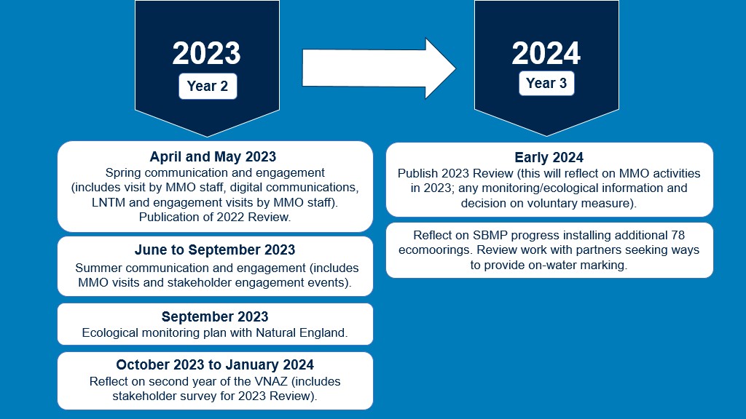Figure 10 MMO timeline for Studland Bay VNAZ 2023 to 2024 with highlighted milestones.

# Annex 1 Results

The survey included a range of question types, including single, multi-selection and open text response questions where responses could be provided in comment boxes (Table A1.1). The only question within the survey that was mandatory, was question 4.

In total there were 562 survey interactions, with 501 that had responded to at least 1 survey question. Due to the nature of the questions not all being mandatory, each question received a varying number of responses. This has been specified for each question within Annex 1 for clarity.

Stakeholder responses were analysed in two ways by calculating percentage of respondents and percentage of responses:

* percentage of respondents was used in single-selection and some of the open text questions. Percentage of respondents was applied when number of responses was equal to number of respondents
* percentage of responses was used in multi-selection and some of the open text questions. Percentage of responses was used when respondents could provide more than one answer to the question, meaning number of responses was not equal to number of respondents.

Table A1.1 Summary of all 2022 VNAZ Review Stakeholder survey questions.

|  |  |  |
| --- | --- | --- |
| **Question number** | **Question** | **Type of question** |
| **Q1** | Are you responding on behalf of a group or organisation, for example a boat club? | Open text response |
| **Q2** | How would you describe your relationship with Studland Bay? Please select all that apply. | Multi-selection |
| **Q3** | What do you value most about visiting Studland Bay? | Open text response |
| **Q4** | Are you a boat user? | Single selection |
| **Q5** | If you launch a boat, where do you typically launch from? | Open text response |
| **Q6** | What type of boat(s) do you use in Studland Bay? Please select all that apply. | Multi-selection |
| **Question number** | **Question** | **Type of question** |
| **Q7** | Have you used an advanced mooring system (or 'ecomooring') in Studland Bay? | Single selection and open text response |
| **Q8** | Have you visited Studland Bay by boat since the introduction of the voluntary no anchor zone (December 2021)? | Single selection |
| **Q9** | Have you spoken to an MMO member of staff on the water whilst visiting Studland Bay? | Single selection and Open text response |
| **Q10** | Have your anchoring habits changed since the voluntary anchor zone was introduced (for example: location or behaviour)? | Open text response |
| **Q11** | How would you describe your willingness to observe the voluntary no anchor zone, please provide reasons for your answer. | Single selection and open text response |
| **Q12** | Prior to this survey, were you aware that Studland Bay is a marine conservation zone (MCZ)? | Single selection |
| **Q13** | Prior to this survey, were you aware of the voluntary no anchor zone in Studland Bay MCZ? | Single selection |
| **Q14** | What activities do you understand are affected by the voluntary no anchor zone? Please select all that apply. | Multi-selection |
| **Q15** | Where have you seen information about the voluntary no anchor zone to date? Please select all that apply. | Multi-selection |
| **Q16** | Are there any other methods of communication MMO could use, to help share information about the voluntary no anchor zone? | Open text response |
| **Q17** | From the information you have seen about the voluntary no anchor zone is it clear what boaters are being asked to do? | Single selection |
| **Question number** | **Question** | **Type of question** |
| **Q18** | Do you need any further guidance about the voluntary no anchor zone?  Yes, please provide further details | Single selection and open text response |
| Question header - how much do you agree with the following statements?: | | |
| **Q19** | “I believe that seagrass is an important habitat that requires protection in Studland Bay.” | Single selection |
| **Q20** | “The voluntary no anchor zone is necessary for the protection of the seagrass beds.” | Single selection |
| **Q21** | “I am confident that I understand what the voluntary no anchor zone aims to achieve.” | Single selection |
| **Q22** | “I feel members of the boating community are aware of the voluntary no anchor zone.” | Single selection |
| **Q23** | “I am satisfied that there has been enough engagement from MMO to date.” | Single selection |
| **Q24** | “I am satisfied with the quality of engagement from MMO to date.” | Single selection |
| **Q25** | Do you have any suggestions for how to reduce the pressure of anchoring on seagrass? | Open text response |
| **Q26** | Do you have any further feedback or comments you would like to share with MMO about the voluntary no anchor zone in Studland Bay? | Open text response |

**Question 1: Are you responding on behalf of a group or organisation, for example a boat club?**

Question 1 was answered by a total of 30 respondents stating that they were responding on behalf of a group or organisation. Table A1.2 provides a breakdown of these responses into 6 different categories.

Table A1.2 Breakdown of responses by different groups and organisations.

|  |  |
| --- | --- |
| **Are you responding on behalf of a group or organisation?** | **Count of responses** |
| Sailing/yacht club | 15 |
| Harbour authority/commissioners | 1 |
| Local business | 2 |
| Environmental non-Governmental organisation | 3 |
| National recreational organisation | 5 |
| Local/community organisation or partnership | 4 |

**Question 2: How would you describe your relationship with Studland Bay? Please select all that apply.**

Question 2was answered by total of 497 stakeholders (Figure A1.1). Respondents could select multiple answers from the options presented. Total of 627 responses were received. 24 respondents shared relationships in the ‘other’ category and included Maritime History, Yacht charter or rental, Environmental concerns, Previous resident/ employment, National club or interest group, Local club or interest group, Leisure / recreation, Beach huts(s).

Figure A1.1 Summary of stakeholder responses for question 2, shown as proportion of different stakeholder relationships with Studland Bay.

**Question 3: What do you value most about visiting Studland Bay?**

Question 3 was answered by a total of 474 respondents, who shared their response in the open comment box provided (Figure A1.2). The most common themes of responses that were raised included the historic safe anchorage of the bay, it’s natural environment and scenery, convenience, and ease of access for boats, peace and tranquillity of the area, value as a location for leisure, recreation and holiday, safe location for the beach, swimming and water sports and facilities on the shore. These are discussed further in section 3.2 Themes.

Figure A1.2 Summary of stakeholder responses for question 3, shown as proportion of different values of Studland Bay raised by respondents.

**Question 4: Are you a boat user?**

Question 4 was single choice questions, answered by 501 respondents (Figure A1.3).

Figure A1.3 Summary of stakeholder responses for question 4, shown as proportion of respondents by boat user status.

**Question 5: If you launch a boat, where do you typically launch from?**

Question 5 was an open text response question, answered by 237 respondents (Figure A1.4). It was not possible to discern a specific launch location from 33 responses provided. Respondents mainly came from the Poole and the wider Dorset area, with Hampshire also being a key point from which to visit.

Figure A1.4 Summary of stakeholder responses received for question 5, shown as proportion of respondents by different boat launching location.

**Question 6: What type of boat(s) do you use in Studland Bay? Please select all that apply.**

Question 6was answered by total of 451 stakeholders (Figure A1.5). Respondents could select multiple answers from the options presented. A total of 573 responses were received. The most common types of boat that respondents used were yachts/sailboats, followed by motorboats/power boats.

Figure A1.5 Summary of stakeholder responses for question 6, shown as proportion of different types of boats used by respondents in Studland Bay. ‘Other’ responses included paddleboards, kayaks, canoes, windsurf/foil windsurf, diving/dive support, sailing training.

**Question 7: Have you used an advanced mooring system - AMS (or 'ecomooring') in Studland Bay?**

Question 7 was divided into two parts - single choice question, which was answered by a total of 449 respondents (Figure A1.6).

Figure A1.6 Summary of stakeholder responses for question 7, shown as proportion of respondents by varied experience in using advanced mooring system (or 'ecomooring') in Studland Bay.

The second part of question 7 was an open text response question, where stakeholders could provide further comments on their experience with ecomoorings in Studland Bay. Stakeholder responses were treated as multi-selection answers, which were then grouped into broad categories. Consequently, respondents could provide answers for multiple feedback types. Stakeholder feedback was analysed to identify themes that were raised and are discussed further in section 3.2 Themes.

General feedback received from respondents, who had used AMS was positive (Figure A1.7). Out of 141 respondents that stated **they had used** an AMS; 128 respondents were able to provide further details to expand on their response (Figure A1.8). Total of 237 responses were received. The most common themes identified for stakeholders who had used AMS prior to the survey were: more moorings were needed, moorings were too far from shore, and they were difficult to use without pickup lines.

Out of 296 respondents that stated **they had not used** an AMS; 192 respondents were able to provide further details to expand on their response (Figure A1.8). A total of 204 responses were received. The most common themes identified for stakeholders who had not used AMS prior to the survey were: more moorings were needed, respondents prefer to anchor outside of the VNAZ or elsewhere in the bay or use an alternative mooring, and they have rarely or not visited.

Figure A1.7 Summary of stakeholder responses received for question 7, which has indicated that they had used AMS. Responses are shown as proportion of respondents by stated AMS experience (positive/negative/neutral or no further details provided).

Figure A1.8 Summary of stakeholder responses for question 7, who were able to provide further details to expand on their response, shown as proportion of responses by different types of feedback provided. Summary includes responses from two groups of stakeholders, which indicated that they had, and they had not used AMS prior to the survey.

**Question 8: Have you visited Studland Bay by boat since the introduction of the voluntary no anchor zone (December 2021)?**

Question 8 was single choice questions, which was answered by a total of 452 respondents (Figure A1.9).

Figure A1.9 Summary of stakeholder responses for question 8, shown as proportion of respondents, who stated whether they had and had not visit Studland Bay by boat since the introduction of the VNAZ.

The second part of question 8 was an open text response question, where stakeholders could provide further comments on their experience with ecomoorings in Studland Bay. Stakeholder responses were treated as multi-selection answers, which were then grouped into broad categories. Consequently, respondents could provide answers for multiple feedback types. 26 respondents shared further feedback, which included:

* bad, neutral or good experience with MMO coastal officer
* respondents believed that views of boaters are not being passed on/listened to
* confirmation of receiving information about VNAZ
* stated that their views were not changes after talking to MMO coastal officers
* raised that more raising awareness and further evidence is needed.

**Question 9: Have you spoken to an MMO member of staff on the water whilst visiting Studland Bay?**

Question 9 was divided into two parts - single choice question, which was answered by a total of 326 respondents (Figure A1.10). If respondent selected option ‘yes’ in first part of question 9, open text response window was available to provide further feedback. Results from this option are discussed in the 3.2 Themes section of the report.

Figure A1.10 Summary of stakeholder responses for question 9, shown as proportion of respondents, who stated whether they had or had not spoken to a MMO member of staff on the water whilst visiting Studland Bay.

**Question 10: Have your anchoring habits changed since the voluntary anchor zone was introduced (for example: location or behaviour)?**

Question 10 was an open text response question, answered by a total of 293 respondents, who provided 588 responses (Figure A1.11). Stakeholder responses were treated as a multi-selection answer, which were categorised into different types of feedback provided (Figure A1.12). Respondents could provide answers for multiple feedback types. Stakeholder feedback shared was analysed to identify themes that were raised and are discussed further in section 3.2 Themes.

Figure A1.11 Summary of stakeholder responses received for question 10, shown as proportion of respondents with different changes in anchoring habits since the VNAZ was introduced (for example: location or behaviour).

Figure A1.12 Summary of stakeholder responses for question 10, who were able to provide further details to expand on their response, shown as proportion of responses by different types of feedback provided.

**Question 11: How would you describe your willingness to observe the voluntary no anchor zone?**

Question 11 was divided into two parts - a single choice question, which was answered by a total of 440 respondents (Figure A1.13) and an open text response which is discussed further below.

Figure A1.13 Summary of stakeholder responses for question 11, shown as proportion of respondents by level of willingness to observe the VNAZ.

The second part of question 11 was an open text response question, where stakeholders could provide further comments on their willingness to observe the VNAZ (Figure A1.14). Stakeholder responses were treated as a multi-selection answer, which were then categorised into different types of feedback provided. Consequently, respondents could provide answers for multiple feedback types. Stakeholder feedback shared was analysed to identify themes that were raised and are discussed further in section 3.2 Themes.

Out of 440 respondents, 217 respondents shared further information on their experience, a total of 245 responses were received (Figure A1.14) including 30 responses for ‘Not willing to observe’, 120 responses for ‘Somewhat willing to observe’ and 95 responses for ‘Willing to observe’.

Figure A1.14 Summary of stakeholder responses for question 11, providing further detail on their willingness to observe the VNAZ. Summary includes responses from three groups of stakeholders, which indicated that they are willing to observe, somewhat willing to observe and not willing to observe.

**Question 12: Prior to this survey, were you aware that Studland Bay is a marine conservation zone (MCZ)?**

Question 12 was single choice questions, which was answered by a total of 478 respondents (Figure A1.15).

Figure A1.15 Summary of stakeholder responses for question 12 (awareness of the MCZ prior to the survey), shown as proportion of respondents.

**Question 13: Prior to this survey, were you aware of the voluntary no anchor zone in Studland Bay MCZ?**

Question 13 was single choice questions, which was answered by a total of 478 respondents (Figure A1.16).

Figure A1.16 Summary of stakeholder responses for question 13, shown as proportion of respondents with different awareness of the VNAZ in Studland Bay MCZ.

**Question 14: What activities do you understand are affected by the voluntary no anchor zone? Please select all that apply.**

Question 14 was answered by a total of 477 respondents (Figure A1.17). It was possible to select multiple answers from the options presented. A total of 900 responses were received.

Figure A1.17 Summary of stakeholder responses for question 14, shown as proportion of activities, which are believed by stakeholders to be affected by the VNAZ.

**Question 15: Where have you seen information about the voluntary no anchor zone to date? Please select all that apply.**

Question 15 was answered by a total of 479 respondents (Figure A1.18). It was possible to select multiple answers from the options presented. A total of 1,321 responses were received.

**Figure A1.18 Summary of stakeholder responses for question 15, shown as proportion of data information sources about the VNAZ, which stakeholders have seen to date. ‘Other’ responses included: RYA, Cruising Association, Boat, Yacht Club or Marina, Yachting publications and magazines, Training centre, Campaigning organisation or groups, Charities, Forums, MMO, Electronic charts / maps, App, Television, Online search engine and Social media.**

**Question 16: Are there any other methods of communication MMO could use, to help share information about the voluntary no anchor zone?**

Question 16 was an open text response question, answered by a total of 140 respondents (Figure A1.19). Stakeholder responses were treated as multi-selection answers, then grouped into broad categories. Respondents could provide answers for multiple feedback types; a total of 1,321 responses were received.

Figure A1.19 Summary of stakeholder responses for question 16, shown as proportion of different methods of communications, which stakeholder selected to support raising awareness of the VNAZ.

**Question 17: From the information you have seen about the voluntary no anchor zone is it clear what boaters are being asked to do?**

Question 17 was single choice questions, which was answered by a total of 466 respondents (Figure A1.20).

Figure A1.20 Summary of stakeholder responses for question 17 (clarity on what the VNAZ asks boats to do) shown as proportion.

**Question 18: Do you need any further guidance about the voluntary no anchor zone?**

Question 18 was divided into two parts - single choice question, which was answered by a total of 469 respondents (Figure A1.21). The second part was an open text response. Please see below for further information.

Figure A1.21 Summary of stakeholder responses for question 18, shown as proportion of respondents, which indicated they do or do not need any further guidance about the VNAZ.

The second part of the question was where stakeholders could provide further comments. Stakeholder responses were treated as multi-selection answers, which were then grouped into broad categories. Respondents could provide answers for multiple feedback types. Part two was answered by 82 respondents, providing 103 responses (Figure A1.22).

Figure A1.22 Summary of stakeholder responses for question 18, who were able to provide further details to expand on their response, shown as proportion of responses by different types of feedback provided.

**Questions 19 to 24: How much you agree with the following statements:**

Question 19 to 24 were single answer questions, where respondents could rate how much they agreed with the statement shared for each question. Questions 19, 20, 21 were answered by total of 475 respondents; question 22 by 474 respondents; question 23 by 473 respondents and question 24 by 472 respondents (Figure A1.23).

Figure A1.23 Summary of responses to questions 19 to 24, asking respondents to rate how much they agreed with a range of statements; selecting from the options strongly agree, agree, neither agree nor disagree, disagree or strongly disagree. Results are expressed in percentage of respondents who selected each option.

**Question 25: Do you have any suggestions for how to reduce the pressure of anchoring on seagrass?**

Question 25 was an open text response question, answered by a total of 325 respondents, (Figure A1.24) providing 446 responses. Stakeholder feedback was analysed to identify themes that were raised and are discussed further in section 3.2 Themes.

Figure A1.24 Summary of stakeholder responses for question 25, who were able to provide suggestion for how to reduce the pressure of anchoring on seagrass, shown as proportion of responses by different types of suggestions provided.

**Question 26: Do you have any further feedback or comments you would like to share with MMO about the voluntary no anchor zone in Studland Bay?**

Question 26 was an open text response question, answered by a total of 219 respondents (Figure A1.25) providing 348 responses. Stakeholder feedback was analysed to identify themes that were raised and are discussed further in section 3.2 Themes.

Figure A1.25 Summary of stakeholder responses for question 26, who were able to provide further feedback regarding no anchor zone in Studland Bay, shown as proportion of responses by different types of suggestions provided.

# Annex 2 Remote monitoring

Figure A2.1 Recreational boats observed within the VNAZ each day (January to June 2022). Boating activity is shown as ‘stationary, not near mooring’ (possible anchorage), ‘stationary, near mooring’ and ‘other activity’. Graph also shows 7-day average for maximum wind speed and maximum temperature. W/E = weekends. ‘Other activity’ includes vessels that enter the VNAZ but may be sailing/motoring (not transiting), intentions unknown or potential signal drop out).

Figure A2.2 Recreational boats observed within the VNAZ each day (July to December 2022). Boating activity is shown as ‘stationary, not near mooring’ (possible anchorage), ‘stationary, near mooring’ and ‘other activity’. Graph also shows 7-day average for maximum wind speed and maximum temperature. W/E = weekends. ‘Other activity’ includes vessels that enter the VNAZ but may be sailing/motoring (not transiting), intentions unknown or potential signal drop out).

# Annex 3 Glossary of terms

**Advanced Mooring System (AMS) -** also referred to as an ecomoorings. These moorings avoid the placement of large mooring blocks on the seabed and chain abrasion through the use of alternate methods (Griffiths et al., 2017).

**Anchorage** – an area off the coast which is suitable for a vessel to anchor.

**Anchoring** – a heavy metal object that is dropped from a boat into the water to prevent the boat from moving away.

**Automatic Identification System (AIS) -** is an automatic tracking system used to exchange navigational information between boats with marine traffic in the same area. AIS is used voluntarily by boat owners, and its main aim is to avoid collisions and control marine traffic.

**Call for evidence** – informal consultation conducted by MMO during byelaw process. The purpose of this is to collect evidence from stakeholders. This allows the best available evidence to be used for the drafting of site level assessments and recommended management options (if required).

**Conservation objectives** - objectives are set for each designated feature of an MPA, to either maintain or restore a designated feature of the protected site.

**Designated features** – a species, habitat, geological or geomorphological entity for which an MPA is identified and managed.

**Ecomooring –** also referred to AMS, avoids the placement of large mooring blocks on the seabed and chain abrasion through the use of alternate methods (Griffiths *et al*., 2017).

**Intertidal coarse sediment -** shores of mobile pebbles, cobbles and gravel which are highly mobile and subject to high degrees of drying between tides.

**Marine conservation zone (MCZ)** – a type of MPA in English, Welsh and Northern Irish waters designated under the Marine and Coastal Access Act 2009[16] (for England and Wales) or the Marine Act (Northern Ireland) 2013[17] (for Northern Ireland).

**Marine Management Organisation (MMO)** - is an executive non-departmental public body, sponsored by the Department for Environment, Food and Rural Affairs (Defra) and is the manager and independent regulator of England’s seas.

**Marine non-licensable activities (mNLA)** –activitieswhich do not require a marine licence and include a range of recreational activities from**mooring and anchoring to boating and SCUBA diving.**

**Marine Protected Area (MPA)** - a generic term to cover all marine areas that are a clearly defined geographical space, recognised, dedicated, and managed, through legal or other effective means, to achieve the long-term conservation of nature with associated ecosystem services and cultural values. This includes special areas of conservation, special protection areas and marine conservation zones (MCZ).

**Mooring** – any permanent structure to which a seaborne vessel may be secured.

**Natural England** - government advisor for the environment in England. This includes aspects of the marine environment of 0 to 12 nautical miles (nm). This organisation has a statutory responsibility to provide conservation advice for MPAs and report on the condition of protected features.

**Subtidal sand** - the**most common habitats found below the level of the lowest low tide around the coast of the United Kingdom.**

**Voluntary No Anchor Zone (VNAZ)** – management measure introduced by MMO to prevent anchors from recreational boats damaging seagrass fronds and roots when they embed into the seabed.

# References

Griffiths, C.A., Langmead, O.A., Readman, J.A.J. and Tillin, H.M. (2017). Anchoring and mooring Impacts in English and Welsh Marine Protected Areas: Reviewing sensitivity, activity, risk and management. A report to Defra Impacts Evidence Group.

1. [Studland_Bay_MCZ_MMO_marine_non-licensable_activity_assessment.pdf](https://assets.publishing.service.gov.uk/government/uploads/system/uploads/attachment_data/file/1037523/Studland_Bay_MCZ_MMO_marine_non-licensable_activity_assessment.pdf)
2. [Studland_Bay_MCZ_Habitat_Protection_Strategy_pdf](https://assets.publishing.service.gov.uk/government/uploads/system/uploads/attachment_data/file/1080350/Studland_Bay_MCZ_Habitat_Protection_Strategy_.pdf)
3. [Managing marine non-licensable activity in Studland Bay Marine Conservation Zone](https://www.gov.uk/government/publications/managing-marine-non-licensable-activities-studland-bay-next-steps)
4. [ReMEDIES seagrass infographic](https://saveourseabed.co.uk/about-our-seabed/seagrass-maerl/)
5. [Voluntary no anchor zone – Coordinates Information Sheet](https://assets.publishing.service.gov.uk/government/uploads/system/uploads/attachment_data/file/1083767/Studland_Bay_-_Coordinates__1_.pdf)
6. [Lymington Harbour guide 2023](https://www.lymingtonharbour.co.uk/content/S636985256362913589/Lymington%20Harbour%20Guide%202023%20LR.pdf), on page 28.
7. [Yarmouth Harbour Visitor Guide 2023](https://www.yarmouth-harbour.co.uk/harbour-info/visitors-guide/), on page 20.
8. [Studland Bay Voluntary No Anchor Zone - 2022 Review - GOV.UK](https://www.gov.uk/government/news/studland-bay-voluntary-no-anchor-zone-2022-review) 
9. [Marine and Coastal Access Act 2009, s.129](https://www.legislation.gov.uk/ukpga/2009/23/section/129)
10. [Studland Bay MCZ MMO Marine Non-licensable Activity Assessment](https://assets.publishing.service.gov.uk/government/uploads/system/uploads/attachment_data/file/1037523/Studland_Bay_MCZ_MMO_marine_non-licensable_activity_assessment.pdf)
11. [Studland Bay MCZ Frequently Asked Questions](https://assets.publishing.service.gov.uk/government/uploads/system/uploads/attachment_data/file/1080349/Studland_Bay_MCZ_Frequently_Asked_Questions_.pdf)
12. [Evidence and the Marine Management Organisation](https://www.gov.uk/government/publications/evidence-and-the-marine-management-organisation-mmo)
13. [Defra - Environmental principles policy statement - The polluter pays principle](https://www.gov.uk/government/publications/environmental-principles-policy-statement/environmental-principles-policy-statement#:~:text=Description%3A%20The%20polluter%20pays%20principle,damage%2C%20or%20the%20wider%20community.)
14. [Studland Bay Marine Partnership webpage](https://www.dorsetcoasthaveyoursay.co.uk/studland-bay-marine-partnership)
15. [MMO2030_MMO Strategic Plan_July 2022_pdf](https://assets.publishing.service.gov.uk/government/uploads/system/uploads/attachment_data/file/1114006/MMO_Strategy-Final_PP_v.11__July_2022_.pdf)
16. [Marine and Coastal Access Act 2009](https://www.legislation.gov.uk/ukpga/2009/23/contents)
17. [Marine Act (Northern Ireland) 2013](http://www.legislation.gov.uk/nia/2013/10/contents)