**Marriage recognition or validity of marriage**

To whom it may concern,

Marriage in the UK is governed by separate and different legislation in England and Wales, Scotland and Northern Ireland. None of the Register Offices in England and Wales, Scotland and Northern Ireland issue certificates of marital status.

It is not necessary or possible to register in the UK a marriage that has taken place under another country’s law.

Only the courts in England and Wales can recognise a marriage under English and Welsh law which has taken place in a foreign jurisdiction. Whether the court will recognise such a marriage depends on two independent factors being satisfied separately: the parties must have capacity to marry and they must comply with the form of marriage. Capacity to marry is governed by the law of each party’s domicile. The usual rule in terms of the form of marriage is that if a marriage is valid under local law, the marriage will be recognised in English and Welsh law. If the use of the local form of marriage is impossible, the marriage will be recognised if the marriage is celebrated in accordance with the requirements of the English and Welsh common law. A matter which goes to both capacity and form is consent. No marriage is valid if, by the law of party’s domicile, one party does not consent to marry the other.

UK marriage certificates are not amended or updated after the couple are divorced.

*This information contained in this Note is general and should not be taken as a definitive statement of law nor legal advice. Any legal advice required should be obtained independently.*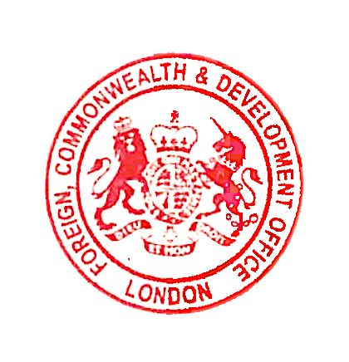

Consular & Crisis Directorate

**Foreign, Commonwealth & Development Office**