NOTICE OF ORDER

Wildlife and Countryside Act 1981 – Section 53
DORSET COUNCIL
(Footpath from East Lane (D20502) to D20503 Public Road East of Coombe Cottages, Bradford Abbas) Definitive Map and Statement Modification Order 2017

Notice is hereby given that the above referenced Order has been submitted to the Secretary of State for Environment, Food and Rural Affairs for determination. An Inspector will be appointed by the Secretary of State to determine the Order.

The start date for the above Order is 26 July 2024.

Consideration of the Order will take the form of a public local inquiry.

The Inquiry will be held at Committee Room 1, County Hall, Colliton Park, Dorchester, Dorset, DT1 1XJ on Tuesday 10 December 2024 at 10.00am.

The appointed Inspector will also open the Inquiry as a virtual event on
Tuesday 10 December 2024 at 10.00am.

Anyone wishing to attend the inquiry virtually must register that interest with the Order Making Authority as soon as possible prior to the Inquiry, by telephone, details of which are set out in this notice. To take part using video, participants will need to have access to Microsoft Teams (via an app or web browser). The link https://support.microsoft.com/en-us/office/welcome-to-microsoft-teams-b98d533f-118e-4bae-bf44-3df2470c2b12 gives further information on how to use this. Alternatively, you can take part by telephone. Registered participants will receive individual joining instructions, providing details of any requirements, guidance and support, whether joining by Teams or telephone.

The effect of the Order, if confirmed without modifications, will be to modify the definitive map and statement for the area by adding a Footpath at Bradford Abbas in the West Dorset District as follows:

From its junction with East Lane (D20502), west north west of East Farm at ST 58731547, east along a loose stone/gravel surfaced track to ST 58751547, continue east, passing through the Saxon Maybank development with buildings on either side and passing to the north of East Farm to ST 58931547. Then turn north east to ST 58951548 and continue north east along a hard stone surfaced track, hedged on both sides, south west of Coombe Cottages to ST 59021556. Continue north east, passing to the south east of Coombe Cottages to its junction with the D20503 Road at ST 59061560. Width: 9 metres at ST 58731547, narrowing to 5 metres at ST 58751547 and 4 metres at ST 58931547, widening to 9 metres at ST 58951548 and ST 59021556 and 10 metres at ST 59061560.

Any queries relating to this Order should be referred to Helen Sparks by email: helen.sparks@planninginspectorate.gov.uk quoting reference number ROW/3323995 on all correspondence. Alternatively, queries may be sent in writing to The Planning Inspectorate, Rights of Way Section, Room 3/A Eagle Wing, Temple Quay House, 2 The Square, Temple Quay, Bristol, BS1 6PN. Telephone: 0303 444 5646.

Any person wishing to view the statements of case and other documents relating to this Order may do so by appointment at County Hall, Colliton Park, Dorchester, Dorset DT1 1XJ or can be viewed on the Council’s website at:- https://www.dorsetcouncil.gov.uk/countryside-coast-parks/rights-of-way/definitive-map-and-statement/orders-with-the-secretary-of-state-for-determination.
The relevant officer for this matter if there are any queries is Vanessa Penny, Definitive Map Manager Telephone Number: (01305) 224719.

Timetable for sending in statements of case and proofs of evidence

Within 8 weeks of the start date by [20 September 2024]

The Order Making Authority must ensure their statement of case is received by the Secretary of State. As soon as possible after the deadline, the Secretary of State will send a copy (excluding copies of any supporting documents - these will be available to view at the Authority’s offices) to everyone who has made an objection or representation and the applicant and any other person who has written to us in respect of the Order.

Within 14 weeks of the start date [by 1 November 2024]

Everyone who has made an objection or representation and anyone who wishes to give evidence at the Inquiry must ensure their statement of case is received by the Secretary of State. As soon as possible after the deadline, the Secretary of State will send full copies to the Authority. Copies will also be sent to the applicant, every person who has made an objection or representation and any other person who has written to us in respect of the Order (excluding copies of any supporting documents - these will be available to view at the Authority’s offices).

Within the same period the applicant (if applicable) must ensure their statement of case is received by the Secretary of State. As soon as possible after the deadline, the Secretary of State will send a full copy to the Authority. Copies will also be sent to everyone who has made an objection or representation and any other person who has written to us in respect of the Order (excluding copies of any supporting documents - these will be available to view at the Authority’s offices).

4 weeks before the date of the inquiry [by 12 November 2024]

The Authority, everyone who has made an objection or representation, the applicant (if applicable) and anyone who wishes to give evidence at the Inquiry must ensure their proof of evidence (together with any summary) is received by the Secretary of State. As soon as possible after the deadline, the Secretary of State will send copies of:

- the Authority’s proof of evidence to everyone who has made an objection or representation, the applicant and anyone who has submitted a statement of case (including copies of any supporting documents – although none should be submitted with a proof of evidence);

- the applicant’s proof of evidence to the Authority, everyone who has made an objection or representation and anyone else who has submitted a statement of case (including copies of any supporting documents – although none should be submitted with a proof of evidence); and

- all other proofs of evidence to the Authority, the applicant, everyone who has made an objection or representation and anyone else who has submitted a statement of case (including copies of any supporting documents – although none should not be submitted with a proof of evidence).

All parties must keep to the timetable set out above and ensure that statements of case and proofs of evidence are received by the Secretary of State on time. Late documents will be returned.

We cannot accept any inflammatory, discriminatory or abusive comments. Any documents containing such comments will be returned.

Notice of order for inquiry

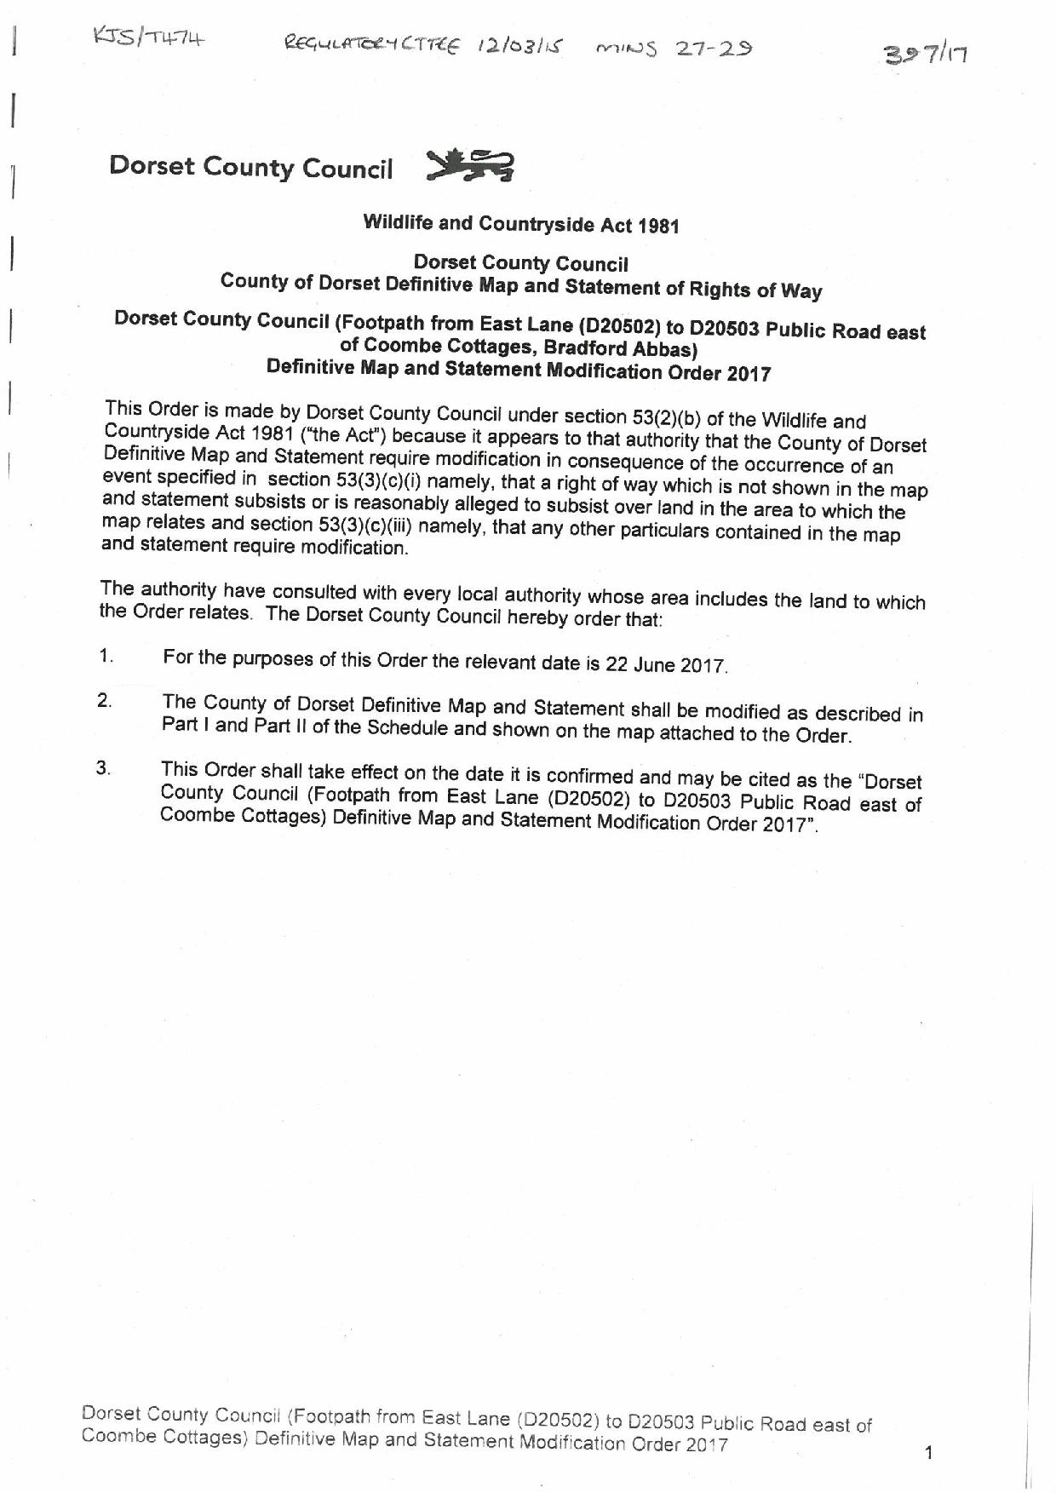

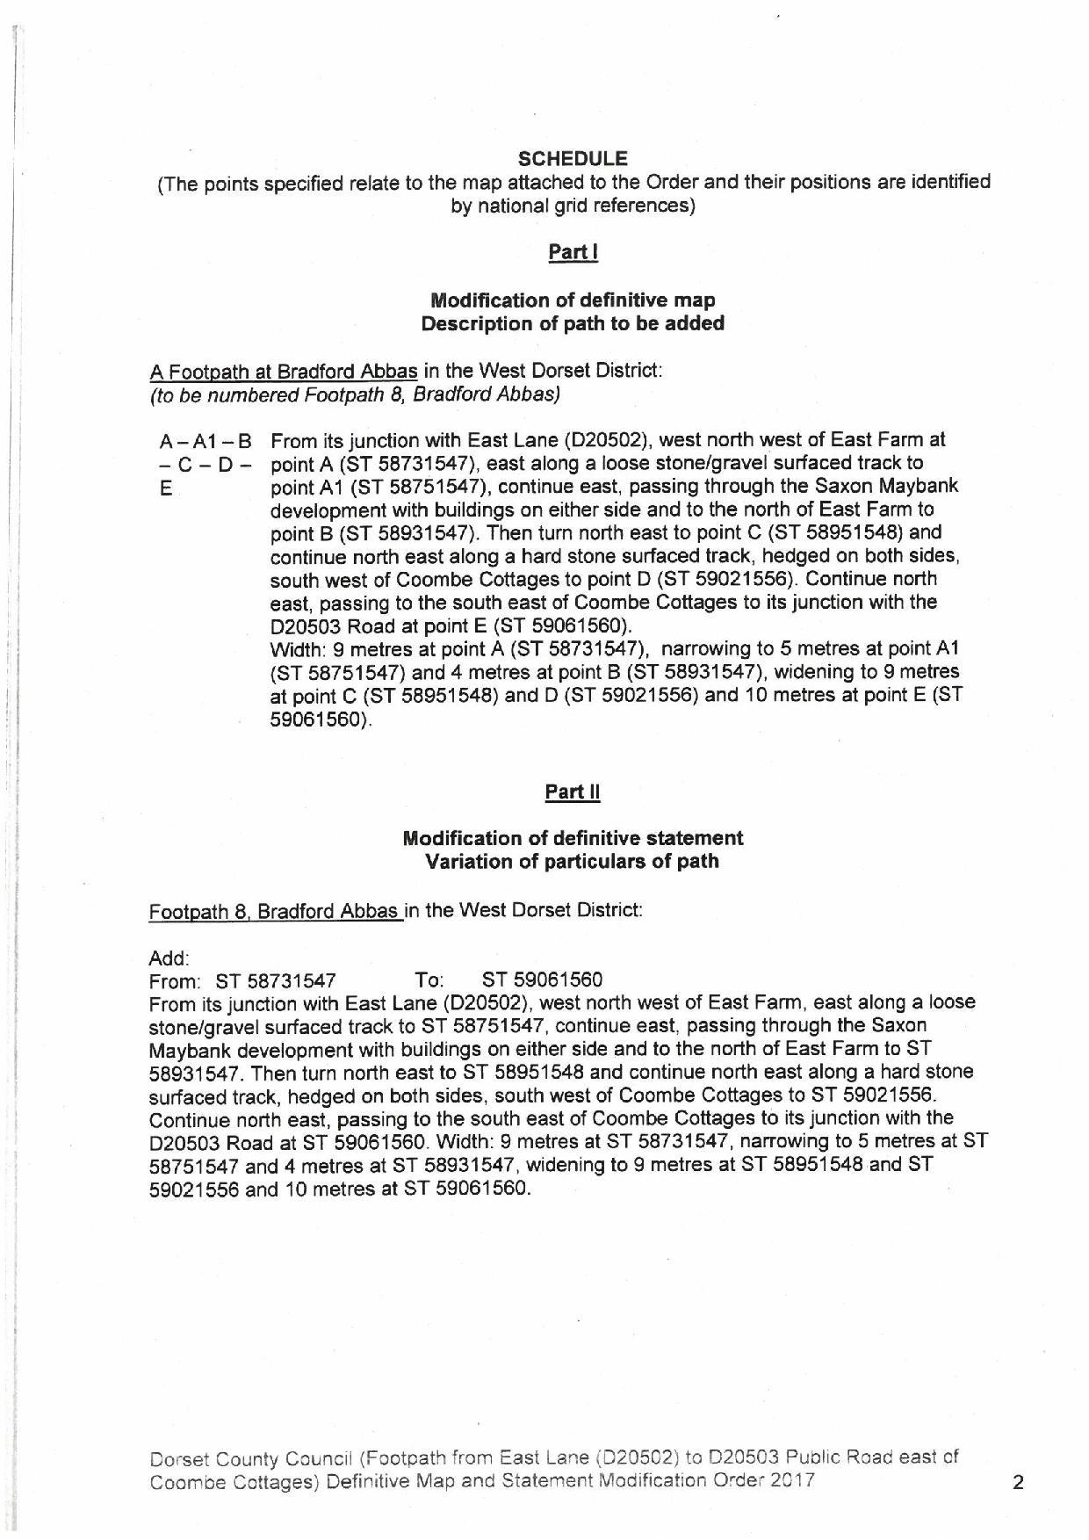

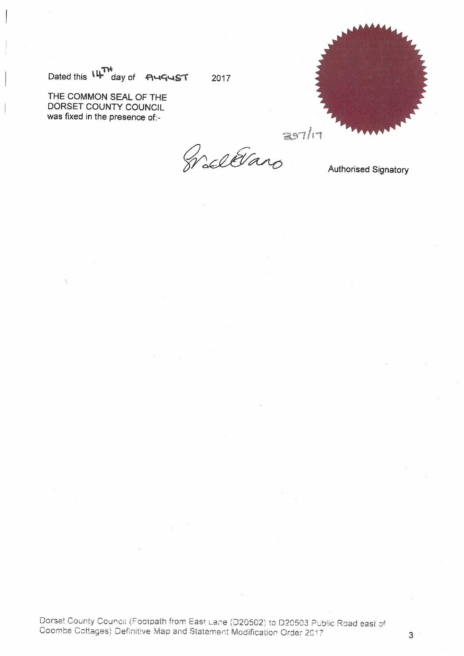

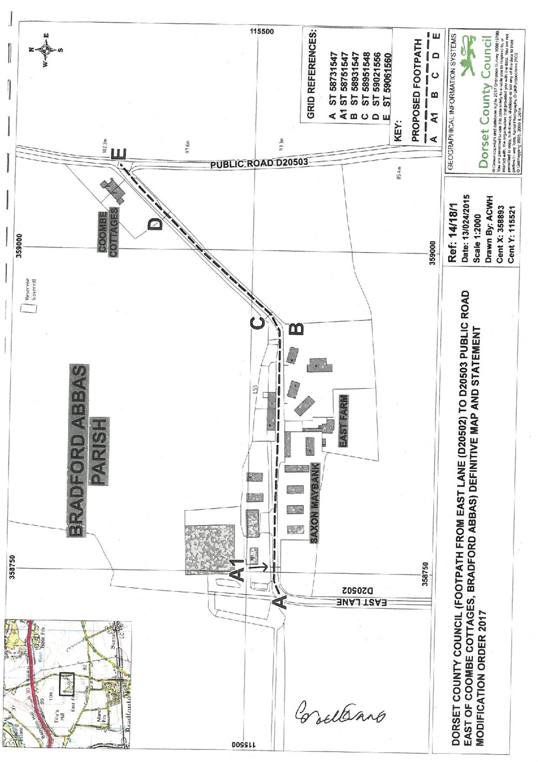

If you wish to make a legal submission, this should be submitted at the same time as your statement of case. Otherwise legal submissions will have to be submitted in writing on the day of the inquiry.

