

|  |
| --- |
| **Interim Order Decision** |
| Site visit made on 21 May 2024 |
| **by A Behn Dip MS MIPROW** |
| **an Inspector appointed by the Secretary of State for Environment, Food and Rural Affairs** |
| **Decision date: 8 July 2024** |

|  |
| --- |
| **Order Ref: ROW/3314355** |
| * This Order is made under Section 119 of the Highways Act 1980 (the 1980 Act) and is known as the Dorset Council (Footpath 51, Dorchester, and Footpath 6, Winterborne Monkton) Public Path Diversion Order 2020. |
| * The Order is dated 25 September 2020 and proposes to divert 2 public footpaths as shown on the Order Map and described in the Order Schedule. |
| * There were 2 objections and 2 representations outstanding when Dorset Council (the Council) submitted the Order to the Secretary of State for Environment, Food and Rural Affairs for confirmation.   **Summary of Decision: The Order is proposed for confirmation subject to the modifications set out in the Formal Decision, which require advertising.** |
|  |

**Preliminary Matters**

1. I made an unaccompanied site visit on Tuesday 21 May 2024, when I was able to walk the currently used and proposed routes. The walked route of Footpath 51 (points A - B) differs slightly to the definitive line of the path, but is in close proximity. This is also the case for Footpath 6 between points B - B1. Points B1 to C were accessible but the field was cropped and the definitive line not visible. For the purposes of this decision, I will consider the footpaths as though they were open and available to use on the definitive line.
2. I note that the Order states it is made under section 53(2)(a) of the Wildlife and Countryside Act 1981 (the 1981 Act), wherein it should have stated 53(2)(b). I consider this is likely a typographical error and it makes no difference to the understanding of the Order. The Order and the accompanying papers are clear upon the grounds and legislation under which it is made. Should the Order be confirmed I will modify it accordingly.
3. In writing this decision I have found it convenient to refer to the points marked on the Order Map and the Ramblers plan and I therefore attach copies of these.

**Main Issues**

1. For the Order to be confirmed, I must be satisfied, by virtue of Section 119 of the 1980 Act, that:

* it is expedient, in the interests of the landowner, the occupier or the public, that the footpaths should be diverted.
* the new rights of way will not be substantially less convenient to the public.
* any new termination points will be substantially as convenient to the public.
* it is expedient to confirm the Order having regard to the effect which:

(a) the diversions would have on public enjoyment of the ways as a whole.

(b) the coming into operation of the Order would have, in respect of other land served by the existing paths; and the land over which the new rights of way would be created, together with any land held with it.

1. Regard should also be given to any material provision contained in a rights of way improvement plan (ROWIP) for the area.

Reasoning

***Whether it is expedient in the interests of the landowner, the occupier, or the public that the rights of way should be diverted***

1. In 2015, the Duchy of Cornwall, (the applicant), submitted an application to divert Footpath 6 (FP6) Winterborne Monkton. It was later established that Footpath 51 (FP51), Dorchester was also affected by the proposed diversion and this was added to the application.
2. The application was made in the interests of the landowner, on the grounds of allowing better land management by moving a cross field route to the field edge. The field is currently dissected by FP6 and diversion of this path would undoubtedly enable easier management of the land.
3. One objector felt that the proposed diversions were not in the interests of the landowner in that the route involved construction of 0.6 miles of new path which would entail a loss of agricultural land as well as installation of gates and fencing. However the route of the proposed diversion is already in existence as an established permissive path, made available by the landowner in conjunction with the tenant farmer, both of whom wholly support the proposal.
4. Diversion of FP6 subsequently requires diversion of FP51 which adjoins it. Although the Order was made specifically in the interests of the landowner, it is quite clearly the case that the diversions are also in the interests of the public. FP6 crosses at a diagonal, a heavily used road (A35) with a national speed limit of 60mph, posing a considerable safety issue to both pedestrians and road users.
5. Accordingly I consider that it would be expedient in the interests of the landowner and in the interests of the public to divert FP51 and FP6. As requested by the Council, and supported by the landowner and the Ramblers, should the Order be confirmed, I will modify it accordingly to show the diversion is in the interests of both.

***Whether the new rights of way will not be substantially less convenient to the public***

1. Diverting these footpaths would have the effect of doubling the combined length of both footpaths from 727 metres to 1473 metres. Although the increase in length is significant, this needs to be weighed against the current inconvenience in respect of the inherent danger of crossing the Dorchester Bypass as well as the general purpose of travel.
2. The proposed diversions are substantially more convenient to the public in respect of safety, as the proposed diversion route offers safe passage through an underpass, rather than the requirement to cross a busy national speed limit road.
3. The footpaths as a whole, comprise a single route, leading from an urban area into the open countryside and I consider that use must be predominantly recreational or part of a much longer onward journey. One objector commented that the proposed diversion was substantially longer and would increase the distance to visit Maiden Castle by 0.5 miles. I accept this to be the case, however when contemplating the overall distance travelled to Maiden Castle using rural public rights of way, the extra length, whilst less convenient is not substantially so, when considering travelling in a recreational capacity in a rural setting.
4. The objector in his correspondence also suggested a more direct walking route from the underpass for walkers who may wish to visit Maiden Castle, suggesting it would be more beneficial than the proposed diversion. Albeit the current route and proposed diversions can be utilised with other rights of way to reach Maiden Castle, suggestion of an alternative route solely for the purpose of reaching this particular site of interest is not a matter before me.
5. Overall, I do not consider the proposed diversions are substantially less convenient to the public.

***Whether any new termination points are substantially as convenient to the public***

1. Since FP51 and FP6 form a single route, it is appropriate that the termination points are considered in the manner of one continuous path. The proposed eastern termination point, D, is approximately 127 metres southeast of the original termination point A. It remains on the same highway that is crossed by the current definitive line just prior to its original termination point. The proposed western termination at point R is 26 metres south west of the original termination point C, again remaining on the same highway. In the context of the overall diversion, I consider that the termination points of the proposed diversion remain substantially as convenient.

***The effect of the diversions on public enjoyment as a whole***

1. FP51 is an urban path that leads over a grassed and hedged bund that borders the A35, terminating at the edge of the road. FP6, its continuation, crosses the A35 Dorchester bypass diagonally. On the opposite side of the A35 is a stile, leading to a gently curving cross field path that terminates at Bridport Road. FP6 enjoys a semi-rural aspect, with views across the open countryside once the A35 has been negotiated.
2. The Ramblers are supportive in principle to the diversion of the footpaths that are the subject of this Order, stating the current route has been listed in a dossier of routes requiring safe crossing points since 1995. They accept that the underpass is a suitable means of achieving this but have concerns that the proposed routes either side of the underpass would have a detrimental impact on public enjoyment of the path as a whole.
3. The proposed diversion of FP51 is via points D-E-F-G-H-I-J on the Order Map. The concern of the Ramblers for this part of the diversion is between points D-H, where the route travels through a small industrial estate. They consider this part of the route visually unattractive, running between warehouses, factories, and offices with no mitigating natural features. They also consider that this part of the proposed diversion has the potential for conflict between vehicular traffic and walkers.
4. On my site visit I noted that although only a short distance, this part of the proposed diversion entailed walking for part, on the access road through the business park, where the flow of traffic was intermittent but present. There were indications on site that there was further development to be undertaken, which aligns with the Ramblers objection, wherein they stated planning permission had been granted for a further 21 units on this site.
5. The Ramblers proposed an alternative route, which is shown as V-W-X-Y (Z) on their attached plan, running alongside a walled allotment before circuiting Middle Farm House and exiting to the highway at Middle Farm Way.
6. Albeit the landowner remains of the view that the route incorporating points D-H is wholly appropriate, they accept, along with the Council, that there is merit in the Ramblers alternative proposal for this section and would agree to modification of this particular section, should it be considered more suitable.
7. I walked the Rambler’s suggested route whilst on my site visit and found it to be an existing path that was pleasant and appeared well used, with no potential conflicts. I do consider this a preferable route to the Order route for points D-H and should I be minded to confirm the Order, I will consider modifying the diversion route accordingly.
8. Turning to FP6, the Ramblers felt that the section of proposed diversion from points N-O was very close to the A35 with its associated noise and fumes, as well as being separated from the road by only a post and wire fence. They also pointed out the deep gullies on that section caused by erosion.
9. The Council considered that this section of the route was a much safer alternative to crossing the A35 and pointed out that there were several A roads in the area with no barrier at all. I concur with the Council that in comparison to the current route of FP6 from points B-B1, this proposed section is much safer and I consider the noise and fumes an inevitable inconvenience considering the location and necessity to cross the A35 to continue an onward journey. On my site visit I noted that only a short part of this section was at the same level of the road, with the gradient rising between points N-O. For the most part the proposed route was either below or above the road and I did not feel threatened by the passing traffic.
10. On my site visit I did note the deeply eroded gullies on the surface of the proposed diversion between points N-O, however the Council have affirmed that should the Order be confirmed, it will not come into effect until works have been undertaken to bring the footpath to the required standard, and that they would then take on the maintenance of the surface.
11. Previous correspondence from the Ramblers pointed out that the underpass has potential for flooding and I did note a very muddy surface when walking this part of the proposed route, however the Council has confirmed that works would be carried out to improve the surface and drainage prior to the Order coming into effect.
12. Considering points O-P of the proposed diversion of FP6, the Ramblers mentioned there were large holes along the southern edge of this fenced path, likely to be inactive badger setts. The Council commented that the holes were to the side of the route and did not affect the proposed footpath and certainly when walking this section of footpath, I did not encounter any holes affecting the path.
13. The Ramblers did suggest an alternative route to the proposed diversion of FP6, from point L on the Order map. They felt that the route shown on their attached plan as L-T-S, would mean that users would not have to walk in close proximity to the A35 at any point. They also suggested that another alternative would be to move points N-O slightly south west onto land that was not cropped and add a hedge to reduce any noise and fumes.
14. The applicant was strongly opposed to both of these suggested alternatives, commenting that the Order route presented the best option for farm management, particularly balancing stock welfare requirements with public enjoyment. To move points N-O slightly inland would, they felt, compromise their land use, resulting in a sterile unproductive area, as well as encroachment on an environmental strip.
15. An objector commented that the proposed diversion materially degraded the landscape value of the path and that the view to Maiden Castle which was completely clear and open on the current route, was obstructed by the hedge. Whilst I accept that the view of Maiden Castle is slightly more restricted on the proposed diversion, the views are still retained for the most part, with the hedging only being in situ between points O1 to P. I also note that the Council have stated that this hedge will be removed or cut to the height of the adjacent fencing to further reduce any restriction of views.
16. With regard to the rest of the proposed diversion, I do not consider the landscape value of FP51 and FP6 is lost. Negotiating a steep highway bund, followed by crossing a very busy road is not materially degraded by utilising a farm track and the underpass instead. On my site visit I observed walkers using the proposed diversion through the underpass, but saw no-one using the current route over the highway bund and across the A road.
17. I do accept that the proposed diversion of FP51 for a short stretch through the business park is visually less attractive, however should the Order be confirmed I will consider a modification to align this part of the proposed diversion to the alternative route suggested by the Ramblers. This will retain the semi-rural feel of the footpaths as a whole.
18. The enjoyment of any path is subjective by nature and of course, open to varying opinions. The proposed diversions, with modification to that part of FP51 discussed above, would retain the semi-rural feel of the original routes. Whilst points O-N remain close to the A35 and would be subject for a short stretch to the noise emanating from the bypass, the dangerous crossing point of the current route, which I consider is far less enjoyable to the public, is removed. Overall, I consider that the effect of the diversions will have minimal impact on public enjoyment as a whole.

***The effect the coming into operation of the Order would have with respect to other land served by the existing rights of way and the land over which the new rights of way would be created***

1. The land on which both the current footpaths and the proposed diversions, including those suggested by the Ramblers are situated, are within the land ownership of the applicant. No issues are raised which suggest that the diversions would have any adverse effect on land served by the existing routes or on the land over which the alternative routes would be created.

***The Equality Act 2010***

1. I concur with the Council’s view that the proposed diversions broadly fulfil the requirements of the Equality Act. The current routes of the footpaths require negotiation of a steep bund, followed by crossing a busy road, neither of which can be easily used by wheelchairs or mobility scooters, pushchairs, or people with impaired mobility. The Council deemed the current route particularly hazardous for walkers with young children or dogs and felt that the proposed diversions were a safer and more accessible route, with the only limitations being the pedestrian gates situated on the Order route.
2. The Ramblers were in general agreement with this view, albeit they did point out that considerable works were needed to bring points M-N to a standard whereby it was wheelchair or mobility scooter friendly.

***Consideration of the Order in light of any material provision contained in the ROWIP***

1. It is the view of the Council that the diversions fulfil a number of objectives in their ROWIP. They consider that the Order improves the accessibility of the network (theme 1.6), identifies a road severance location, and seeks opportunities to make improvements (theme 3.9), alongside working with partners to address road safety (theme 3.10).
2. The Ramblers accept the above, but feel that the proposed diversion fails to meet theme 3.9 which is seeking opportunities to develop networks of paths and public outdoor space consisting of attractive, safe off-road routes enabling people of all ages, need and abilities to walk/ride safely in and around their village/town, out to neighbouring settlements and into and about the wider countryside. They consider that the Order route through the business park is unattractive, involves a chalk-surfaced gradient and potentially involves conflict with vehicles.
3. Overall I find that the proposed diversions of FP51 and FP6 do align with the objectives outlined in the ROWIP, albeit I accept the view of the Ramblers in respect of the proposed diversion of FP51, that the alternative route they have suggested is a better fit for theme 3.9 than the original proposal. Albeit the Order map does not include the land where point Z is situated, should I confirm the Order I will modify it to show the suggested route as far as point Y, which is on the same highway.

**Other Matters**

1. A local resident had noted the removal of some wooden fences from the highway bund close to FP51 and queried whether the hedges on the bank would be cut if the footpath were to be diverted. There was also correspondence from a statutory utility querying their easement rights and any works that might affect a gas main crossing the Order route.
2. The Order if confirmed would not affect any easement rights. Any queries regarding future works on the diversion route, or the cutting of hedges on the bank of the A35 are matters outside of the scope of this decision and should be referred to Dorset Council.

**Conclusion**

1. I have found that the Order is expedient in the interests of the landowner for the purposes of better land management and also in the interest of the public in respect of the inconvenience and danger of the current footpath crossing a high speed, busy A road.
2. Albeit the proposed diversion route is double the length of the current paths, I find it substantially more convenient to the public in respect of offering a safe alternative to crossing the Dorchester bypass. I find it a little less convenient, but not substantially so, in respect of the extra distance needing to be travelled. This is offset by the nature and purpose of these rural footpaths, which are likely to be used in a recreational capacity and part of a longer onward journey.
3. With regard to the alternative routes put forward by the Ramblers, I concur that north of the A35, the alternative route via the walled allotments is a more preferable route than that section that is proposed to run through the business park, the merits of which are accepted by the applicant and the Council. However I am in agreement with the Council and the applicant, that the alternative route west of the underpass that was suggested by the Ramblers in the interest of moving the route away from the A35 for its short stretch, would be more detrimental to the landowner’s interests, than the brief respite it would offer for the public from the noise of the A35. Albeit the proposed diversions lessen the amount of time that views across to Maiden Castle are available, these views are still retained for a significant length of the proposed route.
4. Overall, when considering the proposed diversions in a rural context, I regard there to be minimal decrease in public enjoyment ‘as a whole’ and I therefore consider it is expedient to confirm the Order.
5. Having regard to the above, and all other matters raised in the written representations, I conclude that the Order should be confirmed with modifications.

**Formal Decision**

1. I propose to confirm the Order subject to the following modifications:

* On the first paragraph of the Order, line 2, after ‘that in the’ **add** *‘interests of the public and in the’*
* On the second paragraph of the Order, **delete** 53A(2) and **insert** *53(2)(b)*
* On the Order at point 3. After ‘from the date of confirmation of this Order’ **add** ‘*or on the date which Dorset Council certify that work has been carried out to bring the sites of the new highways into a fit condition for use by the public*’
* On the Schedule, Part 2, Description of site of new paths, Footpath 51, Dorchester, on the first line, **delete all of the text from** ‘D’ to ‘track to’ on line 4 of the same paragraph.

**Insert** the text, ‘*D (SY 67419019) travelling in a meandering generally southerly direction to point E (SY 67429012), then to point F (SY 67409009), then to point G (SY 67399003), then to’*

* On the Schedule, Part 3, Limitations and conditions, above Point I, **add** *Point E (SY 67429012) Pedestrian gate*
* On the Schedule, Part 4, Modification of Definitive Statement, Footpath 51, Dorchester, second paragraph, first line, **delete** SY 67279014 and **insert** *SY 67419019*
* On the Schedule, Part 4, Modification of Definitive Statement, Footpath 51, Dorchester, second paragraph, second line, **delete all of the text from** ‘west’ to ‘track’ on line 4 of the same paragraph.

**Insert** the text ‘*travelling in a meandering generally southerly direction via SY 67429012, SY 67409009 and SY 67399003’*

* On the Schedule, Part 4, Modification of Definitive Statement, Footpath 51, Dorchester, second paragraph, line 7, **delete** gate and **insert** ‘*gates*’
* On the Schedule, Part 4, Modification of Definitive Statement, Footpath 51, Dorchester, second paragraph, line 8, after ‘Pedestrian gates at SY 67389001’, **add** ‘*and SY 67429012’*
* On the Order Map, **delete** the route D-E-F-G-H as shown by the red crosses and **insert** the route D-E-F-G-H as shown by the broken red line
* On the Grid References, **delete** the grid references for D,E,F,G

**Insert new grid references**  D – SY 67419019, E – SY 67429012 , F – SY 67409009, G – SY 67399003

1. Since the confirmed Order would affect land not affected by the Order as submitted, I am required by virtue of Paragraph 2(3) of Schedule 6 to the 1980 Act to give notice of the proposal to modify the Order and to give an opportunity for objections and representations to be made to the proposed modifications. A letter will be sent to interested persons about the advertisement procedure.

*Mrs A Behn*

**INSPECTOR**

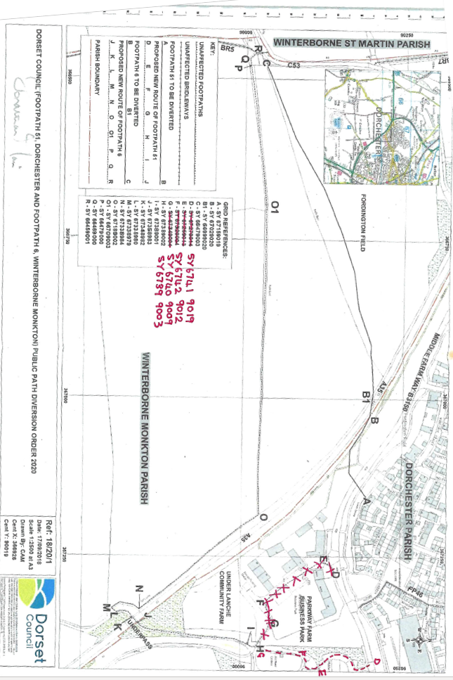



Proposed routes suggested by the Ramblers