Application Decisions
Site visit made on 16 July 2024
by Helen O'Connor LLB MA MRTPI
an Inspector appointed by the Secretary of State for Environment, Food and Rural Affairs
Decision date: 30 July 2024

Application A Ref: COM/3333979
Woodbury Common, Devon
Register Unit: CL136
Registration Authority: Devon County Council

- The application dated 13 November 2023 is made under Section 16 of the Commons Act 2006 (“the 2006 Act”) to deregister and exchange land registered as common land.
- The application is made by David James Roper Robinson, Noel George Herbert Manns, Venn Bridge LLP and Braundshill Holdings Limited (owners of the release and replacement land).
- The release land comprises 16,910m² of land at Blackhill Quarry.
- The replacement land comprises of 34,030m² of land in total, consisting of six separate parcels at or near Blackhill Quarry.

Application B Ref: COM/3333989
Woodbury Common, Devon
Register Unit: CL136
Registration Authority: Devon County Council

- The application, dated 13 November 2023, is made under Section 38 of the 2006 Act for consent to carry out works on common land.
- The application is made by David James Roper Robinson, Noel George Herbert Manns, Venn Bridge LLP and Braundshill Holdings Limited.
- The works comprise underground cabling and the erection of a bat hibernaculum.

Decisions

Application A
- Consent is granted and an Order of Exchange given in accordance with the application dated 13 November 2023, to deregister and exchange common land at Woodbury Common, Devon. As part of the Order of Exchange, a copy of the application plan (Drawing A) showing the areas for deregistration and exchange is attached to this decision.

Application B
- Consent is granted for the works in accordance with the application dated 13 November 2023 and the accompanying plans, subject to the following condition:
- The works shall commence no later than 3 years from the date of this decision.

Reason: In the interests of certainty.
- For the purposes of identification only, a copy of the application plans showing the location of the cabling works (Drawing B) and bat hibernaculum (Drawing C) is attached to this decision.

Preliminary matters and background
- Planning permission was granted (reference 22/2546/MFUL) for the installation of a battery energy storage facility and associated infrastructure, including underground cabling, at Blackhill Quarry in July 2023. The development approved broadly correlates with the release land proposed in Application A, and the underground cabling shown in Application B. Although within Woodbury Common, this land has longstanding industrial use, including as a quarry, the processing and storage of minerals and other commercial development. The approved battery energy storage facility was subject to planning conditions which included measures for habitat creation, mitigation and management. One of the ecological mitigation measures was the provision of a bat hibernaculum. Separate planning permission (reference 23/2312/FUL) was granted in March 2024 for a bat hibernaculum which correlates with the details shown in Application B.
- Accordingly, the applicants have submitted both a section 16 (to deregister and exchange land (Application A)) and a section 38 application (for works (Application B)) under the 2006 Act. They indicate that both would be necessary to enable them to deliver the battery energy storage facility approved. Hence, although they are two separate applications, they are intrinsically linked. I have borne in mind the statutory requirements in respect of sections 16 and 38 of the 2006 Act as appropriate. However, to reduce repetition, I have dealt with both applications together in this decision letter unless stated otherwise.
- In relation to both applications, the applicants have provided a signed Unilateral Undertaking (UU) dated 12 July 2024 pursuant to section 106 of the Town and Country Planning Act 1990. Subject to the issuing of consents for both applications, this includes an obligation requiring the owners to enter into a dedication instrument that would accord with section 16 of the Countryside and Rights of Way Act 2000 (CROW Act). In effect, that would voluntarily dedicate the replacement land as access land for the purposes of the CROW Act. In addition, in relation to the replacement land, there are obligations to allow permissive access to users on horseback and bicycle and to remove any fencing. I shall consider the UU as part of my decisions.

Main Issues
- I am required by Sections 16(6) and 39(1) of the 2006 Act to have regard to the following in determining these applications:

(a) the interests of persons having rights in relation to, or occupying, the release land (for Appeal A) and the land (for Application B) (and in particular persons exercising rights of common over it);

(b) the interests of the neighbourhood;

(c) the public interest, including the public interest in nature conservation; the conservation of the landscape; the protection of public rights of access to any area of land; and the protection of archaeological remains and features of historic interest; and

(d) any other matter considered to be relevant.

The Applications

Application A

The Release Land
- The release land amounts to 16,910m² situated towards the southern end of Woodbury Common. Woodbury Common is a substantial registered unit, reference CL136 (extending to about 283 hectares). It adjoins other registered units of common land to the east and south. The release land is irregularly shaped but relates to a former worked quarry and associated buildings. It later served as a processing plant for the importation, processing and storage of sand and gravel, as well as other commercial uses. Consequently, there are extensive areas of concrete hardstanding and large utilitarian buildings on the land, with very little vegetation.
- Owing to the quarrying and industrial uses, the release land is excepted land to which the public and commoners have no rights of access. The topography combined with fencing physically reinforce this. Moreover, because planning permissions were granted for industrial development, the applicants have confirmed that the release land is excluded from any restoration scheme associated with the former quarry use that would otherwise return it to publicly accessible land.
- For the purposes of identification, a copy of the application plan is attached to this decision at Drawing A. The release land is shaded in red and labelled parcel 7.

The Replacement Land
- The replacement land is in six parcels that total 34,030m². They range in size and appearance as described below, but all are pockets of land that are totally or partially bounded by common land. As such, they appear as areas of ‘infill’ that were probably originally excluded from common land registration because they were formerly forestry plantations. There are no formal public access rights to any of the parcels.
- Parcel 1 is broadly rectangular and amounts to 7950m². It forms part of a larger area of conifer plantation woodland and mixed scrubland and lies about 200m northeast of the release land. It is otherwise surrounded by CL136 with no boundary features.
- Parcel 2 is a small square parcel of conifer woodland measuring 1320m². It lies about 540m east of the release land. It is contiguous with CL136 and Bicton Common CL82, with no physical boundary from either.
- Parcel 3 is the furthest from the release land lying about 830m southeast of it and surrounded by Bicton Common. It is a square parcel of land amounting to 3260m² and comprising broadleaved woodland and mixed scrub. There is no boundary fencing.
- Parcel 4 is the smallest parcel at 750m². Triangular in shape, it comprises broadleaved woodland with Scots pine and sweet chestnut. Denoted by a shallow ditch, it lies about 700m southeast of the release land on the boundary of Woodbury Common and Lympstone Common (CL39).
- Parcel 5 is the biggest parcel situated about 600m south of the release land. Measuring 15,680m², it is a large block of mature conifer plantation. Although I observed some remnant fence posts, I did not see any post and wire fencing as described in the application. It borders Woodbury Common on three sides and is close to Lympstone Common to the south.
- Finally, parcel 6 is the closest area, adjoining part of the release land to the south. It is a rectangular block of conifer plantation amounting to 5070m².
- The replacement land is shaded in green on Drawing A and labelled parcels 1-6.

Application B
- The works proposed comprise two elements. Firstly, it is proposed to lay a length of approximately 550m of underground cable which would form part of the proposed connecting cable from the battery storage plant to the point of connection onto the National Grid Energy Distribution network. It is proposed to excavate a trench to a depth of 1.5m and width of 1m broadly following the route of Woodbury Bridleway 11. Thereafter, the trench would be back filled and the bridleway surface reinstated. It is estimated that this would take 2-3 days’ work to complete.
- In addition, a purpose-built bat hibernaculum is proposed close to the proposed release land in Application A. This would involve the introduction of a permanent 6m x 5m rectangular structure, The single storey building would be built into earth banks to the sides and rear and would have a slate pitched roof.

Representations and Objections
- Two representations per application were made in response to the notices of the respective applications, albeit that in some cases these were combined. In relation to Application A, a further representation was received after the deadline given in the notice.
- Having regard to the Deregistration and Exchange of Common Land and Greens (Procedure) (England) Regulations 2007 (the Regulations), I must consider the representations received within the requisite time period. Whilst not obliged to consider the late representation, I am not aware that the Regulations expressly prohibit its consideration or remove any discretion to do so. I am satisfied no one would be prejudiced by my taking it into account as part of my determinations.
- Returning to the substance of the representations received, Natural England (NE) raises no objection in principle to either application. In relation to Application A, they consider the release land is of limited ecological value with public access restricted, whereas the replacement land would provide a larger and more suitable area for public access. In this respect they welcome the applicants’ commitment to dedicate the replacement land under section 16 of the CROW Act.
- In relation to Application B, NE acknowledge the connection to, and their previous involvement as statutory consultee with, the battery energy storage facility development. They confirm that as part of the planning application an Appropriate Assessment under the Conservation of Habitats and Species Regulations 2017 (as amended) (the Habitat Regulations) was undertaken. As part of that process, NE considered that the development in that case would not have an adverse effect on the integrity of any European habitat sites. This finding was subject to the mitigation works associated with that development being carried out in accordance with the planning conditions. With respect to the cabling works, NE consider the works should minimise any impact on recreational users. They further consider that the bat hibernaculum would have a limited impact on public access and the landscape.
- The Open Spaces Society (OSS) refer to the extent of replacement land and present lack of public access to the release land as strong factors in support of Application A. They consider that the section 106 agreement securing a dedication instrument relating to public access, and the removal of fencing should be entered into prior to the issue of any consent, or alternatively made a conditional part of any consent order. They also note that the existing commons are open to horse riding under general licence and suggest that the section 16 dedication instrument is also used to permanently lift any restriction on horse riding. The OSS raised no objection to the proposed works in Application B.
- The Devon Countryside Access Forum consider Application A to represent a beneficial and sensible rationalisation of small pockets of land which would then have formalised common land status and public access. They confirm that the industrial area at Blackhill Quarry has not had public access for many decades, and it mostly constitutes hardstanding with no particular conservation value. As such they support the proposal to deregister and exchange common land.

Assessment
- In determining the applications, I have had regard to the Department for Environment, Food and Rural Affairs Common Land consents policy, November 2015 (the 2015 Guidance) published for the guidance of both the Planning Inspectorate and applicants.
- Paragraph 3.2 sets out overall policy objectives to protect commons. Of relevance to Application A is the outcome that the stock of common land and greens is not diminished so that any deregistration of registered land is balanced by the registration of other land of at least equal benefit. It goes on to set the outcome that works should take place on common land only where they maintain or improve the condition of the common or where they confer some wider public benefit and are either temporary in duration or have no significant or lasting impact. This has direct relevance to Application B.

The interests of those occupying or having rights over the land
- Mr I J and Mrs S Sargent of Furze House are the only registered commoners for Woodbury Common. They have rights to cut heather for bedding and some timber for the repair of fences. In addition, they have grazing rights for modest numbers of specified animals. The evidence before me indicates that these rights are not exercised. On that basis, neither application would adversely affect the rights of the commoners.
- In any event, given the industrial use, fencing and excepted nature of the release land, in practical terms the commoners would be unable to exercise such rights in relation to it. The replacement land proposed in Application A would provide a greater quantity of more suitable land. Hence, it would be in the interests of commoners. Moreover, the temporary trenching works and provision of a small ecological facility proposed in Application B would be unlikely to present any notable obstacle to the exercise of such rights across the registered common unit.
- Blackhill Engineering Services Limited have a leasehold interest in part of the release land. However, written confirmation that they raise no objection to either application dated 26 October 2023 is provided. I consider that they are best placed to judge the likely impact on their interests, and I have no basis to find to the contrary.
- Therefore, overall, and in relation to both applications, I am satisfied that the interests of those occupying or having rights over the land would not be adversely affected.

The interests of the neighbourhood
- The 2015 Guidance indicates that the issues to be considered in this context include whether the exchange or construction of the works would prevent local people from using the common in the way they are used to, and whether or not there would be an interference with the future use and enjoyment of the land as a whole. It also provides for positive benefits to be taken into account.
- Given the predominantly rural context of Woodbury Common, nearby settlements are few and small in scale. It follows that this curtails the number of local people likely to reside in the neighbourhood. This is reinforced by available survey evidence that indicates that users of the area primarily travelled from some distance away and visited mostly for recreational purposes. Nevertheless, the use of the area by small numbers of local people cannot be ruled out, and where this is the case, their use of Woodbury Common would probably be more frequent.
- Application A would provide considerably more replacement land than would be released. Significantly, the replacement land would not be excepted from public access. Furthermore, the UU provided would ensure a voluntary dedication of exchange land as access land. In effect, this would mean that the CROW Act access rights would apply immediately without needing to wait until the conclusive map is reviewed and exchange land added. As such, local people (along with the public) would benefit from increased access to common land, which would also be conveniently situated adjacent to existing common land, nearby public rights of way and recreational routes.
- In relation to Application B, the trenching associated with the underground cabling would temporarily disrupt access along a linear stretch of common land. Nevertheless, this would be for a short period, with access available thereafter. The presence of the proposed bat hibernaculum would prevent access onto a 30m² area of common land, which represents a very small area in the context of the registered unit. Moreover, as its purpose is to support populations of bats, if anything, its use by protected species would probably enrich the experiences of local people (and others) when using the common for recreational enjoyment.
- Accordingly, there is nothing before me to indicate that there would be any significant adverse effect on the interests of the neighbourhood. Nor is there any basis to conclude that the proposed exchange or works would interfere with the future use and enjoyment of the common by local people, rather the opposite.

The public interest

The protection of public rights of access
- As previously mentioned, the release land is not accessible to the public. In contrast, the six replacement parcels of land would become accessible to the public, as when the conclusive map is reviewed, they would constitute ‘access land’ for the purposes of the CROW Act. Hence, even in the absence of a voluntary dedication, the replacement land represents an improvement on the present situation.
- Nevertheless, the obligation in the UU that requires the applicants to enter into a dedication instrument in accordance with section 16 of the CROW Act would secure immediate public access to the replacement land. Hence, it would not be necessary to wait for the conclusive map to be reviewed. Given the uncertain timeframe of such a review, this weighs considerably in favour of the proposed exchange. Moreover, given that the extent of replacement land is also considerably larger than the release land, there would be a notable gain in the area available for public access.
- My observations were that all the parcels of replacement land are free of boundary fencing, with shallow ditches and earth bunding, where present, presenting little physical hindrance to public access. Although none appeared to be present, the UU provides an obligation to remove any fencing on the replacement land.
- The six parcels of land are well related to and contiguous with other common land, and close to public rights of way. These are factors which would facilitate easy public access.
- The applicants indicate that although they do not intend to include access on horse or bicycle as part of the dedication instrument required by the UU, they would grant permissive access insofar as it would mirror those applicable to the surrounding common land. This is reflected in a separate obligation contained in the UU. I am satisfied that this approach would be consistent with public rights of access elsewhere on Woodbury Common and adjoining common land.
- The trenching proposed in Application B would temporarily disrupt access along a bridleway, but this would be for a short period with the surface restored thereafter. I am mindful that there are specific legislative requirements that also apply to any obstruction to a public right of way.
- The bat hibernaculum proposed would represent a modest structure, made unobtrusive by earth banks to the sides and associated planting. Nevertheless, its presence would prevent public access onto an area measuring 30m². The applicants calculate that this equates to a 0.001% reduction in the useable area of Woodbury Common. Hence, the practical impact on public access would be negligible.
- Moreover, paragraph 5.8 of the 2015 Guidance asks whether the works are consistent with the use and enjoyment of the land as common land. Therefore, in addition to physical access, it is also reasonable to consider the enjoyment derived from experiencing common land. Under the heading of ‘Protecting commons- our policy objectives’, paragraph 3.1 of the 2015 Guidance refers to safeguarding commons for current and future generations to use and enjoy and improving the contribution of common land to enhancing biodiversity and conserving wildlife. In these respects, the provision of the bat hibernaculum would be consistent with the use and enjoyment of the land as common land. The provision of a refuge for protected species, could in many instances enhance the public enjoyment of the common.
- Taking these factors together, Application A represents a marked improvement to public rights of access whereas there would be a minor degree of localised harm in respect of the works in Application B.

Nature conservation and biodiversity
- The release land, replacement land and the area that would be affected by the proposed works are located either within or adjacent to the East Devon Pebblebed Heaths Site of Special Scientific Interest (SSSI), the East Devon Pebblebed Heaths Special Area of Conservation (SAC) and the East Devon Heaths Special Protection Area (SPA). The SSSI is a national designation, whereas the SAC and SPA are habitats recognised under the Habitat Regulations. The designations reflect the importance of the lowland heath habitat and its associated flora and fauna, which includes rare and vulnerable species of birds.
- The applications before me form part of a wider project to deliver a battery energy storage facility. The noise, lighting and activity arising from the development and its construction (including the cabling works) would be likely to result in some disturbance to wildlife, including birds. Hence, it was found during the recent planning application process, that there was a risk of a significant effect on the internationally important interest features of the SAC and SPA. As such, the project was the subject of an Appropriate Assessment under the Habitat Regulations as part of the planning application, which considered mitigation measures.
- As part of that process, consultation was undertaken under Regulation 63(3) of the Habitat Regulations. Natural England outline their response in that case, confirming that the mitigation measures proposed would be sufficient to avoid an adverse impact to the integrity of the SAC and SPA. The mitigation measures included the creation of additional heathland, additional native planting, bat boxes and the provision of Great Crested Newt (GCN) and bat hibernacula. Such measures were secured by way of planning conditions. The applicants have confirmed that the mitigation measures have been delivered save for the bat hibernaculum, which is the subject of Application B.
- The submitted Preliminary Ecological Appraisal confirms that the release land is of low ecological value which is consistent with its industrial usage and level of hardstanding. The replacement parcels comprise a mix of conifer woodland or plantation, broadleaved woodland and mixed scrub. By comparison they are richer in ecological terms. In combination with the increase in area, this would result in a net gain to the biodiversity of Woodbury Common. Hence, Application A would further the interests of nature conservation and biodiversity, which weighs in its favour.
- In terms of the works proposed in Application B, there would be no loss of heathland or woodland habitat to the SAC or SPA. The trenching works would take place along a bridleway, the surface of which I observed to comprise a mixture of tarmac and gravel. Hence, vegetation is sparse making it unlikely that the physical incursion would directly harm wildlife. Avoidance measures to protect GCN and badger during the short construction period are secured as part of the planning permission. A fenced buffer would be used to safeguard hedgerows from accidental damage. Works would take place outside of the nesting season for birds. In addition, there are planning conditions imposed on the planning approval that require the agreement of a Construction and Environment Management Plan as well as an Arboricultural Impact Assessment and method statement to be provided. This would secure tree protection measures along the route of the cabling works, including the section that is the subject of Application B. Taking these factors together, it is unlikely that the temporary works would have any notable adverse impact upon biodiversity or nature conservation.
- As indicated above, the provision of the bat hibernaculum forms part of the necessary mitigation measures associated with the planning permission. It comprises a specially designed roosting area (including a maternity roost) that is likely to support the maintenance and probable expansion of the local bat population. Hence, this element of Application B would be of direct benefit to nature conservation and biodiversity.

Conservation of the landscape
- The release land, replacement land and areas of proposed works all fall within the East Devon National Landscape (EDNL) (previously known as the East Devon Area of Outstanding Natural Beauty). The special qualities of the EDNL include its diversity as it encompasses coastline, woodland coombes, river valleys and expanses of heathland.
- My observations of the release land were that the profile of its landform, presence of hardstanding and utilitarian buildings were somewhat at odds with the surrounding land, where natural features prevail. Hence, it contributes little to the special qualities of the EDNL. The likely effects on the EDNL arising from the approved battery energy storage facility were considered in depth as part of that process. However, insofar as Application A is concerned, the inclusion of a greater quantity of replacement land which also lies within the EDNL and where natural features dominate, would assist in conserving and increasing the landscape value of Woodbury Common.
- In relation to Application B, the cabling works were considered as part of the Landscape and Visual Appraisal prepared for the approved planning development. This found that the trenching would be unlikely to cause any substantial long-term landscape effects to the bridleway concerned, as the trench would be back filled with the surface reinstated, and replanting undertaken.
- The modest scale and earth banking to the sides of the proposed bat hibernaculum, together with scrub planting would minimise the visual effects on the landscape character of this part of Woodbury Common. Nevertheless, there would be a small, localised harmful effect given that it would introduce built form onto land where there is presently none. Overall, Application B would cause a minor degree of localised harm to the landscape.

Archaeological remains and features of historic interest
- There are no listed buildings or scheduled monuments on the release land, replacement land or the area of the proposed works. The nearest scheduled monument lies about 20m away from of replacement land parcel 4 within Lympstone Common and there would be little change to its surroundings arising from either application. Accordingly, there is little basis to consider that either proposal would result in any material harm to archaeological remains or features of historic interest.

Other relevant matters
- The main impetus for both applications is to allow the approved battery energy storage facility to proceed. The facility could complement intermittent sources of energy, such as wind and solar energy by helping to avoid fluctuations in electricity supply. Hence, it is probable that it would support the more efficient use of renewable energy and thereby assist in a transition to low carbon energy. As such, the facility would align with national and local objectives in relation to energy use and measures to address climate change. This wider public benefit is relevant to my determinations and weighs moderately in favour of permitting them.

Conclusions
- Having regard to the statutory criteria and 2015 Guidance, Application A would increase the stock of common land. Furthermore, for the reasons outlined above, I am satisfied that the replacement land would be of greater benefit than the release land. I do not find that there are any relevant matters which indicate that the application should be refused.
- In relation to the works in Application B, there would be a minor degree of localised harm to public access and conservation of the landscape. In the case of the proposed cabling this would be temporary. In relation to the bat hibernaculum, it would concern a very small area such that the harmful effects would be negligible. Weighed against that harm is that it would benefit the conservation of a protected species. Moreover, the measures would be likely to yield wider public benefits in terms of energy policy. The sum of those benefits is sufficient to tip the balance in favour of the works.
- Consequently, on balance, I find that the works in Application B would maintain the condition of the common or they confer some wider public benefit and are either temporary in duration or have no significant or lasting impact.
- Therefore, having regard to all matters raised in the applications and written representations, I find that consent for an exchange of common land should be granted, and an Order of Exchange given in respect of Application A; and that consent should be granted in respect of the works in Application B.

Helen O’Connor

Inspector

Application A

Consent Order

On behalf of the Secretary of State for Environment, Food and Rural Affairs and pursuant to section 17(1) and (2) of the Commons Act 2006, I HEREBY ORDER Devon County Council, as commons registration authority for the area in which the release land and the replacement land are situated:
- to remove the release land from its register of common land, by amending register unit CL136 to exclude the release land;
- to register the replacement land as common land, by amending register unit CL136 to include the replacement land; and
- to register as exercisable over the replacement land (in addition to remaining exercisable over the remainder of the land comprised in register unit CL136) any rights of common which, immediately before the date on which the release land is removed from the register, are registered as exercisable over the release land and the remainder of the land comprised in register unit CL136.

First Schedule – the release land

Colour On Plan – Drawing A | Description | Extent
Shaded red | Land at Blackhill Quarry (Parcel 7 on Drawing A). | 16,910m²

Second Schedule – the replacement land

Colour On Plan – Drawing A | Description | Extent
Shaded green | Land at or near Blackhill Quarry comprising six constituent parts:  Parcel 1 – 7950m² northeast of release land  Parcel 2 – 1320m² east of release land  Parcel 3 – 3260m² southeast of release land  Parcel 4 – 750m² southeast of release land  Parcel 5 – 15,680m² south of release land  Parcel 6 – 5070m² southwest of release land | Total  34,030m²

Helen O’Connor

Inspector

Drawing A – Copy of Application A plan (not to scale)

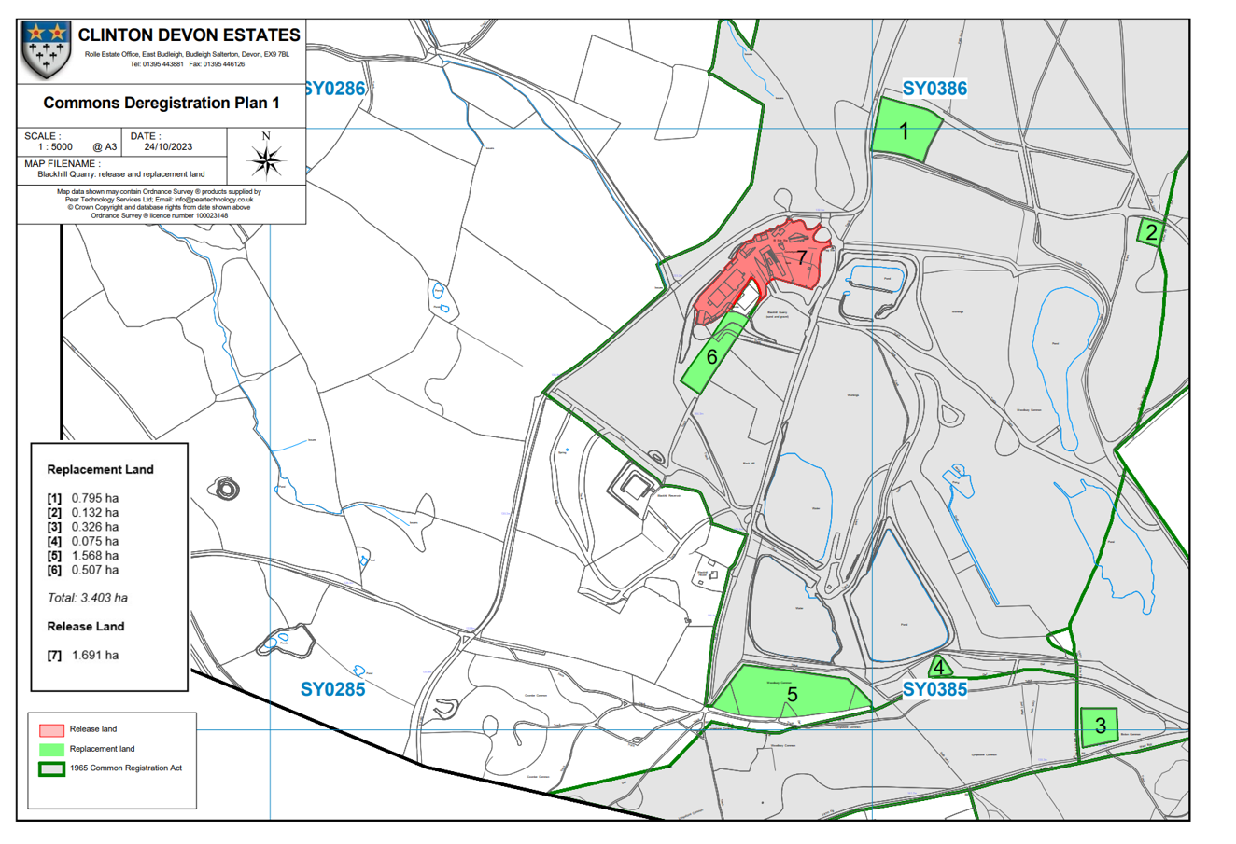

Drawing B – Copy of Application B plan, underground cabling (not to scale)

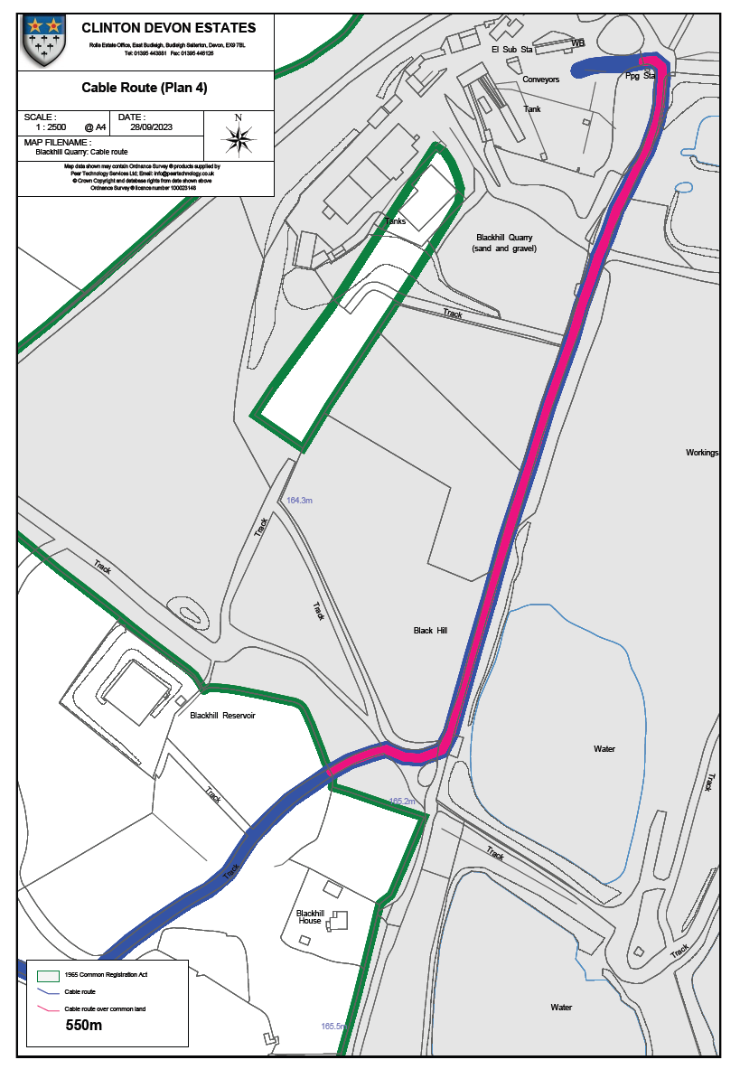

Drawing C – Copy of Application B plan, bat hibernaculum (not to scale)

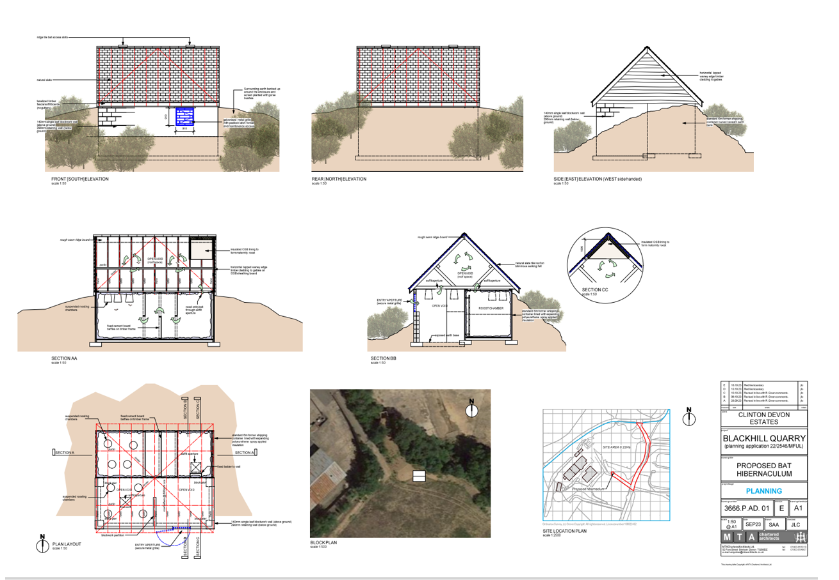

Paragraph 4.13 Applicant Statement in Support

