NOTICE OF ORDER

WILDLIFE AND COUNTRYSIDE ACT 1981

Hertfordshire County Council
Hertfordshire County Council’s (Little Berkhamsted 18) Modification Order
2021

Notice is hereby given that the above referenced Order has been submitted to the Secretary of State for Environment, Food and Rural Affairs for determination. An Inspector will be appointed by the Secretary of State to determine the Order.

The start date for the above Order is 15 July 2024.

Consideration of the Order will take the form of a public local inquiry.

The Inquiry will be held at The Priory Hall, Ware Priory, High St, Ware, SG12 9AL on Tuesday 10 December 2024 at 10.00am.

The effect of the Order, if confirmed without modifications, will be to modify the Definitive Map and Statement for the area by:- deleting that part of Little Berkhamsted bridleway 18 commencing at a junction with Little Berkhamsted Lane at TL 2905 0787 and running generally north north west for approximately 200 metres to TL 2897 0806 and adding to them a bridleway commencing at a junction with Little Berkhamsted Lane at TL 2907 0788 and running generally north north west for approximately 85 metres along the drive of Breach House (no.8 Little Berkhamsted Lane), between no.10 Little Berkhamsted Lane and Breach House, continuing to a point adjacent to the north east corner of the walled garden at TL 2904 0795. Then continuing generally north north west across a paddock for approximately 125 metres to a junction with Little Berkhamsted Bridleway 18 north west of the pond at TL 2897 0806.

Varying the particulars relating to Little Berkhamsted bridleway 18 by amending the Definitive Statement to reflect the changes outlined above and re-adding the description of Little Berkhamsted Bridleway 18 from its junction with Little Berkhamsted Bridleway 19 generally north to the Lower Hatfield Road.

Any queries relating to this Order should be referred to Nabiha Hussain by email: Nabiha.Hussain.ox@planninginspectorate.gov.uk quoting reference number ROW/3311608 on all correspondence. Alternatively, queries may be sent in writing to The Planning Inspectorate, Rights of Way Section, Room 3/A Eagle Wing, Temple Quay House, 2 The Square, Temple Quay, Bristol, BS1 6PN.

Any person wishing to view the statements of case and other documents relating to this Order may do so by appointment at Front Reception of Hertfordshire County Council, County Hall, Pegs Lane, Hertford, SG13 8DN, from 9.00 am to 4.00 pm on Monday to Friday or at East Herts District Council www.eastherts.gov.uk. Please contact Gavin Harbour-Cooper tel 01992 556186 or email Gavin.Harbour-Cooper@hertfordshire.gov.uk

Timetable for sending in statements of case and proofs of evidence

Within 8 weeks of the start date [by 9 September 2024]

The Order Making Authority must ensure their statement of case is received by the Secretary of State. As soon as possible after the deadline, the Secretary of State will send a copy (excluding copies of any supporting documents - these will be available to view at the Authority’s offices) to everyone who has made an objection or representation and the applicant and any other person who has written to us in respect of the Order.

Within 14 weeks of the start date [by 21 October 2024]

Everyone who has made an objection or representation and anyone who wishes to give evidence at the Inquiry must ensure their statement of case is received by the Secretary of State. As soon as possible after the deadline, the Secretary of State will send full copies to the Authority. Copies will also be sent to the applicant, every person who has made an objection or representation and any other person who has written to us in respect of the Order (excluding copies of any supporting documents - these will be available to view at the Authority’s offices).

Within the same period the applicant (if applicable) must ensure their statement of case is received by the Secretary of State. As soon as possible after the deadline, the Secretary of State will send a full copy to the Authority. Copies will also be sent to everyone who has made an objection or representation and any other person who has written to us in respect of the Order (excluding copies of any supporting documents - these will be available to view at the Authority’s offices).

weeks before the date of the inquiry [by 12 November 2024]

The Authority, everyone who has made an objection or representation, the applicant (if applicable) and anyone who wishes to give evidence at the Inquiry must ensure their proof of evidence (together with any summary) is

received by the Secretary of State. As soon as possible after the deadline, the Secretary of State will send copies of:

- the Authority’s proof of evidence to everyone who has made an objection or representation, the applicant and anyone who has submitted a statement of case (including copies of any supporting documents – although none should be submitted with a proof of evidence);

- the applicant’s proof of evidence to the Authority, everyone who has made an objection or representation and anyone else who has submitted a statement of case (including copies of any supporting documents – although none should be submitted with a proof of evidence); and

- all other proofs of evidence to the Authority, the applicant, everyone who has made an objection or representation and anyone else who has submitted a statement of case (including copies of any supporting documents – although none should not be submitted with a proof of evidence).

All parties must keep to the timetable set out above and ensure that statements of case and proofs of evidence are received by the Secretary of State on time. Late documents will be returned.

We cannot accept any inflammatory, discriminatory or abusive comments. Any documents containing such comments will be returned.

Notice of order for inquiry
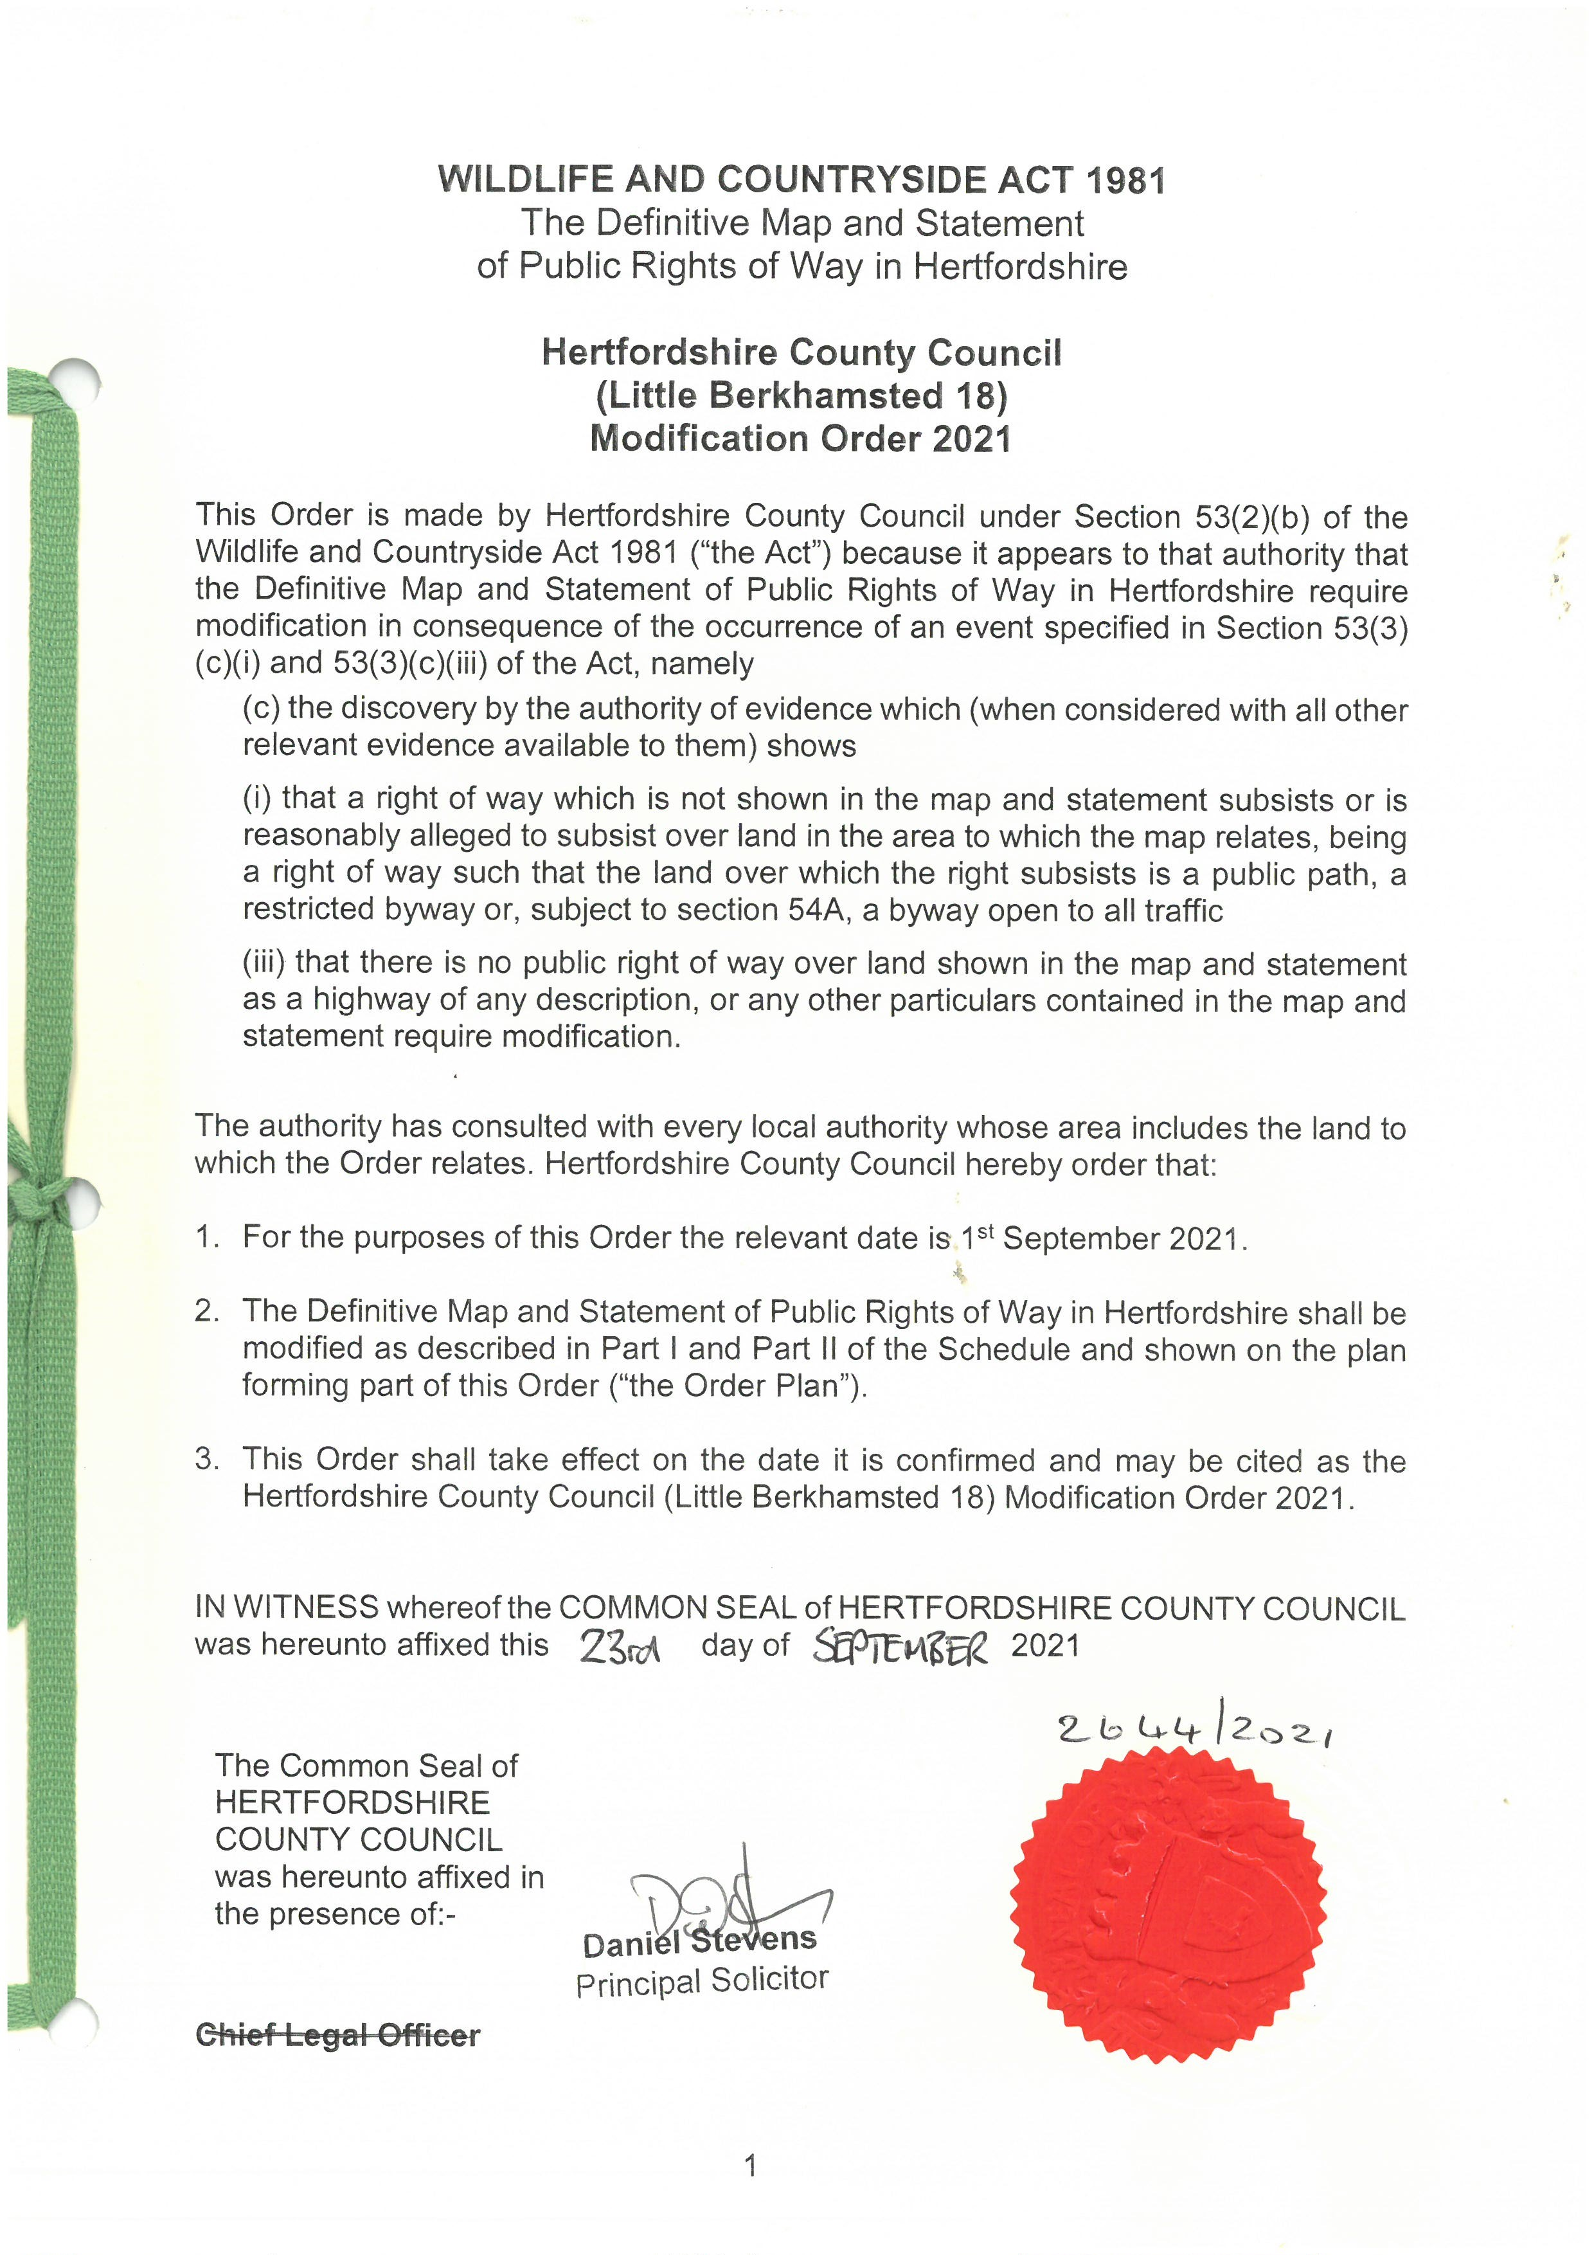
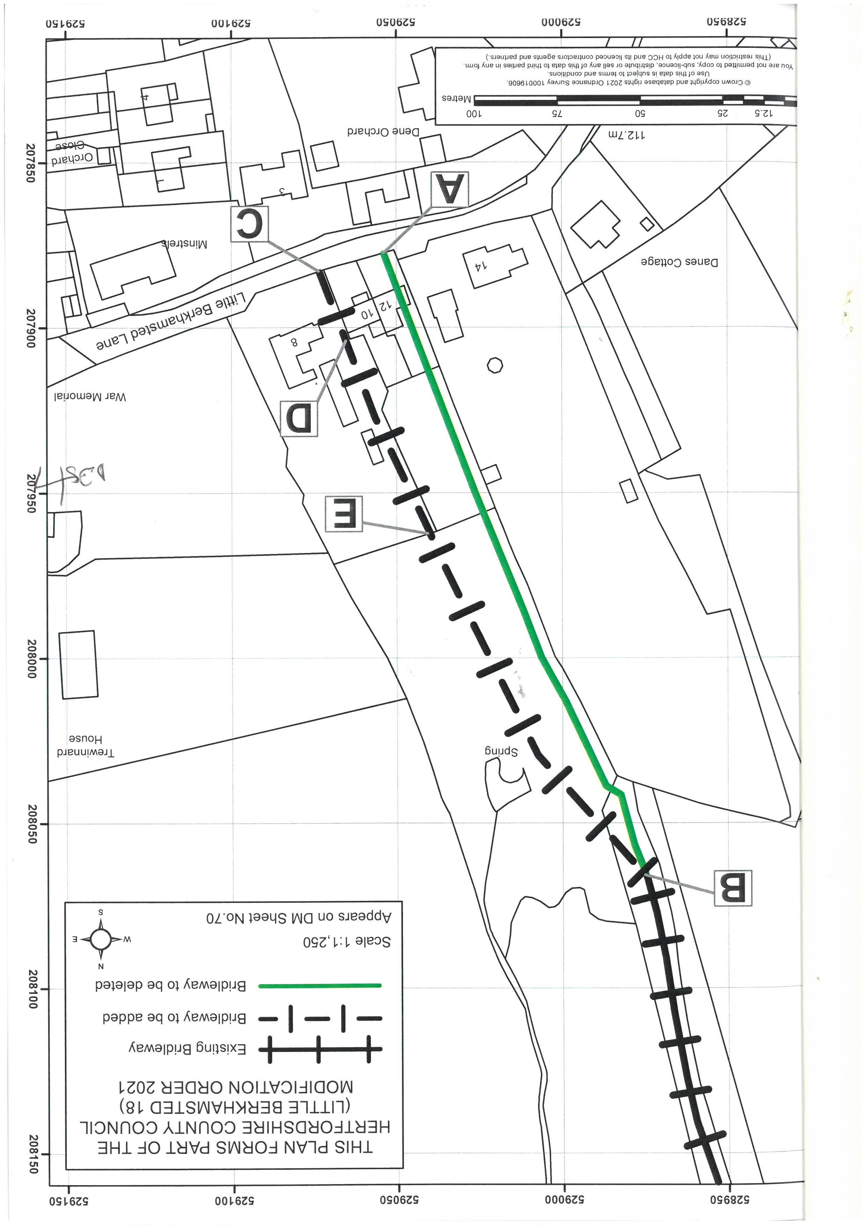
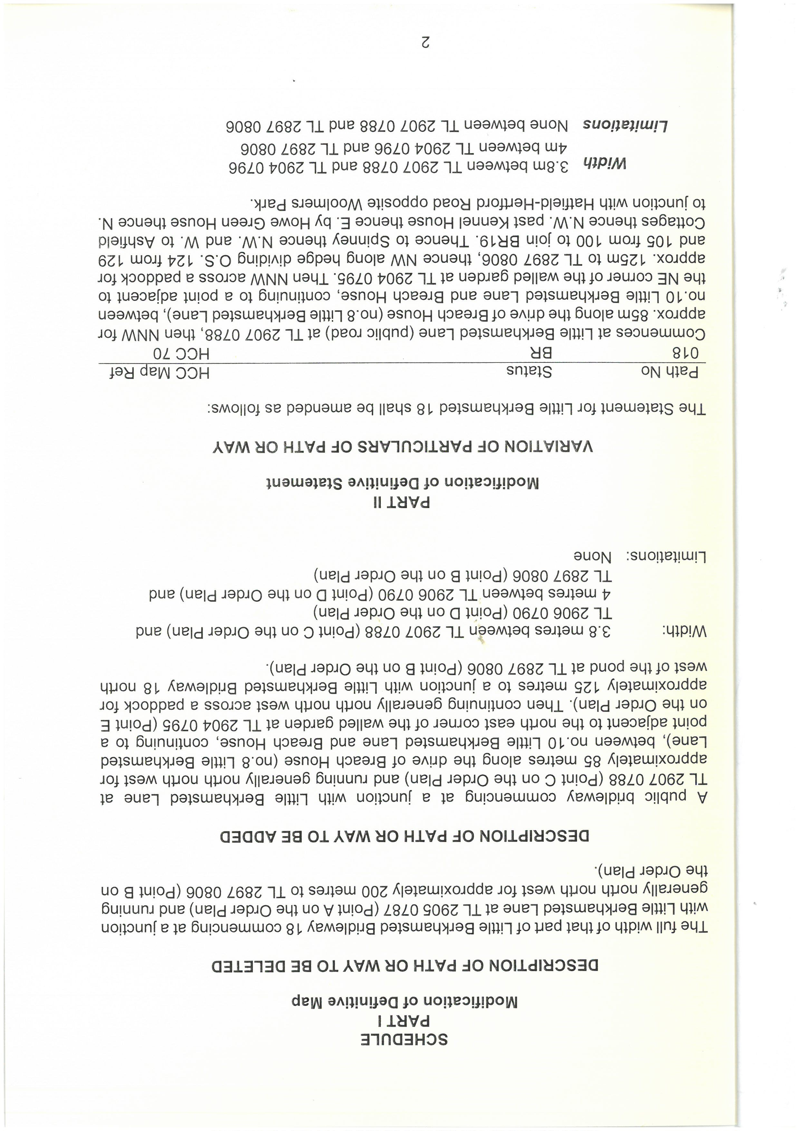

If you wish to make a legal submission, this should be submitted at the same time as your statement of case. Otherwise legal submissions will have to be submitted in writing on the day of the inquiry.

