NOTICE OF ORDER

Wildlife and Countryside Act 1981
Nottinghamshire County Council
Nottinghamshire County Council (Kings Clipstone Footpath No.11 & Clipstone Footpath No.24) Modification Order 2021

Notice is hereby given that the above referenced Order has been submitted to the Secretary of State for Environment, Food and Rural Affairs for determination. An Inspector will be appointed by the Secretary of State to determine the Order.

The start date for the above Order is 5 July 2024

Consideration of the Order will take the form of a public local inquiry.

The Inquiry will be held at Focus Point Hall, Vale Road, Mansfield Woodhouse, Mansfield, NG19 8DR on 3 December 2024 at 10.00am.

The effect of the Order, if confirmed without modifications, will be to modify the definitive map and statement for the above Area by adding the footpath commencing from grid reference SK 5919 6466, at the junction with King’s Clipstone Bridleway No.4, then proceeding for a distance of approximately 786 metres in a south-easterly then south-south-easterly direction to a point SK 5962 6404, at the junction with Cavendish Way, Clipstone, as shown on the order map.

Any queries relating to this Order should be referred to Paul Scrivener by email: Rightsofway2@planninginspectorate.gov.uk quoting reference number ROW/3310140 on all correspondence. Alternatively, queries may be sent in writing to The Planning Inspectorate, Rights of Way Section, Room 3/A Eagle Wing, Temple Quay House, 2 The Square, Temple Quay, Bristol, BS1 6PN. Telephone: 0303 444 5000.

Any person wishing to view the statements of case and other documents relating to this Order may do so by appointment at Countryside Access Team, Nottinghamshire County Council, County Hall, West Bridgford, Nottingham, NG2 7QP. Monday to Friday between 8:30 and 16:30. Please Contact Diana Clarke on diana.clarke1@nottscc.gov.uk or 0115 8043671.

Timetable for sending in statements of case and proofs of evidence

Within 8 weeks of the start date by [by 31 August 2024]

The Order Making Authority must ensure their statement of case is received by the Secretary of State. As soon as possible after the deadline, the Secretary of State will send a copy (excluding copies of any supporting documents - these will be available to view at the Authority’s offices) to everyone who has made an objection or representation and the applicant and any other person who has written to us in respect of the Order.

Within 14 weeks of the start date [by 12 October 2024]

Everyone who has made an objection or representation and anyone who wishes to give evidence at the Inquiry must ensure their statement of case is received by the Secretary of State. As soon as possible after the deadline, the Secretary of State will send full copies to the Authority. Copies will also be sent to the applicant, every person who has made an objection or representation and any other person who has written to us in respect of the Order (excluding copies of any supporting documents - these will be available to view at the Authority’s offices).

Within the same period the applicant (if applicable) must ensure their statement of case is received by the Secretary of State. As soon as possible after the deadline, the Secretary of State will send a full copy to the Authority. Copies will also be sent to everyone who has made an objection or representation and any other person who has written to us in respect of the Order (excluding copies of any supporting documents - these will be available to view at the Authority’s offices).

4 weeks before the date of the inquiry [by 5 November 2024]

The Authority, everyone who has made an objection or representation, the applicant (if applicable) and anyone who wishes to give evidence at the Inquiry must ensure their proof of evidence (together with any summary) is received by the Secretary of State. As soon as possible after the deadline, the Secretary of State will send copies of:

- the Authority’s proof of evidence to everyone who has made an objection or representation, the applicant and anyone who has submitted a statement of case (including copies of any supporting documents – although none should be submitted with a proof of evidence);

- the applicant’s proof of evidence to the Authority, everyone who has made an objection or representation and anyone else who has submitted a statement of case (including copies of any supporting documents – although none should be submitted with a proof of evidence); and

- all other proofs of evidence to the Authority, the applicant, everyone who has made an objection or representation and anyone else who has submitted a statement of case (including copies of any supporting documents – although none should not be submitted with a proof of evidence).

All parties must keep to the timetable set out above and ensure that statements of case and proofs of evidence are received by the Secretary of State on time. Late documents will be returned.

We cannot accept any inflammatory, discriminatory or abusive comments. Any documents containing such comments will be returned.

Notice of order for inquiry

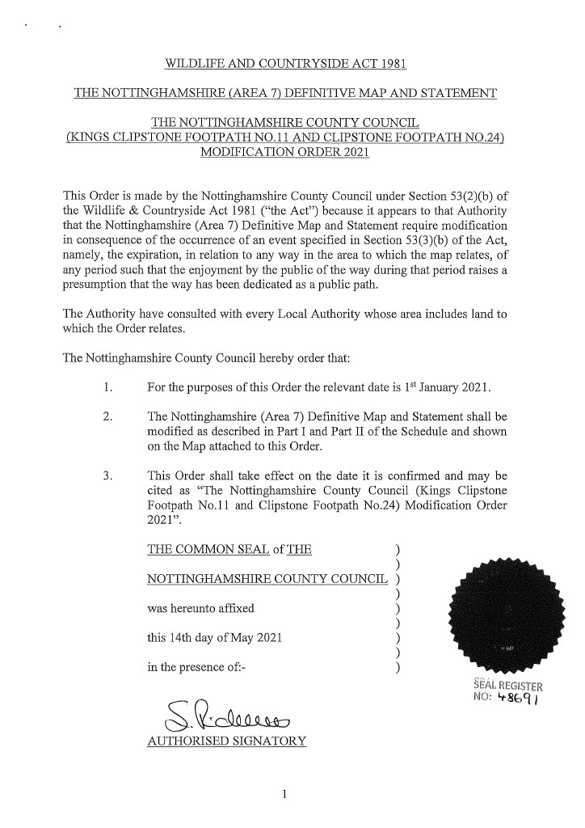
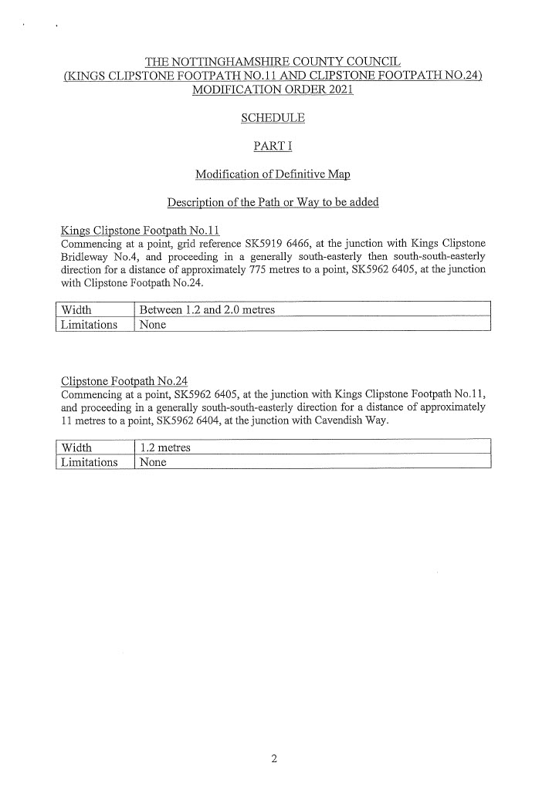
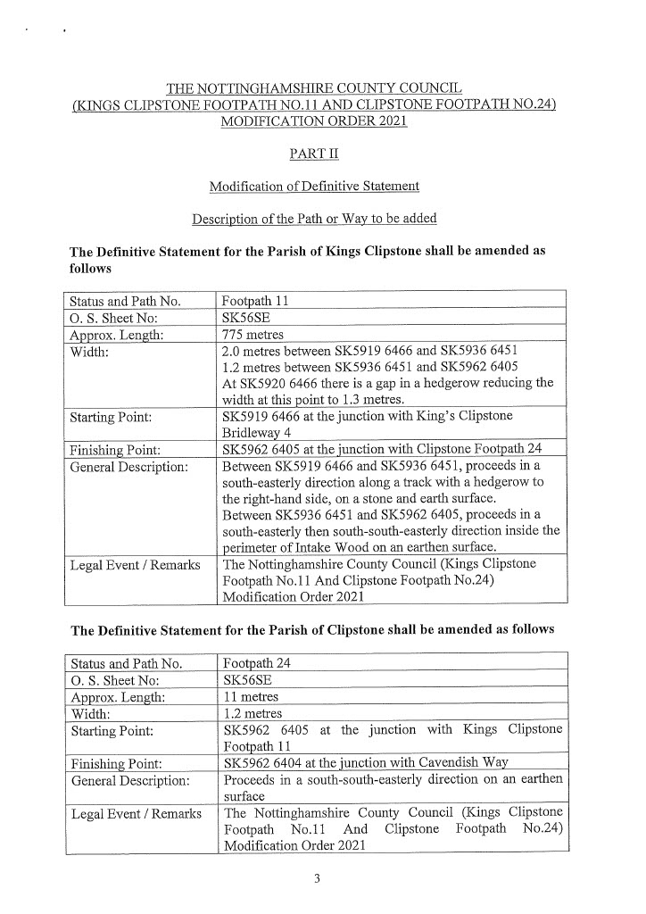
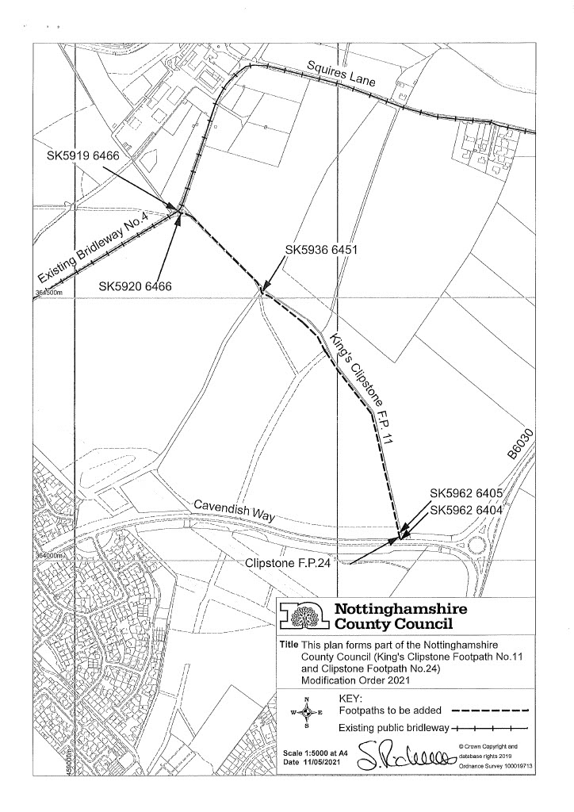

If you wish to make a legal submission, this should be submitted at the same time as your statement of case. Otherwise legal submissions will have to be submitted in writing on the day of the inquiry.

