NOTICE OF ORDER

Wildlife and Countryside Act 1981
Kirklees Metropolitan Council
Kirklees Council (Huddersfield 231 – Sandy Lane to Nether Moor Road, South Crosland) Definitive Map Modification Order 2020

Notice is hereby given that the above referenced Order has been submitted to the Secretary of State for Environment, Food and Rural Affairs for determination. Following an earlier inquiry, the Inspector appointed to determine the Order issued a letter in which he/she proposed to make modifications to the Order as drafted. Following advertisement of those proposals objections/representations have been received.

The start date for the above Order is 15 July 2024.

Consideration of the Order will take the form of a public local inquiry. It is being held so that the Inspector can hear evidence in respect of the Inspector’s proposed modifications and new evidence in respect of the unmodified part of the Order.

The Inquiry will be held at Brian Jackson House, 2 New North Parade, Huddersfield, HD1 5JP on 10 December 2024 at 10.00am.

The effect of the Order, if confirmed without modifications will be to modify the definitive map and statement for the area by downgrading Huddersfield 231 from a byway open to all traffic to a bridleway commencing at its junction with Sandy Lane at grid reference SE 1149 1317 and then continuing in a north-easterly direction to grid reference SE 1203 1354 at Nether Moor Road.

The effect of the proposed modification(s) would be to
In the Order schedule: Part 1
• Delete the word ‘bridleway’ and replace with ‘footpath’.
In the Order schedule: Part 2
• In the ‘General’ column, first entry, insert the word ‘wall’ after ‘Gate’.
• In the ‘General’ column, second entry, replace grid reference ‘SE 1170 1338’
with ‘SE 1167 1336’.
On the Order map:
• The line style to be changed to that of a footpath.
• In the key, delete the word ‘Bridleway’ and replace with ‘Footpath’.
• Replace grid reference ‘SE 1170 1338’ with ‘SE 1167 1336’.
• Move point D to grid reference ‘SE 1167 1336’.

Any queries relating to this Order should be referred to Zoe McPhail by email: zoe.mcphail@planninginspectorate.gov.uk quoting reference number ROW/3278454M on all correspondence. Alternatively, queries may be sent in writing to The Planning Inspectorate, Rights of Way Section, Room 3/A Eagle Wing, Temple Quay House, 2 The Square, Temple Quay, Bristol, BS1 6PN. Telephone: 0303 444 5481.

Any person wishing to view the statements of case and other documents relating to this Order may do so by appointment at| Honley Library, West Avenue, Honley, HD9 6HF and Kirklees Council Customer Service Centre, Civic Centre 3, High St, Huddersfield HD1 2TG and may be inspected free of charge during normal working hours. Please contact Harry Garland on harry.garland@kirklees.gov.uk or (01484) 221000.

Timetable for sending in statements of case and proofs of evidence

Within 8 weeks of the start date [by 9 September 2024]

The Order Making Authority, the applicant and everyone who has made an objection or representation following the proposed modifications and anyone who wishes to give evidence at the Inquiry must ensure their statement of case is received by the Secretary of State. As soon as possible after receiving it the Secretary of State will send a full copy to the Authority. Copies (excluding copies of any supporting documents - these will be available to view at the Authority’s offices) will also be sent to everyone who has made an objection or representation following the modifications, the applicant and anyone else who has previously written to us in respect of the Order.

4 weeks before the date of the inquiry [by 12 November 2024]

The Authority, everyone who has made an objection or representation following the proposed modifications, the applicant (if applicable) and anyone who wishes to give evidence at the Inquiry must ensure their proof of evidence (together with any summary) is received the Secretary of State. As soon as possible after receiving them, the Secretary of State will send copies of:

- the Authority’s proof of evidence to everyone who has made an objection or representation following the proposed modifications, the applicant, anyone who has submitted a statement of case and anyone else who has previously written to us in respect of the Order;

- the applicant’s proof of evidence to the Authority, everyone who has made an objection or representation following the proposed modifications, anyone who has submitted a statement of case and anyone else who has previously written to us in respect of the Order; and

- all other proofs of evidence to the Authority, the applicant and anyone else who has either submitted a statement of case or who has previously written to us in respect of the Order .

All parties must keep to the timetable set out above and ensure that statements of case and proofs of evidence are received by the Secretary of State on time. Late documents will be returned.

We cannot accept any inflammatory, discriminatory or abusive comments. Any documents containing such comments will be returned.

Notice of order for inquiry mods

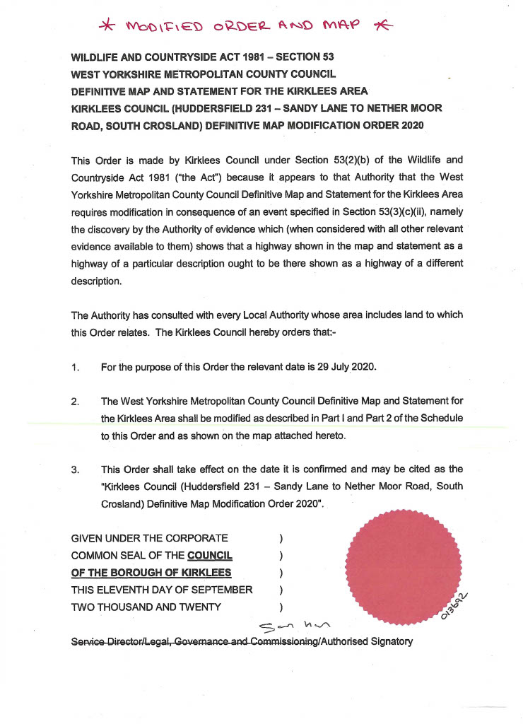
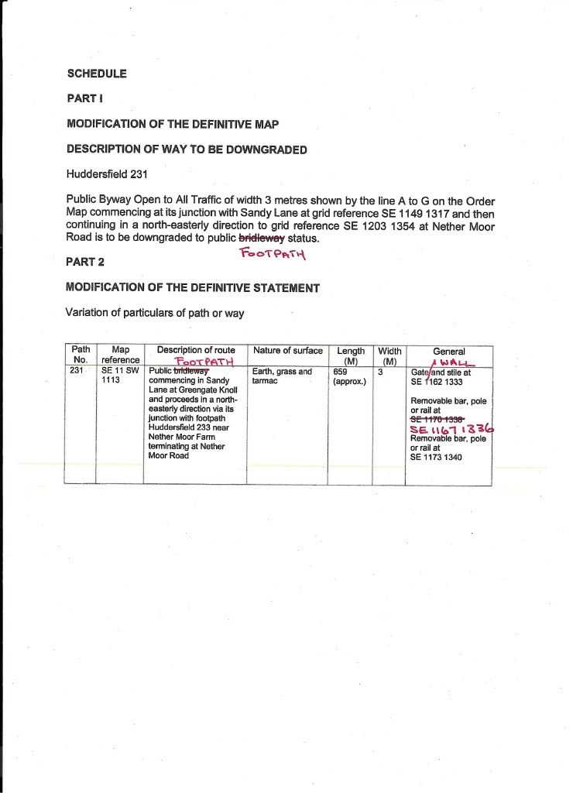
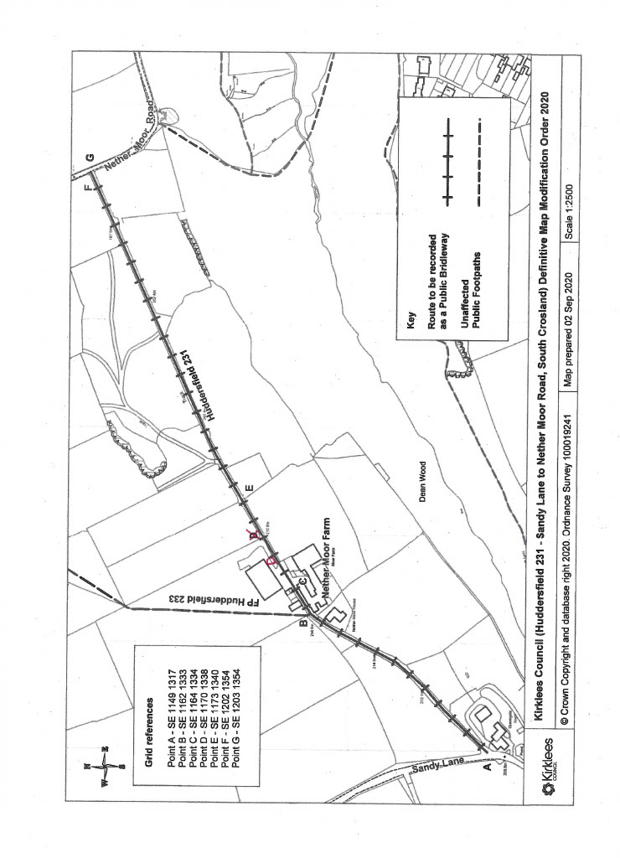

If you wish to make a legal submission, this should be submitted at the same time as your statement of case. Otherwise legal submissions will have to be submitted in writing on the day of the inquiry.

