ASEAN-UK collaborations on Engineering Biology

What is engineering biology?

Engineering biology is recognised as a transformative technology and one of the UK’s five critical emerging technology priorities. This technology is defined as the design, scaling and commercialisation of biology-derived products and services that can transform sectors or produce existing products more sustainably, including for example the development of mRNA vaccines to fight COVID. Advancements in engineering biology has the potential to revolutionise various industries and enhance sustainability.
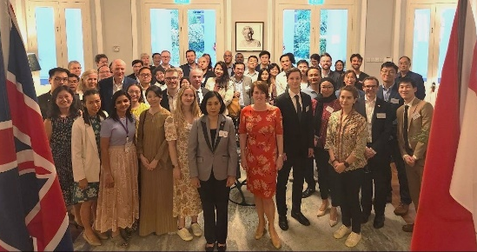

Facilitating a dialogue

International collaboration is vital to promoting and embedding a culture of responsible innovation in addition to learning from and demonstrating best practice. The mutual advancement in science and technology is a key initiative of the UK-ASEAN (Association of Southeast Asian Nations) Plan of Action.
Attendees at the British High Commission, including Dr Kanchana Wanichkorn from ASEAN Secretariat who delivered the keynote speech.

At the inaugural 2023 ASEAN-UK Dialogue on Science, Technology and Innovation in the Philippines, SIN Singapore proposed the ASEAN-UK Regional Training and Workshop on Engineering Biology as one of the first three projects delivering our shared commitment in science and technology.

Impact: Driving UK-ASEAN collaboration

The ASEAN-accredited workshop was led by SIN Singapore and held in Singapore from 26 February to 1 March 2024. The workshop was delivered by a team of 12 UK and seven Singaporean experts on Engineering Biology. Over 25 participants from all ten ASEAN Member States and representatives from the ASEAN Secretariat also attended the event.

The agenda featured state-of-the-art Engineering Biology research, economic development strategies, and its practical applications across health, agriculture, food security, and climate change. The potential applications and benefits highlighted led to a collective commitment from participants to promote Engineering Biology in their home countries.
The workshop also emphasised the significance of responsible innovations, regulations and standards, providing ASEAN officials with a comprehensive understanding of Engineering Biology’s promise to tackle global challenges.
The UK experts then travelled to Bangkok, in a trip coordinated by SIN Thailand, where they led a UK-Thailand workshop on Engineering Biology as part of the UK-Southeast Asia Tech Week. The workshop enabled meaningful dialogue between the UK experts and Thai stakeholders across government, academia and businesses on important areas such as navigating regulations and promoting innovation ecosystem growth. The engagement highlighted Thailand’s priorities and growing appetite to partner with the UK on Engineering Biology.
The event encouraged dialogue and set the stage for future UK-ASEAN collaborations in science and technology. Hosting the workshop reaffirms the UK’s dedication to deepening its scientific and technological ties with ASEAN, building on the strong foundation established since becoming an ASEAN Dialogue Partner.

For more information on this, please contact: Karl.Zimmerman@fcdo.gov.uk

