Department for Environment, Food and Rural Affairs  Scottish Government  Welsh Government | 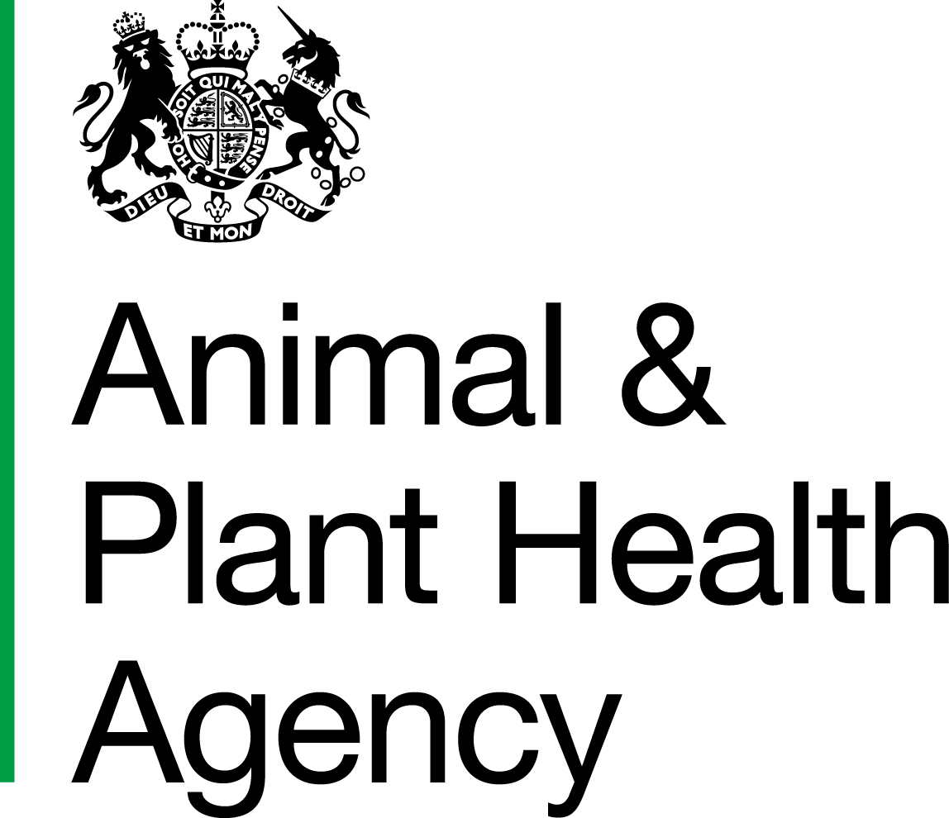
Food Competent Certifying Officer - Request for Authorisation Eligibility Check
For candidates wishing to become a Food Competent Certifying Officer (FCCO) but who do not fully meet the listed eligibility requirements, this form can be used to request an eligibility check from the Animal and Plant Health Agency (APHA).
Consideration will be given to candidates who are studying for the Higher Certificate in Official Controls (HCOC) awarded by the Scottish Food Safety Officer’s Registration Board (SFSORB) and whom have completed both the Higher Certificate in Food Premises Inspection and the Higher Certificate in Food Standards Inspection.
This form should be submitted to: CSCOneHealthOVTeam@apha.gov.uk
Candidate Name:
Candidate Declaration:
I confirm that I have successfully completed the Higher Certificate in Food Premises Inspection and the Higher Certificate in Food Standards Inspection awarded by the Scottish Food Safety Officer’s Registration Board (SFSORB) and am working to attain the Higher Certificate in Official Controls.
Candidate signature:
Date:

Name of Senior Manager/ Lead Food Operator:
(must be the same as the manager completing the ET208)
Declaration by Senior Manager/Lead Food Officer:
By signing I confirm that I am a Senior Manager in Food Standards Scotland (FSS) /a Lead Food Officer in a Local Authority (LA) (delete as applicable) and that the person listed above for authorisation is employed or contracted by FSS/insert LA name (delete as applicable). I confirm that they are actively working towards the Higher Certificate in Official Controls. This person meets all the other specified eligibility criteria and in my opinion has the required experience to carry out the FCCO role.
Manager’s Signature:
Date

DATA PROTECTION
For information on how we handle personal data please go to www.gov.uk and search Animal and Plant Health Agency Personal Information Charter.

APHA is an Executive Agency of the Department for Environment, Food and Rural Affairs and also works on behalf of the Scottish Government, Welsh Government and Food Standards Agency to safeguard animal and plant health for the benefit of people, the environment and the economy.

