Application Decision
by Harry Wood
Appointed by the Secretary of State for Environment, Food and Rural Affairs
Decision date: 19 July 2024

Application Ref: COM/3337725
Marlborough Common, Marlborough, SN8 1DL
Register Unit Number: CL 62
Commons Registration Authority: Wiltshire Council

- The application, dated 25 January 2024, is made under Section 38 of the Commons Act 2006 (the 2006 Act) for consent to carry out restricted works on common land.
- The application is made by Marlborough Rugby Football Club.
- The works comprise:
- The extension of the existing club building. The proposed extension will be recessed from the original building by 100mm and measure approximately 9m² in floor space.
- Temporary Heras fencing for the duration of the construction measuring approximately 10m long.

Decision
- Consent is granted for the works in accordance with the application dated 25 January 2024 and the plans submitted with it subject to the following conditions:

- the works shall begin no later than three years from the date of this decision;
REASON: To provide certainty to users of Marlborough Common.
- the land shall be fully reinstated within one month from the completion of the works.
REASON: To retain access for commoners, public and livestock across Marlborough Common.
- For the purposes of identification only the extension is shown in red on figure 1 and the location of the club building is shown on figure 2.

Preliminary Matters
- I have had regard to Defra’s Common Land Consents Policy Guidance (November 2015) in determining this application under section 38, which has been published for the guidance of both the Planning Inspectorate and applicants. However, every application will be considered on its merits and a determination will depart from the guidance if it appears appropriate to do so. In such cases, the decision will explain why it has departed from the guidance.

- This application has been determined solely on the basis of written evidence. I have taken account of the representations made by the Open Spaces Society (OSS), Natural England (NE) and Marlborough Town Council (MTC).

- I am required by section 39 of the 2006 Act to have regard to the following in determining this application:
- the interests of persons having rights in relation to, or occupying, the land (and in particular persons exercising rights of common over it);
- the interests of the neighbourhood;
- the public interest: Section 39(2) of the 2006 Act provides that the public interest includes the public interest in, nature conservation, the conservation of the landscape; the protection of public rights of access to any area of land, and the protection of archaeological remains and features of historic interest;
- any other matter considered to be relevant.

Reasons

- The applicant explains that the purpose of the works is to extend the current club building to expand the kitchen facilities on site and allow the club to offer a wider range of refreshments to those using the facilities.

- The applicant also explains that the club has had a large increase in members and the facilities need to be able to provide for all those attending events. The facilities are also important for acquiring the funding necessary for the maintenance of the site.

The interests of those occupying or having rights over the land
- Marlborough Town Council are the owner of the land and have stated that the application has their full support and they have no objections to the proposed works. The common land register records no rights over the whole of the land know as Marlborough Common.

- The applicant advises that the common is regularly used for recreational activities. They add that they have not noted any rights of common being carried out and there are no rights recorded in the common land register.

- I am satisfied that the applicant has carried out the required consultation and no further comments were received.

The interests of the neighbourhood and public access
- The interests of the neighbourhood relate to whether the works will unacceptably interfere with the way the common land is used by local people and is closely linked with interests of public access.

- Marlborough Common comprises of three open green spaces divided by a public carriageway. Parts of the common have been converted into football and rugby pitches with grass maintenance, barriers and goal posts denoting these areas. The common predominantly consists of open green spaces with hedge, shrub and tree coverage.

- Parts of the Common also appear to have been converted into a golf course with sand bunkers present.

- The club building sits close to the southwestern boundary of the Common and is accessible by foot and by vehicle via St Luke’s Crescent.

- The planned expansion is adjoined to the existing club building which the applicant describes as “T shaped” with the extension sitting in the space between one of the intersecting parts of the building.

- The expansion of the existing building would have an impact on access to the Common converting the small patch of existing grass, where it will be located, into a permanent structure. This will prevent access to an area of the Common which, by extension, would also no longer be available for recreational use.

- However, I consider it unlikely that this area of common is accessed regularly for recreational use due to it being enclosed on two sides by the existing club building.

- The proposed extension of the club building is likely to increase the number of people accessing this area of the Common for recreational activities and is therefore in the interest of many users of the Common.

- The temporary fencing would also impact access, blocking access to the areas of the common where the works are taking place. but This impact will be minimal, however, due to the small sizes of the areas the fencing is surrounding and the fact that the Common will still be accessible via other routes. The fencing is also planned to be temporary in nature. I am satisfied that such fencing is appropriate on health and safety grounds and that it will be removed on completion of the works, which can be secured by attaching a suitable condition to the consent.

- NE have been consulted on the application and stated they do not believe that the works as planned will have any adverse effects on the Common's biodiversity, landscape appeal or its accessibility for the public.

- OSS have stated that in 1997 consent was given to construct a rugby clubhouse on the common along with the extensive parking facilities now evident.

- They outline that this has “facilitated the dedication of much of the common to sports uses, including rugby and golf. Consequently, the common largely has become a “levelled, completely familiar monoculture of easily replicated, gang-mown sports turf.”

- They state all its special qualities have been destroyed and that society will continue to oppose the domination of the Common by sports uses. However, in this case, the extension is relatively minor, and the society does not intend to oppose it.

- I have noted that a large amount of the Common does appear to have been dedicated to recreational sports usage with the rugby and football pitches and golf course being present. It is unclear from this application whether access to these areas is restricted to members of the public.

- However, this application relates specifically to the expansion of the existing club building which only covers around 9m² of the Common where it is unlikely any recreational activity is taking place.

- I am therefore of the opinion that the proposed works will not adversely affect public access to the Common or the wider interests of the neighbourhood.

The public interest
- As well as the public interest in the protection of public rights of access, the Guidance (November 2015) outlines the public interest in nature conservation, the conservation of the landscape and the protection of archaeological remains and features of historic interest.

Nature conservation and Conservation of the landscape
- NE have provided comment on the application and stated that they do not anticipate the works having any detrimental effect on these interests.

- The Common has no special designated landscape value.

- The proposed works would introduce a new permanent artificial feature onto the Common. However, this expansion only covers a small area of the Common and it is not envisioned that this will harm the nature conservation or landscape value of the Common

- The applicant details that the extension will be made of the same materials as the existing club building and be in keeping with its style and design. The extension is small only covering 9m² of ground space and will be a single story as is the existing building. In conclusion the extension will not impact the visuals of the common.

- I am satisfied that nature conservation interests will not be harmed by the proposed works and I consider that overall the works will not affect the landscape interests of the Common.

Protection of archaeological remains and features of historic interest.
- The applicant has stated that there are no archaeological features within the proposed works area. Historic England and the local authority archaeological service have been consulted and did not comment.

- There is no evidence before me to suggest that these interests will be harmed by the proposed works.

Conclusion

- Defra’s Common Land consents policy states that consent will not normally be granted under section 38 for permanent buildings on common land, because such development is normally incompatible with the future use of the land as common land. However, where such buildings are intrinsically related to the enjoyment or management of the common, such as a cricket pavilion, lambing shed or a keeper’s hut, consent under section 38 may be considered appropriate.

- I conclude that the proposed works are in line with this policy. I also consider that the works will be in the interests of the rugby club and the wider community and will not unacceptably harm any of the other interests set out in paragraph 5 above. Consent is therefore granted for the works described subject to the condition set out at paragraph 1.

Harry Wood

Figure 1 – works plan
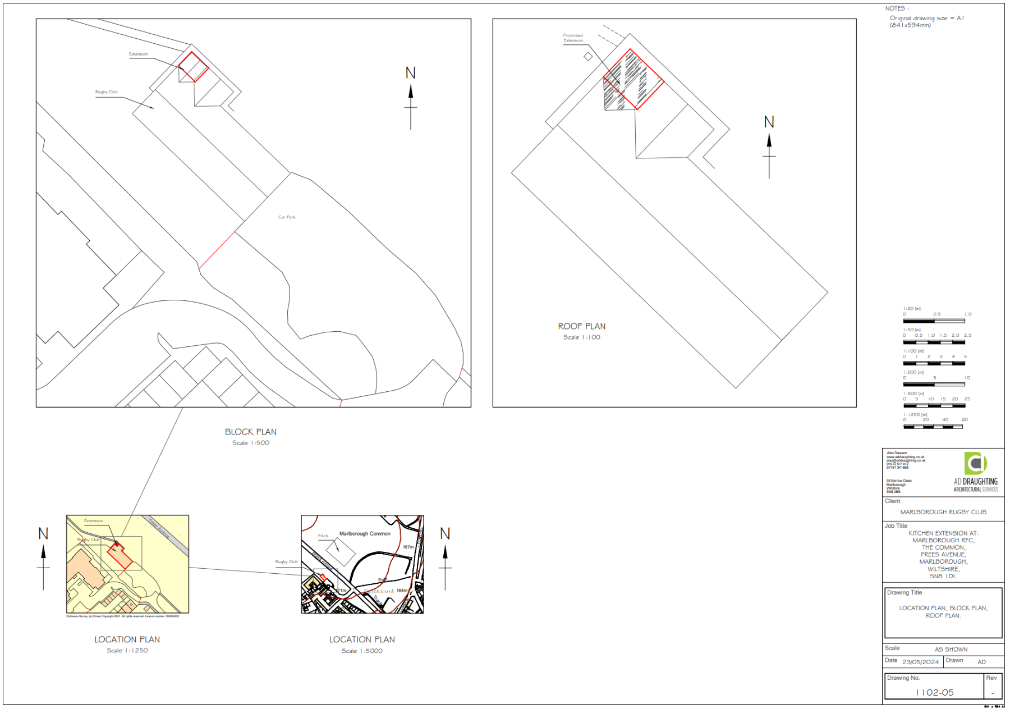

Figure 2 – Location of club building on the common

