National Child Measurement Programme: parent feedback letters

Updates to the letters for 2024
A new section on supporting your child to have healthy gums and teeth added to the letter. We have added this to make every contact count and to maximise the opportunity to provide parents with information to promote their child’s health.
Child weight category is described in the letters as:
- below the expected weight range for their age, sex and height – in the underweight letter
- growing as expected for their age, sex and height – in the healthy weight letter
- above the expected weight range for their age, sex and height – in the overweight and very overweight letters

The parent feedback letters
These parent feedback letters can be used by local authority and service providers' delivery staff when sharing feedback with parents.
NCMP data in the NCMP IT system shows 4 child body mass index (BMI) weight categories, but this document has 3 template feedback letters for:
- healthy weight
- underweight
- overweight and very overweight which are combined
The letters show highlighted sections where local authorities can add bespoke text, such as information about local services and contact numbers.
The NCMP IT system can generate letters for parents using the editable template through mail merging with the ‘Letter generation’ extract that is produced by the NCMP system. It is set up to produce the 3 different letters depending on the child’s BMI category and school year.
Guidance for local authorities about producing the letters is provided in the NHS England NCMP IT system user guide part 4, generating feedback letters.

Sending the letters
The letters should be posted to parents or carers as soon as possible (at most within 6 weeks of measurement). We recommend that the post-measurement leaflet and the dental health tips leaflet are enclosed with feedback letters to parents. The post-measurement leaflet provides relevant messaging and signposts to the NHS Healthy Steps - Step this way website for further information.
You can order or download these leaflets from the DHSC campaign resource centre. You will need to sign in or register first.

Letter for children with a weight status of underweight

Private and confidential
[NHS number]
Dear Parent or carer of [FirstName] [LastName],
We recently wrote to you about measuring [FirstName]’s height and weight as part of the National Child Measurement Programme (NCMP). Here are [FirstName]’s measurements:
[FirstName]’s measurement data
Height (cm) | [Height]
Weight (kg) | [Weight]
Date of measurement | [DOM]

Your child’s measurements are confidential
These measurements suggest that on the day they were measured, [FirstName] would be considered below the expected weight range for their age, sex and height.
You can find out how [FirstName]'s measurement was calculated and check how [FirstName] is growing over time, by going to the NHS ‘Calculate your body mass index (BMI)’ webpage.
The information in this letter is private. It has not been shared with [FirstName] other children or school staff. Your [local NHS/local authority public health team] keeps this information securely.
You may feel [FirstName] is too young to receive this information, or that sharing it could be more negative than positive. It is up to you, as their parent or guardian, to decide what is right for your child.
We recognise that talking about weight can be a difficult subject which is why [First Name]’s measurements have only been communicated to you. These measurements only represent a one-off assessment of your child’s growth on the day they were measured. A GP, school nurse, or other health professional can help you understand how this fits in with their growth, development and behaviour.
Most children who are underweight are healthy, but some may require healthy growth support from a healthcare professional. More information is available from the NHS Better Health ‘Children’s weight’ webpage.

What could I do now?
A healthy diet and being physically active are both important for children’s growth and wellbeing.

Supporting your child to be physically active
Children need to be active for at least an hour every day. So, if you are doing this already, that’s brilliant! It is a good idea to mix moderate activity like brisk walking with vigorous activity like running or fast cycling. Exercise can help build a stronger heart, bones and be a good opportunity for children and families to socialise. We have provided a leaflet on activities in your area [local authority to include leaflet or remove this sentence] or visit the NHS Better Health ‘Activities for kids’ webpage.

Supporting your child to eat healthily
Having a healthier weight can improve your child’s health and wellbeing. If you are not already doing so, eating healthily can be good for the whole family. This can be hard for a lot of people, so there is help available. For information of other ways to encourage your child to eat a healthy, balanced diet, visit the NHS ‘Eatwell Guide’ webpage
If you would like advice about talking to your child about weight, visit the University of Bath’s ‘Talking to your child about weight: a guide for parents and caregivers of children aged 4 to 11 years’ webpage to download a guide. Or if you would like to talk to someone about the NCMP and your child’s health and growth, please contact the NCMP team on [local authority to insert team and contact number].

Supporting your child to have healthy gums and teeth
Healthy gums and teeth are also part of a healthy lifestyle. Simple advice available at the NHS ‘Children’s teeth’ webpage will help your child have healthy gums and prevent tooth decay.
For further information on looking after your child’s teeth, please visit the NHS ‘Sugar: the facts’ and ‘Tooth decay’ webpages.
Kind regards,
[Sender name and job title]

Letter for children with a weight status of healthy weight

Private and confidential
[NHS number]
Dear parent/carer of [FirstName] [LastName],
We recently wrote to you about measuring [FirstName]'s height and weight as part of the National Child Measurement Programme (NCMP). Here are [FirstName]’s measurements.
[FirstName]’s measurement data
Height (cm) | [Height]
Weight (kg) | [Weight]
Date of measurement | [Date of measurement]

Your child’s measurements are confidential
These measurements suggest that on the day they were measured, [FirstName] is growing as expected for their age, sex and height.
You can find out how [FirstName]’s measurement was calculated and check how [FirstName] is growing over time, by going to the NHS ‘Calculate your body mass index (BMI)’ webpage.
The information in this letter is private. It has not been shared with [First Name], other children or school staff. Your [local NHS/local authority public health team] keeps this information securely.
You may feel [First Name] is too young to receive this information, or that sharing it could be more negative than positive. It is up to you, as their parent or guardian, to decide what is right for your child.
We recognise that talking about weight can be a difficult subject which is why [First Name]’s measurements have only been communicated to you. These measurements only represent a one-off assessment of your child’s growth on the day they were measured. A GP, school nurse, or other health professional can help you understand how this fits in with their growth, development and behaviour.
Having a healthy weight benefits your child’s health and wellbeing. If you are not already doing so, being active and eating healthily can be good for the whole family. More information is available from the NHS Better Health ‘Children’s weight’ webpage.

What could I do now?
A healthy diet and being physically active are both important for children’s growth and wellbeing.

Supporting your child to eat healthily and be physically active
Take a look at the NHS Better Health ‘Easy ways to eat well and move more’ website for healthy and easy recipe ideas.
Children need to be active for at least an hour every day. If you are doing this already, that’s brilliant. It is a good idea to mix moderate activity like brisk walking with vigorous activity like running or fast cycling. We have provided a leaflet on activities in your area [local authority to include leaflet or remove this sentence] or visit the NHS Better Health ‘Activities for kids’ webpage.
Another way to help maintain a balanced diet and physical activity for your family is the NHS Healthy Steps email programme. Sign up for the 8-week Healthy Steps emails and you will be sent lots of low-cost easy tips, fun games, healthy swaps and tasty recipes on a budget.
Scan the QR code or visit ‘healthysteps.uk’ to sign up.
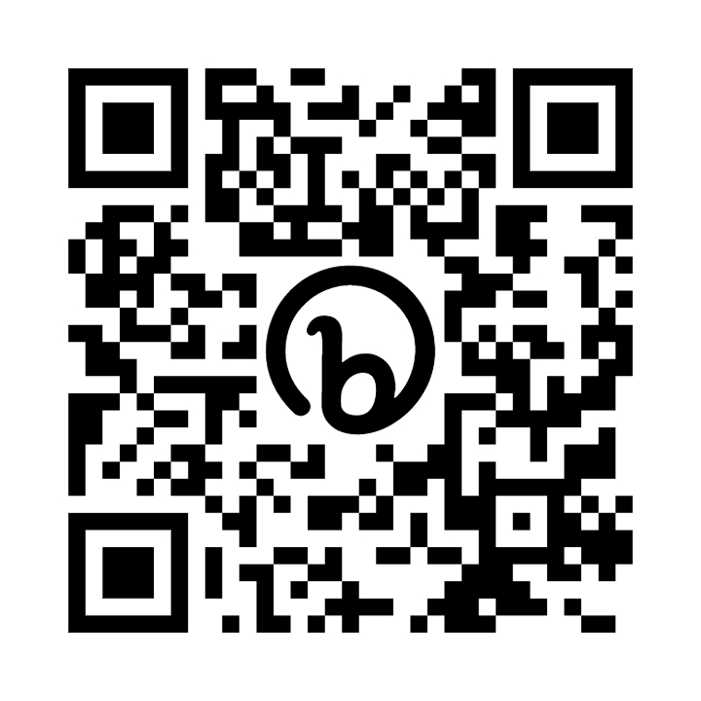
If you would like advice about talking to your child about weight, visit the University of Bath’s ‘Talking to your child about weight: a guide for parents and caregivers of children aged 4-11 years’ webpage to download a guide. Or if you would like to talk to someone about the NCMP and your child’s health and growth, please contact the NCMP team on [local authority to insert team and contact number].

Supporting your child to have healthy gums and teeth
Healthy gums and teeth are also part of a healthy lifestyle. Simple advice available at the NHS ‘Children's teeth’ webpage will help your child have healthy gums and prevent tooth decay. For further information on looking after your child’s teeth, please visit the NHS ‘Sugar: the facts’ and ‘Tooth decay’ webpages.
Kind Regards,
[Sender name and job title]

Letter for children with a weight status of overweight and very overweight

Private and confidential
[NHS number]
Dear Parent/Carer of [FirstName] [LastName],
We recently wrote to you about measuring [FirstName]’s height and weight as part of the National Child Measurement Programme (NCMP). Here are [FirstName]’s measurements.
[FirstName]’s measurement data
Height (cm) | [Height]
Weight (kg) | [Weight]
Date of measurement | [Date of measurement]

Your child’s measurements are confidential
These measurements suggest that on the day they were measured, [First Name] would be above the expected weight range for their age, sex and height.
You can find out how [FirstName]’s measurement was calculated and check how [FirstName] is growing over time, by going to the NHS ‘Calculate your body mass index (BMI)’ webpage.
The information in this letter is private. It has not been shared with [First Name], other children or school staff. Your [local NHS or local authority public health team] keeps this information securely.
You may feel [First Name] is too young to receive this information, or that sharing it could be more negative than positive. It is up to you, as their parent or guardian, to decide what is right for your child.
We recognise that talking about weight can be a difficult subject which is why [First Name]’s measurements have only been communicated to you. These measurements only represent a one-off assessment of your child’s growth on the day they were measured. A GP, school nurse, or other health professional can help you understand how this fits in with their growth, development and behaviour.
Having a healthier weight can improve your child’s health and wellbeing. If you are not already doing so, being active and eating healthily can be good for the whole family. This can be hard for a lot of people, so there is help available. More information is available from the NHS Better Health ‘Children’s weight’ webpage.

What could I do now?
Many families find it difficult to get children to eat a healthy diet and stay active enough for their health and growth.

Supporting your child to eat healthily and be physically active
[FirstName] has been reserved a place at the [local authority to insert name of local child and family weight management service].
This is a free and fun club to help children and their families achieve and maintain a healthy growth and wellbeing. See the enclosed leaflet or call [local authority to insert contact number for local family weight management service]. or email [local authority to insert email address for local family weight management service],
[Delete lines above if there are no local child and family weight management services available]

Other sources of advice and information
Take a look at the NHS Better Health ‘Easy ways to eat well and move more’ website for healthy and easy recipe ideas.
Children need to be active for at least an hour every day. If you are doing this already, that’s brilliant. It is a good idea to mix moderate activity like brisk walking with vigorous activity like running or fast cycling. We have provided a leaflet on activities in your area [local authority] to include leaflet or remove this sentence] or visit the NHS Better Health ‘Activities for kids’ webpage.
Another way to help maintain a balanced diet and physical activity for your family is the NHS Healthy Steps email programme. Sign up for the 8-week Healthy Steps emails and you will be sent lots of low-cost easy tips, fun games, healthy swaps and tasty recipes on a budget.
Scan the QR code or visit ‘healthysteps.uk’ to sign up.
If you would like advice about talking to your child about weight, visit the University of Bath’s ‘Talking to your child about weight: a guide for parents and caregivers of children aged 4-11 years’ webpage to download a guide. Or if you would like to talk to someone about the NCMP and your child’s health and growth, please contact the NCMP team on [local authority to insert team and contact number].

Supporting your child to have healthy gums and teeth
Healthy gums and teeth are also part of a healthy lifestyle. Simple advice available at the NHS 'Children's teeth’ webpage will help your child have healthy gums and prevent tooth decay. For further information on looking after your child’s teeth, please visit the NHS ‘Sugar: the facts’ and 'Tooth decay’ webpages.
Kind regards,
[Sender name and job title]

