Department for Environment, Food and Rural Affairs  Scottish Government  Welsh Government | 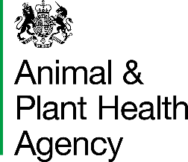
OCQ (AHP) - Certification Support Officer (CSO) Request for Eligibility

To request approval to register on the CSO course on the basis of experience rather than the specified academic qualification.

This form should be submitted to: CSCOneHealthOVTeam@apha.gov.uk

Candidate Name:
Relevant Experience: | For each relevant role please provide a description of, the environment in which you worked, the type of work you carried out in your role and the length of time worked in that role.
Academic Qualifications:
Other Qualifications: | Please provide details of any other qualifications you hold which may be relevant to your eligibility for the CSO role.

DATA PROTECTION
For information on how we handle personal data please go to www.gov.uk and search Animal and Plant Health Agency Personal Information Charter.

APHA is an Executive Agency of the Department for Environment, Food and Rural Affairs and also works on behalf of the Scottish Government, Welsh Government and Food Standards Agency to safeguard animal and plant health for the benefit of people, the environment and the economy

