Application Decision
by Harry Wood
Appointed by the Secretary of State for Environment, Food and Rural Affairs
Decision date: 26 June 2024

Application Ref: COM/3334826
Jacobs Well Recreation Ground, Stringers Common, Guildford, Surrey, GU4 7PX
Register Unit Number: CL 352
Commons Registration Authority: Surrey County Council

- The application, dated 3 November 2023, is made under Section 38 of the Commons Act 2006 (the 2006 Act) for consent to carry out restricted works on common land.
- The application is made by Worplesdon Parish Council.
- The works comprise:
- To dig up and replace 93m² of the existing track with grasscrete. The track will measure 31m long by 3m wide;
- To dig up and replace 19m² of the track’s bell mouth with tarmac. The bell mouth measures 3.3m deep by 8.3m at the widest part;
- To create four parking spaces amounting to an area of 64m². The parking spaces will be made of grasscrete and measure 10m long by 6m deep with 2m by 1m splays at both sides of the parking area;
- To construct a wooden fence with added chicken wire around the parking spaces on three sides. The fence measuring 1.22m high by 18m long.

Decision
- Consent is granted for the works described at i), ii) and iii) above in accordance with the application dated 3 November 2023 and the plans submitted with it subject to the conditions set out below. Consent is not granted for the fencing works described at iv) above:

- the works shall begin no later than three years from the date of this decision;
REASON: To provide certainty to users of Stringers Common.
- the land shall be fully reinstated within one month from the completion of the works.
REASON: To retain access for commoners, public and livestock across Stringers Common.

- For the purposes of identification only the location of the works is shown on the attached plan.

Preliminary Matters
- I have had regard to Defra’s Common Land Consents Policy Guidance (November 2015) in determining this application under section 38, which has been published for the guidance of both the Planning Inspectorate and applicants. However, every application will be considered on its merits and a determination will depart from the guidance if it appears appropriate to do so. In such cases, the decision will explain why it has departed from the guidance.

- This application has been determined solely on the basis of written evidence. I have taken account of the representations made by the Open Spaces Society (OSS), Natural England (NE) and Vanessa Sturt.

- I am required by section 39 of the 2006 Act to have regard to the following in determining this application:
- the interests of persons having rights in relation to, or occupying, the land (and in particular persons exercising rights of common over it);
- the interests of the neighbourhood;
- the public interest; Section 39(2) of the 2006 Act provides that the public interest includes the public interest in; nature conservation; the conservation of the landscape; the protection of public rights of access to any area of land; and the protection of archaeological remains and features of historic interest;
- any other matter considered to be relevant.

Reasons

- The applicant explains that in the 1980s a play area was constructed within the Recreation Ground, which partly sits over the top of the originally consented parking area. Due to a large number of complaints about anti-social behaviour within the previous parking area, over an extended period of time, the remainder of the parking area was closed off. This led to further complaints about the lack of parking facilities for those wishing to specifically use the play area. Most of the complainants are either disabled, elderly, or have disabled children. The Parish Council therefore wishes to construct four parking spaces at a repositioned tree-free location within the recreation ground in addition to resurfacing the adjoining track to ensure that a wider group of users can access these public facilities.

The interests of those occupying or having rights over the land
- Worplesdon Parish Council are the owner of the land and the applicant. The common land register records rights to graze 50 cattle, 10 horses and 55 sheep over the whole of the land know as Stringers Common.

- The applicants advise that they are not aware of any rights being carried out over the land.

- In this case the Planning Inspectorate received comment from Ms Vanessa Sturt that they had not been consulted on the application and wished to be consulted before the application continued as they hold rights over Stringers Common. The Planning Inspectorate contacted Ms Sturt for further comment and no comments were received.

- I am satisfied that all those who have rights over the common were consulted and no further comments were received.

The interests of the neighbourhood and public access
- The interests of the neighbourhood relate to whether the works will unacceptably interfere with the way the common land is used by local people and is closely linked with interests of public access.

- The area of common noted as Jacobs Well Recreation Grounds within the application forms part of Stringers Common. The area of the works is primarily located on an existing track leading through the common to a residential area with open green spaces either side of it.

- The planned parking area would be adjacent to the track noted as ‘White House Lane’ on the attached plan and is adjacent to a play area on the common.

- The replacement of the existing track with a grasscrete track would not affect access to the common and would only change the current surface of the track which is currently made up of a dirt and gravel surface.

- The replacing of the material of the surface for this track would also not impact the way the common is currently used and therefore I believe it will have no impact on the interest of the neighbourhood.

- The bell mouth to the track is also mainly comprised of a dirt and gravel surface, although there are elements of old tarmac surfaces present. The resurfacing of this bell mouth will smooth this area of the track that is currently uneven offering a small improvement to access to the common.

- The planned parking area will also be surfaced with grasscrete material which would replace a grassed area on the common. The applicant explains that this area will be designated as a parking area for disabled people.

- Although the resurfacing of this area would not necessarily make this part of the common more accessible it would designate an area of the common for use of individuals to access the common. This would increase opportunity to access the common and offer improvement to the recreational value of the common with the interests of the neighbourhood being highlighted.

- The fence detailed in the application would surround the parking area on three sides and would introduce a permanent barrier onto the common where it is located. Although the fence itself would not significantly impact the way the common is currently used it would offer an impediment to areas of the common.

- NE have been consulted on the application and stated they do not believe that that the works as planned will have any adverse effects on the common's biodiversity, landscape appeal or its accessibility for the public.

- OSS have stated that the chestnut-paling fence with wire netting appears to be unnecessary. Although the applicant argues that the fencing will provide protection to users of the recreation ground and to wildlife, OSS state that it is hard to see how those who are parking vehicles, accessed along a track off Jacobs Well Road, are likely to handle their vehicles in such a way as to pose a possible risk to either users or wildlife on the common.

- They also state that incorporation of wire netting into the fencing seems likely to have the opposite effect: wildlife is likely to be trapped within the parking area, unable to escape except on the open side. OSS see no reason why the parking area needs to be delimited in any way other than to prevent the vehicles being driven beyond it—and this could be achieved, as now, by the use of wooden logs.

- In response the applicant stated that the proposed parking area is adjacent to a pond which children frequent with their carers, a fenced-in play area, and a recreation ground.

- The proposal to include a short stretch of fencing was to act as a buffer to “minimise the opportunity for accidental vehicle-land user interactions”. The wire-netting was included at the suggestion of residents who intended wildfowl to be discouraged from entering parking bays and being concealed by parked vehicles. They state the wire-fencing could be excluded from further consultations were it to be central to the decision-making process.

- In Autumn 2023, a stricken vehicle was recovered from the existing temporary parking area after a log section became wedged under the vehicle. As such, the Parish Council is of the opinion that provision of this short length of rural-style fencing would be safer at this location than log sections.

- OSS have stated they uphold their view that the fencing is unnecessary.

- In this case the track is already a permanent feature on the common and the resurfacing of it will not introduce any new permanent features. I believe these works will offer improvement to the common by providing better opportunities to access the common and will not unacceptably interfere with the interests of the neighbourhood or public rights of access. By contrast, I am of the view that the fencing would create an unacceptable impediment to public access.

The public interest
- As well as the public interest in the protection of public rights of access, the Guidance (November 2015) outlines the public interest in nature conservation, the conservation of the landscape and the protection of archaeological remains and features of historic interest.

Nature conservation and Conservation of the landscape
- NE have provided comment on the application and stated that they do not anticipate the works having any detrimental effect.

- The common has no special designated landscape value.

- The proposed works would introduce new permanent artificial features as the they include the construction of a permanent fence. Consent for this element of the application has not been granted.

- The current track appears to be in a state of ill-repair in some places and the proposed works seek to address this which will improve the visuals of the common.

- The applicant also plans to use grasscrete for sections of the track which will be more in keeping with the surrounding natural elements of the common as opposed to using tarmac.

- I am satisfied that nature conservation interests will not be harmed by the proposed works and I consider that overall, the works will not affect the landscape interests of the common.

Protection of archaeological remains and features of historic interest.
- The applicant has stated that there are no archaeological features within the proposed works area. Historic England and the local authority archaeological service have been consulted and did not comment.

- There is no evidence before me to suggest that these interests will be harmed by the proposed works.

Other relevant matters

- In this case I am of the opinion that the consent sought for a fence surrounding the parking area should not be granted.

- Although it is not my opinion that the fence itself would have a major impact on the interests of uses of the common and the way the common is used it would introduce a new permanent impediment to the common.

- The Common Land Consents Policy outlines that when consent for fencing is sought, the objective of the fence is and what other measures could be taken should be considered. In this case the main objectives are for the prevention of vehicle accidents between motorists and those using the common and to prevent wildlife from accessing the new parking area.

- Although I appreciate the comments of the applicant, in this case I am of the opinion that there are no grounds within the Common Land Consents Policy to grant consent for fencing for the prevention of traffic accidents. Furthermore, there are already measures in place, such as logs acting as natural barriers, to prevent access to areas of the common by vehicle. More logs or larger logs could be used to outline the parking spaces and can be more easily adjusted without the need of further consent(s) to suit the needs of the common.

- Consent is not required to construct information boards so the parking space can still be noted as space for disabled people.

- Although there are some grounds within the Common Land Consents Policy to consent for fencing to prevent animals accessing areas of the common this is usually for the prevention of livestock ingress/egress and not wildlife. Consents of this kind are usually sought in cases where environmental schemes are taking place on the common so that animals need to be excluded for the success of the project and are often limited to the duration of the scheme.

- I again appreciate the comments of the applicant in this case, but I am of the opinion that accidents that could involve wild animals could be mitigated by the use of clear signage and increased awareness of those accessing the common by vehicle.

Conclusion

- Defra’s Common Land Consents Policy advises that “where it is proposed to construct or improve an access way across a common, such an application may be consistent with the continuing use of the land as common land, even where the access way is entirely for private benefit, because the construction will not in itself prevent public access, or access for commoners” animals. The Secretary of State takes the view that, in some circumstances, a paved access way may be the only practical means of achieving access to land adjacent to or on the common and I am satisfied that the policy applies is this case.

- I conclude that the proposed works on the track will enable the required access to users of the common without unacceptably harming the interests set out in paragraph 5 above. Consent is therefore granted for the works described at i), ii) and iii) but consent for the works described at iv) is not granted as the proposed fencing would create an unacceptable impediment to public access.

Harry Wood

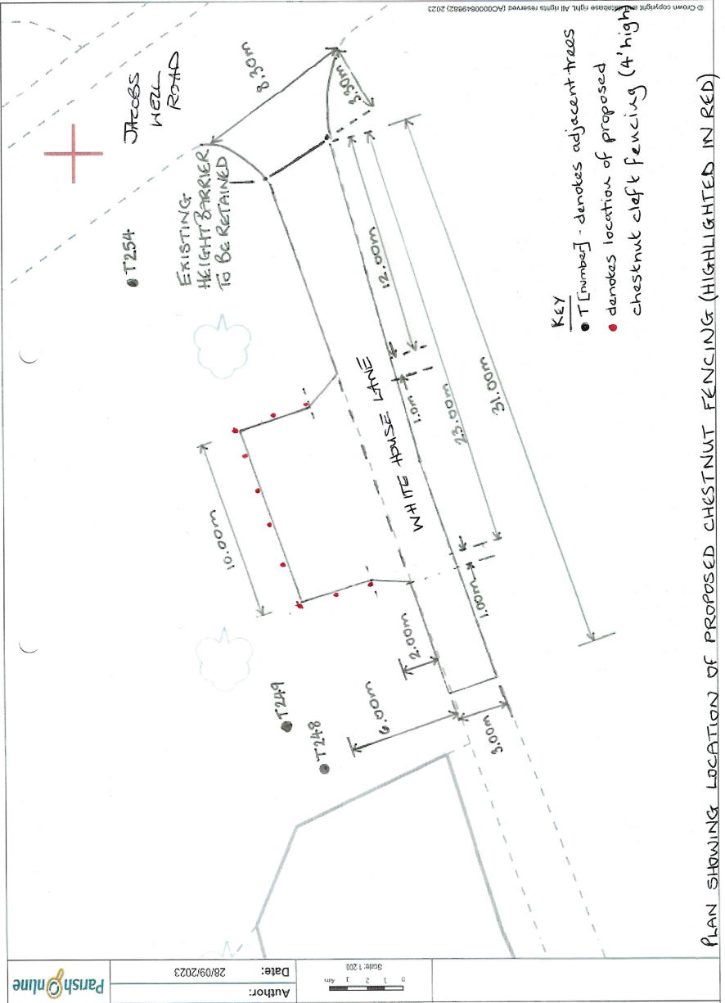
Plan 1 – Location of works on the common

