Notice of variation and consolidation with introductory note
  - The Environmental Permitting (England & Wales) Regulations 2016
Kellogg Company of Great Britain Limited
Manchester Cereals and Biscuits
Park Road
Stretford
Manchester
M32 8RA

Variation application number
EPR/BS3140IS/V006

Permit number
EPR/BS3140IS

Manchester Cereals and Biscuits
Permit number EPR/BS3140IS

Introductory note

This introductory note does not form a part of the notice
Under the Environmental Permitting (England & Wales) Regulations 2016 (schedule 5, part 1, paragraph 19) a variation may comprise a consolidated permit reflecting the variations and a notice specifying the variations included in that consolidated permit.
Schedule 1 of the notice specifies the conditions that have been varied and schedule 2 comprises a consolidated permit which reflects the variations being made. All the conditions of the permit have been varied and are subject to the right of appeal.
This consolidated permit has been issued following a full review against the best available techniques (BAT) conclusions for the Food, Drink and Milk Industries published on 4th December 2019 in the official journal of the European Union.
We have implemented the requirements of the Medium Combustion Plant directive, and incorporated post-dated requirements for 2025.
The schedules specify the changes made to the permit.
The main features of the permit are as follows.
The Manchester Cereals and Biscuits installation is located along Park Road within the Trafford Park industrial area of West Manchester at National Grid Reference SJ 79040 95650. There are factories located to the north and west of the site with residential areas to the south and east with the closest sensitive receptor being located within 100m of a residential sensitive receptor. The site manufactures ready to eat corn, rice, and biscuit based breakfast cereals. Approximately 195,000 tonnes of product are produced per annum.
The Environmental Permit is for the main listed activity falling under:
Section 6.8 Part A(1)(d)(ii): Treating and processing materials intended for the production of food products from vegetable raw materials at plant with a finished product production capacity of more than 300 tonnes per day (average value on annual basis).
There is also a secondary activity falling under:
Section 5.4 Part A (1) a) (ii): Physico-chemical Treatment of non-hazardous waste waters exceeding 50 tonnes per day.
The installation is served by two 11 MWth natural gas fired boilers. These boilers are used to produce steam, for direct process use and factory space heating.
The site processes all process effluent via an on-site effluent treatment plant (ETP). Firstly, the solids are collected from the main drains via screens and sent for anaerobic digestion (AD) off site. The effluent then passes through a dissolved air flotation (DAF) plant before being passed through a membrane bio-reactor (MBR) where the effluent undergoes biological treatment before ultrafiltration via the membrane system.
All effluent is then discharge to sewer under consent from United Utilities for further treatment.
The closest designated habitat is Manchester Mosses, which is a special area of conservation (SAC) which is located 9km northwest of the site. There are several local wildlife sites and a local nature reserve within the 10km screening distance. There are no special protection areas (SPAs) or RAMSAR within 10km of the site.
The status log of a permit sets out the permitting history, including any changes to the permit reference number.
Status log of the permit
Description | Date | Comments
Application BS3140IS | Duly Made  22/03/2005 | Application for a Section 6.8 A(1)(d)(ii) installation to allow for the manufacture of breakfast cereals and biscuits.
Response to request for further information | 22/07/2005 | Request to extend determination.
Response to request for further information | 22/10/2005 | Response to request for information regarding the Combined Heat and Power (CHP) Plant.
Response to request for further information | 07/11/2005 | Response to request for information (Schedule 4 Notice).
Response to request for further information | 14/12/2005 | Request to extend determination.
Response to request for further information | 21/12/2005 | Response to request for further information regarding emission points to air, H1 impact assessment and the Application Site Report.
Response to request for further information | 03/03/2006 | Response to request for information regarding the commissioning, operation and impact of emissions from the CHP Plant.
Permit issued | 31/03/2006 | Original Permit issued to Kellogg Company of Great Britain Limited.
Variation Issued  GP3834UH | 11/05/2007 | Variation to include emissions limits on the cooling water discharge point for temperature and daily flow. It also includes an improvement condition to investigate options to reduce chloride levels in the cooling water.
Application  EPR/BS3140IS/V003  (Variation) | 15/08/2012 | Application returned not duly made.
Application  EPR/BS3140IS/V003  (Variation) | Duly made  07/01/2013 | Application to vary permit to add a Reverse Osmosis (RO) plant and hot gas by-pass stack.
Response to request for further information | 13/02/2013 | Revised site plan showing green boundary
Response to request for further information | 25/03/2013 | Request for removal of emission point A2 and of reference to gas oil tanks in the listed activities table.
Response to request for further information | 26/03/2013 | Revised site layout plan showing emission points (DRG.No.55353).
Variation determined  EPR/BS3140IS | 27/03/2013 | Variation notice issued.
Application Variation  EPR/BS3140IS/V004 | Duly Made  09/03/2015 | Variation to include 4 new emission points in the permit and to remove 9 emission points due to changes in the manufacturing process.
Variation determined EPR/BS3140IS | 22/04/2015 | Variation notice issued.
Application Variation  EPR/BS3140IS/V005 | Duly Made  03/11/2022 | Variation to remove emissions points, remove Section 1.1 Part A(1)(a) due to the removal of the CHP plant, update site plan, add remaining boilers as directly associated activity, reference
Additional Information | 05/05/2023 | Revised boundary drawing removing reference to the CHP. Updated Best Available Techniques and Risk Assessment documents also provided.
Variation determined EPR/BS3140IS | 19/07/2023 | Notice of variation issued.
Application EPR/BS3140IS/V006 (variation and consolidation) | Regulation 61 Notice response received  04/02/2023 | Environment Agency initiated variation and consolidation following the Food, Drink & Milk Industries sector permit review.
Additional Information | 22/02/2024 | Information received regarding BAT 6, BAT 7, BAT 13, BAT 14 and air emissions.
Variation determined and consolidation issued EPR/BS3140IS  (Billing ref. BP3233AR). | 10/06/2024 | Varied and consolidated permit issued in modern format

End of introductory note

Notice of variation and consolidation

The Environmental Permitting (England and Wales) Regulations 2016
The Environment Agency in exercise of its powers under regulation 20 of the Environmental Permitting (England and Wales) Regulations 2016 varies

Permit number
EPR/BS3140IS

Issued to
Kellogg Company of Great Britain Limited (“the operator”)
whose registered office is
Orange Tower Media City UK
Salford
Greater Manchester
M50 2HF
company registration number 00199171
to operate a regulated facility at
Manchester Cereals and Biscuits
Park Road
Stretford
Manchester
M32 8RA
to the extent set out in the schedules.
The notice shall take effect from 10/06/2024

Name | Date
Sandra Cavill | 10/06/2024

Authorised on behalf of the Environment Agency

Schedule 1
All conditions have been varied by the consolidated permit as a result of an Environment Agency initiated variation.

Schedule 2 – consolidated permit
Consolidated permit issued as a separate document.

Permit

The Environmental Permitting (England and Wales) Regulations 2016

Permit number
EPR/BS3140IS
This is the consolidated permit referred to in the variation and consolidation notice for application EPR/BS3140IS/V006 authorising,
Kellogg Company of Great Britain Limited (“the operator”),
whose registered office is
Orange Tower Media City UK
Salford
Greater Manchester
M50 2HF
company registration number 00199171
to operate an installation at
Manchester Cereals and Biscuits
Park Road
Stretford
Manchester
M32 8RA
to the extent authorised by and subject to the conditions of this permit.
Name | Date
Sandra Cavill | 10/06/2024

Authorised on behalf of the Environment Agency

Conditions
- Management
  - General management
    - The operator shall manage and operate the activities:
      - in accordance with a written management system that identifies and minimises risks of pollution, including those arising from operations, maintenance, accidents, incidents, non-conformances, closure and those drawn to the attention of the operator as a result of complaints; and
      - using sufficient competent persons and resources.
    - Records demonstrating compliance with condition 1.1.1 shall be maintained.
    - Any person having duties that are or may be affected by the matters set out in this permit shall have convenient access to a copy of it kept at or near the place where those duties are carried out.
  - Energy efficiency
    - The operator shall:
      - take appropriate measures to ensure that energy is used efficiently in the activities;
      - review and record at least every four years whether there are suitable opportunities to improve the energy efficiency of the activities; and
      - take any further appropriate measures identified by a review.
  - Efficient use of raw materials
    - The operator shall:
      - take appropriate measures to ensure that raw materials and water are used efficiently in the activities;
      - maintain records of raw materials and water used in the activities;
      - review and record at least every four years whether there are suitable alternative materials that could reduce environmental impact or opportunities to improve the efficiency of raw material and water use; and
      - take any further appropriate measures identified by a review.
  - Avoidance, recovery and disposal of wastes produced by the activities
    - The operator shall take appropriate measures to ensure that:
      - the waste hierarchy referred to in Article 4 of the Waste Framework Directive is applied to the generation of waste by the activities; and
      - any waste generated by the activities is treated in accordance with the waste hierarchy referred to in Article 4 of the Waste Framework Directive; and
      - where disposal is necessary, this is undertaken in a manner which minimises its impact on the environment.
    - The operator shall review and record at least every four years whether changes to those measures should be made and take any further appropriate measures identified by a review.
- Operations
  - Permitted activities
    - The operator is only authorised to carry out the activities specified in schedule 1 table S1.1 (the “activities”).
  - The site
    - The activities shall not extend beyond the site, being the land shown edged in green on the site plan at schedule 7 to this permit.
  - Operating techniques
    - The activities shall, subject to the conditions of this permit, be operated using the techniques and in the manner described in the documentation specified in schedule 1, table S1.2, unless otherwise agreed in writing by the Environment Agency.
    - If notified by the Environment Agency that the activities are giving rise to pollution, the operator shall submit to the Environment Agency for approval within the period specified, a revision of any plan or other documentation (“plan”) specified in schedule 1, table S1.2 or otherwise required under this permit which identifies and minimises the risks of pollution relevant to that plan , and shall implement the approved revised plan in place of the original from the date of approval, unless otherwise agreed in writing by the Environment Agency.
    - Any raw materials or fuels listed in schedule 2 table S2.1 shall conform to the specifications set out in that table.
    - The operator shall ensure that where waste produced by the activities is sent to a relevant waste operation, that operation is provided with the following information, prior to the receipt of the waste:
      - the nature of the process producing the waste;
      - the composition of the waste;
      - the handling requirements of the waste;
      - the hazardous property associated with the waste, if applicable; and
      - the waste code of the waste.
    - The operator shall ensure that where waste produced by the activities is sent to a landfill site, it meets the waste acceptance criteria for that landfill.
  - Improvement programme
    - The operator shall complete the improvements specified in schedule 1 table S1.3 by the date specified in that table unless otherwise agreed in writing by the Environment Agency.
    - Except in the case of an improvement which consists only of a submission to the Environment Agency, the operator shall notify the Environment Agency within 14 days of completion of each improvement.
- Emissions and monitoring
  - Emissions to water, air or land
    - There shall be no point source emissions to water, air or land except from the sources and emission points listed in schedule 3 tables S3.1, S3.2 and S3.3.
    - The limits given in schedule 3 shall not be exceeded.
    - Periodic monitoring shall be carried out at least once every 5 years for groundwater and 10 years for soil unless such monitoring is based on a systematic appraisal of the risk of contamination.
    - For the following activities referenced in schedule 1, table S1.1 (AR3) the first monitoring measurements shall be carried out within four months of 01/01/2025 or of the date when the MCP is first put into operation, whichever is later.
  - Emissions of substances not controlled by emission limits
    - Emissions of substances not controlled by emission limits (excluding odour) shall not cause pollution. The operator shall not be taken to have breached this condition if appropriate measures, including, but not limited to, those specified in any approved emissions management plan, have been taken to prevent or where that is not practicable, to minimise, those emissions.
    - The operator shall:
      - if notified by the Environment Agency that the activities are giving rise to pollution, submit to the Environment Agency for approval within the period specified, an emissions management plan which identifies and minimises the risks of pollution from emissions of substances not controlled by emission limits;
      - implement the approved emissions management plan, from the date of approval, unless otherwise agreed in writing by the Environment Agency.
    - All liquids in containers, whose emission to water or land could cause pollution, shall be provided with secondary containment, unless the operator has used other appropriate measures to prevent or where that is not practicable, to minimise, leakage and spillage from the primary container.
  - Odour
    - Emissions from the activities shall be free from odour at levels likely to cause pollution outside the site, as perceived by an authorised officer of the Environment Agency, unless the operator has used appropriate measures, including, but not limited to, those specified in any approved odour management plan, to prevent or where that is not practicable to minimise the odour.
    - The operator shall:
      - if notified by the Environment Agency that the activities are giving rise to pollution outside the site due to odour, submit to the Environment Agency for approval within the period specified, an odour management plan which identifies and minimises the risks of pollution from odour;
      - implement the approved odour management plan, from the date of approval, unless otherwise agreed in writing by the Environment Agency.
  - Noise and vibration
    - Emissions from the activities shall be free from noise and vibration at levels likely to cause pollution outside the site, as perceived by an authorised officer of the Environment Agency, unless the operator has used appropriate measures, including, but not limited to, those specified in any approved noise and vibration management plan to prevent or where that is not practicable to minimise the noise and vibration.
    - The operator shall:
      - if notified by the Environment Agency that the activities are giving rise to pollution outside the site due to noise and vibration, submit to the Environment Agency for approval within the period specified, a noise and vibration management plan which identifies and minimises the risks of pollution from noise and vibration;
      - implement the approved noise and vibration management plan, from the date of approval, unless otherwise agreed in writing by the Environment Agency.
  - Monitoring
    - The operator shall, unless otherwise agreed in writing by the Environment Agency, undertake the monitoring specified in the following tables in schedule 3 to this permit:
      - point source emissions specified in tables S3.1 and S3.2.
    - The operator shall maintain records of all monitoring required by this permit including records of the taking and analysis of samples, instrument measurements (periodic and continual), calibrations, examinations, tests and surveys and any assessment or evaluation made on the basis of such data.
    - Monitoring equipment, techniques, personnel and organisations employed for the emissions monitoring programme and the environmental or other monitoring specified in condition 3.5.1 shall have either MCERTS certification or MCERTS accreditation (as appropriate), where available, unless otherwise agreed in writing by the Environment Agency.
    - Permanent means of access shall be provided to enable sampling/monitoring to be carried out in relation to the emission points specified in schedule 3 tables S3.1 and S3.2 unless otherwise agreed in writing by the Environment Agency.

  - Pests
    - The activities shall not give rise to the presence of pests which are likely to cause pollution, hazard or annoyance outside the boundary of the site. The operator shall not be taken to have breached this condition if appropriate measures, including, but not limited to, those specified in any approved pests management plan, have been taken to prevent or where that is not practicable, to minimise the presence of pests on the site.
    - The operator shall:
      - if notified by the Environment Agency, submit to the Environment Agency for approval within the period specified, a pests management plan which identifies and minimises risks of pollution from pests;
      - implement the pests management plan, from the date of approval, unless otherwise agreed in writing by the Environment Agency.
- Information
  - Records
    - All records required to be made by this permit shall:
      - be legible;
      - be made as soon as reasonably practicable;
      - if amended, be amended in such a way that the original and any subsequent amendments remain legible, or are capable of retrieval; and
      - be retained, unless otherwise agreed in writing by the Environment Agency, for at least 6 years from the date when the records were made, or in the case of the following records until permit surrender:
        - off-site environmental effects; and
        - matters which affect the condition of the land and groundwater.
    - The operator shall keep on site all records, plans and the management system required to be maintained by this permit, unless otherwise agreed in writing by the Environment Agency.
  - Reporting
    - The operator shall send all reports and notifications required by the permit to the Environment Agency using the contact details supplied in writing by the Environment Agency.
    - A report or reports on the performance of the activities over the previous year shall be submitted to the Environment Agency by 31 January (or other date agreed in writing by the Environment Agency) each year. The report(s) shall include as a minimum:
      - a review of the results of the monitoring and assessment carried out in accordance with the permit including an interpretive review of that data;
      - the annual production/treatment data set out in schedule 4 table S4.2; and
      - the performance parameters set out in schedule 4 table S4.3 using the forms specified in table S4.4 of that schedule.
    - Within 28 days of the end of the reporting period the operator shall, unless otherwise agreed in writing by the Environment Agency, submit reports of the monitoring and assessment carried out in accordance with the conditions of this permit, as follows:
      - in respect of the parameters and emission points specified in schedule 4 table S4.1;
      - for the reporting periods specified in schedule 4 table S4.1 and using the forms specified in schedule 4 table S4.4; and
      - giving the information from such results and assessments as may be required by the forms specified in those tables.
    - The operator shall, unless notice under this condition has been served within the preceding four years, submit to the Environment Agency, within six months of receipt of a written notice, a report assessing whether there are other appropriate measures that could be taken to prevent, or where that is not practicable, to minimise pollution.
  - Notifications
    - In the event:
      - that the operation of the activities gives rise to an incident or accident which significantly affects or may significantly affect the environment, the operator must immediately—
        - inform the Environment Agency,
        - take the measures necessary to limit the environmental consequences of such an incident or accident, and
        - take the measures necessary to prevent further possible incidents or accidents;
      - of a breach of any permit condition the operator must immediately—
        - inform the Environment Agency, and
        - take the measures necessary to ensure that compliance is restored within the shortest possible time;
      - of a breach of permit condition which poses an immediate danger to human health or threatens to cause an immediate significant adverse effect on the environment, the operator must immediately suspend the operation of the activities or the relevant part of it until compliance with the permit conditions has been restored.
    - Any information provided under condition 4.3.1 shall be confirmed by sending the information listed in schedule 5 to this permit within the time period specified in that schedule.
    - Where the Environment Agency has requested in writing that it shall be notified when the operator is to undertake monitoring and/or spot sampling, the operator shall inform the Environment Agency when the relevant monitoring and/or spot sampling is to take place. The operator shall provide this information to the Environment Agency at least 14 days before the date the monitoring is to be undertaken..
    - The Environment Agency shall be notified within 14 days of the occurrence of the following matters, except where such disclosure is prohibited by Stock Exchange rules:
Where the operator is a registered company:
      - any change in the operator’s trading name, registered name or registered office address; and
      - any steps taken with a view to the operator going into administration, entering into a company voluntary arrangement or being wound up.
Where the operator is a corporate body other than a registered company:
      - any change in the operator’s name or address; and
      - any steps taken with a view to the dissolution of the operator.
In any other case:
      - the death of any of the named operators (where the operator consists of more than one named individual);
      - any change in the operator’s name(s) or address(es); and
      - any steps taken with a view to the operator, or any one of them, going into bankruptcy, entering into a composition or arrangement with creditors, or, in the case of them being in a partnership, dissolving the partnership.
    - Where the operator proposes to make a change in the nature or functioning, or an extension of the activities, which may have consequences for the environment and the change is not otherwise the subject of an application for approval under the Regulations or this permit:
      - the Environment Agency shall be notified at least 14 days before making the change; and
      - the notification shall contain a description of the proposed change in operation.
    - The Environment Agency shall be given at least 14 days’ notice before implementation of any part of the site closure plan.
    - Where the operator has entered into a climate change agreement with the Government, the Environment Agency shall be notified within one month of:
      - a decision by the Secretary of State not to re-certify the agreement;
      - a decision by either the operator or the Secretary of State to terminate the agreement; and
      - any subsequent decision by the Secretary of State to re-certify such an agreement.
  - Interpretation
    - In this permit the expressions listed in schedule 6 shall have the meaning given in that schedule.
    - In this permit references to reports and notifications mean written reports and notifications, except where reference is made to notification being made “immediately”, in which case it may be provided by telephone.

Schedule 1 – Operations
Table S1.1 activities
Activity reference | Activity listed in Schedule 1 of the EP Regulations | Description of specified activity | Limits of specified activity
AR1 | Section 6.8 Part A1 (d) (ii) | Treating and processing materials intended for the production of food products from vegetable raw materials at plant with a finished product production capacity of more than 300 tonnes per day (average value on annual basis) | From receipt of raw materials (Grains) to the site to the despatch of biscuits and cereal products.  Production capacity is limited to 532 tonnes per day.
AR2 | Section 5.4 Part A1 (a) (ii) | Physico-chemical Treatment of non-hazardous waste waters exceeding 50 tonnes per day. | From generation of waste water from onsite processes, to treatment via screening and dissolved air flotation, passing through a membrane bio-reactor for biological treatment then finally onto ultrafiltration prior to discharge to then final treatment sewer.
Directly Associated Activity
AR3 | Steam supply | Medium Combustion plants:  2 x natural gas fired boilers (11 MWth) | From receipt of fuel to release of products of combustion to air.
AR4 | Raw material storage and handling | Storage and handling of raw materials at the installation | From receipt of raw materials to dispatch of final product.
AR5 | Use of refrigerants | Use of refrigerants in cooling, chilling and/or freezing systems at the installation. | From receipt of raw materials to dispatch of final product.
AR6 | Storage and use of chemicals and oils | Storage and use of chemicals and oils at the installation. | From receipt of chemicals and oils to disposal of wastes arising.
AR7 | Waste storage and handling | Storage and handling of waste materials | From generation of waste to storage pending removal for disposal or recovery.
AR8 | Surface water drainage | Collection of uncontaminated site surface waters | Handling and storage of site drainage until discharge to the site surface water system.

Table S1.2 Operating techniques
Description | Parts | Date Received
Application  BS3140IS | The response to questions 2.1 and 2.2 provided in pages 9 to 63 of the Application. | 22/03/2005
Letter received from the Operator | References to the status of improvements to the pollution prevention measures detailed in the Application Site Report, the use of standby fuels, the decommissioning of boilers 6 & 7 and the specification and operation of the Effluent Treatment Plant. | 21/12/2005
Letter received from the Operator | References to the specification and operation of the Effluent treatment Plant and emission points to air. | 03/03/2006
Application EPR/BS3140IS/V003 | Responses to Part C3 section 3 and referenced supporting documentation | 21/11/2012
Response to request for further information | Request for removal of emission point A2 and of reference to gas oil tanks in the listed activities table. | 25/03/2013
Response to request for further information | Revised site layout plan showing emission points (DRG.No.55353) | 26/03/2013
Application EPR/BS3140IS/V004 | Responses to Part C3 section 3 and referenced supporting documentation. | 05/02/2015
Additional Information | Confirmation that no abatement will be fitted to emission points 12C-F. Details of where emission points removed from the permit will be diverted to. Updated emission points plan provided. | 20/03/2015
Application EPR/BS3140IS/V005 | Application form Part C3 section 3 technical standards | 01/01/2022
Additional information received | Revised documents including site boundary plan, ‘Best Available Techniques Assessment’ (Ref: 410.064621.00001 dated May 2023), and ‘Environmental Risk Assessment’ (Ref: 410.064621.00001 dated May 2023). | 05/05/2023
Regulation 61 (1) Notice – Responses to questions dated 04/10/2022 | All parts | Received 04/02/2023
Request for further information dated 08/02/2024 | Technical standards in relation to Best available techniques as described in BAT conclusions under Directive 2010/75/EU of the European Parliament and of the Council on establishing best available techniques (BAT) conclusions for the food, drink and milk industries, BAT Conclusions Numbers 6, 7, 13 and 14. In addition to information on air emissions. | Received 08/03/2024

Table S1.3 Improvement programme requirements
Reference | Requirement | Date
IC9 | The operator shall submit, for approval by the Environment Agency, a monitoring procedure for particulate matter emissions from principal emission points on site. The procedure must describe how the operator will implement a rolling monitoring programme which shall include, but not be limited to the following:  - Methodology for how representative monitoring will be carried out annually, with a minimum of 3-point sources on a rolling-basis.  - Ensuring the key process stages are prioritised.  - Identify any principal emission points excluded from the rolling monitoring programme and provide a justification for this.  - Provide a commencement date for the programme which will demonstrate compliance with the permit requirements.  The monitoring procedure shall address the requirements of BAT Conclusions for Food, Drink and Milk Industries with respect to BAT 5. | 12 months from permit issue or as agreed in writing by the Environment Agency
IC10 | The operator shall produce a climate change adaptation plan, which will form part of the EMS.  The plan shall include, but not be limited to:  - Details of how the installation has or could be affected by severe weather;  - The scale of the impact of severe weather on the operations within the installation;  - An action plan and timetable for any improvements to be made to minimise the impact of severe weather at the installation.  The Operator shall implement any necessary improvements to a timetable agreed in writing with the Environment Agency. | 6 months from permit issue or as agreed in writing by the Environment Agency

Schedule 2 – Waste types, raw materials and fuels
Table S2.1 Raw materials and fuels
Raw materials and fuel description | Specification
-- | --

Schedule 3 – Emissions and monitoring
Table S3.1 Point source emissions to air – emission limits and monitoring requirements
Emission point ref. & location | Source | Parameter | Limit (including unit) | Reference period | Monitoring frequency | Monitoring standard or method
A1 [Point 26 on site plan in Schedule 7] | Boiler 1 (11 MWth natural gas fired boiler) | Oxides of Nitrogen  (NO and NO₂ expressed as NO_{x}) | 200 mg/m3 | Periodic | Every three years | BS EN 14792
 |  | Carbon monoxide | No Limit | Periodic | Every three years | MCERTS  BS EN15058
 | Boiler 2 (11 MWth natural gas fired boiler) | Oxides of Nitrogen  (NO and NO₂ expressed as NO_{x}) | 200 mg/m3 | Periodic | Every three years | BS EN 14792
 |  | Carbon monoxide | No Limit | Periodic | Every three years | MCERTS  BS EN15058
A4 – A9 [Point 8A - F on site plan in Schedule 7] | Corn Toasting oven bleed fan cyclones 1-11 | No parameters set | No limit set | -- | -- | --
A15 – A20 [Point 8L-Q on site plan in Schedule 7] | Corn Oven exhaust fan modules 1-11 | No parameters set | No limit set | -- | -- | --
A26 – A32 [Point 16A-G on site plan in Schedule 7] | Wet scrubbers | No parameters set | No limit set | -- | -- | --
A37 [Point 10a on site plan in Schedule 7] | Dry dust Filter systems (premium conveyor system) | No parameters set | No limit set | -- | -- | --
A38 [Point 10b on site plan in Schedule 7] | Dry dust Filter systems (North corn conveyor) | No parameters set | No limit set | -- | -- | --
A39 [Point 10c on site plan in Schedule 7] | Dry dust Filter systems (South corn conveyor) | No parameters set | No limit set | -- | -- | --
A41 [Point 21 on site plan in Schedule 7] | Cereal dust extraction | No parameters set | No limit set | -- | -- | --
A42 and A43 [Point 13a and 13b on site plan in Schedule 7] | Bivac vacuum system | No parameters set | No limit set | -- | -- | --
A44, A45 and A46 [Point 15, 22 and 23A (retrospectively) on site plan in Schedule 7] | Bivac vacuum system | No parameters set | No limit set | -- | -- | --
A48 [Point 23b on site plan in Schedule 7] | Sugar silo displaced air vent | No parameters set | No limit set | -- | -- | --
A49 and A50 [Point 12a and 12b on site plan in Schedule 7] | Extraction fan | No parameters set | No limit set | -- | -- | --
A51 [Point 14 on site plan in Schedule 7] | Local exhaust vent | No parameters set | No limit set | -- | -- | --
A52-A24 [Points 18A – 18C on site plan in Schedule 7] | Syrup steam vents | No parameters set | No limit set | -- | -- | --
A55 [Point 19 on site plan in Schedule 7] | Air exhaust for liquid ring vacuum pumps | No parameters set | No limit set | -- | -- | --
A59 and A60 [Point 12D and 24 on site plan in Schedule 7] | Steam vents | No parameters set | No limit set | -- | -- | --
A61 and A62 [Points 28A and 28B on site plan in Schedule 7] | Battery charging room extraction | No parameters set | No limit set | -- | -- | --
A69 [Point 6 on site plan in Schedule 7] | Cereal dryer exhaust | No parameters set | No limit set | -- | -- | --
A70 [Point 7 on site plan in Schedule 7] | Battery charging – room extraction | No parameters set | No limit set | -- | -- | --

Table S3.2 Point Source emissions to water (other than sewer) and land – emission limits and monitoring requirements
Emission point ref. & location | Source | Parameter | Limit (incl. unit) | Reference Period | Monitoring frequency | Monitoring standard or method
W1 [Point ‘Bore hole outlet’ on site plan in schedule 7] emission to Ground – Bridgewater Canal | Cooling water discharge from grain rolls | Temperature | 20°C | Continuous | Continuous | Temperature Probe
 |  | Flow rate | 4654m³ | Daily | Daily | SCA estimation of flow and load
Table S3.3 Point source emissions to sewer, effluent treatment plant or other transfers off-site– emission limits and monitoring requirements
Emission point ref. & location | Source | Parameter | Limit (incl. Unit) | Reference period | Monitoring frequency | Monitoring standard or method
S1 [Point SW1 on site plan in schedule 7] emission to Davyhulme wastewater treatment works – united utilities | Treated process effluent from onsite effluent treatment plant | No Parameters Set | No limit set | -- | -- | --

Schedule 4 – Reporting
Parameters, for which reports shall be made, in accordance with conditions of this permit, are listed below.
Table S4.1 Reporting of monitoring data
Parameter | Emission or monitoring point/reference | Reporting period | Period begins
Point source emissions to air  Parameters as required by condition 3.5.1 | A1 | First monitoring undertaken in accordance with Condition 3.1.4 to be reported within 3 months, and then every 3 years thereafter. | From first monitoring requirements in accordance with Condition 3.1.4
Point source emissions to water (other than sewer)  Parameters as required by condition 3.5.1 | W1 | Quarterly | 1 January, 1 April, 1 July & 1 October

Table S4.2: Annual production/treatment
Parameter | Units
Cereal and Biscuit products Produced | tonnes

Table S4.3 Performance parameters
Parameter | Frequency of assessment | Units
Water usage | Annually | m³
Energy usage | Annually | MWh
Waste | Annually | tonnes
COD loss efficiency | Annually* | COD te/te product
Food waste | Annually | Tonnes
*COD loss efficiency to be calculated on a weekly frequency, reported annually

Table S4.4 Reporting forms
Parameter | Reporting form | Form version number and date
Point source emissions to air | Emissions to Air Reporting Form, or other form as agreed in writing by the Environment Agency | Version 1, 08/03/2021
Point source emissions to water (other than sewer) | Emissions to Water Reporting Form, or other form as agreed in writing by the Environment Agency | Version 1, 08/03/2021
Water usage | Water Usage Reporting Form, or other form as agreed in writing by the Environment Agency | Version 1, 08/03/2021
Energy usage | Energy Usage Reporting Form, or other form as agreed in writing by the Environment Agency | Version 1, 08/03/2021
Food Waste | Food waste Reporting Form, or other form as agreed in writing by the Environment Agency | Version 1  06/02/2023
Other performance parameters | Other Performance Parameters Reporting Form, or other form as agreed in writing by the Environment Agency | Version 1, 08/03/2021

Schedule 5 – Notification
These pages outline the information that the operator must provide.
Units of measurement used in information supplied under Part A and B requirements shall be appropriate to the circumstances of the emission. Where appropriate, a comparison should be made of actual emissions and authorised emission limits.
If any information is considered commercially confidential, it should be separated from non-confidential information, supplied on a separate sheet and accompanied by an application for commercial confidentiality under the provisions of the EP Regulations.

Part A
Permit Number
Name of operator
Location of Facility
Time and date of the detection

(a) Notification requirements for any malfunction, breakdown or failure of equipment or techniques, accident, or emission of a substance not controlled by an emission limit which has caused, is causing or may cause significant pollution
To be notified within 24 hours of detection
Date and time of the event
Reference or description of the location of the event
Description of where any release into the environment took place
Substances(s) potentially released
Best estimate of the quantity or rate of release of substances
Measures taken, or intended to be taken, to stop any emission
Description of the failure or accident.

(b) Notification requirements for the breach of a limit
To be notified within 24 hours of detection unless otherwise specified below
Emission point reference/ source
Parameter(s)
Limit
Measured value and uncertainty
Date and time of monitoring
Measures taken, or intended to be taken, to stop the emission

Time periods for notification following detection of a breach of a limit
Parameter | Notification period

(c) Notification requirements for the breach of permit conditions not related to limits
To be notified within 24 hours of detection
Condition breached
Date, time and duration of breach
Details of the permit breach i.e. what happened including impacts observed.
Measures taken, or intended to be taken, to restore permit compliance.

(d) Notification requirements for the detection of any significant adverse environmental effect
To be notified within 24 hours of detection
Description of where the effect on the environment was detected
Substances(s) detected
Concentrations of substances detected
Date of monitoring/sampling

Part B – to be submitted as soon as practicable
Any more accurate information on the matters for notification under Part A.
Measures taken, or intended to be taken, to prevent a recurrence of the incident
Measures taken, or intended to be taken, to rectify, limit or prevent any pollution of the environment which has been or may be caused by the emission
The dates of any unauthorised emissions from the facility in the preceding 24 months.

Name*
Post
Signature
Date
* authorised to sign on behalf of the operator

Schedule 6 – Interpretation
“accident” means an accident that may result in pollution.
“application” means the application for this permit, together with any additional information supplied by the operator as part of the application and any response to a notice served under Schedule 5 to the EP Regulations.
“authorised officer” means any person authorised by the Environment Agency under section 108(1) of The Environment Act 1995 to exercise, in accordance with the terms of any such authorisation, any power specified in section 108(4) of that Act.
“average over the sampling period” means the average value of three consecutive measurements of at least 30 minutes each, unless otherwise stated, as defined in the General Considerations section of the Food, Drink & Milk Industries BAT Conclusions.
“emissions to land” includes emissions to groundwater.
“EP Regulations” means The Environmental Permitting (England and Wales) Regulations SI 2016 No.1154 and words and expressions used in this permit which are also used in the Regulations have the same meanings as in those Regulations.
“emissions of substances not controlled by emission limits” means emissions of substances to air, water or land from the activities, either from the emission points specified in schedule 3 or from other localised or diffuse sources, which are not controlled by an emission limit.
“Food waste” reporting: Reporting of food waste to use a methodology such as the global Food Loss and Waste Accounting and Reporting Standard (FLW standard), WRAP’s Target Measure Act initiative or similar.
“groundwater” means all water, which is below the surface of the ground in the saturation zone and in direct contact with the ground or subsoil.
“Industrial Emissions Directive” means DIRECTIVE 2010/75/EU OF THE EUROPEAN PARLIAMENT AND OF THE COUNCIL of 24 November 2010 on industrial emissions, as read in accordance with Schedule 1A to the Environmental Permitting (England and Wales) Regulations 2016.
“MCERTS” means the Environment Agency’s Monitoring Certification Scheme.
“Medium Combustion Plant” or ”MCP” means a combustion plant with a rated thermal input equal to or greater than 1 MW but less than 50 MW. An “existing medium combustion plant” is combustion plant operating before 20 December 2018.
“Medium Combustion Plant Directive” or “MCPD” means Directive 2015/2193/EU of the European Parliament and of the Council on the limitation of emissions of certain pollutants into the air from medium combustion plants, as read in accordance with Schedule 1A to the Environmental Permitting (England and Wales) Regulations 2016.
“Pests” means Birds, Vermin and Insects.
Where a minimum limit is set for any emission parameter, for example pH, reference to exceeding the limit shall mean that the parameter shall not be less than that limit.
Unless otherwise stated, any references in this permit to concentrations of substances in emissions into air means:
- in relation to emissions from combustion processes, the concentration in dry air at a temperature of 273K, at a pressure of 101.3 kPa and with an oxygen content of 3% dry for liquid and gaseous fuels, 6% dry for solid fuels; and/or
- in relation to emissions from gas engines or gas turbines, the concentration in dry air at a temperature of 273K, at a pressure of 101.3 kPa and with an oxygen content of 15% dry for liquid and gaseous fuels; and/or
- in relation to emissions from non-combustion sources, the concentration at a temperature of 273K and at a pressure of 101.3 kPa, with no correction for water vapour content
“year” means calendar year ending 31 December.

Schedule 7 – Site plan
- Site boundary
N
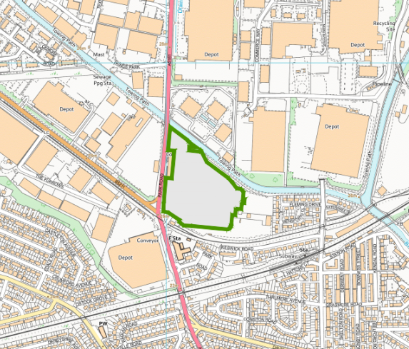

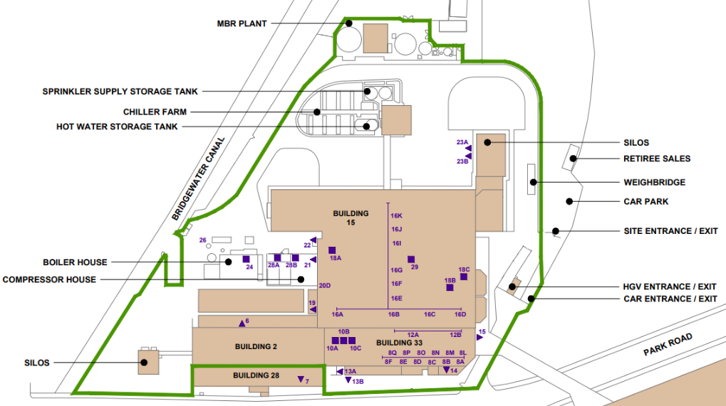
- Air emission point plan

- Water emission point plan
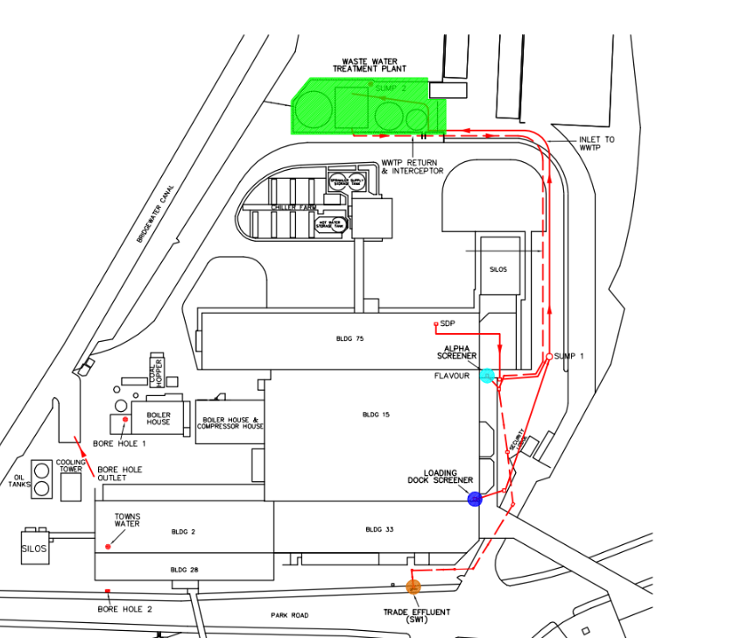

END OF PERMIT

