Application Decision
by Harry Wood
Appointed by the Secretary of State for Environment, Food and Rural Affairs
Decision date: 14 June 2024

Application Ref: COM/3334578
SOUTHAMPTON CENTRAL PARKS COMMON, SOUTHAMPTON CITY CENTRE, HOGLANDS PARK, SO14 3JJ
Register Unit Number: CL3
Commons Registration Authority: Southampton City Council

- The application, dated 3 December 2023, is made under Section 38 of the Commons Act 2006 (the 2006 Act) for consent to carry out restricted works on common land.
- The application is made by Southampton City Council.
- The works comprise:
- replacing the current steel skate ramp with sculptural skate terrain made from concrete and with ecofriendly lighting with the terrain covering approximately 840m²;
- temporary Heras fencing measuring 3.5m Long by 2m High. Approximately 231m of fencing to be in place at one time to create a 2361m² working area.
Decision
- Consent is granted for the works in accordance with the application dated 3 December 2023 and the plans submitted with it subject to the following conditions:

- the works shall begin no later than three years from the date of this decision;
REASON: To provide certainty to users of Southampton central parks common
- the land shall be fully reinstated within one month from the completion of the works.
REASON: To retain access for commoners and the public across Southampton central parks common.
- For the purposes of identification only the location of the works is shown outlined in red (figure 1) and in blue (figure 2) on the attached plan.

Preliminary Matters
- I have had regard to Defra’s Common Land Consents Policy Guidance (Defra November 2015) in determining this application, which has been published for the guidance of both the Planning Inspectorate and applicants. However, every application will be considered on its merits and a determination will depart from the guidance if it appears appropriate to do so. In such cases, the decision will explain why it has departed from the guidance.

- This application has been determined solely on the basis of written evidence. I have taken account of the representations made by Skateboard GB (SGB), Professor Iain Borden and We Skate Soton (WSS)

Main Issues
- I am required by section 39 of the Commons Act 2006 (the 2006 Act) to have regard to the following in determining applications under Article 12 of the 1967 Act:
- the interests of persons having rights in relation to, or occupying, the land (and in particular persons exercising rights of common over it);
- the interests of the neighbourhood;
- the public interest; Section 39(2) of the 2006 Act provides that the public interest includes the public interest in; nature conservation; the conservation of the landscape; the protection of public rights of access to any area of land; and the protection of archaeological remains and features of historic interest. And
- any other matter considered to be relevant.

Reasons
- Southampton City Council have explained that the existing steel skate ramp needs structural maintenance and has come to the end of its lifespan. The council seek to improve the recreational value of the common by overhauling the design of the skate park making it safer and more accessible to the public as well as improving the visuals and biodiversity of the surrounding park.

The interests of those occupying or having rights over the land
- Southampton City Council is the owner of the land. The common land register records rights to dig marl over parts of the common to Hampshire County Council.

- The applicant has confirmed that no rights are actively carried out on the common and Hampshire County Council have stated in writing to the applicant that they do not intend to carry out this right.

- I am satisfied that the works will not harm the interests of those occupying the land and the interests of those having rights over the land.
The interests of the neighbourhood and public access
- Southampton central parks common is composed of serval pieces of greenspace divided by surrounding highways off the common and a number of footways through the common. The planned works sit within part of the common referred to as ‘Hoglands Park’.

- The areas of common surrounding the works identified in this application are large open grass spaces with the current skate ramp located near the centre of the space opposite one other permanent structure noted as a pavilion.

- The applicant has explained that the design of the new skate terrain will overhaul the current skate ramp and its foundation structure, replacing the large 2-meter-tall steel ramp with a more open concreate skateboarding area that includes a wide range of obstacles and is designed to be more organic in shape.

- The new skate terrain will provide a flatter and more open area providing better access to the area of common where it is located. It is also likely that the more open area and smoother concreate surfaces being used will improve access for wheelchair users.

- The addition of the new skate terrain will introduce artificial barriers onto the common which potentially could act as trip hazards. However, the structure currently in place has a larger impact on access across the common blocking any access to the area of the common where it is located. The new skate terrain can be easily navigated via other routes around and through the common.

- The temporary fencing would have a larger impact, blocking access to the areas of the common where the works are taking place, but this will be minimal due to the small sizes of the areas the fencing is surrounding and the fact that the common will still be accessible via other routes. The fencing is also planned to be temporary in nature. I am satisfied that such fencing is appropriate on health and safety grounds and that it will be removed on completion of the works, which can be secured by attaching a suitable condition to the consent.

- SGB have stated that the design increases accessibility to the public which was regarded as a key feature for diverse and safe usage of the facility. They also outline how the use of innovative and non-traditional skatepark design features, including sculptural elements, will engage young people in physical activity. They further outline how these features will enable a much wider range of participants to enjoy the experience of skateboarding than is usually possible in traditional skateparks highlighting its recreational value.

- Professor Borden has stated that the skate terrain is of innovative design and outlined that it will be a very accessible landscape, which would be attractive to a diverse range of users of different abilities.

- In conclusion I am satisfied that the proposed works will not harm the interests of public access.

Nature conservation and Conservation of the landscape
- As well as the public interest in the protection of public rights of access, I must also have regard to the public interest in nature conservation, the conservation of the landscape and the protection of archaeological remains and features of historic interest.

- The applicant has detailed that the skate terrain will be made of smooth concreate. Although this would introduce permanent artificial features into the landscape, it will replace the structure currently in place that has fallen out of repair and is graffitied.

- The new skate terrain will also be designed to lay more naturally in the landscape which will help to create better views across the common. WSS have outlined that they are happy to see the park has been designed to offer good sightlines.

- The applicant has provided a plan outlining the trees surrounding the proposed working area and their critical root zones to detail their aim to avoid damage during the time works are carried out.

- Additionally, the applicant has provided further information on the drainage plan for the structure which is designed to create soakaway gardens. This would have a positive effect on the biodiversity of the common as well as the visuals of the common.

- I am satisfied that nature conservation interests will not be harmed by the works, and I consider that overall, the works will have little to no impact on landscape interests.

Protection of archaeological remains and features of historic interest.
- The applicant has stated that Central Parks is registered as Grade II with Historic England List Entry 1001323. Historic England and the local authority archaeological service have been consulted and did not comment.

- There is no evidence before me to suggest that these interests will be harmed by the proposed works.

Conclusion
- I conclude that the works will benefit the neighbourhood by providing improved skate facilities for the common increasing its recreational value and providing benefit to the value of the landscape without seriously harming the other interests set out in paragraph 5 above. Consent for the works is therefore granted subject to the conditions set out at paragraph 1.

Harry Wood

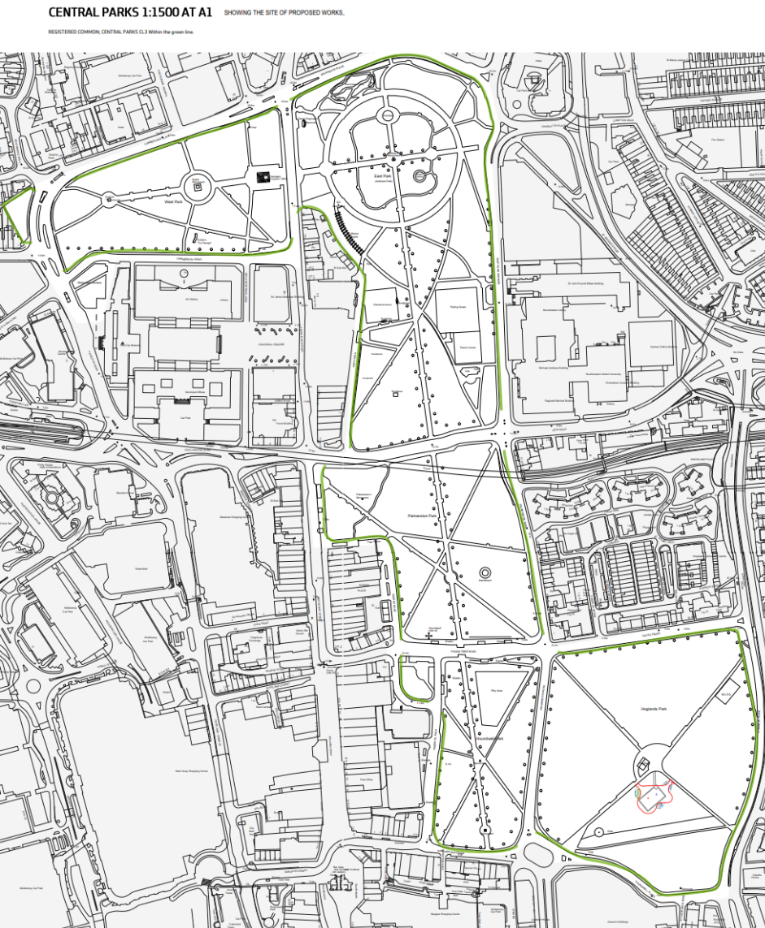
Figure 1 – Works location on common:

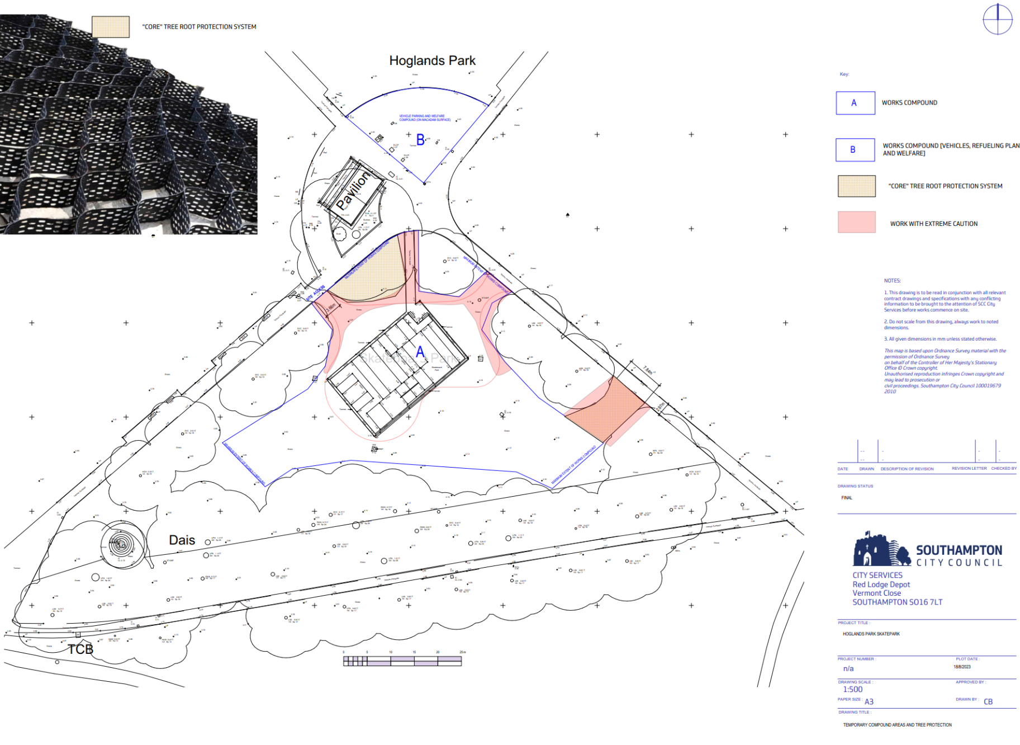
Figure 2 – Working area outlined in blue:

