NOTICE OF ORDER

Wildlife and Countryside Act 1981 – Section 53
CORNWALL COUNCIL
(Addition of a Footpath and a Restricted Byway at Metherell in the Parish of Calstock) Modification Order 2021

Notice is hereby given that the above referenced Order has been submitted to the Secretary of State for Environment, Food and Rural Affairs for determination. An Inspector will be appointed by the Secretary of State to determine the Order.

The start date for the above Order is 23 April 2024.

Consideration of the Order will take the form of a public local inquiry.

The Inquiry will be held at The Old Chapel, Sand Lane, Calstock, Cornwall, PL18 9QX on Tuesday 15 October 2024 at 10.00am.

The appointed Inspector will also open the Inquiry as a virtual event on Tuesday 15 October 2024 at 10.00am.

Anyone wishing to attend the inquiry virtually must register that interest with the Council as soon as possible prior to the Inquiry, but no later than midday on Friday 11 October 2024, either by email or telephone, details of which are set out in this notice. To take part using video, participants will need to have access to Microsoft Teams (via an app or web browser). The link https://support.microsoft.com/en-us/office/welcome-to-microsoft-teams-b98d533f-118e-4bae-bf44-3df2470c2b12 gives further information on how to use this. Alternatively, you can take part by telephone. Registered participants will receive individual joining instructions, providing details of any requirements, guidance and support, whether joining by Teams or telephone.

The effect of the Order, if confirmed without modifications, will be to modify the definitive map and statement for the area by:
(i) Adding a length of Public Footpath in the Parish of Calstock commencing at Footpath Number 9 Calstock approximately 17 metres north-west of ‘Lower Brookland Farm’ at Ordnance Survey Grid Reference (OSGR) SX 4094/6947 shown as point ‘A’ on the map attached to the Order then running in a generally south-easterly direction for a distance of 462 metres to its junction with a Restricted Byway to be added by this Order approximately 196 metres north-west of ‘Newton Farm’ at OSGR SX 4131/6921 shown as point ‘B’ on the attached Order map and
(ii) Adding a length of Restricted Byway in the Parish of Calstock commencing at a Public Footpath to be added by this Order approximately 196 metres north-west of ‘Newton Farm’ at OSGR SX 4131/6921 shown as point ‘B’ on the attached Order map then running in a generally easterly then south-easterly then east-north-easterly direction for a distance of 238 metres to its junction with Unclassified Road (U6168) approximately 42 metres north-east of ‘Newton Farm’ at OSGR SX 4149/6909 shown as point ‘C’ on the attached Order map.

Any queries relating to this Order should be referred to Helen Sparks by email: helen.sparks@planninginspectorate.gov.uk
quoting reference number ROW/3311106 on all correspondence. Alternatively, queries may be sent in writing to The Planning Inspectorate, Rights of Way Section, Room 3/A Eagle Wing, Temple Quay House, 2 The Square, Temple Quay, Bristol, BS1 6PN. Telephone: 0303 444 5646.

Any person wishing to view the statements of case and other documents relating to this Order may access them on Cornwall Council’s website:
https://www.cornwall.gov.uk/environment-and-planning/countryside/public-rightsof-way/definitive-map-modification-orders/submissions-to-the-secretary-of-state/
Contact Ms Hannah Rodger, Cornwall Council, PO Box 676, Threemilestone, Truro, TR1 9EQ with any queries by Telephone 0300 1234 2202 or E-mail Hannah.Rodger@cornwall.gov.uk.

Timetable for sending in statements of case and proofs of evidence

Within 8 weeks of the start date by [by 18 June 2024]

The Order Making Authority must ensure their statement of case is received by the Secretary of State. As soon as possible after the deadline, the Secretary of State will send a copy (excluding copies of any supporting documents - these will be available to view at the Authority’s offices) to everyone who has made an objection or representation and the applicant and any other person who has written to us in respect of the Order.

Within 14 weeks of the start date [by 30 July 2024]

Everyone who has made an objection or representation and anyone who wishes to give evidence at the Inquiry must ensure their statement of case is received by the Secretary of State. As soon as possible after the deadline, the Secretary of State will send full copies to the Authority. Copies will also be sent to the applicant, every person who has made an objection or representation and any other person who has written to us in respect of the Order (excluding copies of any supporting documents - these will be available to view at the Authority’s offices).

Within the same period the applicant (if applicable) must ensure their statement of case is received by the Secretary of State. As soon as possible after the deadline, the Secretary of State will send a full copy to the Authority. Copies will also be sent to everyone who has made an objection or representation and any other person who has written to us in respect of the Order (excluding copies of any supporting documents - these will be available to view at the Authority’s offices).

4 weeks before the date of the inquiry [by 17 September 2024]

The Authority, everyone who has made an objection or representation, the applicant (if applicable) and anyone who wishes to give evidence at the Inquiry must ensure their proof of evidence (together with any summary) is received by the Secretary of State. As soon as possible after the deadline, the Secretary of State will send copies of:

- the Authority’s proof of evidence to everyone who has made an objection or representation, the applicant and anyone who has submitted a statement of case (including copies of any supporting documents – although none should be submitted with a proof of evidence);

- the applicant’s proof of evidence to the Authority, everyone who has made an objection or representation and anyone else who has submitted a statement of case (including copies of any supporting documents – although none should be submitted with a proof of evidence); and

- all other proofs of evidence to the Authority, the applicant, everyone who has made an objection or representation and anyone else who has submitted a statement of case (including copies of any supporting documents – although none should not be submitted with a proof of evidence).

All parties must keep to the timetable set out above and ensure that statements of case and proofs of evidence are received by the Secretary of State on time. Late documents will be returned.

We cannot accept any inflammatory, discriminatory or abusive comments. Any documents containing such comments will be returned.

Notice of order for inquiry

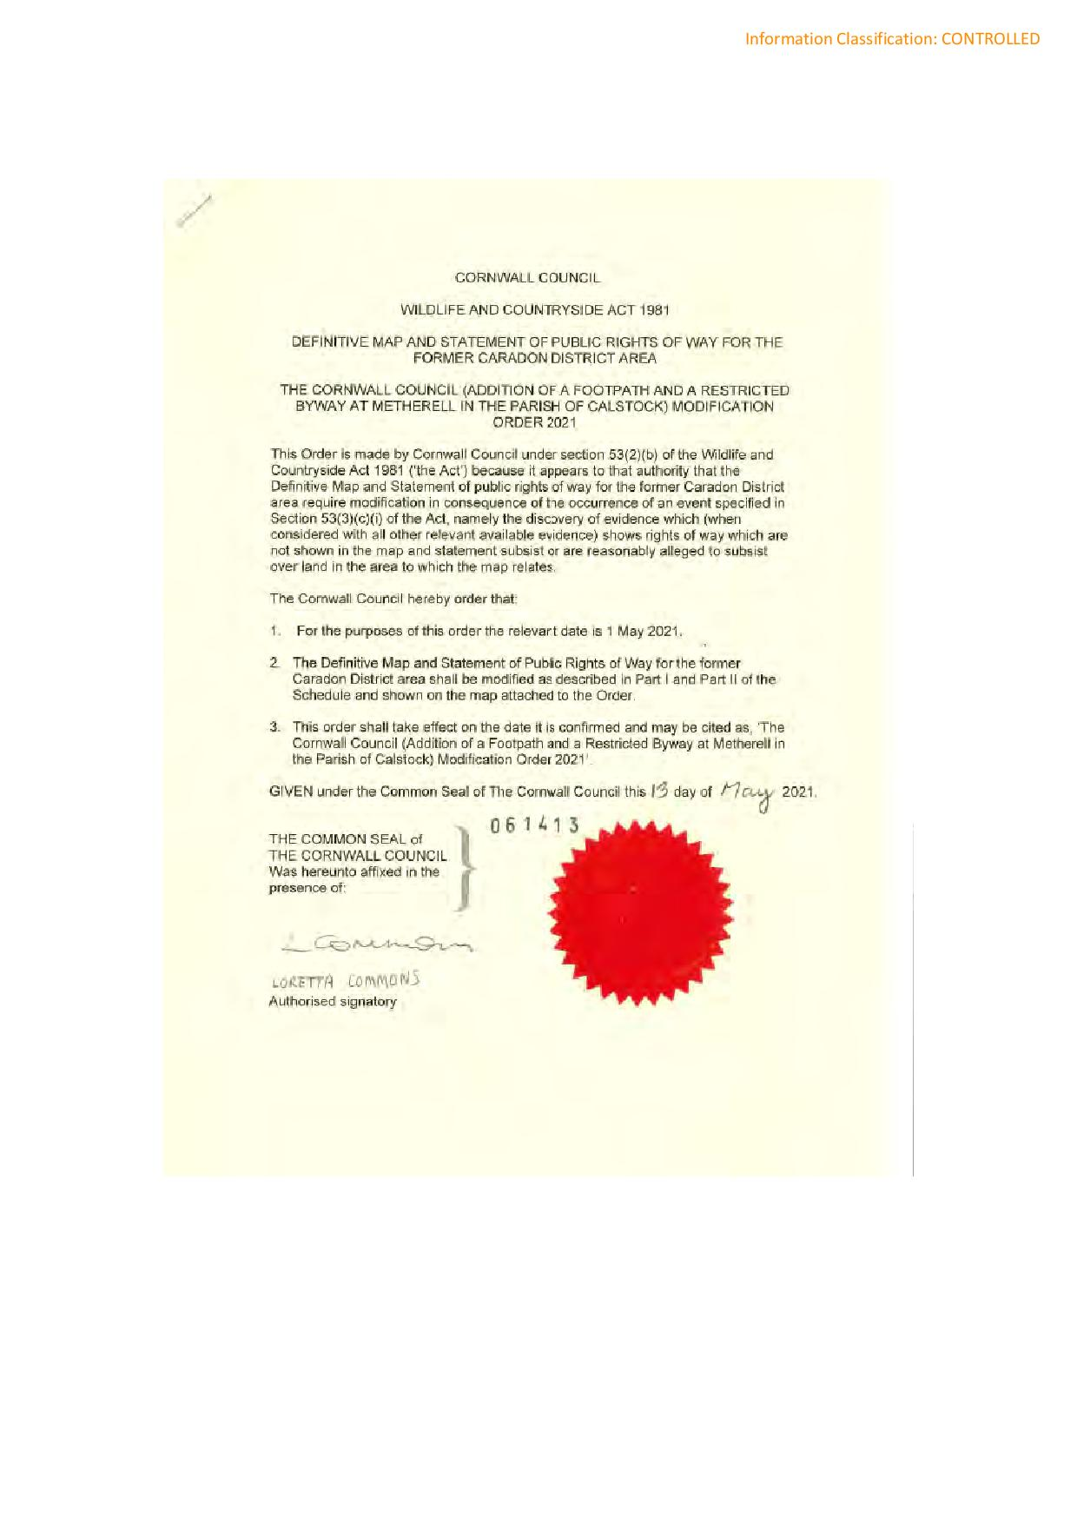

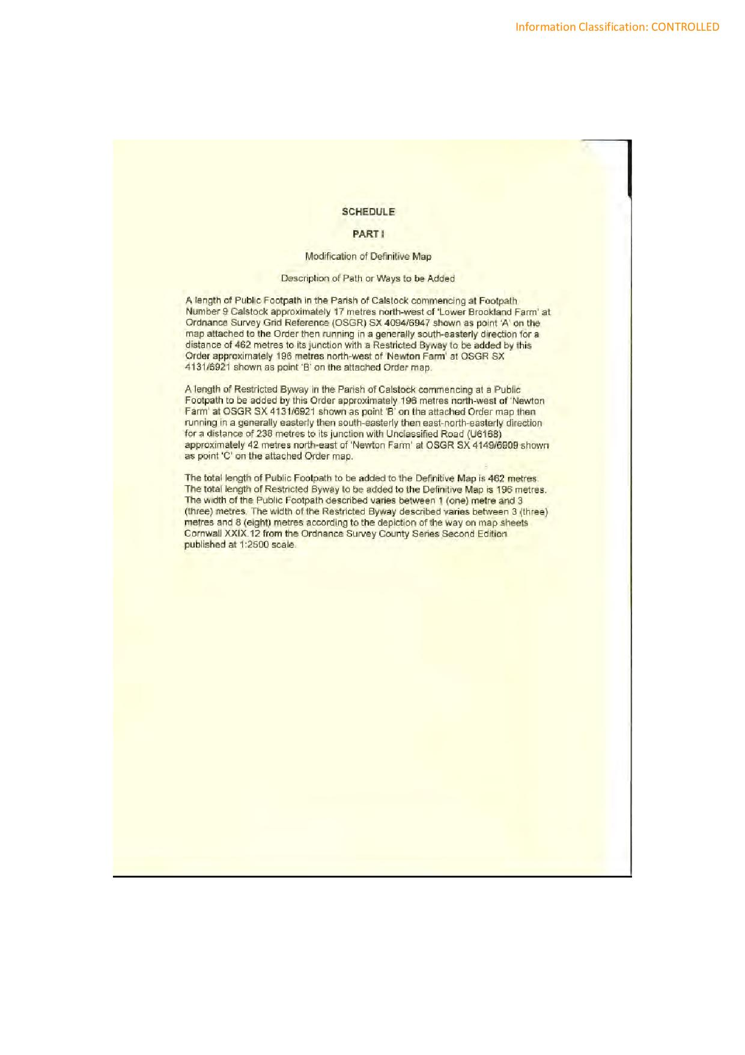

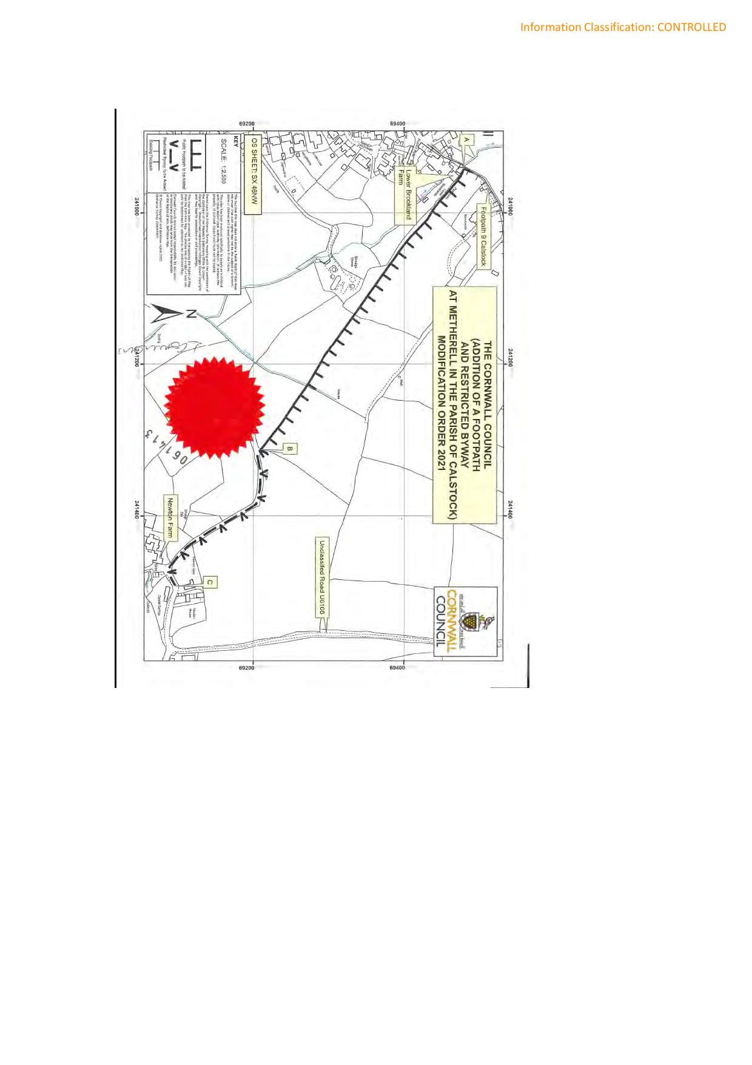

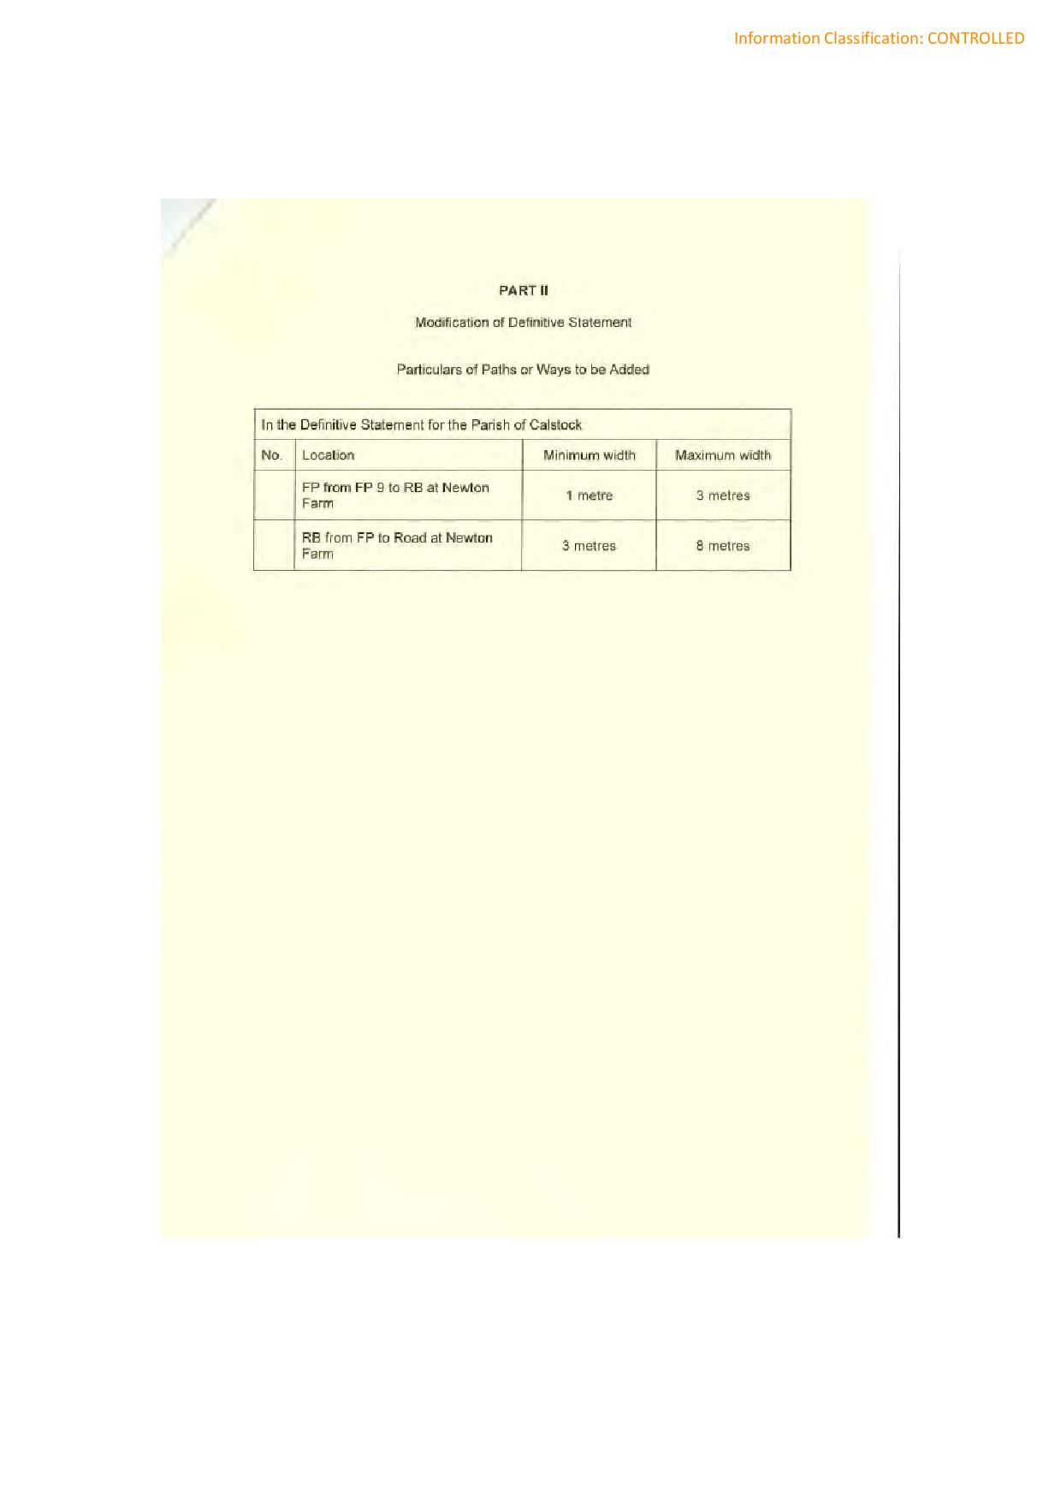

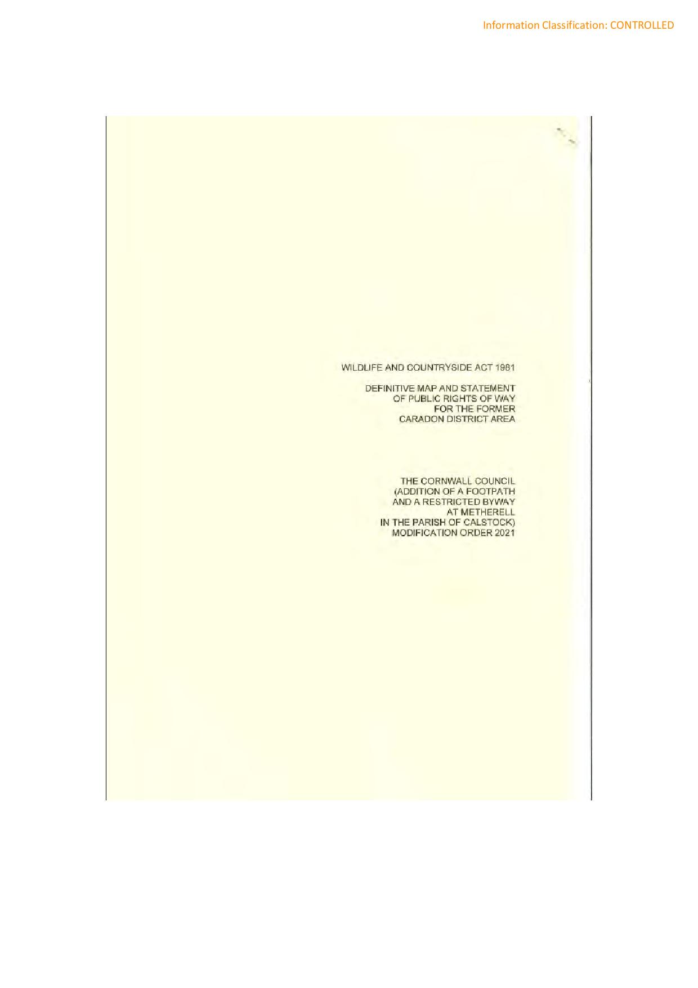

If you wish to make a legal submission, this should be submitted at the same time as your statement of case. Otherwise legal submissions will have to be submitted in writing on the day of the inquiry.

