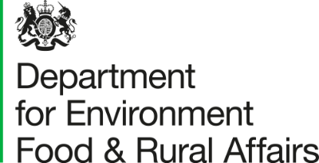

England Bovine Tuberculosis (TB) Quarterly Overview

Released: 12 June 2024
Next update: 11 September 2024

This document has been designed to complement the Accredited Official Statistics release. A further Great Britain bTB Overview showing the trends for England, Wales and Scotland is available.

These statistics have been produced to the high professional standards set out in the Code of Practice for Statistics. They are obtained from the Animal and Plant Health Agency (APHA) work management IT support system (Sam).
Feedback can be sent to: tbstatistics@defra.gov.uk

A – Herd Incidence
Figure A1 - New herd incidents per 100 herd years at risk of infection
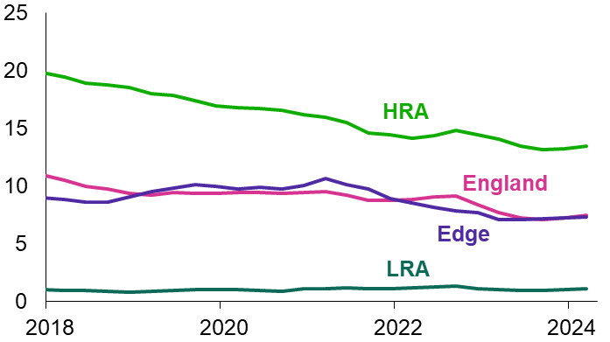
The headline incidence rate in England between April 2023 and March 2024 was 7.5, a decrease of 0.2 compared to the previous year. This means that for every 1,000 unrestricted herds in a year, we would expect a new bTB breakdown to be detected in 75 herds. The incidence rates in the HRA decreased compared to the previous 12 months, while the other two risk areas increased.

Table A1 – New Herd Incidents
Date | England | HRA | Edge | LRA
2021 | 2,865 | 2,161 | 576 | 128
2022 | 2,954 | 2,304 | 497 | 153
2023 | 2,461 | 1,872 | 450 | 139
Apr 2022 - Mar 2023 | 2,714 | 2,114 | 457 | 143
Apr 2023 - Mar 2024 | 2,491 | 1,886 | 455 | 150
% change | -8% | -11% | -0% | +5%

B – Herd prevalence
Figure B1 - Disease restricted herds as a percentage of registered herds
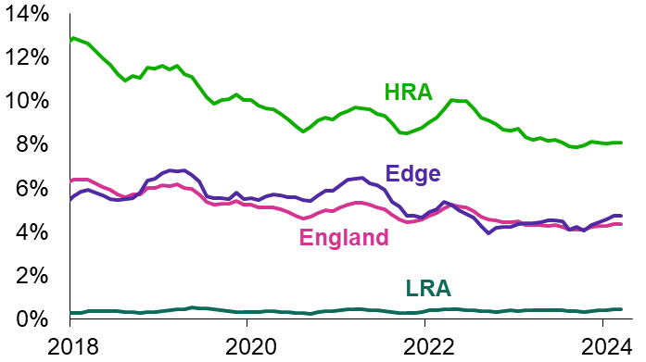
At the end of March 2024, 4.4% of herds were not TB-free in England, compared to 4.3% 12 months before. High Risk Area prevalence decreased from 8.2% to 8.1% between March 2023 and March 2024. Edge area prevalence has seen a year-on-year increase and is above the England rate.

Table B1 – Herds not OTF due to a bovine TB incident
Date | England | HRA | Edge | LRA
2021 | 2,131 | 1,682 | 387 | 62
2022 | 2,076 | 1,648 | 351 | 77
2023 | 1,901 | 1,475 | 353 | 73
At 31 Mar 2023 | 1,986 | 1,548 | 361 | 77
At 31 Mar 2024 | 1,922 | 1,466 | 372 | 84
% change | -3% | -5% | +3% | +9%

C – Total animals slaughtered
Figure C1 – Test positive animals and direct contacts slaughtered
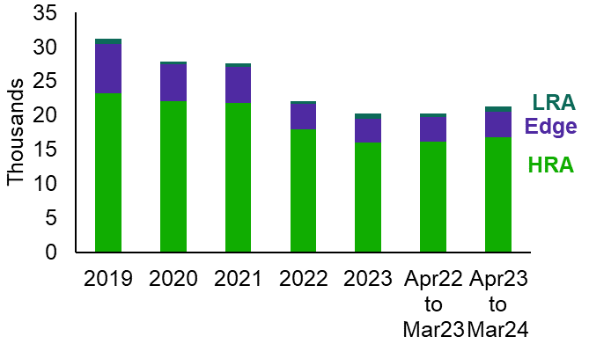
Between April 2023 and March 2024, 21,298 cattle were slaughtered in England due to a TB incident, compared to 20,212 for the previous 12 months, a 5% increase.

D – Total cattle tests
Figure D1 – Cattle tests
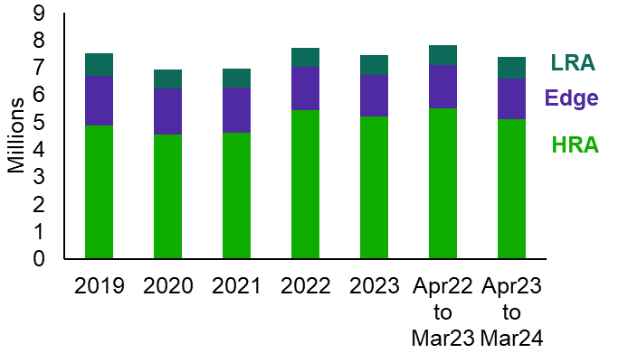
Total cattle tests in England between April 2023 and March 2024 were over 7.3 million, a 6% decrease on the previous 12 months. The HRA and Edge saw decreases in the number of tests compared to the previous 12 months, while the LRA saw an increase.

A – New herd incidents per 100 herd years at risk
12 months to end | England | High risk area | Edge  area | Low risk area
March 2023 | 7.7 | 14.1 | 7.1 | 1.0
March 2024 | 7.5 | 13.5 | 7.3 | 1.1

B – Disease restricted herds as a percentage of registered herds
At end | England | High risk area | Edge  area | Low risk area
March 2023 | 4.3% | 8.2% | 4.4% | 0.4%
March 2024 | 4.4% | 8.1% | 4.7% | 0.5%

C – Total animals slaughtered
12 months to end | England | High risk area | Edge  area | Low risk area
March 2023 | 20,212 | 16,118 | 3,602 | 492
March 2024 | 21,298 | 16,783 | 3,791 | 724
% change | +5% | +4% | +5% | +47%

D – Total cattle tests
12 months to end | England | High risk area | Edge  area | Low risk area
March 2023 | 7,833,560 | 5,504,799 | 1,583,734 | 745,027
March 2024 | 7,374,415 | 5,119,066 | 1,488,763 | 766,586
% change | -6% | -7% | -6% | +3%

Short term changes in these statistics should be considered in the context of long term trends published in the quarterly datasets.

Media Enquiries to: 020 8225 7318 (Press Office)

TB Areas of Great Britain
This table highlights the measures included in this document along with the others available in the Accredited Official Statistics release.
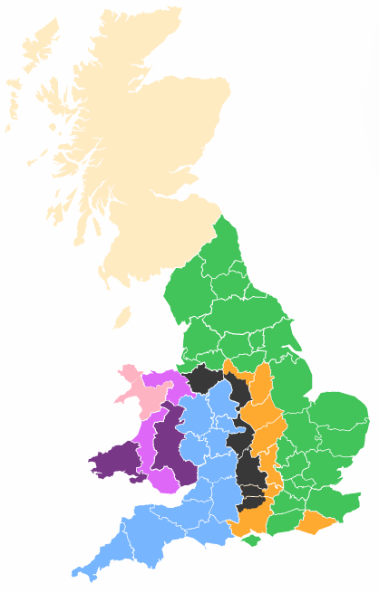
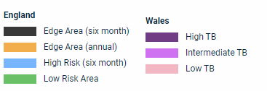
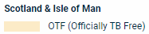
This map was sourced from TB Hub.
Testing intervals for England are available online.
This data is based on Edge area definition since January 2018.
An interactive dashboard is also available.
Label | Measure | Description
A | New herd incidents per 100 herd years at risk of infection during the year | This is the headline measure of herd incidence. See “Herd incidence methodology paper”.
 | New herd incidents where OTF status is withdrawn (OTFW) per 100 herd years at risk of infection during the year | In the LRA there are proportionately more false positive results to the skin test than elsewhere in England. Consequently it is also important to consider the number of new herd TB incidents where officially TB free status is withdrawn (OTFW) following confirmation of TB.
B | Number of non-OTF herds at the end of the period as a percentage of registered herds | Herd prevalence is not published at county level but may be derived from the county number of herds and non OTF herds measures.
 | Number of cattle herds registered on Sam | By the end of 2023 there are roughly the same number of registered herds in the Low and High Risk Areas at around 18,250 and 18,500 respectively. In the Edge area there are approx. 7,950.
B1 | Herds not officially TB free at the end of the period due to a bovine TB incident (non OTF herds) | Herds which were not officially TB-free (OTF) due to a TB incident, at the end of the month specified i.e. herds with an open breakdown with OTF status suspended or withdrawn.
 | Herds not officially TB free during the period due to a bovine TB incident (non OTF herds) | Herds with OTF status suspended or withdrawn due to a TB incident, during the period shown. A herd with more than one incident in the period will be counted more than once.
 | Herds under movement restrictions at the end of the period | Counts the number of herds that have had a restriction notice served in the period and is still in effect at the end of the period. Restrictions could be due to:   TB testing or detection at slaughterhouse   Overdue test   Some movement restrictions on animals testing as IRs pending their next test.
 | Total tests on herds | Herds for which tuberculin skin testing is carried out on at least one animal. Excludes:   Pre- and post-movement (these are published online separately)   Gamma interferon blood tests   Private tests.
 | Tests on officially TB free herds (OTF) | Any test carried out in an OTF herd. Excludes:  Pre- and post-movement, Gamma interferon blood tests, Short interval tests, Private tests, TB Unit Tests.
D | Total cattle tests | The number of tests on cattle. An individual animal could be tested more than once in each time period. Includes interferon-gamma blood tests and antibody tests that have been completed. Data for Scotland does not include antibody tests.
A1 | New herd incidents (NHI) | Herds which were previously OTF but either had cattle that reacted to a tuberculin test or had a tuberculous animal disclosed by routine meat inspection at slaughter.
 | NHI of which: officially TB free herd status withdrawn (OTFW) | OTF is withdrawn either because:   Lesions typical of TB detected at post-mortem examination of test reactors or inconclusive reactors, or   Samples from one or more reactor, inconclusive reactor or a slaughterhouse case produce PCR and/or positive culture results for M bovis.
 | NHI of which: officially TB free herd status suspended (OTFS) | OTF suspended because of reactors in the herds, but post-mortem evidence of TB is not detected. It remains suspended until further herd tests confirm no infection on the farm.
 | NHI of which: still unclassified TB Incidents (pending culture results) | Not currently OTFW, but where testing was still underway and could become OTFW if tests revealed any reactors with post-mortem evidence of TB or a PCR and/or positive culture result.
C | Total animals slaughtered | TB test positive animals slaughtered + Inconclusive reactors slaughtered + Direct contacts (DC) Slaughtered.
 | TB test positive animals slaughtered | Count of animals compulsorily slaughtered because it responded to the tuberculin skin test, antibody test, or interferon-gamma test in a way that was consistent with it being infected with M bovis.
 | Inconclusive reactors slaughtered (Wales only and starts April 2017) | Inconclusive reactors are animals showing positive reactions to bovine tuberculin that are not strong enough for them to be deemed reactors.
 | Direct contacts (DCs) slaughtered | An animal in an OTFW incident that, although not a test reactor, was considered to have been exposed to M bovis and compulsorily slaughtered.
 | Slaughterhouse cases reported to APHA | Non-reactor and non-direct contact animals that displayed suspect lesions of TB during post-mortem meat inspection at routine slaughter.
 | Confirmed slaughterhouse cases | Slaughterhouse cases where laboratory tests have confirmed presence M bovis.
© Crown copyright 2024

