Annexes:
Ecological survey and assessment for woodland creation (England)

Annexes

Annex 1 Process of development of guidance, consultation and steering group membership
- 20 ecological consultants were emailed in July asking for feedback on the current survey instructions. Replies were received from 5
- a further 2 consultants were asked if they would give more detailed feedback on a revised draft (they were chosen because they had carried out a number of surveys using the instructions in 2021 and 2022)
- key stakeholders were asked to contribute to the review as follows, and those in bold provided responses: RSPB; Natural England; Institute of Chartered Foresters; White Rose Forest; ConFor; Yorkshire Dales, North York Moors and Northumberland National Parks; MoD
- the majority of comments received were positive, with some useful suggestions put forward. Comments were incorporated wherever possible and all consultees were thanked for their input and provided with an explanation in cases where their comments had not been included

Steering group members:
Meg Coates (FC)
Bob Cussen (NE)
Jeremy Dick (FC)
Jay Doyle MCIEEM (FC)
Kath Godfrey (NE)
Steve Heaton MCIEEM (NE)
Lisa Kerslake CEcol FCIEEM (FC)(Chair)
Keith McSweeney (FC)
Orlando Methuen-Campbell ACIEEM (FC)
Callum Nixon (FC)
Ellen Payton (NE)
Dan Turner (NE)
Phil Wilson MCIEEM (FC)

As well as the above, thanks are also due to the following for their comments/contributions:
Ross Ahmed, Bob Edmonds, Declan Ghee, Sally Hayns, James Longley, Tony Martin, Mark Nason, Jason Reynolds, Tim Ross, Jackie Smith, Lizzie Walker, Rob Weston.

Annex 2 Standard survey payments

Hectare | Peat | Habitat (NVC) | Birds | Note
Payment per hectare up to first 20 ha | £15.00 | £65.00 | £100.00 | Tiers applied to manage variation in costs due to size
Payment per hectare for every ha over 20 | £15.00 | £10.00 | £15.00

These payment rates apply where WCPs opt to accept a flat rate rather than obtaining 3 quotes. The rates will come into effect at the end of November 2023.

The rates currently apply only to the specific surveys indicated above. They do not currently apply to preliminary surveys, UKHab habitat surveys or any other survey type. Rates for these will be provided in due course.

Annex 3 Pricing schedule
Not to be completed if proposing to use FC provided standardised survey costs.

Woodland creation proposal: ………………………………….

Costs supplied by: …………………………………………………….

Date of quotation: …………………………………………………….

OVERALL COSTS

Direct purchases at cost | Description | ESTIMATED cost ex. VAT | Cost incl. VAT (if applicable)
Data search costs | Fees charged by LERC or other bodies for provision of data
OS map data | Purchase of OS mapping data and licences (for production of maps)
TOTAL

For the completion of/tasks | Sub-tasks | Cost ex. VAT | Cost incl. VAT (if applicable)
Health and safety documentation
Desk study & interpretation of LRC or similar data
Survey and assessment fieldwork
Travel, accommodation and subsistence
Reporting and impact assessment
External review, where needed (e.g. sole traders)
TOTAL

Annex 4 Day rates
NOT TO BE COMPLETED IF PROPOSING TO USE FC PROVIDED STANDARDISED SURVEY COSTS

DAY RATES USED TO CALCULATE OVERALL COSTS
Task/s | Sub-task/s | To be undertaken by | Cost ex. VAT | Cost incl. VAT (if applicable)

Costs for all items should be based on the Forestry Commission’s Ecological Survey and Assessment for Woodland Creation in England.

In addition, itemise and cost individually all other work you identify as required in order to fulfil the brief (using the blank rows and any additional sheets necessary).The costings should include estimated expenses.

Signed …………………...........................................................................................
On behalf of ………………………………………………………………………………………………
Position ……………………………………………………………………………………………………
Company address ……………………………………………………………………………………….
Company telephone …………………………………………………………………………………….
VAT number (where relevant) …………………………………………………………………………..
Company registration number (where a limited company): ………………………………………….

Annex 5 Bespoke plants, fungi and lichen survey methodology for new woodland creation

Additional qualifications and experience
The surveyor must be able to:
- operate at minimum FISC Level five. If a FISC assessment hasn’t been undertaken, evidence of the surveyor’s ability to operate at this level must be provided
- effectively review existing species records to generate a list of target species for surveying
- provide evidence of the surveyor’s ability to effectively identify and record bryophytes, lichens and charophytes or of a subcontractor able to do this type of work where needed. The taxonomic expertise required will be informed by the characteristics of the site
- use cover values (DAFOR, % cover)
- record, transpose and map grid references
- use the referee system to identify unknown plants and verify records
- assess the importance of populations at geographical scales
- understand the specific requirements of target species to make assessments of population sustainability
- report clearly and concisely

Additional desk study and data search
Prior to the survey, the surveyor should review historic records from the parcel and vicinity, noting which noteworthy species have been present. Historic records for vascular plants and charophytes may be accessed with permission via the BSBI database BSBI Distribution Database. NBN datasets are too incomplete for vascular plants and charophytes and should not be used for these groups.
NBN data may be used to view bryophyte, fungi and lichen records. Alternatively, a data search from a local records centre could be commissioned for these groups. Although some bryophytes, fungi and lichen are readily identifiable, many of the rare, threatened and notable species are difficult to identify without specialist knowledge and experience. In order to carry out an up-to-date assessment of the interest of a site proposed for tree planting, a suitably experienced surveyor would ideally carry out a survey. It is recognised that in practice this is unlikely to be feasible for most proposed tree planting sites. So in order to assess the bryophyte, fungi and lichen interest of such sites, you should make a desk-based assessment. Past records of the bryophytes, fungi and lichens for the site should be reviewed by checking the records on the NBN (or other taxon group focused repositories of records). If records of significance are found for a site, these may be sufficient for a decision about tree planting or an experienced specialist surveyor may need to undertake a field assessment. It is considered likely that many sites of significance for bryophytes will also be highlighted as significant by the vascular plant assessments.
Field survey methods:
Surveys should be scheduled to reflect the peaks in the flowering periods of habitats at the surveyed parcel/s. Some parcels may require 2 or more visits to judge the interest, where multiple habitats are present or where a habitat has two distinct peaks in interest. For example, spring and summer for autumn and spring cultivated arable margins respectively.
As a guide, the following times are appropriate for these broad habitats/groups:
Woodland and scrub: April to May
Grassland: April to May and July to August (prior to hay cut if relevant)
Heathland: June to August
Wetland: June to September
Rock exposures: February to May
Sand dune: April to June
Arable, horticulture: April to May and July to Aug
Brownfield, urban: May to July
Upland: May to July
Bryophytes: October to March
Fungi: Fruiting period of the target species – usually autumn or spring
Lichen: January to December

In the field:
- the whole of the parcel should be walked noting communities (mentally noting is ok as this is not a habitat/NVC survey) to guide closer inspection
- all habitat types should be visited
- typically species-rich or otherwise interesting habitat features such as flushes, arable margins, transitions, open ground or ancient fragments, should be inspected in detail
- the surveyor should bear in mind the potential for tree planting to have environmental impacts on the surrounding area outside the footprint of the proposed planting area, including but not limited to increase shading, shelter, leaf-fall or hydrological change. Such areas should also be surveyed
- all species and subspecific taxa present should be recorded
- critical taxa should be attempted (or representatively sampled) rather than recording aggregates
- photographs and/or specimens of plants not identifiable in the field should be taken for later identification or passing to experts (for example, VC recorders or the BSBI panel of referees)
- records should be in the form of a list of species and subspecific taxa with DAFOR scale assigned to each species. For larger or complex sites it may be desirable to break the list down by habitat or parcel
- for all noteworthy species* a 10-figure grid reference should be recorded (and accuracy of the GPS device noted), photographs taken and a note made describing the population size and habitat

*A noteworthy species is any species that is any of the following:
- listed in an IUCN threatened category (CR, EN, VU) or an extinct category (RE, EW, EX) on the Vascular Plant Red List for England
- Nationally Rare or Nationally Scarce
- listed on Schedule 8 of the Wildlife and Countryside Act (as amended)
- listed on Section 41 of Natural Environment and Rural Communities (NERC) Act
- an axiophyte Vascular plant 'axiophyte' scores for Great Britain
- listed on relevant county rare plant register (if one exists for the vice county in which the proposal is sited) or potential to be listed under the RPR guidelines (if one doesn’t yet exist for the vice county in which the proposal is sited) Rare Plant Registers (BSBI)
- a species in a critical genus typically recorded as an aggregate, for example Rubus, Taraxacum, Hieracium, Euphrasia

Conservation designations for UK taxa may be viewed here: Conservation designations for UK taxa (JNCC)
Assessment of the likely impacts and mitigations
For each noteworthy species the importance of the location to the species should be determined and an assessment made of its sustainability at the location under ideal management, under the recent prevailing management, and if planted per the proposal.
Cumulative impact (for example in relation to other woodland creation proposals in the area) and consideration of impacts on functionally linked land (for example ground water dependent ecosystems) should be assessed. A brief overview of potential mitigation and/or compensation measures to address any negative effects may be included where the landowner has agreed to mitigate or compensate on land that is within their control. Suggestions for mitigation or compensation that cannot be secured in this way should not be included. A summary of the assessment information may be provided in tabular format, if appropriate.
Reporting
The report should include:
- a list of all plant species present at the surveyed parcel, each with their abundance indicated using DAFOR scale. This list may be broken down by habitat or sub-parcel for larger sites
- minimum 10-figure grid references for all instances of noteworthy species, alongside their population attributes and habitat. Grid references should be provided in table form in the report and as a shapefile
- a map highlighting the area covered by the survey, including any areas outside the parcel to be planted which may be impacted. Locations of noteworthy species should be mapped onto a basemap of the surveyed parcel with a legend indicating the species
- photographs of noteworthy species recorded and their habitats
- an assessment of the importance of the location to each noteworthy species
- an assessment of the sustainability at the location of each noteworthy species under ideal management, under the recent (for example 10 years) prevailing management and if planted with trees as per the proposal. Sustainability of populations may include interpretation of signs of successful regeneration (flowering, seed set, presence of seedlings), extent and proximity of suitable habitats and historic trends
- possible mitigations were relevant, such as recommendations for alterations to the planting proposal to avoid detrimental impacts on noteworthy species and their habitats
- assessment of site suitability
Plant records should be submitted to the relevant BSBI vice county recorder.
Assessment of site suitability
You must assess and make recommendations about the suitability of the site for woodland creation. Note that there is a presumption against planting on priority open habitats with the exception of a limited number of circumstances as outlined in Principles for afforestation on or near priority habitats. Where woodland creation is deemed appropriate and open habitat is to be retained, you should make recommendations about methods and viability of future management, for example whether the site could be maintained by grazing or hay cutting. You should show your conclusions on a map of the footprint divided into green, amber and red zones:
□ green = woodland creation appropriate, for example, no noteworthy plant species present. No impacts likely on nearby habitat supporting noteworthy plant species
□ amber = woodland creation may be appropriate (subject to FC and NE approval). For example, noteworthy plant species present as part of a locally important population. Woodland creation design plan can effectively accommodate and enable sustainable management of population
□ red = woodland creation not appropriate. Noteworthy plant species present in populations important at regional/national/international scales. Woodland creation design plan cannot effectively accommodate and ensure sustainable management of population, and will compromise it
Alex Prendergast - Vascular Plants Senior Specialist, Natural England

Tailored example – Rare Arable Plants – To be supplied in due course

Annex 6 Seasonal effectiveness of grassland survey

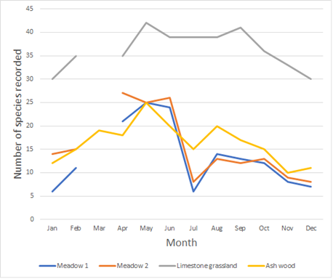

Seasonal effectiveness of grassland survey
The graph shows number of species recorded in 5 x 5m permanent plots visited by an expert botanist in a number of species-rich habitats over the course of a year from April 2019 to March 2020. Each plot was divided into 16 cells to aid intensive search purposes. Plots were recorded in two meadows, a limestone grassland and an ash woodland. The data demonstrate the importance of the timing of the survey in identifying interest/habitat value.

For the two meadow plots surveyed these graphs show a steep decline in species diversity apparent following hay cut in early July (last one not recorded because of Covid restrictions).

Annex 7 Assessment of good quality semi-improved grassland*

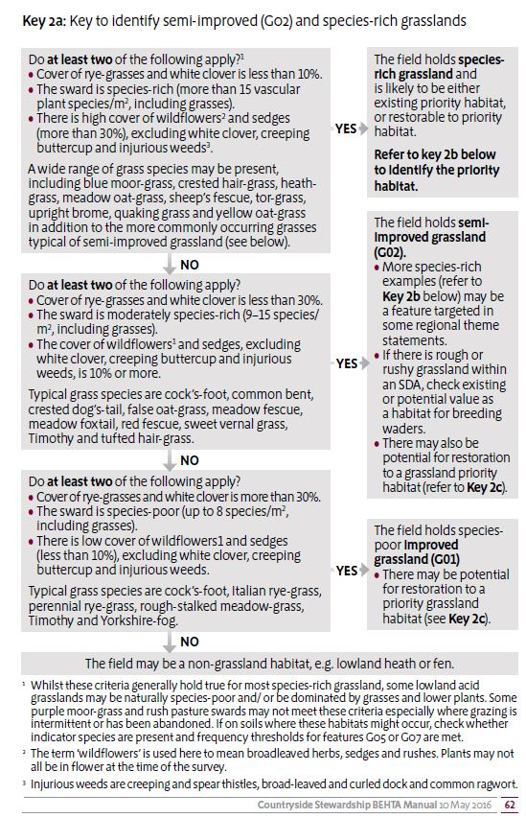
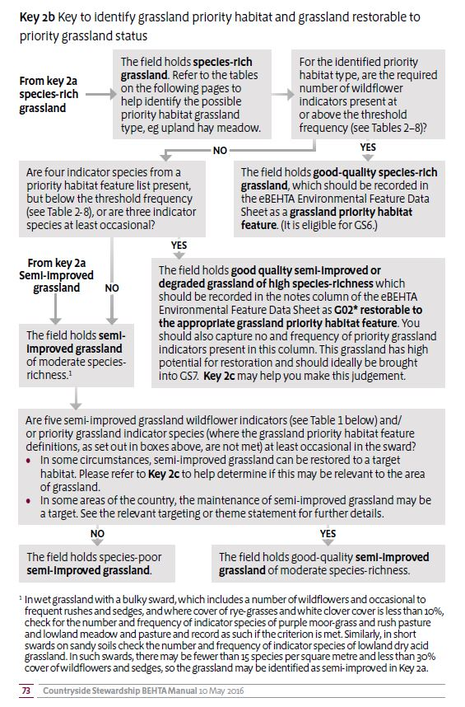

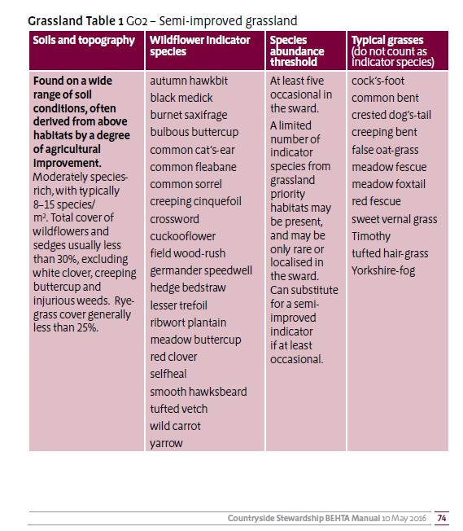

*The above documents are extracts from Natural England’s Countryside Stewardship Baseline Evaluation of Higher Tier Agreements (BEHTA) Manual Part 2. Second Edition – May 2016.

If you would like a full copy, please contact your local Natural England adviser.

Annex 8 Research-based rationale for revised breeding bird survey methods (updated 2023)
A bird survey method in relation to woodland creation was developed in late 2021, for surveys due to take place in 2022. Whilst aimed primarily at breeding waders, it was also designed to gather data on other important species. It incorporated three separate survey methods - and there was confusion due to complexity and difficulties due to the number of survey visits required to follow the method.
We convened a group of ornithologists and other practitioners to review the method, with the aims of reducing complexity and survey effort without significantly compromising results. The group comprised members of the BSGG, NE and FC. BTO and RSPB were consulted and, based on their advice, a revised method was developed. In essence, this comprised 3 visits to the buffer (waders only), using one method that is a combination of the two previously used. It also comprised 4 visits to the planting footprint, using the BSGG method, and focusing all priority species (S1, Annex 1, Red and Amber BoCC, SPI), unless there are also non-priority specialist species that need to be recorded.
It was agreed that the situation would be kept under review, and that the last 2 years’ survey results would be used to carry out an analysis of survey efficacy, to inform the optimum number of visits.

This analysis was carried out in 2023 by Edinburgh Napier University/Findlay Ecology Services. It provided general support for the suggestion that 4 visits may represent an adequate trade-off between effort and efficacy, particularly in relation to an assessment of species-richness (10-11% reduction in species richness for a reduction in visits from 6 to 4 – 33%). Territory density reduction however, was found to more or less match the reduction in survey effort at 33%. Whilst this may have an implication in particular for wader territory densities, standard surveys for breeding waders typically comprise either 2 or 3 visits. This means our approach of 4 visits in the site footprint and 3 in the buffer would generally be considered more than adequate. However, we will keep the results of breeding wader surveys under review.

Annex 9 Example survey map and density calculation
This Annex provides a hypothetical example of a survey map and table to help guide the presentation of bird survey results and calculation of wader breeding density.
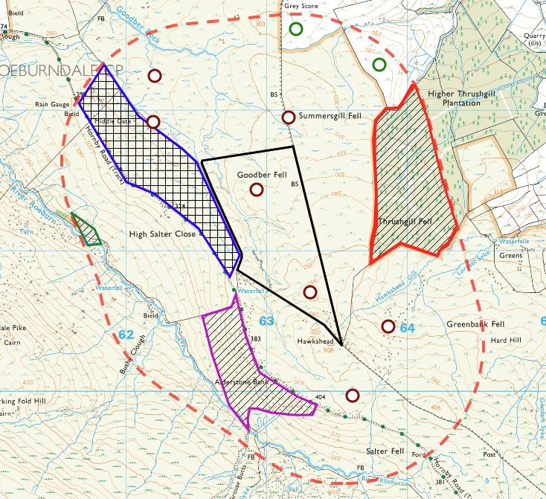
Key
Black line – proposed woodland creation site
Red dashed line – 1km buffer extent
Red and green hatch – existing woodland
Magenta hatch – area of slope >20° (unsuitable for waders)
Blue cross hatch – area of refused access permission
Brown – curlew territories (7)
Green – lapwing territories (2)
Exclusions from density calculation
Existing woodland: Thrushgill Fell 0.5 km²
R Roeburn 0.02 km²
Slope >20°: Alderstone Bank 0.27 km²
Access refusal: Middle gate 0.51 km²
Total area excluded: 1.3 km²

Summary table
 | Planting site |  | Buffer |  | Total
Total areas | 0.63 km² |  | 6.82 km² |  | 7.45 km²
Area minus exclusions | 0.63 km² |  | 5.52 km² |  | 6.15 km²
Species | Pairs | Density  (km⁻²) | Pairs | Density  (km⁻²) | Pairs | Density  (km⁻²)
Curlew | 2 | 3.17 | 5 | 0.91 | 7 | 1.14
Lapwing | 0 | - | 2 | 0.36 | 2 | 0.33

Annex 10 Report templates/checklists
This annex contains report templates/checklists for Vegetation Survey and Assessment (p18) and Breeding Birds (p24). If you require a Word version of these templates please contact your FC Area Ecologist as below.

East and East Midlands
Meg Coates meg.coates@forestrycommission.gov.uk

North-west and West Midlands
Phil Wilson phil.wilson@forestrycommission.gov.uk
Callum Axford-Nixon callum.nixon@forestrycommission.gov.uk

South-east and London
Sebastian Crichton sebastian.crichton@forestrycommission.gov.uk

South-west
Richard Knott richard.knott@forestrycommission.gov.uk

Yorkshire and North-east
Lisa Kerslake lisa.kerslake@forestrycommission.gov.uk
Keith McSweeney keith.mcsweeney@forestrycommission.gov.uk

Vegetation Survey and Assessment - Report Template

This template has been produced to supplement the Ecological Survey and assessment for woodland creation (England). It is not mandatory to use but is intended to make it clear what is required in survey reports produced for woodland creation following the FC guidance. It is not a substitute for the guidance, which contains the full details you will need.
A draft of the report should be submitted in MS word format to enable commenting by FC and other partners (e.g. Natural England). Pictures may need to be compressed for the draft or sent via a file transfer system. Final versions can be sent in pdf format and pictures should be high resolution.
Broad principles:
- Include important information set out in survey instructions but be concise.
- Any photographs utilised in the report must be labelled to clearly indicate what they are showing and where they were taken.
- We would encourage all consultants to use and refer to the ‘CIEEM Guidelines For Ecological Report Writing (2017)’ & to ensure clarity within their reports.
Attach shapefiles to the report. Preferred formats are geodatabase or shapefiles.

Report checklist:
Contents:
Include a detailed breakdown of each section of the report with corresponding page numbers. The below are suggested sections.
- Executive Summary
- Introduction
- Methods
- Desk Study
- Results
- Assessment of Site Suitability
- Appendices

Executive Summary:
☐ Basic description of the brief presented
☐ Brief description of the site
☐ Brief description of results of desk and field visit
☐ Headline conclusions

Introduction:
☐ In depth description of the brief, the site location and the survey type
☐ Scope and aims of the survey and report
☐ Include basic map of the site set within the wider context
☐ Staff who undertook the survey and their qualifications – ensure this complies with the requirements in the survey specifications

Methods:
☐ State level of desk study undertaken
☐ State dates, times and surveyors for visits
☐ Detail survey methods including National Vegetation Classification (NVC) or UKHab
☐ If software was used to analyse NVC results please give its name
☐ State the number of quadrats assessed during the survey with a list of vegetation communities and number of quadrats analysed for each (ideally 5)
☐ Condition assessment utilising the statutory biodiversity metric
☐ Any limitations that may have impacted on the survey effort

Desk Study:

☐ Include sources of information, Local Record Centre, MAGIC etc.
☐ Include closest records of notable species, their distance and direction from the site on a map
☐ Include details of any nearby statutory designated sites or Local Wildlife Sites
☐ Include details of any nearby Priority Habitats
☐ Include details of any other important habitats including grass moorland, fragmented heath, Good Quality Semi-improved Grassland and no main habitat but additional habitat exists
☐ Interpretation of data search records (full records in appendix)

Results:
☐ Summary of NVC/UKHab, indicating where Priority or important Habitats
☐ At least 1 map detailing habitat types, with further maps for complex sites
☐ At least 1 map showing any Priority Habitat and other important habitat present within the site cross referenced to any tables
☐ At least 1 map showing the NVC/UKHab communities and locations of each quadrat surveyed and quadrat data clearly laid out in tabular format
☐ Describe each NVC/UKHab community under a separate heading
☐ Describe each Priority Habitat/other important habitat type under separate headings, with condition assessments utilising the Biodiversity Metric Technical Annex 1
☐ The quadrat data, including 8 figure grid reference, for each NVC community should be presented after the NVC/UKHab community description alongside the results of any computer analysis e.g. Tablefit
☐ If relevant please include a full species list for each NVC community with DAFOR in a tabular form
☐ Include photographs representative of the main vegetation communities found

Assessment of Site Suitability:
☐ Detail of any buffer areas that may be needed for onsite/offsite Priority Habitats
☐ Red/Amber/Green map showing areas where woodland creation is not appropriate/may be appropriate/is appropriate. Any comments made in this section must be clearly linked to the findings of the survey
☐ Where relevant, provide comment on cumulative impact and on open habitat management and its functional connectivity

Table 1 – Communities on site
UKHab Classification | NVC Code | NVC Community | Corresponding Priority Habitat Type | Condition Assessment | Area on Site (ha)
Table 1. Example table showing vegetation communities (Delete NVC/UKHab as applicable)

Table 2 – Example M23b Quadrat Data
Species | Quadrats Domin Values |  |  |  |  | Frequency | Range
 | Q1 | Q2 | Q3 | Q4 | Q5
 | SD1234 1234 | SD0987 7890 | SD4332 1234 | SD5688 8765 | SD5432 7890
Juncus effusus | 9 | 10 | 10 | 10 | 9 | V | (9-10)
Holcus lanatus | 6 | 4 | 3 | 3 | 4 | V | (3-6)
Lotus pedunculatus | 2 | 3 | 2 | 4 |  | IV | (2-4)
Galium palustre | 1 |  | 2 | 2 | 2 | IV | (1-2)
Cirsium palustre | 4 |  | 4 |  | 4 | III | (4)
Calliergonella cuspidata |  | 2 | 2 |  | 3 | III | (2-3)
Ranunculus repens |  | 4 |  | 4 |  | II | (4)
Equisetum palustre | 2 |  |  | 3 |  | II | (2-3)
Kingbergia praelonga |  | 1 |  | 2 |  | II | (1-2)
Cardamine flexuosa |  |  |  |  | 2 | I | (2)
Prunella vulgaris |  |  |  | 1 |  | I | (1)
Brachythecium rutabulum | 1 |  |  |  |  | I | (1)
Table 2 is an example of how the quadrat data for each plant community should be presented within the Results section.

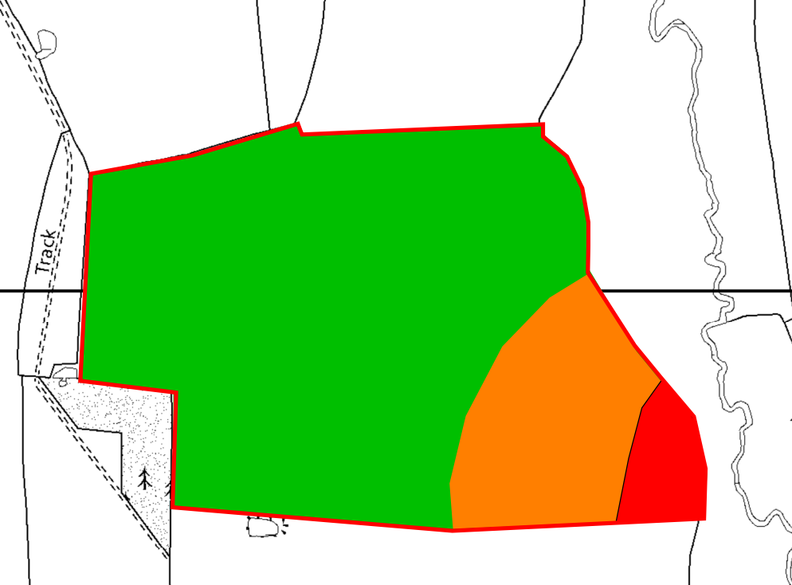
Figure 1. Example of a Red Amber Green (RAG) Map indicating where the surveyor considers land appropriate for planting, where it requires professional judgement and where it isn’t appropriate.

Table 3 – Attributes for shapefiles
Polygons:
NVC / UKHab | Date | Condition assessment result | RAG status | Priority habitat | List of habitat codes
Survey type used | Date surveyed | Poor/Mod/ Good | Red/Amber/ Green | Priority habitat type/Important habitat (e.g. waxcap grassland, GQSIG, etc)/Not priority habitat | UKHab and/ or NVC code for each mapped polygon
Points:
Target notes
Description of feature

Breeding Bird Survey - Report Template

This template has been produced to supplement the Ecological Survey and assessment for woodland creation (England). It is not mandatory to use but is intended to make it clear what is required in survey reports produced for woodland creation following the FC guidance. It is not a substitute for the guidance, which contains the full details you will need.
A draft of the report should be submitted in MS word format to enable commenting by FC and other partners (e.g. Natural England). Pictures may need to be compressed for the draft or sent via a file transfer system. Final versions can be sent in pdf format and pictures should be high resolution.
Broad principles:
- Include important information set out in survey instructions but be concise
- Separate information for buffer area and woodland creation (planting) site
- Be clear where density results have been recorded or calculated from
- Be clear what has and hasn’t been surveyed and give explanation for areas excluded
- Present timings of visits in tables (format below)
- Any photographs utilised in the report must be labelled to clearly indicate what they are showing and where they were taken
- We would encourage all consultants to use and refer to the ‘CIEEM Guidelines For Ecological Report Writing (2017)’ & to ensure clarity within their reports
Attach shapefiles to the report including planting site and buffer areas surveyed. Preferred formats are geodatabase or shapefiles.

Report checklist:

Contents:
Include a detailed breakdown of each section of the report with corresponding page numbers. The below are suggested sections.
- Executive Summary
- Introduction
- Methods
- Desk Study
- Results
- Discussion/Conclusions
- Appendices

Executive summary:
☐ Basic description of the brief presented
☐ Brief description of the site
☐ Brief description of results of desk and field visits
☐ Headline conclusions

Introduction:
☐ In depth description of the brief and the site location
☐ Scope and aims of the survey and report
☐ Include basic map of the site set within the wider context
☐ Factors on site that could impact breeding waders
☐ Staff who undertook the survey and their qualifications – ensure this complies with the requirements in the survey guidance

Methods:
☐ State level of desk study undertaken
☐ State dates, times and surveyors for visits. (See tables 1 & 2 below)
☐ If visits/timings are outside of the survey requirements explain the reasons why (surveys completed outside of the required timings may not be accepted)
☐ List equipment used for survey (e.g. thermal imaging/acoustic/other technology)
☐ Include maps of areas that were/weren’t able to be accessed/surveyed
☐ If any areas were unable to be accessed, give details of why e.g. owner of buffer land refused access permission
☐ Confirmation that survey method in guidance followed (no deviation from this allowed without prior agreement with FC)
☐ Include map of transect route followed for planting site and buffer
☐ Any limitations that may have impacted on the survey
☐ Include clear map of area surveyed or excluded. It is expected that the whole eligible planting site is surveyed. Annex 9 of the survey instructions shows an example survey map

Table 1 - Woodland creation site survey:
Visit number: | Required date window: | Date surveyed | Start time (within +/- 30mins of sunrise) | End Time (by mid-morning) | Surveyor/s
1 | 20th March – 10th April (must be done by this date)
2 | 16th April – 15th May
3 | 16th May – 15th June
4 | 16th June – 10th July (must be done by this date)

Table 2 - Buffer area survey:
Visit number: | Required date window: | Date surveyed | Start time | End Time | Surveyor/s
1 | 5th April - Mid April
2 | 5th April – 15th June (2 weeks between previous and 3rd survey)
3 | After 15th June

Desk Study:
☐ Include sources of information, Local Record Centre, MAGIC etc.
☐ Include closest records of notable species, their distance and direction from the site on a map
☐ Include details of any nearby statutory designated sites or Local Wildlife Sites
☐ Interpretation of data search records (full records in appendix)

Results:
Survey results: Maps and tables of key records including:
☐ Amalgamated map of total territories/pairs of waders and other priority species (separate maps may be needed for large areas or high numbers)
☐ If using possible, probable, confirmed: Provide separate map of total territories/pairs of probable or confirmed breeding waders
☐ Number of probable/confirmed territories recorded in site footprint, buffer and both (can be combined with Table 3 below)
☐ Lists/tables of all wader species and any Schedule 1/Annex 1/other priority species
☐ Wader density calculations (See Table 3 below)
☐ Full records/raw data from separate survey visits in appendix

Table 3 - Density calculations:
 | Planting Site |  | Buffer |  | Total
Total area (KM²)
Area minus exclusions (KM²)
Species | Pairs | Density (km⁻²) | Pairs | Density (km⁻²) | Pairs | Density (km⁻²)
Curlew
Lapwing
Redshank
Snipe*
Oystercatcher*
*Calculation for these species optional

Discussion:
☐ Any explanatory notes relating to survey, including when professional judgement had to be used

Conclusions:
☐ Forestry Commission and its partners will draw their own conclusions from the data provided. There is no need to include detailed conclusions on whether the woodland creation proposal should proceed or not

Appendices:
Include raw data here:
☐ Full data search results
☐ Maps of raw data (e.g individual survey visits) and other data (See example Figures 1 - 2)
☐ Territory maps (if not included in main body)
☐ Survey area including detail of buffer area surveyed with permission, or excluded due to no permission
☐ Attach shapefiles of all maps

Table 4 – Attributes for shapefiles:
Polygons:
Actual surveyed area/areas
Points:
Point type | Species (only wader species)
Approximate central point of each territory/pair | Curlew
 | Lapwing
 | Redshank

Example maps below:
Figure 1 - Example survey map. Black Line = Woodland creation footprint. Red dashed line = 1km buffer extent. Red and green hatch = existing woodland. Magenta hatch = area of slope >20°. Blue cross hatch = area refused access permission. Brown point = curlew territory. Green point = lapwing territory.

Figure 2 – Example route map. Red dashed line – 1km buffer survey area. Black line – woodland creation footprint. Purple line - survey route taken.

K.J. Walker unpublished data phenology.
Borthwick M.D, Findlay M.A, Briers R.A and White, P.J.C (2023). Optimisation of open-habitat bird surveys – a report to the Forestry Commission. Edinburgh Napier University/Findlay Ecology Services

