FCDO
IMPACT Programme
Building Capacity in Sustainability Reporting and Catalytic Capital
Call for Proposals - Scope of Requirement

- FCDO IMPACT Programme is inviting partners to submit proposals to deliver projects related to growing capacity on sustainability reporting in Emerging Markets and Developing Economies (Part A) & strengthening the coordination of catalytic capital providers (Part B)

- These activities will:
  - Support key networks within EMDEs to adopt and apply the new International Sustainability Standards (ISSB S1 & S2), and participate in future standard-setting consultations.
  - Support the creation of tools or methodologies for enterprises and investors to measure, disclose and allocate capital to address environmental and social risks and opportunities.
  - Strengthen coordination and collaboration within impact investment sectors in EMDEs.

The Context
Part A) – Impact Transparency
- Sustainability and climate-related factors are becoming a key part of investment decision-making. To drive quality and consistency in sustainability reporting for the needs of investors and financial markets, the International Sustainability Standards Board (ISSB) is developing standards that will result in a high-quality, comprehensive global baseline of sustainability disclosures. In 2023, ISSB released its first two standards on general sustainability and climate-related disclosures, with work underway to support jurisdictions and reporting entities in adoption.

- Support to governments, regulators, as well as to key market stakeholders (companies, accountants, stock exchanges, financial advisors, and others) will be critical in implementing ISSB standards and achieving the global baseline, but also strengthening the quality of impact investment beyond ISSB through standards and disclosures. This is especially important in Emerging Markets and Developing Economies (EMDEs) where capacity to engage with ISSB standard-setting is more constrained, and where there is also the strongest need for better data to inform investment decisions and maintain access to global financial markets.

- Complementary efforts are underway, often led by the impact investment sector, to build on the global reporting baseline and improve the scope, quality, or comparability of reports, for example through:

  - Considering other factors beyond climate and sustainability.
  - Enabling companies to account for broader impact on stakeholders and systems (i.e. impact that may not be considered ‘financially material’ to a firm’s performance).
  - Assessing the monetary value of impact.

- The above are all critical factors in mobilising finance for the SDGs and climate transition. That is why FCDO has committed in the 2023 Development White Paper to “ensure appropriate global regulations and standards that do not unduly inhibit flows of finance to low- and middle-income countries, while encouraging adoption of globally accepted accounting and sustainability standards, working across Government and with international partners”.

Part B) – Catalytic capital

- Beyond corporate reporting, the impact investing sector can be ‘catalytic’ in broadening the appeal of EMDE to mainstream investors and increase the allocation of capital to the most important developmental and environmental needs of local economies.

- Catalytic capital is patient, risk-tolerant, concessionary, and flexible. It is an essential tool to support impact-driven enterprises and organisations that lack access to capital on suitable terms through the conventional marketplace.

- These investments, when targeted effectively, can unlock additional investment through risk reduction, building track record and aggregating investment opportunities, particularly in the SME and informal sectors.

- To ensure the scalability and longer-term sustainability, the coordination of this capital needs to be supported and directed by in-country needs and plans.

The scope and objectives
Scope
- The grant proposals must be aligned closely to one of the below objectives and be Official Development Assistance (ODA) eligible in all cases.

- The grant proposal should highlight the organisation’s specific technical and regional expertise to oversee the grant in relation to the objective and the broader IMPACT programme Theory of Change (Annex A).

Objectives
- Objectives A – Impact Transparency

Objective A1: Support private sector networks that will drive the adoption and application of new ISSB disclosures and empower organisations to participate in further impact standard development (through ISSB or other standards in development).

Objective A2: Increase capacity inside national regulators or regional/national financial institutions to integrate ISSB and capture opportunities to increase mobilisation and efficiency of SDG aligned capital.

Objective A3: Support companies across the value chain with capacity building or tools to identifying opportunities to increase impactful environmental and social business practices.

- Objectives B – Catalytic and impact capital & mobilisation

Objective B1: Strengthen the integrity of catalytic or impact investment through industry collaboration and building of standards and principles.

Objective B2: Support the participation of local capital providers in the delivery of investment: enhancing the long-term sustainability and technical capacity to deliver on the SDGs in EMDEs.

The scope of the work
- The scope of the work is the delivery of capacity building (technical assistance) projects and does not include capital spending (investment) projects.

- We advise that each individual proposal submitted encompass one of the core objectives, above. Proposals may include secondary work towards other objectives.

What is needed
Eligibility
- Not-for-profit organisations can apply.

Applicants must use the application form to:
- Demonstrate extensive experience working with professional financial market participants. (Pre-qualification question – proposals not demonstrating experience will not be assessed further)

- Demonstrate experience working within an Emerging Markets and Developing Economies context, specifically in Africa and South or South East Asia. (Pre-qualification question – proposals not demonstrating experience will not be assessed further)

- Demonstrate why the organisation and approach is the most effective to deliver the objectives outlined in the proposal.

- Demonstrate a clearly articulated theory of change (including any demonstration effects), financial management process and risk strategy

- Demonstrate the skills and capacity to deliver the impact and outcomes as set out in their theory of change and outline the organisation’s additionality to achieving these objectives.

- Demonstrate a clear approach for assessing the needs of local stakeholders, and ensuring feedback from target audiences is incorporated into programme design, delivery and adaptation.

- Demonstrate an understanding of the key cost drivers associated with the delivery of the programme and value for money.

Budget
- The budget available for each project will be up to £200k for the 2024/25 financial year.

Duration
- The funding period is from September 2024 to March 2025. In budgeting, please note that project funding can only start at the grant signature date.

Geographic priorities
- We are specifically interested in work in Sub-Saharan Africa and South and South East Asia. However, projects with further benefits to other EMDEs will also be considered.

Thematic priorities
  - There are no sector specific requirements, rather market supporting activities should benefit multiple industrial and/or commercial sectors.
  - If relevant, please signpost support or benefits to Fragile and Conflict Affect States (FCAS)

Programme budget
- Proposals should align expected payments with specific milestones throughout project delivery.

Non-discrimination
- Organisations must ensure that projects or activities uphold the principle of non-discrimination, including on the basis of age, disability, gender, gender identity, marriage or civil partnership, pregnancy and maternity, race, religion or belief, sex and sexual orientation.

Due diligence
- FCDO undertakes due diligence assessments of all organisations funded. It will assess whether the organisation has the necessary policies, processes, governance systems and resources including human resources with the right skills and experience to manage FCDO funds, for the purpose they were awarded, and to deliver the programme successfully. The regional funding organisations will be responsible for the due diligence assessments of the grassroots organisations funded.

Reporting, performance and financial requirements
- Quarterly narrative progress report covering progress against the agreed work plan, emerging evidence and learning and an updated assessment of programme risks; and a quarterly expenditure and forecasting report. A project completion report on the delivery of the final outputs.

Upholding the International Development Act (Gender Equality)
- Projects will uphold the UK International Development (Gender Equality) Act throughout their operations and are expected to give due consideration to gender equality throughout their activities to empower and protect women and girls and support gender equality.

UK Development Branding
- A visibility statement forms part of the Accountable Grant Arrangement which explains how the project will acknowledge UK funding. Exemptions from the use of UK Development branding is available for work in sensitive contexts on a case-by-case basis.

Transparency
- Each Partner will publish to the International Aid Transparency Initiative (IATI) standard on all its FCDO ODA funding within six months of the start of this Arrangement. FCDO expects the Partner to publish to the IATI standard on all its non-FCDO funding and for downstream partners to publish to the IATI standard on their funding. The intention of this commitment is to allow traceability throughout the delivery chain. For more details on IATI standards see: http://www.aidtransparency.net/

Ethics
- Selected organisations will uphold the highest standards of ethics throughout their operations. Organisations should have appropriate processes in place to safeguard ethics in all aspects of operations and to escalate and address any unforeseen ethical issues that may arise during the delivery of project activities.

Timeline

- Submission of the Project Proposal Form to Woody.Clarke@fcdo.gov.uk & daniella.varghese@fcdo.gov.uk by 08 July 2024 23:59 BST.

- Applications are assessed and scored against the criteria attached by 05 August 2024.

- FCDO will complete Due Diligence Assessments (DD), approximately a month.

- Once the indicative budget for the project has been agreed and on satisfactory completion of the due diligence assessment, an Accountable Grant Arrangement (AGA) is expected to be issued by 30 August 2024. [could be same day DD is completed]

Contact
- Woody Clarke (woody.clarke@fcdo.gov.uk)

- Radana Toner (radana.toner@fcdo.gov.uk)

Scoring Methodology
The applications will be assessed using the following scoring methodology:
5 | Excellent, addresses the requirements of the ToR and where relevant demonstrated fine tuning, to match expectations, and is of a quality and level of detail and understanding that provides confidence in certainty of delivery and permits full contractual reliance (where applicable).
4 | An understanding of all issues relating to delivery of the ToR and tailoring the response to demonstrate that proposals are feasible so that there is a strong level of confidence that they will deliver; translated well into contractual terms (where applicable).
3 | Understands most of the issues relating to delivery of the ToR and address them appropriately with sufficient information, but only some relevant tailoring and so only some confidence that they will be able to deliver in line with expectations.
2 | Some misunderstandings of the issues relating to delivery of the ToR and a generally low level of quality information and detail. Poor appetite to tailor when asked and so fails to meet expectations in many ways and provides insufficient confidence.
1 | Complete failure to address the requirements of the ToR.

Criteria and Weightings
Success Criteria | Score | Weighting | Total
Demonstrating that the approaches in the proposal are the most effective way to support impact transparency or catalytic capital objectives. | 1-5 | (x5) | 25
Demonstrate the skills and capacity to deliver the impact and outcomes as set out in the Theory of Change | 1-5 | (x5) | 25
Demonstrate a clear approach for assessing the needs of local stakeholders, and ensuring feedback from target audiences is incorporated into programme design, delivery and adaptation. | 1-5 | (x5) | 25
Demonstrate an understanding of the key cost drivers associated with the delivery of the programme and value for money. | 1-5 | (x2) | 10

Annex A – Theory of Change
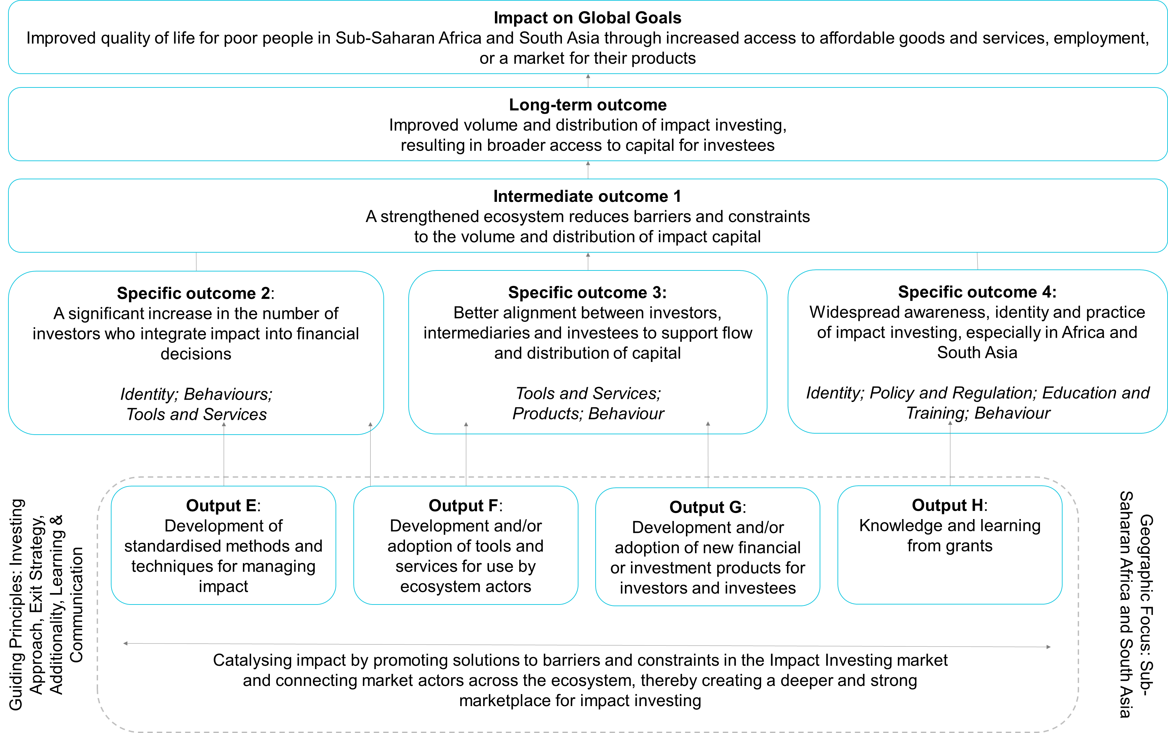

itf-report2023.pdf (impact-taskforce.com)
See, for example: Catalytic Capital Consortium - MacArthur Foundation (macfound.org)
DAC List of ODA Recipients - OECD

