2023 Mobile phone and seatbelt survey

Department for Transport

Project reference: 10150

30 May 2024

Quality information
Prepared by |  | Checked by |  | Verified by |  | Approved by
Scott Stephenson  Associate Director |  | Giulia Siino  Senior Consultant

Revision History
Revision | Revision date | Details | Authorized | Name | Position
0.1 | 04/03/2024 | 1st draft
0.2 | 28/03/2024 | 2nd draft
0.4 | 24/05/2024 | 3rd draft

Distribution List
# Hard Copies | PDF Required | Association / Company Name

Prepared for:
Department for Transport

Prepared by:
Scott Stephenson
Associate Director
E: scott.stephenson@aecom.com

‌AECOM Limited
12 Regan Way
Chetwynd Business Park
Nottingham NG9 6RZ
United Kingdom

T: +44 (115) 827 8000
aecom.com

AECOM Limited has prepared this Report for the sole use of Department for Transport in accordance with the terms and conditions of appointment.
AECOM shall have no duty, responsibility and/or liability to any party in connection with this Report howsoever arising other than that arising to the Client under the Appointment. Save as provided in the Appointment, no warranty, expressed or implied, is made as to the professional advice included in this Report or any other services provided by AECOM.
Table of Contents

1. Introduction 1
1.1 Project background 1
1.2 Project aims and objectives 2
1.3 Driver distraction: the issues 2
1.4 Seatbelt use 3
1.5 The 2021 survey methodology 4
1.6 Evolution of the survey methodology 4
1.7 The 2023 survey methodology 8
2. Survey methodology 8
2.1 Site selection 9
2.2 Survey data requirements 11
2.3 Survey fieldwork 13
2.4 Survey analysis 14
2.5 Training 16
2.6 Survey data weighting 17
3. Survey results and validation 18
3.1 High-level summary of survey data 18
3.2 Survey data validation 19
3.3 Quality assurance 23
4. Additional surveys 27
4.1 Scotland survey 27
4.2 Night-time survey 30
5. Conclusion 33
6. Appendices 34
6.1 List of survey sites 34
6.2 Data coding 37
6.3 Comparison of manual- and camera-based surveys 41

Figures
Figure 1. Comparison of images using different camera configurations captured during Pilot day 1. 5
Figure 2. Comparison of images of the same vehicles captured using the visible light video camera (left) and the Acusensus Heads-Up infrared camera (right) during Pilot day 2. 7
Figure 3. The Acusensus Heads-Up system deployed using the AECOM vehicle. 14
Figure 4. Survey analysis desktop setup. 15
Figure 5. Distribution of driver age for entire survey data set (code 99 is unknown). 22
Figure 6. Percentage of male and female drivers in the full survey data set (excluding unknowns). 23
Figure 7. The number of observations made in each of the age brackets. 24
Figure 8. The number of observations made of male and female. 25
Figure 9. The rate of mobile phone non-compliance, by site. 26
Figure 10. The rate of seatbelt non-compliance by drivers, by site. 27

Tables
Table 1. Sample size by site type (* note the 2023 survey was carried out in England only). 10
Table 2. Percentage of survey sample by road type in comparison to the DfT Road traffic estimates (*note the 2023 survey only included sites located in England). 10
Table 3. The percentage of survey observations made in the morning and afternoon. 11
Table 4. The number of vehicles surveyed compared to the traffic count. 11
Table 5. The survey data requirements. 12
Table 6. The survey data validation check list. 16
Table 7. The traffic counts and survey counts from each of the 25 sites in the 2023 survey. 20
Table 8. Sample size by site type (Scotland sites). 28
Table 9. Percentage of survey sample by road type in comparison to the DfT Road traffic estimates (Scotland sites). 29
Table 10. Comparison of raw survey results between England and Scotland. 30
Table 11. Sample size by site (night-time sites). 31
Table 12. Comparison of raw survey results between day-time and night-time surveys. 32
Table 13. The objectives of the project and how they were met. 33
Table 14. Comparison of observations made using manual and Acusensus Heads-Up systems. 41
Table 15. Comparison of observations made between the first and second Acusensus Heads-Up systems. 42

Introduction
The main objective of the survey work outlined in this report was to establish the level of compliance with current legislation of mobile phone use by drivers and seat belt use of all vehicle occupants. This is to support the Department for Transport’s (DfT) actions to maintain high standards of safety on the road network.
This report presents the methodology used to conduct the 2023 mobile phone use and seat belt surveys. The previous survey (carried out in 2021) used roadside video cameras and subsequent video analysis, and surveys prior to this (including in 2017 and 2014) were performed by manual survey techniques by roadside observers. For the 2023 survey, the approach evolved further to use infrared images captured automatically by a mobile roadside sensor and later reviewing the images for non-compliant activities.
This work is necessary because:
- Driver distraction was identified as a contributory factor in 22 fatal and 674 injury-related collisions in Great Britain in 2022. It is illegal to use a hand-held mobile phone or similar device in a vehicle, even when stopped at traffic.
- Approximately 21% of all car occupant fatalities were not wearing seatbelts in 2022.
This work extends the surveys conducted on behalf of the DfT since 1988 and therefore provides evidence of non-compliance behaviours when using the national road network.
The main survey was carried out across 25 sites throughout England on weekdays, between October and November 2023. In addition, 5 surveys were carried out in Scotland in February 2024, and 3 night-time surveys (6pm to 12am) were carried out during February 2024 at three of the main survey sites in England. The data analysis, verification, and validation were completed by May 2024.

Project background
The Department for Transport performs regular surveys to assess hand-held mobile phone use and seatbelt compliance amongst drivers and vehicle occupants. The aim is to gather evidence and understanding of the level of compliance amongst all vehicle occupants.
These surveys started in 1988, initially focusing on seatbelt usage by vehicle occupants on the national road network. Since 2002, the surveys have included observations of mobile phone use. Prior to the survey presented in this report (conducted in 2023), the survey was last carried out in 2021.
These regular surveys were at first conducted using manual recording techniques, where observers stationed at the roadside manually recorded their observations. In 2021, video surveys were introduced, which reduced the difficulties and limitations of manual recording, particularly around consistency, accuracy, and assurance.
A further change in methodology was made for the 2023 survey. A pilot study comparing two recording methods demonstrated that using images from cameras working in the infrared spectrum not only reduced the reflections from vehicle windscreens but was also performed better under poor lighting conditions, including darkness. This technology was therefore adopted for the 2023 survey.

Project aims and objectives
The aim of the survey was to provide evidence of driver compliance with hand-held mobile phone legislation and to assess seatbelt wearing rates among drivers and passengers.
To achieve this, the following objectives were set:
- Perform survey fieldwork at 25 sites across England.
- Analyse and appropriately weight the survey fieldwork data.
- Independently verify and validate the survey data to provide assurance regarding its completeness, logic, and accuracy.
This work contributes to the Department for Transport’s efforts to continue the downwards trend in the numbers of people killed or seriously injured (KSI), which had started to slow in 2017.

Driver distraction: the issues
Research into the use of a hand-held mobile phones while driving has yielded the following findings:
- It increases the risk of being involved in a road crash by up to nine times.
- Reaction time to hazardous events increases by up to 50% when talking on a hand-held or hands-free mobile device.
- Sending and retrieving text messages results in a 400% increase in time spent with eyes off the road and leads to 140% more incorrect lane changes (ibid).
- After interacting with an information system such as a phone or other device, it can take nearly half a minute to regain full attention (ibid).
- Phoning while driving can impair ability to focus on the road to an extent comparable to a blood alcohol level of 0.5g/litre (50mg per 100ml), which is close to the drink drive limit (80 mg per 100ml) in the UK.
- Dialling and conversing on a hand-held mobile increases the risk of crashes and near crashes to more than 3%.
- Mobile phone use by other drivers contributes to driver frustration in customer satisfaction surveys.
- 3% of all drivers admit to using a hand-held phone while driving during every journey.
In recognition of the continuing problem of driver distraction due to mobile phone use, in March 2022 the law was tightened to reduce ambiguity. The present fixed penalty – 6 points and a £200 fine – applies to drivers or riders who are:
- Stopped at traffic lights.
- Queuing in traffic.
- Supervising a learner driver.
- Driving a car that turns off the engine when you stop moving.
- Holding and using a device that is offline or in flight mode.

Seatbelt use
Great Britain has some of the highest seatbelt compliance figures in the world. It is also one of the countries where the wearing of seatbelts, and enforcement of seatbelt laws, has the highest public support. However, there remains a minority of drivers and vehicle occupants who continue to not wear a seatbelt. This section describes the problem related to vehicle occupants not wearing a seatbelt, and the law that is applied to identify the offence.
In 2017, 98.6% of drivers, 93.1% of front seat passengers, and 90.7% of rear seat passengers were observed using a seatbelt. Yet a determined few who do not use seatbelts contribute disproportionately to recorded KSIs:
- The Department for Transport found that 21% of car occupants who were killed in 2022 were not wearing a seatbelt. This indicates that car occupants who do not wear a seatbelt are disproportionately likely to be killed in road collisions. This level of seatbelt compliance as a contributory factor to road fatalities has remained over 20% for the last 6 years.
- A study by the Parliamentary Advisory Council for the Transport Safety (PACTS) in 2018, based on data collected by the Police Forensic Collison Investigator (PFCI), concluded that almost a third (31%) of people who died in vehicles in Great Britain were not wearing a seatbelt.
The law in the United Kingdom states you must wear a seatbelt if one is fitted in the seat being used, with few exemptions: These include:
- Drivers reversing, or supervising a learner driver who is reversing.
- Occupants in vehicles used by police, fire and rescue services.
- Passengers in trade vehicles investigating a fault.
- Drivers of goods vehicles making deliveries travelling no more than 50 metres between stops.
- Licensed taxi drivers plying for hire or carrying passengers.
- Individuals holding medical exemption, provided by their doctor via a Certificate of Exemption from Compulsory Seatbelt Wearing.
Additionally, the law clarifies that:
- Mandatory seatbelt usage for pregnant individuals, unless medically exempted by a doctor.
- Mandatory seatbelt usage for disabled drivers or passengers, unless medically exempted, potentially requiring vehicle adaptations.
A fine of up to £500 can be issued if the vehicle occupant is not wearing a seatbelt when they are supposed to. Additionally, the driver can be fined up to £500 if a child under 14 is not in the correct car seat or wearing a seatbelt.

The 2021 survey methodology
The methodology employed in the 2021 survey was intended to align with that of the 2017 survey, but with a significant difference: using video cameras to record the scene and performing the observations back in the office.
The reasons for its adoption were as follows:
- This use of video technologies captured evidence that was consistent, auditable, and repeatable.
- Removing survey personnel from site meant safer working conditions and eliminated possible ‘observer’ effects on driver behaviour.
- Desk-based video analysis allowed the analyst to pause and rewind the footage as required.
- Quality assurance could be performed by independently analysing the video.
- Using video and video snapshots could be used to demonstrate examples of non-compliance.
- The automated approach allowed the recording of mobile phone use and seatbelt compliance simultaneously.
- It enabled other analysts or supervisors to watch the same video, to help ensure consistent and accurate information was being logged.

Evolution of the survey methodology
The intention for the 2023 survey was to follow the 2021 methodology and use visible-light video cameras to record footage and perform the analysis post-survey. A pre-survey pilot study was carried out to optimise the 2023 survey methodology based on the lessons learned from the 2021 survey.
Pilot day 1 involved capture of video at the roadside using various camera configurations, such as different heights, offsets, angles, filters, shutter speeds, and frame rates. The video was analysed using the same methodology as the 2021 survey, and the result was an optimum camera configuration.
Pilot day 2 used tested the optimum camera configuration. Ground truth was provided by the use of an Acusensus Heads-Up system, which uses infrared cameras triggered by a radar system to capture images of vehicle interiors.

Pilot day 1: Testing of camera configurations
Pilot day 1 was performed on the A4130 near Didcot. This was chosen as it was close to a 2021 survey site that had been noted to be challenging due to glare, there was a large carriageway offset, and dark conditions. There was also a layby nearby to facilitate safe site setup.
Video for each configuration was recorded for approximately 30 minutes and downloaded between configurations. The video was quickly assessed on site to make sure it had recorded properly. Video files were labelled and stored in appropriate folders and uploaded to secure servers after completion of the site work.
Figure 1. Comparison of images using different camera configurations captured during Pilot day 1.
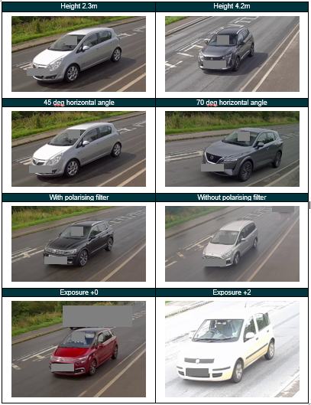

The video was subsequently analysed. Figure 1 provides example comparison images captured using different camera configurations. The output of the analysis was better knowledge of the camera configuration for an optimised and realistic camera setup. Notably:
- Lower height generally gave better in-vehicle coverage.
- Greater horizontal angle gave better coverage, particularly for the rear seats.
- The polarising filter improved coverage in some conditions, by reducing reflections and glare.
- The optimum exposure depended upon lighting conditions.
- Faster frame rate allows for a greater choice of frames for analysis, leading to a better outcome but at the cost of extra memory.

Pilot day 2: Testing optimum camera configuration
Pilot day 2 was performed on the A34 north Hinksey. This site had previously been used for data collection related to a different project involving the Acusensus Heads-Up system and was noted for having a relatively high rate of driver phone use.
For this test, the optimum video camera configuration was compared to the Acusensus Heads-Up system. The two systems were set up in such a way as to allow direct comparison of the images.
- The video cameras were set up using the optimum configuration on suitable street furniture. Video was recorded for 30mins, downloaded, and assessed for quality. The cameras were then either re-configured and set to record again or kept in the configuration and left to record.
- The Acusensus Heads-Up system was deployed on the AECOM Sensor Test Vehicle (STV) on the same road link, but downstream from the video cameras (as the STV gantry and livery may influence road user behaviour). The Acusensus system was set to audit mode (to capture images of all vehicles).
A sequence of 111 vehicles were analysed by two different analysts: Each working solely on one of the image capture systems. Figure 2 shows example images captured by each of the systems of the same vehicles.
Regarding phone use, the visible light analyst identified one and five additional instances of the driver with something in their hand. However, the infrared images clearly show no phone use in any of these cases. In the case of seatbelt compliance, the infrared light analyst found five drivers unrestrained, while the visible light camera assessment found only one. Comparison of these non-compliant activities shows the strength of the infrared method over the visible light method. The visible light analyst found approximately the same number of female drivers, but fewer males and more records of unsure regarding driver sex.

Figure 2. Comparison of images of the same vehicles captured using the visible light video camera (left) and the Acusensus Heads-Up infrared camera (right) during Pilot day 2.
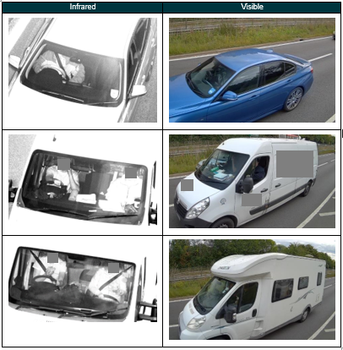

Pilot conclusions
The pilot enabled the following further improvements to be made over the 2021 survey:
- The greatest improvements come from lower camera heights and greater horizontal camera angles (i.e. more perpendicular to the direction of travel).
- However, there is no one-size-fits-all optimum camera setup.
- Low camera heights (2.5 metres and below) may risk obstruction or vandalism, depending on the location.
- Using a polarising filter can reduce windscreen glare, but not in all lighting conditions as the angle of polarisation is critical.
- Higher frame rate improved visibility by providing a larger pool of frames to observe.
- Image comparison showed that in most cases the best results are obtained using infrared cameras.
- Occasionally the Acusensus Heads-Up system on the STV, with its high position, failed to see the upper body and sometimes hands, of van and truck drivers due to looking down into a cabin with a flatter, more vertical windscreen.
- In the event of poor visibility conditions, the relative importance of sampling consistency (e.g. for comparison with same date and time) versus good image quality needs to be considered before re-scheduling.

The 2023 survey methodology
Upon review of the pilot study results, it was concluded that improvements could be made to the 2021 methodology, but it would only result in marginal improvements to image quality. In addition, the images provided by the Acusensus Heads-Up system were of very good quality, offering a significant improvement in survey accuracy and consistency.
However, the challenge with using the Heads-Up system for the 2023 survey lay in the cost and availability of the systems, as well as the logistical constraints of visiting 90 sites to complete 135 surveys within the desired timeframe (to match the approach of the 2021 survey). Following further discussions and revision of the survey methodology, it was agreed to use the Acusensus Heads-Up system to perform the survey. Although the Acusensus Heads-Up system had demonstrated its ability to detect non-compliance, there were some trade-offs:
- The 2023 survey would use a single Heads-Up system to visit 25 sites.
- The sites would be in England only.
- No observations of rear seat passengers would be made.
Following the completion of the main survey using the England sites, additional survey work was commissioned as follows:
- 5 surveys at sites in Scotland.
- 3 surveys at night-time (6pm to 12am) at three of the main survey sites in England.
The results of these additional surveys is included in Section 4.

Survey methodology
This section delves into the survey methodology, offering a comprehensive overview of the processes involved in data collection and analysis. Emphasising the need for comparison with surveys conducted in 2021, it details the systematic approach adopted across various phases.
The selection of survey sites is explained, encompassing the rationale, methodology, and criteria guiding site selection. Additionally, it outlines the diverse types and categories of data required for the survey, underscoring their significance in informing the analytical framework. The methods and equipment employed during fieldwork are explained, alongside the training provided to observers and analysts to ensure consistency.
Note this section considers the main survey at 25 sites across England. Similar processes were followed during the implementation of the additional survey work.

Site selection
The 2023 survey required a survey from 25 sites across England only. As with previous surveys, the selection of sites was made to provide a representative sample of road user behaviour. The criteria for site selection were as follows:
- Similar traffic volume to previous surveys (approximately 50,000 vehicles).
- Provide good geographic diversity.
- Include both rural and urban areas.
- Include both major and minor roads.
- Provide a balanced distribution of morning and afternoon observations.
Sites used in previous surveys were reviewed but deemed unsuitable for the 2023 survey. This was primarily because the Acusensus Heads-Up system was to be deployed using the AECOM Sensor Test Vehicle (shown in Figure 3), which required a flat hardstanding parking area and no overhead obstructions. Therefore, new sites were sought, with local backup sites identified in case of deployment issues. As fewer sites were to be surveyed in 2023 than previous surveys, each site had to provide as much value as possible, making it inefficient to survey locations with minimal traffic flow.
Due to the limited number of sites, the selection process was crucial. Previous surveys had observed between 43,000 and 60,000 vehicles, requiring each site to have a reasonable traffic flow (averaging approximately 2,000 vehicle observations per site). Operational challenges, such as the need for secure parking and absence of overhead obstructions for the AECOM vehicle deployment, were also considered.
The estimated traffic flow for each site was found by reviewing Department for Transport traffic count data., while site type was determined by reviewing ONS BUA mapping and road classifications. The resulting selection of sites provided a more balanced survey across the site types, in comparison to the National Travel Survey. For instance, the plan would provide a much-improved sample across rural roads, and rural minor roads in particular, as shown in Table 1. It is notable that the approach in the 2021 survey oversampled observations.
Table 1. Sample size by site type (* note the 2023 survey was carried out in England only).
Site type |  | Sample size total  (England and Wales only) |  |  | Difference between 2017 and 2023 | Number of sites (2023)
Area | Road | 2017 | 2021 | 2023* | %
Rural | Major | 10,078 | 12,342 | 19,376 | +92.3% | 8
Rural | Minor | 2,723 | 7,487 | 9,023 | +231.4% | 8
Urban | Major | 16,978 | 18,975 | 9,033 | -46.8% | 4
Urban | Minor | 13,589 | 21,795 | 11,918 | -12.3% | 5
 | Total | 43,368 | 60,599 | 49,350 |  | 25

Previous surveys required significant weighting of the results from each site to produce representative figures, but the site selection for the 2023 survey meant that weights were reduced significantly. This was because the sample for each site type more closely resembled that of the DfT Road traffic estimates, as shown in Table 2.
Table 2. Percentage of survey sample by road type in comparison to the DfT Road traffic estimates (*note the 2023 survey only included sites located in England).
Site type |  | Traffic % (England and Wales)
Area | Road | DfT estimates | 2017 survey | 2021 survey | 2023 survey*
Rural | Major | 37% | 23% | 20% | 39%
Rural | Minor | 19% | 6% | 12% | 18%
Urban | Major | 18% | 39% | 31% | 18%
Urban | Minor | 26% | 31% | 36% | 24%

The selected survey sites and the planned time for the surveys to take place also provided a better balance between morning and afternoon sessions, as shown in Table 3.
Table 3. The percentage of survey observations made in the morning and afternoon.
Time of day | 2023 sample size | % comparison with previous surveys
Time of day | 2023 sample size | 2017 | 2021 | 2023
Morning (6am to 12pm) | 25,158 | 59% | 32% | 51%
Afternoon (12pm to 6pm) | 24,192 | 41% | 68% | 49%

The challenge to provide a comprehensive survey with only 25 sites, compared to the previous 90, has led to a more efficient deployment of survey equipment. As with previous surveys, not all vehicles passing the survey equipment were observed (although they were all counted to prevent potential bias at heavily trafficked sites. However, as shown in Table 4, the proportion of vehicles passing the survey equipment during deployment that were observed was much higher in 2023 (66%) compared to 2021 (40%).
Table 4. The number of vehicles surveyed compared to the traffic count.
Survey year | Number of surveys | Traffic count | Survey count
2021 | 135 | 150,636 | 60,599
2023 | 25 | 75,074 | 49,350

Survey data requirements
The survey data requirements replicate those captured during the previous survey in 2021, with the following changes:
- No observations of rear seat passengers.
- Additional status of vehicle motion (Stationary, normal speed, crawling, moving off, coming to stop).
- Removed vehicle colour (this was not used in analysis and is not possible to determine using infrared images).
- More types in the category of driver phone use.
- Recording of whether the presence of the camera appears to have influenced behaviour.
- Increased types in age categories (age brackets of 10 years).
- More types in the category of restraint.
- Removal of stationary or moving site types (no stationary site types were selected as the camera-based approach makes this redundant).
Table 5 provides a summary of the data required for the mobile phone use and seat belt compliance surveys in 2023. Alongside each of these surveys, a traffic count survey was also required.
Table 5. The survey data requirements.
Ref | Data | Included
Site information
 | Site | ☑
 | Date | ☑
 | Time | ☑
 | Incident number | ☑
 | Weekday | ☑
 | Staff ID | ☑
 | Conditions | ☑
Vehicle details
 | Vehicle type | ☑
 | Vehicle motion | ☑
Driver
 | Driver mobile phone | ☑
 | Other behaviour | ☑
 | STV influence | ☑
 | Driver sex | ☑
 | Driver age | ☑
 | Driver restraint | ☑
 | Number of passengers | ☑
Front seat passengers
 | Sex | ☑
 | Age | ☑
 | Restraint | ☑
Comments
 | Other notable observations | ☑

Survey fieldwork
This section presents the fieldwork data collection methods used and gives an overview of the equipment used. The survey fieldwork was completed throughout October and November 2023. Unlike previous surveys, there was no requirement to finish the surveys before the clocks changed from BST to GMT, as the performance of the infrared cameras is not affected by ambient light.

Fieldwork planning
The deployment of the Acusensus Heads-Up system is performed using customised AECOM vehicle. A risk assessment was produced, based on existing practice. This considered all survey operatives, road users, and pedestrians prior to installation, during the recording of data, and during decommissioning.
Where required, local authorities were contacted in advance of the survey to inform them of the intention to perform the survey work on behalf of the Department for Transport and to obtain the necessary permissions for parking the AECOM vehicle (if applicable). Where there was no response from the authorities, the survey work continued as would be normal for the deployment of the AECOM vehicle, with subsequent engagement managed accordingly.

Survey equipment
The Acusensus Heads-up system is designed to capture high-resolution, prosecutable evidence of individuals engaging in illegal driver behaviour at any time and during all weather conditions.
The strengths of the system include:
- The capability to capture images day or night, enduring various weather conditions, including challenging scenarios such as sun glare.
- The detection of vehicles traveling at speeds of up to 186mph without motion blur or distortion, facilitated by high-performance sensor technology.
- An advanced automated recognition system that effectively minimizes false positives while ensuring no valid offenses are overlooked (this system was disabled during the 2023 survey, as images of all vehicles were required).
- The enforcement pedigree guarantees the integrity of encrypted and signed traceable packages from the camera onward.

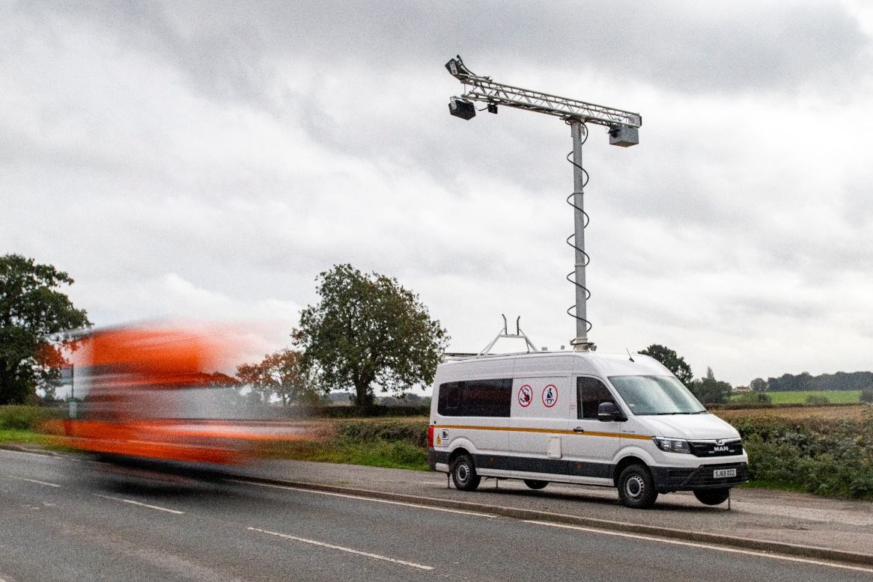
Figure 3. The Acusensus Heads-Up system deployed using the AECOM vehicle.
The Heads-Up system was operated in a survey deployment mode. This mode facilitates systematic observation and documentation of driver behaviour, offering valuable insights into patterns and trends. During survey mode, the offense detection functionality is intentionally deactivated, allowing the system to capture images of all passing vehicles. Subsequently, the collected data undergoes human review, during which any offenses are identified alongside vehicle, driver, and front seat passenger details.
The deployment of the AECOM vehicle follows a strictly defined and highly detailed procedure to ensure the safety of operational staff and members of the public, and to produce the best quality images. These procedures are not detailed within this report.

Post-survey fieldwork and data retrieval
Once the survey fieldwork is completed, the survey team follows a decommissioning process to safely stow the equipment and restore the site to its original condition.
The captured images are encrypted and then uploaded to a UK-based cloud server for secure storage via a cellular connection. The duration of this process can vary depending on factors such as connection strength and the number of vehicles observed.
The images are then downloaded to the office for analysis using a dedicated laptop running bespoke software to allow the images to be decrypted. The laptop is securely stored at an AECOM office and is accessible only to project team members and makes use of two-factor authentication.

Survey analysis
This section provides an overview of the high-level analysis process, the typical setup, the quality assurance process, and the steps involved in the survey data validation.

Analysis: High-level process
Throughout the survey process, analysts executed several steps to ensure accuracy and reliability.
In the high-level process, the first step involved checking the images for suitable quality. Following this, a suitable sample size was determined from each site, ensuring representation across the entire 6-hour survey period. The images corresponding to the sample were then selected. The location, time, and date data were automatically extracted from the image files and pre-populated onto an analysis spreadsheet. Subsequently, both the spreadsheet and images were passed to an analyst for completion. Once the analysis was finished, it was returned and merged into a master spreadsheet. Finally, survey validation and quality assurance processes were conducted to ensure accuracy and reliability.

Survey analysis – desktop setup
Figure 4 shows the typical setup used by the analyst. The images were display on one screen and the spreadsheet was edited on a separate screen.
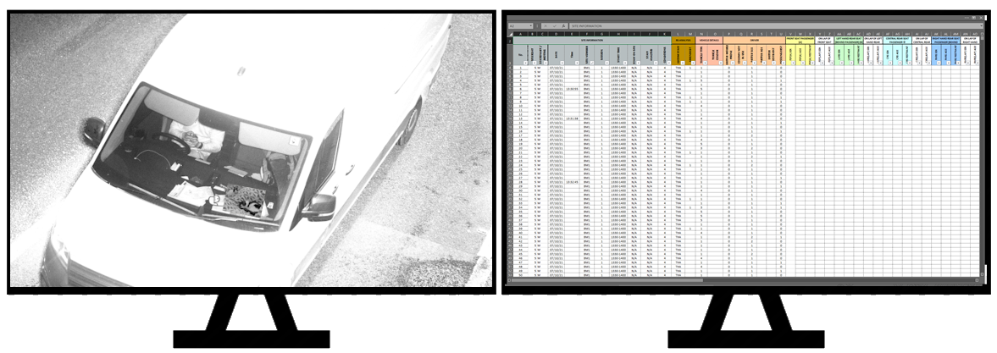
Figure 4. Survey analysis desktop setup.

Survey analysis: Quality assurance
Unlike previous surveys, no quality assurance was required to be performed at the roadside. The production of images from the fieldwork was evidence the process had been followed.
To assess the quality of the image analysis, two forms of quality assurance were completed:
- All vehicles identified as non-compliant (or potentially non-compliant) were independently analysed.
- A random sample of vehicles were independently analysed.
Further details of this quality assurance can be found in Section 3.3.

Validation
The validation of the survey data was completed in three categories: Checking the completeness of the data, the logic, and the accuracy. The checklist shown in Table 6 was used to guide the validation. The results of the validation can be found in Section 3.
Table 6. The survey data validation check list.
Validation area | Checklist item
Data completeness | Does the data match the survey session? | ☑
Data completeness | Is the survey metadata complete (conditions, time, site name, etc)? | ☑
Data completeness | Is the site sample size adequate? | ☑
Data completeness | Is the data in the correct format (e.g. date, time)? | ☑
Data completeness | Is there missing data? | ☑
Data logic | Are comments relevant to session? | ☑
Data logic | Are there data conflicts (e.g. adults in child seats)? | ☑
Data logic | Is the dataset unique? | ☑
Data logic | Is the traffic count greater or equal to the count in previous surveys? | ☑
Data logic | Are there any obvious outliers? | ☑
Data accuracy | Are overall site data values valid (e.g. within sensible thresholds)?
Data accuracy | Mobile phone use | ☑
Data accuracy | Driver seatbelt compliance | ☑
Data accuracy | Driver age | ☑
Data accuracy | Driver sex | ☑
Data accuracy | Front seat passenger seatbelt compliance | ☑
Data accuracy | Is the comparison with the QA data satisfactory? | ☑
Data accuracy | Is data correct for random checks of vehicles (compliant and non-compliant)? | ☑
Data accuracy | Is the false positive rate acceptable? (% miss-identified) | ☑
Data accuracy | Is the false negative rate acceptable? (% missed) | ☑

Training
When it comes to traffic survey observation, ensuring impartiality and accuracy in data collection is paramount. To achieve this, the image analysts underwent structured training supplemented with comprehensive documentation, aiming to standardise observation practices and minimise potential biases. The following elements constituted the training methodology:
1. Structured training with prepared and shared documentation. These materials outline the objectives of the survey, standardised procedures for data collection, and guidelines to reduce bias in observation.
2. Examples of images shown: during training, analysts were exposed to a diverse range of sample images captured by the cameras. These images show various scenarios, encompassing different types of vehicles, drivers, and passengers encountered during the survey.
3. Identification of vehicle types and typical characteristics: image analysts were trained to distinguish between different types of vehicles and recognise their typical characteristics. This included identifying vehicles such as cars, trucks, motorcycles, and bicycles, as well as noting distinguishing features of each type.
4. Driver age classification: the training emphasised the accurate classification of driver ages based on observable characteristics. This included assessing body shape, skin and hair condition, clothing attire, accessories, and other clues indicative of age. For instance, indicators such as muscle tone, skin firmness, hair condition, and attire choices were considered when estimating driver ages.
5. Assessment of mobile phone use: image analysts were trained to assess mobile phone usage among drivers by observing the position of their hands and their interactions with the device. This included identifying instances where the phone is held to the ear, operated manually while driving, or used in speaker mode close to the mouth.
6. Evaluation of seatbelt usage: analysts were instructed to diligently assess both drivers and passengers for seatbelt usage. This involved checking for visible indicators such as seatbelt buckles, reflections of seatbelts, or any obstructions under the arm or behind the back, which may have suggested non-compliance with seatbelt regulations.
7. Familiarity with technology: while the technology deployed for image analysis may be novel for traffic surveys, the image analysts were accustomed to working with such systems. Many have prior experience with similar technologies deployed for various purposes, enabling them to adapt quickly and effectively to the specific requirements of our survey.
By adhering to these rigorous training protocols, the image analysts were equipped with the necessary skills and knowledge to limit the introduction of bias in their observations, thereby enhancing the reliability and integrity of the survey data.

Survey data weighting
To provide a representative survey of non-compliance, each observation needs to be appropriately weighted in two ways:
- Sampling weights are used ensure the survey results are not biased by sites with a high or low number of survey observations. The sampling weights adjust for low or high survey counts for site categories. For instance, sites where the survey count (for the site category) is relatively low are weighted higher, and sites where the survey count is relatively high are weighted lower.
- Traffic weights are used to ensure the survey results are representative of expected traffic flow for the site categories. For instance, if the percentage of traffic flow for a particular site category is known to be 20% (according to TRA0306 2022) and the percentage of all survey data for this site category is found to be 15%, then a higher weight is required.
In a change to previous surveys, the calculation of the weights was simpler in 2023. This was because:
- Weights did not need to be calculated separately for moving and stationary site categories, as only surveys at moving sites were carried out during the 2023 survey.
- Weights did not need to account for weekday or weekend, as only weekday surveys were performed.
- Separate weights were calculated for the surveys in England and Scotland, but no weights were required for Great Britain as a whole. (Note that no surveys were carried out at sites in Wales in 2023).

Sampling weights
The sampling weight is determined by comparing the proportion of vehicles surveyed in each survey with that of the proportion of the total vehicles surveyed for that site category.
The steps to calculate the sampling weights were:
- Calculate the proportion of vehicles that were surveyed for each site category. Divide the total survey count by the total traffic count per site category.
- For each survey (there were 25 surveys in 2023), calculate the proportion of vehicles that were surveyed (surveyed divided by counted). This excludes cycles and code 99s for mobile phone use or seat belt use.
- For each survey, calculate the sampling weight by dividing the appropriate value for the site category (1) by (2).
This calculation was repeated to calculate two sets of weights applicable to England and Scotland.

Traffic weights
The traffic weight is determined by reviewing the observed traffic count for each road type in each country and comparing them to the expected traffic volumes derived from DfT Road traffic estimates for that road type. Traffic weights consider the traffic counted and not the number of vehicles surveyed (full traffic counts were made for each 6-hour survey session, but not all vehicles were surveyed for mobile phone and seat belt use).
For instance, if we expect the percentage of traffic using a major, rural road to be 35%, and the comparable percentage in the 2023 survey is 25%, then a traffic weight of 1.4 is applied to any survey with this road type.
Each set of traffic weights sums to 1. Within each set of traffic weights there are four road types: Major rural, major urban, minor rural, and minor urban.
The expected traffic volumes were calculated using the 2022 DfT Road traffic estimates (TRA0103 Average traffic by day of week) and the related estimate that 75.6% of traffic happens on a weekday.

Survey results and validation

High-level summary of survey data
The results of the 2023 survey on mobile phone use and seat belt use can be found on the gov.uk website and are not included in this report. The inference of rates of non-compliance from numbers presented in this report will not be reliable, as the raw survey data is weighted before statistics can be calculated. The following high-level numbers summarise the 2023 survey data:
- The survey fieldwork took place between the 2nd of October and 24th of November 2023.
- 25 sites were visited to capture infrared images of all vehicles passing, and all images captured at all sites were suitable for analysis.
- Each site visit lasted for 6 hours, either 6am to 12pm, or 12pm to 6pm.
- All surveys took place on weekdays.
- The total traffic count across all surveys was 75,074 vehicles (excluding cycles).
- A total of 49,322 vehicles were observed for mobile phone use.
- A total of 49,322 vehicles were observed for seat belt use.
- 144 drivers were observed using a mobile phone (either to ear or in hand).
- 1007 drivers of cars, vans, or goods vehicles were observed not using a seat belt.

Survey data validation
The survey data was validated by following the steps outline in Section 2.4.4. The results of the validation are presented below.

Data completeness

Does the data match the survey session?
The images contain header information including the location, time, and date. A spot check of the images ensures the survey observations match those of the images used. All survey information was found to match the survey session.

Is the survey metadata complete (conditions, time, site name, etc)?
The survey observation spreadsheet includes columns for site information and conditions. A simple check was made to identify any missing data. There was no missing data, and all entries were appropriate to the data type (for instance, time information was entered in the correct format).

Is the site sample size adequate?
The survey plan was based on estimated traffic flows. The actual flows varied slightly in reality, but it was possible to adjust the sampling approach to produce a survey from observations that closely match the DfT Road traffic estimates. This is demonstrated in Table 2 in Section 2.2.
Table 7 shows the traffic counts and survey counts from each of the 25 sites. It is notable that some of the sites have low traffic counts (these are primarily quite rural roads) and other sites have very high traffic counts (these are primarily busy major roads).
Table 7. The traffic counts and survey counts from each of the 25 sites in the 2023 survey.
Site ID | Urban / rural | Major / minor | AM / PM | Traffic count | Survey count
036 | Rural | Major | PM | 6864 | 2602
037 | Urban | Major | PM | 3795 | 2371
046 | Rural | Major | PM | 4097 | 1600
052 | Rural | Major | AM | 4061 | 2517
053 | Rural | Minor | AM | 908 | 913
054 | Rural | Major | AM | 5297 | 3291
055 | Rural | Major | PM | 2163 | 2161
056 | Urban | Minor | PM | 2802 | 2724
057 | Urban | Minor | PM | 3046 | 3046
058 | Rural | Minor | AM | 415 | 414
059 | Urban | Minor | AM | 2619 | 2619
060 | Urban | Major | PM | 4355 | 2700
062 | Urban | Major | AM | 2459 | 1349
063 | Rural | Minor | AM | 725 | 725
064 | Rural | Minor | PM | 1041 | 1041
065 | Rural | Major | AM | 11524 | 3996
066 | Rural | Minor | AM | 2131 | 2131
067 | Urban | Minor | AM | 1469 | 1464
068 | Rural | Major | PM | 1601 | 1601
069 | Urban | Major | PM | 4890 | 2600
077 | Rural | Major | AM | 2834 | 1602
078 | Rural | Minor | AM | 2178 | 2060
079 | Urban | Minor | AM | 2060 | 2058
080 | Rural | Minor | PM | 840 | 840
081 | Rural | Minor | PM | 900 | 897

Is the data in the correct format (e.g. date, time)?
Each of the data types was checked for correct format. This is straight-forward to determine using the spreadsheet. The analyst is not required to manually input the site ID, time, date, or incident number – this information is automatically extracted from the image files using a script.

Is there missing data?
Each of the data types was assessed for missing data. While certain data types (such as vehicle type) are mandatory for each vehicle, others (such as front seat passenger details) may be absent if not applicable. The data types were systematically checked for missing data using data filters, including checking that data was included for complementary data types (such as front seat passenger has data for sex, age, and restraint).
Some small adjustments were necessary where the analyst had not captured data. Although this is not ideal, the benefit of the 2023 methodology is that the images can be re-observed to completed missing data.

Data logic
This section summarises the checks made to determine whether the survey data was logical.

Is the dataset unique?
The survey data was checked for duplicated data using the spreadsheet functions. The survey data was also spot checked to identify any obvious errors. The validation determined the dataset was unique.

Is the traffic count greater or equal to the count in previous surveys?
As shown in the tables provided in Section 2.1, the total survey count was in line with previous surveys. It was greater than the 2017 survey. It was lower than the 2021 survey, although that survey was oversampled to account for the new methodology.
Most significantly, the 2023 survey captured survey observations more closely aligned to the National Travel Survey. This is highlighted in Table 1, and a good example is the 2023 survey was able to achieve a much greater sample from rural-minor site types. This means the weightings required to correct the observations from each site are all much closer to 1 than any previous survey.

Data accuracy
This section examines whether the overall data values appear to be valid and within sensible thresholds.

Mobile phone and seatbelt compliance rates
The unweighted rate of driver phone use in the 2023 survey was notably lower than previous surveys, although specific figures are omitted to prevent misquoting. There are several potential reasons for the difference, including:
- Changes in methodology from video survey to infrared image capture. The 2021 survey used video cameras and other previous surveys used a roadside manual survey approach.
- Stricter penalties introduced in March 2017 and the tightening of the law in March 2022 may have had an impact.
- The presence of a vehicle with bright warning livery and a camera on a cantilevered gantry may have influenced behaviour.
- Compliance rates may have also improved to various well-publicised initiatives and enforcement activities targeting mobile phone use and seatbelt wearing.
- There is a greater penetration of vehicles within the national vehicle fleet with technology aimed to reduce non-compliance. This includes seatbelt warning systems and infotainment systems with Bluetooth or Smartphone integration platforms (such as Android Auto and CarPlay).

Driver age
The 2023 survey used a more granular driver age classification, utilising 10-year age brackets instead of three broad brackets of previous survey:
- 17 to 29 years old
- 30 to 59 years old
- 60+ years old.
This adjustment aimed to enhance data validity and facilitate comparisons with previous surveys by merging age brackets.
Figure 5 illustrates a logical distribution of driver ages identified in the 2023 survey, with the most common age group being between 30 and 39 years old. The number of observations resulting in unknown ages was notably lower in 2023 than in 2021 (7.9% versus 15.6%), indicating improved image clarity. Additionally, the scarcity of drivers in the youngest age bracket is partly attributed to the legal driving age in the UK being 17 years old.

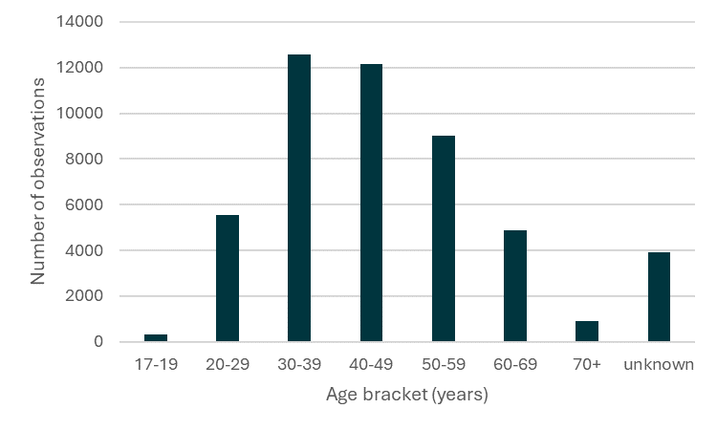
Figure 5. Distribution of driver age for entire survey data set (code 99 is unknown).

Driver sex
The split between male and female drivers observed in the 2023 survey is shown in Figure 6. Consistently with previous surveys, the number of male drivers significantly exceeds than the number of female drivers.
As with driver age, the number of unknowns for driver sex improved in the 2023 survey compared to the 2021 survey. Specifically, the improvement was substantial: the percentage of unknown observations of driver sex in 2021 was 9.3%, whereas in 2023 this reduced to 0.8%.
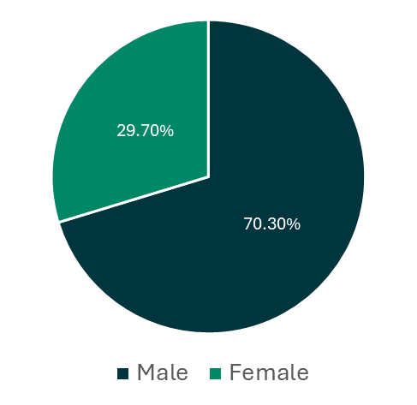
Figure 6. Percentage of male and female drivers in the full survey data set (excluding unknowns).

Front seat passenger seatbelt compliance
The number of vehicles with a front seat passenger remained consistent with that observed during the 2021 survey, accounting for slightly under one-third of all vehicles. The mix of age, sex, and seatbelt compliance displayed very similar patterns.
Similar to the observations of drivers, there was a substantial reduction in the number of unknown observations, such as age and sex, compared to the 2021 survey. The percentage of unknowns for front seat passenger age dropped from 11.0% to 1.7%, while those for front seat passenger sex dropped from 7.9% to 2.9%. This measure suggests the analysts were more confident in their observations during the 2023 survey.

Quality assurance
The quality assurance was carried out by independently analysing two sets of data:
- A random selection of vehicles (998 total).
- All vehicles originally flagged as non-compliant or with some potential non-compliance (such as a driver holding an object) (1,543 total).
In total, 5.2% of all vehicles underwent an independent quality assurance check.
This verification occurred after the completion of the original survey analysis. To ensure confidence in the results, the original survey data was shared with the Department for Transport prior to commencing the quality assurance analysis.
The quality assurance process mirrored to the original analysis, with an analyst tasked with reviewing a batch of images to capture observations. The quality assurance analyst worked with a blank spreadsheet, unaware of the observations made by the original analyst.
This section provides a summary of this quality assurance, along with insights into the general accuracy and challenges of human-based observation.

Vehicle and driver characteristics
Across the whole quality assurance analysis, vehicle type observations matched in 93.3% of cases (90.7% during random QA and 94.8% during the non-compliance QA). However, disparities were noted in two primary areas:
- Some vehicles, particularly large vans and small goods vehicles could be easily misclassified. Distinguishing between the two categories posed a challenge for analysts.
- The QA analyst identified more private hire vehicles, especially during the non-compliance QA. However, this came from the prevalence of taxi and private hire drivers not wearing seatbelts, leading to a higher concentration of non-compliant instances in the QA batch.
Regarding driver characteristics, only 38.0% of observations matched initially. While this may seem low, the 2023 survey employed a more detailed age scale compared to previous surveys. Grouping ages into brackets similar to those used in the 2021 survey increased the matched percentage to 67.5%.
When examined further, the age distribution determined during both analysis stages exhibited remarkable similarity. Figure 7 shows the number of observations from the original analysis and the corresponding QA analysis that are in each age bracket.

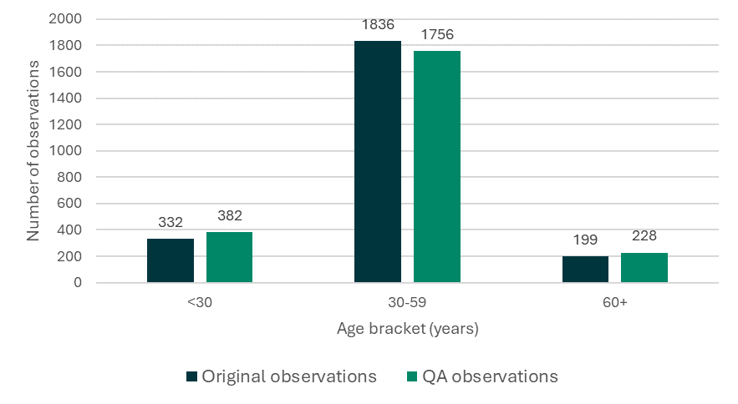
Figure 7. The number of observations made in each of the age brackets.
The observations of driver sex were likewise examined. Overall, the QA analysis matched with the original analysis in 91.1% of observations. As with driver age, further examination shows the overall male-female ratio is very similar between the two sets of analysis (76.8% male in the original analysis versus 76.7% male in the QA analysis). This is shown in Figure 8.
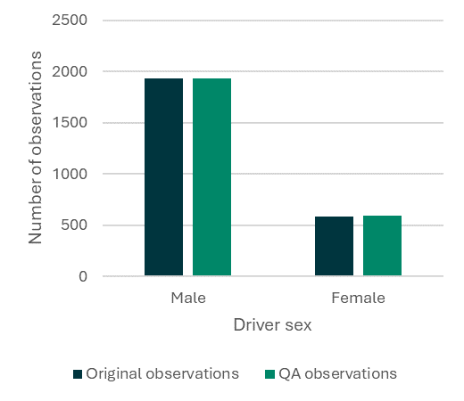
Figure 8. The number of observations made of male and female.

Mobile phone compliance
During the original analysis, the analyst operated under a slightly lower confidence threshold when documenting driver mobile phone use. This approach was based on the understanding that instances of non-compliance would undergo a more rigorous examination during the quality assurance process. Therefore, it is somewhat unfair to solely evaluate the original analysis's performance in this aspect.
The non-compliance QA inevitably found numerous cases where drivers flagged for phone use in the original analysis could not be confidently classified as such. In fact, 42.3% of drivers identified in the original analysis as using a phone were re-classified during the non-compliance QA. Most typically they were re-classified as not using a phone, but some were determined to be simply holding an object, eating, drinking, or grooming.
In addition, it is noted that some drivers (0.2%) were observed interacting with a phone in a compliant manner (such as in a cradle), and 2.0% of drivers were using their hands for some other purpose such as eating, drinking, or grooming.
This quality assurance has highlighted the particular challenge around observing driver phone use from the roadside.
Notably, the random QA found one false negative (for example, a case of non-compliant behaviour that is incorrectly classified as compliant) and zero false positives (for example, a case of compliant behaviour that is incorrectly classified as non-compliant). Although only around five cases of driver mobile phone use would have been expected in the random QA data set, these values are still considered low.
Figure 9 shows the rate of driver mobile phone use non-compliance by site. As with previous surveys, there are sites with a rate of 0.0% (in the case of the 2023 survey there are two sites, whereas in the 2021 survey there were three sites). Generally, there are no outliers related to mobile phone use non-compliance by site.
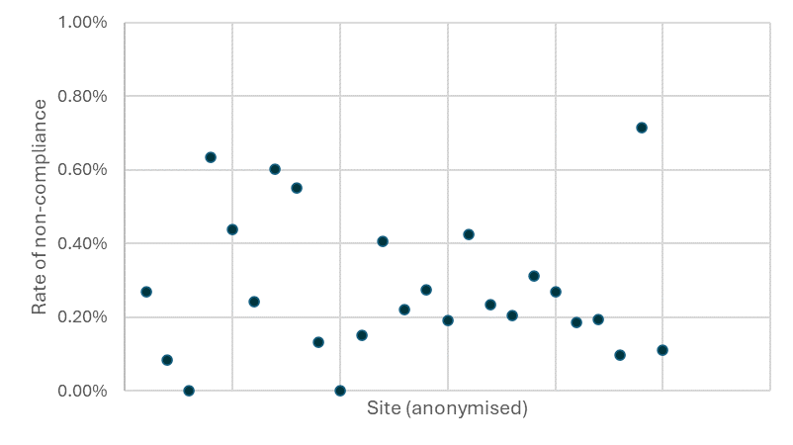
Figure 9. The rate of mobile phone non-compliance, by site.

Seatbelt compliance
Similarly to the approach with driver mobile phone compliance, the original analyst was asked to apply a lower confidence threshold when observing driver seatbelt compliance.
During the non-compliance QA, it was found that 15.6% of drivers identified as non-compliant in the original analysis were in fact compliant. This outcome was anticipated due to the utilisation of a lower confidence threshold during the original analysis.
In the case of the random QA, the QA analyst identified four false negatives and four false positives. Upon examination, these instances typically occurred in situations where the visibility of the seatbelt was compromised. Factors contributing to this included minor obscurity, bulky or busy clothing, or inadequate contrast.
Figure 10 shows the rate of driver seatbelt non-compliance by site. As with previous surveys, there are no sites with a rate of 0.0%. Generally, there are no outliers related to seatbelt non-compliance by site.

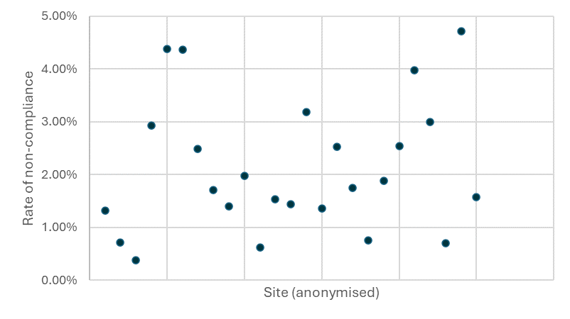
Figure 10. The rate of seatbelt non-compliance by drivers, by site.

Additional surveys
Following the completion of the main survey in 2023 at 25 sites in England, two additional survey campaigns were commissioned. Firstly, a survey of 5 sites in Scotland, and secondly, a survey at three sites during night-time (6pm to 12am). The survey approach was the same as that of the main survey, thus it is not outline in detail here.
Below are the results of the two additional surveys.

Scotland survey

Site selection
The Scotland survey was carried out during one week in February 2024. As can be seen in Table 8, the number of survey observations was much smaller in comparison to previous surveys. There were also no observations made at sites classified as rural-minor (these sites typically have relatively low traffic flow).
Table 8. Sample size by site type (Scotland sites).
Site type |  | Sample size total  (Scotland only) |  |  | Number of sites (2023)
Area | Road | 2017 | 2021 | 2023
Rural | Major | 7,368 | 7,915 | 2,416 | 2
Rural | Minor | 2,671 | 2,288 | 0 | 0
Urban | Major | 8,032 | 8,949 | 949 | 1
Urban | Minor | 4,708 | 7,895 | 2,829 | 2
 | Total | 22,779 | 27,047 | 6,194 | 5

Despite the small overall survey sample, the survey provided an adequate representation of traffic on Scotland’s roads, albeit with no observations on rural-minor roads. Table 9 shows the percentages of traffic captured for each site type.
All five site surveys were carried out on a weekday. Three surveys were carried out in the morning (6am to 12pm) and two in the afternoon (12pm to 6pm). The resulting survey count provided 67% of the observations in the morning.
Table 9. Percentage of survey sample by road type in comparison to the DfT Road traffic estimates (Scotland sites).
Site type |  | Traffic % (Scotland)
Area | Road | DfT est. | 2017 survey | 2021 survey | 2023 survey
Rural | Major | 37% | 32% | 29% | 39%
Rural | Minor | 18% | 12% | 8% | 0%
Urban | Major | 19% | 35% | 33% | 15%
Urban | Minor | 26% | 21% | 29% | 46%

High-level summary of survey data
The results of the 2023 survey on mobile phone use and seat belt use can be found on the gov.uk website and are not included in this report. The inference of rates of non-compliance from numbers presented in this report will not be reliable, as the raw survey data is weighted before statistics can be calculated. The following high-level numbers summarise the survey data collected during the Scotland campaign:
- The survey fieldwork took place between the 19th and the 23rd February 2024.
- 5 sites were visited to capture infrared images of all vehicles passing, and all images captured at all sites were suitable for analysis.
- Each site visit lasted for 6 hours, either 6am to 12pm, or 12pm to 6pm.
- All surveys took place on weekdays.
- The total traffic count across all surveys was 11,353 vehicles (excluding cycles).
- A total of 6,194 vehicles were observed for mobile phone use.
- A total of 6,194 vehicles were observed for seat belt use.
- 19 drivers were observed using a mobile phone (either to ear or in hand).
- 179 drivers of cars, vans, or goods vehicles were observed not using a seat belt

Survey data validation
Table 10 provides a comparison of the raw survey results between England and Scotland (note as previous these are unweighted figures and should not be considered formal rates). As with surveys carried out in previous years, the rates of non-compliance are higher in Scotland.
The spread of observations in the sex, age, and vehicle type categories are within expected ranges, and provide assurance the survey observations are valid.
Table 10. Comparison of raw survey results between England and Scotland.
 |  |  | England 2023 | Scotland 2024
Total survey observations |  |  | 49,322 | 6,194
Driver | Using phone |  | 0.29% | 0.36%
Driver | Unrestrained |  | 2.07% | 2.77%
Driver | Sex | Male | 70.30% | 66.38%
Driver | Age | (17-29) | 12.95% | 14.87%
Driver | Age | (30-59) | 74.32% | 73.27%
Driver | Age | (60+) | 12.73% | 11.79%
Front seat passenger | Unrestrained |  | 4.03% | 3.46%
Front seat passenger | Sex | Male | 44.55% | 46.24%
Front seat passenger | Age | <14 | 8.08% | 6.53%
Front seat passenger | Age | (14-29) | 20.41% | 22.24%
Front seat passenger | Age | (30-59) | 51.39% | 52.73%
Front seat passenger | Age | (60+) | 20.13% | 18.22%
Vehicle type | Car |  | 73.37% | 73.25%
Vehicle type | Taxi |  | 0.38% | 0.77%
Vehicle type | Private hire |  | 0.31% | 0.21%
Vehicle type | Van |  | 19.18% | 15.76%
Vehicle type | Goods vehicle |  | 6.21% | 8.66%
Vehicle type | Bus |  | 0.54% | 1.08%

Night-time survey

Site selection
The night-time survey was carried out in February 2024. Three sites were surveyed. The locations chosen were selected from the list of sites used for the main survey in England in 2023, to allow for a comparison between day-time and night-time compliance. However, it should be noted the surveys were carried out at different times of year.
The sample size for the surveys during day-time (carried out in October 2023) and night-time (carried out in February 2024) can be seen in Table 11.
Table 11. Sample size by site (night-time sites).
 | Sample size total
Approximate location | 2023  day-time | 2024  night-time
Hull | 2,371 | 1,703
Nottingham | 2,517 | 2,127
Derby | 3,291 | 1,069
Total | 8,179 | 4,899

All night-time site surveys were carried out on a weekday, and all were carried out in the evening (6pm to 12am). Two of the roads were of the type rural-major, and one was of the type urban-major.

High-level summary of survey data
The results of the 2023 survey on mobile phone use and seat belt use can be found on the gov.uk website and are not included in this report. The inference of rates of non-compliance from numbers presented in this report will not be reliable, as the raw survey data is weighted before statistics can be calculated. The following high-level numbers summarise the survey data collected during the night-time campaign:
- The survey fieldwork took place between the 1st and the 7th February 2024.
- 3 sites were visited to capture infrared images of all vehicles passing, and all images captured at all sites were suitable for analysis.
- Each site visit lasted for 6 hours, from 6pm to 12am.
- All surveys took place on weekdays.
- The total traffic count across all surveys was 4,899 vehicles (excluding cycles).
- A total of 4,899 vehicles were observed for mobile phone use.
- A total of 4,899 vehicles were observed for seat belt use.
- 42 drivers were observed using a mobile phone (either to ear or in hand).
- 238 drivers of cars, vans, or goods vehicles were observed not using a seat belt

Survey data validation
Table 12 provides a comparison of the raw survey results between the day-time and night-time surveys (note as previous these are unweighted figures and should not be considered formal rates). The general rates of non-compliance were found to be higher in during the night-time surveys.
The spread of observations in the sex, age, and vehicle type categories are within expected ranges, and provide assurance the survey observations are valid.
Table 12. Comparison of raw survey results between day-time and night-time surveys.
 |  |  | 2023  Day-time | 2024  Night-time
Total survey observations |  |  | 8,179 | 4,899
Driver | Using phone |  | 0.32% | 0.85%
Driver | Unrestrained |  | 2.87% | 4.99%
Driver | Sex | Male | 76.06% | 75.90%
Driver | Age | (17-29) | 12.48% | 13.81%
Driver | Age | (30-59) | 77.03% | 77.02%
Driver | Age | (60+) | 10.48% | 9.16%
Front seat passenger | Unrestrained |  | 5.75% | 3.80%
Front seat passenger | Sex | Male | 55.92% | 48.82%
Front seat passenger | Age | <14 | 3.23% | 5.63%
Front seat passenger | Age | (14-29) | 20.83% | 31.01%
Front seat passenger | Age | (30-59) | 59.66% | 50.42%
Front seat passenger | Age | (60+) | 16.16% | 12.94%
Vehicle type | Car |  | 64.11% | 79.75%
Vehicle type | Taxi |  | 0.43% | 0.55%
Vehicle type | Private hire |  | 0.73% | 1.67%
Vehicle type | Van |  | 21.18% | 8.76%
Vehicle type | Goods vehicle |  | 13.31% | 8.96%
Vehicle type | Bus |  | 0.23% | 0.24%
These are the notable differences between the day-time and night-time surveys:
- The rate of mobile phone use non-compliance is higher.
- The rate of driver seatbelt non-compliance is higher.
- The rate of front seat passenger seatbelt non-compliance is lower.
- Front seat passengers are generally younger.
- There were a higher proportion of cars, and lower proportion of commercial vehicles.

Conclusion
The aim of the survey was to provide evidence of driver compliance with hand-held mobile phone legislation and to assess seatbelt wearing rates among drivers and front seat passengers. A set of objectives were set to achieve this aim. These objectives, and how they were met, are summarised in Table 13.
Table 13. The objectives of the project and how they were met.
Original objective | How the objective was met
Perform survey fieldwork at 25 sites across England. | Surveys were carried out at 25 sites in England. These surveys were carried out in 5 location clusters across 5 separate weeks.  In addition, 5 surveys were carried out in Scotland and 3 additional surveys were carried out during night-time.
Analyse and appropriately weight the survey fieldwork data. | 49,322 vehicles were observed for non-compliance in the main survey for the sites in England. An additional 6,194 vehicles were observed for the Scotland surveys and 4,899 vehicles were observed for the night-time surveys.  The weights were calculated separately for the England and Scotland surveys to allow non-compliance rates to be calculated appropriately to reflect the sampling approach and traffic volumes of the road types.
Independently verify and validate the survey data to provide assurance regarding its completeness, logic, and accuracy. | 5.2% of all vehicles in the England survey were subject to a second independent review. To ensure this independence, the results of the first review were shared with the DfT prior to the start of the independent review. Checks for data completeness, logic, and accuracy were carried out and provided assurance the observations were valid.  Additional tests were carried out to understand how the approach using the Acusensus Heads-Up differs from the traditional manual approach, and whether the AECOM STV had any impact on road user behaviour.
In conclusion, this project achieve its aim of providing evidence of driver compliance with hand-held mobile phone legislation and to assess seatbelt wearing rates among drivers and front seat passengers. It has demonstrated the use of infrared images as provided by the Acusensus Heads-Up system is capable of providing accurate, consistent, and robust analysis of such behaviour.

Appendices

List of survey sites
Site ID | Road name | Country | Urban/ Rural | Major/ Minor | Speed Limit | Latitude | Longitude | Survey date | Traffic count | Survey count
DC01 | A3015 Honiton Road | England | Urban | Major | 40 | 50.7283 | -3.4658 | 26/10/2023 | 2,459 | 1,349
DC03 | A392 | England | Urban | Major | 30 | 50.4012 | -5.0580 | 23/10/2023 | 4,355 | 2,700
DC10 | B3285 | England | Rural | Minor | 60 | 50.3363 | -5.0635 | 24/10/2023 | 1,041 | 1,041
DC14 | A30 Launceston | England | Rural | Major | 70 | 50.6365 | -4.3236 | 25/10/2023 | 4,097 | 1,600
DC16 | B3174 London Road | England | Rural | Minor | 60 | 50.7536 | -3.3654 | 27/10/2023 | 725 | 725
DH01 | A688 | England | Urban | Major | 60 | 54.6402 | -1.6851 | 03/11/2023 | 4,890 | 2,600
DH08 | A19 | England | Rural | Major | 70 | 54.7438 | -1.3648 | 30/10/2023 | 11,524 | 3,996
DH09 | A68 | England | Rural | Major | 60 | 54.6868 | -1.7867 | 02/11/2023 | 1,601 | 1,601
DH15 | B1404 Seaton Lane | England | Urban | Minor | 30 | 54.8443 | -1.3715 | 01/11/2023 | 1,469 | 1,464
DH18 | B1284 | England | Rural | Minor | 40 | 54.8358 | -1.4904 | 31/10/2023 | 2,131 | 2,131
HU01 | A1165 Clough Road | England | Urban | Major | 30 | 53.7674 | -0.3376 | 09/10/2023 | 3,795 | 2,371
HU07 | A63 | England | Rural | Major | 70 | 53.7625 | -0.6245 | 10/10/2023 | 6,864 | 2,602
HU22 | B1231 Anlaby Road | England | Urban | Minor | 30 | 53.7444 | -0.4028 | 13/10/2023 | 2,619 | 2,619
HU23 | B1362 Hull Road | England | Urban | Minor | 30 | 53.7402 | -0.2102 | 11/10/2023 | 3,046 | 3,046
HU24 | B1242 Southgate | England | Rural | Minor | 30 | 53.9070 | -0.1721 | 12/10/2023 | 415 | 414
ND02 | A52 Ashbourne Road | England | Rural | Major | 40 | 52.9451 | -1.5667 | 05/10/2023 | 2,163 | 2,161
ND09 | A453 Remembrance Way | England | Rural | Major | 70 | 52.8783 | -1.2277 | 02/10/2023 | 4,061 | 2,517
ND13 | A38 | England | Rural | Major | 40 | 52.9233 | -1.5119 | 04/10/2023 | 5,297 | 3,291
ND18 | B5010 Derby Road | England | Rural | Minor | 60 | 52.9139 | -1.3414 | 03/10/2023 | 908 | 913
ND20 | Swiney Way, Nottingham | England | Urban | Minor | 30 | 52.9076 | -1.2494 | 06/10/2023 | 2,802 | 2,724
SC01 | M8 | Scotland | Rural | Major | 70 | 55.8446 | -3.8904 | 22/02/2024 | 1,948 | 1,341
SC02 | Maxwellton Road, East Kilbride | Scotland | Urban | Minor | 30 | 55.7766 | -4.1453 | 23/02/2024 | 1,476 | 1,404
SC03 | Colinton Road, Edinburgh | Scotland | Urban | Minor | 30 | 55.9293 | -3.2255 | 21/02/2024 | 1,436 | 1,425
SC04 | A9, north of Perth | Scotland | Rural | Major | 60 | 56.5718 | -3.6232 | 19/02/2024 | 4,910 | 1,075
SC05 | A803 Kirkintilloch Road, Glasgow | Scotland | Urban | Major | 30 | 55.9037 | -4.2260 | 20/02/2024 | 1,583 | 949
SX10 | A26 | England | Rural | Major | 60 | 50.8423 | 0.0473 | 22/11/2023 | 2,834 | 1,602
SX14 | Upper Shoreham Road | England | Urban | Minor | 30 | 50.8396 | -0.2669 | 24/11/2023 | 2,060 | 2,058
SX21 | B2145 Selsey Road | England | Rural | Minor | 30 | 50.7596 | -0.7872 | 23/11/2023 | 2,178 | 2,060
SX28 | Worthing Road | England | Rural | Minor | 30 | 51.0235 | -0.3525 | 21/11/2023 | 900 | 897
SX30 | Laughton Road | England | Rural | Minor | 60 | 50.8992 | 0.1138 | 20/11/2023 | 840 | 840

Data coding
The tables below show the categories, data types, and codes used to record the observations.

Vehicle
VEHICLE TYPE
Duplicate observation | 0
CAR | 1
TAXI | 2
PRIVATE HIRE | 3
VAN | 4
GOODS VEHICLE / LORRY | 5
BUS/COACH/MINIBUS | 6
MOTORCYCLE | 7
PEDAL CYCLE | 8
BLANK | 99

VEHICLE MOTION
STATIONARY | 0
NORMAL SPEED | 1
CRAWLING | 2
MOVING OFF | 3
COMING TO STOP | 4

Driver
DRIVER MOBILE PHONE
NO PHONE | 0
Phone to ear | 10
Phone in speaker mode close to mouth | 11
Phone resting on shoulder / chest | 12
Hand (one hand) | 20
Hand (two hands) | 21
Hand (connecting cable) | 22
Headphones (drivers) | 30
Headphones (motor / pedal cyclists only) | 31
Object in hand (not a phone) | 40
Grooming | 41
Eating | 42
Drinking | 43
Smoking | 44
Phone on lap (no hands) | 50
Touching phone in cradle (one hand) | 51
Touching phone in cradle (two hands) | 52
Smartwatch (looking) | 53
Smartwatch (touching) | 54
Passenger holding phone for driver | 55
Other behaviour | 60
Unable to see | 99

SEX
MALE | 1
FEMALE | 2
UNKNOWN | 99

AGE
n/a | 1
n/a | 2
n/a | 3
n/a | 4
(17-19) | 10
(20-29) | 20
(30-39) | 30
(40-49) | 40
(50-59) | 50
(60-69) | 60
(70+) | 70
UNKNOWN | 99

DRIVER RESTRAINT
Restrained | 10
5-point harness | 11
Lap belt only (older vehicle) | 12
Unrestrained | 20
Seat belt buckled but behind back | 21
Passenger belt in driver buckle | 22
Seat belt passing under arm | 23
Holding seat belt away from body | 24
Seat belt over shoulder but not buckled | 25
Unable to see | 99

Passenger
SEX
MALE | 1
FEMALE | 2
UNKNOWN | 99

AGE
Baby (<1) | 1
Toddler (1-4) | 2
Young child (5-9) | 3
Older child (10-13) | 4
Younger (14-19) | 10
(20-29) | 20
(30-39) | 30
(40-49) | 40
(50-59) | 50
(60-69) | 60
(70+) | 70
Unable to see | 99

RESTRAINT
Restrained | 10
5 point harness | 11
Lap belt only (older vehicle) | 12
Unrestrained | 20
Seat belt buckled but behind back | 21
Passenger belt in driver buckle | 22
Seat belt passing under arm | 23
Holding seat belt away from body | 24
Seat belt over shoulder but not buckled | 25
Rear facing baby seat | 30
Child seat | 40
Booster seat | 50
On lap | 60
Unable to see | 99

Comparison of manual- and camera-based surveys
The 2021 survey introduced the use of a video camera-based methodology. Roadside cameras captured video of the traffic and desktop video analysis subsequently recorded the observations. The benefits of this approach were described in the 2021 methodology report.
The 2023 survey continued this evolution by using the Acusensus Heads-Up system. This system provides infrared images of the vehicles, triggered by a radar. These images help to reduce some of the downsides of the video-camera based approach from 2021: namely, providing much clearer images of the vehicle interior.
However, there remained uncertainty about how these new approaches compared with the manual approach used in most previous surveys (including 2017). The results of non-compliance in both the 2021 and 2023 are notably different to 2017, and it was not clear whether this difference was related to the change in methodology or an actual change in road user behaviour.
Additional tests were therefore designed to answer two questions:
- How does the Acusensus Heads-Up system compare to the traditional manual approach?
- Does the presence of the AECOM STV change behaviour?
To perform these tests, simultaneous observations of road user behaviour were made using the different approaches at the same location. Manual observers were positioned at the roadside, followed by the first Acusensus Heads-Up system approximately 50 metres further along the road segment, and a second Acusensus Heads-Up system approximately 200 metres further still.
The first Acusensus Heads-Up system was partly hidden behind a tall fence, with only the gantry and cameras visible to road users. This was intended to reduce any impact of road users changing their behaviour in reaction to the bright livery of the vehicle. The second Acusensus Heads-Up system was positioned in clearly visible location.
Observations were carried out during day-light hours at a location on the A5.

How does the Acusensus Heads-Up system compare to the traditional manual approach?
Manual observations were captured for two 1.5-hour sessions. The Acusensus Heads-Up system was operational throughout. As shown in Table 14, this accounted for 3,356 vehicles. During these periods, the manual observers recorded 32 instances of driver phone use (a non-compliance rate of 0.95%), whereas the analysis of the Acusensus Heads-Up images identified only 10 instances (a non-compliance rate of 0.30%).
These rates are very similar to the typical rates found during previous surveys using each of the approaches (in 2017 and 2023), suggesting the difference in non-compliance rates is primarily due to the approach implemented.
The analysis approach used during the 2023 survey required the analysts to record other driver behaviours involving use of their hands (such as eating, smoking, grooming, etc). Altogether, the 2023 survey found 2.75% of all drivers were doing something with their hands. During this additional test, the manual observers noted great uncertainty about what drivers were doing with their hands, and that many of these other actions can easily be confused with phone use from the roadside. In particular, it is easy to mis-identify the use of electronic cigarettes as phone use.
Note the surveys were performed on a road with free-flowing traffic. As with the manual approach of previous surveys, this means no observations of seatbelt compliance were made (it is very difficult to observe this accurately from the roadside). However, the analysis of the Acusensus Heads-Up images does allow observations of seatbelt compliance. As with the rates of mobile phone use non-compliance, the rate of seatbelt non-compliance found with the Acusensus Heads-Up system during this period was similar to that observed during the 2023 survey.
Table 14. Comparison of observations made using manual and Acusensus Heads-Up systems.
 | Manual | Acusensus Heads-Up | Notes
Time period | 10.00 to 11.30  12.30 to 14.00 | As manual
Vehicle count | 3,356 | 3,356 | 1,757 in AM, 1,599 in PM
Driver phone | 32 (0.95%) | 10 (0.30%) | Rates very similar to previous DfT surveys for each approach
Driver unrestrained | n/a | 72 (2.15%) | Rates very similar to previous DfT surveys for each approach
After a review of the survey results and discussion with the observers and analysts, the following conclusions were found:
- The rates of phone non-compliance were consistent with observations made in previous DfT surveys using each of the different approaches.
- Confidence of phone use observations is much higher using the Acusensus Heads-Up system than the manual approach. For instance, there is a high level of ambiguity using the manual approach, whereas the analyst can be very certain phone use is phone use when reviewing the infrared images provided by the Acusensus Heads-Up system.
- There is a very likely high false positive rate when using the manual approach (for instance, drivers using electronic cigarettes being mis-identified as using phones).
- There is a possible small false negative rate when using the Acusensus Heads-Up system (for instance, phones held out of sight, such as under the steering wheel).
- Consistency is very high using the Acusensus Heads-Up system. The analyst can spend more time reviewing the images if necessary, or to seek a second opinion. The manual approach is subject to human error and fatigue.
- Likewise, the Acusensus Heads-Up approach provides a robust result. There is no time limit to the image review, whereas the manual observer has only one chance to see the offence.
- Validation of the observations is very comprehensive using the Acusensus Heads-Up approach. All images can be independently reviewed if necessary. The manual approach would typically use spot checks, limiting the validation.

Does the presence of the STV change behaviour?
The Acusensus Heads-Up system is deployed using the AECOM STV. This is a useful platform that allows the system to be deployed quickly and safely across the road network. However, the appearance of the AECOM STV is similar to that of enforcement vehicles, such as those used by Safety Camera Partnerships. The deployment of the Acusensus Heads-Up system has also been reported broadly by news organisations in the UK, thus awareness of the system as an enforcement mechanism for mobile phone and seatbelt compliance may be well known.
To test the impact of the AECOM STV on road user behaviour, two Acusensus Heads-Up systems were deployed approximately 200 metres apart. The first system was partially hidden behind a roadside fence, and the second was positioned in a clearly visible location.
A 6.5-hour survey was performed on the A5, and a sample of the vehicles were subsequently analysed. As the survey was performed on a two-lane carriageway, it was possible the vehicles could change lane (and order), so the comparison focused on non-compliant vehicles.
Table 15. Comparison of observations made between the first and second Acusensus Heads-Up systems.
 | First system | Second system | Notes
Time period | 08.00 to 14.30
Vehicle count | 2,380
Driver phone | 14 (0.58%) | 3 | i.e. 3 drivers continued to use their phone
Driver unrestrained | 38 (1.59%) | 38 | i.e. all drivers continued without a seatbelt
As is shown in Table 15, there were 14 drivers found to be using a phone at the first system, but only 3 of those continued to be using their phone at the second system. However, there were also drivers found to be using a phone at the second system who were not using a phone at the first system. Regarding seatbelt use, there were 38 drivers found to be unrestrained at the first system, and all of these drivers continued to be unrestrained at the second system.
The conclusions from this test are:
- The impact of the AECOM STV on phone use is inconclusive from this test. Drivers’ use of mobile phones is transient, and it was not possible to abstract this from any change of phone use caused by the presence of the AECOM STV. It is not certain the AECOM STV has no impact on behaviour, however there is no evidence the AECOM STV causes a 3- or 4-times reduction in phone use.
- Seatbelt use is shown not to change in reaction to AECOM STV.

https://www.gov.uk/government/statistics/reported-road-casualties-great-britain-annual-report-2022/reported-road-casualties-great-britain-annual-report-2022
https://www.gov.uk/government/statistics/seatbelt-and-mobile-phone-use-surveys-2021
https://www.gov.uk/government/collections/road-accidents-and-safety-statistics
https://www.cambsdriveiq.co.uk/mobile_phone_report.pdf
https://trafikverket.ineko.se/Files/sv-SE/10969/RelatedFiles/2007_35_analysis_of_the_literature_the_use_of_mobile_phones_while_driving.pdf
https://www.sciencedirect.com/science/article/pii/S0022437514000310#bb0140
https://www.tandfonline.com/doi/full/10.1080/00140131003672023?casa_token=wuc4TUq5OEMAAAAA%3AhWhDJXh4FXLYMblXp19T5osVIo9Ro5CjW_QVpDk1oshDhLw3YH5pxSYoAqGj-QqPL8HG6ozCSgk
https://www.autoexpress.co.uk/car-news/consumer-news/92588/mobile-phone-use-tops-list-of-uk-drivers-biggest-pet-hates
https://www.brake.org.uk/files/downloads/Reports/Direct-Line-Safe-Driving/In-vehicle-distraction-Direct-Line-Safe-Driving-Report-2019.pdf
https://www.gov.uk/government/statistics/reported-road-casualties-great-britain-annual-report-2022/reported-road-casualties-great-britain-annual-report-2022
https://www.pacts.org.uk/wp-content/uploads/Report-4.pdf
https://www.gov.uk/seat-belts-law
https://www.gov.uk/government/statistical-data-sets/road-traffic-statistics-tra
https://www.gov.uk/government/statistical-data-sets/road-traffic-statistics-tra

