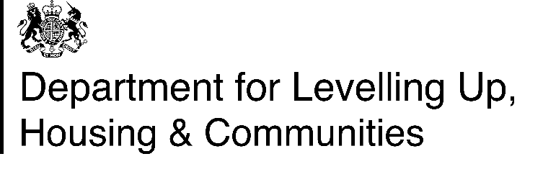
GAHOS 4 - Notice confirming completion of landlord checks
Instructions for landlords
Please use this Notice to confirm that you have completed the necessary checks to sell the applicant(s) a share in their home through the Grenfell Assisted Home Ownership Scheme (GAHOS).
The applicant should receive this Notice no later than 4 weeks following your receipt of their GAHOS 2 – Notice of application to the Grenfell Assisted Home Ownership Scheme.
Part A of this Notice to be completed in all cases.
Part B of this Notice to be completed if a share in the home can be sold to the applicant(s).
Part C of this Notice to be completed if a share in the home cannot be sold to the applicant(s). This must include information on what can be done to resolve the issue(s) highlighted by the checks. For example, how the applicant(s) can pay off any rent arrears they may have.
Please delete these instructions before sending a completed version of this Notice to the applicant(s).
Please also delete any instructions below in yellow before sending this Notice to the applicant(s).
Part A: Landlord’s name
Name:
Click or tap here to enter text.

Part B: Sale of a share in the home to the applicant(s)

To: Click or tap here to enter text.,
We received your notice of application to purchase a share in the below home through the Grenfell Assisted Home Ownership Scheme (GAHOS) on Click or tap here to enter text..

Address (including postcode):
Click or tap here to enter text.

We have now completed all the necessary checks and we are pleased to confirm that we can now move to the next stage of the application process. This involves having your home valued.
If your home is a flat, we will notify you of the outcome of the valuation process no later than Click or tap here to enter text. (This date should be no later than 12 weeks from the date of this Notice).
If your home is a house, we will notify you of the outcome of the valuation process no later than Click or tap here to enter text. (This date should be no later than eight weeks from the date of this Notice).
We will notify you of the outcome of the valuation process by sending you a copy of the GAHOS – Key information about the home document. You must read this document in full as it will contain important information about your home that will be relevant to the mortgage and legal advice you will need before completing your purchase.
Signed: Click or tap here to enter text.

Job title: Click or tap here to enter text.

Date: Click or tap here to enter text.

Part C: Issues affecting sale

To: Click or tap here to enter text.,
We received your notice of application to purchase a share in the below home through GAHOS on Click or tap here to enter text..

Address (including postcode):
Click or tap here to enter text.

We have now completed all the necessary checks and they have highlighted an issue that means we are unable to sell you a share in your home through GAHOS. (If appropriate) I have provided further information about this issue in the box below.
(If appropriate) I have also included information about how you can resolve this issue. Once this issue has been resolved, you can reapply to purchase a share in your home through GAHOS.

(If appropriate) Further information about the issue identified and how it can be resolved:
Click or tap here to enter text.

If you would like to discuss any of the above information in more detail, please contact Click or tap here to enter text..

Signed: Click or tap here to enter text.

Job title: Click or tap here to enter text.

Date: Click or tap here to enter text.

