Department for Environment, Food and Rural Affairs  Scottish Government  Welsh Government | 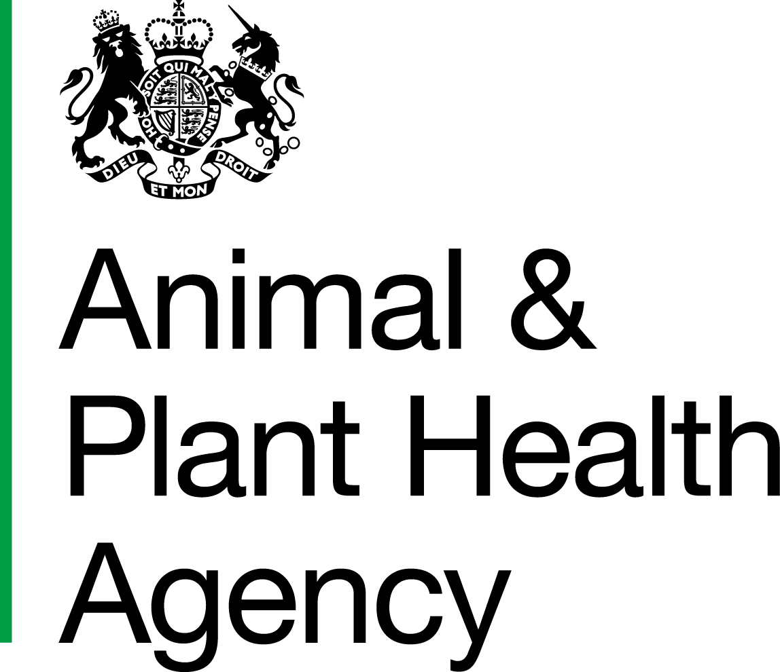
Application for an Official Stamp Replacement

* Mandatory fields

* OV/CSO/FCCO Name
* SP/CSO/NV Number
* Role | OV |  | CSO |  | FCCO
*Practice/Employer’s Email Address
*Contact Number

* Current Practice/Employer’s Name
* Current Practice/Employer’s Address
* My Current Stamp has been: | Stolen |  | Lost |  | Damaged
Lost Property Number/Crime Reference Number (if applicable)
Additional Comments
* Signature

DATA PROTECTION
For information on how we handle personal data please go to www.gov.uk and search Animal and Plant Health Agency Personal Information Charter.
Once completed please return to:

Email: | CSCOneHealthOVTeam@apha.gov.uk
Post: | OV Team  Animal and Plant Health Agency  Customer Service Centre One Health  County Hall, Spetchley Road  Worcester  WR5 2NP

Applications will be actioned in ten working days. For OVs your stamp will be posted to the address provided on your Improve International training. For AHPs and FCCOs the stamp will be posted to your employer’s address.
You must ensure that the details on your Improve International dashboard are up-to-date and match those provided on this form.

APHA is an Executive Agency of the Department for Environment, Food and Rural Affairs and also works on behalf of the Scottish Government, Welsh Government and Food Standards Agency to safeguard animal and plant health for the benefit of people, the environment and the economy.

