Department for Environment, Food and Rural Affairs  Scottish Government  Welsh Government | 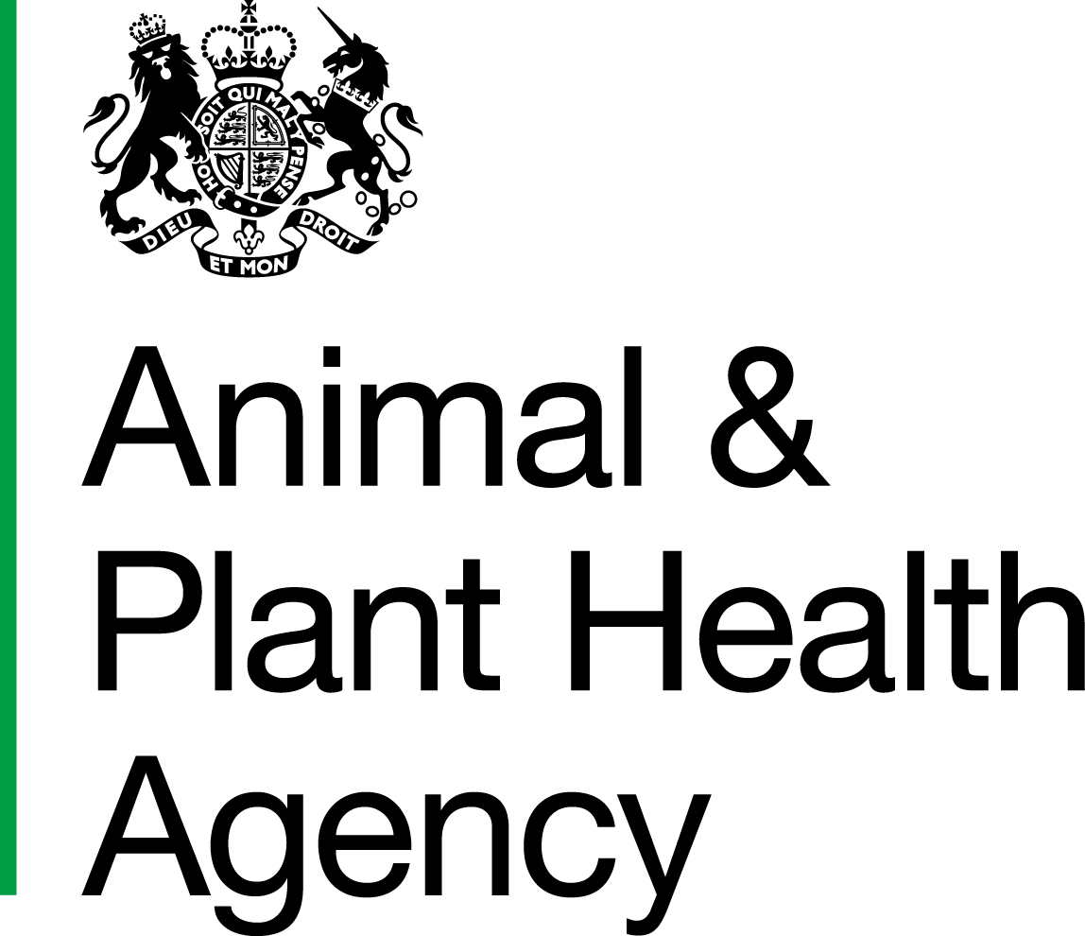
Sam Registration

Please ensure this form is completed in BLACK pen and BLOCK LETTERS

Section A Practice Registration
Is the practice already registered to Sam? | Yes |  | No

Section B Existing Sam Users who have moved to a new practice

Name of old practice |  | Name of new practice

Section C Authorisation

This section must be completed by the Principal or Partner of Veterinary Practice.
By signing this I request that the person(s) listed be granted access to the Sam application and that I will inform Animal and Plant Health Agency immediately in the event that any person’s access to Sam should be withdrawn.
I confirm that the practice has signed the Data Confidentiality Agreement with Animal and Plant Health Agency (APHA).

Name |  | Date
Role
Signature

DATA PROTECTION
For information on how we handle personal data please go to www.gov.uk and search Animal and Plant Health Agency Personal Information Charter.

Section D registration details

Practice Name |  | Animal Health Office
VAT Number |  | Practice Email address
Practice Address |  | Practice Postcode
 |  | Practice Telephone number

SP Number 1 | Title | First Name | Surname | Role 2 | Signature 3 | Other Practice Name 4 | Other SP Number4

¹ - Leave blank if OV Practice Admin or OV Practice Manager, otherwise enter your allocated SP number
² - Enter one of the following – Official Veterinarian, OV Practice Admin, OV Practice Manager
³ - By signing this you are agreeing to keep your username and password secure and not divulge them to anybody else
4 - If you carry out work for other OV Practice(s), record the Practice(s) name and your additional SP number

Please return completed form to the OV Appointments Team, County Hall, Spetchley Road, Worcester, WR5 2NP. Phone: 03000 200 301. Fax number: 01905 768649. Email: ovteam@apha.gov.uk

APHA is an Executive Agency of the Department for Environment, Food and Rural Affairs and also works on behalf of the Scottish Government, Welsh Government and Food Standards Agency to safeguard animal and plant health for the benefit of people, the environment and the economy.

