Application for Metrology Stickers
Please email completed form to metrologystickers@businessandtrade.gov.uk along with your purchase order (if payment is required). If you have any questions about the completion of the form please email or call 0121 345 1201.
If you are completing this form by hand please write legibly in BLOCK CAPITALS.
Costings can be found here: https://www.gov.uk/guidance/approved-verification-guidance-application-form-and-stickers
Note: 2022 is used in the examples below, the stickers you receive will be dated for 2024.
To avoid delay only request stickers you are authorised to use.
WEIGHTS AND MEASURES AUTHORITIES ONLY
DISQUALIFICATION STICKER   | TOTAL NUMBER OF STICKERS REQUIRED:
GB RE-QUALIFICATION STICKER  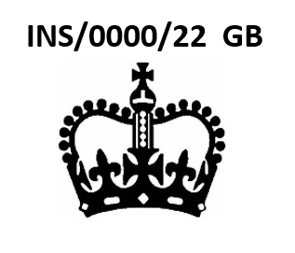 | TOTAL NUMBER OF STICKERS REQUIRED PER STAMP NUMBER:
 | AUTHORISED STAMP NUMBER(S):
NI RE-QUALIFICATION STICKER  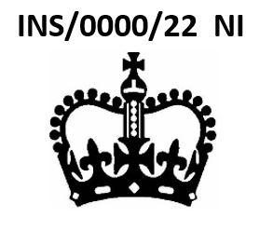 | TOTAL NUMBER OF STICKERS REQUIRED PER STAMP NUMBER:
 | AUTHORISED STAMP NUMBER(S):
QUALIFYING NI GOODS  RE-QUALIFICATION STICKER  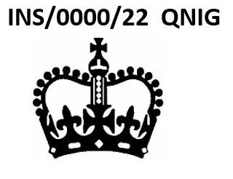 | TOTAL NUMBER OF STICKERS REQUIRED PER STAMP NUMBER:
 | AUTHORISED STAMP NUMBER(S):

APPROVED VERIFIERS ONLY
GB RE-QUALIFICATION STICKER  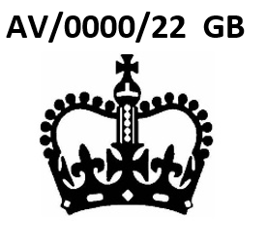 | TOTAL NUMBER OF STICKERS REQUIRED PER STAMP NUMBER:
 | AUTHORISED STAMP NUMBER(S):
NI RE-QUALIFICATION STICKER  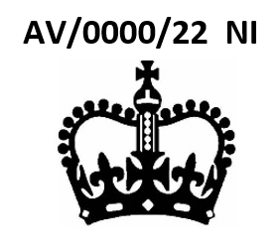 | TOTAL NUMBER OF STICKERS REQUIRED PER STAMP NUMBER:
 | AUTHORISED STAMP NUMBER(S):
QUALIFYING NI GOODS  RE-QUALIFICATION STICKER  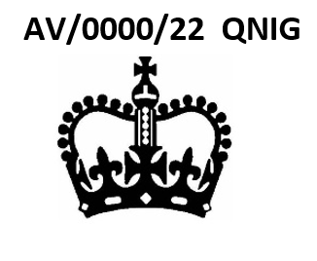 | TOTAL NUMBER OF STICKERS REQUIRED PER STAMP NUMBER:
 | AUTHORISED STAMP NUMBER(S):

UK APPROVED BODY INITIAL VERIFICATION
IDENTIFICATION NUMBER STICKER
 | TOTAL NUMBER OF STICKERS REQUIRED:
 | UK APPROVED BODY NUMBER:

UK APPROVED BODY (Module F/F1) ONLY
Non Automatic Weighing Instruments (NAWI) only
GB RE-QUALIFICATION STICKER  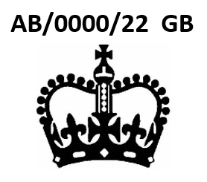 | TOTAL NUMBER OF STICKERS REQUIRED PER STAMP NUMBER:
 | APPROVED BODY NUMBER:
NI RE-QUALIFICATION STICKER  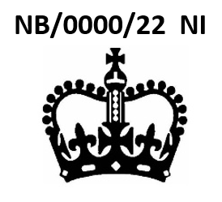 | TOTAL NUMBER OF STICKERS REQUIRED PER STAMP NUMBER:
 | APPROVED BODY NUMBER:
QUALIFYING NI GOODS  RE-QUALIFICATION STICKER  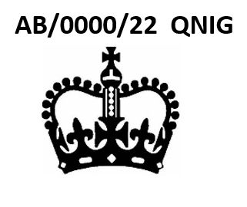 | TOTAL NUMBER OF STICKERS REQUIRED PER STAMP NUMBER:
 | APPROVED BODY NUMBER:

UK APPROVED MANUFACTURER ONLY
Non Automatic Weighing Instruments (NAWI) only
GB RE-QUALIFICATION STICKER  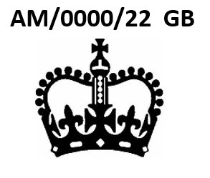 | TOTAL NUMBER OF STICKERS REQUIRED PER STAMP NUMBER:
 | APPROVED MANUFACTURER NUMBER:
NI RE-QUALIFICATION STICKER  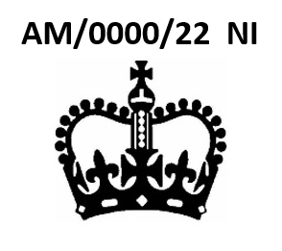 | TOTAL NUMBER OF STICKERS REQUIRED PER STAMP NUMBER:
 | APPROVED MANUFACTURER NUMBER:
QUALIFYING NI GOODS  RE-QUALIFICATION STICKER  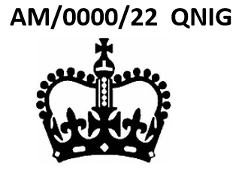 | TOTAL NUMBER OF STICKERS REQUIRED PER STAMP NUMBER:
 | APPROVED MANUFACTURER NUMBER:

REQUESTER DETAILS
Full name of contact
Telephone Number
Email Address
Purchase Order Number

Name of organisation and full postal address including postcode (for delivery)
Useful Links:
Approved Manufacturer List
https://www.gov.uk/guidance/approved-manufacturers-conformity-assessment
Approved Verifier List
https://www.gov.uk/guidance/approved-verification-guidance-application-form-and-stickers#identify-an-approved-verifier
Approved Body List
https://find-a-conformity-assessment-body.service.gov.uk/?Keywords=&LegislativeAreas=Non-automatic+weighing+instruments

