Department for Environment, Food and Rural Affairs  Scottish Government  Welsh Government | 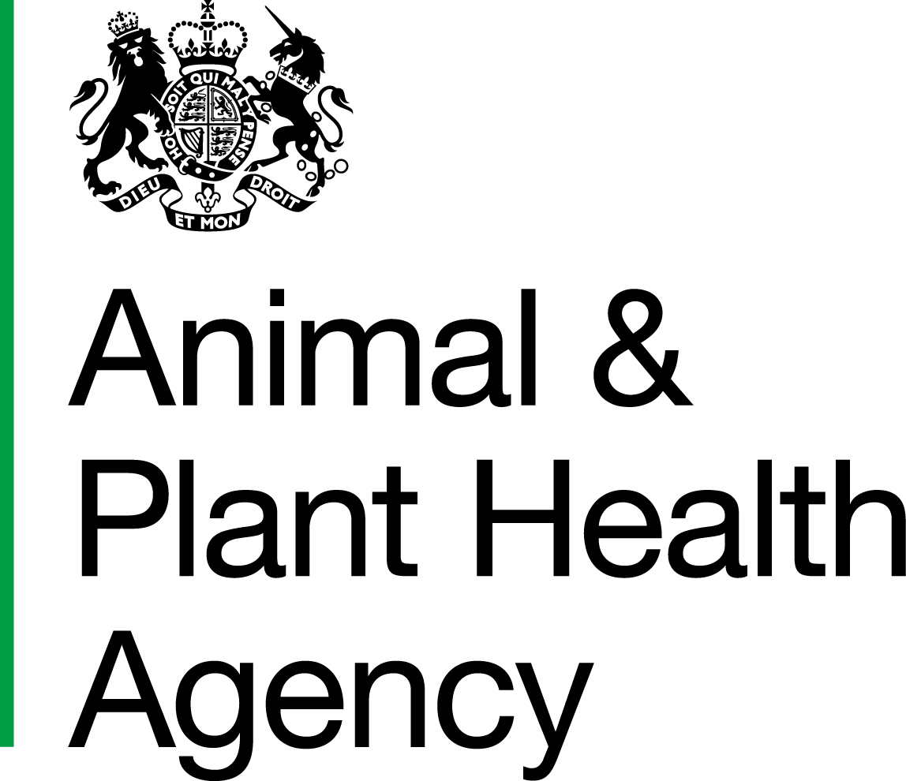
Payment of Official Veterinarian Fees

Practice Declaration

- I acknowledge receipt of the HM Customs and Excise Conditions on the Official Veterinarian (OV) Fees Self-billing Invoicing System (OV10).

- I agree to abide by the conditions insofar as they relate to OVs.

- I am prepared to accept self-billing invoices for OV work from Defra.

Signature |  | Position
Name in  BLOCK LETTERS |  | Date
For Practice Title |  | VAT Registration Number
Practice Address

DATA PROTECTION
For information on how we handle personal data please go to www.gov.uk and search Animal and Plant Health Agency Personal Information Charter.

This declaration should be sent to the Head of Field Delivery England (HFDE)/Head of Field Delivery Scotland (HFDS)/Head of Field Delivery Wales (HFDW) in whose area the practice is situated.

APHA is an Executive Agency of the Department for Environment, Food and Rural Affairs and also works on behalf of the Scottish Government, Welsh Government and Food Standards Agency to safeguard animal and plant health for the benefit of people, the environment and the economy.

