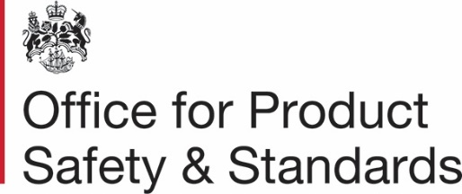

The Office for Product Safety and Standards as a Supporting Regulator for Primary Authority
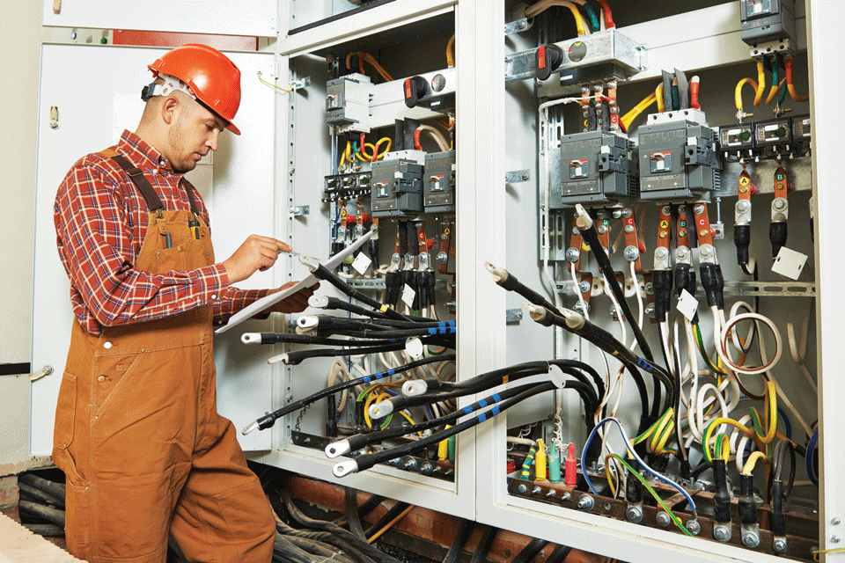

April 2024

Contents
Introduction and background 3
The Office for Product Safety and Standards’ offer 3
Examples of how the Office for Product Safety and Standards can support partnerships as a supporting regulator 4
Annex A: Service Standards 5
Working with you 5
Costings 5
Links to our role as a national regulator 6
Having your say 6
How to contact us 6
Annex B: Request template and flowchart 7
Primary Authority support request template 7
Process flowchart 8

Introduction and background
The Office for Product Safety and Standards (OPSS) was created in January 2018 to deliver consumer protection and to support business confidence, productivity, and growth. OPSS regulates a wide range of products with a focus on their safety and integrity.
Certain relevant national regulators are specified as supporting regulators in Primary Authority. This includes the Secretary of State in relation to their role with respect to regulatory functions concerning weights and measures and product safety regulation . OPSS acts in this capacity on behalf of the Secretary of State.
The role of a supporting regulator fits within OPSS’ wider remit of bringing together policy expertise and practical experience to ensure that regulation is delivered effectively in ways that reduce burdens on business, save public money and properly protect citizens and communities.
This document sets out the approach that OPSS takes to being a supporting regulator. It provides information for primary authorities, businesses and co-ordinators about how support can be provided and provides practical information on the operation of the approach.

The Office for Product Safety and Standards’ offer
OPSS will work with primary authorities and their partner businesses and co-ordinators to agree arrangements to provide support to the primary authority in its provision of Primary Authority Advice or Primary Authority Advice to Local Authorities, or in its development and management of an inspection plan. These arrangements may relate to a single piece of work, such as the preparation or review of specific advice, or they may relate more widely to the primary authority’s partnership work with a business or a group of businesses.
OPSS’ involvement as a supporting regulator can bring a range of benefits to the primary authority and the partner business, or group of businesses, such as:
- access to the supporting regulator’s technical expertise in the regulatory area;
- up-to-date knowledge of forthcoming changes to regulatory requirements and guidance;
- the ability to agree an interpretation of generic guidance that is tailored to the particular circumstances of the business, or group of businesses, for example, to take account of technological or other innovation;
- improved co-ordination with other regulators utilising links into networks of expertise, such as Sector Panels; regional, national and international regulatory liaison groups; industry groups etc.;
- a wider perspective on inspection plans and national inspection strategies drawing on broad sources of data and intelligence; and
- access to technical facilities such as testing facilities.
OPSS can provide supporting regulator guidance in relation to its existing stock of legislation. Please note that supporting regulator advice cannot currently be provided in relation to construction products.
In carrying out the supporting regulator role, OPSS will be working with the other supporting regulators to share best practice and align processes where appropriate.

Examples of how the Office for Product Safety and Standards can support partnerships as a supporting regulator
Example 1: Tailored support on compliance – new products
Business A has developed a new product and is considering how it complies with the law. This new product is not fully covered by any existing standards, and due to the novel nature of this product, it is open to interpretation as to which set of regulations would apply. Business A asks its primary authority for advice on how to demonstrate that the product is safe and agrees with its primary authority to work with OPSS as a supporting regulator on this request. OPSS works with the business and the primary authority to consider options for assessing the safety of the product and on technical documentation demonstrating that the product is safe. Once a conclusion is reached the primary authority issues Primary Authority Advice that the new product complies with the legislation.
Example 2: Advice on Trade Association guidance
Trade Association B has member businesses which import and manufacture products. Many of the member businesses are small businesses. The Trade Association provides technical expertise, interpreting the relevant British Standards and producing user friendly guidance for its members. Trade Association B is updating this guidance and arranges with its primary authority to work with OPSS as a supporting regulator at an early stage to ensure that the updated guidance takes account of any imminent changes to the legislation or standards. Once the guidance is finalised the primary authority issues Primary Authority Advice to confirm that the guidance is adequate to deliver compliance.
Example 3: Support for an inspection plan
A significant percentage of the goods supplied in the UK are weighed or measured on equipment maintained under contracts. Members of Trade Association C carry out this work to an agreed Code of Practice and the Trade Association can access information on which equipment is properly maintained and compliant. Trade Association C works with its primary authority and OPSS as a supporting regulator to enable Primary Authority Advice and an Inspection Plan to be developed. Intelligence on businesses covered by the inspection plan is shared with local authorities via the Primary Authority Register, enabling enforcing authority resources to be targeted at those less likely to comply with the law.

Annex A: Service Standards
These Service Standards describe the working arrangements within OPSS for provision of services as a supporting regulator for Primary Authority. They have been developed mainly for primary authorities although they may also be of interest to businesses and co-ordinators within the scheme. In this Annex, OPSS are referred to as ‘we’ and the primary authority requesting the support is referred to as ‘you’.
Support will be provided having regard to the Primary Authority Statutory Guidance. We can provide support at an early stage in the development of Primary Authority Advice, Primary Authority Advice to Local Authorities or an inspection plan or we can have more detailed involvement including agreeing a final version. When we have agreed a final version of Primary Authority Advice, Primary Authority Advice to Local Authorities or an inspection plan, we will act consistently with this in our dealings with the business or group of businesses.

Working with you
In responding to requests for our services we will provide a nominated contact who will:
- acknowledge your request within 5 working days;
- seek to fully understand the nature of your request;
- seek to gain an understanding of how your partner business, or co-ordinator operates;
- explain what we may or may not be able to do;
- agree timescales, costings and preferred methods of communication with you;
- agree a written summary of working arrangements with you;
- keep you informed of progress throughout our involvement; and
- maintain records of the support provided.
In all your dealings with us you can expect, and will receive, an efficient and professional service. We will:
- be courteous and polite;
- always identify themselves by name in dealings with you, and provide you with contact details; and
- provide details of how to discuss any concerns you may have.

Costings
OPSS can recover the costs incurred for offering support requested by the primary authority.
In calculating these costs, OPSS takes into account the guidance issued by HM Treasury in Managing Public Money.

Links to our role as a national regulator
The role of a supporting regulator fits within OPSS’ national regulator remit.
We will use information received from primary authorities to support these regulatory objectives, to further our knowledge and understanding of the regulated business community and individual businesses, and to improve our ability to regulate effectively and efficiently.
We appreciate that not every enquiry we receive will result in supporting regulator work; therefore your details may be passed to other teams within OPSS, to provide assistance. Further information is available at:
https://www.gov.uk/government/organisations/office-for-product-safety-and-standards.

Having your say
If you are dissatisfied or wish to comment on our service or behaviour, please send us your complaint or comments. Our aim is to resolve any problems or difficulties quickly and fairly. We manage complaints about our service, or about the conduct of our staff, through our Complaints Policy, and you can comment by contacting us using the details below.

How to contact us
To discuss how we can provide supporting regulator support to a partnership or to comment on our service please email lau.opss@businessandtrade.gov.uk using the subject heading ‘Supporting Regulator.’ Alternatively, you can call us on 0121 345 1201.

Annex B: Request template and flowchart
- This template is for the use of primary authorities who wish to request support from OPSS as a supporting regulator for weights and measures and the safety of consumer products.
- If you have any queries about completing the document, please email lau.opss@businessandtrade.gov.uk.

Primary Authority support request template
Name of primary authority
Contact details of primary authority
(name / telephone number / email address)
Name of partner business or co-ordinator
Business sector or main business activity
Contact details of partner business or co-ordinator
Details of scope of support requested (please be as specific as possible)
Is there existing guidance in relation to this request? |  | Yes / No
If ‘yes’, please give details
Is there existing Primary Authority Advice in relation to this request? |  | Yes / No
If ‘yes’, please give details
Has the business or co-ordinator agreed to this request? |  | Yes / No
Has the business or co-ordinator previously sought advice from OPSS or other body in relation to this request? |  | Yes / No
Please send this completed form to lau.opss@businessandtrade.gov.uk

Process flowchart
▼
Primary authority reviews existing guidance to check
whether supporting regulator input is required.
▼
Primary authority contacts OPSS using the template form, clarifying the scope of the support requested, and why any existing guidance is insufficient.
▼
OPSS considers the request and whether it can assist,
giving an initial response within 5 working days.
▼
Primary authority and OPSS have a discussion to ensure the
request is correctly scoped, confirm it is not addressed in another
forum, and estimate the resources and time it requires.
▼
Primary authority clarifies the nature of the support it is seeking.
▼
OPSS confirms the nature of the support that will be
provided along with a timeframe and any cost of providing the support.
▼
A written summary of working arrangements is created to include the request, nature of support to be provided, timeframe, costings and confidentiality.
▼
Supporting regulator support provided.
▼
Primary authority issues the Primary Authority Advice produced or
inspection plan developed with OPSS.

Supporting Regulators are specified by R2 and the Schedule of The Co-ordination of Regulatory Enforcement Regulations 2017.
https://www.gov.uk/government/publications/managing-public-money

