Application Decision
by Harry Wood
Appointed by the Secretary of State for Environment, Food and Rural Affairs
Decision date: 5 April 2024

Application Ref: COM/3332044
Shortwood Common, Staines Upon Thames, Surrey, TW18 4NZ
Register Unit Number: CL 31
Commons Registration Authority: Surrey County Council

- The application, dated 23 October 2023, is made under Section 38 of the Commons Act 2006 (the 2006 Act) for consent to carry out restricted works on common land.
- The application is made by Fisher German LLP for Cadent Gas Ltd.
- The works comprise:
- the digging of approximately 1m by 1m trial holes to identify and excavate a nitrogen sleeve for grout filling;
- temporary fencing consisting of Heras fencing measuring 3.5m wide by 2m tall with approximately 160m of fencing to be in place at one time to create a 40m by 40m working area.

Decision
- Consent is granted for the works in accordance with the application dated 23 October 2023 and the plans submitted with it subject to the following conditions:

- the works shall begin no later than three years from the date of this decision;
- the land shall be fully reinstated within one month from the completion of the works.
- For the purposes of identification only the location of the works area is shown by the red area on the attached plans.

Preliminary Matters
- I have had regard to Defra’s Common Land Consents Policy Guidance (November 2015) in determining this application under section 38, which has been published for the guidance of both the Planning Inspectorate and applicants. However, every application will be considered on its merits and a determination will depart from the guidance if it appears appropriate to do so. In such cases, the decision will explain why it has departed from the guidance.

- This application has been determined solely on the basis of written evidence. I have taken account of the representations made by the Open Spaces Society (OSS) and Natural England (NE).

- I am required by section 39 of the 2006 Act to have regard to the following in determining this application:
- the interests of persons having rights in relation to, or occupying, the land (and in particular persons exercising rights of common over it);
- the interests of the neighbourhood;
- the public interest; Section 39(2) of the 2006 Act provides that the public interest includes the public interest in; nature conservation; the conservation of the landscape; the protection of public rights of access to any area of land; and the protection of archaeological remains and features of historic interest. And
- any other matter considered to be relevant.

Reasons

- The applicant explains that the purpose of the works is to ensure the safe functioning of the pipeline and that the pipeline sleeve needs to be refilled to stop the potential corrosion of the pipe. The fencing is required to prevent access to the working area while the works are being carried out for health and safety reasons.

The interests of those occupying or having rights over the land

- Dr Mohammad Husainy is the owner of the land. They have been consulted by the applicant and have provided no objection to the project. The common land register records rights to graze two cows and one horse.

- The applicant advises that no grazing rights are carried out on the land but it is commonly walked over due to public footpaths running over the common.

- I am satisfied that all those with rights of common had the opportunity to comment about the potential impact of the application proposals on these rights and no such comments were received.

The interests of the neighbourhood and public access
- The interests of the neighbourhood relate to whether the works will unacceptably interfere with the way the common land is used by local people and is closely linked with interests of public access. The applicant is planning to dig trial holes to find and excavate an underground nitrogen sleeve which will create impediments on the common where the holes and excavation take place however, this will only cover a small area of the common and the wider common will be unaffected. These features will have a minimal impact on access and are temporary in nature.

- The temporary fencing would have a larger impact, blocking access to the areas of the common where the works are taking place, but this will be minimal due to the small size of the area the fencing is surrounding and the common will still be accessible via other routes. The fencing is also planned to be temporary in nature. I am satisfied that such fencing is appropriate on health and safety grounds and that it will be removed on completion of the works, which can be secured by attaching a suitable condition to the consent.

- NE have stated the works and associated fencing will directly affect a public right of way which leads across the common from London Road and runs along its southern boundary. Public rights of way should remain open and available for public use at all times unless closed or diverted following agreement with the Local Highway Authority. In this case they believe the relevant authority would be Surrey County Council. They also state the applicant must also make good any damage to the surface of the public right of way caused during the work.

- They further outline that due to the presence of the public footpath they anticipate the area will be frequently used by pedestrians. For the period that the works are being undertaken such use will not be possible due to the Heras fencing however given that the works are temporary in nature they do not see any long-term adverse impacts.

- OSS have provided no objection to the proposed works within this consent.

- In this case no new permanent features are being introduced into the common and I believe the works will provide wider benefit to the neighbourhood by improving and maintaining the safe usage of the nitrogen sleeve. I conclude the works will have minimal impact on the recreational value of the common and the works will not unacceptably interfere with the interests of the neighbourhood or public rights of access.

The public interest
- As well as the public interest in the protection of public rights of access, the Guidance (November 2015) outlines the public interest in nature conservation, the conservation of the landscape and the protection of archaeological remains and features of historic interest.

Nature conservation and Conservation of the landscape
- The applicant has stated that the works full within the boundary of the Staines Moor SSSI and consent under Section S28H of the Wildlife and Countryside Act 1981 for the works has been acquired from NE on 28/11/2023.

- NE have stated that the Staines Moor SSSI chiefly consists of a semi-natural stretch of the River Colne which flows through it, and three adjacent reservoirs. Staines Moor represents the largest area of alluvial meadows in Surrey and supports a rich flora while the reservoirs hold nationally important populations of wintering wildfowl. A pond at the site carries an aquatic flora which is of national importance; this flora includes one plant which is extremely rare in Britain.

- NE in conclusion state that there will be some adverse impacts on the landscape while the works are taking place which will mainly be due to the presence of the Heras fencing. As the fencing will only be in place for a short period (5 days), provided the area is fully reinstated after the works are completed and they do not anticipate any lasting impact on the common.

- The proposed works will not introduce any new permanent artificial features as they are being carried out to repair existing underground features or will be temporary in nature.

- The applicant has stated that once the works have been carried out that the land will be returned to its original condition. This will reduce their visual impact on the common.

- I am satisfied that nature conservation interests will not be harmed by the works and I consider that overall, the works will have only a small impact on landscape interests while the works are being carried out.

Protection of archaeological remains and features of historic interest.
- The applicant has stated that there are no archaeological features within the proposed works area. Historic England and the local authority archaeological service have been consulted and did not comment.

- There is no evidence before me to suggest that these interests will be harmed by the proposed works.

Other Matters

- Within their representations OSS have stated they believe that a number of works not included in this application fall within the common land boundary of Shortwood Common. The applicant has responded to this stating they do not believe the works fall within the boundary and therefore have not sought consent for them.

- The Planning Inspectorate take the view that it is for the applicant to decide, in these cases, whether restricted works they want to carry out fall within the boundary of a common and seek the appropriate consent. In this instance there is no reason before me why the submitted section 38 application should not be determined.

Conclusion

- Defra’s Common Land Consents Policy advises that “works may be proposed in relation to common land which do not benefit the common, but confer some wider benefit on the local community, such as minor works undertaken by a statutory undertaker (e.g. a water utility) to provide or improve the public service to local residents and businesses. Consent under section 38 may be appropriate where the works are of temporary duration (such as a worksite), where the works will be installed underground (such as a pipeline or pumping station), or where their physical presence would be so slight as to cause negligible impact on the land in question (such as a control booth or manhole), and the proposals ensure the full restoration of the land affected and confer a public benefit.”

- I conclude that the permanent works will benefit the local community by improving the condition of the nitrogen sleeve and are important on health and safety grounds. The permanent works will not seriously harm the other interests set out in paragraph 5 above. Consent for the works is therefore granted subject to the conditions set out at paragraph 1.

Harry Wood

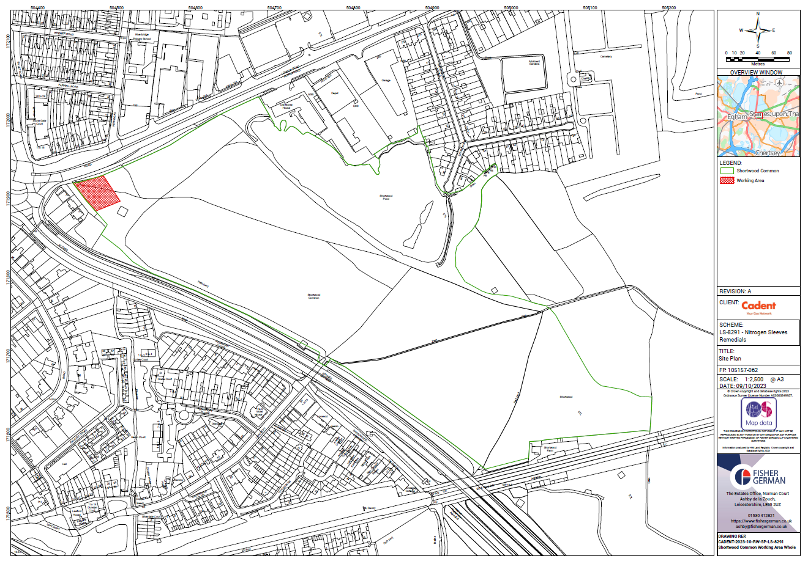
Figure 1 – Works area within common land

